SC-RRT: A Search-State-Driven Path Planning Algorithm with Adaptive Asymmetric Dual-Ellipsoid Constrained Sampling

搜索状态驱动的自适应非对称双椭球约束采样SC-RRT路径规划算法

Yan Wu¹ · Xingyu Guo¹ · MuChun Fan¹ · Feng Hong¹ ·HongYu Gao¹ · JiaLe Hu¹

Abstract:
To address the issues of invalid sampling, slow convergence, and decreased success rates under high obstacle density in complex environments encountered by sampling-based path planning algorithms, this paper proposes an SC-RRT path planning algorithm based on Adaptive Dual-Ellipsoid Constrained Sampling.Within a bidirectional parallel expansion framework, the proposed method introduces intermediate points for guidance, decomposing the global planning task into staged subproblems. By constructing scalable and asymmetric bidirectional informed sampling subsets, the sampling process progressively concentrates on feasible paths with greater potential for improvement. This forms an Adaptive Dual-Ellipsoid Constrained Sampling (ADCS) strategy, which significantly increases the density of effective samples while maintaining exploration coverage. To mitigate invalid sampling caused by over-expansion or premature contraction of the informed subset due to cost estimation bias, this paper establishes a Search State Feedback-Based Online Regulation (SSFOR) mechanism. By utilizing the historical evolution sequence of the current best path cost as feedback, a closed-loop regulation is applied to the hyper-ellipsoid expansion factor γ and the heuristic sampling probability p. This enables the construction of an informed sampling subset that evolves in real time with the search process, allowing adaptive allocation of sampling density between the global exploration space and locally constrained regions. As a result, redundant expansions are effectively suppressed while search continuity is maintained. Furthermore, by incorporating an asymmetric hyper-ellipsoid constraint strategy to directionally compress and expand the sampling space, the algorithm enhances its resolution capability along potential feasible corridor directions.
In simulation experiments comparing multiple path planning algorithms under varying obstacle densities and spatial dimensions, SC-RRT demonstrates notable performance advantages. Compared with the most structurally similar method, Dynamic-RRT, SC-RRT reduces path length by approximately 10.5% and achieves a path efficiency of 0.9553. Although its path quality is slightly inferior to that of the asymptotically optimal Informed RRT*, the planning time is only 16.2% of the latter, with the number of nodes reduced by approximately 94.2%. These results indicate that SC-RRT achieves a more favorable balance among path quality, planning efficiency, and computational resource consumption. While maintaining search completeness, it effectively suppresses invalid exploration and operates stably across diverse scenarios without requiring prior parameter tuning. Furthermore, its modular ADCS and SSFOR designs can be integrated as independent components into other RRT-based planning frameworks.
Keywords：Sampling-based path planning; asymmetric dual-ellipsoid informed sampling; bidirectional tree search; online parameter regulation; motion planning
- Introduction
With the rapid development of Industry 4.0 and service robotics technologies, intelligent robots have become a core driver for enhancing automation levels and operational efficiency in manufacturing, service, and other sectors. Their application scenarios have expanded from structured factory settings to dynamic and complex human–robot collaborative environments[1][4]. This trend places higher demands on robots’ autonomous decision-making capabilities, particularly on path planning algorithms as a core technical module, whose performance directly determines the safety, reliability, and real-time performance of robotic operations[5][7] . Therefore, conducting in-depth research on robot path planning algorithms in complex environments is of significant theoretical value and plays a crucial role in advancing the engineering application of intelligent robots. The core task of path planning is to generate a collision-free trajectory that satisfies motion constraints for the robot within the configuration space defined by a known start and goal, while balancing the two fundamental objectives of real-time responsiveness and path optimality[8]-[9]. In dynamic environments, randomly distributed obstacles and system uncertainties further

¹ School of Mechanical Engineering, Shanghai Institute of Technology, Shanghai 201418, China
² Corresponding Author: Xingyu Guo
³ Email:Gxyhaoxianghenlihai@gmail.com
exacerbate the difficulty of planning. The shrinkage of feasible regions under sampling constraints and the decline in tree growth efficiency become particularly pronounced [10], making it a key challenge in current research to simultaneously achieve rapid convergence and high-quality paths. [11][12]
The Rapidly Exploring Random Tree (RRT) algorithm and its bidirectional variants, such as Bidirectional RRT*, are classical sampling-based path planning methods. Owing to their probabilistic completeness and ease of implementation, they have been widely applied in complex environments[13][14]. However, the traditional Bidirectional RRT* algorithm still suffers from inherent limitations, such as strong randomness in the sampling process, low search efficiency, and insufficient geometric smoothness of the planned paths[15][16]. These limitations restrict its performance in scenarios involving large-scale environments, dense obstacles, or dynamically distributed obstacles[17][18]. To address the aforementioned issues, researchers in recent years have proposed various improvement strategies from the perspectives of sampling guidance, coordination of search strategies, and path structure optimization. A representative line of work enhances convergence efficiency by improving the bidirectional search framework and sampling guidance mechanisms, with particular emphasis on improving accessibility in “difficult-to-sample” scenarios such as narrow passages[19]. ARRT-Connect [20] , proposed by Li and Chen (2022), as well as ABQ-RRT* based on similar principles, adaptively adjust the sampling strategy according to the scale of unexplored regions identified through dual-tree exploration. By incorporating the principal component analysis (PCA) approach introduced by Tahirovic and Ferizbegovic (2018) in RRT [21], these methods enhance the directional growth of trees within “elongated feasible corridors,” thereby accelerating exploration and connectivity in narrow environments.
However, such methods may still generate a large number of redundant sampling points in regions unrelated to the optimal path when operating in high-dimensional spaces or complex environments with multiple passages, thereby reducing overall planning efficiency. In particular, as the environment scale increases or obstacle density rises, fixed sampling bias strategies struggle to adapt to the varying demands of different search stages, leading to diminished guidance effectiveness of the informed subset. Informed RRT* proposed by Gammell et al. [23][24] restricts the sampling space to an informed subset defined by a hyper-ellipsoid with the start and goal states as its foci, thereby concentrating the sampling process on regions that can potentially improve the cost of the current best path. This work establishes the theoretical foundation for cost-guided constrained sampling. Building upon this foundation, Gammell et al. further proposed the BIT* algorithm [25][26] , which unifies informed sampling and graph search into a heuristic search over an implicit random geometric graph, thereby further improving planning efficiency in high-dimensional scenarios. To further reduce the sensitivity of fixed ellipsoids to cost estimation bias, recent studies have attempted to introduce dynamic corridor constraints [27] or adaptive bidirectional hyper-ellipsoidal sampling [28] to enhance the adaptability of the sampling domain. The Dynamic-RRT algorithm proposed by Zhao et al. innovatively introduces a heuristic hyper-ellipsoidal constrained sampling mechanism. By estimating the path cost through expanded nodes, it restricts the sampling space to a hyper-ellipsoid with the start and goal states as its foci and the estimated path length as the major axis, thereby significantly improving the effectiveness of new node generation [29]. Meanwhile, the algorithm incorporates the Pareto Dominance principle[30] and dynamic programming concepts. By selecting Pareto-optimal nodes as new starting points to decompose the planning problem, it further reduces convergence time while ensuring path length optimization. Its performance is significantly superior to classical algorithms such as RRT, RRT*, and Informed RRT. Such methods effectively balance convergence speed and path quality through sampling space constraints and problem decomposition strategies. However, the performance of the sampling constraint mechanism in this algorithm still heavily depends on the accuracy of path cost estimation. When the cost is overestimated, the ellipsoidal constraint region becomes excessively large, leading to a considerable number of invalid samples; when the cost is underestimated, the constraint region shrinks prematurely, potentially excluding feasible optimal paths from the sampling space and causing the algorithm to converge to a suboptimal solution or even fail. Moreover, Dynamic-RRT adopts a unidirectional search framework, in which the informed subset is defined solely by the start and goal as focal points. In complex environments, its ability to guide the global search direction remains limited, and redundant expansions may still occur.
Overall, existing improvement methods still exhibit a pronounced trade-off between efficiency and optimality. While sampling guidance or bidirectional connectivity strategies can accelerate the acquisition of feasible solutions, they generally lack guarantees of asymptotic optimality. In contrast, cost-driven constrained sampling and problem decomposition approaches can increase the proportion of effective samples and improve path quality; however, their performance is highly sensitive to the accuracy of cost estimation. Moreover, the constraint domains are typically static or only weakly adaptive, which may lead to excessive shrinkage in the early search stage, reducing reachability, or cause oscillations in sampling ratios and tree expansion behavior when cost values fluctuate, thereby weakening global robustness and convergence consistency.
To address the aforementioned issues, this paper proposes an SC-RRT algorithm based on an adaptive asymmetric dual-ellipsoid constrained sampling subset. Within a bidirectional parallel search framework guided by intermediate points, the algorithm constructs asymmetric dual-ellipsoid sampling subsets on the start and goal sides that can independently expand and contract. To overcome the sensitivity of traditional constrained sampling to cost estimation bias and to prevent premature shrinkage or ineffective expansion of the sampling space, a search state feedback-based online regulation mechanism is established. Using the current best path cost and its historical evolution as feedback, a closed-loop control strategy is employed to adjust the scale of the hyper-ellipsoidal informed subsets. During the stage when a stable feasible solution has not yet been obtained, the constraints are moderately relaxed to enhance exploration coverage; once feasible paths emerge and continue to improve, the constraints are progressively strengthened to increase effective sampling density and suppress redundant expansions. In this way, a controllable dynamic balance is achieved among convergence speed, path quality, and search stability. Comparative experiments are conducted in representative scenarios with varying obstacle densities and spatial dimensions, using Dynamic-RRT and classical RRT variants as baselines. The effectiveness of the proposed mechanisms is systematically evaluated in terms of path length, planning time, node scale, and path smoothness.
- Algorithm statement
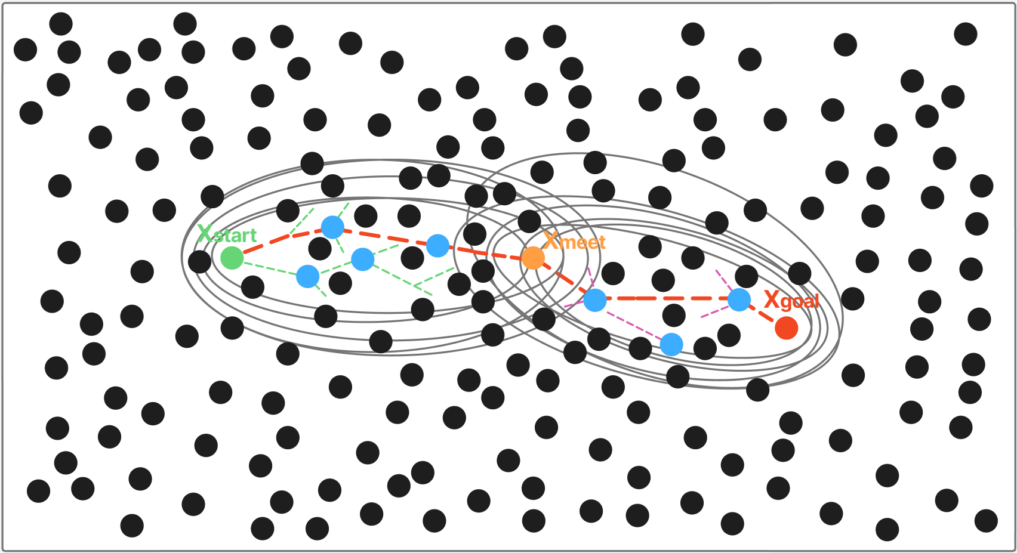
Figure 1.Schematic Diagram of the Search State-Driven Adaptive Asymmetric Dual-Ellipsoid Constrained Sampling SC-RRT Path Planning Algorithm
To establish the mathematical model of the path planning problem[31], the Cartesian workspace and the configuration space are defined, where m and n denote the corresponding dimensions, respectively[32]. There exists a mapping relationship between the workspace and the configuration space. Path planning is primarily carried out in the configuration space C, while obstacle information is mapped from the workspace W to the configuration space through coordinate transformation. Let the state be defined as, and partition the space into the collision-free region , shown as the white area in the figure, and the obstacle region , represented by the black circular obstacles, such that . The planning start and goal states are denoted as as illustrated in Figure 1.
The SC-RRT algorithm constructs two random trees T_{A},T_{B} from the start state x_{start} and the goal state x_{goal} , respectively, and introduces a dynamic intermediate point , thereby decoupling the global search into two subproblems: “start–intermediate” and “goal–intermediate,” as defined in Equation (1). 其中中介点 $x_{meet}$基于双树搜索状态在线更新。与传统单一静态椭球不同，本文所构建的超椭球体并非固定形状，其参数随路径代价改进与中介点迁移更新，以$x_{meet}$为桥梁，根据搜索过程中的路径代价变化与扩展状态自适应地进行伸缩，在起点侧与目标点侧分别在构建超椭球体采样约束，在保证潜在最优路径覆盖性的同时，逐步收紧采样域边界，有效减少无效采样。
  - 自适应非对称双椭球采样子集约束策略
本文提出一种非对称双椭球约束采样子集机制，实现非对称采样范围调节。与概率路线图方法（PRM）[33]基于多查询图结构的离线规划模式不同，本方法在双树扩展中兼顾全局探索与局部精细搜索，最终实现路径长度、规划时间及节点规模的同步降低，策略整体思想如示意图 1 所示。
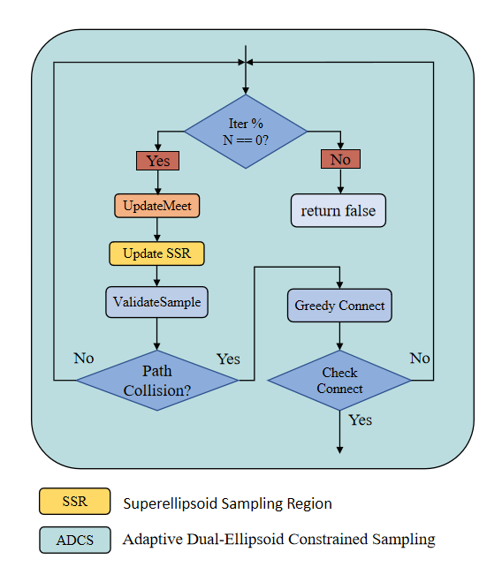
图2：自适应双椭球约束采样策略，ADCS
该采样策略的核心是动态计算超椭球体的约束参数，对于任意一个方向，以起点侧为例，其定义为：
其中
- 表示为 SSFOR 机制在线调节的膨胀系数；
- 表示从起点侧经启发式评估的最优总代价估计；
- 是从起点x_{start}到节点x的累积路径代价；
- 是节点x到中介点x_{meet}的启发式距离；
终点侧以对应方式定义，两个椭球分别独立更新，形成非对称约束结构。每次迭代中，以概率p在上述椭球内执行知情采样，以一定概率向对侧树 Pareto 支配原则选取的最优节点方向偏置采样，以剩余概率执行全局均匀采样。保证搜索既集中于有效区域，又保留全局覆盖能力。
对每个新扩展节点，优先尝试与对侧树直接连接，若超出阈值则由对树贪心逼近；一旦双树成功连接，对拼接路径执行节点重连优化与自适应平滑处理[34][35]，生成最终可行路径。
  - 基于搜索状态的在线调节机制

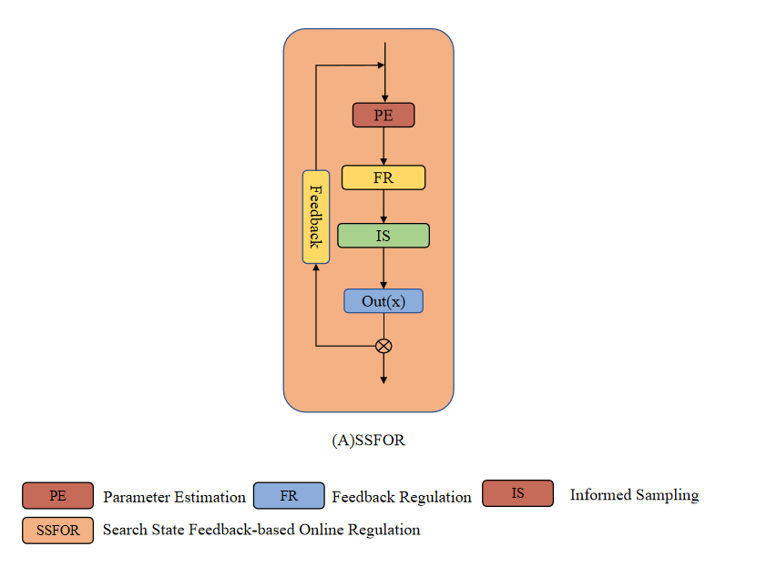

图3：基于搜索状态的在线调节机制，SSFOR

ADCS的有效性取决于膨胀系数 𝛾 与知情采样比例 𝑝 的适时调整。已有加速收敛的改进方法如路径偏置采样[36]、批量前向传播搜索[37]、代价下界权衡[38]及任意时间规划框架[39][40]多采用预设静态参数，启发式采样剪枝[41]亦需预定义阈值，均缺乏面向搜索状态的在线反馈调节能力。为此，本文提出 SSFOR 机制对二者实施闭环调节：以最优路径代价总预估的相对下降速率作为当前搜索进展信号，当路径代价持续无明显改进时，判定当前约束可能过紧或搜索陷入停滞，相应增大 $γ$ 以扩展椭球覆盖范围、降低 $p$以增加全局随机探索；反之，当路径代价持续有效改进时，减小 $γ$ 收紧约束采样子集、提高$p$ 强化知情采样，加速局部收敛。

为确保上述调节过程的有界性与可重复性，本文对两个参数的取值范围及初始状态作出如下规定，超椭球扩张因子 γ 的取值范围设定为 γ∈[1.0, 4.0]，基准值 γ₀=1.5，算法启动时初始化为 γ=2.5，以保证搜索初期具有足够的探索覆盖能力；γ 越大，椭球膨胀程度越高，算法倾向于广域探索，γ 越小，约束采样子集越紧凑，算法转入局部收敛强化。启发式采样概率 p 的取值范围设定为 p∈[0.2, 0.95]，基准值 p₀=0.8，初始值设为 p=0.0，使算法在尚未获得任何可行路径前完全依赖全局随机采样进行初始探索；p 越高，知情采样比例越大，偏向局部精细搜索，p 越低，全局随机采样比例增加，维持搜索多样性。约束过松时大量节点落在低效区域，约束过紧时在障碍物密集场景中有效采样率骤降；在 SSFOR 的闭环调节下，两个参数始终保持在上述有效范围内波动，防止约束采样子集出现无界膨胀或过度收缩，使约束强度与当前搜索阶段持续匹配。

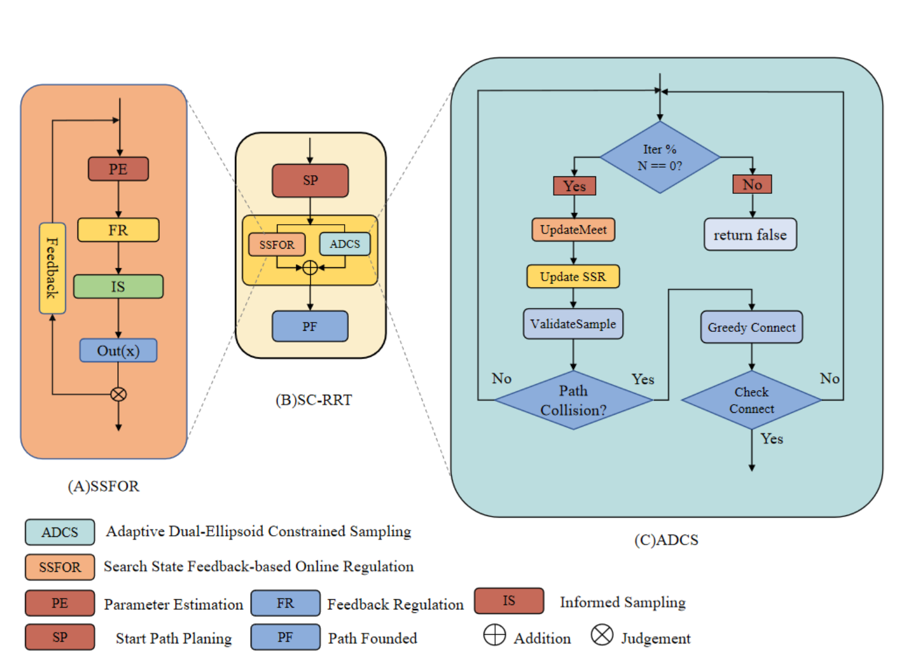

图4 SC-RRT算法总体框架。算法由搜索规划主循环、基于搜索状态反馈的在线调节机制、自适应双超椭球约束采样和可行性验证与双树连接四个模块组成。虚线箭头表示从搜索状态到采样参数调节的反馈路径。

Fig. 4 Overall framework of the SC-RRT algorithm. The algorithm consists of four modules: the search planning main loop, the search-state-based online adjustment mechanism, the adaptive dual-ellipsoid constrained sampling, and the feasibility verification with bidirectional tree connection. Dashed arrows indicate the feedback path from search state to sampling parameter regulation.

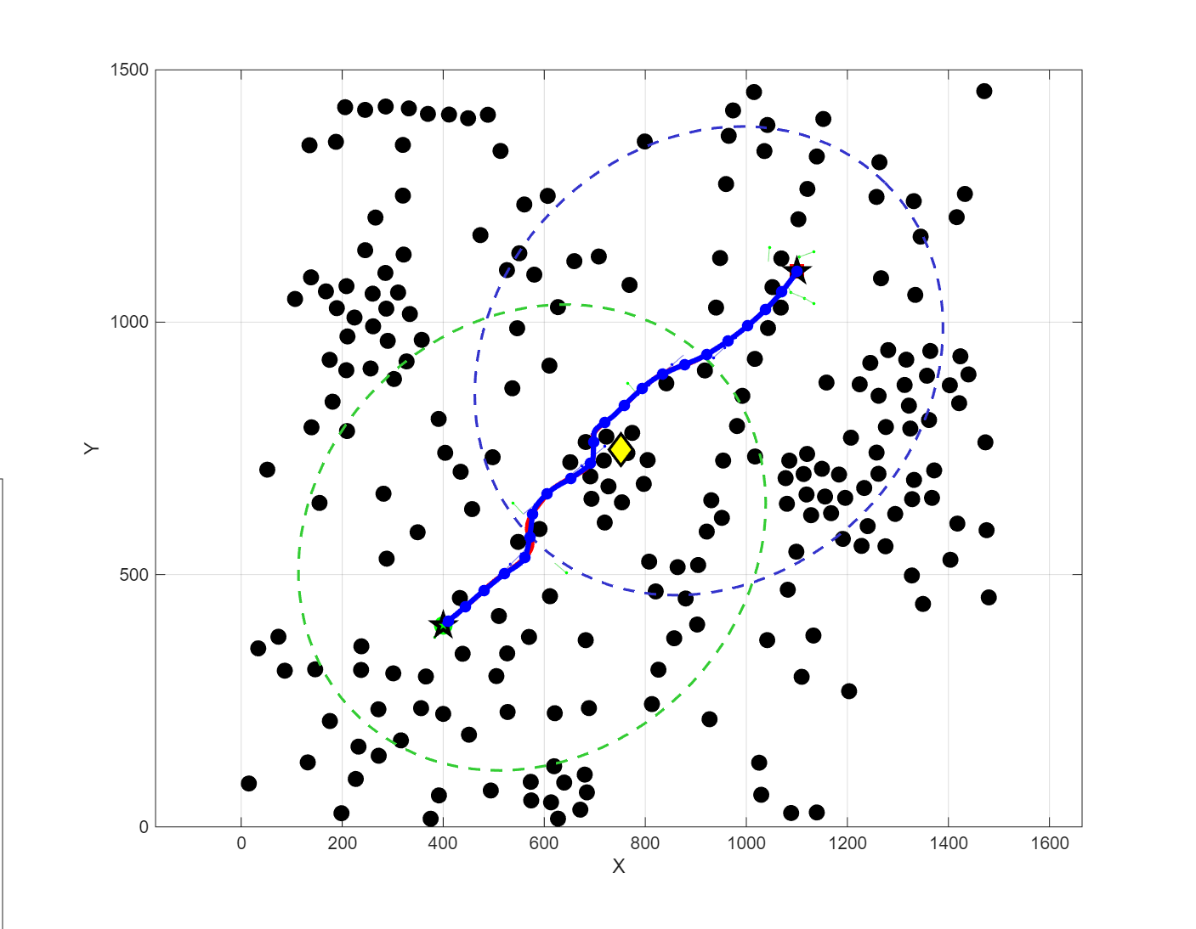
图5：2D环境下路径规划可视化对比
- Simulation
为系统评估 SC-RRT 在环境规模与障碍物密度保持一致条件下的性能，本研究在二维与三维空间下分别开展了仿真对比实验，结果如图6、图7所示。评估指标包括路径长度（Path Length）为路径相邻节点欧氏距离之和（mm）；收敛时间（Convergence Time）为算法完整运行时间（s）；节点数量（Node Count）为算法规划过程中生成的采样节点总数；路径效率（Path Efficiency）为起终点直线距离与实际路径长度的比值，越接近1.0表示路径越趋近最优。
Table 1 Environment configurations
Dimension | Environment | Obstacles | Start | Goal | Max Iteration
2 | 1500*1500 | 225 | (75, 75) | (1425, 1425) | 5000
3 | 1500*1500*1500 | 400 | (75, 75, 75) | (1425, 1425, 1425) | 88000
根据对路径规划的过往研究，选取五种代表性路径规划算法RRT、RRT-Connect、RRT*、Informed RRT*、Dynamic-RRT与本文算法SC-RRT进行对比，验证本文算法的性能与稳定性，为确保不同路径规划算法性能对比的公平性，本文在相同的环境空间和障碍物配置下，对多种算法的路径长度、收敛时间等性能指标进行评估，以表1中规定的环境为例，进行500次运行。
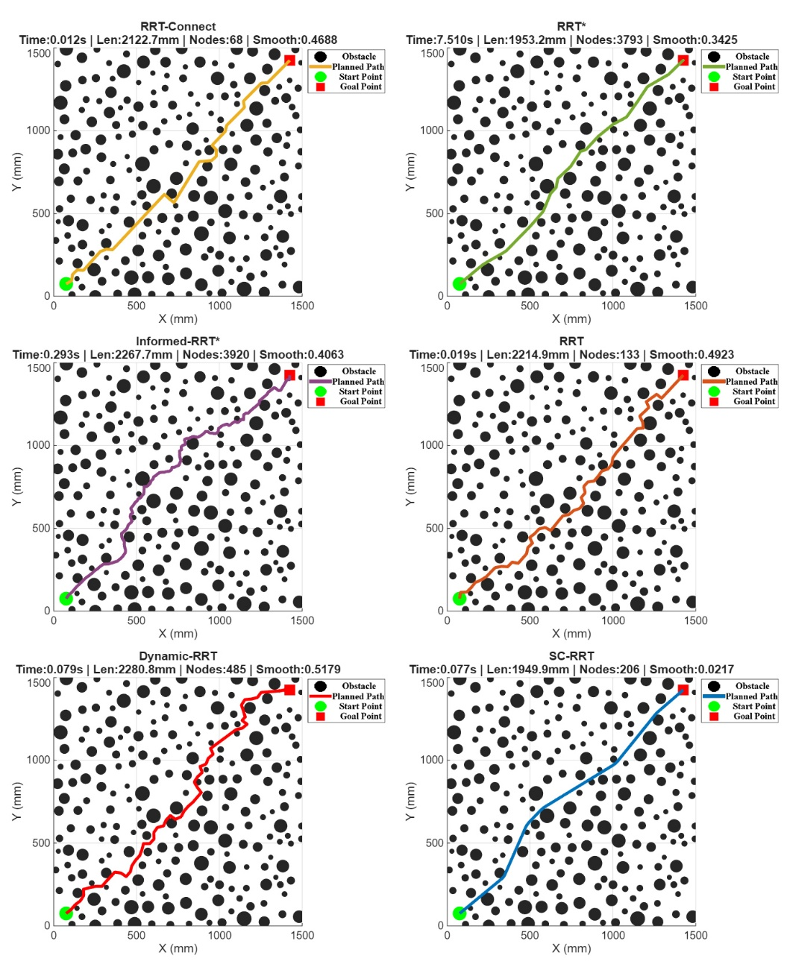
图6 二维空间下不同路径规划算法对比实验结果
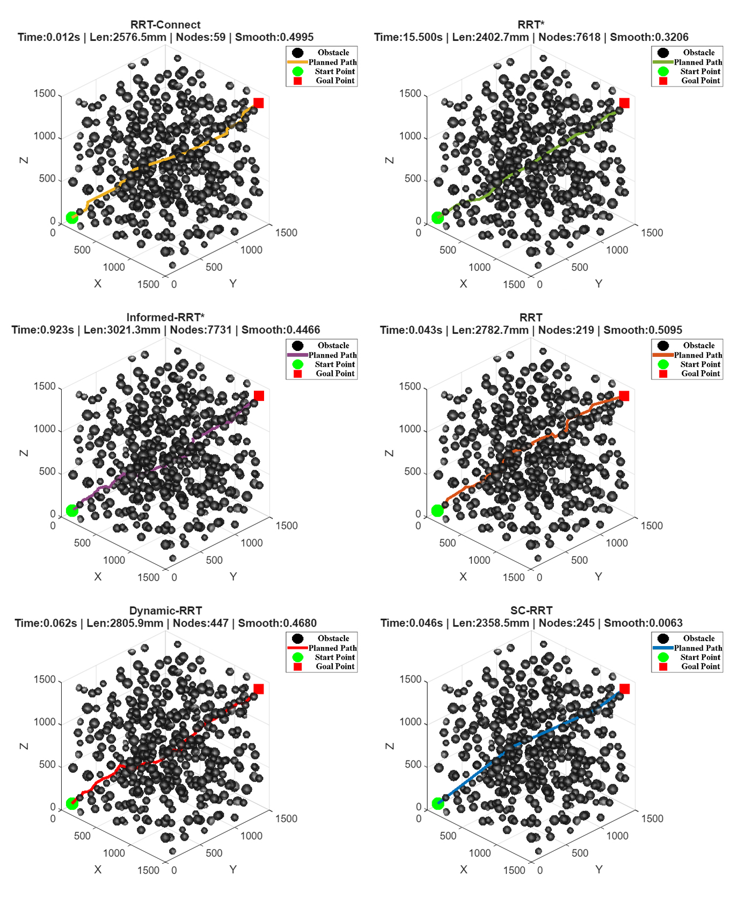
图7 三维空间下不同路径规划算法对比实验结果

Table 2 Comparison of Path Planning Algorithms
Algorithm | Path Length /mm | Convergence time /s | Node Count | Path Efficiency
RRT | 2329.5500±126.2500 | 0.0409±0.0305 | 279.4000 ± 175.5000 | 0.8219 ± 0.0429
RRT-connect | 2143.2400±93.4900 | 0.0108±0.0053 | 69.3000 ± 10.8000 | 0.8924 ± 0.0376
RRT* | 1970.7200±19.9400 | 0.1629 ± 0.0843 | 3846.6000 ± 99.7000 | 0.9689 ± 0.0098
Informed RRT* | 1938.4500±24.1300 | 0.2134 ± 0.0487 | 3612.3000 ± 108.6000 | 0.9714 ± 0.0076
SC-RRT | 2049.0900±57.5300 | 0.0345 ± 0.0124 | 209.6000 ± 38.5000 | 0.9553 ± 0.0265
Dynamic-RRT | 2288.1300±136.0200 | 0.0414 ± 0.0384 | 281.3000 ± 160.2000 | 0.8372 ± 0.0468
在二维与三维不同障碍密度的典型场景中，以相同环境配置与计算预算为约束，对SC-RRT与RRT、RRT-Connect、RRT*、Informed RRT*及Dynamic-RRT等主流算法展开系统性对比，结果如Table 2所示。总体而言，Dynamic-RRT的渐进最优性依赖充足的时间才能充分发挥，在实时性要求较高的场景下存在明显局限；而当随机采样节点$x_{rand}$的概率分布偏向目标方向时，其路径长度与效率指标虽有所改善，但提升幅度有限。相比之下，SC-RRT凭借在线自适应调节机制（SSFOR），在保持相近路径长度的前提下，显著压缩了收敛时间与采样规模，综合实时性能明显优于Dynamic-RRT。
在路径质量方面，SC-RRT表现突出。其平均路径长度为2049.09 mm，较Dynamic-RRT缩短约10.5%，与渐进最优的RRT*相差仅4.0%，却以极低的计算代价实现了接近最优的路径质量。SC-RRT 的路径效率指标达到 0.9553，在所有对比算法中位居第三。仅次于渐进最优的Informed RRT*与RRT*，但其规划时间仅为Informed RRT*的16.2%，在路径质量与计算效率之间实现了显著更优的平衡。与经典 RRT*相比，路径效率差距为 1.40%。这表明 SC-RRT 在保持较高路径质量的同时，显著提升了规划速度，证明了ADCS紧凑采样机制所生成的路径在几何形态上高度趋近直线，冗余绕行得到有效抑制。
在计算效率方面，SC-RRT的平均收敛时间为0.0345 s，节点消耗仅为209.6个，具备优异的实时响应能力。而RRT*虽保证渐进最优，但其节点数高达3846.6个，收敛时间达0.1629 s，SC-RRT相对其实现了近4.7倍的提速，在时间敏感型任务中优势尤为显著。
路径稳定性方面，SC-RRT的路径长度标准差仅为±57.53 mm，远低于RRT的±126.25 mm及Dynamic-RRT的±136.02 mm，规划结果的一致性与可重复性显著更优。综上，SC-RRT在路径质量、计算效率与规划稳定性之间实现了最优综合平衡，并在二维与三维不同障碍密度场景下均保持稳定收敛和良好可扩展性，展现出良好的泛化能力与工程实用价值。
- Conclusion
针对采样式路径规划算法在障碍密集环境中有效采样比例低、收敛速度慢且知情子集对代价估计偏差敏感的问题，本文提出了SC-RRT算法。该算法包含两个紧密耦合的核心机制。
一，自适应非对称双椭球约束采样（ADCS）。引入基于双树搜索状态在线更新的动态中介点，将全局规划任务分解为"起点—中介点"与"终点—中介点"两个方向性子问题，并分别构造尺度可独立调节的超椭球知情子集。与Dynamic-RRT以起点和终点为固定焦点的单一对称椭球不同，ADCS的非对称双椭球结构能够针对两侧搜索进展差异进行方向性压缩与扩展，在保持探索覆盖性的同时显著提高潜在可行通道上的采样密度，有效缓解了引言中指出的单向框架全局引导能力不足的问题。
二，基于搜索状态反馈的在线调节机制（SSFOR）。以当前最优路径代价及其近期历史序列为反馈信号，实时输出超椭球扩张因子$γ$与知情采样概率$p$，对知情子集的体积与采样分配比例实施闭环调节。当路径改进停滞时自动扩大探索范围，当改进高效时逐步收紧约束以强化局部收敛，从而克服传统方法中代价高估导致采样知情子集过大或代价低估导致采样知情子集过早收缩的敏感性问题。
在二维与三维不同障碍密度的典型场景中，以相同环境配置与计算预算为约束，在ADCS的双向非对称约束与SSFOR闭环调节的协同作用下，SC-RRT在不同维度空间与障碍分布条件下均表现出更一致的收敛行为、更少的冗余扩展与更高的规划稳定性。证明了自适应非对称双椭球约束采样策略与在线约束反馈调节的结合是提升采样式规划算法综合性能的有效途径。为同类采样式规划算法突破代价估计偏差敏感性提供了可推广的建模范式。SC-RRT继承了Informed RRT*的概率完备性，并在渐进最优性框架下通过双向扩展与动态约束调节进一步加速收敛，理论性质与工程效率得到协同保障。

Authors' Contributions All authors contributed to the conception and design of the study. Xingyu Guo wrote the manuscript and performed the research. Technical support was provided by Muchun Fan, Feng Hong. Valuable comments on manuscript revision were provided by Hongyu Gao. Prof. Yan Wu provided guidance for manuscript writing. All authors have read and approved the final manuscript.

Funding None
Code availability The source code in this paper is not publicly available.

Declarations
Ethics approval Not applicable.

Competing interests The authors have no relevant financial or non- financial interests to disclose.

Consent to participate Not applicable.

Consent for publication Not applicable.

References
- Zhong R Y, Xu X, Klotz E, et al. Intelligent manufacturing in the context of industry 4.0: A review[J]. Engineering, 2017, 3(5): 616–630.
- Wirtz J, Patterson P G, Kunz W H, et al. Brave new world: Service robots in the frontline[J]. Journal of Service Management, 2018, 29(5): 907–931.
- Ajoudani A, Zanchettin A M, Ivaldi S, et al. Progress and prospects of the human-robot collaboration[J]. Autonomous Robots, 2018, 42(5): 957–975.
- Villani V, Pini F, Leali F, et al. Survey on human-robot collaboration in industrial settings: Safety, intuitive interfaces and applications[J]. Mechatronics, 2018, 55: 248–266.
- Elbanhawi M, Simic M. Sampling-based robot motion planning: A review[J]. IEEE Access, 2014, 2: 56–77.
- Karaman S, Frazzoli E. Sampling-based algorithms for optimal motion planning[J]. International Journal of Robotics Research, 2011, 30(7): 846–894.
- Mac T T, Copot C, Tran D T, et al. Heuristic approaches in robot path planning: A survey[J]. Robotics and Autonomous Systems, 2016, 86: 13–28.
- LaValle S M. Planning Algorithms[M]. Cambridge: Cambridge University Press, 2006. ISBN: 978-0-521-86205-9.
- Latombe J C. Robot Motion Planning[M]. Boston, MA: Springer, 1991. ISBN: 978-0-7923-9129-1.
- Kingston Z, Moll M, Kavraki L E. Sampling-based methods for motion planning with constraints[J]. Annual Review of Control, Robotics, and Autonomous Systems, 2018, 1: 159–185.
- Mohanan M G, Salgoankar A. A survey of robotic motion planning in dynamic environments[J]. Robotics and Autonomous Systems, 2018, 100: 171–185.
- Aggarwal S, Kumar N. Path planning techniques for unmanned aerial vehicles: A review, solutions, and challenges[J]. Computer Communications, 2020, 149: 270–299.
- LaValle S M. Rapidly-exploring random trees: A new tool for path planning[R]. TR 98-11, Computer Science Department, Iowa State University, 1998.
- LaValle S M, Kuffner J J. Randomized kinodynamic planning[J]. International Journal of Robotics Research, 2001, 20(5): 378–400.
- Kuffner J J, LaValle S M. RRT-Connect: An efficient approach to single-query path planning[C]. Proceedings of IEEE International Conference on Robotics and Automation (ICRA), San Francisco, CA, USA: IEEE, 2000: 995–1001.
- Gammell J D, Barfoot T D, Srinivasa S S. Asymptotically optimal sampling-based motion planning methods[J]. Annual Review of Control, Robotics, and Autonomous Systems, 2021, 4: 295–318.
- Qureshi A H, Ayaz Y. Intelligent bidirectional rapidly-exploring random trees for optimal motion planning in complex cluttered environments[J]. Robotics and Autonomous Systems, 2016, 68: 1–11.
- Ding J, Zhou Y, Huang X, et al. An improved RRT* algorithm for robot path planning based on path expansion heuristic sampling[J]. Journal of Computational Science, 2023, 67: 101904.
- Noreen I, Khan A, Habib Z. Optimal path planning using RRT* based approaches: A survey and future directions[J]. International Journal of Advanced Computer Science and Applications, 2016, 7(11): 97–107. DOI: 10.14569/IJACSA.2016.071114
- Li B, Chen B. An adaptive rapidly-exploring random tree[J]. IEEE/CAA Journal of Automatica Sinica, 2022, 9(2): 283–294.
- Huang Z, Gao Y, Guo J, et al. An adaptive bidirectional quick optimal rapidly-exploring random tree algorithm for path planning[J]. Engineering Applications of Artificial Intelligence, 2024, 133: 108072.
- Tahirovic A, Ferizbegovic M. Rapidly-exploring random vines (RRV) for motion planning in configuration spaces with narrow passages[C]. Proceedings of IEEE International Conference on Robotics and Automation (ICRA), Brisbane, QLD, Australia: IEEE, 2018: 7055–7062.
- Gammell J D, Srinivasa S S, Barfoot T D. Informed RRT*: Optimal sampling-based path planning focused via direct sampling of an admissible ellipsoidal heuristic[C]. Proceedings of IEEE/RSJ International Conference on Intelligent Robots and Systems (IROS), Chicago, IL, USA: IEEE, 2014: 2997–3004.
- Gammell J D, Srinivasa S S, Barfoot T D. Informed sampling for asymptotically optimal path planning[J]. IEEE Transactions on Robotics, 2018, 34(4): 966–984.
- Gammell J D, Srinivasa S S, Barfoot T D. Batch informed trees (BIT*): Sampling-based optimal planning via the heuristically guided search of implicit random geometric graphs[C]. Proceedings of IEEE International Conference on Robotics and Automation (ICRA), Seattle, WA, USA: IEEE, 2015: 3067–3074.
- Gammell J D, Barfoot T D, Srinivasa S S. Batch Informed Trees (BIT*): Informed asymptotically optimal anytime search[J]. International Journal of Robotics Research, 2020, 39(5): 543–567. DOI: 10.1177/0278364919890396
- Yuan L, Zhao J, Li W, et al. Improved informed-RRT* based path planning and trajectory optimization for mobile robots[J]. International Journal of Precision Engineering and Manufacturing, 2023, 24(3): 469–482.
- Zeng Z, Chang Y. ABF-RRT*: Bidirectional fast optimal rapidly-exploring random tree via adaptive sampling of a permissible hyper-ellipsoid[J]. Journal of King Saud University - Computer and Information Sciences, 2025, 37: 165.
- Zhao P, Chang Y, Wu W, et al. Dynamic RRT: Fast feasible path planning in randomly distributed obstacle environments[J]. Journal of Intelligent & Robotic Systems, 2023, 107(1): 48.
- Deb K, Pratap A, Agarwal S, et al. A fast and elitist multiobjective genetic algorithm: NSGA-II[J]. IEEE Transactions on Evolutionary Computation, 2002, 6(2): 182–197. DOI: 10.1109/4235.996017
- Choset H, Lynch K M, Hutchinson S, et al. Principles of Robot Motion: Theory, Algorithms, and Implementations[M]. Cambridge, MA: MIT Press, 2005. ISBN: 978-0-262-03327-5.
- Lynch K M, Park F C. Modern Robotics: Mechanics, Planning, and Control[M]. Cambridge: Cambridge University Press, 2017. ISBN: 978-1-107-15630-2. DOI: 10.1017/9781316661239
- Kavraki L E, Švestka P, Latombe J C, et al. Probabilistic roadmaps for path planning in high-dimensional configuration spaces[J]. IEEE Transactions on Robotics and Automation, 1996, 12(4): 566–580. DOI: 10.1109/70.508439
- Ravankar A, Ravankar A A, Kobayashi Y, et al. Path smoothing techniques in robot navigation: State-of-the-art, current and future challenges[J]. Sensors, 2018, 18(9): 3170. DOI: 10.3390/s18093170
- Yang K, Sukkarieh S. An analytical continuous-curvature path-smoothing algorithm[J]. IEEE Transactions on Robotics, 2010, 26(3): 561–568. DOI: 10.1109/TRO.2010.2042990
- Nasir J, Islam F, Malik U, et al. RRT*-SMART: A rapid convergence implementation of RRT*[J]. International Journal of Advanced Robotic Systems, 2013, 10(7): 299. DOI: 10.5772/56718
- Janson L, Schmerling E, Clark A, et al. Fast marching tree: A fast marching sampling-based method for optimal motion planning in many dimensions[J]. International Journal of Robotics Research, 2015, 34(7): 883–921. DOI: 10.1177/0278364915577958
- Salzman O, Halperin D. Asymptotically near-optimal RRT for fast, high-quality, motion planning[C]. Proceedings of IEEE International Conference on Robotics and Automation (ICRA), Hong Kong, China: IEEE, 2014: 4680–4685. DOI: 10.1109/ICRA.2014.6907543
- Ferguson D, Stentz A. Anytime RRTs[C]. Proceedings of IEEE/RSJ International Conference on Intelligent Robots and Systems (IROS), San Diego, CA, USA: IEEE, 2006: 5369–5375. DOI: 10.1109/IROS.2006.282100
- Karaman S, Walter M R, Perez A, et al. Anytime motion planning using the RRT*[C]. Proceedings of IEEE International Conference on Robotics and Automation (ICRA), Shanghai, China: IEEE, 2011: 1478–1483. DOI: 10.1109/ICRA.2011.5980479
- Akgun B, Stilman M. Sampling heuristics for optimal motion planning in high dimensions[C]. Proceedings of IEEE/RSJ International Conference on Intelligent Robots and Systems (IROS), San Francisco, CA, USA: IEEE, 2011: 2640–2645. DOI: 10.1109/IROS.2011.6095077

