SC-RRT: Superellipsoid-Constrained Bidirectional RRT with Adaptive Dual-Super-Ellipsoid Sampling
Yan Wu, Xingyu Guo¹∗, Muchun Fan¹, Feng Hong¹, Hongyu Gao¹, Jianyu Zheng¹
Abstract: Sampling-based path planning algorithms commonly suffer from excessive invalid samples, slow convergence, and inefficient exploration in obstacle-dense environments. This paper presents SC-RRT, a path planning algorithm based on adaptive asymmetric dual-super-ellipsoid constrained sampling. Within a bidirectional parallel expansion framework, SC-RRT employs an intermediate meeting point x_{meet} to decompose the global task into staged subproblems. Scale-variable, asymmetric informed sampling subsets are constructed in both directions to concentrate sampling toward feasible regions with greater improvement potential, forming the Adaptive Dual-Super-Ellipsoid Constrained Sampling strategy (ADCS). To suppress invalid sampling caused by over-inflation or premature contraction of the informed subset due to cost estimation bias, a Search State Feedback Online Regulation mechanism (SSFOR) is developed. SSFOR uses the historical evolution of the optimal path cost to perform closed-loop adjustment of the super-ellipsoid expansion factor γ and heuristic sampling probability p, enabling the informed subset to evolve with search progress while reducing redundant expansion. Asymmetric super-ellipsoidal constraints further sharpen resolution along feasible passage directions. Simulation experiments show that SC-RRT reduces path length by approximately 10.5% compared with Dynamic-RRT, achieving a path efficiency of 0.9553. Although path quality is marginally lower than Informed RRT*, planning time is only 16.2% of the latter with node count reduced by 94.2%. SC-RRT thus achieves a favorable balance between path quality and computational efficiency while reducing the need for manual parameter adjustment during the search process. its modular ADCS and SSFOR components can be independently integrated into other RRT-based frameworks.
Keywords: Sampling-based path planning, Informed sampling, bidirectional tree
search, online parameter regulation, motion planning

- Introduction
With the rapid advancement of Industry 4.0 and service robotics, intelligent robots have become a key driver of automation and operational efficiency across manufacturing, service, and related sectors[1,3]. Their application scope has expanded from structured factory settings to dynamic, complex environments where humans and robots work in close collaboration [4,5].Accordingly, in-depth research into robot path planning algorithms for complex environments carries not only considerable theoretical value, but also practical significance for advancing the real-world engineering deployment of intelligent robots. The core objective of path planning is to generate a collision-free trajectory for a robot within a known configuration space defined by a start point and a goal point, subject to kinematic constraints, while balancing two fundamental requirements: real-time responsiveness and path optimality [6,7]. Indynamic environments, randomly distributed obstacles and system uncertainties further compound the difficulty of planning. The shrinkage of the feasible region under sampling constraints and the resulting decline in tree growth efficiency are particularly pronounced [8], making the simultaneous achievement of fast convergence and high-quality paths a central challenge in current research [9,10].
The Rapidly Exploring Random Tree (RRT) algorithm and its bidirectional variants, such as Bidirectional RRT*, are classical sampling-based path planning method[11,12]. Owing to their probabilistic completeness and ease of implementation, they have been widely applied in complex environments [13,14]. However, the traditional Bidirectional RRT* algorithm still suffers from inherent limitations, such as strong randomness in the sampling process, low search efficiency, and insufficient geometric smoothness of the planned paths [15,16]. These limitations restrict its performance in scenarios involving large-scale environments, dense obstacles, or dynamically distributed obstacles [17,18]. Researchers have proposed various improvement strategies from the perspectives of sampling guidance, coordination of search strategies, and path structure optimization. A representative line of work enhances convergence efficiency by improving the bidirectional search framework and sampling guidance mechanisms, with particular emphasis on improving accessibility in difficult to-sample scenarios such as narrow passages [19]. ARRT-Connect [20], proposed by Li and Chen (2022), as well as ABQ-RRT* [21] based on similar principles, adaptively adjust the sampling strategy according to the scale of unexplored regions identified through dual-tree exploration. By incorporating the principal component analysis (PCA) approach introduced by Tahirovic and Ferizbegovic (2018) in RRT [22], these methods enhance the directional growth of trees within elongated feasible corridors, thereby accelerating exploration and connectivity in narrow environments.
However, such methods may still generate a large number of redundant sampling points in regions unrelated to the optimal path when operating in high-dimensional spaces or complex environments with multiple passages, thereby reducing overall planning efficiency. In particular, as the environment scale increases or obstacle density rises, fixed sampling bias strategies struggle to adapt to the varying demands of different search stages, leading to diminished guidance effectiveness of the informed subset. Informed RRT* proposed by Gammell et al. [23,24] restricts the sampling space to an informed subset defined by a super-ellipsoid with the start and goal states as its foci, thereby concentrating the sampling process on regions that can potentially improve the cost of the current best path. This work establishes the theoretical foundation for cost-guided constrained sampling. Building upon this foundation, Gammell et al. further proposed the BIT* algorithm [25,26], which unifies informed sampling and graph search into a heuristic search over an implicit random geometric graph, thereby further improving planning efficiency in high-dimensional scenarios. To further reduce the sensitivity of fixed super-ellipsoids to cost estimation bias, recent studies have attempted to introduce dynamic corridor constraints [27] or adaptive bidirectional super-ellipsoid sampling [28] to enhance the adaptability of the sampling domain. The Dynamic-RRT algorithm proposed by Zhao et al. innovatively introduces a heuristic super-ellipsoid constrained sampling mechanism. By estimating the path cost through expanded nodes, it restricts the sampling space to a super-ellipsoid with the start and goal states as its foci and the estimated path length as the major axis, thereby significantly improving the effectiveness of new node generation [29]. Meanwhile, the algorithm incorporates the Pareto Dominance principle [30] and dynamic programming concepts. By selecting Pareto-optimal nodes as new starting points to decompose the planning problem, it further reduces convergence time while ensuring path length optimization. Its performance is significantly superior to classical algorithms such as RRT, RRT*, and Informed RRT. Such methods effectively balance convergence speed and path quality through sampling space constraints and problem decomposition strategies. However, the performance of the sampling constraint mechanism in this algorithm still heavily depends on the accuracy of path cost estimation. When the cost is overestimated, the ellipsoidal constraint region becomes excessively large, leading to a considerable number of invalid samples; when the cost is underestimated, the constraint region shrinks prematurely, potentially excluding feasible optimal paths from the sampling space and causing the algorithm to converge to a suboptimal solution or even fail. Moreover, Dynamic-RRT adopts a unidirectional search framework, in which the informed subset is defined solely by the start and goal as focal points. In complex environments, its ability to guide the global search direction remains limited, and redundant expansions may still occur.
Overall, existing improvement methods still exhibit a pronounced trade-off between efficiency and optimality. While sampling guidance or bidirectional connectivity strategies can accelerate the acquisition of feasible solutions, they generally lack guarantees of asymptotic optimality. In contrast, cost-driven constrained sampling and problem decomposition approaches can increase the proportion of effective samples and improve path quality; however, their performance is highly sensitive to the accuracy of cost estimation. Moreover, the constraint domains are typically static or only weakly adaptive, which may lead to excessive shrinkage in the early search stage, reducing reachability, or cause oscillations in sampling ratios and tree expansion behavior when cost values fluctuate, thereby weakening global robustness and convergence consistency. To this end, this paper proposes an SC-RRT algorithm based on an adaptive asymmetric dual-super-ellipsoid constrained sampling subset. Within a bidirectional parallel search framework guided by intermediate points, the algorithm constructs asymmetric dual-super-ellipsoid sampling subsets on the start and goal sides that can independently expand and contract. To overcome the sensitivity of traditional constrained sampling to cost estimation bias and to prevent premature shrinkage or ineffective expansion of the sampling space, a search state feedback-based online regulation mechanism is established. Using the current best path cost and its historical evolution as feedback, a closed-loop control strategy is employed to adjust the scale of the super-ellipsoid informed subsets. During the stage when a stable feasible solution has not yet been obtained, the constraints are moderately relaxed to enhance exploration coverage; once feasible paths emerge and continue to improve, the constraints are progressively strengthened to increase effective sampling density and suppress redundant expansions. In this way, a controllable dynamic balance is achieved among convergence speed, path quality, and search stability. Comparative experiments are conducted in representative scenarios with representative obstacle densities and spatial dimensions, using Dynamic-RRT and classical RRT variants as baselines. The effectiveness of the proposed mechanisms is systematically evaluated in terms of path length, planning time, node count, and path efficiency.
- Proposed Method
  - Problem Formulation and Environment Modeling
To establish the mathematical model of the path planning problem [31], the Cartesian workspace W ⊆ R m and the configuration space C ⊆ R^{n} are defined, where m and n denote the corresponding dimensions, respectively [32]. Let the state be defined as:
and partition the space into:
• Collision-free region: W_{free} (white area)
• Obstacle region: W_{obs} (black circular obstacles)
Such that:
The planning start and goal states are denoted by x_{start} and x_{goal}, respectively, where both satisfy x_{start}, x_{goal} ∈ W_{free}, as illustrated in Figure 1. The SC-RRT algorithm constructs two random trees T_{A} and T_{B} from the start state x_{start} and the goal state x_{goal}, respectively, and introduces a dynamic intermediate point x_{meet}, thereby decoupling the global search into two subproblems: “start–intermediate” and “goal–intermediate,” as defined in Equation (1). The intermediate point x_{meet} is updated online based on the bidirectional search states. Unlike a traditional single static ellipsoid, the super-ellipsoid constructed in this paper does not maintain a fixed shape. Its parameters are dynamically updated as the path cost improves and the intermediate point shifts. Using x_{meet} as a bridge, the superellipsoid adaptively expands and contracts according to changes in path cost and the exploration states during the search process. Sampling constraints are constructed separately on the start side and the goal side, ensuring coverage of potentially optimal paths while progressively tightening the sampling domain boundaries, thereby effectively reducing invalid samples.

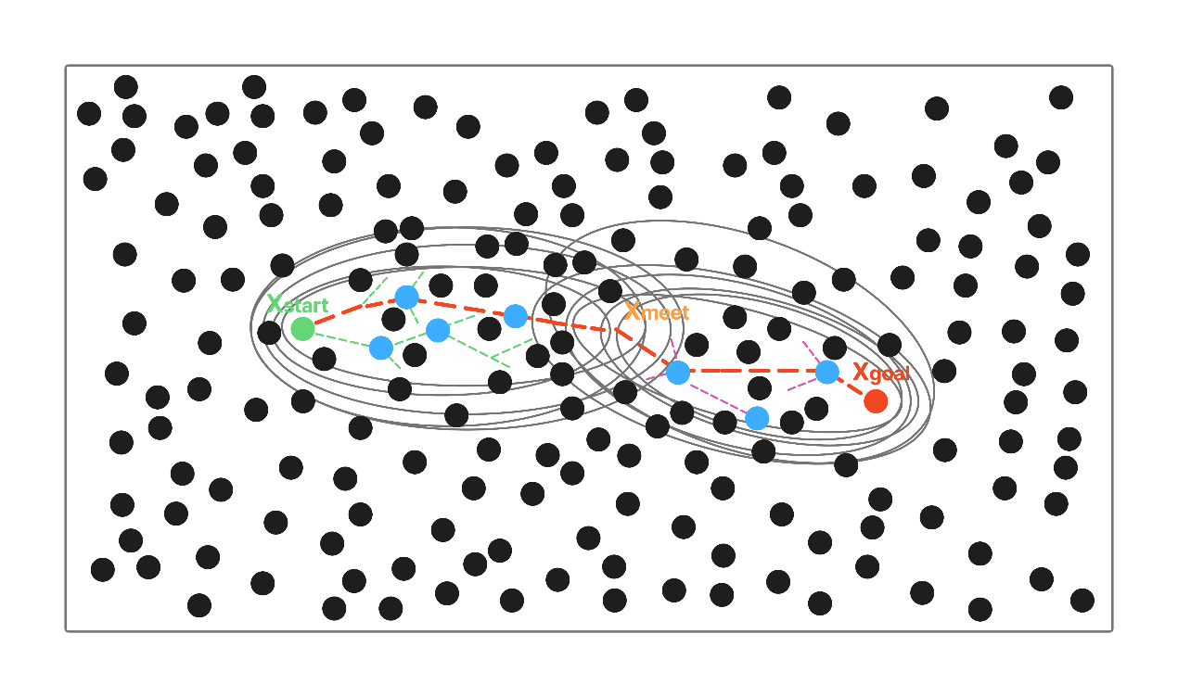
Fig.1 Schematic Diagram of the Search State-Driven Adaptive Asymmetric dual-super-ellipsoid
Constrained Sampling SC-RRT Path Planning Algorithm
  - An Adaptive Asymmetric Dual-Super-Ellipsoid Constrained Sampling (ADCS) Strategy
This paper proposes an asymmetric dual-super-ellipsoidal constrained sampling subset mechanism, as illustrated in Figure 2, to achieve asymmetric regulation of the sampling domain. Unlike the Probabilistic Roadmap (PRM) method [33], which adopts an offline planning paradigm based on a multi-query graph structure, the proposed approach balances global exploration and local refined search during bidirectional tree expansion. Ultimately, it achieves simultaneous reductions in path length, planning time, and the number of nodes.
The core of this sampling strategy lies in dynamically computing the constraint parameters of the super-ellipsoid. For either direction, taking the start side as an example, it is defined as follows:
Where:
• denotes the expansion coefficient adaptively adjusted online by the SSFOR mechanism;
• denotes the estimated optimal total cost from the start side based on heuristic evaluation;
• ∥x − f₁∥ denotes the accumulated path cost from the start node x_{start} to node x;
• ∥x − f₂∥ denotes the heuristic distance from node x to the intermediate point x_{meet}.
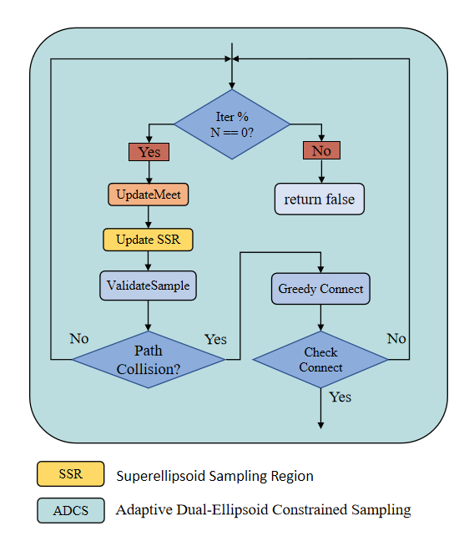
Fig. 2 Flowchart of the Adaptive Asymmetric dual-super-ellipsoid Constrained Sampling Strategy
The goal-side super-ellipsoid is defined analogously. The two super-ellipsoids are updated independently, forming an asymmetric constraint structure. In each iteration, informed sampling is conducted within the above super-ellipsoids with probability p; with a certain probability, biased sampling is performed toward the optimal node selected from the opposite tree according to the Pareto dominance principle; and with the remaining probability, global uniform sampling is carried out. This ensures that the search remains focused on effective regions while preserving global coverage capability.
For each newly expanded node, a direct connection to the opposite tree is attempted first. If the distance exceeds the threshold, the opposite tree greedily advances toward it. Once the two trees are successfully connected, node rewiring optimization and adaptive smoothing are performed on the concatenated path [34, 35], yielding the final feasible path.
  - Search State Feedback-Based Online Regulation (SSFOR)Mechanism
The effectiveness of ADCS depends on the timely adjustment of the expansion coefficient γ and the informed sampling ratio p. Existing convergence-acceleration methods, such as path-biased sampling [36], batch forward-propagation search [37], cost lower bound trade-off strategies [38], and anytime planning frameworks [39, 40], generally adopt preset static parameters. Heuristic sampling pruning methods [41] also require predefined thresholds, and thus lack online feedback regulation based on the search state. To address this limitation, this paper proposes the SSFOR mechanism to implement closed-loop regulation of both parameters, as detailed in the flowchart of Figure 3. The relative rate of decrease in the estimated total optimal path cost is used as a signal of the current search progress. When the path cost shows no significant improvement over time, the constraints are considered potentially too restrictive or the search is deemed to have stagnated. Accordingly, γ is increased to expand the super-ellipsoidal coverage, and p is reduced to enhance global random exploration. Conversely, when the path cost continues to improve effectively, γ is decreased to tighten the constrained sampling subset, while p is increased to strengthen informed sampling and accelerate local convergence.
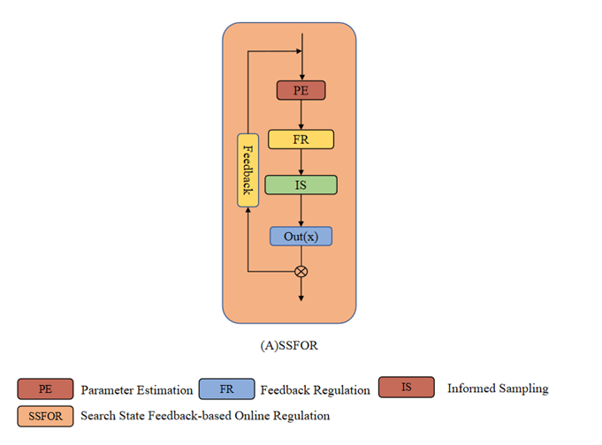
Fig. 3 Flow diagram of the Search State Feedback-Based Online Regulation (SSFOR) mechanism
To ensure the boundedness and reproducibility of the above adjustment process, this paper specifies the value range and initial states of the two parameters as follows: The super-ellipsoid expansion factor γ is defined within the range γ ∈ [1.0, 4.0], with a nominal value of γ₀ = 1.5. At algorithm initialization, γ is set to 2.5 to ensure sufficient exploratory coverage during the early stage of the search. A larger γ corresponds to a greater degree of super-ellipsoidal expansion, leading the algorithm to favor broader exploration. Conversely, a smaller γ results in a more compact constrained sampling subset, causing the algorithm to shift toward intensified local convergence. The heuristic sampling probability p is defined within the range p ∈ [0.2, 0.95], with a nominal value of p₀ = 0.8. The initial value is set to the lower bound p = 0.2, so that before any feasible path is obtained, the algorithm relies entirely on global random sampling for initial exploration. A higher p corresponds to a greater proportion of informed sampling, favoring refined local search; a lower p increases the proportion of global random sampling, thereby maintaining search diversity. When the constraint is overly relaxed, a large number of nodes fall into inefficient regions; when it is overly restrictive, the effective sampling rate drops sharply in obstacle-dense environments. Under the closed-loop regulation of SSFOR, both parameters fluctuate within the aforementioned valid ranges, preventing unbounded expansion or excessive contraction of the constrained sampling subset, and ensuring that the constraint strength continuously matches the current stage of the search. The overall framework of SC-RRT, comprising the main search loop, SSFOR-based online regulation, and ADCS sampling, is illustrated in Figure 4.
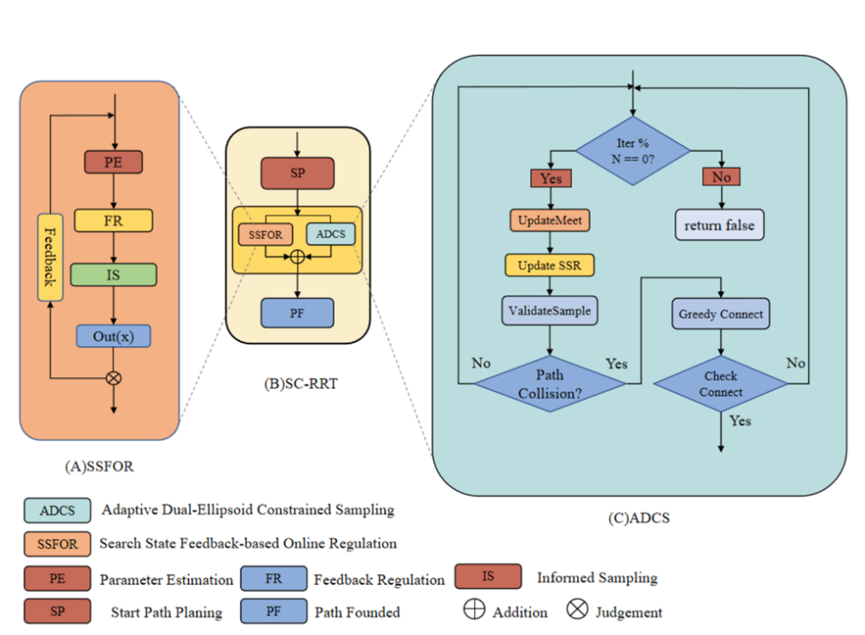
Fig. 4 Overall framework of the SC-RRT algorithm. It consists of the main search loop, SSFOR-based online regulation, and ADCS sampling. Dashed arrows indicate the internal implementation of
key modules
The sequential search process of SC-RRT in a representative 2D environment is depicted in Figure 5, where the progressive convergence of the dual-super-ellipsoid constrained sampling regions can be observed.
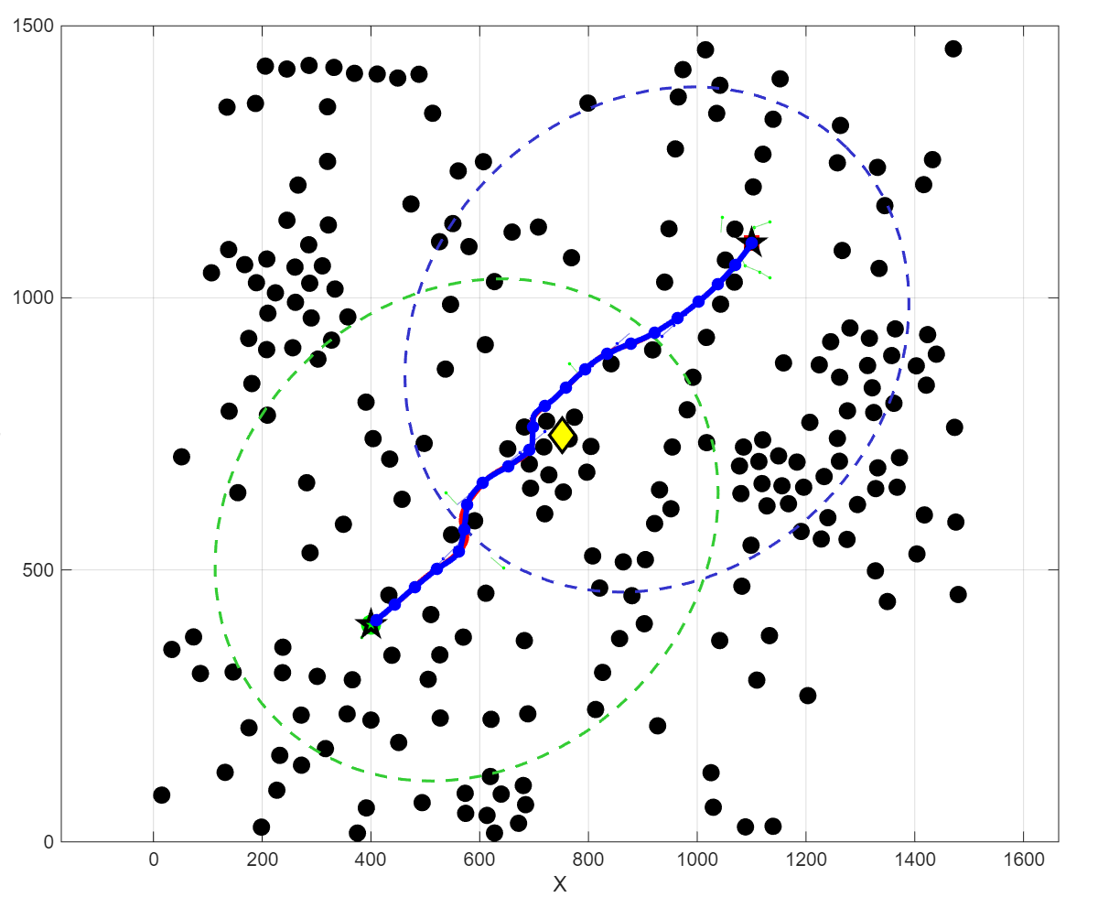
Fig.5 Path planning process of SC-RRT in a 2D environment.
- Experiment
  - Algorithm Comparison Experiments in Baseline Environments
To systematically evaluate the performance of SC-RRT under consistent environmental scale and obstacle density, comparative simulation experiments were conducted in both two-dimensional and three-dimensional spaces. The results are shown in Figures 6 and 7. The evaluation metrics include: Path Length, defined as the sum of the Euclidean distances between adjacent nodes along the path (mm); Convergence Time, defined as the time required for the algorithm to achieve path convergence (s); Node Count, defined as the total number of sampled nodes generated during the planning process; and The path efficiency η is formally defined as:
Whereis the total path length along the planned path , and ∥x_{goal} − x_{start}∥ is the straight-line distance. Values of η closer to 1.0 indicate near-optimal paths.
Based on previous studies in path planning, five representative algorithms—RRT, RRT-Connect, RRT*, Informed RRT*, and Dynamic-RRT—were selected for comparison with the proposed SC-RRT algorithm to validate its performance and stability. To ensure fairness in performance comparison among different path planning algorithms, all methods were evaluated under identical environmental spaces and obstacle configurations. Using the environment specified in Table 1 as an example, each algorithm was executed 500 times, and performance metrics such as path length and convergence time were assessed.
Tab.1 Environment Configuration
Dimension | Environment | Obstacles | Start | Goal | Max Iter
2 | 1500*1500 | 225 | （75，75） | (1425，1425) | 5000
3 | 1500*1500*1500 | 400 | (75, 75, 75) | (1425，1425，1425) | 5000
Under typical scenarios with representative obstacle densities in both two-dimensional and three-dimensional spaces, a systematic comparison was conducted between SC-RRT and mainstream algorithms including RRT, RRT-Connect, RRT*, Informed RRT*, and Dynamic-RRT, under identical environmental configurations and computational budgets. The results are presented in Table 2. Overall, the asymptotic optimality of Dynamic-RRT relies on sufficient computation time to be fully realized, which leads to notable limitations in scenarios with high real-time requirements. Although biasing the probability distribution of the random sample node x_{rand} toward the goal direction yields some improvement in path length and efficiency metrics, the degree of enhancement remains limited. In contrast, leveraging the online adaptive regulation mechanism (SSFOR), SC-RRT significantly reduces convergence time and sampling scale while maintaining comparable path length, demonstrating superior overall real-time performance compared to Dynamic-RRT. Regarding path quality, SC-RRT achieves an average path length of 2049.09 mm. This represents a 10.5% reduction compared to Dynamic-RRT and deviates by only 4.0% from the asymptotically optimal RRT*, yet it incurs a fraction of the computational cost. SC-RRT achieves a path efficiency of 0.9553, remaining close to RRT* (0.9689) and Informed RRT (0.9714), while requiring substantially less computational time. Crucially, SC-RRT accomplishes this with a planning time that is just 16.2% of Informed RRT*’s requirement. The marginal 1.40% efficiency gap compared to RRT* highlights SC-RRT’s ability
to approach optimality without the associated time penalty. These metrics validate that the ADCS mechanism effectively concentrates sampling along near-straight corridors, minimizing detours while drastically accelerating convergence. Furthermore, the low standard deviation in path length (±57.53 mm) confirms the algorithm’s stability across diverse obstacle configurations. In terms of computational efficiency, SC-RRT achieves an average convergence time of 0.0345 s, with a node consumption of only 209.6, demonstrating excellent real-time responsiveness. Although RRT* guarantees asymptotic optimality, it requires as many as 3846.6 nodes and a convergence time of 0.1629 s. In comparison, SC-RRT achieves nearly a 4.7-fold speedup, highlighting its significant advantage in time-sensitive tasks.
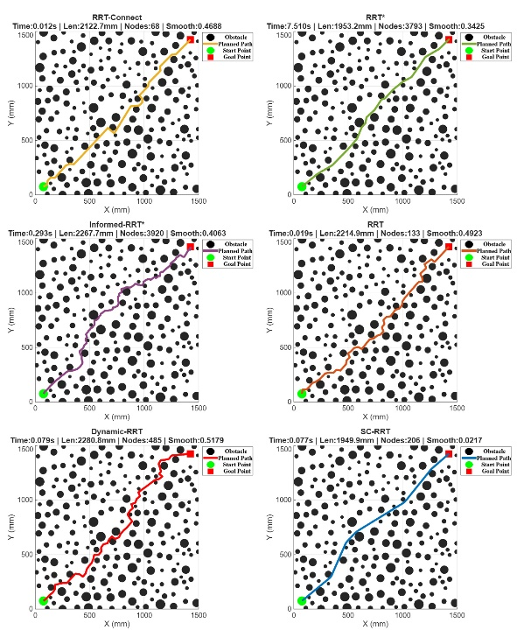
Fig.6 Comparison Results of Different Path Planning Algorithms in Two-Dimensional Space.
In terms of path stability, SC-RRT exhibits a path length standard deviation of only ±57.53 mm, which is significantly lower than that of RRT (±126.25 mm) and Dynamic-RRT (±136.02 mm), demonstrating markedly superior consistency and reproducibility in planning results. Overall, SC-RRT achieves a favorable balance among path quality, computational efficiency, and planning stability. It maintains stable convergence and strong scalability across both two-dimensional and three-dimensional scenarios with representative obstacle densities, demonstrating robust generalization capability and substantial practical engineering value.
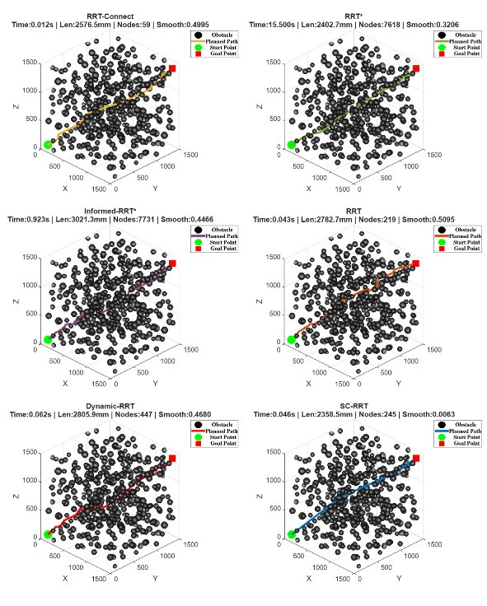
Fig.7 Comparison Results of Different Path Planning Algorithms in Three-Dimensional Space.
Tab.2 Comparison of Path Planning Algorithms
Algorithm | Path Length (mm) | Convergence Time (s) | Node Count | Path Efficiency
RRT | 2329.5500 ± 126.2500 | 0.0409 ± 0.0305 | 279.4000 ± 175.5000 | 0.8219 ± 0.0429
RRT-connect | 2143.2400 ± 93.4900 | 0.0108 ± 0.0053 | 69.3000 ± 10.8000 | 0.8924 ± 0.0376
RRT* | 1970.7200 ± 19.9400 | 0.1629 ± 0.0843 | 3846.6000 ± 99.7000 | 0.9689 ± 0.0098
Informed RRT* | 1938.4500 ± 24.1300 | 0.2134 ± 0.0487 | 3612.3000 ± 108.6000 | 0.9714 ± 0.0076
SC-RRT | 2049.0900 ± 57.5300 | 0.0345 ± 0.0124 | 209.6000 ± 38.5000 | 0.9553 ± 0.0265
Dynamic-RRT | 2288.1300 ± 136.0200 | 0.0414 ± 0.0384 | 281.3000 ± 160.2000 | 0.8372 ± 0.0468
总体而言，SC-RRT在路径质量与计算效率之间取得了较好的平衡。尽管RRT和Informed RRT能够获得略短的路径和更高的路径效率，但其计算时间明显高于SC-RRT。相比之下，SC-RRT在保持较高路径质量的同时显著降低了计算开销，表明该方法适用于复杂环境下的高效路径规划。
  - Real-world Validation of SC-RRT on a Robotic Manipulation Platform
为进一步验证SC-RRT算法由仿真环境向真实机器人系统迁移的有效性，本文在机器人操作平台上开展了实机验证。实验选取具有复杂三维曲面结构和连续空间运动需求的实际任务场景，对所提出路径规划算法在真实环境中的路径生成能力和执行稳定性进行验证，实验平台配置如表3所示，其中，一维力传感器仅用于监测机器人执行过程中的末端接触状态，不参与路径规划或轨迹优化，因此,力相关指标不作为本文的性能评价指标。
实验中，将人体背部曲面作为典型的非结构化三维工作空间，并将视觉识别获得的多个空间目标点作为连续运动规划的目标序列，形成multi-target continuous trajectory planning任务。该任务具有复杂空间约束、多个目标点连续分布以及机器人运动范围受限等特点，与SC-RRT采用的双向搜索和超椭球约束采样机制具有较好的契合性。通过实验，可进一步检验SC-RRT在真实环境中的空间搜索与路径生成能力。
如图8-10所示，RGB-D视觉系统获取目标区域的三维结构信息并完成点云重建。随后根据视觉识别结果获得多个空间目标点，并将其输入SC-RRT进行连续路径规划。针对连续目标点之间的复杂空间约束，SC-RRT通过双向搜索减少无效搜索，并利用超椭球约束采样机制将采样集中于潜在可行区域，从而逐段生成连接目标点的连续无碰路径，并最终形成完整的多目标连续运动路径。规划结果随后由真实机械臂执行，以验证所生成路径在实际机器人系统中的可执行性。
Tab.3 Configuration of the Real Robotic Experimental Platform（表格作用是机械臂实验平台配置）
Component | Specification
Robot manipulator | AUBO-i10
Degrees of freedom | 6-DOF
End-effector sensor | KWT1D60-300
Perception system | Deptrum Aurora 930 RGB-D camera
Planning algorithm | SC-RRT
图8展示了SC-RRT算法在真实机器人平台中的执行场景。图8(a) 为机器人与实际工作环境的整体场景，机械臂在真实人体曲面环境中执行规划后的空间运动任务；图8(b)和图8(c)进一步展示了机器人末端的实际运动状态。可以观察到，机械臂能够按照规划轨迹完成连续运动，表明SC-RRT生成的轨迹能够满足真实机器人系统的运动执行要求。
与理想化仿真环境不同，真实实验过程中存在视觉测量误差、环境几何不确定性以及机器人执行误差等因素。因此，该实验主要用于评价SC-RRT算法在真实三维环境中的轨迹生成能力和运动稳定性。
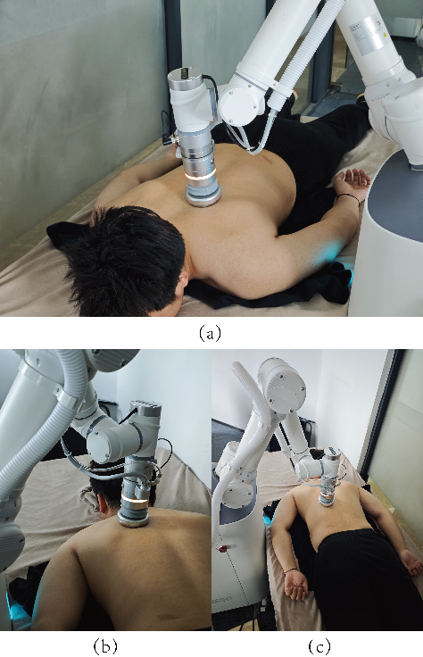
图 8(a) 机器人与实际工作环境的整体场景 图 8(b) 机器人末端的实际运动状态
图 8(c) 系统全景
Fig.8 Real-world execution of SC-RRT on the robotic platform
图9展示了基于RGB-D视觉感知建立的真实三维规划环境。通过Deptrum Aurora 930相机获取目标区域的彩色与深度信息，并利用ROS2驱动完成数据对齐与点云重建，获得人体背部曲面的空间几何表示。并根据视觉识别结果提取多个空间目标点，并将其作为连续路径规划任务中的关键节点。与点云环境同时为SC-RRT提供真实的空间约束信息，使规划过程能够在实际感知环境中进行。
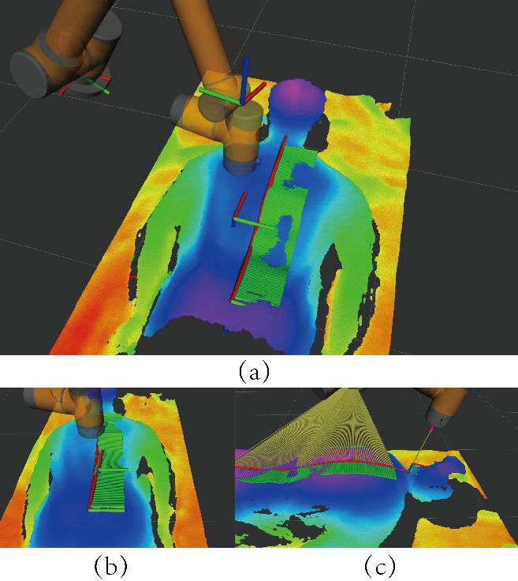
图 9(a)机械臂与人体背部点云整体场景 图 9(b)末端执行器的姿态约束特写
图 9(c) SC-RRT算法路径贴合人体表面特写
Fig.9 RGB-D point cloud reconstruction and planning environment.
图10展示了SC-RRT算法在真实三维点云环境中生成的多目标连续运动轨迹。针对多个空间目标点之间的连续运动需求，SC-RRT通过双向搜索与超椭球约束采样构建受约束的有效搜索空间，并逐段生成连接连续目标点的无碰运动轨迹。从图中可以看出，规划路径能够依次连接多个目标位置，并与人体背部曲面的空间形态保持一致。该结果验证了SC-RRT在真实非结构化三维环境中的多目标连续轨迹生成能力。
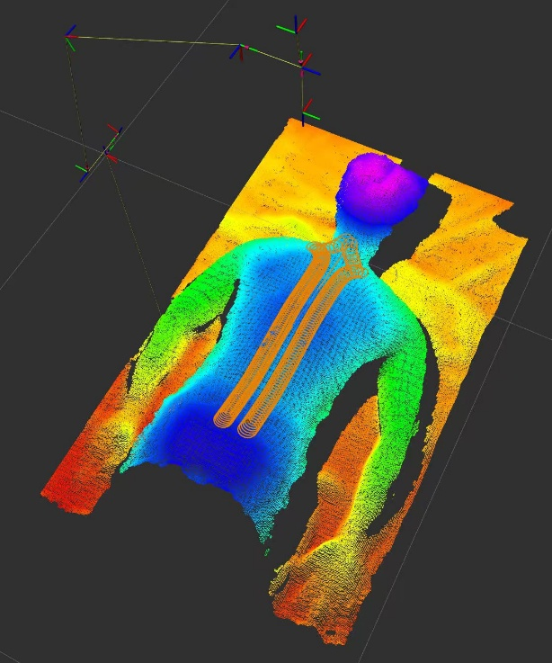
Fig.10 Multi-target continuous trajectory generated by SC-RRT in the real 3D environment
Tab.4 真实机械臂实验性能指标
Metric（指标） | Value（数值）
Executed path length | 3.245m
Planned path length | 3.249m
Path length difference | 0.14%
TCP tracking error | 1.98mm(mean),3.09mm(max)
Maximum joint displacement | 29.78°
表4给出了真实机器人轨迹执行结果。SC-RRT生成的规划轨迹长度为3.249 m，实际执行轨迹长度为3.245 m，两者长度差异仅为0.14%，表明规划轨迹能够被机器人系统较为准确地执行。进一步分析末端轨迹跟踪误差可知，TCP位置误差均值为1.98 mm，最大误差为3.09 mm，说明在真实三维感知环境中，机器人能够保持对规划轨迹的稳定跟踪。
结合图10所示的多目标连续轨迹可以看出，SC-RRT能够在真实人体曲面点云构建的非结构化三维空间中，连续连接多个空间目标点并生成可执行运动路径。与前述仿真实验相比，真实环境进一步引入了视觉感知误差、点云几何不确定性以及机器人执行误差，而规划轨迹仍能够保持较好的执行一致性。这表明SC-RRT不仅在理想化仿真环境中具有较高的搜索效率，同时具备向真实机器人三维工作空间迁移的可行性。
- Conclusions
This study proposed SC-RRT, a sampling-based path planning method for complex spatial environments. By combining bidirectional search with adaptive constrained sampling, the proposed method improves search efficiency while maintaining competitive path quality. Comparative simulation results in two- and three-dimensional environments demonstrate that SC-RRT achieves a favorable balance between path quality and computational efficiency.
Real-world experiments further demonstrated the applicability of SC-RRT to unstructured three-dimensional environments. Multiple spatial target points obtained from RGB-D perception were used to construct a multi-target continuous trajectory planning task, and the generated paths were successfully executed by a six-axis robotic manipulator. The close agreement between the planned and executed paths, together with the low TCP tracking error, confirms the practical executability of the proposed method.
Overall, SC-RRT provides an effective and computationally efficient solution for collision-free path planning in complex three-dimensional environments, with demonstrated transferability from simulation to real robotic systems.
Acknowledgements
The authors would like to thank the School of Mechanical Engineering, Shanghai Institute of Technology, for providing the computational resources.
AI disclosure
During the preparation of this manuscript, the authors used GitHub Copilot as a translation aid to translate the original Chinese draft into English. All AI-assisted output was carefully reviewed and edited by the authors, who take full responsibility for the accuracy, scientific integrity, and originality of the manuscript.
Declarations
Author contributions: Xingyu Guo conceived the algorithm, conducted the simulation experiments, and drafted the manuscript. Yan Wu supervised the research and provided guidance on the overall manuscript. Muchun Fan and Feng Hong provided technical support during implementation. Hongyu Gao and Jianyu Zheng contributed to manuscript revision and provided valuable comments. All authors contributed to the conception and design of the study, and all authors read and approved the final manuscript.
Funding
This research received no specific grant from any funding agency, commercial, or not-for-profit sectors.
Competing interests
The authors declare no competing interests.
Ethics approval
Not applicable.
Consent to participate
Not applicable.
Consent for publication
All authors have approved the manuscript and agree to its submission for publication.
Data availability
The data that support the findings of this study are available from the corresponding author upon reasonable request.
Code availability
The code used in this study is available from the corresponding author upon reasonable request.
References
- Zhong, R.Y., Xu, X., Klotz, E., Newman, S.T.: Intelligent manufacturing in the context of industry 4.0: a review. Engineering 3(5), 616–630 (2017)
- Wirtz, J., Patterson, P.G., Kunz, W.H., Gruber, T., Lu, V.N., Paluch, S., Martins, A.: Brave new world: service robots in the frontline. Journal of service management 29(5), 907–931 (2018)
- Mac, T.T., Copot, C., Tran, D.T., De Keyser, R.: Heuristic approaches in robot path planning: A survey. Robotics and Autonomous Systems 86, 13–28 (2016)
- Ajoudani, A., Zanchettin, A.M., Ivaldi, S., Albu-Sch¨affer, A., Kosuge, K., Khatib, O.: Progress and prospects of the human–robot collaboration. Autonomous robots 42(5), 957–975 (2018)
- Villani, V., Pini, F., Leali, F., Secchi, C.: Survey on human–robot collaboration in industrial settings: Safety, intuitive interfaces and applications. Mechatronics 55, 248–266 (2018)
- LaValle, S.M.: Planning Algorithms. Cambridge university press, Cambridge (2006)
- Latombe, J.-C.: Robot Motion Planning vol. 124. Springer, New York (2012)
- Kingston, Z., Moll, M., Kavraki, L.E.: Sampling-based methods for motion planning with constraints. Annual review of control, robotics, and autonomous systems 1(1), 159–185 (2018)
- Mohanan, M., Salgoankar, A.: A survey of robotic motion planning in dynamic environments. Robotics and Autonomous Systems 100, 171–185 (2018)
- Aggarwal, S., Kumar, N.: Path planning techniques for unmanned aerial vehicles: A review, solutions, and challenges. Computer communications 149, 270–299 (2020)
- Elbanhawi, M., Simic, M.: Sampling-based robot motion planning: A review. Ieee access 2, 56–77 (2014)
- Karaman, S., Frazzoli, E.: Sampling-based algorithms for optimal motion planning. The international journal of robotics research 30(7), 846–894 (2011)
- LaValle, S.: Rapidly-exploring random trees: A new tool for path planning. Research Report 9811 (1998)
- LaValle, S.M., Kuffner Jr, J.J.: Randomized kinodynamic planning. The international journal of robotics research 20(5), 378–400 (2001)
- Kuffner, J.J., LaValle, S.M.: Rrt-connect: An efficient approach to single-query path planning. In: Proceedings 2000 ICRA. Millennium Conference. IEEE International Conference on Robotics and Automation. Symposia Proceedings (Cat.No. 00CH37065), vol. 2, pp. 995–1001 (2000). IEEE
- Gammell, J.D., Strub, M.P.: Asymptotically optimal sampling-based motion planning methods. Annual Review of Control, Robotics, and Autonomous Systems 4(1), 295–318 (2021)
- Qureshi, A.H., Ayaz, Y.: Intelligent bidirectional rapidly-exploring random trees for optimal motion planning in complex cluttered environments. Robotics and Autonomous Systems 68, 1–11 (2015)
- Ding, J., Zhou, Y., Huang, X., Song, K., Lu, S., Wang, L.: An improved rrt* algorithm for robot path planning based on path expansion heuristic sampling. Journal of computational science 67, 101937 (2023)
- Noreen, I., Khan, A., Habib, Z., et al.: Optimal path planning using rrt* based approaches: a survey and future directions. International Journal of Advanced Computer Science and Applications 7(11), 97–107 (2016)
- Li, B., Chen, B.: An adaptive rapidly-exploring random tree. IEEE/CAA Journal of Automatica Sinica 9(2), 283–294 (2021)
- Huang, Z., Gao, Y., Guo, J., Qian, C., Chen, Q.: An adaptive bidirectional quick optimal rapidly-exploring random tree algorithm for path planning. Engineering Applications of Artificial Intelligence 135, 108776 (2024)
- Tahirovic, A., Ferizbegovic, M.: Rapidly-exploring random vines (rrv) for motion planning in configuration spaces with narrow passages. In: 2018 IEEE International Conference on Robotics and Automation (ICRA), pp. 7055–7062 (2018). IEEE
- Gammell, J.D., Srinivasa, S.S., Barfoot, T.D.: Informed rrt*: Optimal samplingbased path planning focused via direct sampling of an admissible ellipsoidal heuristic. In: 2014 IEEE/RSJ International Conference on Intelligent Robots and Systems, pp. 2997–3004 (2014). IEEE
- Gammell, J.D., Barfoot, T.D., Srinivasa, S.S.: Informed sampling for asymptotically optimal path planning. IEEE Transactions on Robotics 34(4), 966–984 (2018)
- Gammell, J.D., Srinivasa, S.S., Barfoot, T.D.: Batch informed trees (bit*): Sampling-based optimal planning via the heuristically guided search of implicit random geometric graphs. In: 2015 IEEE International Conference on Robotics and Automation (ICRA), pp. 3067–3074 (2015). IEEE
- Gammell, J.D., Barfoot, T.D., Srinivasa, S.S.: Batch informed trees (bit*): Informed asymptotically optimal anytime search. The International Journal of Robotics Research 39(5), 543–567 (2020)
- Yuan, L., Zhao, J., Li, W., Hou, J.: Improved informed-rrt* based path planning and trajectory optimization for mobile robots. International Journal of Precision Engineering and Manufacturing 24(3), 435–446 (2023)
- Zeng, Z., Chang, Y.: Abf-rrt*: Bidirectional fast optimal rapidly-exploring random tree via adaptive sampling of a permissible hyper-ellipsoid. Journal of King Saud University Computer and Information Sciences 37(7), 165 (2025)
- Zhao, P., Chang, Y., Wu, W., Luo, H., Zhou, Z., Qiao, Y., Li, Y., Zhao, C., Huang, Z., Liu, B., et al.: Dynamic rrt: fast feasible path planning in randomly distributed obstacle environments. Journal of Intelligent & Robotic Systems 107(4), 48 (2023)
- Deb, K., Pratap, A., Agarwal, S., Meyarivan, T.: A fast and elitist multiobjective genetic algorithm: Nsga-ii. IEEE transactions on evolutionary computation 6(2), 182–197 (2002)
- Choset, H., Lynch, K.M., Hutchinson, S., Kantor, G.A., Burgard, W.: Principles of Robot Motion: Theory, Algorithms, and Implementations. MIT press, Boston (2005)
- Lynch, K.M., Park, F.C.: Modern Robotics. Cambridge University Press, Cambridge (2017)
- Kavraki, L.E., Svestka, P., Latombe, J.-C., Overmars, M.H.: Probabilistic roadmaps for path planning in high-dimensional configuration spaces. IEEE transactions on Robotics and Automation 12(4), 566–580 (2002)
- Ravankar, A., Ravankar, A.A., Kobayashi, Y., Hoshino, Y., Peng, C.-C.: Path smoothing techniques in robot navigation: State-of-the-art, current and future challenges. Sensors 18(9), 3170 (2018)
- Yang, K., Sukkarieh, S.: An analytical continuous-curvature path-smoothing algorithm. IEEE Transactions on Robotics 26(3), 561–568 (2010)
- Nasir, J., Islam, F., Malik, U., Ayaz, Y., Hasan, O., Khan, M., Muhammad, M.S.: Rrt*-smart: A rapid convergence implementation of rrt. International Journal of Advanced Robotic Systems 10(7), 299 (2013)
- Janson, L., Schmerling, E., Clark, A., Pavone, M.: Fast marching tree: A fast marching sampling-based method for optimal motion planning in many dimensions. The International journal of robotics research 34(7), 883–921 (2015)
- Salzman, O., Halperin, D.: Asymptotically near-optimal rrt for fast, high-quality motion planning. IEEE Transactions on Robotics 32(3), 473–483 (2016)
- Ferguson, D., Stentz, A.: Anytime rrts. In: 2006 IEEE/RSJ International Conference on Intelligent Robots and Systems, pp. 5369–5375 (2006). IEEE
- Karaman, S., Walter, M.R., Perez, A., Frazzoli, E., Teller, S.: Anytime motion planning using the rrt. In: 2011 IEEE International Conference on Robotics and Automation, pp. 1478–1483 (2011). ieee
- Akgun, B., Stilman, M.: Sampling heuristics for optimal motion planning in high dimensions. In: 2011 IEEE/RSJ International Conference on Intelligent Robots and Systems, pp. 2640–2645 (2011). IEEE

Statements & Declarations

Funding
The authors declare that no funds, grants, or other support were received during the preparation of this manuscript.

Competing Interests
The authors have no relevant financial or non-financial interests to disclose.

Author Contributions
All authors contributed to the study's conceptual design. Yan Wu supervised the entire manuscript writing process; Xingyu Guo, Wenjun Lv, and Jianyu Zheng prepared the materials; Jiaqing Ye and Jiale Hu collected and analyzed the experimental data; and Xingyu Guo drafted the manuscript. All authors provided revision suggestions, participated in revising all versions, and finally reviewed and approved the final draft.

School of Mechanical Engineering, Shanghai Institute of Technology, Shanghai 201418, China
∗ Corresponding Author:Xingyu Guo E-mail: gxyzhendehenlihai@163.com

