Montana Interactive

Arts Showcase

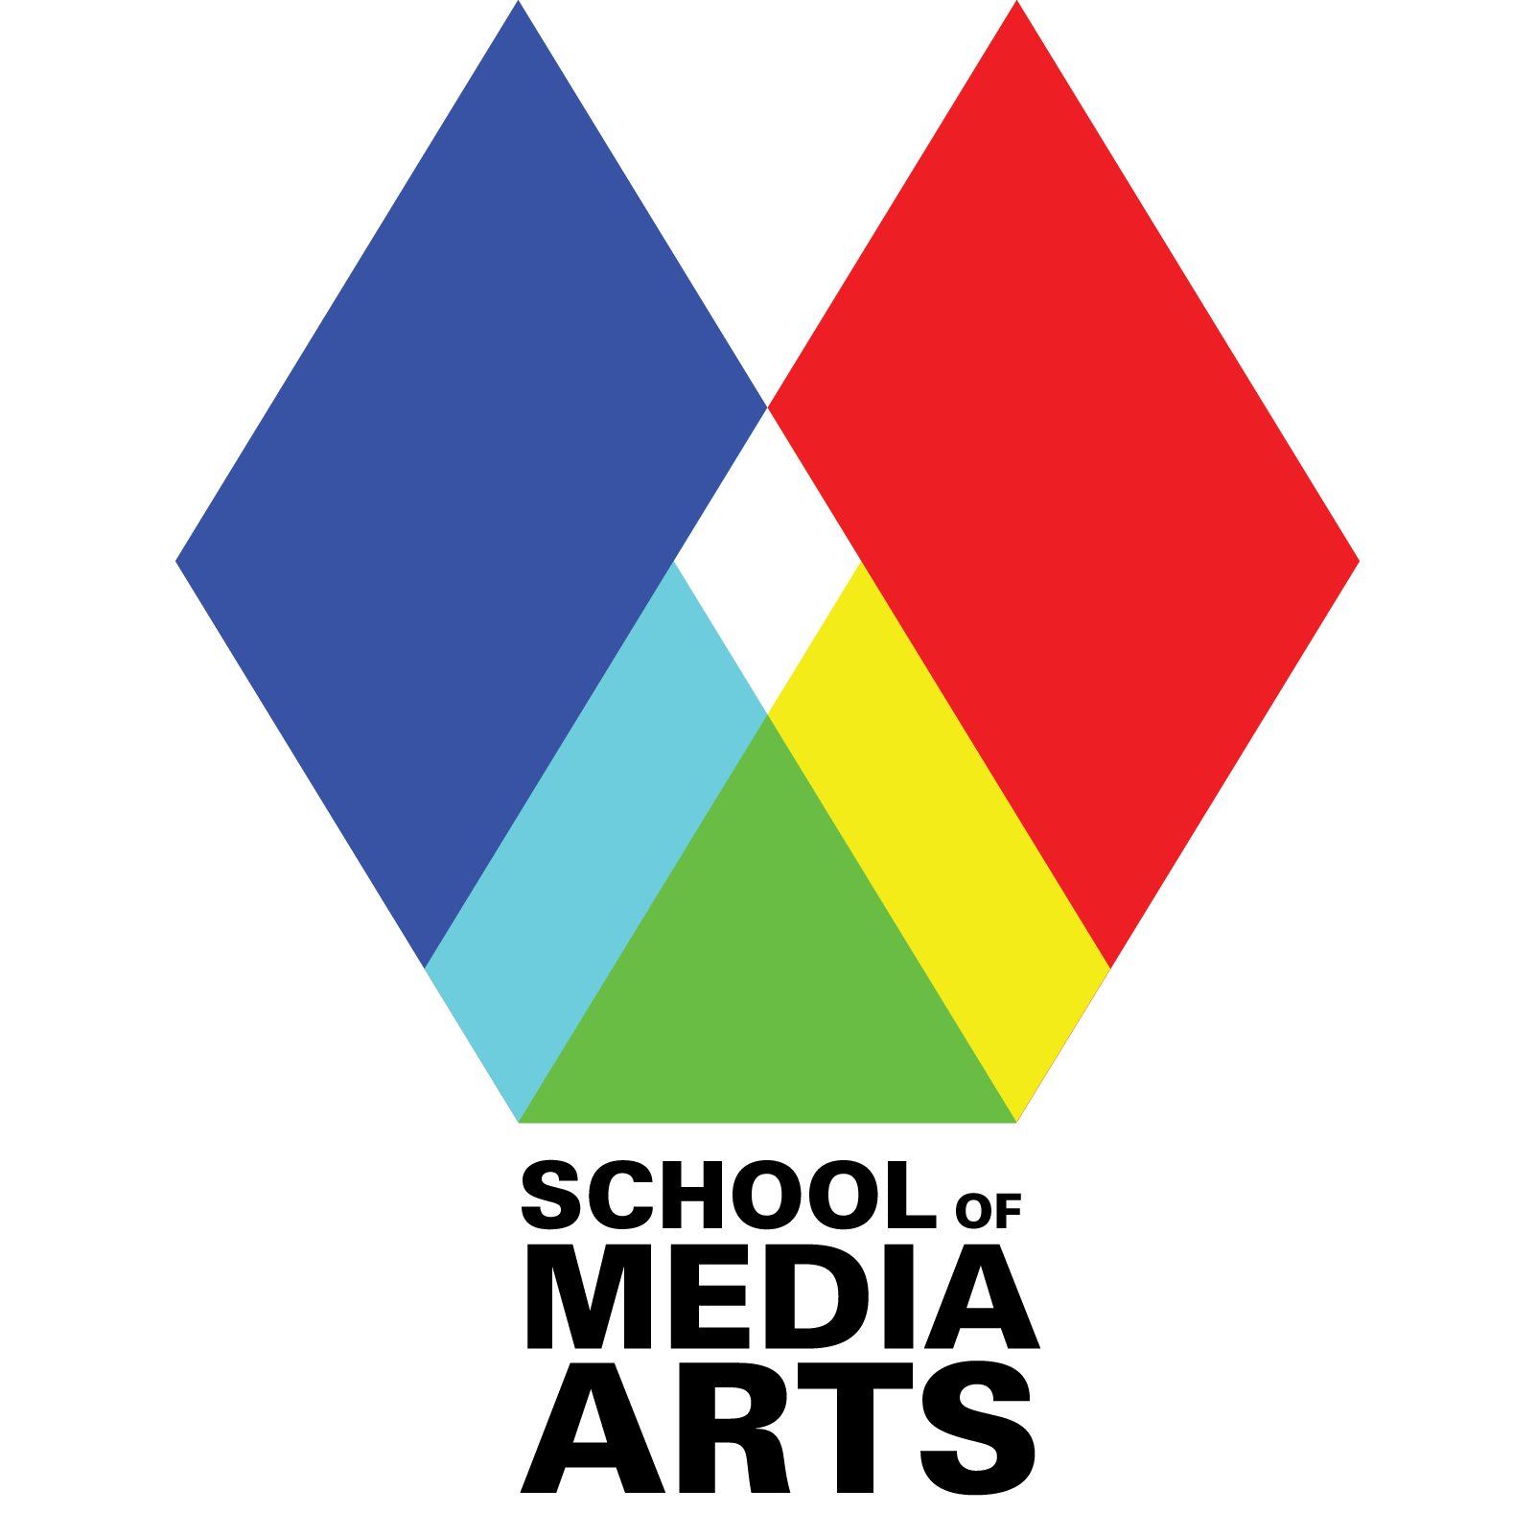

Installations @ 6pm

Interactive Performances @ 7pm

Wednesday, April 25th 2018

**Performances**

7:00pm in McGill Hall Production Studio

The following works were developed, created, and/or composed in Michael Musick’s *Interactive Arts 2* course (MART440). This course explores the theory and technique of interactive art, interactive systems, and general interactivity, with a focus on creating performance-based works. The students have worked quite hard to create the pieces presented here this evening, working to create engaging interactions between the performers and computer systems, solving difficult technical issues, and developing a vocabulary with each other that allows for discussions and critiques.

Password Abby Beno

Performers: Guly Sharifi

Interactive Theater

Rockin’ Story Garrett Gredell

Performers:

Generative Music Score with Musicians

1 V 1 Delaney Cummins

Performers: oni & ket

Belegarth Inspired Theater

The Singing Cube Stone Deavours

Interactive Theater

An ornery cube faces technical difficulties.

Sacagawea Sierra Shaw

Interactive Storytelling

Fair Use Cory Paringer

Interactive Music System

An interactive audio-visual performance using projection mapping and conductive sensors. Will ideally be an abstract soundscape or 'song' which is played by touching projected video clips, and will focus on the unclear boundaries artists face when re-appropriating, sampling, and copying the work of others; primarily in digital forms. I will be taking advantage of the fact that I am a student and have more leniency when stealing these samples in an academic, non-commercial way.

Live Mario Madison Flaget

Interactive Theater

Live Mario explores notions of reality and fantasy by merging live character performance with a virtual video game. The game tracks the area directly in front of a projector screen and feeds that information back into the game. This allows flesh and blood entities to play the game as if they were a virtual character.

Mic Stuff Toby Long

*Interactive Music System*

The Tale Teller’s picturebook Ryan Stipe

Interactive Storytelling

A story book about a Tale Teller attempting to give his stories. Adapted to a picture-book in augmented reality.

Light Conductor Mackenzie Lightfield

Projection Mapping

Reactive Interaction Anna Hill

Performers: Connor McSweeney

Generative Music Score with Musician

Spider Sound (Part 2) Emily Griffin

Interactive Music System

*Spider Sound is an interactive performance piece that allows a performer/dancer to manipulate sound through body movement using a Kinect for motion tracking.*

*Songs used: “I Want You Back” by The Jackson 5 and “Tell Me You Love Me” by Galantis*

untitled music system Nic Goodrich

Interactive Music System

Kinecting Instruments Christoffer Sommerfeld

Interactive Music System

*Kinecting Instruments* is an artwork that explores the relationship our bodies and the world of sound around us. The actor's body becomes the instrument. The movements of their limbs produce music. The piece uses an Xbox 360 Kinect to track the skeletal points of an actor’s body. The body moves and the system will react to the individual's movements and play tones back.

**Installation**

6:00pm – 6:50pm & 8:30pm – 9:00pm

in McGill Hall Studios

The installations presented tonight come from students working with Prof. Michael Musick and/or Prof. Michael Murphy. These are students who have found typical fixed-media work to not allow the full exploration of material or ideas that they desire. These four pieces explore new modes for presenting stories, creating participant experiences, or opportunities for creating connections to ideas.

VR Earthquake Grant Ligo

Media Arts PC LAB, 126

VR Earthquake is a virtual recreation of what it is like to be inside of an earthquake. This piece was made to observe the reaction of the user when told nothing about the piece. Modeled and animated in Autodesk Maya 2015, assembled in Unity Game Engine.

Point of View Laura Lovo

Seminar Lab, 227

Point of View is a collection of interviews of people from Nicaragua who have been affected by assimilation, war, and displacement.

As a filmmaker and visual artist, I strive to listen, observe and collect stories. My focus is on encouraging and empowering community members to tell their stories, create dialogue and celebrate culture in all artistic forms.

Inheritance Riley Woods

Seminar Lab, 228

Inheritance is an exploration of capacity as well as distance. It asks how the self-histories of those formative not only to the explorer, but to the foundations of a regional self can be both conserved, and more, understood. It examines the familial as structure represented by sculptural interpretations of Arnaldo Pomodoro’s work, considers geographic location in relation to the integrity of both individual and cultural identity, and dives into the generational complexities of self-development as influenced by immediate family, but also by histories ingrained within an ancestry—inaccessible to the explorer due to a lack of personal experience, availability of information, and simply, time.

A Different Kind of Divorce (ADKD) Amie Shae

Production Studio

A Different Kind of Divorce is an experimental video installation about one family’s experience after the father comes out as gay. Presented tonight is an audio story (approx 30 minutes total) paired with visual footage of the family’s past. The TV screens in the front of the room will play clips of old family movies representing each family member.   
  
This project is meant to examine a common shared experience and memory. How are details remembered? How is each experience similar (or different) to others?

The School of Media Arts director is Mark Shogren

The *Montana Interactive Arts & Sonic Arts Lab* is looking for students who want to collaborate, create large projects, participate in research, and shape the future of art. If you are interested in taking classes within these areas or being a part of this lab, please speak with Prof. Michael Musick about possible opportunities.

( michael.musick@umontana.edu )

Prof. Michael Murphy’s *Interdisciplinary Arts Lab* brings together upper division and graduate students from across disciplines to experiment with different techniques of creation and collaboration in making art and story. Please contact him for additional information.

( Michael.Murphy@mso.umt.edu )

Thank you for coming to the Montana Interactive Arts Showcase.

Please join us for the full Media Arts Expo, at the Roxy Theater to celebrate all of The School of Media Arts. The expo will be help May 9th & 10th and includes films, installations, performances, still images, and demos by a diverse range of Media Arts Students.

