Computer Algorithms and Complexity
- Verify that the constructed 5 x 5 magic square satisfies the magic square properties by showing that the sums of all rows, columns, and both diagonals are equal to the magic constant.
- Analyze the given code segment and determine the count of each type of statement:
for (int i = 0; i < 4; i++) {
for (int j = 0; j < 4; j++) {
cout << "i=" << i << ", j=" << j << endl;
cout << "i=" << i << ", j=" << j << endl;
}
}
- Explain the sequence of moves required to solve the Tower of Hanoi problem with 3 disks. Use a source peg (A), an auxiliary peg (B), and a destination peg (C). Illustrate each step involved in the process.
- Write the pseudo code for Magic Square.
- Describe the step-by-step process of the Selection algorithm for sorting an array [8, 4, 6, 9, 2, 3, 1] in ascending order.
- Write down the pseudocode of magic square for odd order logic and generate an N x N magic square step by step where N=3.
- Describe the step-by-step process of the Insertion algorithm for sorting an array [8, 4, 6, 9, 2, 3, 1] in ascending order.
- Explain the sequence of moves required to solve the Tower of Hanoi problem with 3 disks. Use a source peg (A), an auxiliary peg (B), and a destination peg (C). Illustrate each step involved in the process by following the rules of Tower of Hanoi.
Digital Logic Design
- Convert the following fractional numbers:
(a) Convert 10101.1012 to decimal.
(b) 42.5₁₀ to Octal.
- Subtract 15 and 7 using the binary 2’s complement method
- Convert the following numbers:
(a) 18.75₁₀ to Binary
(b) Convert 3𝐹16 to decimal.
- Convert 73₁₀ into BCD and Excess-3 code.
Numerical Methods
- Convert the decimal number (572.625)₁₀ into binary. Explain each step clearly and verify the result by reverse conversion
- What are truncation error and round-off error? Compare them and illustrate with examples
- Perform the following floating-point addition and subtraction (using 4 significant digits and normalized scientific notation): A = 0.725 x 10², B = 0.477 x 10². Compute A + B and A - B.
- Write the binary equivalent of the following numbers:
1. Decimal to Binary: (43.167)₁₀ = ?
2. Octal to Binary: (37.45)₈ = ?
- Define Numerical Computing. Interpret the expression 0.964572E5 + 0.586351E3 and describe the steps required to solve it (no calculation needed).
- Use the Regula-Falsi method to determine a root of the equation f(x) = x³ + 4x - 1. Accurate to three decimal places.
- Apply the Newton Raphson method to find a root of the equation f(x) = x² - x - 1. Correct to three decimal places
- Using the true value of π = 3.14159265 and approximate value = 3.14, explain the meaning of absolute error, relative error, and percentage error.
- Find the significant digits of the following numbers. a) 0.004060 b) 30500 c) 0.0078 d) 12.4500 e) 9.020 x 10⁴
- Explain how loss of significance can affect computational result.
Engineering economics
- Define market equilibrium. A demand function is given as Qd = (120 - 4p) and a supply function is given as Qs = (2p + 30). Find out equilibrium price and quantity.
- If both demand and supply increases simultaneously, what may happen to demand and supply and market equilibrium ? Explain.
- Explain the effect of an increase in consumer income on market equilibrium and the effect of technological improvement on equilibrium.
- Define Economics. Explain Economic problem of scarcity and choice.
- Explain how microeconomic theories contribute to efficient resource allocation in an economy.
- Explain the central problems of an economy.
- Differentiate between change in demand vs change in quantity demanded with figure.
- Explain Market Equilibrium with the demand and supply functions created by you. Analyze with figure.
- A demand and supply function is given as: Qd = (200 - 3P) and Qs = (4P + 80). Show the Adjustment of price and quantity when price becomes high and low. Use figure.
CT-2
- Explain central problems of an Economy.
- How these central problems can be solved ?
- Define demand function. Explain the factors those affect demand function.
- Draw a demand schedule and demand curve from a demand function created by you.
- Write down a demand function and supply function. Find out the equilibrium price and quantity.
- Explain three sector circular flow of income model with diagram.
- If price of good A increases from Tk 100 to Tk 500, demand of good B decreases from 20 units to 15 units. Find out the value of elasticity and goods type.
- Proof that, cross elasticity’s value ranges from negative to infinity.
Math
- A leap year contains of 366 days with 29 days in February. If a leap year is selected at random, Compute the probability that the selected leap year will consist of 53 Sundays.
- In a community there are equal number of males and females. Suppose 5% of the males and 2% of the females are disabled. A person is chosen at random. If this person is male, then find the probability that he is disabled ?
- In a factory, three machines, M, K and J are used to make biscuits. Machine M makes 20% of the biscuits. Machine J makes 30% of the biscuits. The rest of the biscuits are made by machine K.
It is known that 7% of the biscuits made by machine J are broken, 5% of the biscuits made by machine K are broken and 3% of the biscuits made by machine M are broken.

a. Draw a tree diagram to illustrate all the possible outcomes and associated probabilities. A biscuit is selected at random.
b. Calculate the probability that the biscuit is made by machine K and is not broken.
c. Calculate the probability that the biscuit is not broken
- In a community there are males and females are distributed as 2:3 of 100%. Suppose 7% of the males and 12% of the females are disabled. A person is chosen at random. If this
person is female, then find the probability that she is not disabled?
- A pair of dice is thrown. Find the probability that sum of the points on the two dice is 10
or greater if a 5 appears on the first die.
- In a factory, three machines, J, K and L are used to make biscuits. Machine J makes
25%of the biscuits. Machine K makes 35% of the biscuits. The rest of the biscuits are
made by machine L.
It is known that 5% of the biscuits made by machine J are broken, 6%of the biscuits made
by machine K are broken and 2% of the biscuits made by machine L are broken.

a. Draw a tree diagram to illustrate all the possible outcomes and associated probabilities. A biscuit is selected at random.
b. Calculate the probability that the biscuit is made by machine J and is not broken.
c. Calculate the probability that the biscuit is broken.
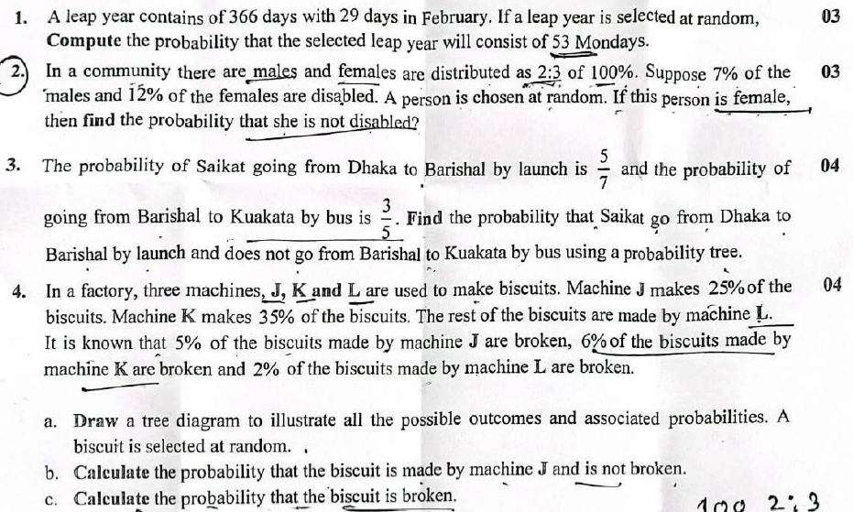

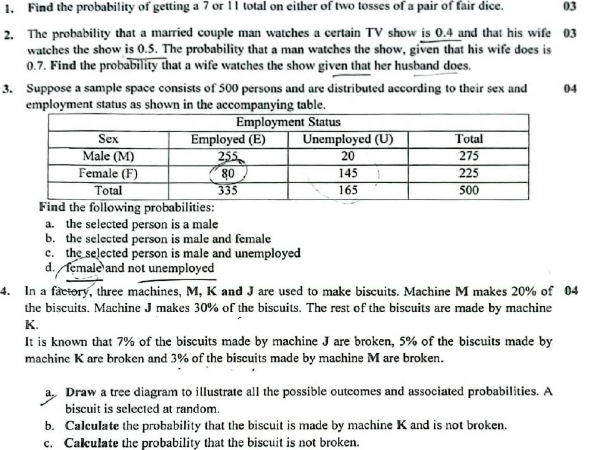

- A leap year contains of 366 days with 29 days in February. If a leap year is selected at random, Compute the probability that the selected leap year will consist of 53 Saturdays.
- In a community there are equal number of males and females. Suppose 5% of the males and 2% of the females are disabled. A person is chosen at random. If this person is male, then find the probability that he is disabled
- Turi will go from Dhaka to Rajshahi and then from Rajshahi to Khulna. However, she couldn’t decide whether to go by bus or train. So, she tossed a coin twice to check her probability. Finally,it was seen that her probability of going from Dhaka to Rajshahi by bus is $\frac{2}{7}$ and the probability of going from Rajshahi to Khulna by train is $\frac{5}{8}$ . Using a Probability Tree, find the probability that Turi does not go to Rajshahi by bus and does not go to Khulna by train.
- In a factory, three machines, J, K and L are used to make biscuits. Machine J makes 25%of the biscuits. Machine K makes 35% of the biscuits. The rest of the biscuits are made by machine L. It is known that 5% of the biscuits made by machine J are broken, 6%of the biscuits made by machine K are broken and 2% of the biscuits made by machine L are broken.
a. Draw a tree diagram to illustrate all the possible outcomes and associated probabilities. a biscuit is selected at random.
b. Calculate the probability that the biscuit is made by machine J and is not broken.
c. Calculate the probability that the biscuit is broken.


