**蓝色：Motivation**

**绿色：novelty/methods**

**黄色：explanation**

**红色：unknown/unclear**

**为什么联合信源信道编码效果会好**

**<https://www.docin.com/p-1005651214.html>**

**信源编码主要考虑信源的统计特性，信道编码主要考虑信道的统计特性。分开设计的优点是设计简单、通用性好，可以分别形成标准。缺点是没有充分利用各自的优势，因而不是最佳的。无线系统的信源编码由于压缩比很高，对差错十分敏感；而信道编码面临十分恶劣的传播环境，但提供的带宽冗余度很小。**

**语义通信的理解：**

**将用户需求和信息含义融入通信过程**

**语义通信的优点：与传统文本传输重建对比**

**深度学习的好处：**

**语义通信有两种noise：physical channel noise and semantic noise（caused by 1）different KBs used by**

**the semantic source and destination. 2）polysemy and synonym**

**）**

**牛凯说语义通信不是语义分割，语义通信要考虑信道特征、传输特征，所以NN提取feature map的时候是要考虑信道响应特征来进行权重，这个权重不是靠人的主观 而是靠学习到的信道、信源特征**

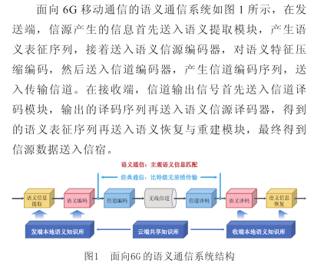[面向6G的语义通信_牛凯 - 道客巴巴 (doc88.com)](http://www.doc88.com/p-47139040280397.html)

**图像语义抽取：**[图像语义提取技术_挂云帆 (guayunfan.com)](https://www.guayunfan.com/lilun/660497.html)

**图像语义描述：**[图像语义描述_挂云帆 (guayunfan.com)](https://www.guayunfan.com/lilun/660498.html)

[清华大学-中国移动联合研究院陶晓明：会话视频语义通信，相同质量下将码率降低为10-20% - 推荐 — C114通信网](http://www.c114.com.cn/news/16/a1200054.html)

**motivation是很重要的**

**Deep Learning Enabled Semantic Communication Systems**

针对任务是文本传输

方法：transformer、迁移学习（体现在先在一个地方训练出一个基本的网络？再放到dynamic环境中吗）、

创新：sentence similarity

问题：

我不理解这个jointly到底是什么意思 联合编码 信源-信道联合编码[基于深度学习的两种信源信道联合编码 详解基于深度学习的两种信源信道联合编码(IT技术) (qb5200.com)](http://www.qb5200.com/article/394828.html)

**deep learned enabled end-to-end (E2E)**

**communication systems have been developed to merge all physical**

**layer blocks in the traditional communication systems，which**

**make joint transceiver optimization possible.**

joint semantic-channel coding and decoding？

为了在语义层面上还原信息，定义新的损失函数——（交叉熵-s，s’、互信息-x，y）

这个mutual information model是干嘛的？-》给出互信息-》只是作为整体的损失函数？

互信息和KL散度的关系

如何去辨别语句的相似度？ Sentence similarity

Idea：

**Deep Joint Source-Channel Coding for Wireless Image Transmission**

**Motivation： 物联网需求**

**Deep JSCC 有效学习噪声弹性编码表示**

**Semantic communication systems for speech transmission**

本文中CSI已知

方法：an attention mechanism

employing squeeze-and-excitation (SE) networks

效果：strong adaptability

两大任务：1）语义信息的学习和语音信号的提取2）减轻无线信道的干扰

问题：

语音传输也能语义通信？达到什么样的效果，原理是什么-》文章通过SE模型来关注重要信息

The objective of the whole transceiver system is to recover speech signals as close as to the original,因此有两大挑战：如何利用语义信息还原（语义编码/解码） 二是信道编码器/解码器的设计，通过添加冗余信息来减轻由物理信道引起的符号错误。-》channel encoder/decoder

However, the bit-to

symbol transformation is not involved in our proposed system.

The raw speech signals are directly mapped into a transmitted

symbol stream by the *speech encoder* and the *channel encoder*,

and recover it at the receiver via inverse operation

如何理解？

Idea：我们真的要尽可能地还原语音信息吗，能不能只还原关键信息呢

语音信息传递的时候，多关注讲话快的地方，因为这个部分的语音比较容易混淆

**Task-oriented multi-user semantic communications for VQA**

How to exploit semantic information for specifific tasks at the effectiveness level is another key area and few researchers pay attention to this area.

we face two challenges: how

to extract the proper semantic information from each user and

how to build a model for multimodal semantic information

fusion at the receiver.

方法：MU-DeepSC发射机采用memory、attention和composition（MAC）神经网络对相关数据进行处理。MU-DeepSC接收器通过提取不同发送器的图像和文本的语义信息，将根据接收器接收到的语义信息直接生成答案

前面三篇文章都说会robust to channel variation 为什么呢？

Semantic communications transmit and recover the meaning

of the transmitted content directly and require no accurate

bit recovery, thus, are more robust to the channels（Task-oriented multi-user semantic communications for VQA）如何理解？

We observe that all DL enabled approaches are more competitive in the

low SNR regime.（Deep Learning Enabled Semantic Communication Systems ）

（牛凯）同样恶劣的信道，语义通信能够关注关键信息，能够有效对抗悬崖效性或者阶梯效应

为什么这篇文章不用tramsformer

语义通信 的意义在哪里， 和普通的数据压缩有什么区别 和图像重构、机器翻译、语音压缩传输有什么区别 -》更加智能？体现在什么地方

**A Lite Distributed Semantic Communication System for Internet of Things**

neural network compression,

pruning, quantization,

**综述类：**

## 面向智能任务的语义通信：理论、技术和挑战

[面向智能任务的语义通信：理论、技术和挑战 (infocomm-journal.com)](http://www.infocomm-journal.com/txxb/article/2022/1000-436x/1000-436x-43-6-00041.shtml)

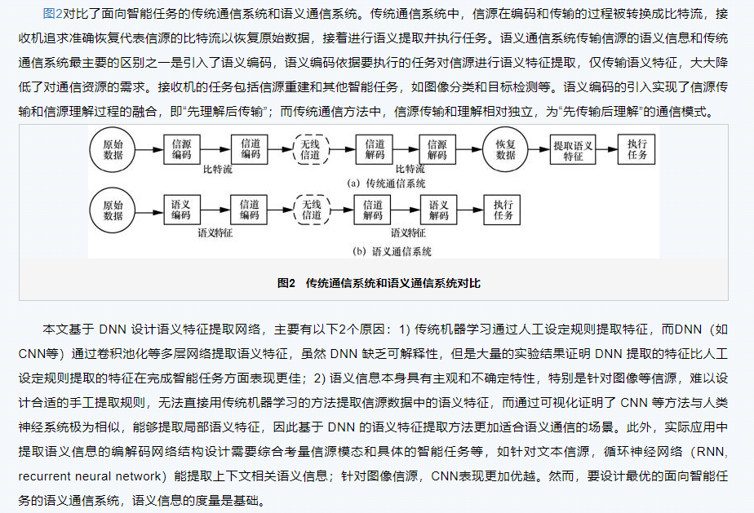

**Semantic Communications: Overview,**

**Open Issues, and Future Research Directions**

着重介绍了与传统语义通信的不同

介绍了语义通信的几种单模态方法（笔者认为这时多模态语义通信方法还没出现）

多用户情况：多用户信号检测和接收器对收到的多用户信号如何解译

语义通信的使用情形

IoT networks, ICV networks, and smart factories.

语义通信的挑战

**Semantic Communications: Principles and Challenges**

语义通信的总体结构和许多问题尚不清楚

1）semantic theory

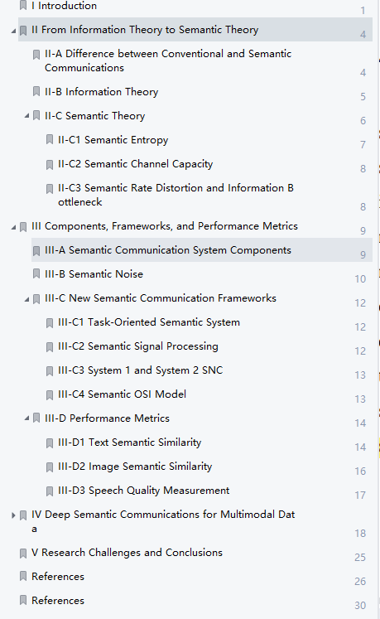

**6G Networks: Beyond Shannon Towards Semantic and Goal-Oriented Communications.(sci 2)**

**Towards goal-oriented semantic signal processing: Applications and future challenges**

**What is Semantic Communication?A View on Conveying Meaning in the Era of Machine Intelligence 2021 10**

**介绍了很多相关应用、还介绍了KG-based语义通信**

three sub-areas:

H2H :

H2M:The typical applications include human and AI symbiosis system, recommendation system, human sensing and care system, and virtual reality (VR)/augmented reality (AR) system.

M2M:The typical applications include M2M SemCom are mainly related to those in the areas of distributed sensing, distributed learning, and distributed consensus (e.g., vehicle platooning).

**A new communication paradigm: from bit accuracy to semantic fidelity**

**From Semantic Communication to Semantic-aware Networking: Model, Architecture, and Open Problems（SCI 1）**

也是knowledge graph？

Semantic Communications: Overview, Open Issues, and Future Research Directions

Open challenge：

1. Semantic Transformation: Semantic ambiguity [15] is another important open challenge, especially when without context, which is also a hard problem in NLP. One difference lies in that the sender clearly know the content to be delivered to the receiver.
2. Semantic Information Theory: Similar to Shannon's information theory, it is urged to study the impact of semantics on conventional information theory, that is the reliable transmission of groundth 𝑠 to receiver. According the discussion of semantic noise above, the capacity depends on semantic transformation, channel noise and semantic recognition. However, a strict bound is required to show the margin of semantic communication. Secondly, conventional communication systems assume that the transmitted symbols set are fixed. However, in semantic communication, the extensibility and openness of semantics leads to that symbols are dynamically changed. How to model the dynamic set and its impact on channel capacity is still unknown.

**————————————————————————**

**Nonlinear Transform Source-Channel Coding for Semantic Communications(CCF A)**

传统的联合信源信道编码（JSCC）是基于统计概率的（？），没有考虑信源语义层面。

为什么叫非线性变换，体现在哪里

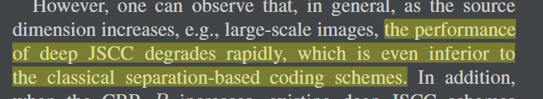通过引入一个隐空间上的熵模型，模型学习prior作为side information

there may still exist clear spatial dependencies among the latent representation ̄y, in which case the performance of the factorized-prior model degrades

Adaptive Rate Transmission: If the learned entropy model indicates the embedding yi of high entropy, its corresponding deep JSCC shall be assigned a high coding rate, and vice versa.

**Resource Allocation for Semantic-Aware Networks**

semantic spectral efficiency (S-SE)

a cellular network

用穷举法和匈牙利算法来解决resource allocation问题

**Semantics-Empowered Communication for Networked Intelligent Systems（sci 1）**

Age of Information(AOI) ,value of information, quality of information

我们提出了一种结构上新的、协同的方法，该方法考虑了信息语义，旨在利用面向目标的信息生成、传输和使用的统一所带来的高度潜在利益，而这三者迄今为止一直是分开处理的。

**Common Language for Goal-Oriented Semantic Communications: A Curriculum Learning Framework.（CCF C）**

**看不懂。。。**

**Attention-based Reinforcement Learning for Real-Time UAV Semantic Communication**

The work introduced a model for implementing semantic communications to address the reliability and latency requirements for drone networks.

**Reliable Semantic Communication System Enabled by Knowledge Graph**

**A Unified Multi-Task Semantic Communication System for Multimodal Data**

The existing works on semantic communications can be mainly divided into two categories: data reconstruction [7]–[14] and task execution [15]–[19].

**Wireless Resource Management in Intelligent Semantic Communication Networks （CCF A）**

Simulations are conducted in a text-based ISC-HetNet, where a Transformer model is utilized to complement the semantic coding part

Since the message itself has become the focus of ISC, a new metric, named as system throughput in message (STM), is apparently more reasonable and applicable when compared to the traditional metric of bit throughput.

With that in mind, the aforementioned message-rateis thus interpreted as the amount of messages that are conveyed or processed per time unit (symbol: msg/s), with the reference of the bit-rate definition (symbol: bit/s)

正是随机系数ηi的介入使P1变成了一个非确定性问题，这也是与传统非语义通信系统中最大的区别

和deepwive都讨论到bandwidth allocation

以下两种方法解决资源分配

第一阶段使用随机规划模型transform the original nondeterministic problem into a deterministic one

第二阶段利用内点方法和启发式算法find the solutions to UA and BA in the ISC-HetNet.

Barrier Method的思想就是通过在原始的目标函数中添加一个障碍函数（也可以理解成惩罚函数）来代替约束条件中的不等式约束 为什么要这么做？

实际上，求解随机规划问题时，总是设法把它转化成确定性数学规划问题，再进行求解。如果随机变量的非确定性或者量的变化很小，对系统的性能不产生严重影响，可以用其数学期望代替这个非确定值，并用确定性方法求解；然后通过敏感性分析来估价非确定性因素对方案的影响程度。

由于数学规划问题的类型有多种，在其中考虑到随机因素的影响，便可得到多种随机规划问题，如随机整数规划、多目标随机规划等等。把随机规划中的随机变量一般化为随机过程，借助[鞅论](https://baike.baidu.com/item/%E9%9E%85%E8%AE%BA?fromModule=lemma_inlink" \t "https://baike.baidu.com/item/%E9%9A%8F%E6%9C%BA%E8%A7%84%E5%88%92/_blank)、时间序列分析、[马尔科夫链](https://baike.baidu.com/item/%E9%A9%AC%E5%B0%94%E7%A7%91%E5%A4%AB%E9%93%BE?fromModule=lemma_inlink" \t "https://baike.baidu.com/item/%E9%9A%8F%E6%9C%BA%E8%A7%84%E5%88%92/_blank)等理论又将极大地丰富随机规划的内容。

卧槽 这不就是随机过程吗

**为什么用这两种方法 不用深度学习模型优化呢？**

**Task-Oriented Multi-User Semantic Communications(CCF A)**

缺点（来自A Unified。。。）：However, the model in [18] still needs to be retrained separately for different tasks and the transceiver architecture has not been unified for different tasks yet.

特别地，我们提出了一种新颖的分层 Transformer，它可以利用更多的文本信息来引导图像信息

**DeepWiVe: Deep-Learning-Aided Wireless Video Transmission(CCF A)**

**和Wireless Resource Management in Intelligent Semantic Communication Networks都讨论到bandwidth allocation**

**Robust Semantic Communications with Masked VQ-VAE Enabled Codebook**

文章认为现有的工作分为两种：一种是数据重建，一种是任务处理

虽然之前基于深度学习(DL)的语义通信系统在某些任务中表现出了非常出色的性能，但噪声的影响和系统鲁棒性仍需要进一步研究。

文章还讨论了the semantic noise in the image domain and that in the text domain

本文主要解决图像问题 codebook是什么

VQ-VAE 传输未掩码部分，减少传输量With such an asymmetrical design, the encoder only processes the unmasked patches and the lightweight decoder reconstructs the image from the encoded features and the mask tokens. In this way, the computational complexity and training time can be significantly reduced.

Transmitting the encoded features of the unmasked patches and the mask tokens to the decoder at the receiver leads to a large reduction in transmission overhead.

Codebook（码本）

• It is simple to train the codebook with a small variance, which makes the semantic communication system more stable.

• The discrete feature representation can combat semantic noise.

• The transmitter simply needs to transmit the indices of basis vectors, which significantly reduces the transmission overhead.

**Cognitive Semantic Communication Systems Driven**

**by Knowledge Graph**

文章认为semantic communication分为三个范式：

第一种是以目标为导向的通信范式，即只传输和任务相关的信息，在这个范式中，语义压缩是通过过滤掉与通信目标不太相关的冗余消息来实现的；

第二种是将原始数据映射到低维空间中；

第三种是利用源和目标之间的共享知识库（knowledge base）来实现语义压缩和通信

第一种有可解释性但没有统一指标（？）第二种没有可解释性

本文认为Knowledge base —— knowledge Graph

Decoding利用KG来帮助还原信息

**但是这个KG是数据集自带的，能不能自己生成一个呢？**

**基于知识图谱的语义通信方法和系统**

专利，不给看

**Reinforcement Learning-powered Semantic Communication via Semantic Similarity（有源码）**

强化学习

**Performance Optimization for Semantic Communications: An Attention-based Reinforcement Learning Approach(CCF A)**

知识图谱能够减少信息量的一个原因之一就是实体对之间的two-token关系能够减少原文的冗余信息

一对多的通信系统？An orthogonal frequency division multiple access (OFDMA) technique is used for semantic information transmission.

本文也使用了知识图谱

不仅考虑语义正确性 还考虑了语义完整性也是借用[29]?

语义提取方法使用了 《实体&抽出&指代消解的Multi-Task》

文章说即使得到了重要性分布，基站依然无法得到最佳的资源块分配方案-》强化学习，BS不知道每个重要分布f (Gi)与最优RB分配之间的关系。

如何利用三元组恢复句子？

**[Effective Communications: A Joint Learning and Communication Framework for Multi-Agent Reinforcement Learning Over Noisy Channels](https://www.aminer.cn/pub/60f170fd5244ab9dcb0a63f0/effective-communications-a-joint-learning-and-communication-framework-for-multi-agent-reinforcement" \t "https://www.aminer.cn/search/_blank)(CCF A)**

**Cross Modal Compression: Towards Human-comprehensible Semantic Compression**

这也很像语义通信啊 好奇度量标准

while the distortion is optimized by preserving the semantic in CMC encoder and decoder. 会不会是一个缺点

这项工作的主要目的是证明跨模态压缩的有效性，因此改进 CMC 的子模块超出了这项工作的范围

生成的图片只是类似而已啊

应用场景呢?或者说motivation：此外，监测语义信息，如身份识别、人流量或车流量，而不是原始信号，正成为大多数应用程序的主要关注点，本文称之为语义监测

**Learning Task-Oriented Communication for Edge Inference: An Information Bottleneck Approach**

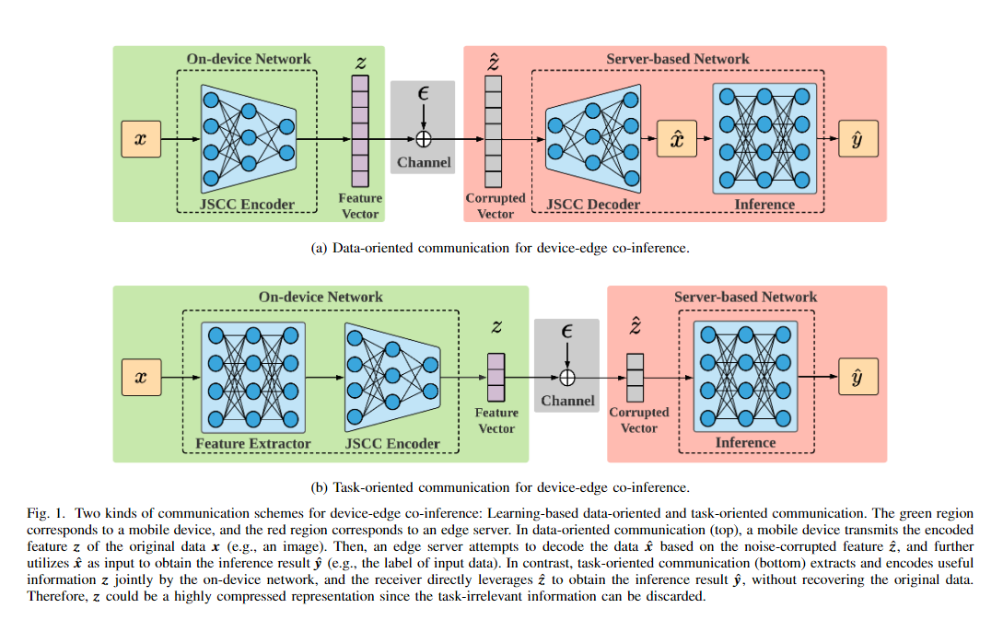

The variational method is a natural way to approximate intractable computations based on some adjustable parameters (e.g., weights in DNNs),

**Semantic-Native Communication: A Simplicial Complex Perspective**

**为什么不和之前论文的方法baseline比较呢？是难以复现吗，还是觉得他们的方法不够权威呢？**

**到底是要解决什么问题？**

**Rethinking Modern Communication from Semantic Coding to Semantic Communication**

Motivation：现有研究的缺点，1）没有考虑信道的动态环境（作者成为通信问题）；2）现有的工作要么依赖于NLP模型来获得语义感知的表示能力，而不是仔细地重新思考语义传输的最终目标，要么还不足以进行大规模推广。

蒸馏机制

可微和不可微的语义相似度/损失函数 提出用强化学习来解决这个问题

太糟糕了 完全没说清楚强化学习的应用 这个蒸馏的定义我也没看出来

知乎用户：

感觉这类跨层设计目前而言还是异想天开。至少对于不同类型的输入。例如语音、文字和图像，“语义通信”都需要不同形式的压缩方案，而不像相对应的对二进制信号的熵编码是统一的框架

。

真的吗？为什么我感觉本来就是需要不同形式的压缩方案呢？

Semantic Communications: Overview, Open Issues, and Future Research Directions

Open issues:

1. InsuffIcIent theoretIcAl reseArch onsemAntIc communIcAtIons
2. InconsIstent kbs At semAntIc source And destInAtIon
3. multI-user InterPretAtIon AlgorIthm desIgn
4. effectIveness level In semAntIc communIcAtIons
5. ImPlementAtIon of semAntIc communIcAtIons

Task-oriented -》新任务需要重新训练

语义通信的安全性问题呢？用传统通信方法来解决？

没有语义解码模型情况下无法恢复原始信息；

多用户问题怎么解决

如何理解语义通信从根本上解决基于数据传统通信协议中存在的跨系统、跨协议、跨网络、难互通问题。