https://opentextbc.ca/teachinginadigitalage/chapter/section-7-5-strengths-and-weaknesses-of-moocs/

http://www.ifres.ulg.ac.be/MOOC-blog/wp-content/uploads/2016/05/engagement-in-moocs-lu.pdf
Khe Foon Hew “Promoting engagement in online courses: What strategies can we learn from three highly rated MOOCS” British Journal of Educational Technology (2014) doi:10.1111/bjet.12235

Lan, M., Hew, K.F. Examining learning engagement in MOOCs: a self-determination theoretical perspective using mixed method. Int J Educ Technol High Educ 17, 7 (2020). https://doi.org/10.1186/s41239-020-0179-5

Challenges of teaching MOOCs include having a sense of speaking into a vacuum when recording video lectures due to the absence of student immediate feedback, being burdened by the heavy demands of time and money, and encountering a lack of student participation in online forums (Hew & Cheung, 2014).

More students watch videos than work on course assignments (Coffrin et al., 2014). A consistent decline in the number of students participating in the courses weekly was found. Factors that appear to predict student grades include the number of MOOC forum posts, and students’ marks in the first 2 weeks (Coetzee et al., 2014; Coffrin et al., 2014).

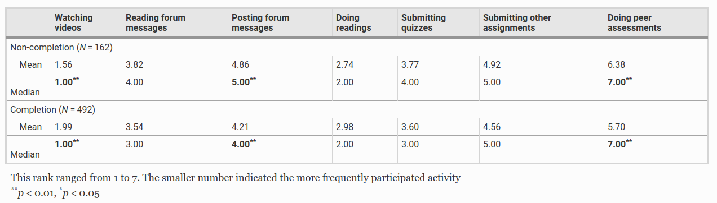
Ci dà un’idea delle attività alle quali assegnare maggiormente i token.

Hew, K. F., & Cheung, W. S. (2014). Students’ and instructors’ use of massive open online courses (MOOCs): Motivations and challenges. Educational research review, 12, 45–58.

Coetzee, D., Fox, A., Hearst, M. A., & Hartmann, B. (2014). Should your MOOC forum use a reputation system? In Proceedings of CSCW 2014, (pp. 1176–1187). New York: ACM Press. https://doi.org/10.1145/2531602.2531657.

Coffrin, C., Corrin, L., de Barba, P., & Kennedy, G. (2014). Visualizing patterns of student engagement and performance in MOOCs. In Paper presented at the Proceedings of the Fourth International Conference on Learning Analytics and Knowledge. https://doi.org/10.1145/2567574.2567586.

BLOCKCHAIN CONTRACTS

Nguyen BM, Dao T, Do B. 2020. Towards a blockchain-based certificate authentication system in Vietnam. PeerJ Computer Science 6:e266 https://doi.org/10.7717/peerj-cs.266

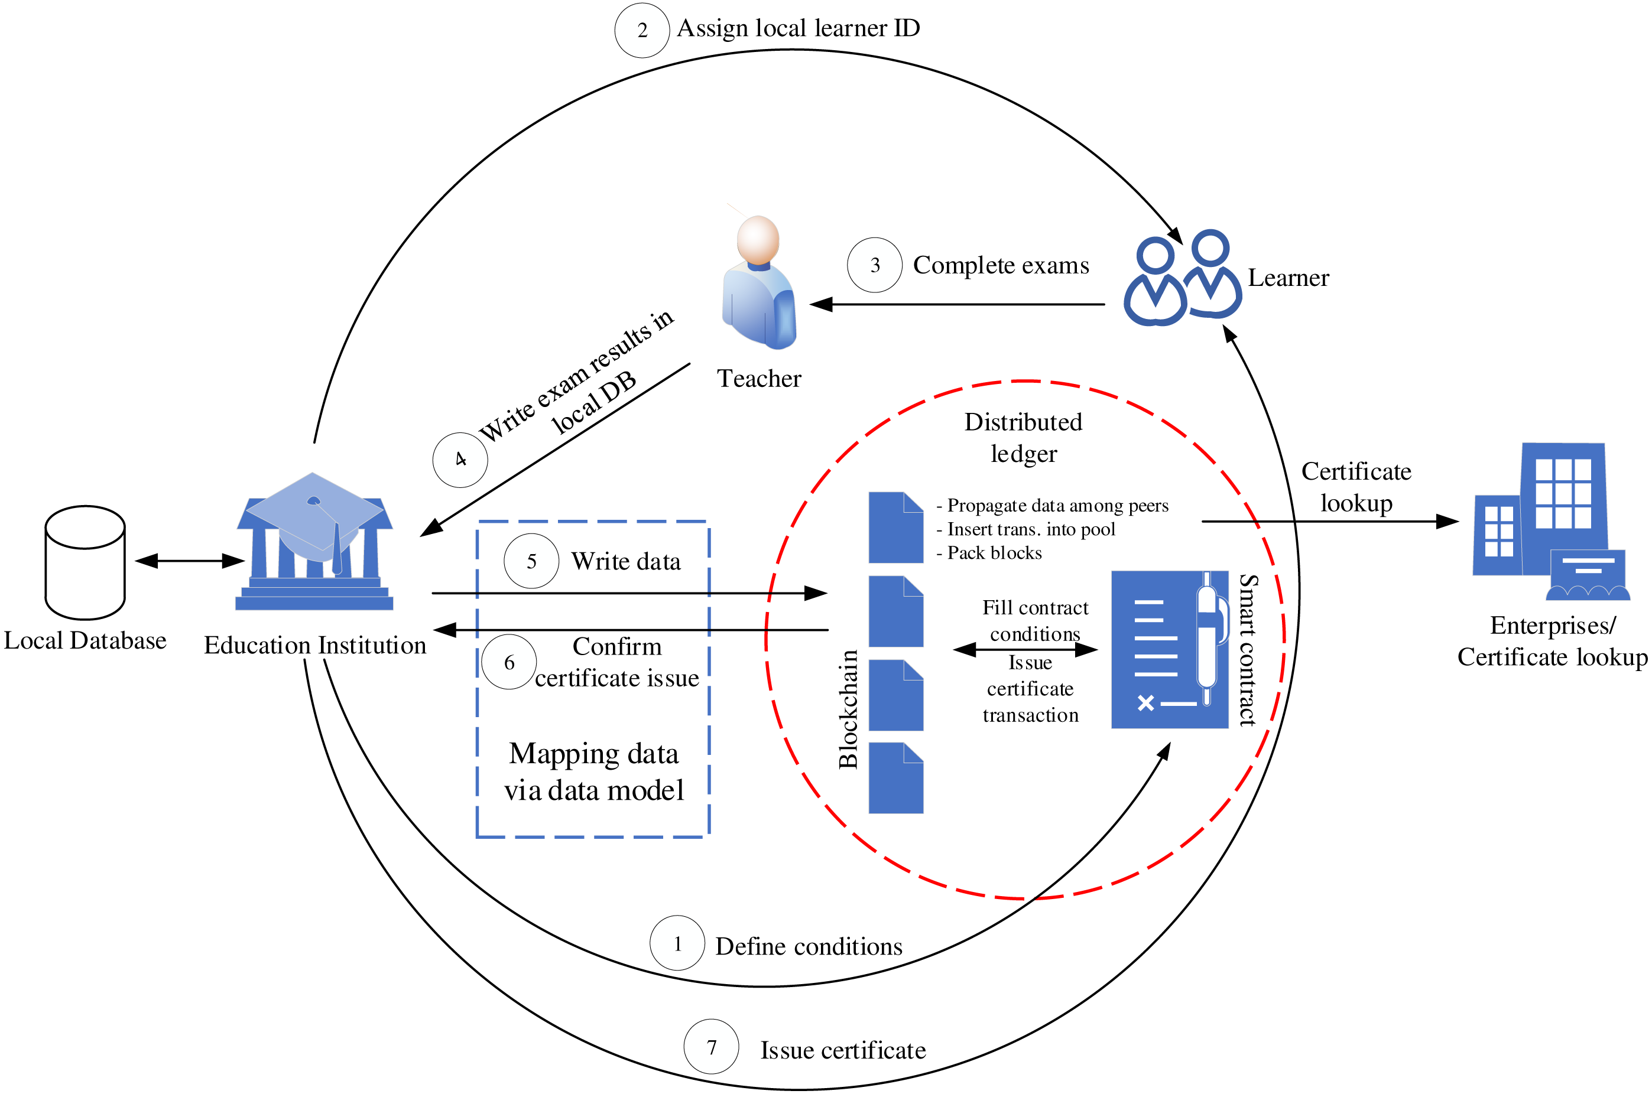
Education institutions play the role of defining training smart contract conditions, which point out the number of credit courses that must be collected by a student before he/she can receive a certificate. In other words, this contract defines education programs with a set of courses. Learners actor must complete the contract conditions through collecting credits of courses. When a learner enrolls in an education institution, a local ID will be issued for the learner (e.g., pupil or student ID) by the institution. As system design, each institution has a local database that provides a data repository for its educational management system. This design suits the most situation in Vietnam, where each university and school has its education management system. The local learner ID thus is a unique identification in the system of that institution. However, to ensure the ID of the learner is unique in VECefblock, we select national IDs provided by the government instead of using local IDs. In case that an educational institution does not store national IDs of leaners, we will make use of learner ID, institution name, timestamp (at the time of registering ID data). These values will be hashed together to create the identification key of the learner in the blockchain network.
In our operation process, the learner will do examinations assigned by teachers actor. Once the learner passes exams, the teacher will write course results into a local database of the education institution. Through the data model presented hereafter, the educational data will automatically be transferred to our VECefBlock.
Once all the smart contract conditions related to credit records are met, a transaction of certificate issue is automatically created and stored on the blockchain network. With our data mapping structure, the certificate issue information will be sent to the educational institution with a key of issued diploma. Based on the advantages of blockchain technology, the certificate information is propagated and verified by blocks stored in many different peer nodes. Therefore, the information can be trusted and cannot be changed by third parties. Based on the certificate information on the blockchain network, the institution will issue both certificates in the form of document and electronic (certificate codes) for learners.
For enterprises who would like to look up a certificate, they can query data stored in blockchain transactions through certificate codes issued for learners. On the other hand, to secure the writing course results processes, we use encrypted private keys in the following manner. During writing the exam result data, teachers must embed their private keys. The educational institution also uses its key (i.e., electronic signatures provided by national CA organizations) combining with the teacher keys to write data in the blockchain system. This mechanism helps prevent fake transactions during writing data of teachers on the local institution database and from the local database to the blockchain network.
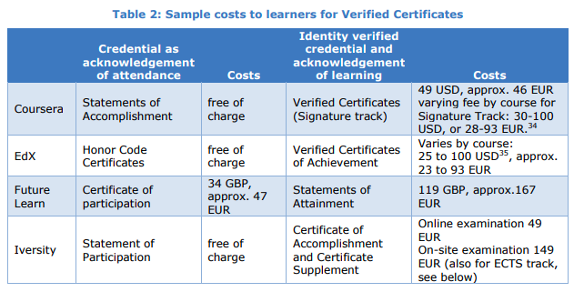
https://www.linkedin.com/pulse/getting-verified-certificate-coursera-worth-carolyn-mcintyre/

average completion rate currently hovering around 15%.
This rate increases dramatically, though, where students opt to pay for a verified certificate. In a study from Harvard and MIT, students who took this option, were found to have a 59% course completion rate compared to only 5% when students enrolled in MOOCs without paying for a verified certificate.

Having a “verified” certificate therefore doesn’t necessarily imply that you have gone through the course assessments, nor learned anything at all for that matter.
Cheating on MOOCs is actually quite easy to do
what employers are really interested in is what you can actually do in real terms, not a piece of paper featuring some course name which doesn’t actually demonstrate anything. And to add insult to injury, most employers wouldn’t accept a MOOC certificate as a valid credential anyway. So, in terms of “advancing careers”, the certificate itself is pretty useless.
There are instances, too, when having the verified certificate can potentially increase your career prospects. The emergence of specialisation programsusing MOOCs holds a lot of promise where marketable job skills are concerned. These programs, such as Specializations from Coursera, X-Series from edX or Nanodegrees from Udacity, are made up of a series of MOOCs which together are designed to give you mastery in a particular subject field. What is particularly relevant about these course series is that they are mostly project-based allowing students to demonstrate the knowledge they’ve acquired in a specialization to an applied project.

Riassunto

Verificare i certificati MOOC tramite blockchain potrebbe non avere un beneficio per tutti i tipi di corsi, in quanto spesso si copia per poter ottenere i certificati finali.
Risulta però più importante per corsi di specializzazione oppure per i corsi di laurea interamente offerti da piattaforme MOOC quali Coursera, perché hanno veramente un ruolo nell’aumento delle skills e le possibilità di assunzione da parte di aziende.
Il poter ottenere un certificato finale (A PAGAMENTO) inoltre di per sé aumenta la partecipazione dell’utente e i tassi di completamento dal 15% al 59%.

Quello che noi stiamo dicendo è che offriremmo certificati verificati tramite blockchain ed in più pagheremmo chi li riceve con dei token?

Metodo per implementare la validazione dei certificati:

(Fonte: Nguyen BM, Dao T, Do B. 2020. Towards a blockchain-based certificate authentication system in Vietnam. PeerJ Computer Science 6:e266 https://doi.org/10.7717/peerj-cs.266)

Partecipazione degli insegnanti e degli studenti:

Challenges of teaching MOOCs include having a sense of speaking into a vacuum when recording video lectures due to the absence of student immediate feedback, being burdened by the heavy demands of time and money, and encountering a lack of student participation in online forums.

More students watch videos than work on course assignments. A consistent decline in the number of students participating in the courses weekly was found. Factors that appear to predict student grades include the number of MOOC forum posts, and students’ marks in the first 2 weeks.

Tabella delle attività alle quali assegnare token

