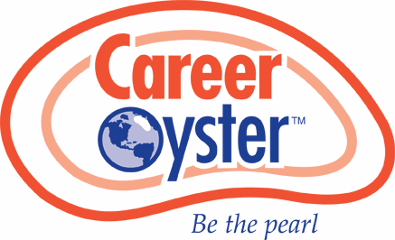
FORMAT

THE WORLD IS YOUR OYSTER — BE THE PEARL!
Career Oyster Podcast — Guest Invite
A short recorded conversation with Professional Recruiting Leaders on what changes might occur in the next 18–24 months — and the moves you're making now so you're not reacting too late.
Schedule Howard at Career Oyster
Ready to connect? careeroyster.youcanbook.me · or simply reply to this email
25–30 min on Zoom/Meet · no prep required
WHAT YOU GET
Finished episode + shareable link, no cost
WE HANDLE IT ALL
Editing, production, hosting — you just show up

3/11/26, 9:36 PM Career Oyster | Podcast Guest Invite
WHAT WE'D COVER
› Your forecast for the next 18–24 months: what shifts first — openings, candidate quality, client expectations, fees.
› AI in the real workflow: where it genuinely helps, where it adds noise, what you'd actually bet on.
› What gets harder as competition rises and reliable "signal" drops.
› The growth moves you're making now at your
company to stay ahead of the market.

"It's not the most qualified candidate who gets the job. It's the candidate who interviews the best."
— Howard Cattie, Founder & Head Coach

FORMAT + WHAT YOU GET
No cost guest spot. We handle editing and production, then send you the finished
episode. Share it for {{companyName}} or keep it internal — totally your call.
TIME 25–30 minutes on Zoom or Meet
PREP None — I'll send 6–8 prompt questions ahead
STYLE Conversational — you can
pass on anything
DELIVERED Full episode + a clean
shareable link
Not the right person? A quick pointer to whoever owns growth or delivery is perfect.
WHY I'M REACHING OUT
I'm putting together a small run of early episodes with operators in Professional Recruiting — people who are close enough to the shift to have real opinions, not just commentary.
The goal is to capture what's coming next and the decisions people are making before the market forces their hand. If you're open, I'll send the one-page outline and a few time options.
ABOUT THE HOST
Howard J. Cattie, Jr.
Founder & Head Coach, Career Oyster
30+ years in Recruiting Leadership
careeroyster.com LinkedIn: /in/howardcattie Cell: 404-386-0265
Howard@CareerOyster.com
Suggested subject line: Podcast guest invite — future trends of Professional Recruiting in 2026 and 2027
© CareerOyster · careeroyster.com
Interested in joining as a guest?
No cost, no commitment — just a good conversation worth sharing.
Schedule Howard at Career Oyster or reply to this email

