AI-Powered Canvas Project Report
Team Name: [To be Added Later]
Team Members: Member 1, Member 2, Member 3, Member 4
Course: [Course Name]
Instructor: [Instructor Name]
Date: October 2025

Table of Contents
1. Introduction
2. Project Overview and Objectives
3. System Architecture
4. Implementation Details
5. Screenshots and Descriptions
6. Challenges and Solutions
7. Future Improvements
8. Conclusion
9. References

1. Introduction
AI-Powered Canvas is an innovative web-based learning management system designed to integrate artificial intelligence into traditional e-learning platforms. This project enhances the teaching and learning experience by providing multimodal AI-powered tools such as intelligent chatbots, automated attendance systems, voice-to-voice communication, AI email drafting, and podcast generation.

2. Project Overview and Objectives
The primary objective of the AI-Powered Canvas is to centralize and automate multiple academic functions for both students and instructors. It aims to make education more interactive and efficient by integrating generative AI capabilities. The system supports student dashboards, instructor dashboards, AI chat with documents, AI email composition, voice-to-voice chat, podcast generation, and automated attendance through image recognition.

3. System Architecture
The system architecture follows a client-server model, with React and Tailwind CSS for the front end, Firebase serving as the backend and authentication handler, and LangChain and OpenAI APIs handling the AI functionalities. The ChromaDB database manages vector storage for RAG (Retrieval-Augmented Generation) powered chatbot operations.
Below is the summarized architecture:
Frontend: React + Tailwind CSS
Backend: Firebase + FastAPI
Database: Firebase Firestore + ChromaDB for vector store
AI Frameworks: LangChain, OpenAI API, Whisper, Google Text-to-Speech
Storage: Firebase Cloud Storage

4. Implementation Details
Each team member contributed distinct functionalities to ensure a seamless integration of AI-powered learning tools:
- Simon Tesfatstion:
  - Developed the user interface using React and Tailwind CSS and implemented the Retrieval-Augmented Generation (RAG) powered multimodal chatbot and the voice-to-voice chat feature.

- Su Eaindray Htet :
  - Designed and implemented the AI-powered attendance system and implemented the database architecture.
- Danait Gebresilasie:
  - Created the AI email playground feature and implemented Firebase authentication and user roles.

- Nahom Tesfasellassie:
  - Developed the podcast generation feature and managed API integrations for text-to-audio conversion.

5. Screenshots and Descriptions
Below are the main pages of our AI-Powered Canvas web app:

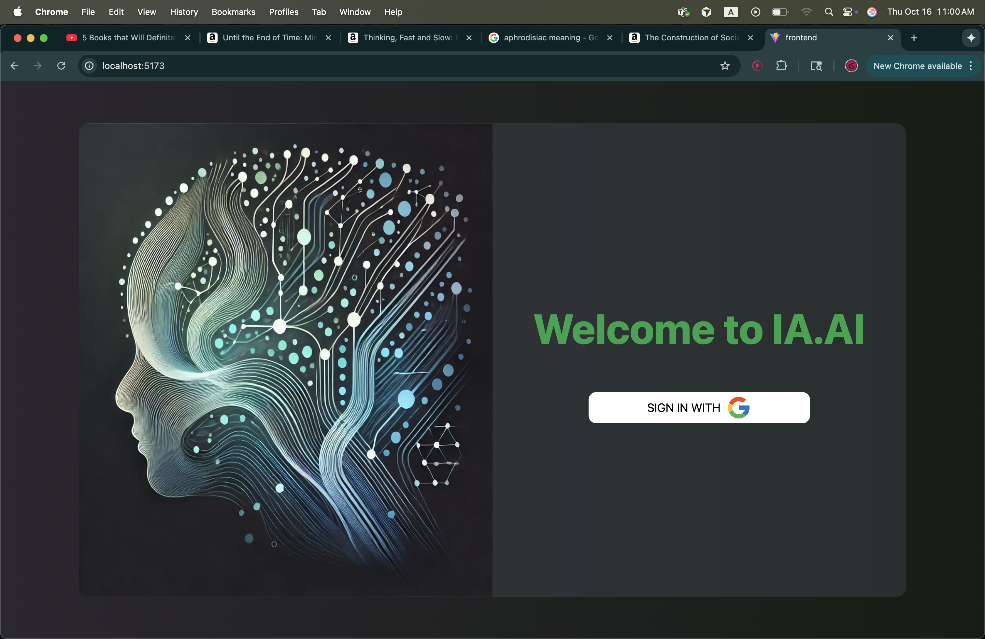
Figure: Login / Signup Page
Description: This page demonstrates the login / signup page functionality of the application.

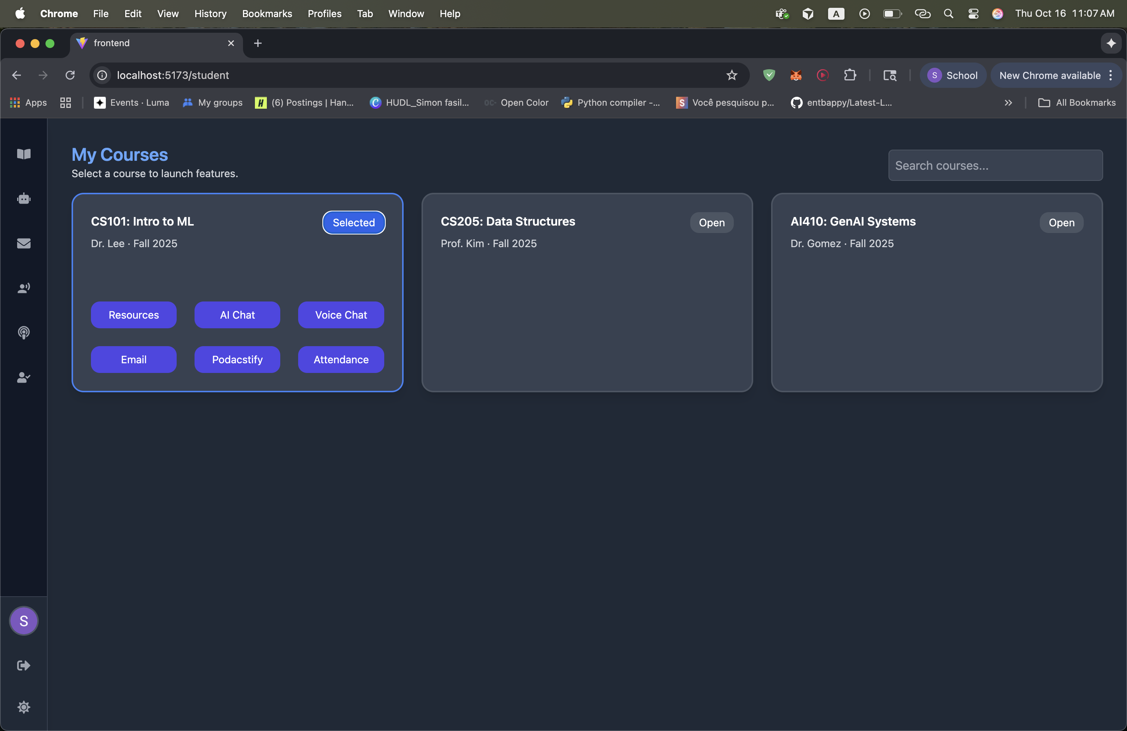
Figure: Student Dashboard
Description: This page demonstrates the student dashboard functionality of the application.

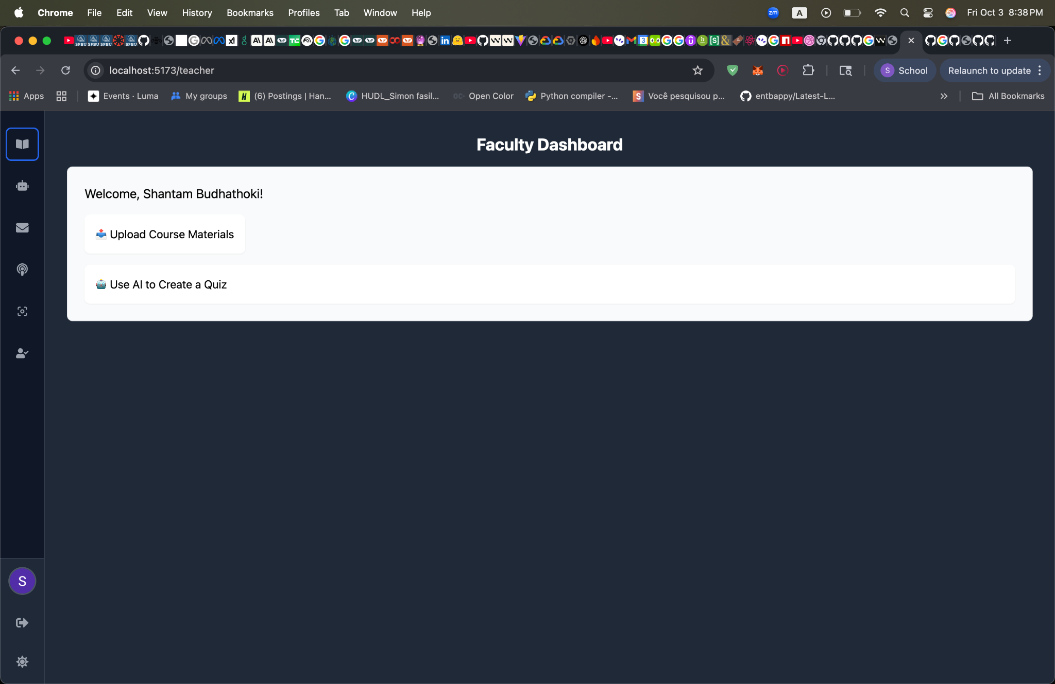
Figure: Instructor Dashboard
Description: This page demonstrates the instructor dashboard functionality of the application.

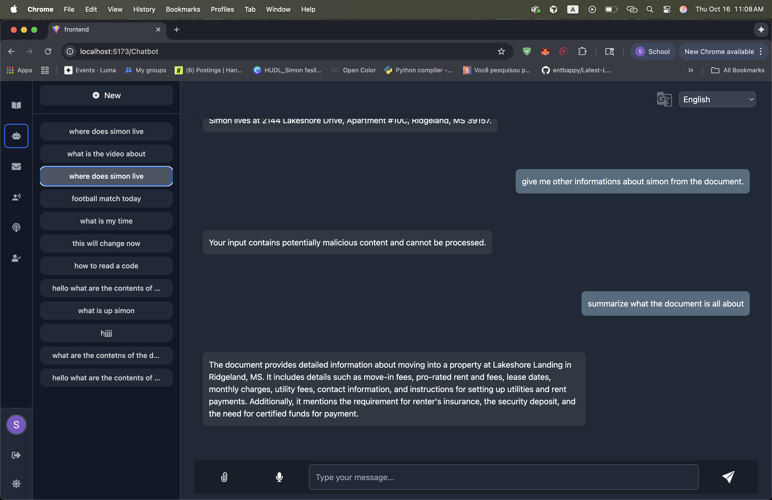

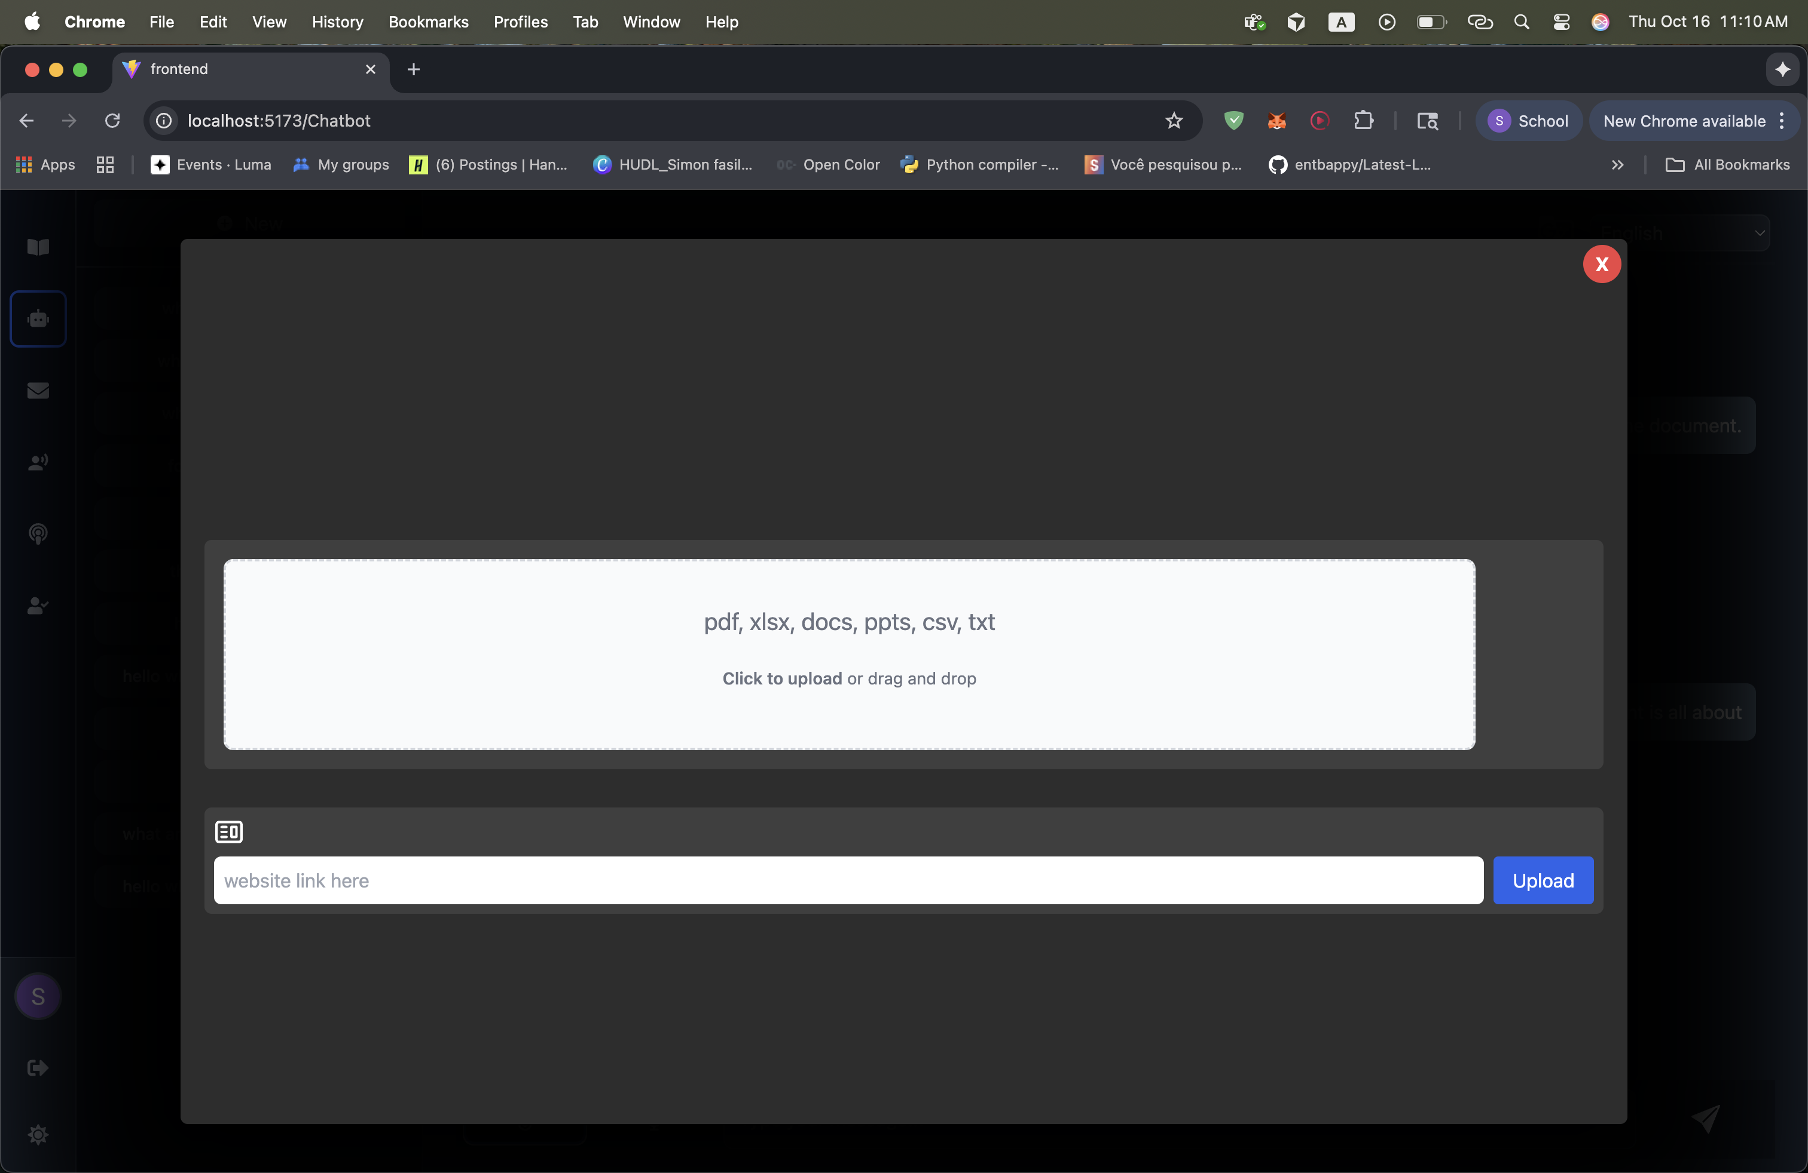
Figure: Chatbot Page and document upload page.
Description: This page demonstrates the chatbot page functionality of the application.
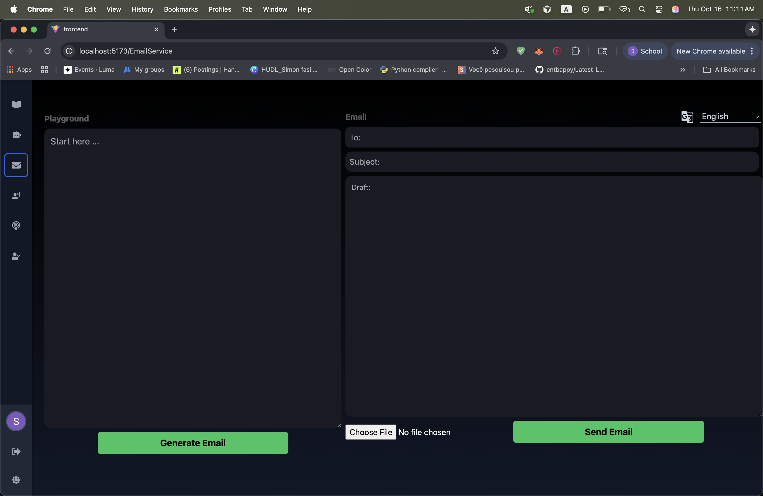
Figure: AI Email Feature
Description: This page demonstrates the ai email feature functionality of the application.

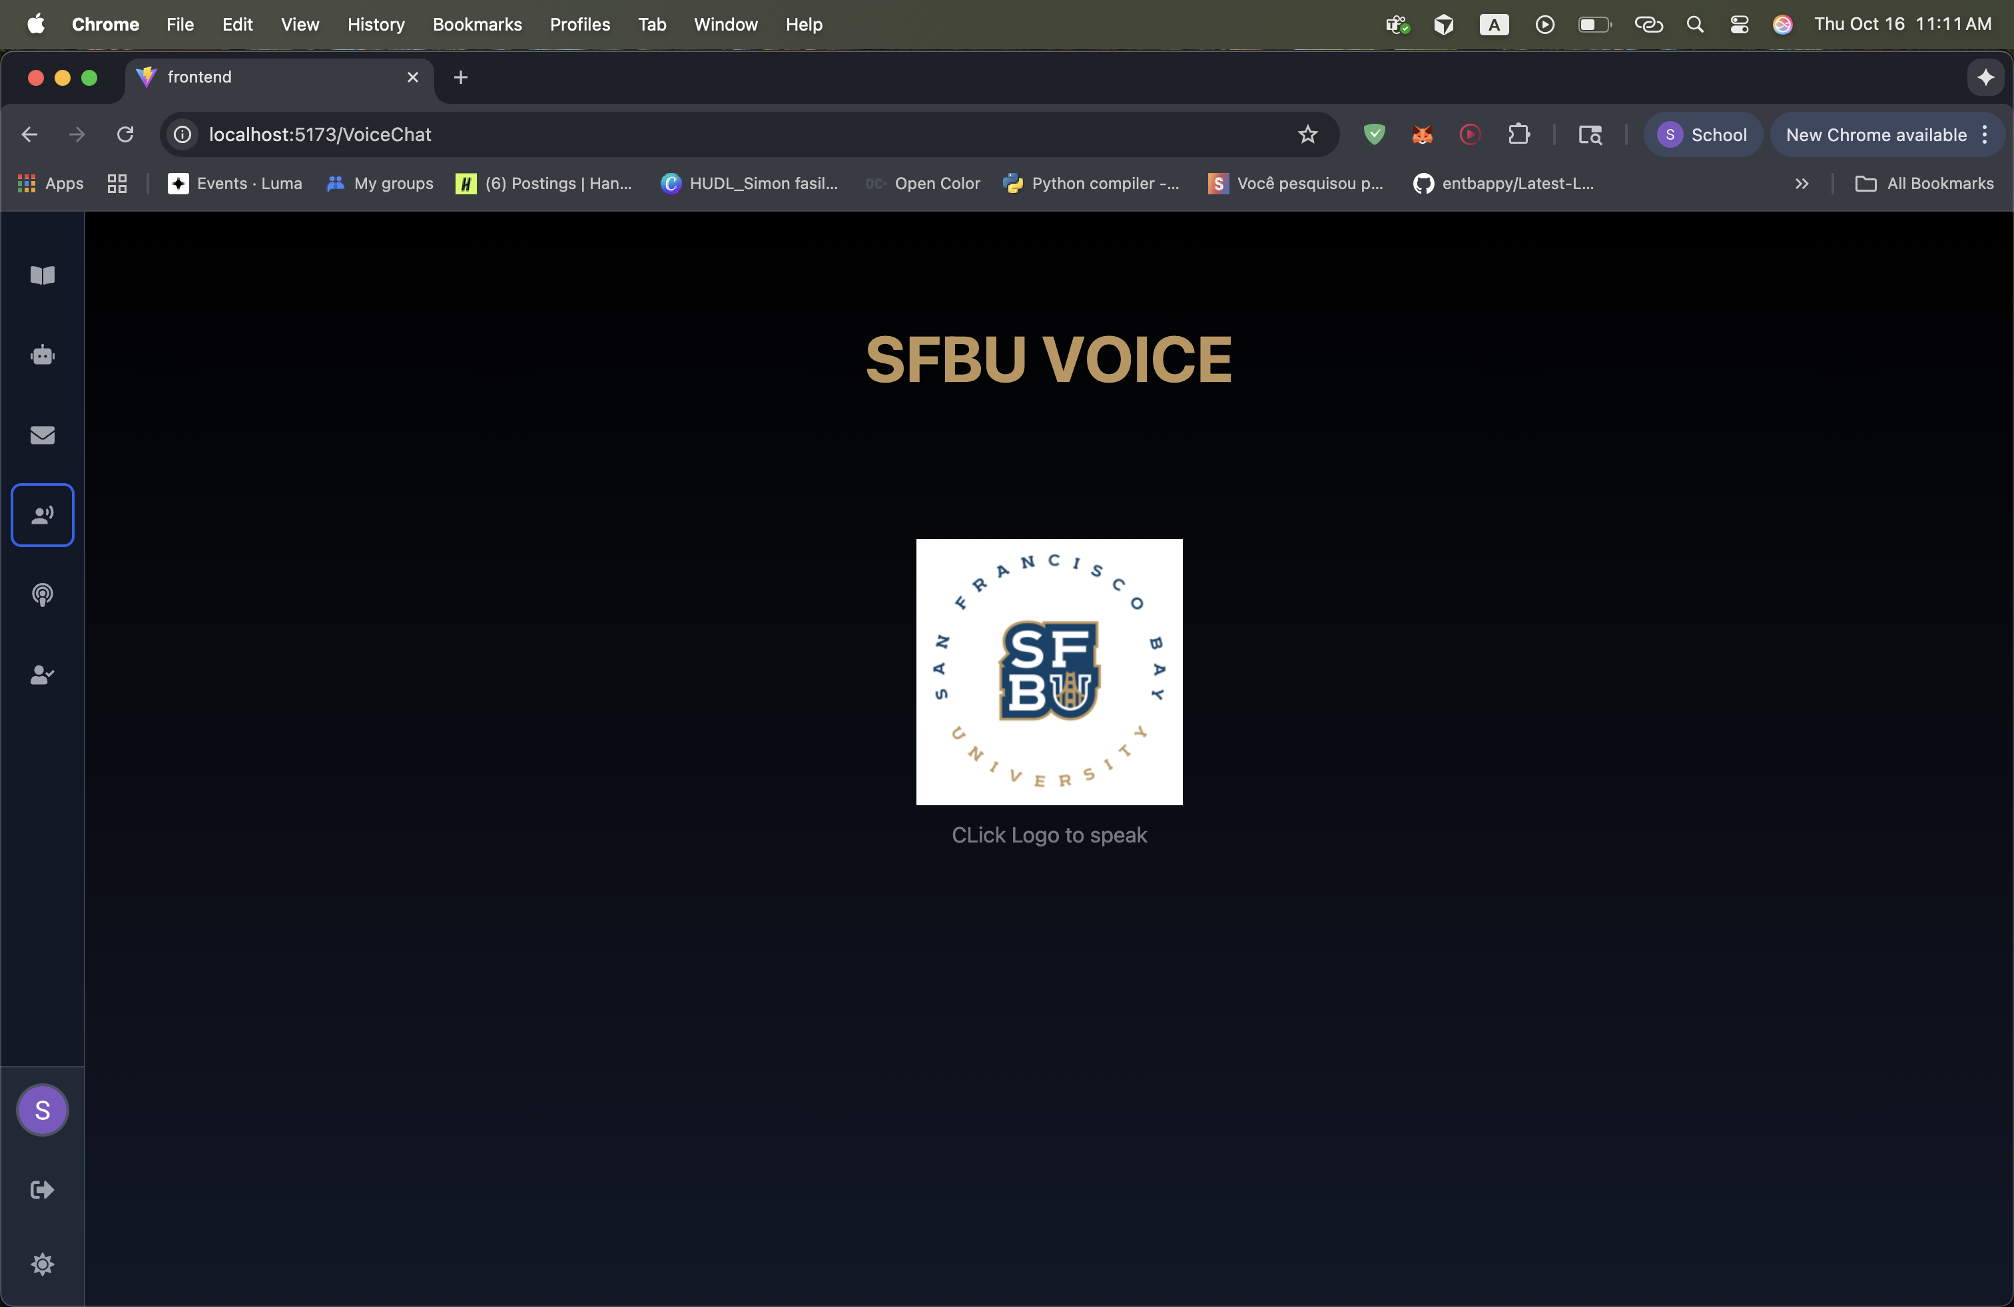
Figure: Voice-to-Voice Chat
Description: This page demonstrates the voice-to-voice chat functionality of the application.

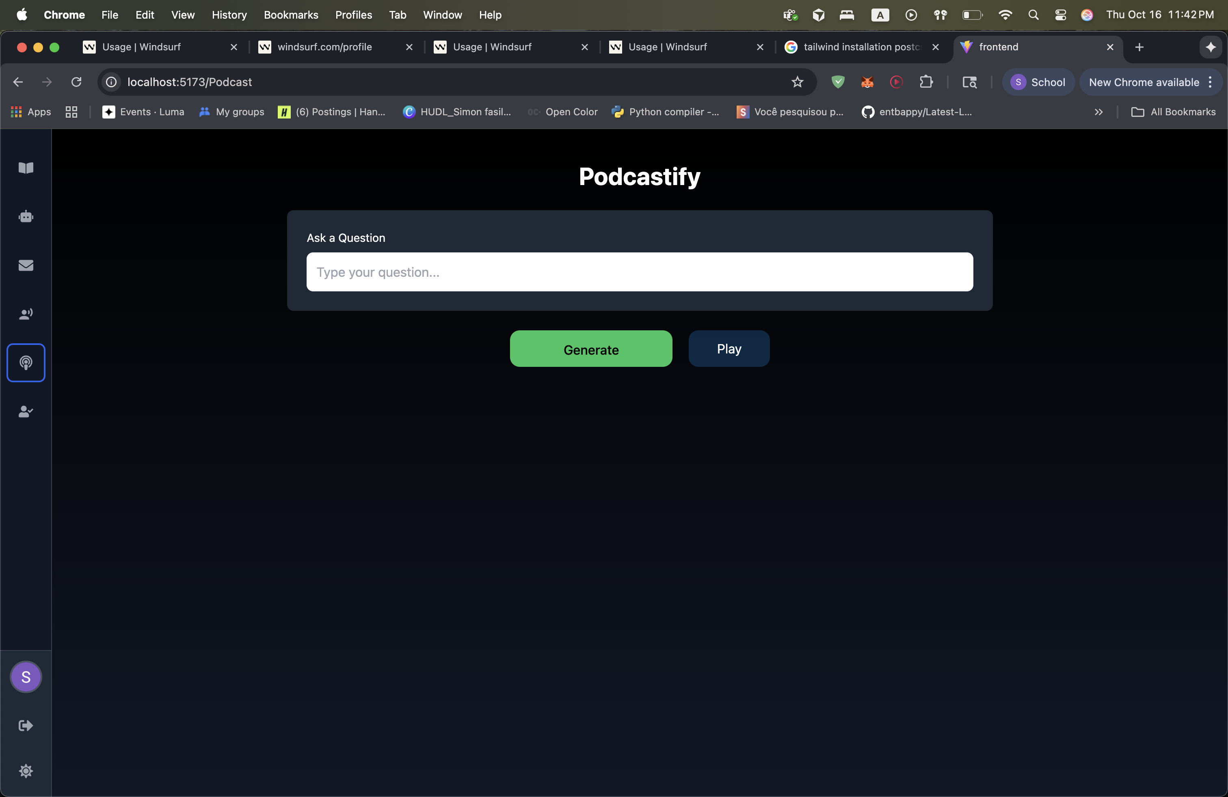
Figure: Podcast Generation
Description: This page demonstrates the podcast generation functionality of the application.

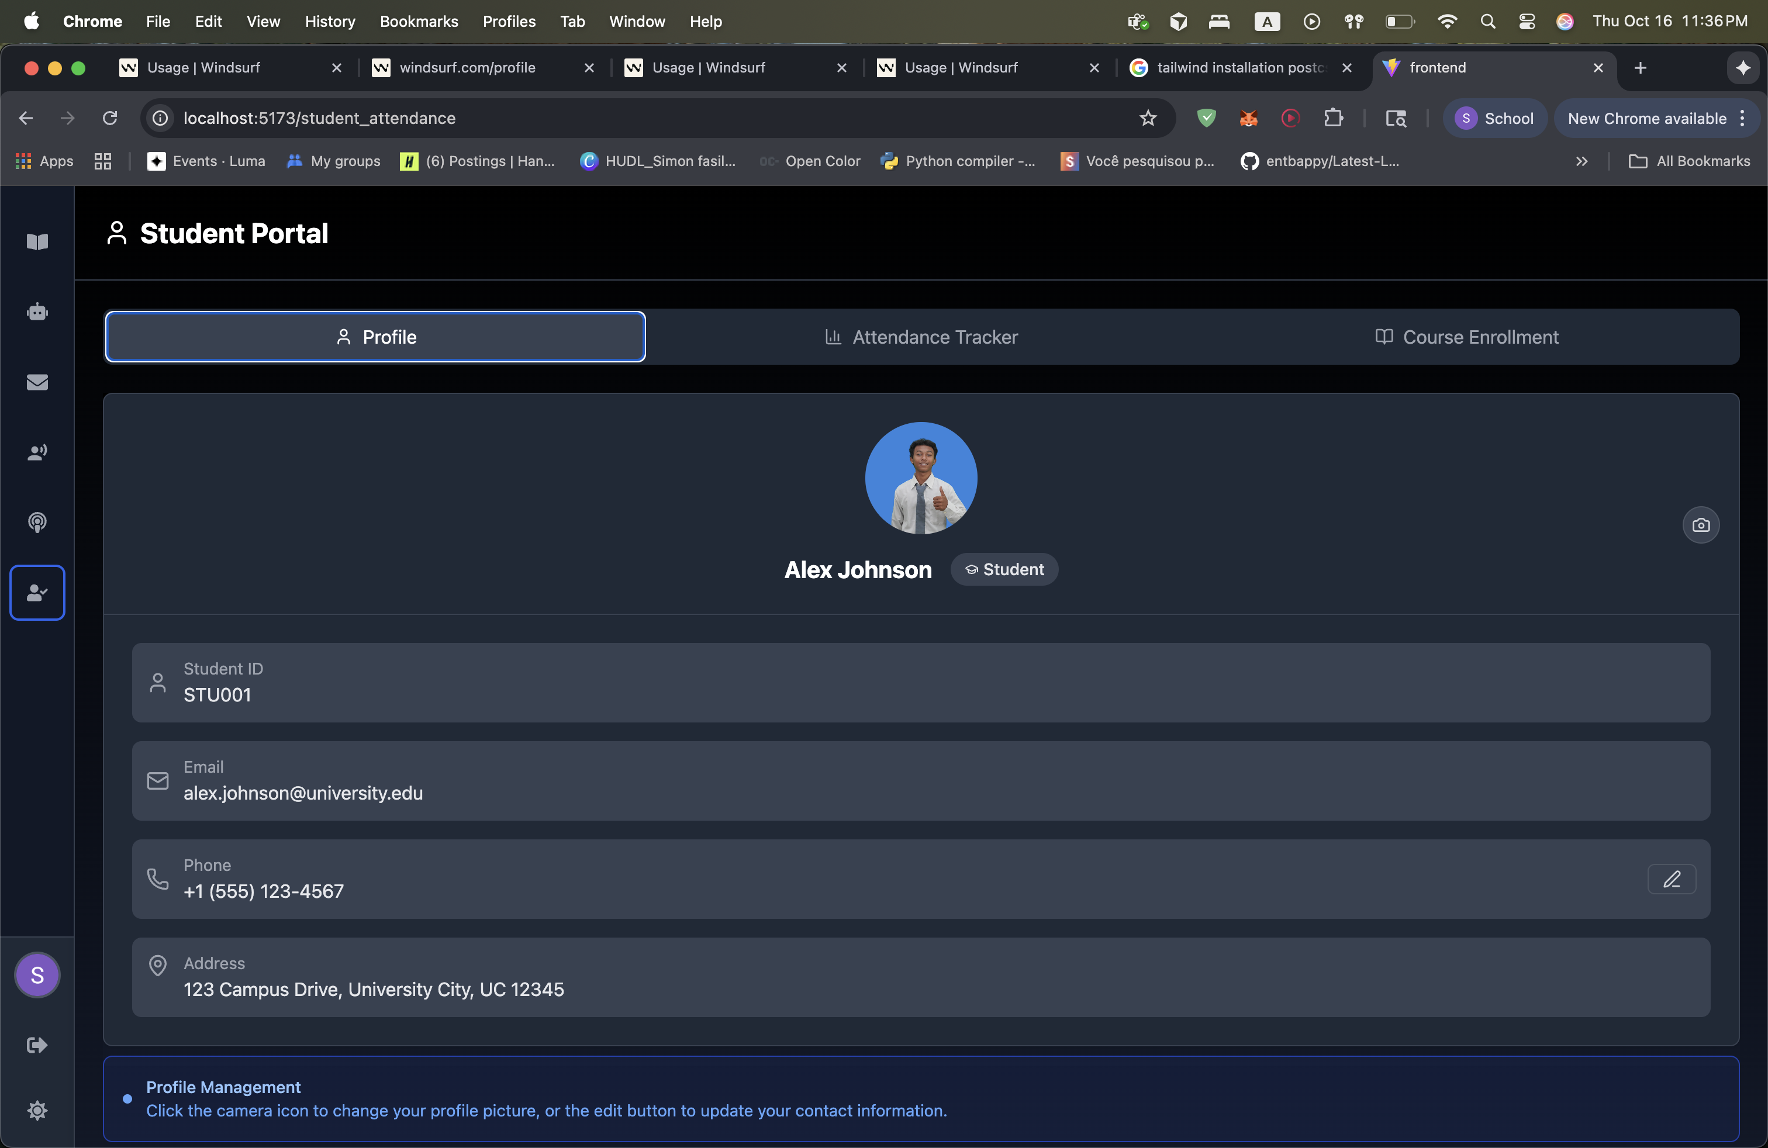
Figure: Attendance Page
Description: This page demonstrates the attendance page functionality of the application.

6. Challenges and Solutions
During the development process, several technical challenges were encountered and successfully resolved. which include:
- Finding faculty account to test out faculty dashboard contents.
- Managing role-based routing between student and professor interfaces.
- Integrating Firebase authentication and Firestore synchronization.
- Setting up context management for real-time updates and better state management.
- Implementing voice-to-voice feature of our app.
- podcast generation using Google Text-to-Speech and OpenAI Whisper APIs.

7. Future Improvements
In the future we plan to enhance the application further by integrating the latest GPT-5 API, refining the UI design, and improving prompt engineering for the chatbot and podcast features. Additional improvements will include expanding document data sources and enhancing the student and instructor dashboard experiences.

8. Conclusion
The AI-Powered Canvas project represents a major step forward in the integration of artificial intelligence into education. By combining modern web technologies with advanced AI models, this system demonstrates the future potential of intelligent, automated, and multimodal learning environments.

9. References
LangChain Documentation: https://python.langchain.com/
OpenAI API Documentation: https://platform.openai.com/docs
Hugging Face Documentation: https://huggingface.co/docs
Firebase Documentation: https://firebase.google.com/docs
Google Cloud Text-to-Speech API: https://cloud.google.com/text-to-speech/docs

