Header

Some text

* 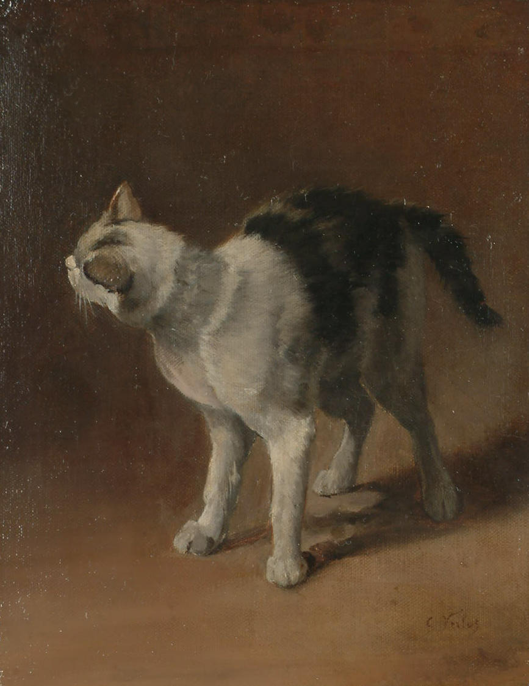Unordered list
* Item 1
* Item 2

1. Ordered list
2. Item 1
3. Item 2

**Bold text**

*Italics*

Underline