Creating the virtual environment issue: solved with conda_env/conda_env_pytorch0.2.yml (<https://github.com/ContinuumIO/anaconda-issues/issues/9480>)

<https://answers.microsoft.com/en-us/windows/forum/all/microsoft-visual-c-140/6f0726e2-6c32-4719-9fe5-aa68b5ad8e6d>

had to install visual studio C++ Build Tools

Problem with futures==3.2.0

mkl-fft==1.0.12 mkl-random==1.0.2 tensorflow==1.13.1 torch==0.2.0.post4

Install python 2.7 instead

virtualenv venv --python=python2.7

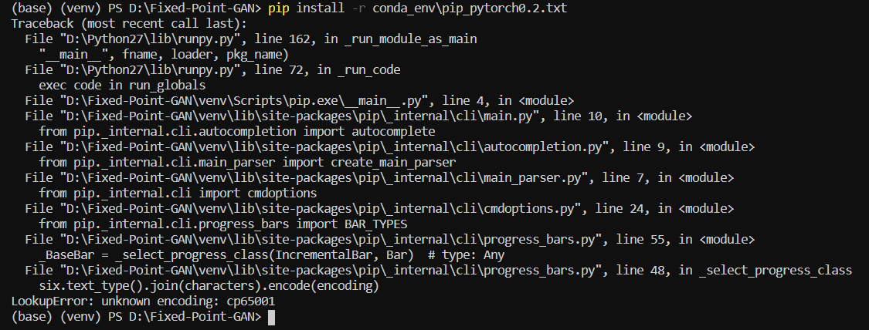

Via anaconda I can’t find the packages

Saman sent me his requirements.txt (he’s running py 3.6.9)

I installed 3.6.8 (there was Win installer, 3.6.9 had to be compiled)

What I did:

* py -3.6 -m venv gan_env
* pip install torch==1.4.0 torchvision==0.5.0 -f <https://download.pytorch.org/whl/torch_stable.html> (I had an issue with the torch version in saman’s file)
* pip install -r requirements.txt
* pip install setuptools==41.0.0 (I had a previous version that was incompatible)

It installed cuda 9.2 automatically

04/08/2020 – seems to work

Download.sh doesn’t work, had to manually download the zip file into the folder that the script creates. After doing so running the script works as intended. I think.

10/08/2020 running main.py with those arguments doesn’t work

25/08/2020 Started using the City servers

List python versions: *find /usr/bin/python* ! -type l*

Dear all,  
  
Hope you are well and safe.  
  
Please find attached a detailed document on how to access Big Data servers. The guide has details for Windows and Mac OS, Linux users can follow the set up for Mac. Essentially there are 3 steps:  
  
1. Set up VPN  
  
2. Use SSH to access the machine  
  
3. Use Slurm to submit your jobs to the queue  
  
The job scheduler (Slurm) is to ensure fair resources to all students, please make efforts to save your model(s)/data accordingly.  
  
In essence, this works as follows. Once you submitted a job and training is finished, then in the output file you can find a place where it says “training finished”, best model XXX. With that number you go to the checkpoint folder and take the best model.  
  
An example of sample batch text would look like:

#! /bin/bash

#SBATCH --job-name="tr"  
#SBATCH --mail-type=ALL  
#SBATCH --[mail-user=timur.mongush@city.ac.uk](mailto:mail-user=timur.mongush@city.ac.uk)  
#SBATCH --nodes=1  
#SBATCH --ntasks-per-node=8  
#SBATCH --output job%J.output  
#SBATCH --error file_err_%J.err  
#SBATCH --gres=gpu:1  
#SBATCH --partition=normal  
  
module load cuda/9.0  
module add python/intel  
python -m netdissect --gan ––model "netdissect.proggan.from_pth_file('models/karras/livingroom_lsun.pth')" --outdir "dissect/livingroom" --layer layer1 layer4 layer7 --size 1000  
  
Also, in the guide you will find a few resources for beginners on Linux commands, text editors, checkpointing your code, etc.  
  
Best wishes,  
Olga

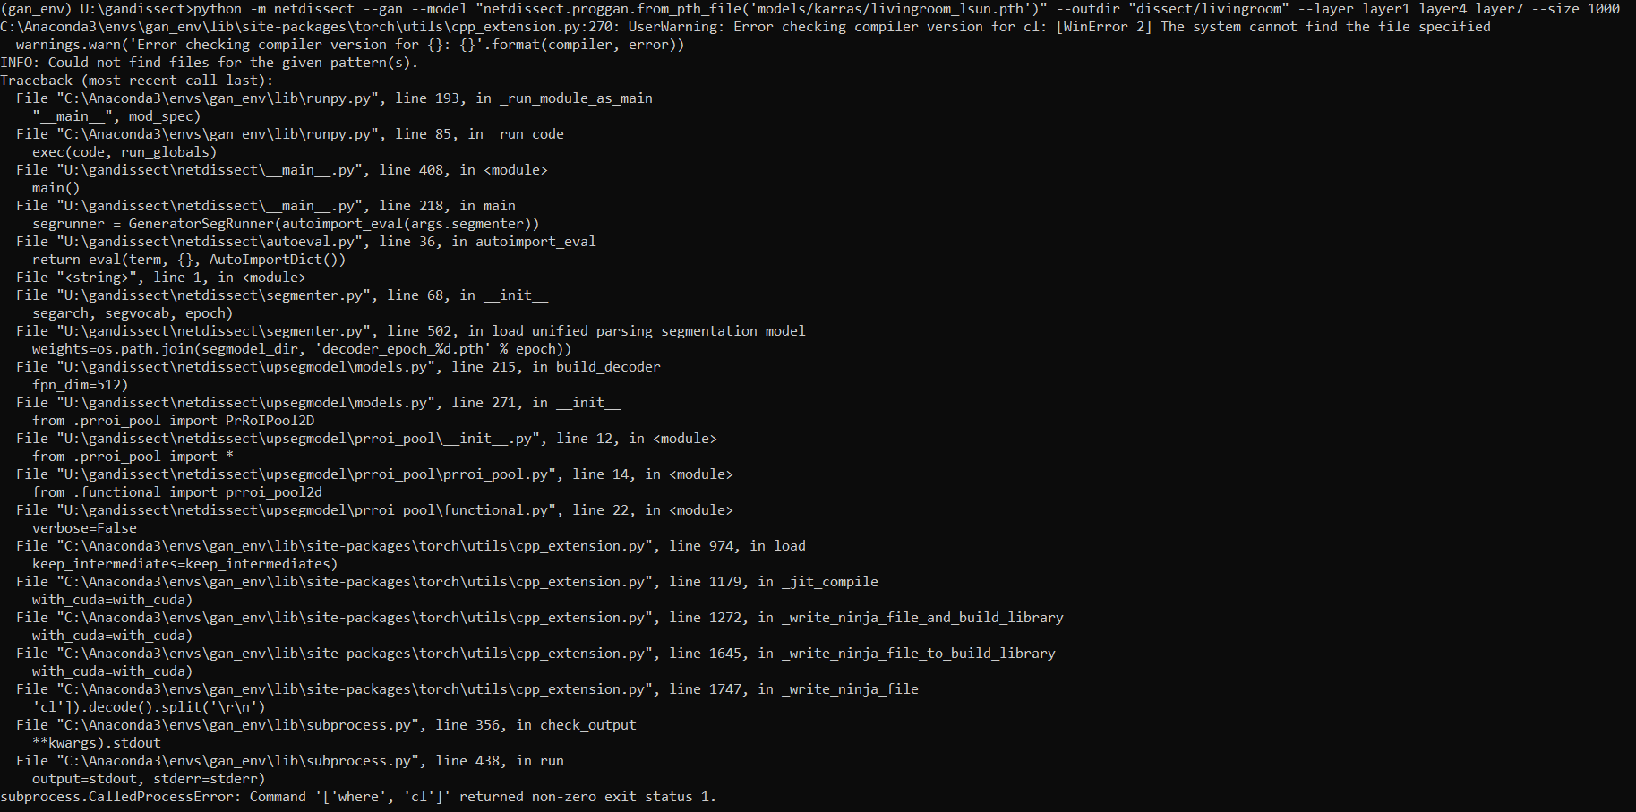

04/09/20

It’s been 1.5 weeks of trying to run the code on City big data servers.

I was getting an error: file_err_17234.err

<https://stackoverflow.com/questions/55890813/how-to-fix-object-arrays-cannot-be-loaded-when-allow-pickle-false-for-imdb-loa/56062555>

Fixed that code, it’s running now.

An error after that:

*File "/home/enterprise.internal.city.ac.uk/aczx084/gandissect/netdissect/segviz.py", line 19, in segment_visualization*

*result = scipy.misc.imresize(result, size, interp='nearest')*

*AttributeError: module 'scipy.misc' has no attribute 'imresize'*

<https://docs.scipy.org/doc/scipy-1.2.1/reference/generated/scipy.misc.imresize.html>:

[**imresize**](https://docs.scipy.org/doc/scipy-1.2.1/reference/generated/scipy.misc.imresize.html#scipy.misc.imresize) is deprecated! [**imresize**](https://docs.scipy.org/doc/scipy-1.2.1/reference/generated/scipy.misc.imresize.html#scipy.misc.imresize) is deprecated in SciPy 1.0.0, and will be removed in 1.3.0. Use Pillow instead: numpy.array(Image.fromarray(arr).resize()).

Set up venv to use FPG on city servers:

<https://community.intel.com/t5/Intel-Distribution-for-Python/python-m-venv-fails-returned-non-zero-exit-status-1/td-p/1156751>

*This doesn't work since we don't build CPython with "ensurepip" enabled. I can provide a workaround for you to create a venv with pip in it:*

*##assuming that you have internet access  
python -m venv foo --without-pip  
source foo/bin/activate  
curl*[*https://bootstrap.pypa.io/get-pip.py*](https://bootstrap.pypa.io/get-pip.py)*| python*

*Your activated env would have pip in it.*

python3.6 -m venv ganenv --without-pip

source ganenv/bin/activate

*curl*[*https://bootstrap.pypa.io/get-pip.py*](https://bootstrap.pypa.io/get-pip.py)*| python*

pip install torch==1.4.0 torchvision==0.5.0

pip install -r myreqs.txt ­