MONTREAL.AI / QUEBEC.AI

CONTINUITY Ω
  - The story and the method
From a disrupted order to a viable way to deliver
Edition 2 / Volume 02 / 7 November 2026
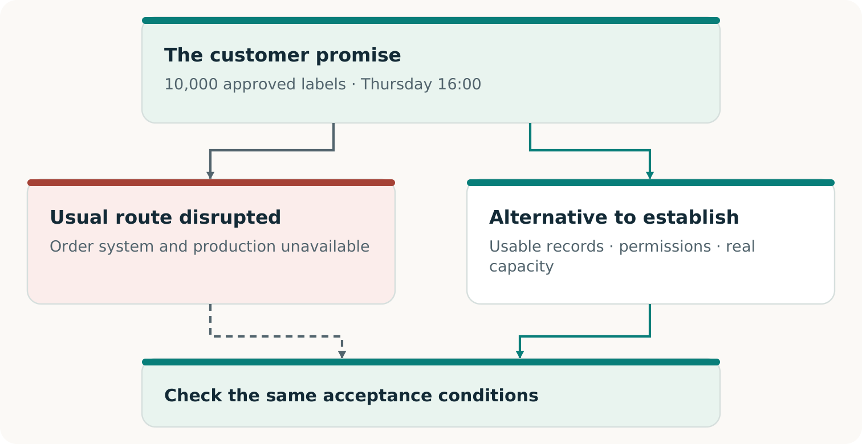
Fictional teaching example
For business leaders, prospective users and curious readers

UNDERSTANDING CONTINUITY Ω

Start where the customer feels the failure
A customer waiting for a delivery needs the right goods on time. The fact that a server has restarted matters because it may help produce that result. It does not, by itself, settle whether the order is correct, the goods can be made or the customer will receive them.
CONTINUITY Ω is a project to help a business keep a defined customer promise when its usual route is disrupted. It investigates what the promise depends on, helps construct missing means and checks whether the resulting arrangement can deliver the agreed outcome. [C1, pp. 5⁠-⁠8]
THE REFERENCE POINT
This customer. This result. This quality. This deadline. These permissions. These acceptance conditions.

That focus creates room for invention. An unavailable application might be restored. A protected record might make the relevant work possible without it. A qualified partner might produce the order while the original site recovers. Each option deserves the same outcome test.

Where the ambition goes further
Continuity planning already uses alternatives, rehearsals and recovery evidence. The research ambition here is to integrate their discovery and construction with voluntary commercial arrangements - and learn which retained capabilities improve later work. A capable conventional service remains a legitimate winner. [C1, pp. 6, 17⁠-⁠21]
The following pages follow one fictional printer order through that reasoning. They explain the opportunity and the evidence needed to pursue it. The practical volumes then turn the same case into a pilot and editable working records.

THE PRINTER’S THURSDAY COMMITMENT

Recover the order the customer accepted
This continuing case is invented for teaching. Its quantities, times and financial figures are not reported customers, measurements or prices. The agreed location and time zone remain part of the fictional commitment.
The accepted order  Deliver 10,000 approved labels, using artwork v3, by Thursday 16:00 at the agreed location. | The restored record  After the incident, the recovered order book shows 8,000 labels. | The retained amendment  An authenticated record outside the restored view shows an accepted increase of 2,000 labels.

A process that checks only whether the application opens could miss the discrepancy. A careful comparison with the retained amendment reveals it. The missing 2,000 labels are part of the customer’s accepted order, not optional extra production.
This is why the source of evidence matters. If no available record distinguishes the 8,000-label history from the 10,000-label history, another reviewer cannot infer which actually occurred. The remedy may be a protected acknowledgment or a better record-preservation process. [C1, pp. 9⁠-⁠10]
TWO CLOCKS MATTER
Service restoration measures when the application can work again. The customer’s deadline measures when the agreed result must be delivered and accepted.

Ordinary reconciliation can find this omission too. CONTINUITY Ω must earn additional value through the complete route it helps construct, the work it saves or the outcome it enables. A fair comparison gives a capable conventional method the same evidence. [C1, pp. 19⁠-⁠20]

FROM AN OBJECTION TO A BETTER ROUTE

Make the second intelligence useful
One AI can propose a plan; another can search for consequential omissions. Give the challenger a concrete question: Does the recovered order preserve every accepted change through the agreed cutoff? In our case, the useful objection identifies the missing 2,000-label amendment and its effect on delivery.
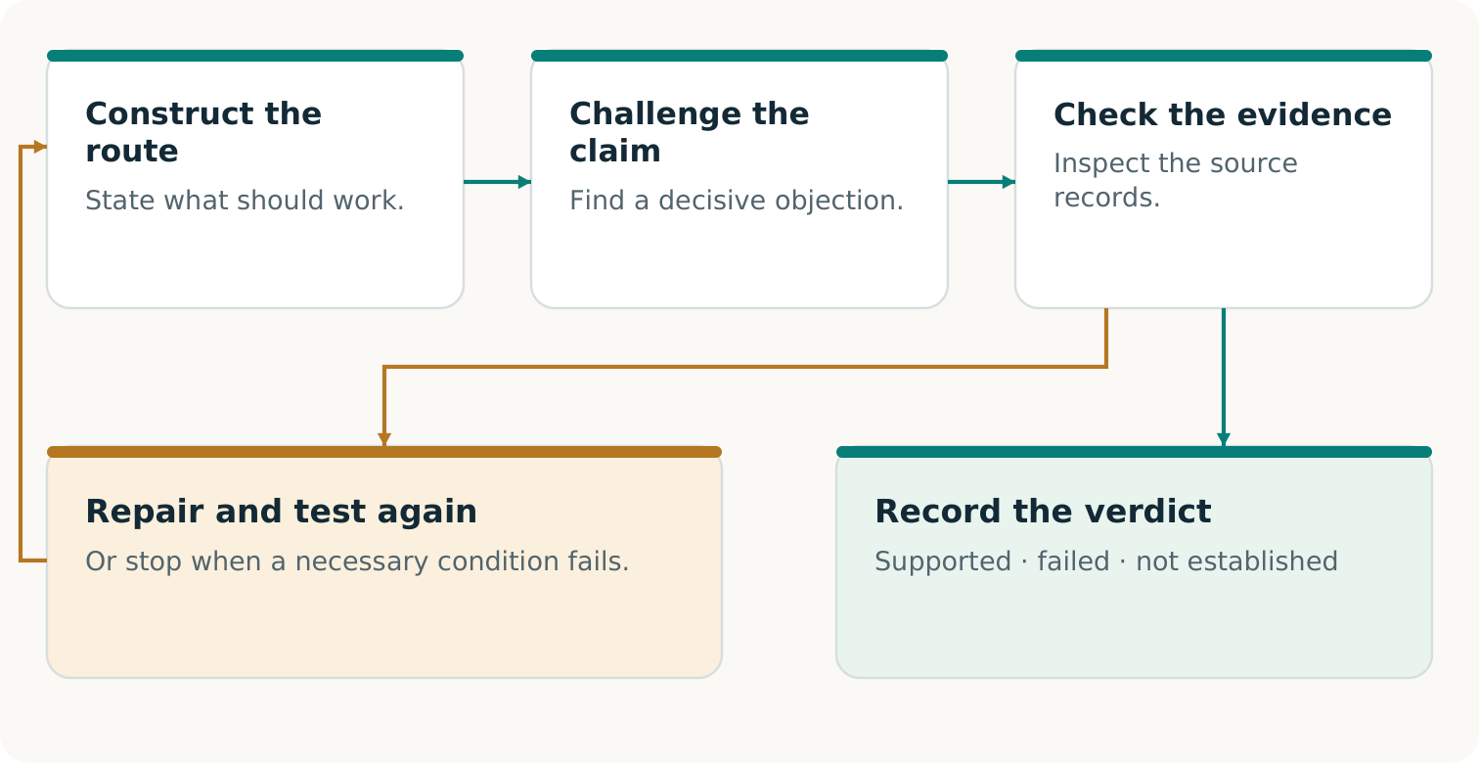
An objection becomes useful when evidence settles it and any repair is checked against the original promise. An objection may also be rejected or remain unresolved.
The challenger needs the source, not just the first reviewer’s summary. Its objection must identify a material requirement, a plausible failure and a way to check the allegation. A second model’s confidence is not the deciding evidence. [C1, pp. 5⁠-⁠6, 10⁠-⁠11]
CONSTRUCTIVE CRITICISM
Find the missing condition, settle whether it matters, then build what the accepted outcome requires. Also challenge an unsupported claim that no workable alternative exists.

TRANSFORMATIONAL INTELLIGENCE IN PRACTICE

Change the means while preserving the agreement
The initial question might be: “How do we restart this plant before Thursday?” The customer’s authorized purpose may permit a broader question: “How can we deliver the approved labels by Thursday 16:00?” [C1, p. 5; F1, pp. 2⁠-⁠3]
Restoring the normal route and constructing an authorized alternative are competing means of meeting the same commitment.
This is the transformational move: examine whether an inherited way of working is unnecessarily restricting the outcome. Build a different information path, production method or cooperation arrangement when it improves the complete result. Keep the strongest existing route available for comparison.
A REAL BOUNDARY
If the agreement requires a particular plant, material or approval, that requirement remains binding. Changing it requires an authorized new agreement; it cannot retroactively make the original promise pass. [C1, pp. 8, 10⁠-⁠11; F1, p. 3]

MAKE THE OBLIGATION PORTABLE

Give the next provider something it can use
The alternate printer cannot work from the sentence “Please finish our urgent order.” It needs enough reliable information and authority to produce the same approved result. Creating that usable handoff is itself a capability. [C1, pp. 11⁠-⁠12]
Describe the work  The current 10,000-label obligation, artwork v3, approved material and quality requirements, delivery details and deadline. | Authorize the work  The necessary use rights, permitted data disclosure, release authority and authenticated way to activate the agreed route. | Close the loop  Stable order identifiers, amendments, cancellations and receipts that prevent duplicate production or invoicing when normal operations resume.

Portability is about preserving meaning. A file conversion is successful only if the next provider receives the correct specification and can use it under the agreed conditions. A beautiful preview cannot replace a production file that the equipment and operators can actually use.

Keep the package small and sufficient
Transfer the necessary approved information through the permitted route. Copying the entire affected environment may add exposure without helping production. Current versions, bounded access and a reachable revocation process matter because a once-valid package can become unsuitable.
A PRACTICAL ACCEPTANCE QUESTION
Could the receiving provider explain exactly what it is authorized to make, demonstrate that its process can make it, and return evidence that reconciles with the original order?

At this point, the case has progressed from a corrected record to a possible operating route. The next question is whether that route will still be usable when the disruption occurs and other customers need it too. [C1, pp. 11⁠-⁠13]

DEPENDENCIES AND SCARCE CAPACITY

Make sure the backup avoids the actual failure
A second printer can still depend on the same failed login, material source or transport link. Another supplier name does not by itself create a usable path. The complete route must survive the disruption being claimed. [C1, pp. 11⁠-⁠12]
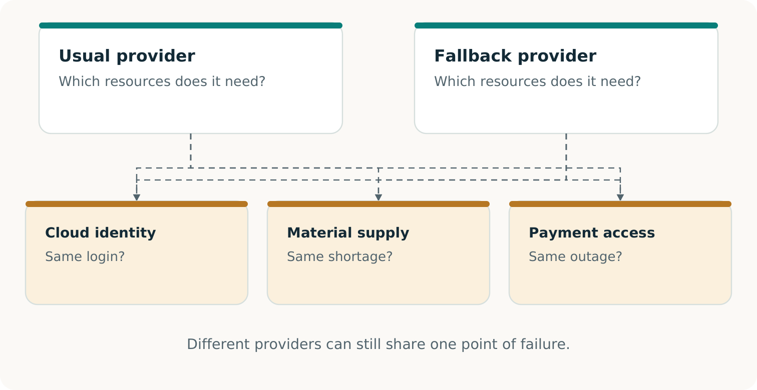
Inspect the whole route, including shared prerequisites. A missing shared dependency can stop every nominal alternative.
In our fictional case, the alternate window has 12,000 units of usable capacity. Earlier protected work already needs 2,000. Exactly 10,000 remain for our order. A further simultaneous request for 5,000 cannot fit without changing the arrangement.
A RESERVATION HAS CONSEQUENCES
It commits scarce capacity under defined conditions. Check existing claims and simultaneous demand; maintain the reservation when circumstances change. A report of spare capacity is not a reservation. [C1, pp. 12⁠-⁠13]

INVENT THE ECONOMY APPLIED TO CONTINUITY

Create an arrangement people can choose
The buyer needs dependable output; the provider needs compensation for capacity and obligations. Preparation, checking and delivery must also be funded. CONTINUITY Ω explores the capability and this voluntary arrangement together. [C1, pp. 17⁠-⁠19; F2, pp. 2⁠-⁠3]
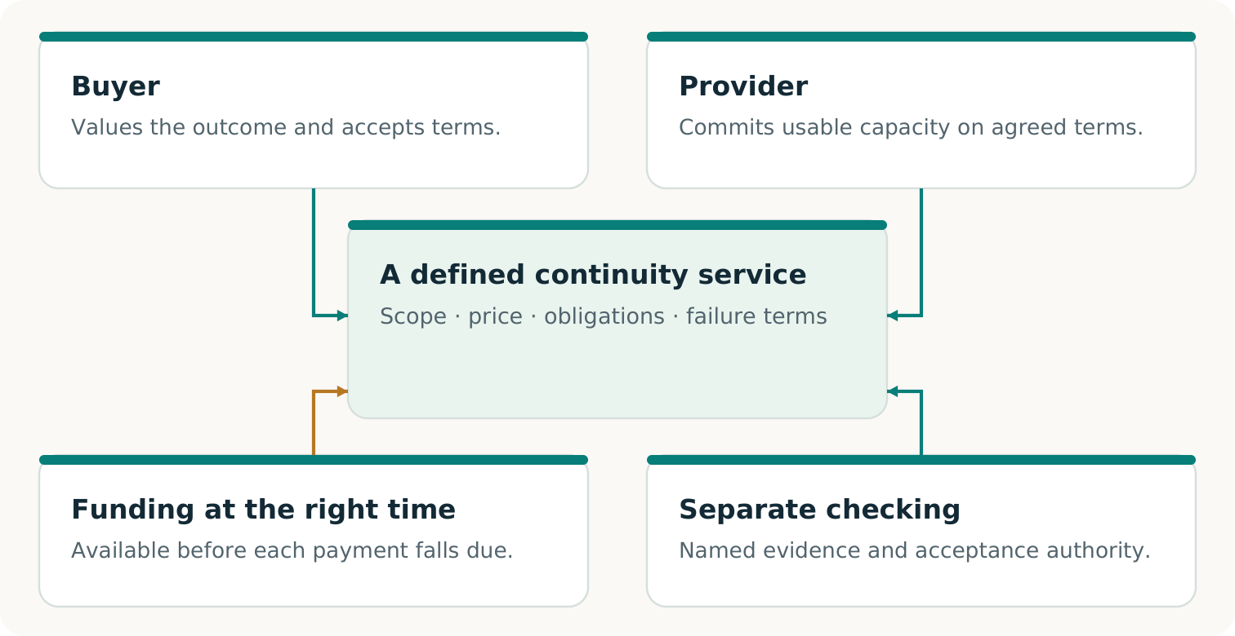
The technical and commercial pieces must fit together. The parties’ consent, alternatives, obligations and funding determine whether the proposed service is usable.
Fictional CAD: the primary printer’s separate purchase of the continuity service, excluding the end customer’s original invoice. A quote of $5,600 against estimated complete cost of $5,000 suggests $600 of projected contribution. But $4,700 falls due before acceptance and only $1,200 is available: a $3,500 funding gap.
THE MISSING MOVE MAY BE ECONOMIC
A permitted funding sequence, different production route or lower preparation cost could change feasibility. Each change needs its own evidence and cost accounting. A projected contribution does not pay the earlier bills. [C1, pp. 18⁠-⁠19]

THREE ACHIEVEMENTS THAT CAN GROW TOGETHER

Separate a working route from a proven market
A good continuity service combines an accepted outcome with an arrangement people can sustain. These achievements are connected, but they answer different questions. Keeping them visible helps the buyer know what is being purchased and the provider know what has been earned.
Outcome  Did the specified work meet the original requirements? For our order, evidence would have to establish the agreed labels, quantity, quality, deadline and acceptance. A software rehearsal establishes only the software result it actually exercised. | Service feasibility  Can the arrangement be carried out under its stated conditions? Consent, rights, simultaneous capacity, incentives, complete costs and funding timing must fit. A supplied model establishes a conditional calculation; actual readiness needs actual evidence. | Commercial proof  Do real participants accept the terms and receive the promised value? Record accepted delivery, collected payment, all campaign costs and continuing obligations. Further independent adoption or renewal is needed to support repeatability. [C1, pp. 8, 17⁠-⁠20; F2, p. 3]

This is where a new economic possibility could emerge. A firm unable to justify a duplicate plant might find a qualified, maintained fallback worthwhile. A provider might find that serving such commitments is worthwhile too. Their preferred arrangement must still beat their credible alternatives and remain feasible when demand arrives together.
PRICE THE STAGE THAT WAS ACTUALLY PURCHASED
A paid preparation exercise establishes a purchase of preparation. It does not establish acceptance of a later reservation or activation offer. Each stage has its own delivered value and evidence. [C1, pp. 8, 19]

Volume 05 gives the dated picture of the existing evidence. It distinguishes the original research, later local software work and the additional observations required for operational or commercial claims.

THE CONTINUITY PASSPORT

Make the result easy to inspect and use
A Continuity Passport records the promise, exercise, observations and when conclusions need rechecking. It makes the next decision easier. [C1, pp. 13⁠-⁠14]
Record | What the reader needs
Commitment | Recipient, output, quantity, quality, deadline, permissions and acceptance authority.
Exercise | Route, inputs, versions, disruption, dependencies, concurrent capacity, results and evidence gaps.
Verification | Source custody, checker, method, producer relationship and trust assumptions.
Use and validity | Terms and capacity status; invoices or collections; costs, duties, expiry, revocation and recheck triggers.

Specify the independence
Separate source custody can protect the reference. Separately implemented checking can expose a shared coding mistake. An outside assessor can add organizational separation. These address different risks. Another AI or code path within the same project does not automatically provide external assurance. [C1, pp. 6, 9, 13, 22⁠-⁠23]
READ EACH VERDICT IN ITS SCOPE
Demonstrated: the stated requirements were met in the exercise. Failed: an applicable requirement was violated. Not established: decisive evidence is missing or outside scope.

Reconciliation can be demonstrated while physical delivery remains unestablished. A correct refusal may pass a safety test while the complete promise fails. Fresh verification checks current evidence; a saved Passport records the past. [C1, pp. 13⁠-⁠14; R1; R3]

THE ALPHA GENESIS FLYWHEEL Ω CONNECTION

Use one capability to make another possible
AI progress may make new tools practical. Suppose a real accepted exercise produces a useful adapter, checking procedure and their validity conditions. A different production process could benefit from that inheritance - or reveal a failed transfer. [C1, p. 21]
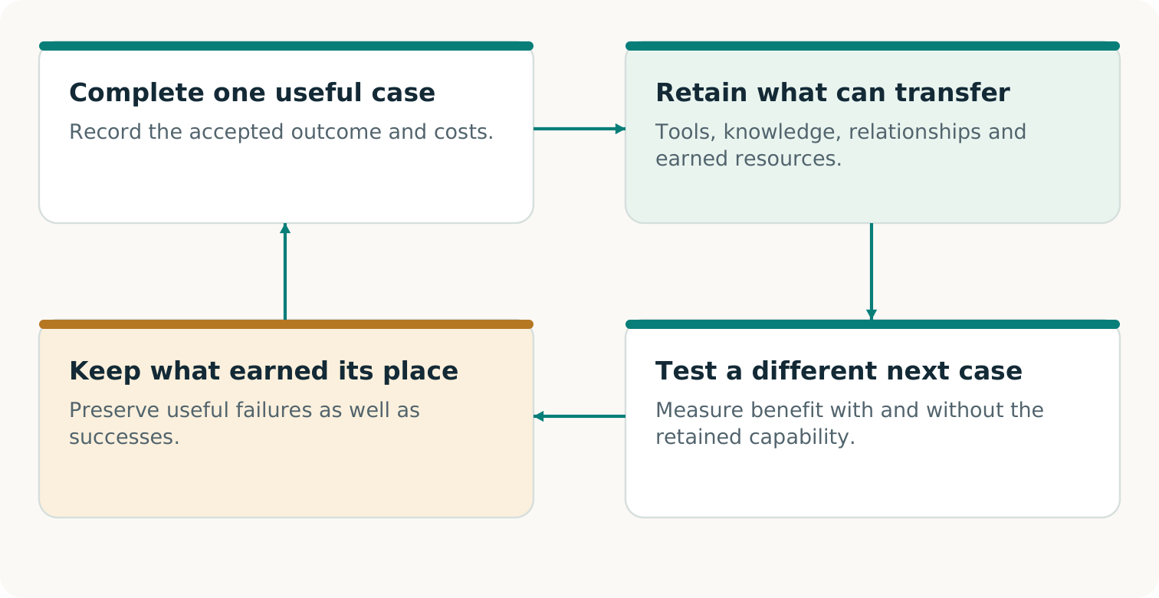
A proposed learning cycle: retain a qualified capability, test its contribution to different fresh work and use the observed result to improve the next decision.
ALPHA GENESIS FLYWHEEL Ω asks whether today’s validated construction improves what can be built next. Three gains need separate evidence: earnings fund continuation; inherited means help a new task; an improved discovery procedure performs better across fresh campaigns. [F3, pp. 3, 8, 20]
A POSSIBLE NEXT OPPORTUNITY
Qualified providers could offer maintained, non-conflicting continuity slots to smaller businesses. That is a hypothesis to construct and test, not a market established by this guide. [C1, p. 21]

FROM UNDERSTANDING TO A USEFUL FIRST EXERCISE

Begin with one promise worth preserving
The right starting point is a consequential commitment with a clear acceptance decision. It is small enough to investigate responsibly and important enough that preserving it would matter. The printer case supplies a way to reason; your actual promise supplies the requirements.
1. Name the outcome. What must reach whom, at what quality, by when, and who can accept it? Include the records and permissions that make those terms authoritative.
2. Find the real obstacle. Compare the strongest available complete routes. Determine whether the blocker is information, technical compatibility, capacity, consent, funding or a combination.
3. Choose a decisive observation. Identify the test that could change the decision. Agree its scope, resources and safe operating boundary before carrying it out. [C1, pp. 19⁠-⁠20]

Keep the choice open
Use an existing service when it provides the better complete result. Construct a missing capability when its prospective value warrants the work. Stop or revise when evidence or economics do not support the next step. A useful method must recognize all three possibilities.
WHAT SUCCESS SHOULD LEAVE BEHIND
An accepted result - or a clearly established obstruction - plus evidence that makes the next decision easier. When a capability is retained, include where it works, what it costs and what would invalidate it.

Continue with the working volumes
Volume 03 develops the pilot around the same fictional order. Volume 04 supplies editable records for the actual promise, participants, capacity, evidence and economics. Volume 05 shows which project claims have support at its stated source revision and which need additional observation.
The ambition is concrete: make an important activity possible through a workable arrangement, demonstrate its value, and retain what helps a different promise next. [C1, pp. 21⁠-⁠23]

Sources and edition
Source IDs refer to the following records. Paper page references use PDF page numbers. Supplied papers are preserved unchanged in the complete archive.
C1 Vincent Boucher. CONTINUITY Ω. Research edition 1.1.1. 6 November 2026.
F1 Vincent Boucher. Transformational Intelligence. Learning to Change the Game. October 2026.
F2 Vincent Boucher. Invent the Economy. Transformational Intelligence for Creating Viable Markets. October 2026.
F3 Vincent Boucher. ALPHA GENESIS FLYWHEEL Ω. Research edition 2.0. 4 November 2026.
R1 Repository overview. Exact source
R3 Executed qualification results. Exact source

Edition record
Reader and practitioner collection 2. Prepared for Vincent Boucher, MONTREAL.AI / QUEBEC.AI. 7 November 2026.
Public main revision: 396227d8da2f55f674f479de16089c7ce28ef290. View revision
This is an editorial edition. Results remain attributed to their source executions; no new operational experiment or external certification is reported here. The separately labeled review branch remains unmerged at the recorded observation.

