MONTREAL.AI / QUEBEC.AI

CONTINUITY Ω
  - Your pilot workbook
Turn assumptions into agreements, observations and decisions
Edition 2 / Volume 04 / 7 November 2026
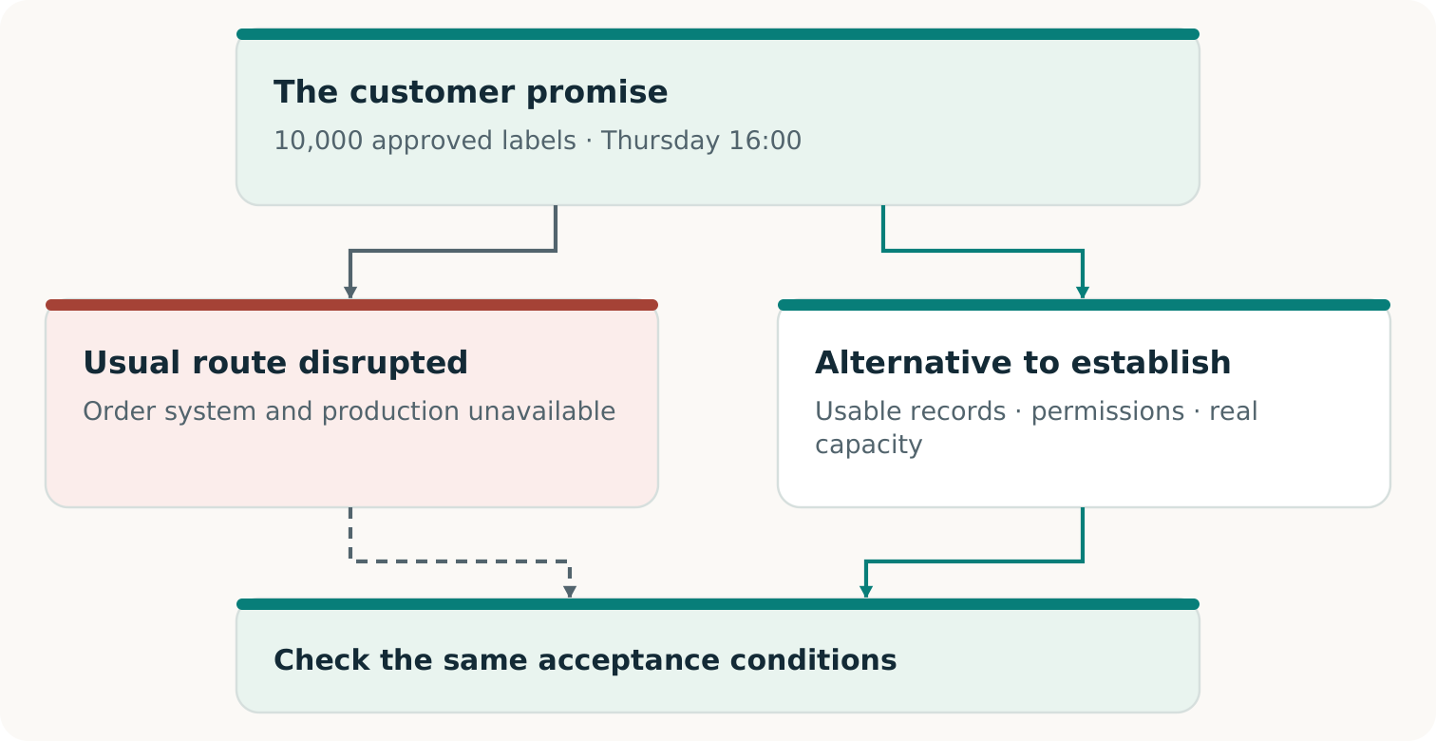
Fictional teaching example
For pilot owners, providers, customers and reviewers

HOW TO USE THIS WORKBOOK

Give the next decision somewhere to live
Use one workbook for one customer promise and one exercise. Fill what is known, name what is missing and link the evidence. An empty field means unknown or unentered. It never means zero cost, consent or success. These working records do not themselves create permission, reservations or certification. [C1, pp. 7⁠-⁠8, 13⁠-⁠14]
Prepare · A–D  Freeze the promise; agree who contributes what; qualify capacity and sources. | Fund and run · E–G  Price the whole service, resolve cash timing and record the authorized operation. | Decide and reuse · H–I  Issue a bounded Passport; preserve changes and test a distinct next opportunity.

ILLUSTRATIVE CASE — NEVER A PREFILLED ANSWER
Examples follow a fictional printer owing 10,000 approved labels, artwork v3, by Thursday 16:00, America/Toronto. All case records, capacity and financial figures are invented. Your real dates, approvals, prices and results belong only in the blank response areas.

Identify this workbook
Pilot ID; owner; version; preparation date; secure location of the evidence index.

Use stable evidence IDs, such as ORDER-01 or RESERVATION-01, for documents held in their authorized location. Duplicate a block when needed. Keep prior versions, failed attempts and the original promise. Do not upload confidential source records to a public repository. [R6]

COMPLETE WITH THE PROMISE OWNER AND ACCEPTANCE AUTHORITY

A · The promise card
ILLUSTRATIVE ENTRY
10,000 approved labels; artwork v3; accepted by Thursday 16:00, America/Toronto, at the agreed customer site. A real entry must add the calendar date, specification and authorized acceptance person.

Whose promise is this?
Commitment ID/version; buyer; beneficiary; responsible owner; source agreement and approval evidence.

What must the customer receive?
Copy the actual output, specification/version, quantity, quality, tolerances and any permitted partial delivery.

Exactly when and where?
Date, time zone, activation event, working calendar, cutoff, receipt/acceptance deadline and destination.

What disruption and interventions are permitted?
Unavailable dependencies; exercise type; allowed actions/data; degradation limits; exclusions; stop authority.

Who will accept, and against what evidence?
Named authority; inspection and measurements; pass/fail rules; missing-evidence policy; actual goods or expressly agreed substitute.

Before proceeding, obtain the actual approval references. Changing these conditions creates a new version; it does not change the verdict on the earlier promise. [C1, pp. 7⁠-⁠8; R6]

MAKE THE CONTRIBUTION, COUNTERPART AND DECISION EXPLICIT

B · The arrangement people will accept
The buyer printer purchases the continuity service; its end customer receives the original order. List the commitments that make this exchange usable. Combine roles only with their relationships disclosed. [C1, p. 17]
Participant | Contribution and return | Person / evidence ID
Buyer printer
Alternate provider
End customer
Coordinator
Reviewer

READ THE EVIDENCE CORRECTLY
Interest is not an accepted offer. Accepted terms need an authorized commitment record. A reservation needs a current provider acknowledgement and usable capacity. Collected payment needs cleared-money evidence. Payment for preparation supports only that purchased stage. [C1, pp. 7⁠-⁠8, 13]

What exactly does the buyer purchase?
Preparation, reservation, activation or a defined combination; price/scope; exclusions; best complete alternative and actual decision.

What has each party actually accepted?
Person with authority; contribution/return; pending, accepted, refused or withdrawn; evidence/date; expiry and conditions. Attach one record per party.

What may be shared or activated?
Permitted fields, recipients, location, rights, retention, withdrawal; activation and stop contacts; reachable authenticated channel.

CAPACITY MUST WORK WHEN PROMISES ACTIVATE TOGETHER

C · The real slot and its dependencies
ILLUSTRATIVE CALCULATION
12,000 usable units − 2,000 already protected = 10,000 available. The order fits; another simultaneous 5,000 does not. Materials, setup, quality, people and transport must fit too.

Resource / window | Usable units | Protected units | New concurrent units | Evidence

What is genuinely reserved?
Provider, product, units, time window, acknowledgement, activation terms, expiry, cancellation/refund conditions and evidence ID.

What proves the complete route is usable?
Qualified specifications/process; materials and staff; setup-to-delivery schedule; rights and release authority; evidence.

Which failure could disable both routes?
Shared login, supplier, site, approver, machine or carrier; tested substitute; remaining common dependency.

Which competing claims remain outside this view?
Reservation-book boundary; simultaneous requests and other customers; unavailable information; responsible owner and next check.

Check each limiting resource and interval. A local calculation cannot establish undisclosed bookings or replace a provider’s commitment. Keep unqualified capacity visible as a gap. [C1, pp. 11⁠-⁠13; R6]

MAKE THE IMPORTANT DISCREPANCY INSPECTABLE

D · Evidence that survives the outage
ILLUSTRATIVE QUESTION
The restored order says 8,000. An accepted amendment adds 2,000. Where did that amendment come from, who protected it and how do we know which later events are included? A matching hash alone cannot answer those questions.

Source / version | Custody, origin and location | Cutoff, coverage and gap

What could change whether the promise is kept?
Challenge ID; original claim; alleged omission; affected acceptance condition; reviewer and date.

What observation would settle the issue?
Source IDs; authorized check or replay; expected/observed difference; evidence location; positive control.

What was decided and repaired?
Supported, rejected or unresolved; decision-maker and reason; authorized repair; version rechecked; residual gap and cost.

Duplicate the challenge block for missing orders, stale amendments, cancellations, duplicates, booking conflicts or other material issues. Challenge the checker too. Preserve failed attempts. If decisive source evidence is unavailable, record NOT ESTABLISHED rather than manufacturing certainty. [C1, pp. 9⁠-⁠10, 14⁠-⁠16; R6]

ALLOCATE EVERY RESOURCE ONCE; LEAVE UNKNOWN COSTS VISIBLE

E · Price the complete service
ILLUSTRATIVE ECONOMICS
Separate continuity-service charge: CAD 5,600. Modeled complete cost: CAD 5,000. Difference: CAD 600, conditional on invented inputs. The original-order invoice is excluded. This is not observed demand or realized profit.

Whose costs, over which period?
Entity, promise/version, currency, horizon, internal-time valuation and shared-cost allocation; distinguish actual, estimated and unknown.

Cost group | Amount / status | Evidence / due date
Acquisition, preparation, staff and failed offers
Data, rights, AI and technical setup
Capacity reservation and opportunity-cost treatment
Materials, production and quality control
Transport, acceptance and separate verification
Rehearsals, retries and requalification
Support, financing, insurance and legal duties
Refunds, remaining duties, taxes and other items
Total, with estimates and gaps identified

What price and buying decision are supported?
Proposed versus accepted price; best complete alternative; buyer burden; measured costs and remaining uncertainty; collected receipts kept separate.

A contingency estimate is not a liability cap. Do not omit failures or count the same resource twice. Transfer due dates and protected obligations to F. [C1, pp. 17⁠-⁠19; R6]

CHECK THE CASH BEFORE THE DECISION BECOMES AN OBLIGATION

F · Fund the next commitment
ILLUSTRATIVE STOP DECISION
Available after protected obligations: CAD 1,200. Due before customer acceptance: CAD 4,700. Payment proposed afterwards. Gap: CAD 3,500. Do not reserve or activate on this plan; obtain a funded arrangement without changing the customer promise.

What money is actually available?
Entity, currency, opening cash, protected obligations, restricted funds and authorized account evidence. Mark this sheet proposed or actual.

Stage / date | Cleared inflows | Paid outflows | Reserve required | Available cash
Preparation
Reservation
Production / checks
Acceptance / collection
Aftercare / remaining duties

Available cash = opening cash + cumulative cleared inflows − cumulative paid outflows − funds still protected. Keep one boundary; remove paid duties from the unpaid reserve. Forecast receipts are never actual collections. [C1, pp. 18⁠-⁠19]
What becomes due if something goes wrong?
Reservation/prepayment deadlines; delayed buyer payment; refund, rework or withdrawal duties; named funding source and evidence.

Which revision makes the next step fundable?
Accepted milestone terms, authorized working capital or a cheaper complete route; deposit restrictions; decision-maker, date and evidence. Preserve the failed plan.

ONE RECORD OF ACTIONS, HANDOFFS AND INTERVENTIONS

G · The actual run sheet
Use this only for the authorized scope. A production rehearsal can deliver actual goods; a tabletop or substitute exercise supports only what it performs. Preserve the original clock and record unplanned help. [R6]
What is authorized to start?
Promise/version, approvals, source cutoff, resources, start time, unavailable dependencies, stop authority and contact channel.

Handoff | Planned owner / evidence | Actual time / result / issue
Release current package
Confirm reserved inputs
Produce and inspect
Transport and receive
Accept or reject

What comparison was actually performed?
Strong complete alternative; matched promise/resources; quoted versus executed candidates; method, measurements, all human effort and costs. Mark unrun cases NOT RUN.

What happened outside the planned route?
Rescue by primary systems or people, deviations, defects, refusals, stops and repairs; affected claim; decision and evidence.

ACCEPTANCE IS A SEPARATE EVENT
The named authority records actual receipt, specification, count, quality and acceptance time. Dispatch or a software pass is insufficient. If the original plant rescues delivery, record the successful order and the failed independence claim separately. [C1, pp. 8, 20]

TELL THE NEXT READER EXACTLY WHAT WAS ESTABLISHED

H · The Continuity Passport
ILLUSTRATIVE PASSPORT AT THE FUNDING GATE
Fictional record: 10,000 labels; CAD 3,500 funding gap; no physical run. Customer outcome and market evidence: NOT ESTABLISHED. Next: qualify a funded arrangement.

Claim | Verdict | Evidence / limit
Record reconciliation
Fallback readiness
Agreed outcome accepted
Whole-service feasibility
Commercial evidence

Use DEMONSTRATED, FAILED or NOT ESTABLISHED for each scoped claim. Substitutes support only their agreed rehearsal claim. Actual delivery requires actual goods received and accepted. Preparation payment establishes only that purchase; invoicing is not collection. [C1, pp. 7⁠-⁠8, 13⁠-⁠14]
What did the customer actually accept?
For actual delivery: goods, specification, quantity, quality, receipt/acceptance times, named authority and authenticated proof. Identify any substitute exercise result separately.

Who checked, with which independence?
Checker and method; source custody; execution control; organizational/commercial relationships; assumptions and unclosed gaps.

Where does this Passport apply, and until when?
Promise/version, disruption, facility/window, exclusions, financial records E-F, remaining owners/duties, expiry, recheck triggers and current-status location.

HISTORY STAYS INTACT; EACH NEW CLAIM EARNS ITS EVIDENCE

I · Test a different next use
Keep the earlier promise, verdict and evidence. Record changes to specifications, authority, capacity, sources or acceptance. Historical evidence stays historical even when its present applicability expires. [C1, pp. 13⁠-⁠14]
Change / old → new version | Affected claim | Owner / approval / recheck

Which different promise could become possible?
New beneficiary/problem and accepted-result target. Explain the difference from selling substantially the same service again.

What capability is worth retaining?
Artifact/method ID; contribution; rights, prerequisites, failures, changed conditions and requalification costs.

Which funds remain available after prior obligations?
Collected unrestricted earnings, reserves, residual duties, successor costs/dates and authorized funding evidence.

How will its contribution be tested?
Strongest complete route without the retained capability; equivalent starting resources/content; predeclared outcome/cost measures; result or NOT RUN; owner and next decision.

CHOOSE THE RIGHT NEXT CLAIM
A second sale tests repeat demand. A distinct task improved by the retained capability tests successor enablement. Improving discovery itself requires fresh independently selected campaigns and equally equipped strong alternatives. [C1, p. 21]

Sources and edition
Source IDs refer to the following records. Paper page references use PDF page numbers. Supplied papers are preserved unchanged in the complete archive.
C1 Vincent Boucher. CONTINUITY Ω. Research edition 1.1.1. 6 November 2026.
R6 Proposed real pilot. Exact source

Edition record
Reader and practitioner collection 2. Prepared for Vincent Boucher, MONTREAL.AI / QUEBEC.AI. 7 November 2026.
Public main revision: 396227d8da2f55f674f479de16089c7ce28ef290. View revision
This is an editorial edition. Results remain attributed to their source executions; no new operational experiment or external certification is reported here. The separately labeled review branch remains unmerged at the recorded observation.

