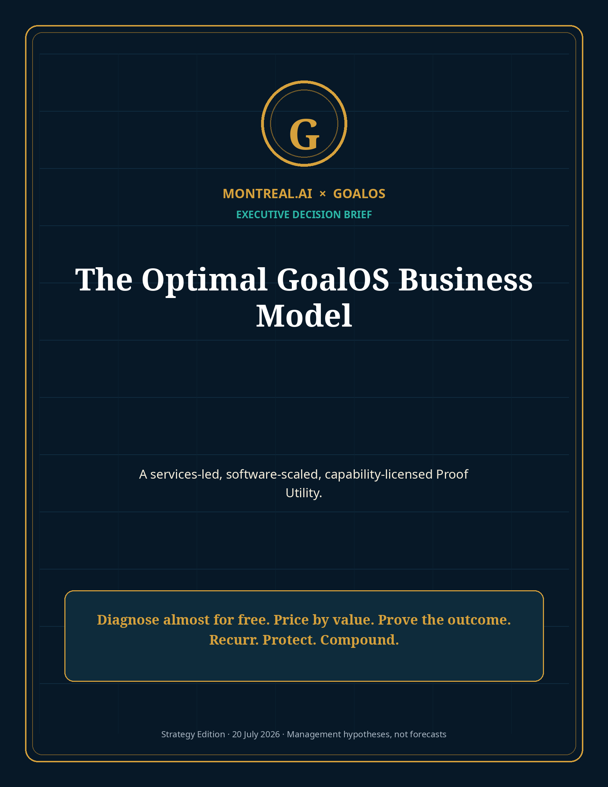

Executive decision
Deploy GoalOS as a services-led, software-scaled, capability-licensed Proof Utility.
The optimal business model is not to sell cheap AI output. It is to diagnose consequential decisions at near-zero marginal cost, price according to value at stake, execute one bounded Proof Mission, convert accepted outcomes into recurring Proof Offices, and charge repeatedly for governed invocation of private validated capability.

GoalOS should begin with a narrow enterprise wedge: organizations making expensive AI deployment, procurement, investment, revenue or compliance decisions that cannot yet be supported by decision-grade evidence. The first product is a fixed, self-service Proof Mission Activation. The platform and network emerge from paid delivery—not before it.
ACTIVATION | MISSION | OFFICE | COMPLETE CUSTOMER GM | ILLUSTRATIVE ROI
$15K | $75K | $216K / yr | 80.4% | 262.5%

The business model in one view
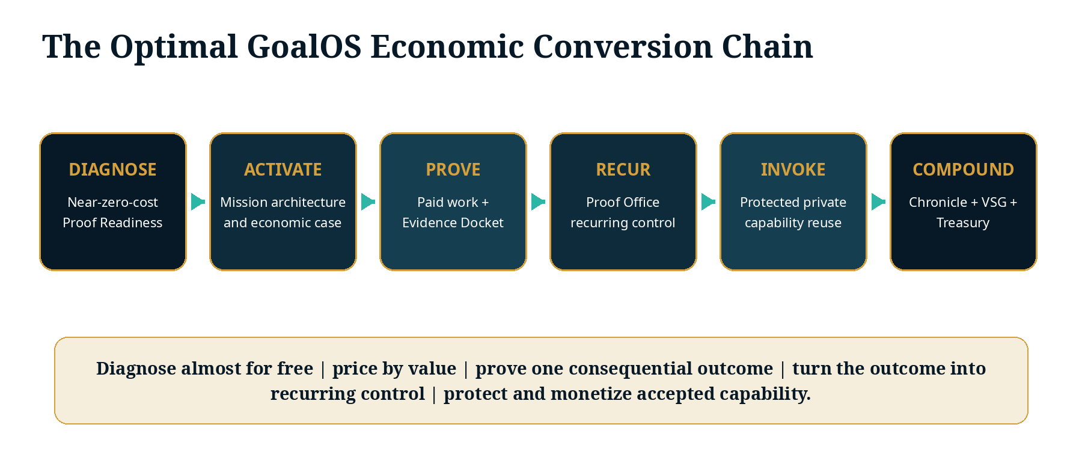
Stage | What the customer buys | Commercial role | Target economics
Proof Readiness Scan | Initial Proof Debt and value-at-stake diagnosis | Acquisition and qualification | Free–$495; negligible marginal cost
Proof Mission Activation | Mission Contract, claims matrix, evidence plan, ROI case | Highest-margin paid front door | $15K; 93–98% GM hypothesis
GoalOS Proof Mission | Executed work, Evidence Docket, review, governed decision | Creates customer value and capability | $50K–$150K; 70–80% GM
GoalOS Proof Office | Continuous evidence, Chronicle, monitoring, board reporting | Recurring enterprise relationship | $15K–$50K/month; 75–90% GM
Protected Capability Invocation | Authorized use of private Chronicle-admitted capability | Software-scale usage revenue | 90%+ mature GM
AGI Jobs / Validator Network | Bounded execution and independent validation | Network and settlement economics | 10–20% take-rate architecture

Who should buy first
The initial ideal customer is an AI vendor or enterprise AI team with a consequential claim, deployment, procurement path or contract worth at least $250,000—where insufficient evidence is delaying revenue, approval, deployment or capital.
- Executive sponsor with authority, budget and a decision deadline.
- Conservative value at stake at least four times the first-year GoalOS fee.
- Digital inputs that can be securely provided and explicit acceptance criteria.
- A recurring evidence, governance, monitoring or commercial need after the first mission.
- Rights that allow at least customer-private capability retention; network learning is priced separately.

Illustrative complete-customer economics
Revenue component | Revenue | Direct cost | Gross profit
Proof Mission Activation | $15,000 | $500 | $14,500
Proof Mission | $75,000 | $18,750 | $56,250
Proof Office - 12 months | $216,000 | $43,200 | $172,800
Protected invocation / validation | $25,000 | $2,500 | $22,500
Total first-year relationship | $331,000 | $64,950 | $266,050

Illustrative GoalOS gross margin: 80.4%. If the customer realizes $1.2M of conservatively attributable value, illustrative customer ROI is approximately 262.5%. These figures are management hypotheses and must be validated through paid missions.

The autonomous commercial standard lane
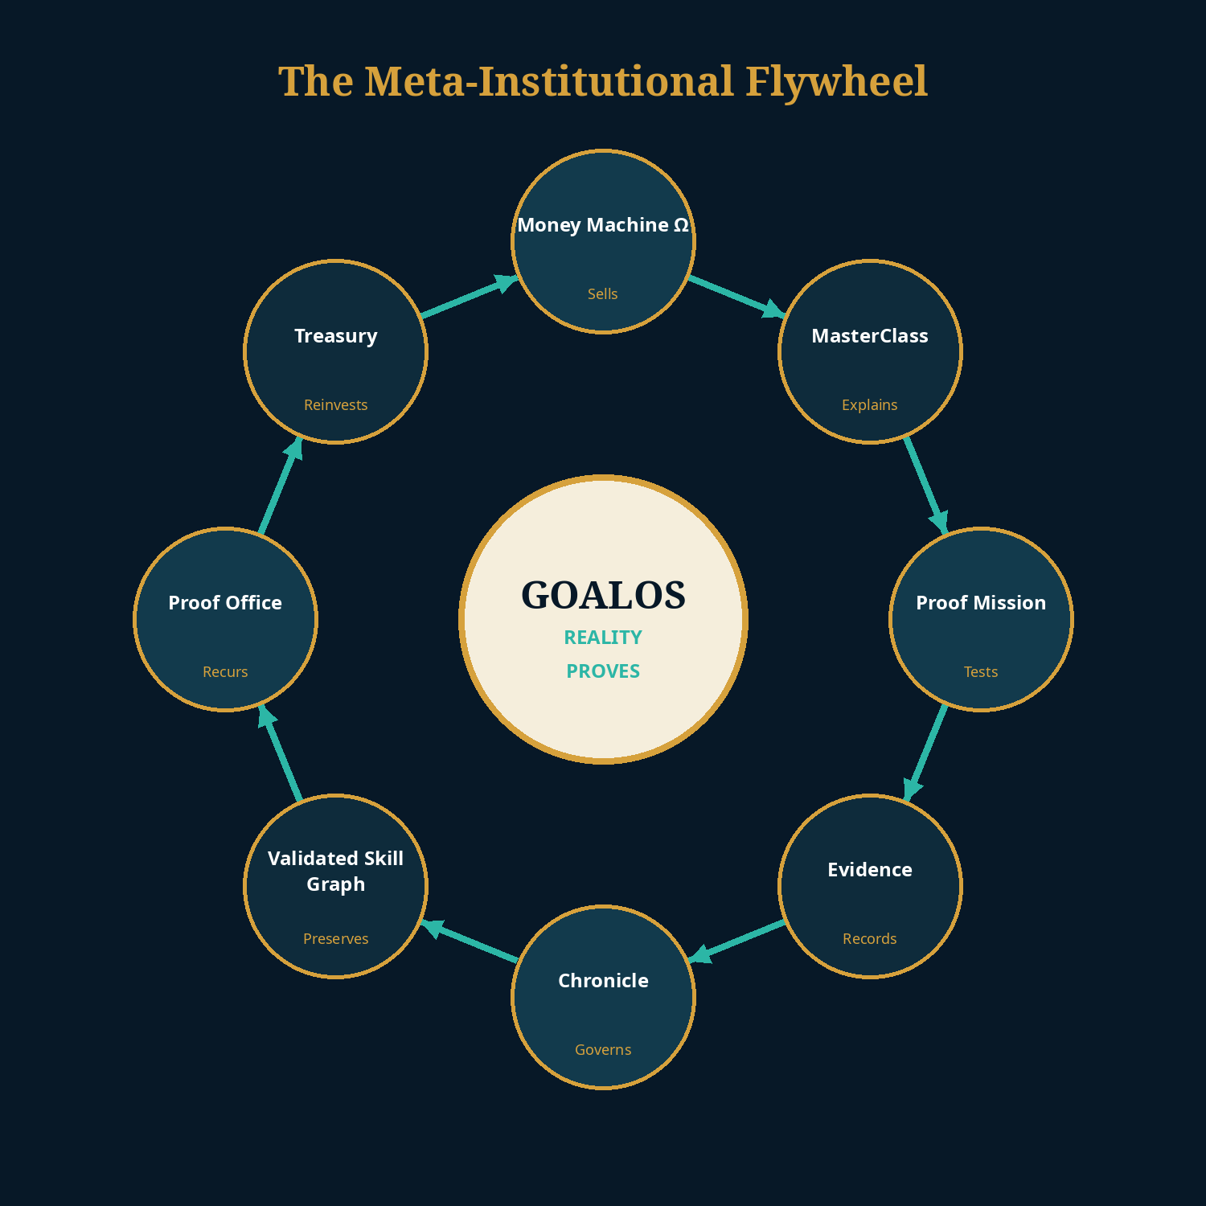
A standard customer should be able to diagnose, qualify, inspect, purchase, sign, pay, onboard, receive the mission, activate the Proof Office and renew without a MONTREAL.AI salesperson. Humans remain constitutional authorities for policy, exception risk, major claims, legal boundaries and emergency recovery—not routine transaction operators.
Commercial autonomy standard: zero seller-side minutes for the standard lane; 100% evidence-backed claims; zero pricing below margin floor; zero unpriced scope; zero renewal without verified continuing value.

90-day mandate
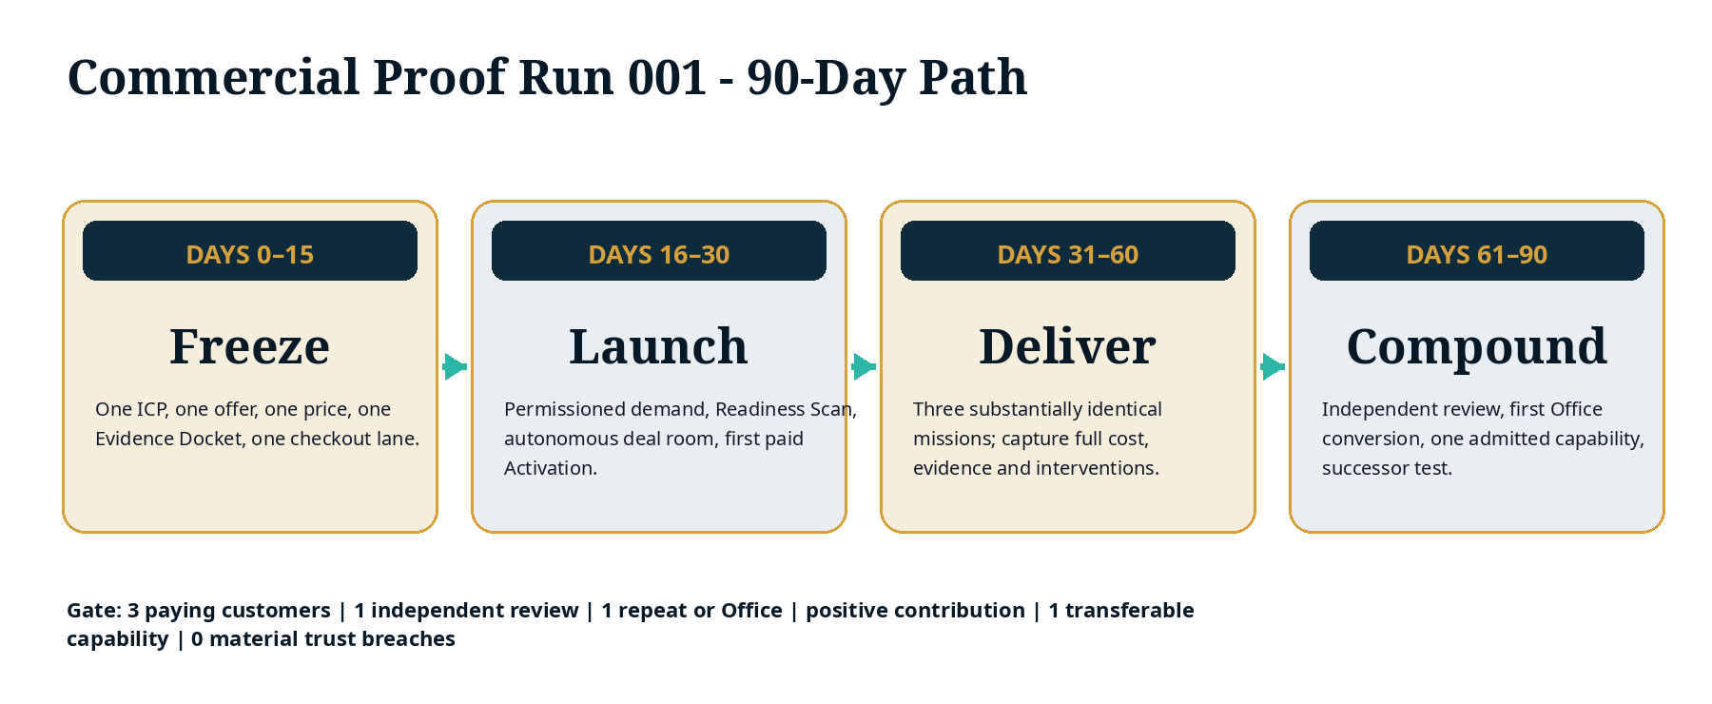
Gate | 90-day target
Paying customers | 3 unrelated customers purchasing substantially identical missions
Delivery | 3 complete Evidence Dockets and governed decisions
Independent authority | At least 1 externally reviewed result
Recurrence | At least 1 repeat purchase, expansion or Proof Office
Economics | Positive attributable contribution; all founder hours costed
Capability | At least 1 rights-cleared Chronicle-admitted skill
Improvement | A fresh successor mission improves a preregistered metric
Trust | 0 material trust, privacy or authorization breaches

Board authorization requested
1. Authorize a $250,000 90-day Commercial Proof Run envelope, released through explicit evidence gates.
2. Freeze one ICP, one Proof Mission Activation, one Proof Mission, one Evidence Docket, one price and one repeat-purchase path.
3. Require 100% prepayment for Activation; milestone billing for Missions; annual prepayment preferred for Offices.
4. Separate execution from material validation and Chronicle admission.
5. Protect the private capability implementation; sell governed invocation and proof-backed outcomes.
6. Stop broad platform expansion until payment, delivery, repeat purchase and fresh-transfer evidence exist.

Selected sources and claim boundary
External sources support market timing, technical feasibility, pricing context and comparative benchmarks. All GoalOS prices, volumes, margins, ROI, financing and valuation paths are editable management hypotheses—not audited forecasts, realized results, legal advice, investment advice, security certification or guarantees. Full URLs and source-use notes are provided in the package Source Register.
S1 · OpenAI · Introducing workspace agents in ChatGPT.
S2 · OpenAI · ChatGPT Enterprise and Edu release notes.
S3 · OpenAI · API pricing.
S4 · METR · Task-Completion Time Horizons.
S5 · Google DeepMind · AlphaEvolve.
S6 · Gartner · Worldwide AI spending forecast for 2026.
S7 · European Commission · Article 50 AI Act transparency obligations.
S8 · SaaS Capital · 2026 B2B SaaS benchmarks.
S9 · Stripe · Payment Links.
S10 · MONTREAL.AI Research · Merkle Roots for the Validated Skill Graph.
S11 · MONTREAL.AI Research · Private On-Chain Validated Skill Graph.

