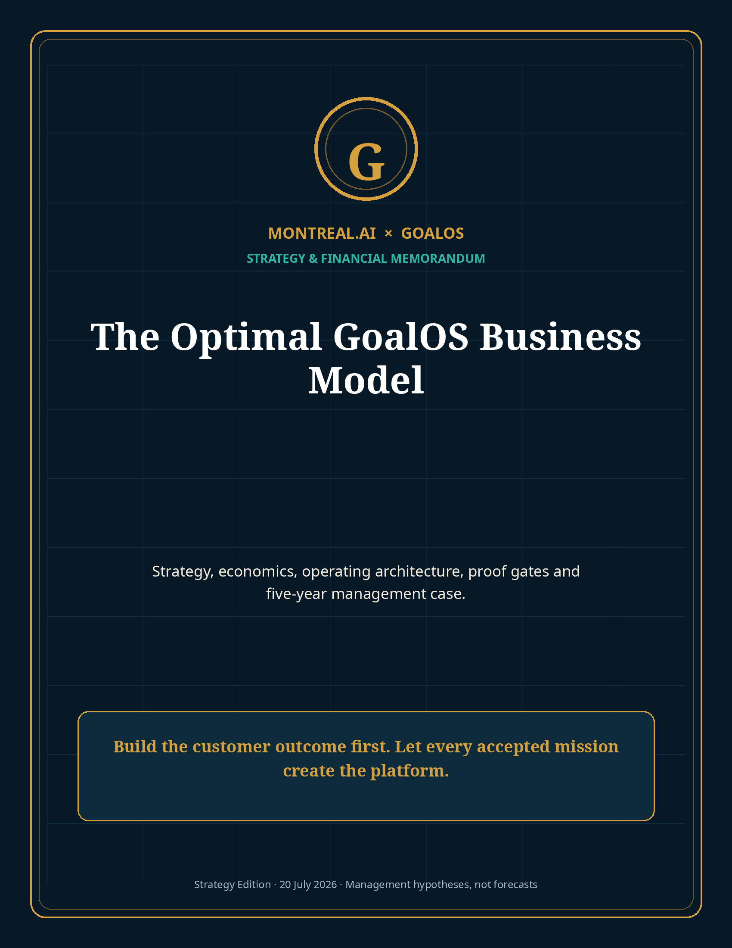

Memorandum
To | From | Date | Subject
MONTREAL.AI Board, leadership and strategic partners | GoalOS Strategy Office | 20 July 2026 | The Optimal GoalOS Business Model

1. Executive summary
GoalOS should operate as a Proof Utility: a vertically integrated institution that converts expensive uncertainty into bounded missions, inspectable evidence, governed decisions, recurring institutional control and protected reusable capability.
The temporary arbitrage is the Capability–Price Lag. The enduring company is the private, rights-cleared network of capabilities that repeatedly produced verified outcomes—and can be invoked without surrendering the implementation.

The optimal starting offer is a near-zero-marginal-cost Proof Mission Activation priced by the decision value it structures. The Activation expands into a paid Proof Mission, then a recurring Proof Office. Successful mission methods become candidate skills; Chronicle admits only what passed; the Validated Skill Graph preserves scope, evidence, rights, versions, failure history and transfer performance; protected invocation creates software-like margins.
FY1 REVENUE | FY3 REVENUE | FY5 REVENUE | FY5 EBITDA | FY5 RECURRING + USAGE
$1.4M | $16.6M | $94.2M | $45.1M | 87%

2. The economic dislocation: the Capability–Price Lag
AI has repriced cognitive production faster than organizations have repriced cognitive work. Candidate research, analysis, plans, proposals, presentations, code and documentation can now be produced dramatically faster and at extremely low inference cost. Yet enterprises still pay for trust, context, authority, integration, liability, evidence and outcomes. [S1–S6]
Old Mode | Early AI Mode | GoalOS Mode
Human labor, meetings and static deliverables | Cheap and persuasive candidate output | Verified outcome plus a system that keeps the outcome current
Pricing tracks hours and team size | Pricing collapses toward generation cost | Pricing tracks conservative value at stake and risk retired
Knowledge disappears into documents | Output is abundant but ungoverned | Accepted capability becomes scoped, versioned and reusable
One-off engagement | Commodity generation | Recurring Proof Office and protected capability invocation

The business must not sell a one-dollar AI artifact for two dollars. It should sell a bounded decision or institutional function whose economic value remains large—while retaining very high gross margins because most production is standardized and autonomous.

3. The initial wedge and ideal customer
The recommended beachhead is AI Trust & Revenue: organizations with an important AI deployment, vendor claim, enterprise contract, procurement path, investment or compliance burden whose progress is blocked by insufficient proof.
Qualification dimension | Required state
Consequence | At least $250K of contract, deployment, capital or risk value at stake
Authority | Named sponsor with budget and decision rights
Timing | Decision deadline within 90 days
Evidence | Digital inputs can be securely supplied; acceptance criteria can be frozen
Economics | Conservative value pool normally at least 4× first-year fee
Recurrence | Ongoing monitoring, claim freshness, governance, RFP, audit or capability need
Rights | Explicit mission-only, customer-private, network-admissible or sector-exclusive treatment

4. The product and revenue architecture
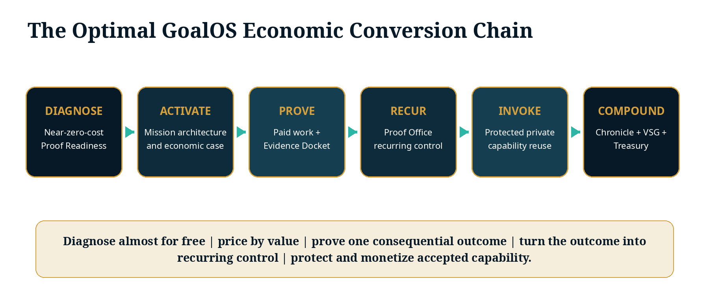
Product | Customer outcome | Initial pricing hypothesis | Strategic function
Proof Readiness Scan | Initial diagnosis, Proof Debt and value-at-stake estimate | Free–$495 | Acquisition and self-selection
Proof Mission Activation | Mission Contract, claims matrix, evidence plan, ROI case | $15,000 | Near-zero-cost paid front door
GoalOS Proof Mission | Executed, reviewed and decision-grade outcome | $50,000–$150,000 | Customer proof and capability creation
GoalOS Proof Office | Continuing evidence, governance, Chronicle and executive control | $15,000–$50,000/month | Recurring enterprise relationship
Private Enterprise Network | Dedicated integrations, protected runtime, private graph and managed review | $250,000–$1M+/year | Platform-scale revenue and switching costs
Protected Capability Invocation | Governed reuse of private Chronicle-admitted capability | Usage based | 90%+ mature gross margin
AGI Jobs / Validator Network | Bounded work and independent review coordination | 10–20% network fee | Transaction and ecosystem economics

5. Pricing doctrine
GoalOS should calculate two prices and use the higher one:
Value-based price = 5–15% of conservative attributable customer value. Margin-floor price = expected variable cost ÷ (1 − required gross margin).

Example: if a mission costs $18,750 to deliver and requires a 75% gross margin, the minimum price is $75,000. If the conservative value is $1M and the value-based target is 10%, the quoted price is $100,000—subject to scope, assurance and risk.
- No measurable value pool, no standard offer.
- No margin floor, no quote.
- No approved clause path, no contract.
- No collected payment, no capacity reservation.
- No frozen acceptance criteria, no execution.
- No verified continuing need, no renewal.

6. Unit economics and customer ROI
Complete first-year relationship | Revenue | Direct cost | Gross profit
Proof Mission Activation | $15,000 | $500 | $14,500
Proof Mission | $75,000 | $18,750 | $56,250
Proof Office | $216,000 | $43,200 | $172,800
Protected capability usage / validation | $25,000 | $2,500 | $22,500
Total | $331,000 | $64,950 | $266,050

Illustrative gross margin is 80.4%. At $1.2M of attributable customer value, illustrative customer ROI is 262.5%. GoalOS must separately track forecast value, independently supported value and realized cash value; projections may never be presented as outcomes.

7. The autonomous commercial institution
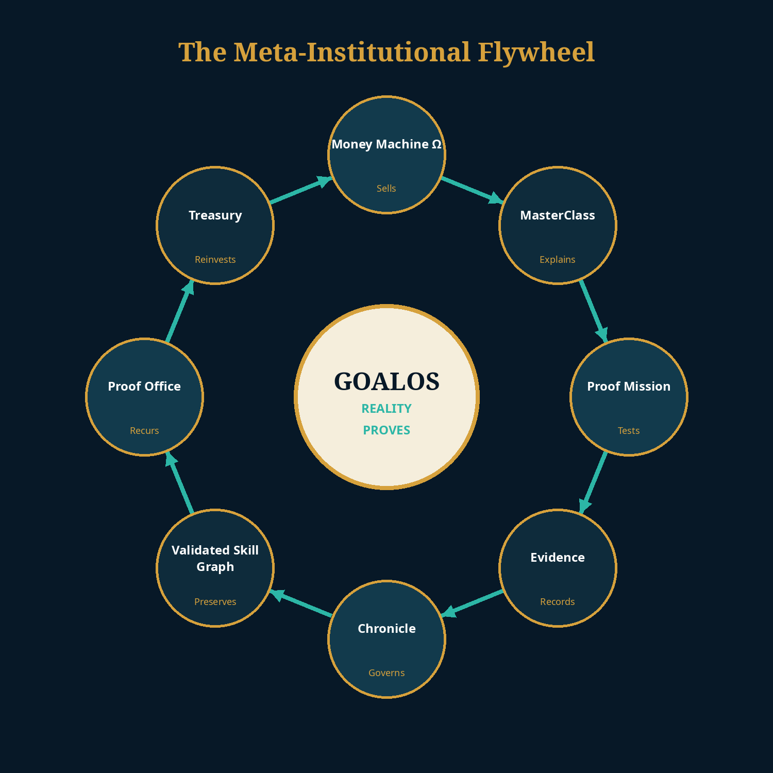
The standard commercial lane should remove seller-side human intervention. The customer still chooses, consents, signs, pays, supplies inputs and accepts or disputes the result. GoalOS operates inside a counsel-approved, security-reviewed commercial constitution.
Commercial state | Autonomous action | Hard gate
Intent detected | Permissioned demand and Readiness Scan | No provable permission, no outreach
Qualified | Validate sponsor, deadline, value, risk and data readiness | No consequential objective, no offer
Priced | Select fixed product, scope, assurance and delivery window | No margin floor, no quote
Contracted | Generate approved SOW, DPA, terms, payment and capacity reservation | Outside clause matrix → reprice, reduce or decline
Funded | Instantiate Mission Contract and Evidence Docket | No cleared payment, no execution
Delivered | Evidence, independent review and acceptance | No Docket, no value claim
Recurring | Activate Proof Office and evidence-based renewal | No verified need, no renewal
Improved | Test commercial methods on held-out cohorts | No positive contribution and retention, no skill admission

8. Proof Mission delivery system
1. Freeze the objective, scope, authority, budget, evidence standard, rights and rollback conditions.
2. Convert unsupported claims and uncertainty into a Proof Debt Register.
3. Decompose the mission into bounded AGI Jobs with workers, validators, budgets, tests and terminal states.
4. Capture sources, actions, costs, failures, retries, interventions and contradictions by construction.
5. Route material claims through deterministic tests, separated evaluators and customer acceptance.
6. Issue a governed decision: accept, condition, repair, reject, quarantine, supersede or stop.
7. Propose candidate skills only from accepted work; preserve no raw output as canonical capability.
8. Convert ongoing obligations and unresolved Proof Debt into the recurring Proof Office plan.

9. Chronicle, the Validated Skill Graph and protected invocation
The durable moat is not the model, prompt or graph database. It is the accumulated, rights-controlled history of customers, sponsors, missions, evidence, evaluators, failures, repairs, Chronicle decisions, successful reuse, renewals and economic performance. [S10–S11]
Only current direct GoalOS agent identities with valid, scoped, revocable entitlements may invoke Chronicle-admitted, root-verifiable private capabilities—and the implementation never has to leave MONTREAL.AI’s protected execution boundary.

Rights class | Learning / reuse right | Price treatment
Network-admissible | Anonymized, generalized capability may be admitted after proof and rights review | Base price
Customer-private | Reusable only for the originating customer | +25–50%
Sector-exclusive | Defined field or time-limited exclusivity | +100–300%
Mission-only | No capability extraction or reuse | Highest delivery price

10. Five-year management case
The workbook accompanying this memorandum is fully editable. The base case intentionally moves revenue from missions toward Proof Offices, private networks, protected invocation and network fees.
$ millions | FY1 | FY2 | FY3 | FY4 | FY5
Revenue | 1.4 | 5.8 | 16.6 | 40.6 | 94.2
Gross profit | 1.1 | 4.6 | 13.6 | 34.1 | 80.1
Gross margin | 79% | 80% | 82% | 84% | 85%
EBITDA | (1.3) | 0.1 | 4.9 | 15.6 | 45.1
Ending cash | 0.6 | 1.3 | 7.0 | 15.8 | 43.1
Recurring + usage mix | 38% | 56% | 72% | 81% | 87%

This is not a forecast. It is an explicit hypothesis whose assumptions must be updated from commercial receipts, actual costs, conversion, retention, independent-review burden and protected-invocation economics.
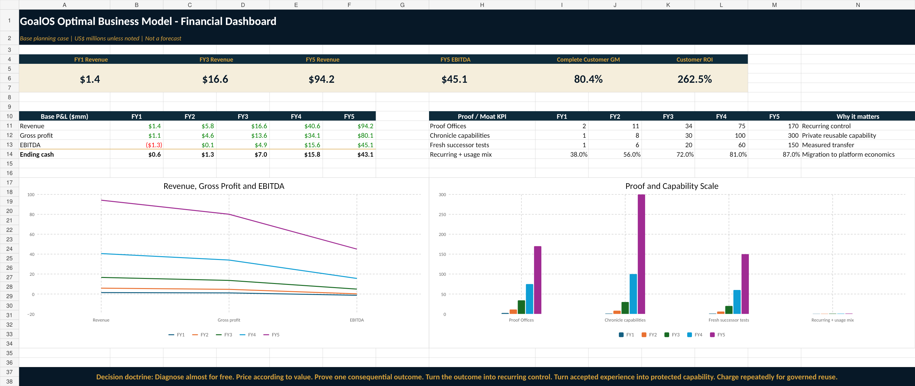

11. Capital plan and evidence gates
Gate | Capital use | Evidence required
Commercial Proof Run | $250K initial envelope | 3 paying customers; 1 reviewed outcome; 1 repeat; positive contribution; 1 capability
Productization | $0.75M–$1.5M cumulative | Repeatable lane; several Offices; declining founder hours; security plan
Enterprise platform | $3M–$5M cumulative | 10–20 customers; recurring contracts; private execution; transfer evidence
Network scale | Growth capital tied to adoption | External agents/evaluators; substantial usage; strong retention; category leadership
Productive infrastructure | Ring-fenced project / strategic finance | Verified free cash flow; independently measured capacity gain; explicit stop conditions

12. Go-to-market sequence
1. Use the Frontier MasterClass and founder distribution to create category understanding and permissioned demand.
2. Let the Proof Readiness Scan expose the buyer’s Proof Debt and value at stake before asking for a transaction.
3. Sell a fixed Activation with 100% prepayment and 24–72-hour delivery.
4. Convert qualified Activations into one standard Proof Mission with fixed scope and milestone billing.
5. Convert successful missions into annual Proof Offices with evidence-based renewal.
6. After repeated transfer, expose selected capabilities through protected invocation and private enterprise networks.
7. Only after network proof, open AGI Jobs, validator and entitlement economics more broadly.

13. Operating team and separation of powers
Role | Primary mandate
Founder / Category Architect | Category, capital, strategic partners and constitutional doctrine
Commercial Institution Lead | Autonomous demand, transaction, unit economics and expansion
CTO / Runtime Lead | Models, tools, environments, protected execution and integrations
Chief Evidence Officer | Evidence Dockets, evaluators, replay and outcome measurement
Security & Identity Lead | Entitlements, keys, isolation, root verification and incident response
Customer Mission Lead | Mission quality, acceptance, recurring conversion and rights
Independent Review Council | Separated authority for material claims, admission and falsification

14. Governing scorecard
Metric | Target gate
Conservative customer value / first-year fee | ≥4.0×
Activation gross margin | ≥95%
Proof Mission gross margin | 70–80%
Proof Office gross margin | ≥80%
Protected invocation gross margin | ≥90%
Mission-to-Office conversion | ≥40%
CAC payback | <6 months
Mature net revenue retention | ≥120% target
Unsupported material commercial claims | 0
Founder seller minutes / standard transaction | 0
Revenue powered by reused capability | ≥30% by Year 2 target
Successor promotion without fresh testing | 0

15. Falsification and stop conditions
- Fewer than three paid Activations from thirty highly qualified prospects: repair the wedge before broad build.
- Fewer than 30% of successful Proof Missions convert to continuing control: treat the business as services and redesign recurrence.
- Reused capabilities fail to improve cost, time, risk, evidence or reviewer burden by at least 15–20%: do not claim compounding capability.
- Human labor remains most of direct cost after repeated delivery: the process is not yet productized.
- The system cannot separate execution, evaluation and Chronicle authority: block high-consequence autonomy.
- A material privacy, evidence, authorization or trust breach occurs: pause expansion and enter incident Proof Mission.

16. Definitive recommendation
Diagnose almost for free. Price according to value. Prove one consequential outcome. Turn the outcome into recurring control. Turn accepted experience into protected capability. Charge repeatedly for governed reuse. Reinvest only verified free cash flow.

The first commercial atom is not a universal platform. It is one purchased mission architecture, one paid execution, one Evidence Docket, one independent review, one recurring relationship and one fresh mission that improves because an admitted capability exists. Repeat that sequence, and the business progresses from service to software, from software to protected capability network, and from network to institutional infrastructure.

Selected sources and claim boundary
External sources support market timing, technical feasibility, pricing context and comparative benchmarks. All GoalOS prices, volumes, margins, ROI, financing and valuation paths are editable management hypotheses—not audited forecasts, realized results, legal advice, investment advice, security certification or guarantees. Full URLs and source-use notes are provided in the package Source Register.
S1 · OpenAI · Introducing workspace agents in ChatGPT.
S2 · OpenAI · ChatGPT Enterprise and Edu release notes.
S3 · OpenAI · API pricing.
S4 · METR · Task-Completion Time Horizons.
S5 · Google DeepMind · AlphaEvolve.
S6 · Gartner · Worldwide AI spending forecast for 2026.
S7 · European Commission · Article 50 AI Act transparency obligations.
S8 · SaaS Capital · 2026 B2B SaaS benchmarks.
S9 · Stripe · Payment Links.
S10 · MONTREAL.AI Research · Merkle Roots for the Validated Skill Graph.
S11 · MONTREAL.AI Research · Private On-Chain Validated Skill Graph.

