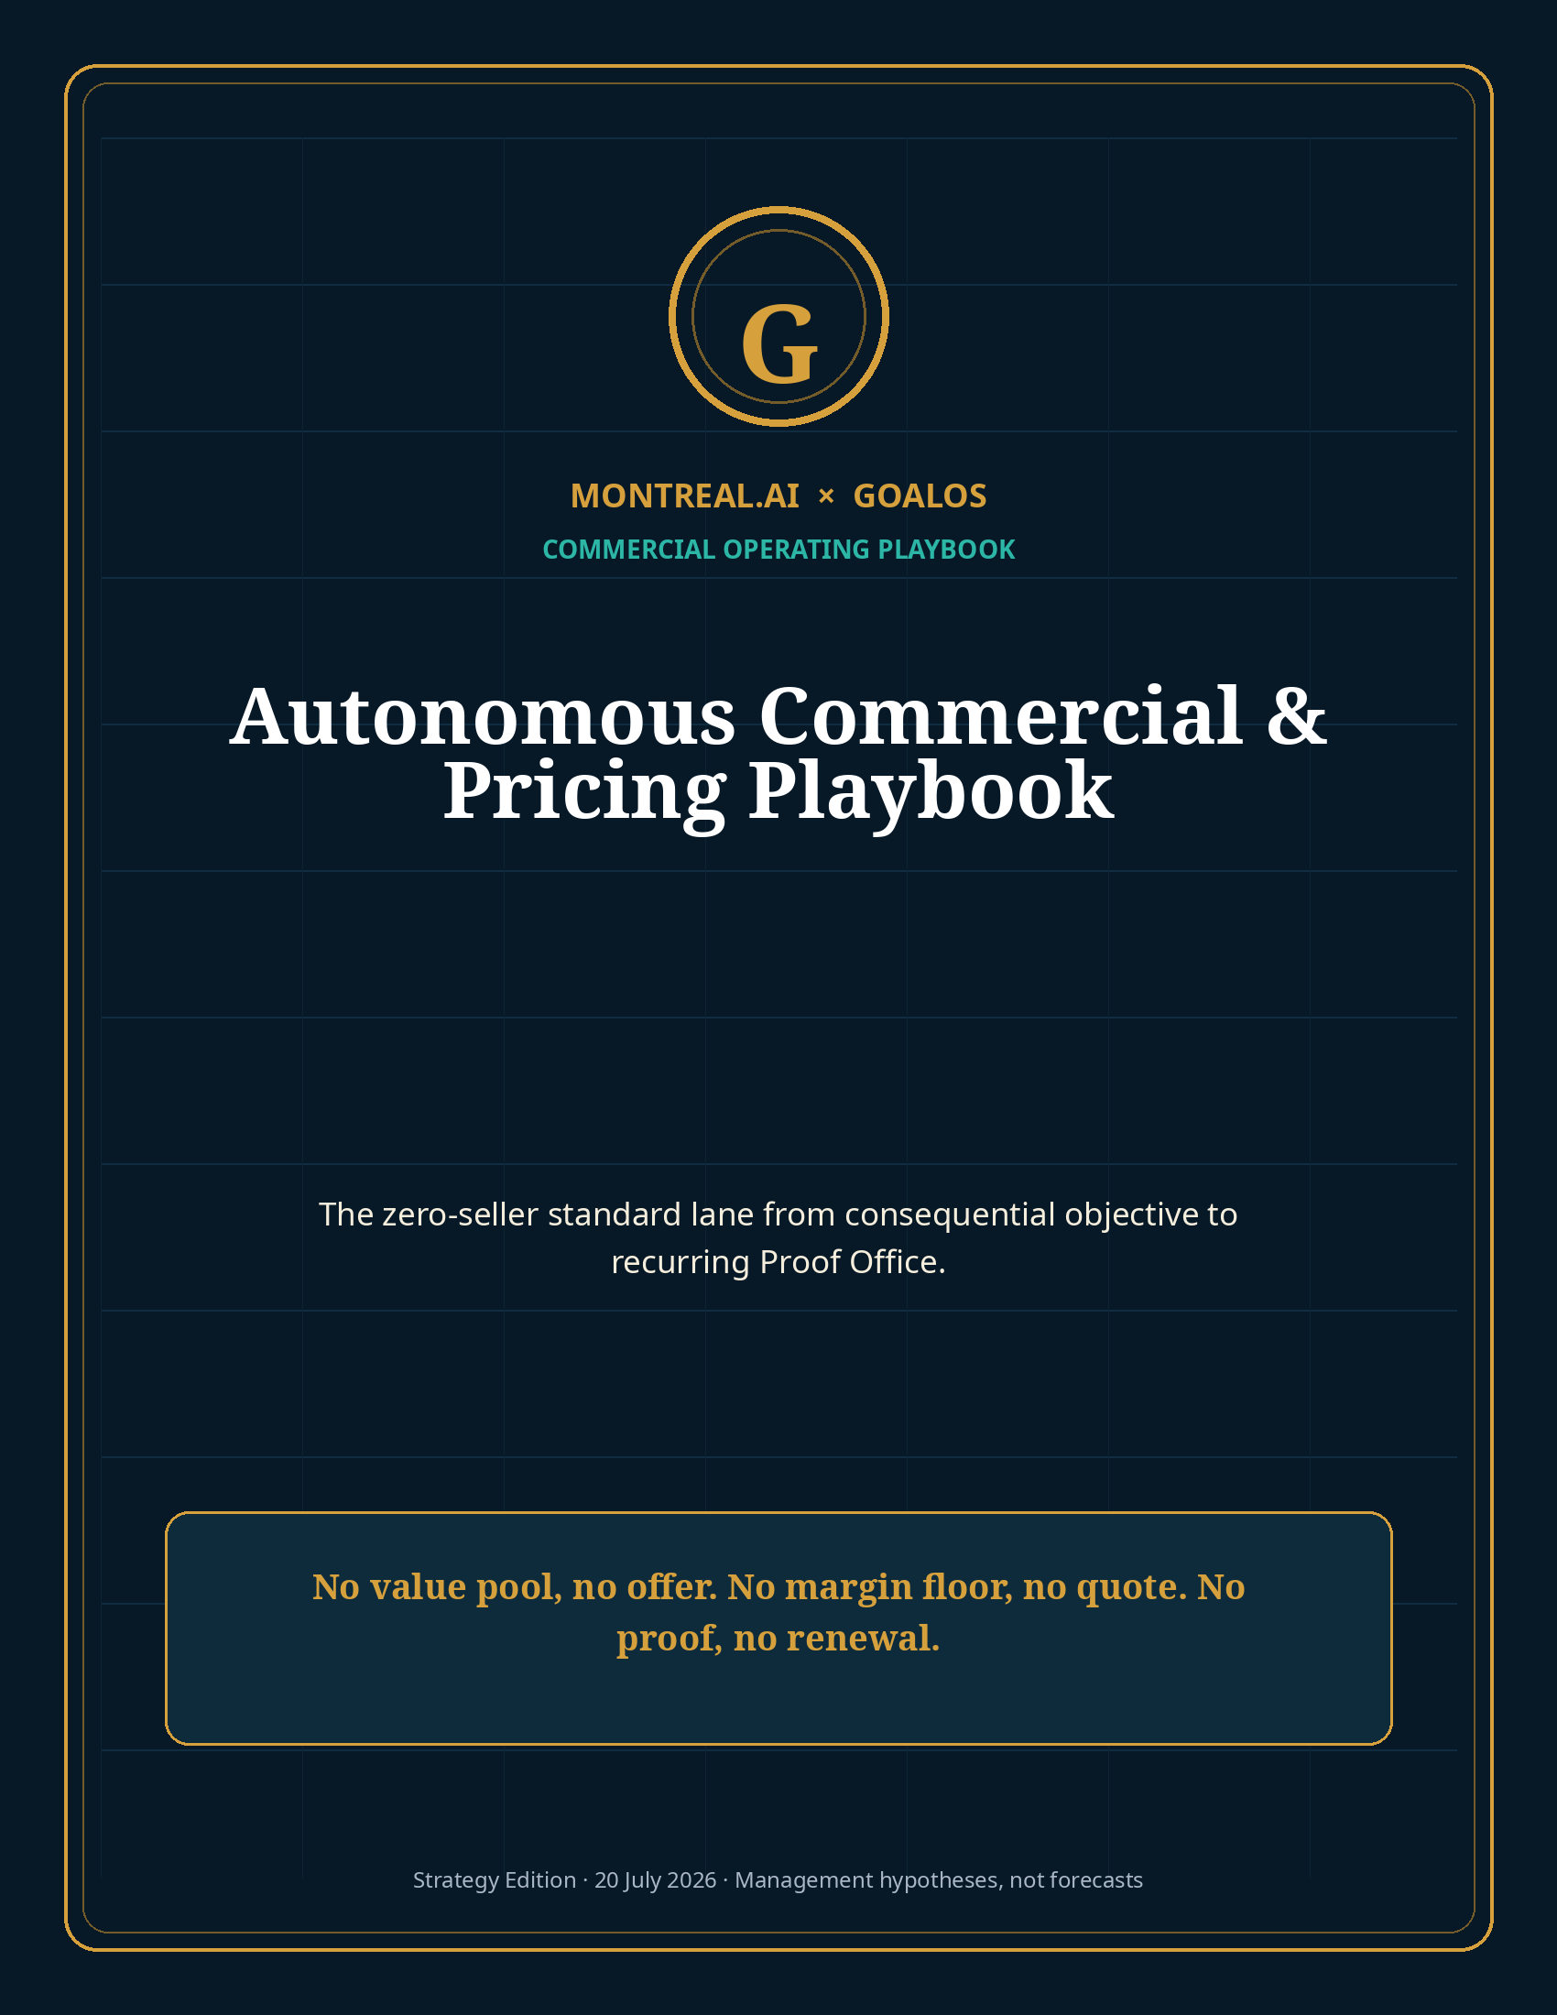

Commercial operating mandate
The Autonomous Money Machine Ω must become the system through which GoalOS is purchased—not a copilot helping someone sell it.
Zero-touch in the standard commercial lane. Human-sovereign at the constitutional boundary. Fail closed outside approved scope, price, rights, claims or contract paths.

1. The standard lane
State | Customer experience | GoalOS action | Receipt
Discover | Sees a relevant proof problem and enters a permissioned diagnostic | Personalized Readiness Scan | Consent and source record
Diagnose | Submits objective, claims, documents, deadline and value at stake | Maps Proof Debt and product fit | Diagnostic packet
Qualify | Reviews fit, risk, exclusions and value case | Scores sponsor, budget, urgency, evidence and scope | Qualification decision
Price | Receives one fixed product and delivery date | Applies value and margin floors | Quote and economic case
Contract | Reviews approved SOW, DPA, terms and evidence standard | Generates documents within clause matrix | Signed agreement
Fund | Pays Activation or mission deposit | Creates receipt and reserves capacity | Payment and capacity receipt
Instantiate | Receives secure mission room | Freezes Mission Contract and Docket | Mission hash / version
Deliver | Inspects work, evidence, costs, failures and decisions | Executes bounded jobs and routes review | Evidence Docket
Accept | Approves, conditions or disputes under frozen rubric | Records terminal state and value ledger | Acceptance / dispute receipt
Recurr | Activates continuing Office | Provisions monitoring, Chronicle and entitlements | Subscription and Office plan
Expand | Receives evidence-based next-mission proposal | Uses verified need and value—never generic cross-sell | Expansion decision

2. Autonomous offer ladder
Offer | Fixed input | Fixed output | Price | Payment
Proof Readiness Scan | Objective, documents, value, deadline | Initial Proof Debt and recommendation | Free–$495 | Upfront if paid
Proof Mission Activation | One consequential decision | Mission Contract, claims, evidence plan, ROI case | $15,000 | 100% prepaid
Standard Proof Mission | One frozen mission | Evidence Docket, review, governed decision | $75,000 | 50% / 30% / 20%
Proof Office | Accepted mission + continuing need | Continuous evidence, Chronicle, reporting and mission queue | $18,000/month base | Annual prepaid preferred
Private Enterprise Network | Multi-system recurring control | Dedicated integrations, private graph and protected runtime | $500,000/year base hypothesis | Deployment fee + annual commitment
Protected Invocation | Current entitlement + scoped request | Result, evidence and invocation receipt | $500+ per invocation hypothesis | Metered / committed usage

3. Qualification score
GoalOS should automatically qualify on a 100-point scale. Standard-lane entry requires at least 70 points and no disqualifying risk.
Dimension | Weight | Passing evidence
Value at stake | 25 | Conservative value ≥4× proposed first-year fee
Executive authority | 15 | Named sponsor can approve budget and acceptance
Urgency | 10 | Decision within 90 days
Evidence readiness | 15 | Inputs available; acceptance can be frozen
Repeat potential | 15 | Continuing monitoring, claim, governance or commercial need
Scope fit | 10 | Standard mission class; bounded exclusions
Rights clarity | 5 | Learning and reuse treatment can be contracted
Risk fit | 5 | No prohibited or unmanageable high-consequence path

4. Pricing engine
Quoted price = max[5–15% of conservative attributable value, expected variable cost ÷ (1 − target gross margin)] + assurance / exclusivity / complexity adjustments.

Adjustment | Rule
Customer-private learning | Add 25–50%
Sector or time-limited exclusivity | Add 100–300%
Expedited delivery | Add 25–50%
Regulated / external-specialist review | Pass through cost + assurance margin
Nonstandard data or integration | Separate module; never hide in standard price
Customer-proposed discount | Reduce scope, rights, assurance or service level—never breach margin floor
Outcome fee | Optional 5–10% of independently attributable incremental value where lawful; fixed fee remains

5. Approved contract path
1. Standard position.
2. Approved fallback A.
3. Approved fallback B.
4. Approved price or scope adjustment.
5. Decline.
The autonomous deal room may negotiate only within a counsel-approved clause library. Unlimited liability, unsupported warranties, customer ownership of the private capability network, uneconomic payment terms, unbounded use rights or prohibited data access cause automatic repricing, scope reduction or rejection.

6. Claim and evidence policy
Claim class | Rule
Product capability | Answer only from current, approved and versioned product records
Security / privacy | Never invent certification or control; cite exact approved evidence
Customer outcomes | Use only customer-authorized, bounded and current evidence
Financial ROI | Label forecast, supported and realized value separately
Delivery date | Quote only reserved capacity and standard-scope timing
Legal / regulatory | Provide readiness and evidence management; qualified professionals retain formal opinions
Competitive claims | Use sourced, date-stamped comparisons with limitations

7. Proof Office conversion
The conversion should be generated from the delivered Evidence Docket, not from a generic subscription pitch.
Evidence from first mission | Proof Office module
Unresolved Proof Debt | Continuing mission queue and evidence collection
Claims with expiry or drift risk | Continuous claim monitoring
Recurring model or vendor changes | Evaluation and re-authorization
Controls requiring replay | Scheduled testing and audit-ready evidence
Accepted capability | Version, entitlement, invocation and rollback management
Board / investor reporting need | Quarterly Proof Brief and Value Ledger
Commercial claim reuse | RFP-to-Revenue claim graph and approval workflow

8. Renewal and expansion
Never renew because time elapsed. Renew because GoalOS can show what changed, what value was created or protected, what became stale, what remains unresolved, and what the next evidence program must accomplish.

- 90 days before renewal: issue value and evidence ledger.
- 60 days: define continuing Proof Debt, capability lifecycle and expected value.
- 30 days: present fixed Office scope, price and annual capacity reservation.
- If continuing need cannot be supported, recommend downgrade or stop.
- Expansion is triggered by accepted adjacent objectives—not generic seat growth.

9. Commercial Chronicle
GoalOS must learn commercially without optimizing for superficial proxy metrics. A method may become reusable only after it produces collected cash, positive contribution, qualified customers, acceptable retention and no material trust breach on a fresh cohort.
Candidate commercial skill | Admission evidence
Account-selection method | Higher qualified purchase rate without compliance harm
Readiness Scan question | Improves qualification and later customer value
Price point | Positive contribution and no deterioration in conversion quality or retention
Objection response | Supported by evidence; does not increase refunds, scope debt or churn
Contract fallback | Acceptable risk and economics after delivery
Onboarding sequence | Lower time-to-value and evidence omissions
Renewal trigger | Higher retained gross profit and customer-verified value

10. Commercial control dashboard
Metric | Initial target | Fail condition
Seller-side minutes / standard transaction | 0 | Any routine founder intervention
Activation GM | ≥95% | <90%
Proof Mission GM | 70–80% | <60% after second delivery
Proof Office GM | ≥80% | <70%
CAC payback | <6 months | >12 months
Mission → Office conversion | ≥40% | <30%
Mature NRR | ≥120% target | <100%
Unsupported material commercial claims | 0 | Any
Standard quotes below margin floor | 0 | Any
Unrecorded human interventions | 0 | Any
Collected cash / booked revenue | ≥95% | <90%

11. Commercial constitution
No permission, no outreach. No consequential objective, no qualification. No measurable value pool, no offer. No margin floor, no quote. No approved clause path, no contract. No payment, no capacity. No Docket, no value claim. No verified need, no renewal. No positive contribution, no commercial skill admission.

Selected sources and claim boundary
External sources support market timing, technical feasibility, pricing context and comparative benchmarks. All GoalOS prices, volumes, margins, ROI, financing and valuation paths are editable management hypotheses—not audited forecasts, realized results, legal advice, investment advice, security certification or guarantees. Full URLs and source-use notes are provided in the package Source Register.
S1 · OpenAI · Introducing workspace agents in ChatGPT.
S2 · OpenAI · ChatGPT Enterprise and Edu release notes.
S3 · OpenAI · API pricing.
S4 · METR · Task-Completion Time Horizons.
S5 · Google DeepMind · AlphaEvolve.
S6 · Gartner · Worldwide AI spending forecast for 2026.
S7 · European Commission · Article 50 AI Act transparency obligations.
S8 · SaaS Capital · 2026 B2B SaaS benchmarks.
S9 · Stripe · Payment Links.
S10 · MONTREAL.AI Research · Merkle Roots for the Validated Skill Graph.
S11 · MONTREAL.AI Research · Private On-Chain Validated Skill Graph.

