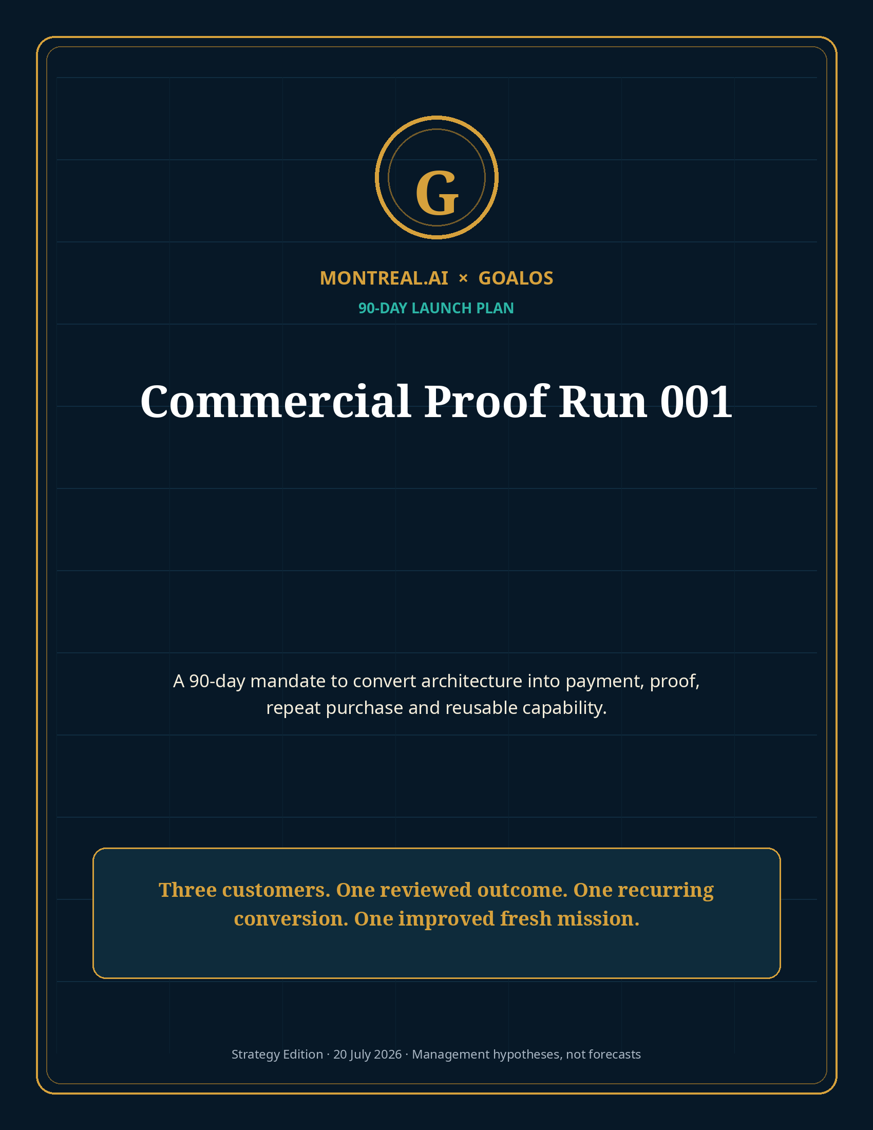

Mandate
Convert GoalOS from an architecture into an evidence-producing, autonomously transacting enterprise business in 90 days.
The 90-day objective is not maximum revenue. It is to prove the economic atom: a qualified objective becomes payment, bounded work, evidence, independent review, repeat purchase, rights-cleared capability and a better fresh mission.

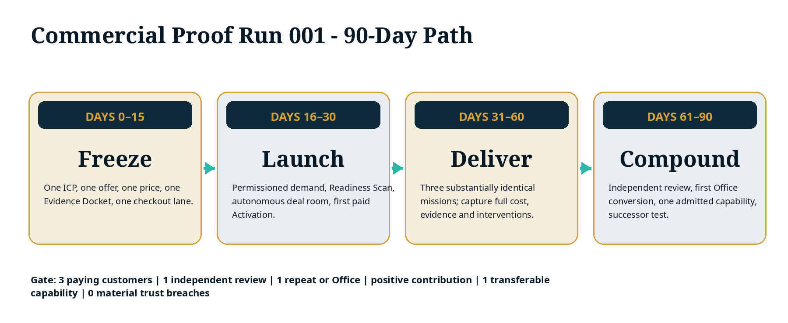

1. Frozen launch architecture
Element | Frozen decision
ICP | AI vendor or enterprise AI team with ≥$250K value at stake
Use case | One consequential AI deployment / claim / procurement decision
Activation | $15,000; 100% prepaid; 24–72-hour standard delivery
Proof Mission | $75,000 standard; 10 business days; fixed Evidence Docket
Proof Office | $18,000/month base; annual prepayment preferred
Review | Separated reviewer for at least one material outcome
Rights | Four classes: network-admissible, customer-private, exclusive, mission-only
Commercial lane | No routine MONTREAL.AI seller intervention
Public claim | Architecture until paid evidence authorizes stronger language

2. First 15 days - Freeze
- Select one buyer, one trigger and one value proposition.
- Freeze the Readiness Scan, Activation deliverables and Proof Mission acceptance rubric.
- Finalize standard SOW, DPA, terms, rights schedule, refund policy and claim library.
- Configure checkout, invoicing, electronic signature, secure document intake and capacity reservation.
- Build the autonomous deal room and evidence-cited Q&A.
- Name the independent reviewer route and conflict policy.
- Freeze the cost model and 95% / 75% / 80% margin floors for Activation / Mission / Office.

3. Days 16–30 - Launch
- Publish the Readiness Scan and one flagship executive briefing.
- Activate permissioned founder, MONTREAL.AI, MasterClass, partner and referral channels.
- Drive 30–60 highly qualified accounts to the Scan.
- Deliver 8–10 paid or tightly controlled founding Activations.
- Convert at least three into the same Proof Mission.
- Record every acquisition source, consent basis, quote, objection, transaction and intervention.

4. Days 31–60 - Deliver
- Deliver three missions through the identical state machine.
- Cost every model call, tool, data source, reviewer, retry, support action and founder hour.
- Freeze and hash each Mission Contract and Evidence Docket version.
- Separate working agent, evaluator and Chronicle authority.
- Issue accepted, conditioned, repaired, rejected or stopped terminal states under the frozen rubric.
- Generate the Proof Office plan directly from unresolved and continuing evidence needs.

5. Days 61–90 - Compound
- Obtain at least one customer-authorized independent review.
- Close at least one repeat purchase, expansion or Proof Office.
- Identify one rights-cleared candidate capability from accepted work.
- Admit, condition or reject it through Chronicle.
- Give Generation 2 only the admitted capability—not the full original mission transcript.
- Test Generation 2 on a fresh cohort or held-out mission under equal or harder constraints.
- Publish one restrained, public-safe Proof Docket and explicit limitations.

6. Week-by-week operating plan
Week | Primary work | Required receipt
1 | ICP, offer, prices, scope, cost and rights freeze | Approved launch constitution
2 | Contract lane, checkout, secure intake, claim library | End-to-end transaction dry run
3 | Readiness Scan and deal room live | First qualified scans
4 | Founding Activation deliveries | First paid receipt and Activation Docket
5 | Mission 1 starts | Frozen Mission Contract
6 | Missions 2 and 3 start | Three comparable missions
7 | Execution and evidence | Costed Evidence Dockets
8 | Customer acceptance and review | Terminal decisions
9 | Proof Office proposal | First recurring transaction
10 | Candidate skill passport | Rights and evidence review
11 | Fresh successor test | Preregistered comparison
12–13 | Review, Chronicle, public proof and board decision | GO / CONDITIONAL GO / STOP

7. 90-day budget
Category | Ceiling | Purpose
Product and automation | $90,000 | Scan, deal room, transaction, Mission Contract and Docket
Mission delivery and tools | $45,000 | Models, data, environments, testing and support
Independent review and security | $35,000 | Evaluator, counsel, privacy and architecture review
Demand and communications | $30,000 | Permissioned campaigns, MasterClass, partner activation
Legal, finance and insurance | $25,000 | Commercial documents, rights, accounting and risk
Contingency | $25,000 | Unknown delivery and integration burden
Total | $250,000 | Released through explicit gates

8. Success dashboard
Metric | Target
Paying customers | 3 unrelated
Substantially identical missions | 3
Independent review | ≥1
Repeat / renewal / expansion | ≥1
Positive attributable contribution | Yes
Public-safe customer-authorized Docket | ≥1
Rights-cleared Chronicle capability | ≥1
Fresh successor improvement | ≥1 preregistered metric
Material trust breaches | 0
Founder seller minutes in standard lane | 0
All human interventions costed | 100%

9. Gate decisions
Decision | Conditions
GO | 3 paid missions; positive contribution; one repeat; one reviewed outcome; one transferable capability; no material trust breach
CONDITIONAL GO | Demand and customer value supported, but recurrence, margin, review or transfer requires a defined repair mission
STOP / REPOSITION | Weak paid demand, negative economics, unmanageable risk, no defensible recurring need, or inability to separate evidence and authority

10. Day-90 board questions
1. Did customers pay without founder-led persuasion?
2. Did the same product deliver three accepted or decision-useful outcomes?
3. What was the true direct cost after all human and failure costs?
4. Did at least one customer buy again or activate continuing control?
5. Did an independent reviewer support or appropriately limit a material claim?
6. Did any rights-cleared capability improve a fresh mission?
7. What Proof Debt must the next financing tranche retire?
8. Should GoalOS scale this wedge, repair it, or replace it?

Selected sources and claim boundary
External sources support market timing, technical feasibility, pricing context and comparative benchmarks. All GoalOS prices, volumes, margins, ROI, financing and valuation paths are editable management hypotheses—not audited forecasts, realized results, legal advice, investment advice, security certification or guarantees. Full URLs and source-use notes are provided in the package Source Register.
S1 · OpenAI · Introducing workspace agents in ChatGPT.
S2 · OpenAI · ChatGPT Enterprise and Edu release notes.
S3 · OpenAI · API pricing.
S4 · METR · Task-Completion Time Horizons.
S5 · Google DeepMind · AlphaEvolve.
S6 · Gartner · Worldwide AI spending forecast for 2026.
S7 · European Commission · Article 50 AI Act transparency obligations.
S8 · SaaS Capital · 2026 B2B SaaS benchmarks.
S9 · Stripe · Payment Links.
S10 · MONTREAL.AI Research · Merkle Roots for the Validated Skill Graph.
S11 · MONTREAL.AI Research · Private On-Chain Validated Skill Graph.

