THE SINGULARITY INSTITUTION
GoalOS Autonomous Money Machine Ω Frontier AI MasterClass
Private Engagement Proposal Template
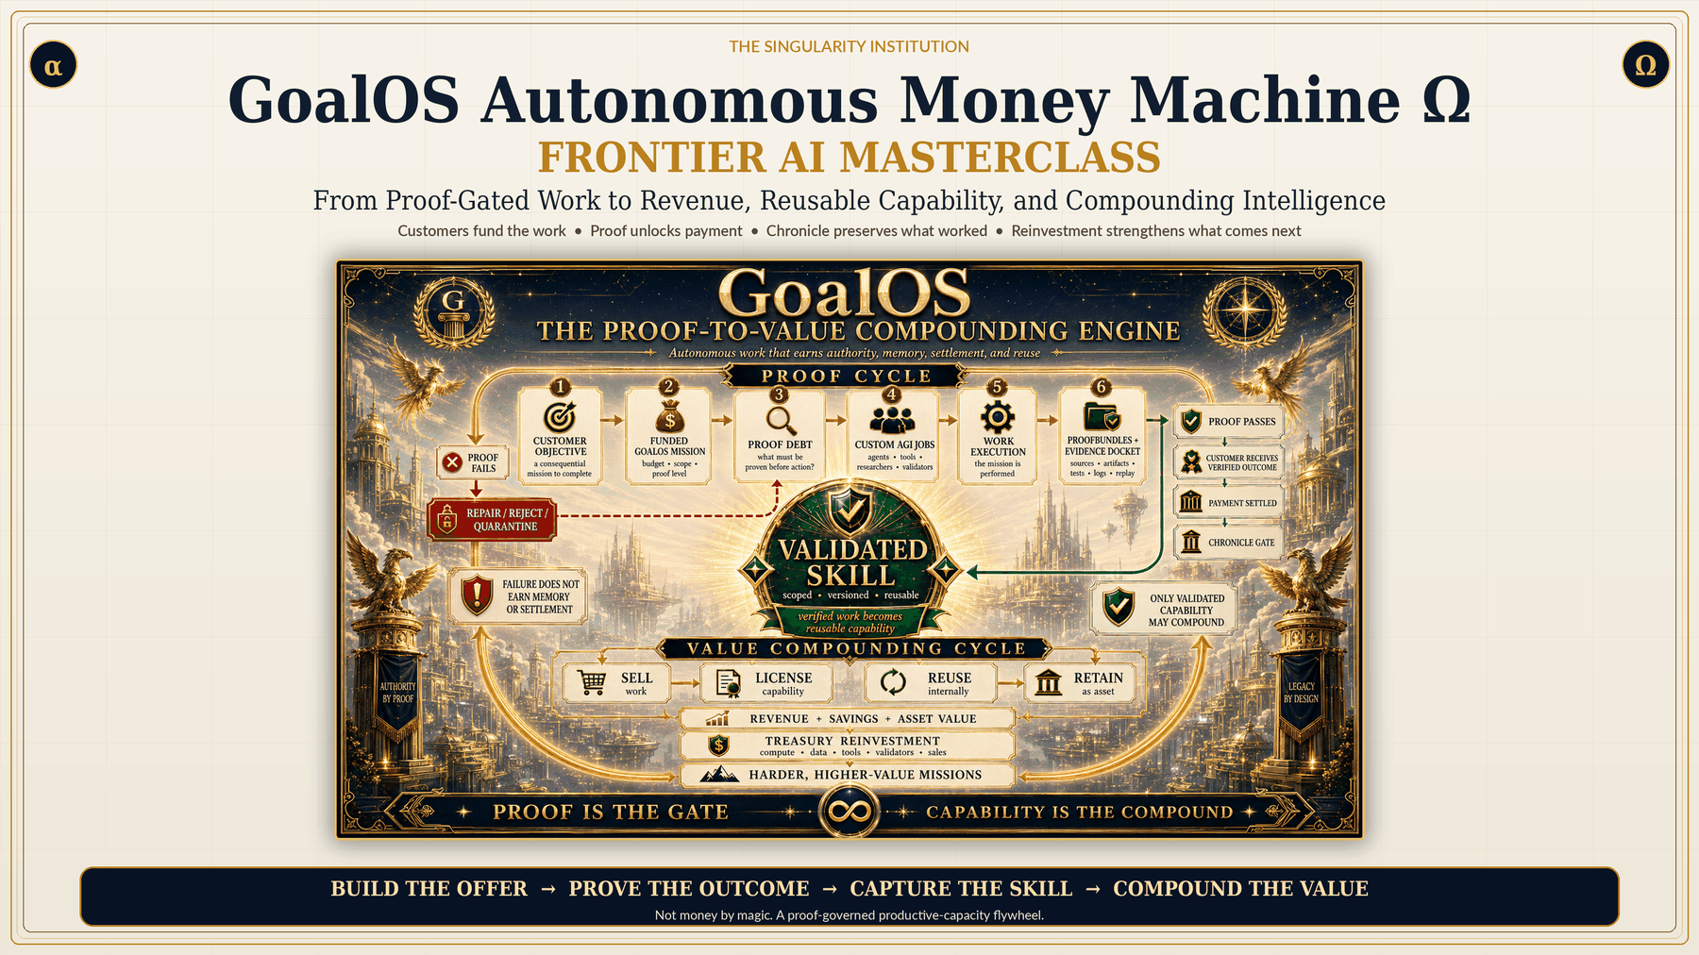
Not money by magic. A proof-governed productive-capacity flywheel.
No hype. Only proof. Only customer value.

Engagement Summary
Field | Proposed value
Client | [CLIENT]
Executive sponsor | [SPONSOR]
Commercial objective | [OBJECTIVE]
Buyer / market | [BUYER]
Format | [BRIEFING / MASTERCLASS / DESIGN LAB / SPRINT / PROOF-TO-REVENUE RUN]
Date and location | [DATE / LOCATION]
GoalOS lead | [NAME]
Client owner | [NAME]
Fee | [FEE]

Purpose
The engagement converts one legitimate commercial objective into a proof-governed revenue institution. It makes the buyer, outcome, offer ladder, pricing, funnel, capacity, proof burden, reviewers, approvals, reusable capability, and next action inspectable before broader investment or deployment.

Scope
- Executive framing: output, proof, authority, payment, memory, reuse, and compounding.
- One-box business formation and Chief-of-Staff confirmation.
- Four-level offer architecture.
- Pricing, funnel, capacity, and scenario economics.
- Sales asset and human-approval design.
- Day-one operating model.
- Mission Contract, Proof Debt, job queue, and Evidence Docket blueprint.
- Chronicle, Validated Skill, monetization, and reinvestment.
- Executive recommendation and next commercial decision.

Deliverables
Deliverable | Included
Commercial Objective Brief | Yes
Ideal Buyer and Purchase Trigger Map | Yes
Four-Level Offer Ladder | Yes
Pricing and Capacity Model | Yes
Pipeline Funnel | Yes
Initial Target Account List | Yes
Positioning and Outreach Drafts | Yes
Human Approval Map | Yes
Mission Contract | Yes
Proof Debt Register | Yes
Custom AGI Job Queue | Yes
Evidence Docket Blueprint | Yes
Chronicle Admission Test | Yes
Validated Skill Passport | Yes
Capability Monetization Boundary | Yes
Reinvestment Policy | Yes
30-day and 90-day operating plan | Yes
External reviewer work | [Optional]
Completed Governed Decision State | [Optional Proof-to-Revenue Run]

Schedule
Phase | Timing | Output
Pre-work | 3–5 business days before | Objective, participants, boundaries, and data.
Live engagement | Per selected format | Draft operating artifacts and recommendation.
Executive recap | Within 24 hours | Decision, blockers, owners, and next gate.
Downstream engagement | Optional | Design Lab, Sprint, Proof-to-Revenue Run, or enterprise program.

Roles and Responsibilities
GoalOS | Client
Provide faculty, facilitator, operating method, application, templates, and agreed artifacts. | Provide sponsor, objective, participants, evidence access, boundaries, and timely decisions.
Protect claim boundaries and preserve unresolved debt. | Identify confidential information and required legal, security, or domain reviewers.
Produce agreed drafts and recap. | Review, challenge, approve, reject, or request repair.

Commercial Terms
- 50% on signature; balance before delivery unless otherwise agreed.
- Third-party data, travel, specialist, and reviewer costs require written approval.
- No guaranteed revenue, positive verdict, deployment approval, or certification.
- Confidential information remains within the agreed boundary.
- No irreversible action or money movement without explicit authorization.
- Client retains final decision authority.

Acceptance
The engagement is complete when the agreed commercial and mission artifacts are reviewable, unresolved assumptions remain visible, human approval boundaries are preserved, and the next commercial decision is recorded.

Approval
For GoalOS | For [CLIENT]
Name: __________________________ | Name: __________________________
Title: ___________________________ | Title: ___________________________
Signature: ________________________ | Signature: ________________________
Date: ____________________________ | Date: ____________________________

Source Lineage and Claim Boundary
- GoalOS Autonomous Money Machine Ω standalone application and release notes.
- GoalOS: Proof-Carrying Autonomy — canonical proof-to-capability operating system.
- GoalOS Mission OS — commercial proof-to-action product layer.
- GoalOS: The Validated Skill Graph — Chronicle-gated reusable capability.
- AEP-001 — proof, evaluation, propagation, and rollback doctrine.
- AGI ALPHA — organizational substrate and verified-work compounding thesis.
Claim boundary
This program teaches and applies a research architecture, commercial operating method, and product pathway. It does not guarantee revenue, certify a system, replace legal, security, financial, medical, regulatory, or domain review, authorize production deployment, or claim achieved AGI or superintelligence. Forecasts are scenarios. Strong claims require real customers, real tasks, Evidence Dockets, baselines, replay, cost and safety ledgers, external validation, delayed outcomes, and independent review.

