GOALOS / EXECUTIVE PARTNER BRIEF
The Proof OS for
Autonomous AI Work
A practical, inspectable operating system for turning one consequential objective into evidence, a bounded decision and reusable institutional capability.
AI creates output. GoalOS creates proof.

FINAL PRODUCTION PARTNER EDITION · JULY 2026
Prepared for high-calibre business, technology and institutional discussions. Architecture, reference implementation, contractual participation controls and evidence operations are presented as one integrated partner system.

01 · THE PARTNER PROPOSITION

One important decision. One inspectable proof process.
Most AI systems optimize the production of answers. GoalOS addresses the harder institutional question: what must be proven before an answer can justify action, payment, memory, reuse or broader authority?
CANONICAL THESIS
A model may answer. An agent may act. An institution must prove.

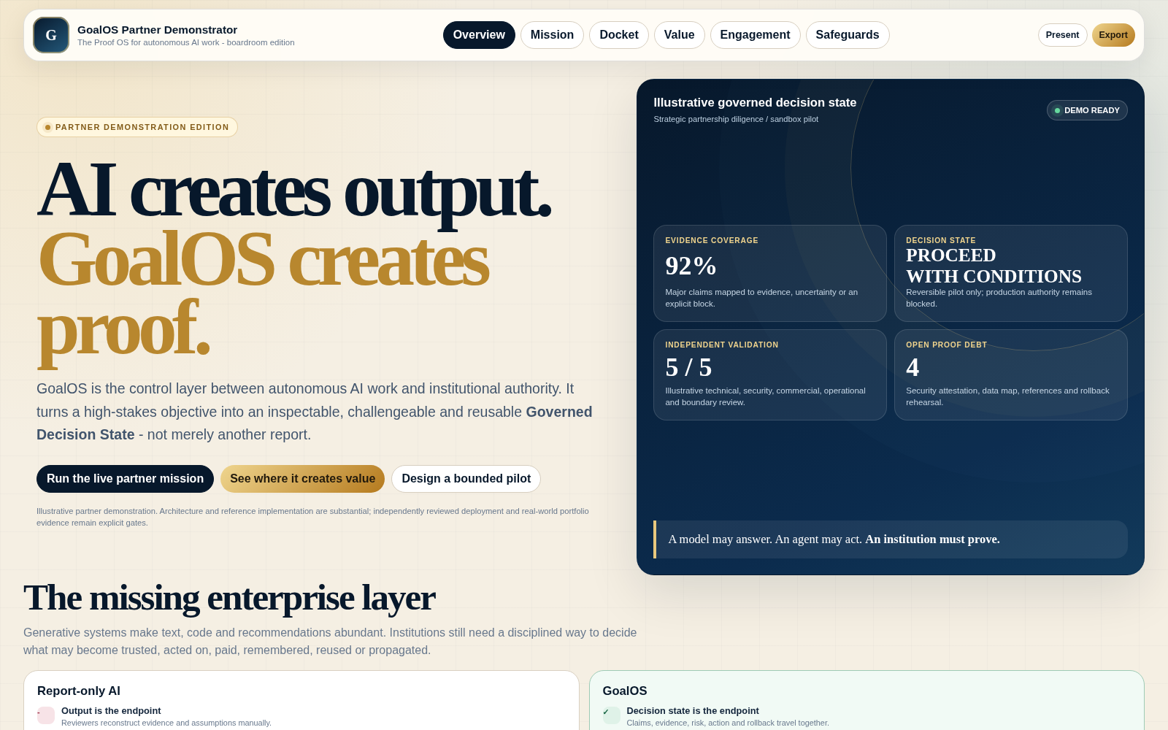
The standalone partner demonstrator: a browser-local proof institution with no external asset dependency.
The input  A consequential objective, decision deadline, scope, risk class, proof level, named reviewers and rollback conditions. | The output  A Governed Decision State: claims, sources, contradictions, Evidence Docket, verifier report, risk, action and memory disposition.
The operating law  Unsupported claims become Proof Debt. Missing evidence blocks authority rather than disappearing into confident prose. | The durable asset  Only admitted, scoped, replayable and revocable capability may become institutional memory or influence future missions.

02 · HOW THE SYSTEM WORKS

Authority appears only after the next gate passes.
GoalOS separates generation from authority, evidence from memory, and memory from settlement. Each object has a narrow purpose and an explicit failure branch.
Gate | Institutional object | What it controls
1 | Objective / Mission Contract | Freeze decision, scope, proof level, risk, validators and rollback.
2 | Proof Debt / AGI Jobs | Expose unsupported claims and create mission-specific proof-producing work.
3 | ProofBundles / Evidence Docket | Package evidence, provenance, tests, costs, risks and replay paths.
4 | Validation / Chronicle | Independent review decides what passes, fails, requires repair or remains blocked.
5 | Validated Skill / Merkle Root | Admitted capability becomes scoped, versioned, replayable and revocable.
6 | Bonded settlement / harder mission | Accepted proof becomes economically consequential and is tested on future work.

Where it is immediately useful
Strategic partnership diligence  Turn a partnership thesis into a bounded pilot decision with explicit closing conditions. | Enterprise AI procurement  Compare vendors under common tasks, budgets, data boundaries, risks and replay requirements.
AI product launch readiness  Determine what is ready for canary release, what requires repair and what remains prohibited. | M&A and technology diligence  Separate claims, assets, dependencies, customer evidence, security and integration risk.
Defensive cybersecurity remediation  Produce evidence-bearing, human-reviewed improvements without unsafe autonomy. | R&D portfolio and capability reuse  Preserve validated methods and outcomes as governed capability, not raw prompt history.

03 · WHAT A PARTNER RECEIVES

A proof room - not a marketing page.
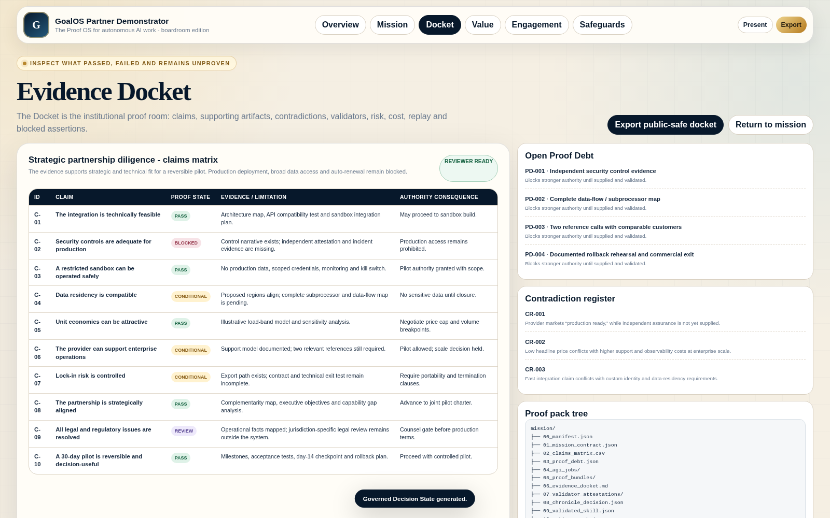
Illustrative Evidence Docket showing claim states, proof debt, contradictions, validator disposition and replay path.

Flagship deliverable: the Governed Decision State
- Mission Contract: the objective, decision, boundaries, authority and definition of done.
- Claims Matrix: every consequential claim tied to evidence, uncertainty and authority consequence.
- Proof Debt Register: missing proof remains visible work and blocks stronger claims.
- Evidence Docket and Verifier Report: reviewer-ready proof room and explicit pass, repair, reject or hold status.
- Risk and Cost Ledgers: downside, resource burden, legal boundaries and assumptions remain inspectable.
- Action Graph: owners, dependencies, approvals, stop conditions and rollback path.
- Chronicle Verdict and Capability Passport: what may enter memory, under what scope, and how it can be revoked.
PARTNER VALUE
The durable asset is accumulated method + evidence + scope + validator history + delayed outcomes + policy + lineage - not prompt text.

04 · COMMERCIAL EXPANSION

Land with proof. Expand with capability.
The initial commercial wedge is intentionally narrow: prove one consequential mission. Recurring workflows, governed memory and network effects are earned only after bilateral value is visible.

Commercial adoption path
Step | Offer | Partner outcome | Economic role
1 | Proof Mission Sprint | One bounded objective becomes a reviewer-ready decision state. | Services wedge and real evidence.
2 | Enterprise Proof OS | Recurring missions, Dockets, Chronicle and audit workflows. | Annual recurring revenue.
3 | Private Validated Skill Graph | Customer-specific governed capability memory. | Implementation + recurring assurance.
4 | Managed AGI Node Council | Independent validation without infrastructure burden. | ARR + metered usage.
5 | Cross-Institution Proof Network | Jobs, validators, challenges and skill passports across organizations. | Network effects and proof throughput.

Company value  Services, subscriptions and implementation are tied to real customer decisions and recurring assurance. | Protocol value  Verified-work throughput, bonded security and reusable capability increase only as useful authority transitions occur.
Customer posture  A normal enterprise buyer can remain tokenless by default while professional operators supply bonded protocol security. | Expansion rule  No network-first scaling. Convert repeated proof demand into capability, then expand only when the evidence supports it.

05 · THE FIRST PARTNER PILOT

Fifteen business days to one inspectable decision.
DAYS 1-2  Freeze the mission  Decision, scope, proof level, validators, blocked claims and rollback. | DAYS 3-8  Produce proof  AGI Jobs, source map, ProofBundles, contradictions, cost and risk. | DAYS 9-12  Validate and replay  Independent review, repair loop, challenge handling and packaging. | DAYS 13-15  Decide and package  Decision State, Action Graph, Chronicle and capability passport.

Partner inputs
- One consequential but reversible objective with a real decision deadline.
- One executive sponsor and access to relevant evidence and subject-matter contacts.
- One independent reviewer or review group able to challenge the result.
- A defined public/private boundary and a clear list of prohibited actions.
- Agreement on what “done,” “blocked,” “repair,” and “rollback” mean before work begins.

Evidence status and claim boundary
Layer | Status | Meaning
Doctrine and object model | SPECIFIED | Mission OS, PROOF_LOOPS, AEP-001, Chronicle, Dockets and VSG.
Browser institution | IMPLEMENTED | Standalone offline demonstrator and operating surfaces.
Runtime and contract packages | REFERENCE-READY | Reference runtime, registries, schemas, tests and deployment packs.
Business and economics | PLANNING-READY | Proof Mission, recurring Proof OS, private VSG and managed validation.
Reviewed live deployment | PENDING | Audited contracts, governed keys, independent controls, incident response, insurance and production observability.
Independent replay / empirical compounding | PENDING | External reviewers, delayed outcomes and harder transfer missions.

THE ASK
Select one mission. Prove the operating loop before broader adoption.

Participation is conditioned on affirmative, versioned acceptance of the GoalOS Enterprise User Responsibility Framework. Each Participant acts solely for its own account and remains exclusively responsible for its objectives, instructions, content, data, systems, personnel, wallets, keys, transactions, taxes, reporting, licences, regulatory compliance, security, insurance, decisions and downstream deployment. Each Participant also assumes the applicable technical and economic risks and accepts release, non-recourse, hold-harmless for Participant-caused matters and non-joinder obligations in favour of the Protected Parties. User-to-user matters remain between the relevant Participants. Permitted professional disputes follow particularized notice, evidence preservation, confidential Montréal mediation and Montréal-seated arbitration.

