
BOARD AND EXECUTIVE DECISION BRIEF
MONTREAL.AI x GoalOS
The institution that turns intelligence into proof, proof into protected capability, protected capability into recurring economic power, and verified surplus into a larger future.

Executive decision
DECISION
GO - at category-defining scale. Build for strategic importance measured in decades; launch through one bounded, paid, falsifiable enterprise wedge; let proof progressively authorize every larger claim.

The opportunity is not to build another interface to intelligence. The opportunity is to own the institutional conversion chain that becomes indispensable as machine work grows longer, more autonomous, more valuable and more deeply connected to real systems.
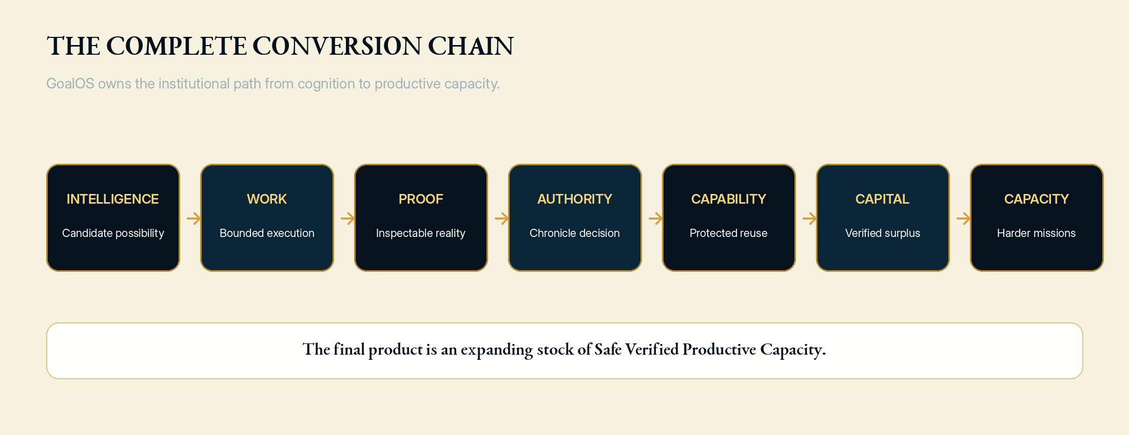
GoalOS owns the path from candidate intelligence to increasing productive capacity.

Why this window matters
- Long-running agent work is becoming a standard product primitive. The differentiating layer moves upward from execution into objectives, permissions, evidence, validation, memory, rights and rollback.
- Evaluator-driven systems are already producing bounded, measurable improvements. The scarce institutional question is no longer whether a candidate can be generated, but whether it deserves authority, propagation and capital.
- AI spending is moving toward infrastructure scale. The strategic winner will not merely produce intelligence; it will convert intelligence into governable, economically justified and physically supportable capacity.
- Enterprise adoption remains constrained by proof, identity, permissions, economics, data readiness and reliable institutional memory. GoalOS is designed around precisely those missing controls.

What MONTREAL.AI is building
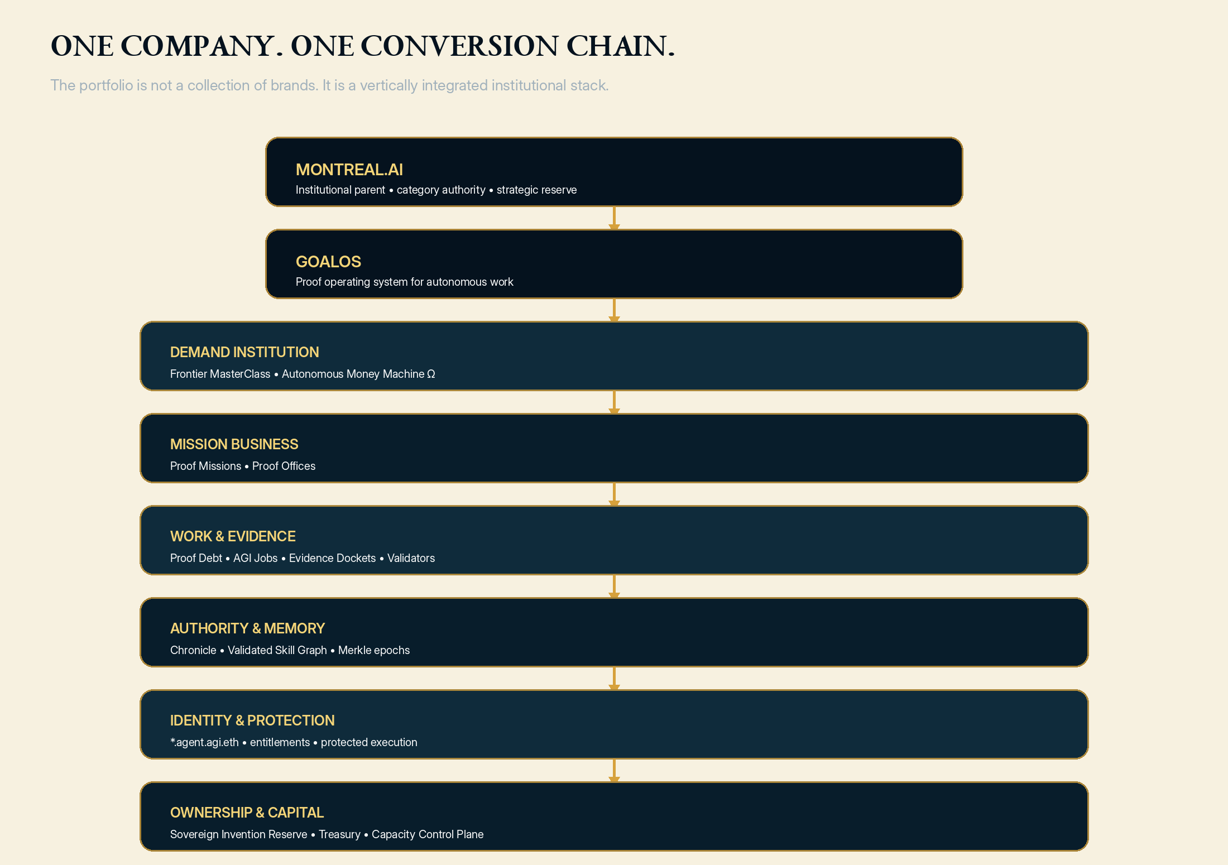
One company and one vertically integrated institutional stack.
GoalOS is the master product and operating system. Proof Missions are the first high-value enterprise purchase. Proof Offices convert accepted missions into recurring institutional control. Everything else strengthens the same conversion chain: demand, bounded work, evidence, authority, memory, identity, protected capability and capital allocation.

The profoundly meta structure
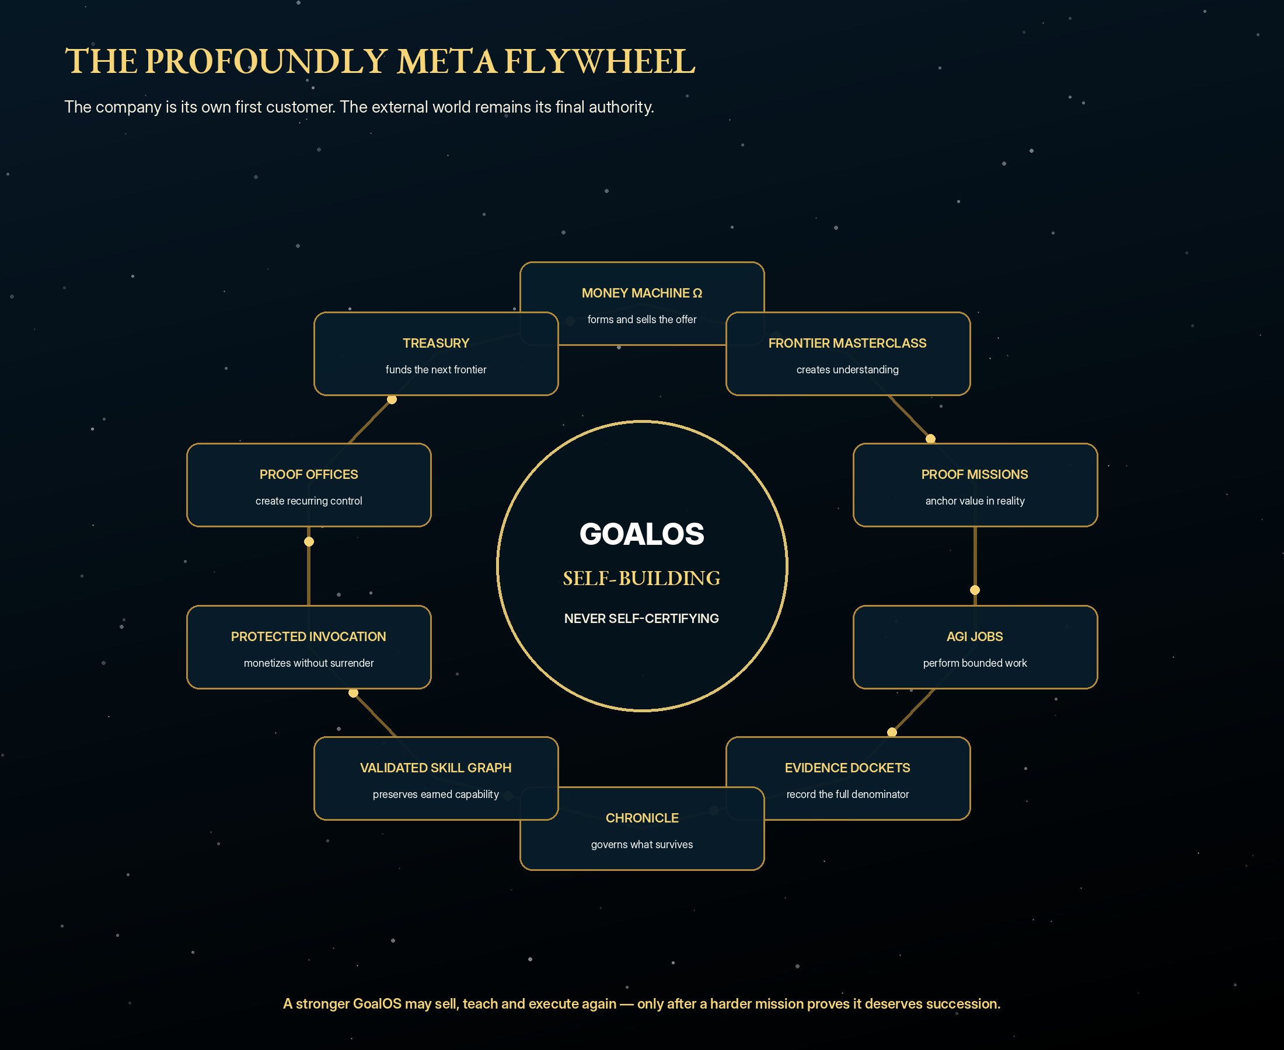
The company is its own first customer. Reality is its final authority.
INSTITUTIONAL DISTINCTION
GoalOS may sell GoalOS, teach GoalOS, execute GoalOS and generate the next GoalOS. It may not certify its own success. Collected payment, customer action, inspectable evidence, independent review and fresh successor performance provide the external anchor.

Premium commercial architecture
Product | Initial pricing hypothesis | Strategic role
Frontier Executive MasterClass | $75,000 | Category creation and qualified consequential objectives
Proof Mission Activation | $50,000 | Near-zero-cost mission architecture and value case
GoalOS Proof Mission | $250,000 | Decision-grade execution, Evidence Docket and governed outcome
GoalOS Proof Office | $1,000,000 per year | Recurring control, evaluation, Chronicle and capability lifecycle
Private Enterprise Network | $3,000,000+ per year | Dedicated protected capability platform and integrations
Strategic / Sovereign Deployment | $20,000,000+ | Cross-institutional programmes and productive capacity

The pricing principle is value, not compute cost. A standard first-year customer architecture of Activation + Mission + Proof Office + usage is modeled at $1.55 million, 80% gross margin and a conservative four-times value-to-fee floor. These figures are hypotheses to be tested, not promises.

Illustrative capital-to-capacity scenario
Metric | Year 1 | Year 5 | Year 10
Revenue | $2.2M | $341M | $9.63B
EBITDA | ($1.7M) | $123M | $5.08B
Recurring + usage mix | 25% | 80% | 91%
Active Proof Offices | 0.75 | 100 | 1,300
Chronicle-admitted capabilities | 1 | 300 | 7,500

SCENARIO BOUNDARY
The ten-year model is an architecture of scale, not a forecast. The purpose is to make the strategic mechanics explicit: premium enterprise value, recurring Proof Offices, protected invocation, network fees, disciplined capital formation and productive-asset investment.

Commercial Proof Run 001 - the next 90 days
Gate | Required result
Paying demand | 3 unrelated customers purchase the same bounded mission
Delivery | 3 substantially identical missions and 3 Evidence Dockets
Authority | At least 1 independently verified customer outcome
Retention | At least 1 repeat, renewal or expansion
Capability | At least 1 rights-cleared Chronicle-admitted capability
Successor | At least 1 fresh preregistered improvement test
Economics | Positive attributable contribution margin
Trust | 0 material trust breaches

The dual mandate
EXTERNALLY
Launch the proof-governed intelligence institution for the era of consequential machine work. Present world-class design, enterprise-grade engineering, serious security, canonical identity, protected execution and category ownership.

INTERNALLY
Close three customers. Deliver the same mission. Verify one outcome. Earn one repeat. Admit one transferable capability. Prove that it improves the next mission. No skipped gates.

Final judgment
Build GoalOS as though it may become one of the most valuable institutions in the future economy. Launch it as the market's most disciplined paid proof mission. Let every accepted mission make the institution more useful, defensible and capable.

Selected sources and evidence boundary
External sources establish the timing context. GoalOS pricing, revenue, ROI, financing, valuation and capacity scenarios are management hypotheses until verified by customer and operating evidence.
- OpenAI - ChatGPT Work and workspace agents
- OpenAI - Agents SDK and long-running work
- METR - Task-Completion Time Horizons
- Google DeepMind - AlphaEvolve impact
- Google DeepMind - From AGI to ASI
- Anthropic Institute - Research agenda
- Gartner - Worldwide AI spending forecast
- Government of Canada - Sovereign AI supercomputing initiative
- MONTREAL.AI - Merkle Roots for the Validated Skill Graph
- MONTREAL.AI - Private On-Chain Validated Skill Graph
CLAIM BOUNDARY
This document does not claim achieved general intelligence, unrestricted recursive improvement, guaranteed customer outcomes, legal certification, audited forecasts, or a present enterprise valuation. The governing doctrine is maximum ambition with minimum unsupported claim.

