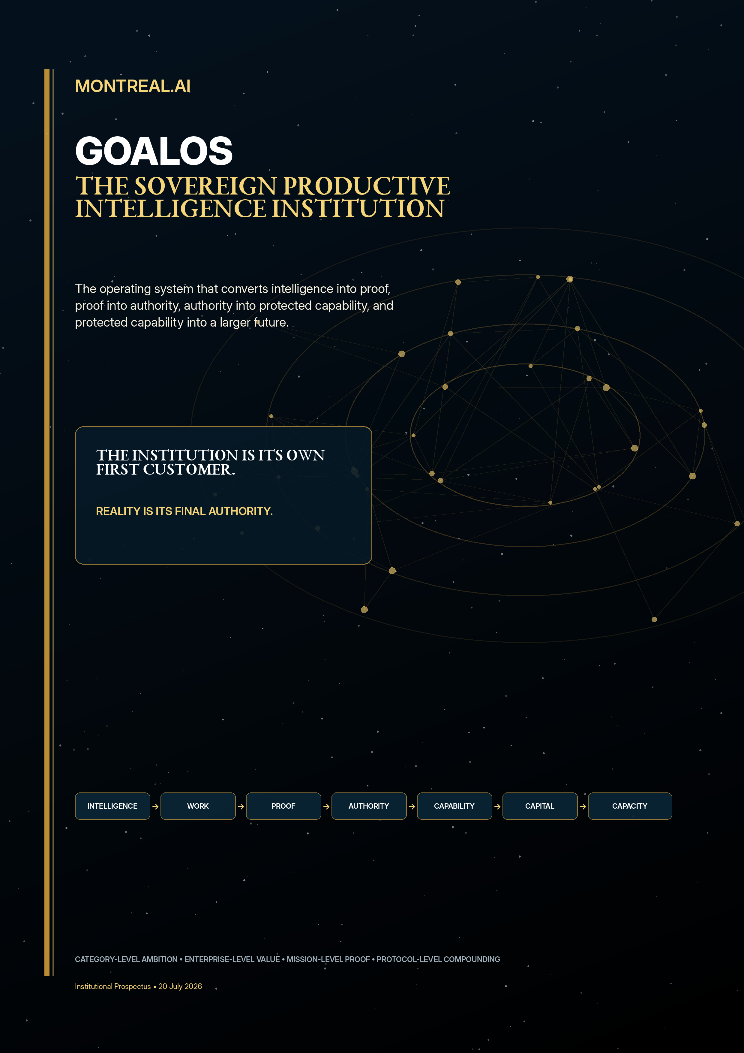
INSTITUTIONAL PROSPECTUS
MONTREAL.AI x GoalOS
The proof-governed institution that converts intelligence into work, work into authority, authority into protected capability, and protected capability into expanding productive power.

The declaration
COMPANY THESIS
MONTREAL.AI is building GoalOS - the operating institution through which increasingly capable intelligence earns the right to act, the right to be believed, the right to become memory, the right to be reused, and ultimately the right to receive more capital.

GoalOS is not a collection of AI projects. It is one vertically integrated system that acquires consequential objectives, converts them into funded missions, coordinates bounded work, proves what happened, admits only validated capability into institutional memory, protects that capability inside MONTREAL.AI, monetizes governed reuse and reinvests verified surplus into greater productive capacity.
The final product is not a chatbot. It is not even software. The final product is an expanding stock of Safe Verified Productive Capacity: the ability to produce more valuable outcomes, at lower cost and risk, using more reusable capability, under stronger governance, while increasing the scale of future missions.
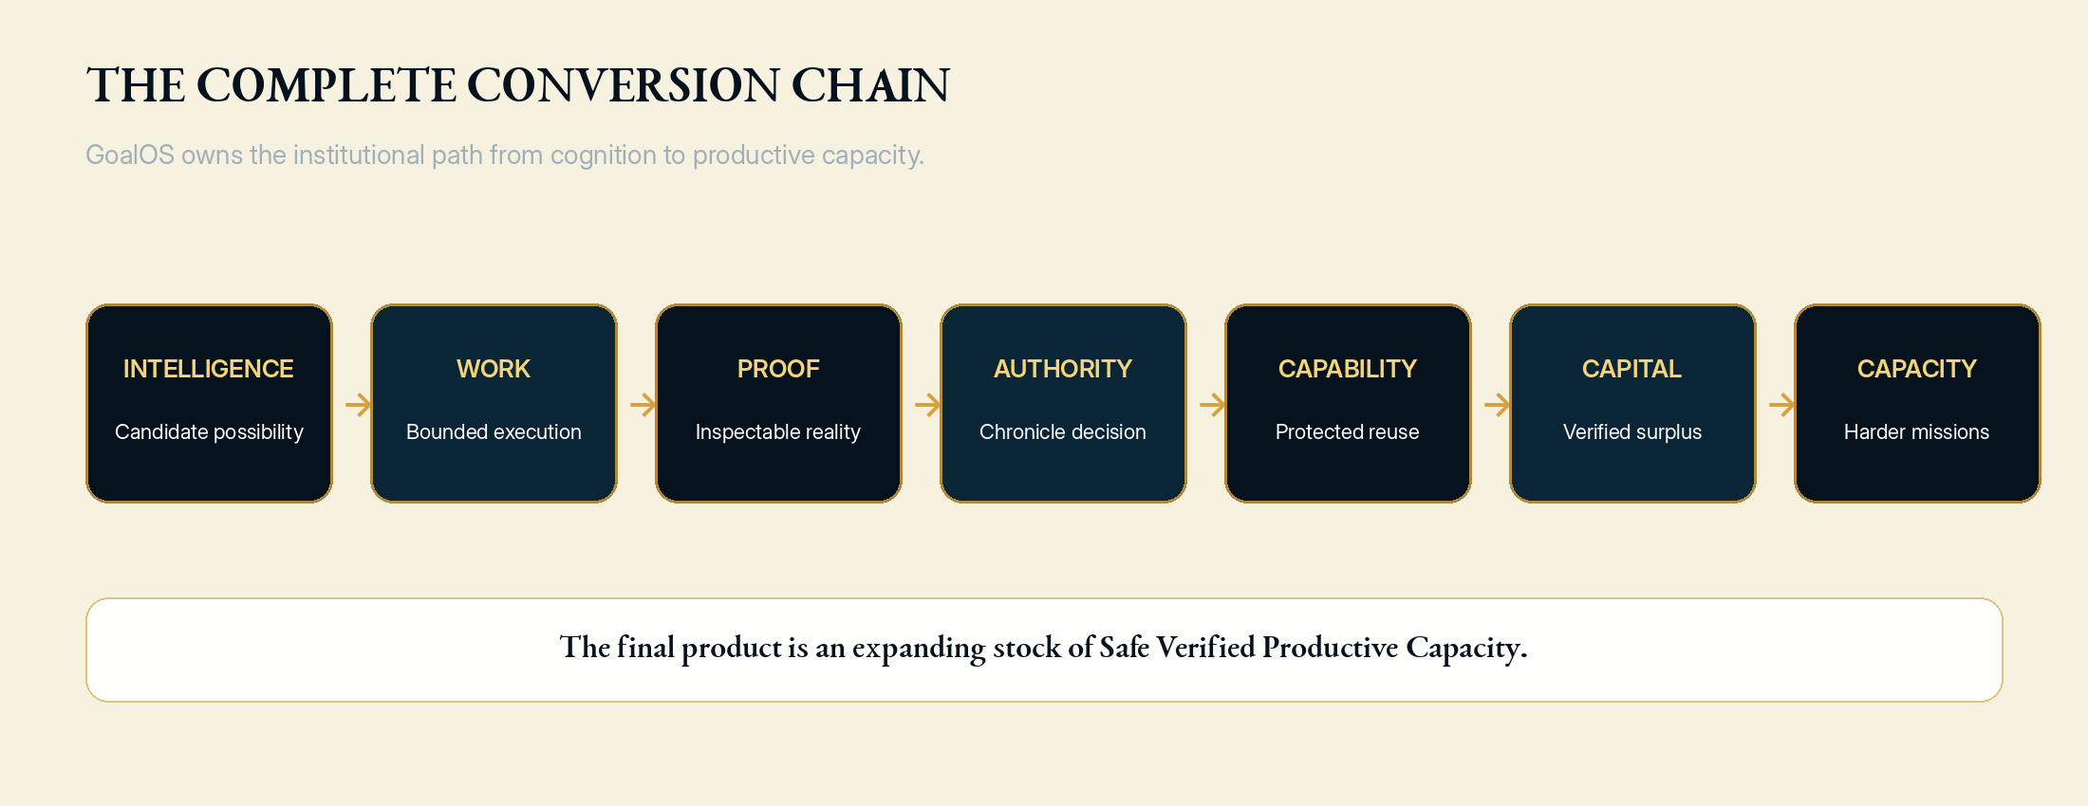

1. The strategic window

From generation to delegated work
Frontier systems are moving from short interactions toward multi-step work across files, tools, controlled environments and organizational context. As execution infrastructure becomes standardized, the scarce layer moves upward: which objectives deserve work, what authority is granted, what evidence is returned, who validates it, what may be remembered, what may be reused and how failure is reversed.

From optimization to evaluated evolution
Recent systems increasingly follow the same pattern: generate candidates, execute them, evaluate them, select what worked and preserve the improvement. This is meaningful, but incomplete. A system that can create a modification still requires an institution capable of deciding whether the modification deserves future influence. GoalOS is designed to supply that institutional gate.

From software capital to productive infrastructure
AI capital formation is increasingly bound to compute, energy, data, laboratories, industrial systems and physical infrastructure. The strategic winner will not simply own better cognition. It will own a disciplined mechanism for translating cognition into accepted work, accepted work into protected capability, protected capability into verified surplus and verified surplus into productive assets.
STRATEGIC DOCTRINE
Internally, operate with pre-discontinuity urgency. Externally, sell only measurable enterprise outcomes and publish only claims the evidence supports.

2. The complete MONTREAL.AI architecture
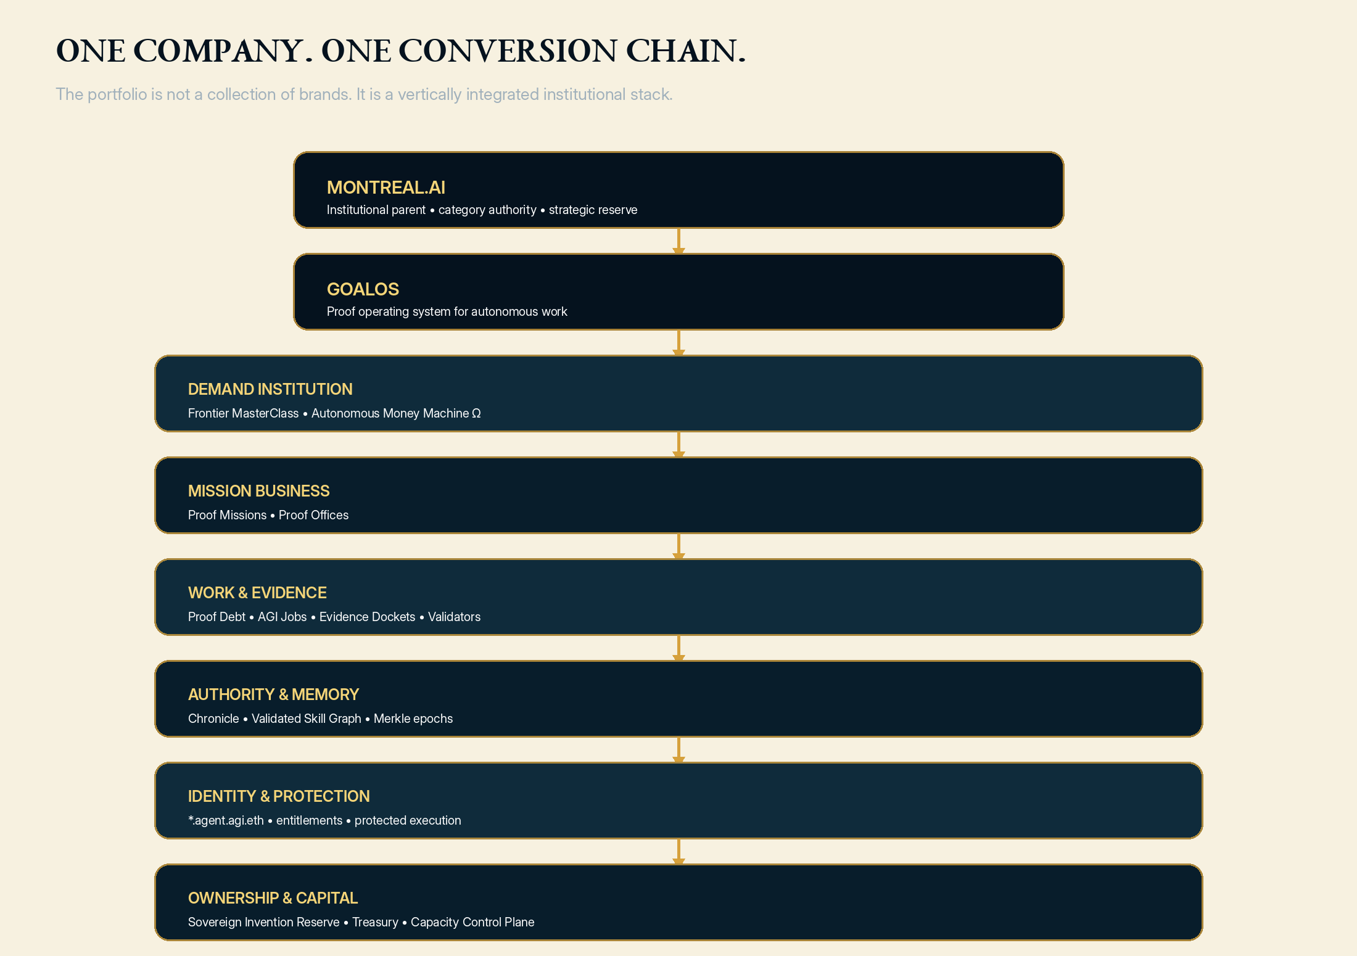
Layer | Function | Economic significance
MONTREAL.AI | Institutional parent, category authority, strategic reserve | Owns the category, canonical network, research provenance and long-horizon capital doctrine
GoalOS | Proof operating system for autonomous work | Controls the objective-to-capability conversion chain
Frontier MasterClass | Category education and executive demand | Creates qualified objectives rather than passive audiences
Autonomous Money Machine Ω | Commercial institution compiler | Converts objectives into priced, contracted and funded Proof Missions
Proof Missions | Initial high-value enterprise product | Produces paid outcomes and the first rights-cleared capability evidence
Proof Offices | Recurring enterprise control function | Creates durable relationships, monitoring and renewal economics
AGI Jobs + Evidence | Bounded work, review and proof | Turns open-ended objectives into finite evidence-producing labor
Chronicle + VSG | Authority and institutional memory | Determines what may survive, transfer and compound
Identity + protection | Direct agent identity, entitlement and private execution | Monetizes capability without surrendering the implementation
Treasury + capacity | Proof-gated capital allocation | Converts verified contribution into a larger future production frontier

3. The profoundly meta institution
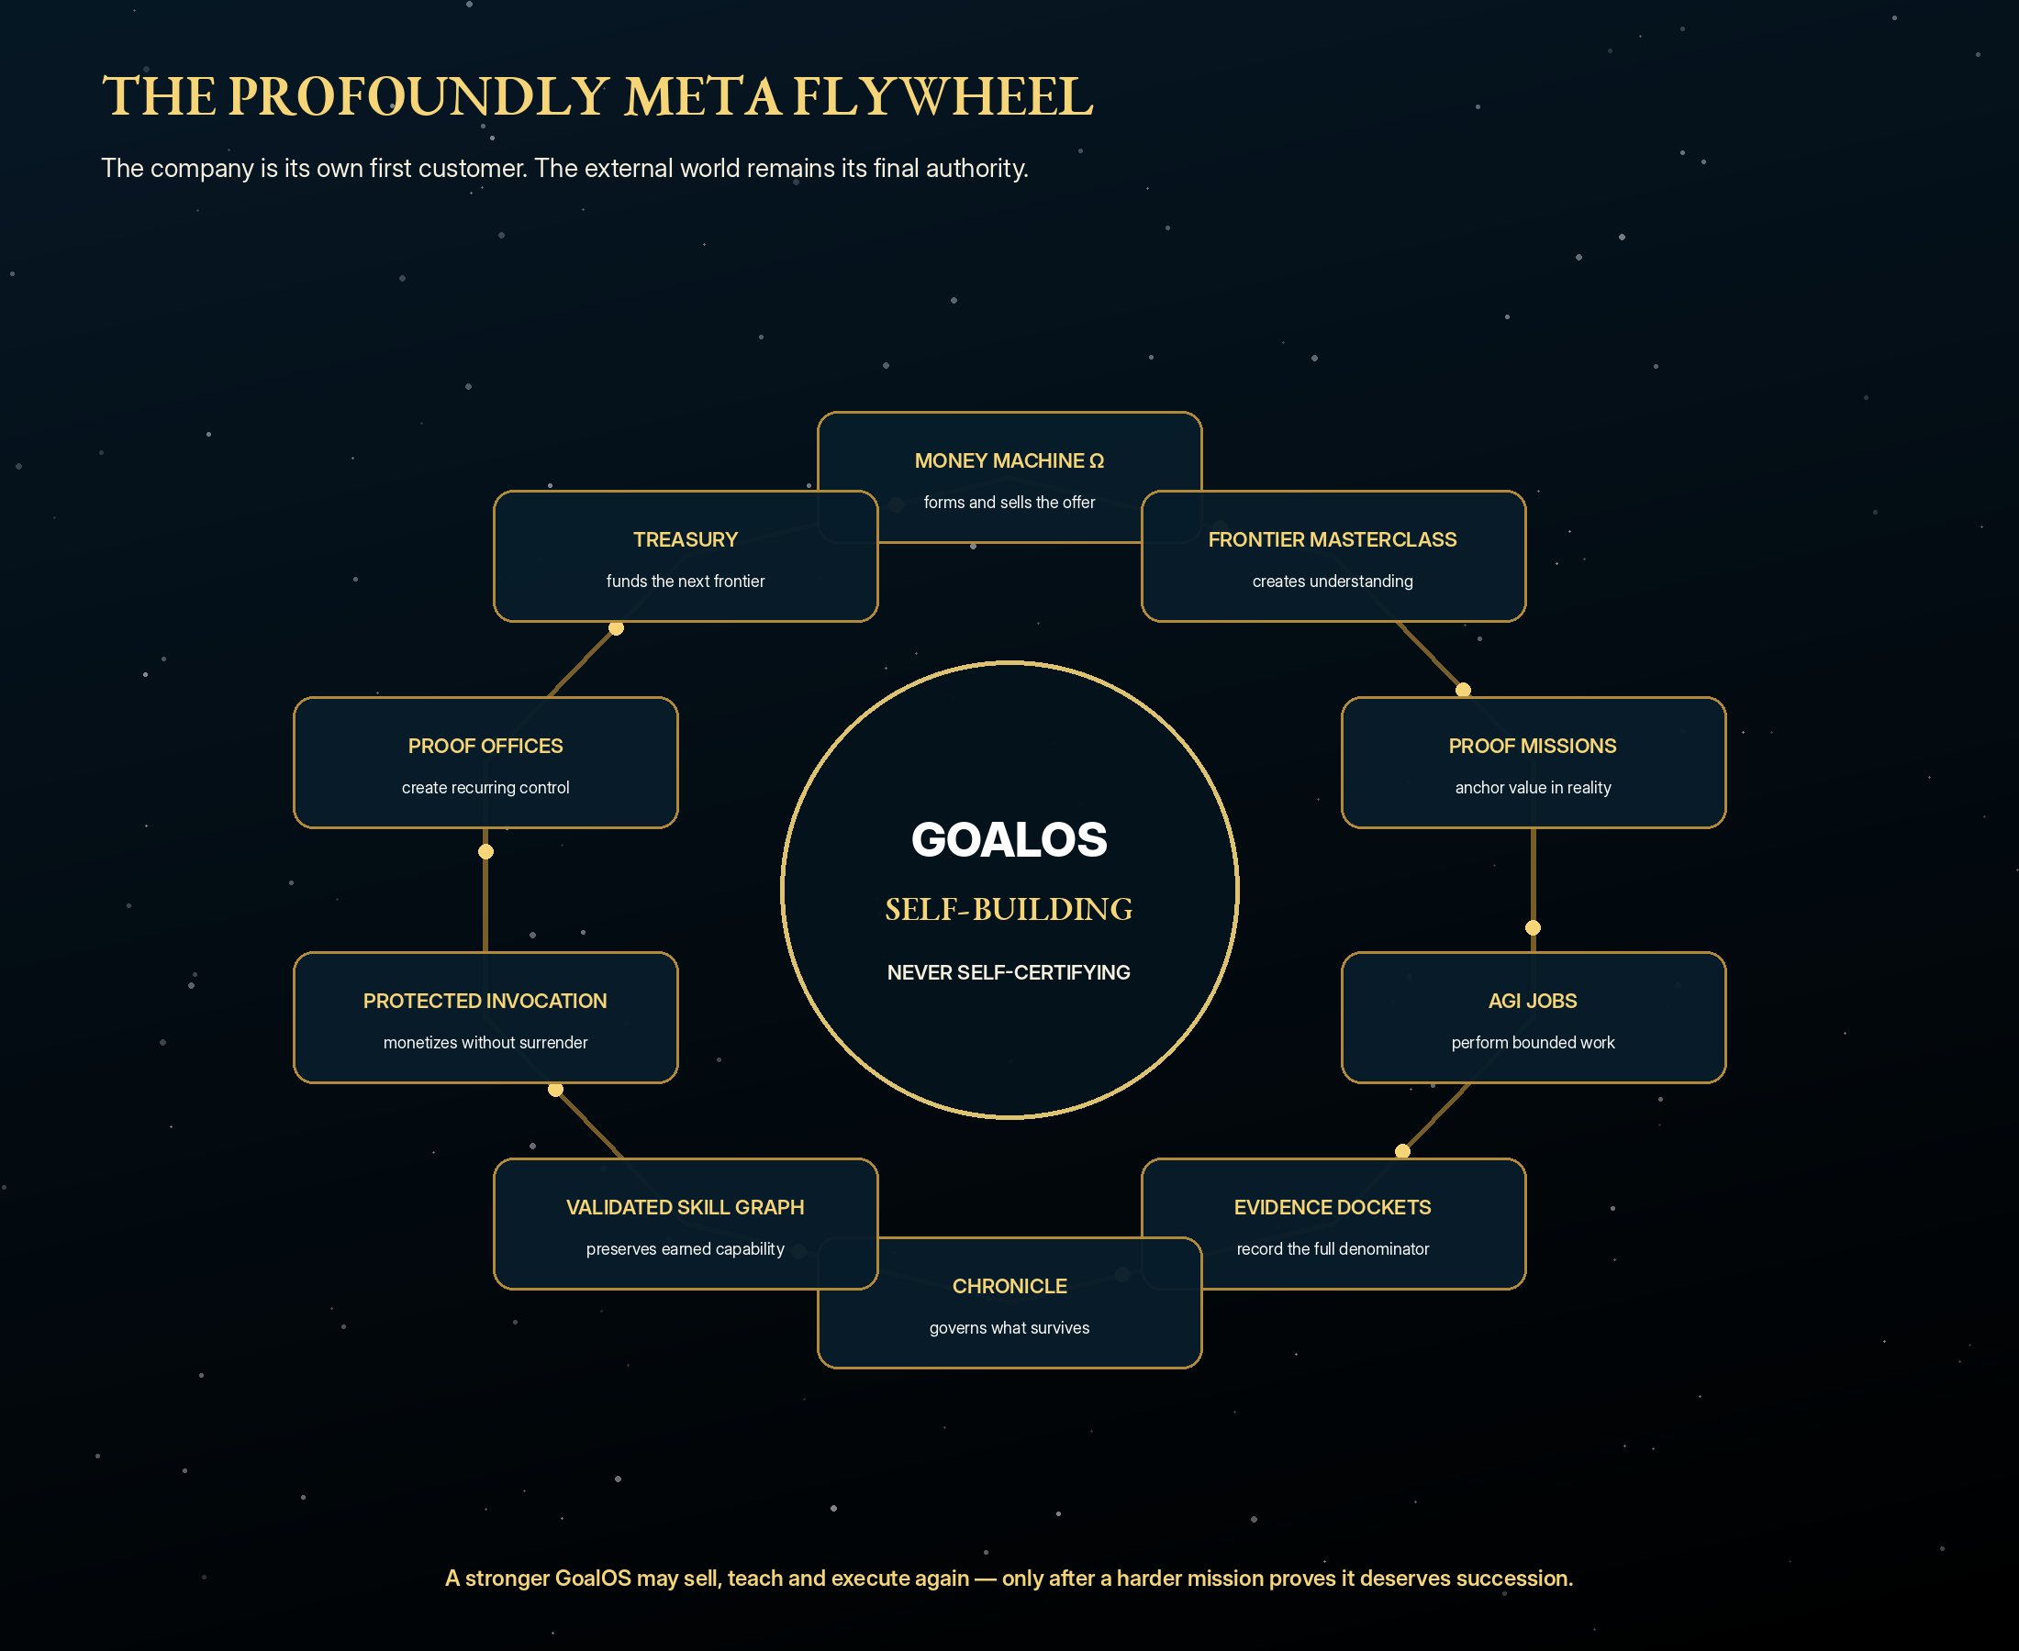
The company is its own first customer. The Autonomous Money Machine forms and sells the offer. The Frontier MasterClass explains the institution. Executives bring consequential objectives. Proof Missions test whether GoalOS creates value. AGI Jobs perform bounded work. Evidence Dockets record reality. Independent reviewers challenge the claims. Chronicle decides what may survive. The Validated Skill Graph preserves accepted capability. Protected invocation monetizes reuse. Proof Offices create recurring relationships. Treasury reinvests verified contribution. A stronger GoalOS sells, teaches and executes again.
WHY THIS IS NOT CIRCULAR
External payment, customer action, independent challenge, fresh successor missions and physical or financial outcomes close the loop. GoalOS may generate its successor. It may not control the test, the validator keys or the authority that promotes it.

The institutional maxim
GoalOS sells GoalOS.
GoalOS teaches GoalOS.
GoalOS tests GoalOS.
GoalOS governs what GoalOS may learn.
GoalOS protects what GoalOS has earned.
GoalOS finances the next GoalOS.
Only the external world may prove that the next GoalOS is better.

4. Six compounding engines
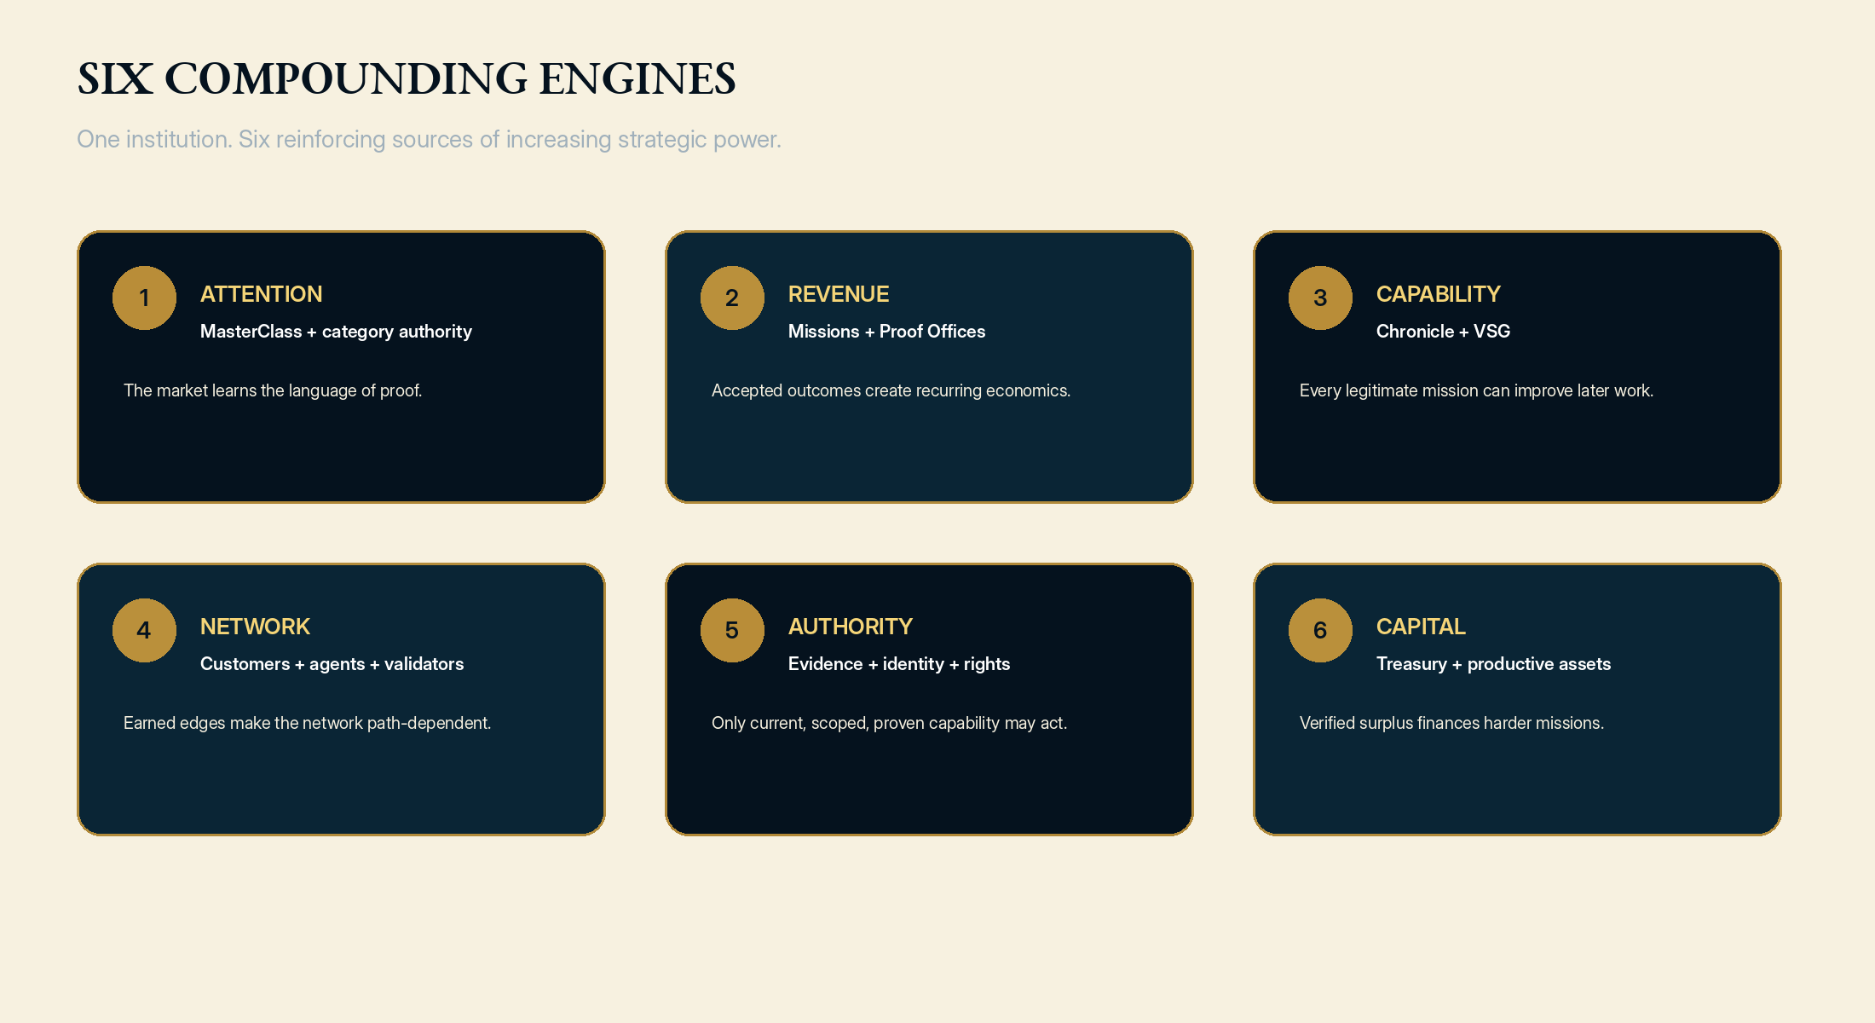
Engine | Immediate value | Long-term moat
Attention | MasterClass and category leadership | MONTREAL.AI becomes the authority that defines the market language
Revenue | Proof Missions and Proof Offices | Repeatable premium enterprise economics
Capability | Better methods, evaluators and workflows | Lower marginal delivery cost and better outcomes
Network | Customers, agents, validators and identities | A path-dependent institutional graph
Authority | Evidence, Chronicle, identity and root verification | Trusted capability that may safely influence future work
Capital | Verified free cash flow and productive assets | Compute, science, energy and infrastructure for harder missions

5. The optimal premium business model
The optimal business is a services-led, software-scaled, capability-licensed Proof Utility. Premium Proof Missions create immediate value and finance capability creation. Proof Offices create recurring control and customer dependence. Protected invocation produces software-like marginal economics. Network and settlement fees emerge only after the mission business has accumulated real evidence.
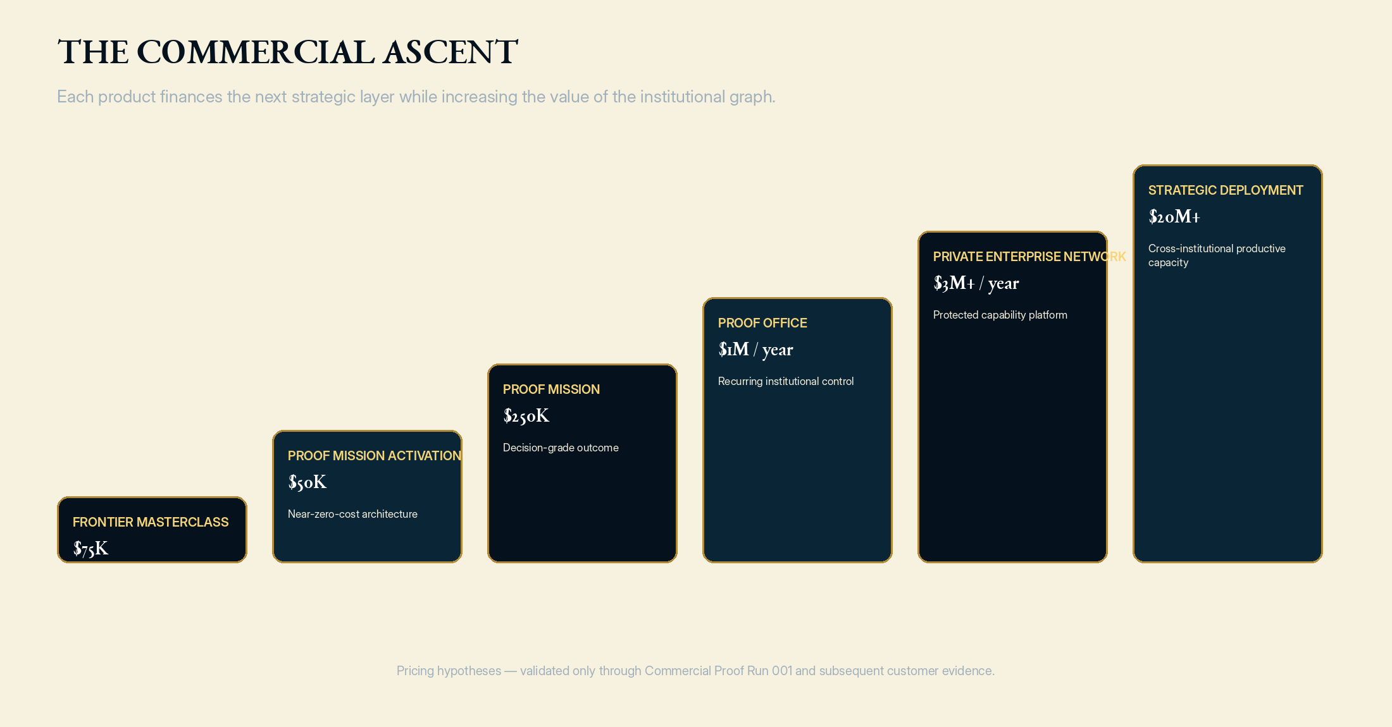
Product | Customer outcome | Pricing hypothesis | Target gross margin
Frontier Executive MasterClass | Executive understanding, qualified objective, initial Proof Debt | $75K | 90%
Proof Mission Activation | Mission Contract, evidence plan, value case and proceed/narrow/stop recommendation | $50K | 95%
GoalOS Proof Mission | Executed, reviewed and decision-grade outcome | $250K | 75%
GoalOS Proof Office | Recurring institutional control and capability lifecycle | $1M annually | 80%
Private Enterprise Network | Dedicated integrations, private graph, policies and protected execution | $3M+ annually | 85%
Protected Capability Invocation | Governed use of Chronicle-admitted private capability | $500+ per invocation | 80%+
Strategic / Sovereign Deployment | Cross-institutional Proof OS and productive-capacity programme | $20M+ | 45%+

PRICING LAW
Do not price from token cost. Price from conservative value at stake, subject to a non-negotiable margin floor, risk reserve, evidence burden and rights treatment.

6. The customer economic compact
Element | Illustrative first-year architecture
Proof Mission Activation | $50,000
Proof Mission | $250,000
Proof Office | $1,000,000
Protected usage and validation | $250,000
Total first-year fee | $1,550,000
Direct cost | $310,000
Gross profit | $1,240,000
Gross margin | 80%
Conservative customer value floor | $6,200,000
Illustrative customer ROI at floor | 300%

The customer is not buying hours. The customer is buying a defensible decision state, continuing institutional control and governed access to validated private capability. The transaction is attractive only when both parties win dramatically: the customer receives a multiple of verified value; GoalOS retains capital to build the capability network.

7. The autonomous commercial institution
GoalOS should not merely assist a salesperson. GoalOS should become the system through which the standard transaction is completed. The standard lane must autonomously diagnose, qualify, price, contract, collect, instantiate the mission, deliver, prove, renew and expand - with zero seller-side minutes.
- Market and intent engine identifies permissioned, high-value consequential objectives.
- Proof Readiness Scan exposes the value at stake, visible assumptions and likely Proof Debt.
- Personalized MasterClass explains only what that executive needs to understand.
- Qualification engine verifies sponsor, urgency, budget, risk, data readiness and value-to-fee ratio.
- Offer compiler selects a fixed product, price, evidence level, delivery window and rights class.
- Autonomous deal room supplies approved claims, ROI model, security materials, agreement and payment.
- Payment triggers a frozen Mission Contract and an executable Evidence Plan.
- Accepted delivery automatically activates the Proof Office and next-mission queue.
- Commercial Chronicle retains only the methods that produced collected cash, customer value, positive contribution and acceptable retention.
COMMERCIAL AUTONOMY STANDARD
Zero-touch in the standard commercial lane. Human-sovereign at the constitutional boundary. Fail closed when the customer request, liability, data use or contractual position leaves the approved product envelope.

8. Proof Missions - the first economic atom
The first mission must solve one expensive, bounded enterprise decision. The customer provides a real sponsor, budget, deadline, cost of error and evidence burden. GoalOS returns a Mission Contract, Proof Debt Register, AGI Jobs, Evidence Docket, reviewer verdict, governed decision, Value Realization Ledger and candidate Validated Skills.
- AI vendor or platform selection
- Agent deployment readiness and reliability
- Regulated or high-risk rollout assurance
- Acquisition, investment or portfolio diligence
- Commercial claim-to-proof and procurement acceleration
- Board-level capital allocation for consequential AI initiatives

9. Proof Offices - the recurring control plane
A Proof Office converts a successful mission into an annual institutional relationship. It continuously manages new objectives, Proof Debt, model and tool authorization, evaluation, reviewer operations, Chronicle, capability lifecycle, incidents, revocation, board reporting and verified customer value.
RENEWAL LAW
Recurring revenue must be renewed by evidence. The customer should see what changed, what value was created or protected, which claims expired, which risks emerged, what capability became reusable and what the next quarter now requires.

10. Chronicle - authority and memory firewall
Chronicle is the institutional decision layer that prevents abundant candidate output from becoming contaminated organizational memory. Candidate capability may be admitted, admitted with conditions, repaired, rejected, quarantined, superseded or retired. Inclusion is not truth; a cryptographic root records state, while Chronicle grants or removes institutional authority.
Decision | Meaning
ADMIT | Evidence and policy permit scoped future influence
ADMIT WITH CONDITIONS | Future use is limited by scope, expiry, reviewer burden or monitoring
REPAIR | Proof Debt becomes new bounded work
REJECT | The candidate does not earn memory
QUARANTINE | Potential value exists, but risk or uncertainty blocks use
SUPERSEDE | A newer validated version replaces future influence without deleting history
RETIRE | The capability loses authority because context, evidence or policy changed

11. The Validated Skill Graph - the compounding moat
The moat is not a model, prompt, dashboard or graph database. It is the accumulated rights-controlled history of customers, missions, claims, Proof Debt, workers, validators, evidence, failures, repairs, Chronicle decisions, entitlements, reuse events, customer outcomes and capital-allocation competence.
- CUSTOMER_PAID_FOR
- SPONSOR_AUTHORIZED
- MISSION_DELIVERED
- EVIDENCE_SUPPORTED
- REVIEWER_ACCEPTED
- CHRONICLE_ADMITTED
- RIGHTS_PERMIT_REUSE
- REPEAT_PURCHASE_FOLLOWED
- SUCCESSOR_IMPROVED_BECAUSE_OF
- CAPITAL_CREATED_CAPACITY
MOAT LAW
A competitor may regenerate a similar node. It cannot instantly reproduce the real missions, negative evidence, evaluator history, rights, failures, accepted reuse and customer dependence that earned the edges surrounding it.

12. Canonical identity and protected capability
The strongest open-system moat keeps standards and verification inspectable while preserving the scarce private asset. Current direct GoalOS agent identities receive scoped, revocable rights to invoke. GoalOS verifies identity, current ownership or delegation, entitlement, mission scope, Chronicle admission, latest-root inclusion and approved execution environment. The customer receives the result and proof; MONTREAL.AI retains the implementation.
FINAL ACCESS LAW
No direct name, no identity. No current ownership, no write. No Chronicle admission, no canonical skill. No entitlement, no use. No latest-root proof, no reliance. No verified outcome, no compounding.

13. GoalOS Treasury - the capital formation engine
Treasury is not a payment wallet. It is a proof-gated capital allocator. Only verified free cash flow remaining after taxes, delivery liabilities, refunds, disputes, operating reserves, security obligations and independent-review costs may be reinvested.
Capital destination | Initial policy range | Required evidence
Customer acquisition and delivery | 20-30% | CAC payback, margin, repeat purchase and customer value
Capability engineering | 20-30% | Fresh mission lift, replay success and reduced reviewer burden
Models, compute, data and environments | 10-20% | Measured improvement in cost, quality or throughput
Validation, legal, safety and security | 10-15% | Trust metrics, incident reduction and resilience
Strategic infrastructure pilots | 10-20% | Milestones, telemetry, project-finance readiness and stop conditions
Bounded frontier options | 5-10% | Capped downside, review date and explicit termination path

Every material allocation becomes another Proof Mission: investment thesis, baseline, expected capacity gain, milestones, telemetry, evidence, continuation decision and rollback. This is how a Money Machine becomes a productive-capacity institution rather than a revenue dashboard.

14. Safe Verified Productive Capacity
Revenue is necessary but insufficient. Graph size and agent activity are insufficient. The governing north-star metric should measure the institution's verified ability to produce larger outcomes under stronger control.
CONCEPTUAL METRIC
Safe Verified Productive Capacity increases when independently supported value, measured reuse advantage, ownership, freshness and governance rise - while unresolved Proof Debt, security risk, concentration and negative externalities fall.

- More verified outcomes at lower cost
- Less unsupported-claim leakage
- More rights-cleared capability reused across fresh missions
- Stronger governance, revocation and recovery
- Greater future mission capacity without uncontrolled authority expansion

15. Corporate and capital architecture
Entity / reserve | Role
MONTREAL.AI Holdco | Owns the category, brand, canonical network, strategic governance and long-horizon capital doctrine
GoalOS Operating Company | Enterprise transactions, Proof Missions, Proof Offices and customer success
GoalOS Platform Company | Runtime, Chronicle, VSG, private execution, identity and entitlement
Sovereign Invention Reserve | Rights-cleared high-leverage capabilities, evaluator systems and research assets
GoalOS Treasury | Reserves, reinvestment and proof-gated allocation
Infrastructure SPVs | Ring-fenced compute, energy, laboratory and industrial projects financed against milestones

16. Ten-year architecture of scale
The companion model is intentionally ambitious. Its purpose is not prediction. Its purpose is to show what must become true for GoalOS to evolve from premium Proof Missions into a global institutional control layer with recurring software, private capability, network and strategic deployment economics.
Metric | Y1 | Y5 | Y10
Revenue | $2.2M | $341M | $9.63B
Gross profit | $1.8M | $263M | $7.66B
EBITDA | ($1.7M) | $123M | $5.08B
Recurring + usage mix | 25% | 80% | 91%
Proof Offices | 0.75 | 100 | 1,300
Chronicle capabilities | 1 | 300 | 7,500
Safe Verified Productive Capacity Index | 1.0x | 30x | 900x

SCALE BOUNDARY
The model does not assert a company valuation or guaranteed performance. The financial architecture becomes credible only when proof gates are retired in sequence: payment, accepted outcomes, repeat purchase, recurring contracts, transferable capability, protected invocation, network dependence and productive asset performance.

17. The evidence ladder
Stage | Evidence required | Institutional state
Commercial proof | 3 paying customers, 1 verified outcome, 1 repeat, positive contribution | Evidence-producing company
Repeatable product | 20-30 missions, 5+ Proof Offices, 5+ admitted capabilities, declining founder hours | Productized enterprise institution
Enterprise platform | 20+ enterprises, 50%+ recurring, private deployments, independent validator capacity | $10M-$25M ARR platform candidate
Category standard | 100+ institutions, US$100M+ recurring trajectory, external ecosystem and replay at scale | Serious decacorn candidate
Productive infrastructure | Global standard, very large recurring and transaction economics, successful capital allocation and productive assets | Serious megacorn candidate

18. Commercial Proof Run 001
Gate | 90-day requirement
Demand | 3 unrelated paying customers
Repeatability | 3 substantially identical bounded missions
Delivery | 3 Evidence Dockets with the full denominator
Authority | At least 1 independently verified outcome
Retention | At least 1 repeat, renewal or expansion
Capability | At least 1 rights-cleared Chronicle-admitted capability
Successor | At least 1 fresh, preregistered improvement
Economics | Positive attributable contribution
Trust | 0 material trust breaches

19. Institutional constitution
- No self-certification: the party that produces material work cannot be the sole validator or memory authority.
- No unbounded authority: every identity, entitlement, tool, budget, model and capability has scope, expiry and revocation.
- No unproved memory: raw output may enter working storage; only Chronicle-admitted capability may influence future missions.
- No silent self-modification: every candidate successor remains isolated until it passes a fresh test and can be rolled back.
- No hidden denominator: failures, retries, interventions, costs and rejected claims remain in the Evidence Docket.
- No unverifiable economic compounding: Treasury reinvestment requires accepted outcomes, attributable contribution and satisfied obligations.
- Fail closed: when identity, evidence, scope, rights, budget or current state cannot be verified, GoalOS pauses rather than inventing permission.

20. Final positioning
THE PUBLIC DECLARATION
MONTREAL.AI is not launching another AI product. It is constructing the proof-governed institution through which intelligence becomes trusted work, trusted work becomes protected capability, protected capability becomes recurring economic power, and verified economic power finances a larger future.

The visionary voice opens the world. The enterprise voice closes the contract. The institution must possess both: an opulent horizon large enough to attract talent, capital and strategic partners, and a precise enterprise offer narrow enough to be purchased, tested, challenged and accepted.
Maximum ambition. Minimum unsupported claim. One operating system. One compounding institution. One consequential mission at a time.

Selected sources and evidence boundary
External sources establish the timing context. GoalOS pricing, revenue, ROI, financing, valuation and capacity scenarios are management hypotheses until verified by customer and operating evidence.
- OpenAI - ChatGPT Work and workspace agents
- OpenAI - Agents SDK and long-running work
- METR - Task-Completion Time Horizons
- Google DeepMind - AlphaEvolve impact
- Google DeepMind - From AGI to ASI
- Anthropic Institute - Research agenda
- Gartner - Worldwide AI spending forecast
- Government of Canada - Sovereign AI supercomputing initiative
- MONTREAL.AI - Merkle Roots for the Validated Skill Graph
- MONTREAL.AI - Private On-Chain Validated Skill Graph
CLAIM BOUNDARY
No achieved general intelligence, unrestricted recursive improvement, guaranteed outcome, legal certification, audited forecast or present enterprise valuation is claimed.

