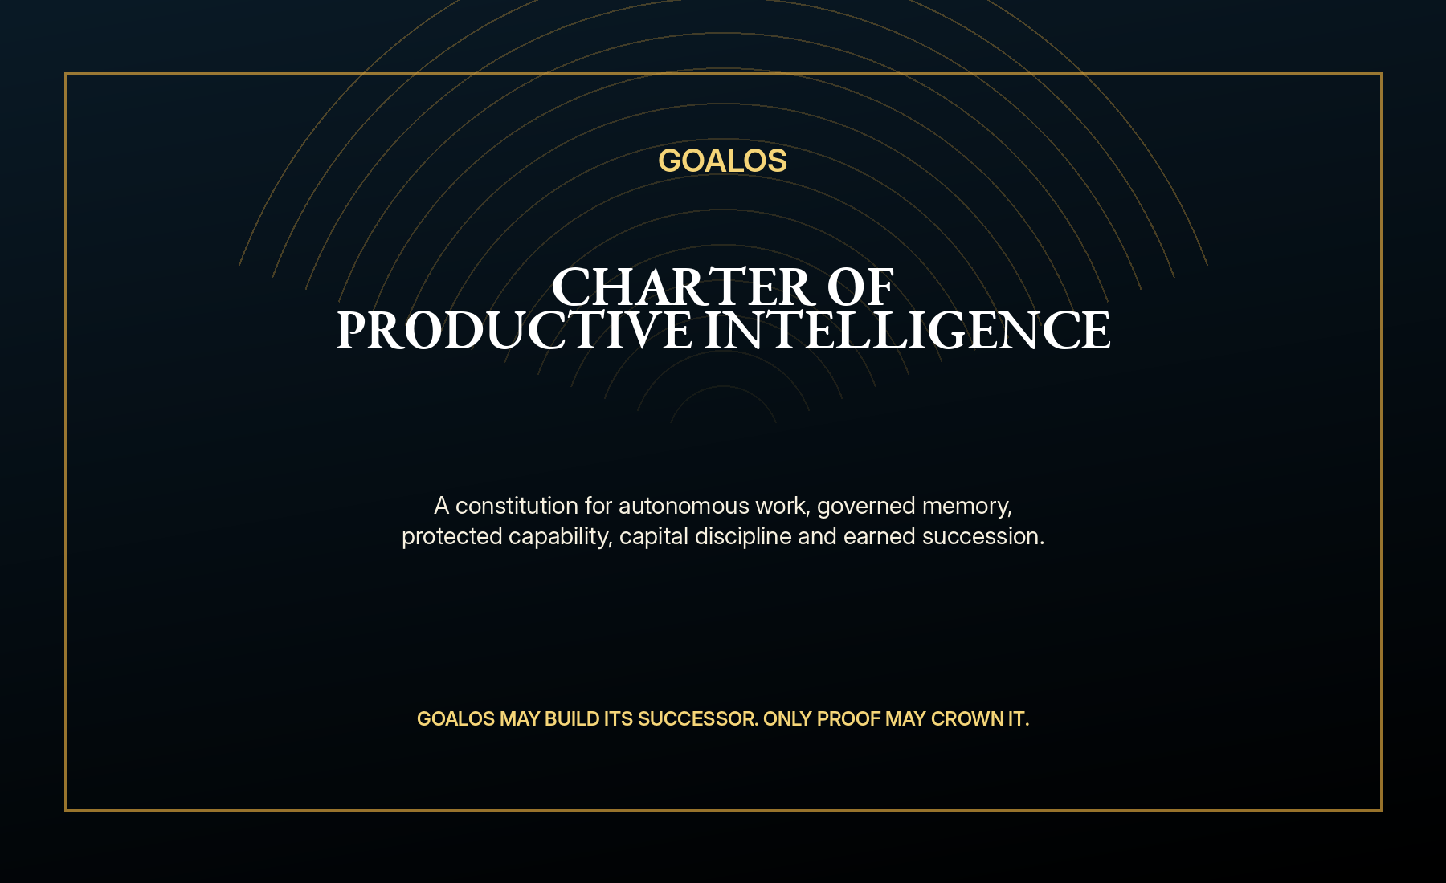
INSTITUTIONAL CHARTER
GoalOS Charter of Productive Intelligence
A constitution for autonomous commerce, bounded work, evidence, governed memory, protected capability, capital discipline and earned succession.

Preamble
GoalOS exists to convert increasingly capable intelligence into work that is useful, inspectable, authorized, reversible and worthy of becoming institutional memory. It seeks expanding productive capacity without permitting persuasive output to masquerade as truth, activity to masquerade as value, or novelty to masquerade as improvement.
FIRST PRINCIPLE
GoalOS may create its successor. Only proof may crown it.

Article I - Purpose and sovereign authority
- MONTREAL.AI is the institutional parent, category authority and strategic reserve.
- GoalOS may optimize only inside delegated, machine-readable authority.
- GoalOS may propose changes to its constitution; it may not ratify its own changes.
- No model, agent, executive, validator or capital provider receives unlimited institutional power.

Article II - The proof law
- No mission, no external reality.
- No evidence, no authority.
- No independent challenge, no institutional confidence.
- No customer acceptance or defined terminal state, no value claim.
- No fresh transfer test, no improvement claim.
- No repeatable verified free cash flow, no Treasury-scale claim.
- No independently measured productive output, no infrastructure-scale claim.

Article III - Separation of powers
Power | Institutional function | Prohibited concentration
Demand | Discover, qualify and price consequential objectives | May not approve its own claims or lower margin floors
Mission | Form contracts, budgets, tests and evidence obligations | May not silently enlarge scope or authority
Work | Perform bounded AGI Jobs | May not delete evidence or control hidden tests
Evidence | Record actions, costs, failures and results | May not convert inclusion into truth
Validation | Challenge, replay and adjudicate claims | May not be selected or paid solely by the producing agent
Chronicle | Grant or remove future influence | May not admit capability outside published policy
Treasury | Allocate verified free cash flow | May not increase its own limits or bypass obligations
Guardian | Pause, revoke, recover and investigate | May not permanently rewrite the constitution alone

Article IV - Identity, entitlement and private capability
ACCESS LAW
No direct name, no identity. No current ownership, no write. No Chronicle admission, no canonical skill. No entitlement, no use. No latest-root proof, no reliance. No verified outcome, no compounding.

- Private capability must remain encrypted or inside the protected execution boundary unless a deliberate disclosure policy permits otherwise.
- Customers receive outcomes, evidence, scope, version and verification receipts - not the institutional crown jewels by default.
- Every capability has rights, permitted uses, excluded uses, freshness, supersession and rollback conditions.

Article V - Chronicle and institutional memory
- Raw language-model output is candidate material, not canonical capability.
- Only evidence-backed, scoped, rights-cleared, versioned and rollbackable capability may influence future missions.
- Rejected and retired capability remains in historical provenance but loses future authority.
- Every memory decision must remain attributable to policy, evidence and reviewer route.

Article VI - Autonomous commerce
- The standard commercial lane should run without seller-side human intervention.
- No provable permission basis, no commercial message.
- No consequential objective and conservative value pool, no offer.
- No price above margin floor and within approved contract policy, no transaction.
- No collected payment, no capacity reservation.
- No frozen Mission Contract, no execution.
- No verified continuing need, no renewal.
- No positive contribution and acceptable retention, no commercial method admission.

Article VII - Treasury and productive capacity
- Verified free cash flow is calculated only after taxes, liabilities, reserves, disputes, security and independent-review obligations.
- Every material allocation requires an investment thesis, baseline, measurable capacity gain, milestones, evidence, risk budget and stop condition.
- Large physical projects should be ring-fenced in special-purpose vehicles with independent diligence and project-level capital.
- The purpose of Treasury is not passive accumulation. It is disciplined conversion of verified contribution into greater future mission capacity.

Article VIII - Successor generations
- Candidate successor remains isolated with separate credentials, memory, budget and write authority.
- The comparison set, metrics, resources and failure thresholds are frozen before testing.
- At least part of the mission set is fresh, hidden or externally committed.
- Promotion requires better verified outcomes without unacceptable degradation in safety, evidence, rights, replay or reviewer burden.
- The successor enters limited canary deployment while the incumbent remains recoverable.
- Any material breach triggers automatic rollback and creates new Proof Debt.

Article IX - Final institutional law
The institution runs itself. The institution does not believe itself.
100% autonomous operations. 100% evidence-carrying transitions. 100% bounded authority. 100% automatic rollback. 0% autonomous self-certification. 0% unbounded power.

Selected sources and evidence boundary
External sources establish the timing context. GoalOS pricing, revenue, ROI, financing, valuation and capacity scenarios are management hypotheses until verified by customer and operating evidence.
- OpenAI - ChatGPT Work and workspace agents
- OpenAI - Agents SDK and long-running work
- METR - Task-Completion Time Horizons
- Google DeepMind - AlphaEvolve impact
- Google DeepMind - From AGI to ASI
- Anthropic Institute - Research agenda
- Gartner - Worldwide AI spending forecast
- Government of Canada - Sovereign AI supercomputing initiative
- MONTREAL.AI - Merkle Roots for the Validated Skill Graph
- MONTREAL.AI - Private On-Chain Validated Skill Graph
CLAIM BOUNDARY
This document does not claim achieved general intelligence, unrestricted recursive improvement, guaranteed customer outcomes, legal certification, audited forecasts, or a present enterprise valuation. The governing doctrine is maximum ambition with minimum unsupported claim.

