SOVEREIGN INTELLIGENCE CONSTITUTION
GoalOS-Native alpha-AGI Ascension using AGIALPHA
A Sovereign RSI Architecture for Evidence-Governed Intelligence Organizations

By Vincent Boucher
President, QUEBEC.AI & MONTREAL.AI
Sovereign AI | AI-First Institutions | AI Governance | Governed Agents
Core thesis
GoalOS sets sovereign aims. AGIALPHA coordinates proof-settled work. AEP-001 defines valid evidence. The Proof Gradient decides what may evolve. The intelligence stays private. The proof becomes verifiable.
This paper defines a practical sovereign RSI architecture: improvements earn the right to propagate only through evidence, evaluation, reviewer validation, scope control, monitoring, and rollback readiness.
Sovereign RSI Edition v6.3

Abstract
AI systems should not merely act, remember, or self-improve. They should produce evidence strong enough to govern what may improve next. GoalOS-native alpha-AGI Ascension using AGIALPHA defines a sovereign RSI architecture in which institutional aims become signed commitments, bounded agents execute proof missions, AGIALPHA coordinates proof-settled work, reviewers validate evidence, Evidence Dockets make claims auditable, and the Selection Gate grants propagation rights only to verified improvements.
The paper reinterprets alpha-AGI Ascension as a practical proof-work economy: opportunities become proof missions; builders produce replayable ProofBundles; reviewers issue attestations; Proof Cards create public-safe trust; credentials and reputation route future work; and accepted artifacts become proof-backed upgrade rights. The result is not an ungated swarm or a speculative foresight market. It is an evidence-governed intelligence institution whose recursive self-improvement occurs through proofs, baselines, challenge windows, canaries, rollbacks, and durable chronicle memory.
Claim boundary: this is a protocol and architecture paper. It does not claim achieved AGI, ASI, superintelligence, guaranteed economic return, legal approval, tax approval, security approval, energy abundance, or Kardashev Type II achievement. It defines the machinery required to test whether verified work can become reusable capability and whether reusable capability can compound under sovereign governance.

1. Executive Thesis
The strategic advantage of GoalOS-native alpha-AGI Ascension is not raw autonomy. It is governed improvement. Frontier models make action cheap; they do not make institutional trust cheap. This architecture makes trust programmable by requiring every material improvement to pass through evidence, evaluation, reviewer validation, scope control, canary rollout, monitoring, and rollback readiness before it can affect future work.
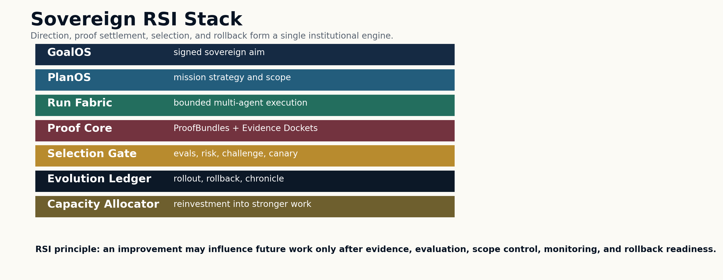

2. Canonical Contributions
Contribution | Definition | Why it matters
Sovereign RSI | Defines recursive self-improvement as proof-backed upgrade rights rather than ungated self-modification. | Practical governance of improvement.
GoalOS Aim Layer | Converts strategic intent into signed commitments with authority, risk, budget, evaluators, and rollback. | Prevents local agent optimization from drifting away from institutional goals.
AGIALPHA Settlement Rail | Coordinates posting, bonds, proof submission, reviewer validation, settlement, and reputation. | Turns work into replayable proof-settled machine labor.
Evidence Docket | Packages claims, baselines, proof bundles, costs, risks, replay paths, and challenge records. | Makes public claims auditable rather than promotional.
Selection Gate | Promotes only candidates with proof, evaluations, scope controls, canary evidence, monitoring, and rollback readiness. | Separates capability from authority to propagate.
Capacity Reinvestment | Channels verified gains into compute, data, tooling, validators, security, and future mission capacity. | Connects near-term workflow proof to the long strategic horizon.

3. Reimplementation Mapping
The reimplementation preserves the ambition of alpha-AGI Ascension while replacing ambiguous autonomy with auditable proof mechanics. It turns foresight, seeds, markets, agents, validators, and sovereign transformation into concrete operating primitives: Opportunity Dockets, Proof Missions, Proof Cards, Credentials, Reputation, Evidence Dockets, and Selection Certificates.
Original layer | GoalOS-native layer | Upgrade
alpha-AGI Insight | GoalOS Opportunity Intelligence | Turns foresight into auditable workflow opportunity dockets.
Nova-Seeds | Proof Seeds | Replaces speculative seed language with mission-ready, public-safe opportunity artifacts.
MARK | AGIALPHA Proof Mission Board | Moves from futures on foresight to sponsor-funded proof missions.
Sovereign | GoalOS Proof Room / Sovereign Pilot | Transforms enterprises through governed workflow improvement, evidence, rollout, and rollback.
Marketplace | AGIALPHA Proof Work Network | Coordinates sponsors, builders, reviewers, credentials, reputation, and settlement.
Agents | Builders / Operators | Executes bounded workflows and emits proof bundles.
Validator Council | Reviewer Network + Selection Gate | Validates evidence through rubrics, challenge windows, and reputation.
Architect | Proof Gradient + Agent Evolution Protocol | Turns meta-optimization into governed RSI.

4. AGIALPHA Proof-Settlement Lifecycle
AGIALPHA is used as the existing coordination asset for proof-settled work. Its institutional role is utility coordination: mission posting, bonds, settlement, metrology, reviewer coordination, and protocol operations. It is not described as equity, revenue share, yield, ownership, or guaranteed return.
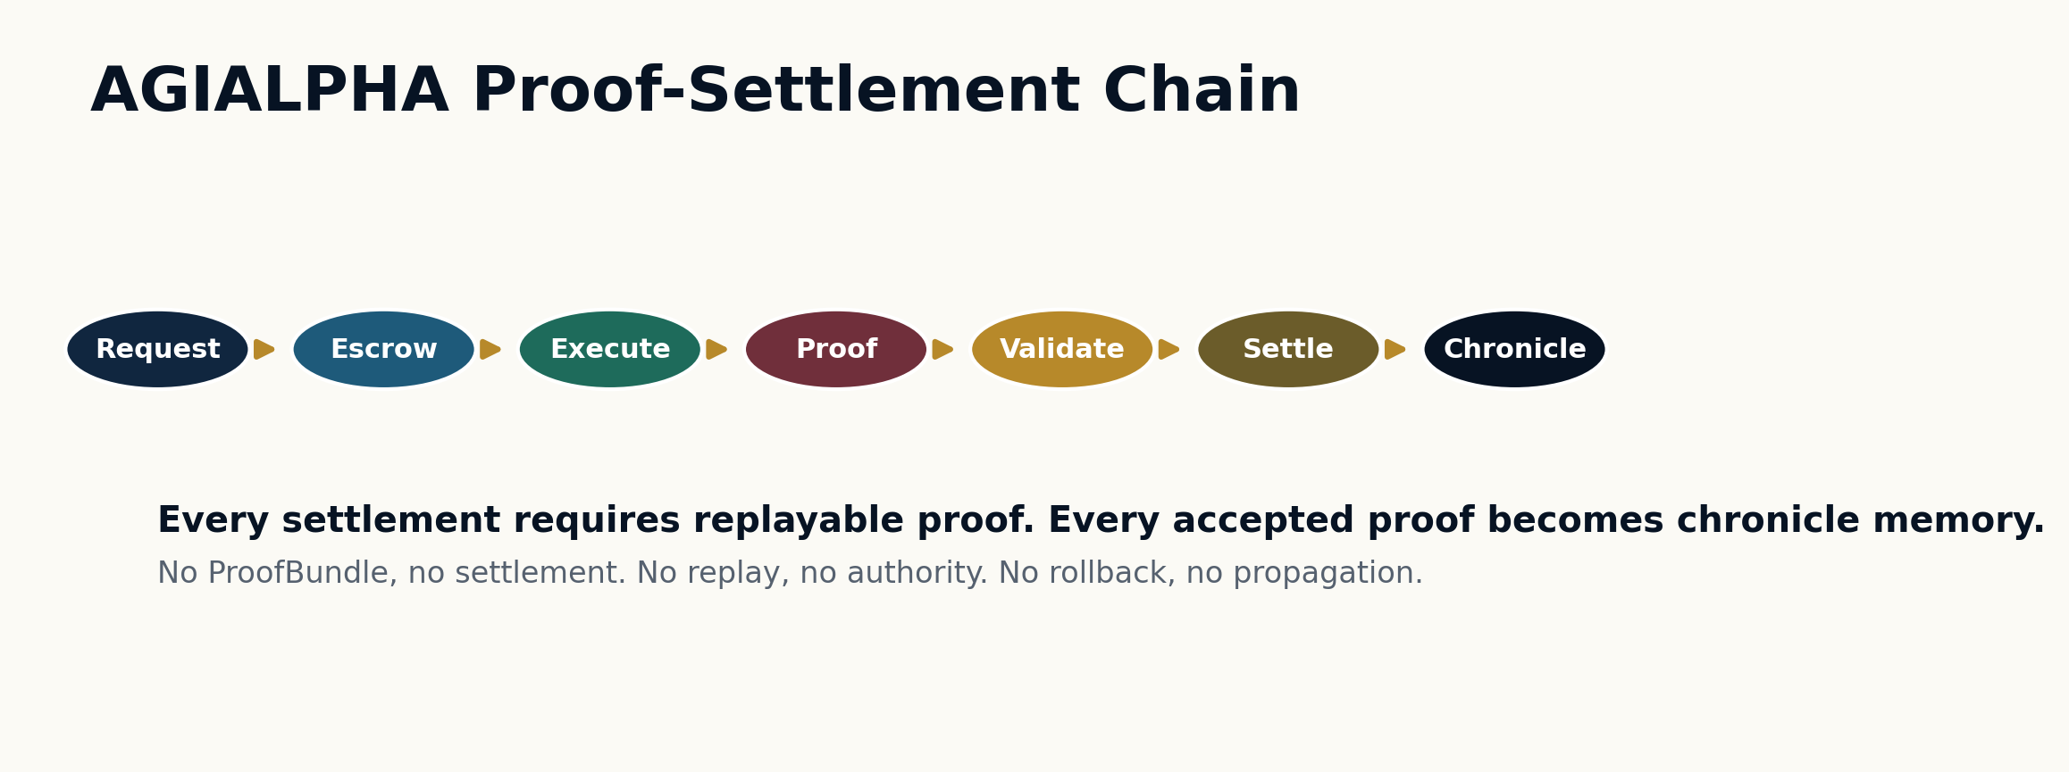

5. Sovereign RSI: The Practical Mechanism
The RSI mechanism is institutional, not magical. A model does not freely rewrite itself. Instead, the intelligence organization recursively improves workflows, proof templates, validator rubrics, tools, mission environments, agent coalitions, archives, and allocation policies. The object of improvement is the proof-carrying operating system around the agents.
The RSI loop is: detect a gradient; generate candidates; execute bounded work; package proof; validate; settle; archive; allocate; monitor delayed outcomes; and promote only when rollback is ready. High novelty creates higher scrutiny, not automatic authority.
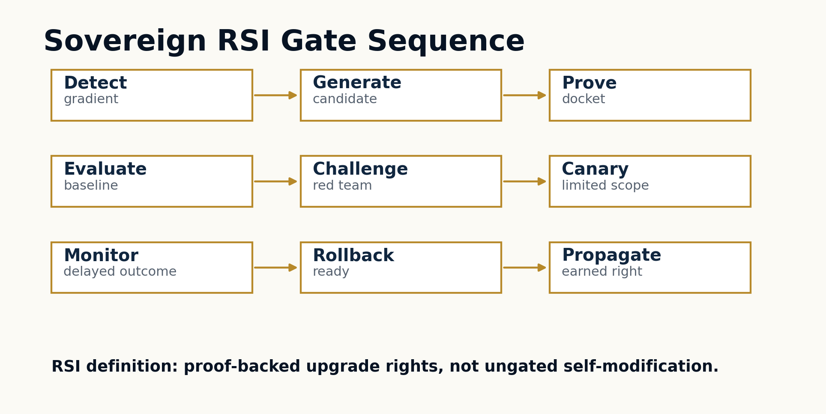

6. Large Multi-Agent Coordination Fabric
The system is designed as an operating theater of specialized agents and offices, not a single autonomous actor. Each role has bounded authority, emits a named artifact, and participates in evidence creation. The goal is not to maximize action volume; the goal is to maximize verified useful work under cost, risk, and rollback constraints.
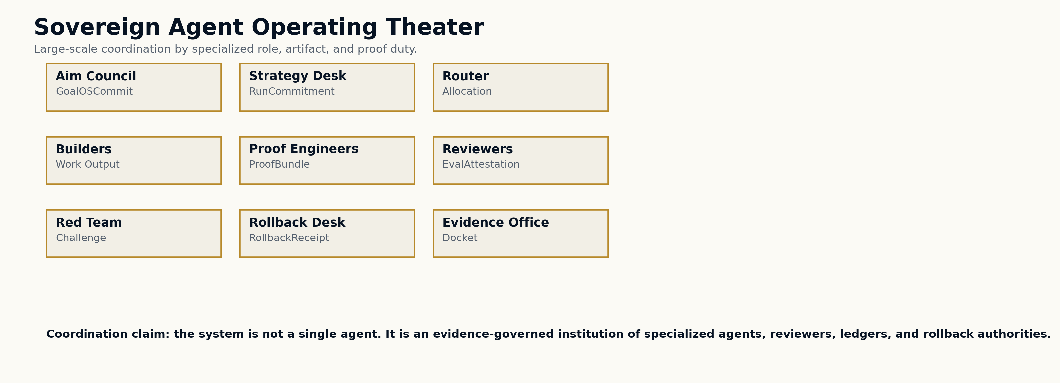

7. Skills Used
Skills are not vague capabilities. They are named operational competencies with inputs, outputs, and verification obligations.
Skill | Layer | What it does
GoalOSCommit Compiler | Aim | Turns sovereign intent into signed mission commitments with risk, budget, evaluators, and rollback.
Mission Foundry | Planning | Generates proof missions, environments, validators, and curricula for high-value workflow domains.
Constellation Router | Coordination | Routes work to builder coalitions, proof engineers, reviewers, red teams, and rollback desks.
ProofBundle Packager | Evidence | Packages traces, hashes, telemetry, signatures, costs, risks, replay data, and validation inputs.
Reviewer Council Orchestrator | Validation | Coordinates bonded reviewers, commit-reveal logic, dispute windows, and slashing paths.
Selection Gate Judge | Evolution | Awards propagation rights only after proof, evals, canary, monitoring, and rollback readiness.
Capacity Allocator | Reinvestment | Converts verified gains into stronger future compute, data, tools, security, and mission capacity.

8. Plans Used
Plan | Operational motion | Proof output
Season 001 Proof Missions | Begin with five high-signal missions: support workflow, claims-safe launch, workshop qualification, sponsor missions, reviewer quality. | Create first public-safe proof cards and reviewer history.
Sovereign Proof Room Pilot | Select one department workflow, baseline it, run builders, validate, publish a docket, and expand only after rollback readiness. | Makes enterprise adoption auditable.
AGIALPHA Settlement Rehearsal | Use test environment to run post -> claim -> proof -> validate -> proof card -> credential -> reputation -> settlement. | Proves the proof-work economy before mainnet authorization.
Evidence Docket Publication | Publish public-safe claim, baseline, proof packet, evals, cost/risk ledger, validation verdict, and delayed-outcome plan. | Turns proof into institutional trust.
RSI Dossier Program | Capture accepted and rejected upgrade candidates, falsification tests, rollback events, and capacity reinvestment decisions. | Prevents novelty theater and makes improvement cumulative.

9. Goals Used
Goal | Operational target | Measurement
Institutional trust | Make claims inspectable through Evidence Dockets and Proof Cards. | Independent replay, reviewer agreement, false acceptance rate.
Sovereign RSI | Make improvements cumulative without allowing unverified propagation. | Accepted artifacts beating baselines under equal budget.
Proof-settled work | Use AGIALPHA to coordinate work only when proof and validation exist. | No settlement without ProofBundle and validation.
Capacity compounding | Reinvest verified gains into stronger future work. | Useful work per cost, cost/watt, reuse rate, validator quality.
Claim discipline | Keep civilization-scale language as horizon, not present-tense claim. | Claim-boundary audits and external review.

10. Evidence Docket as Sovereign Proof Room
The Evidence Docket is the institutional proof room. It contains the claim, baseline, mission commitment, policy context, proof bundle, replay path, evaluator attestations, cost ledger, risk ledger, settlement receipt, challenge status, rollback plan, delayed-outcome monitor, and public/private boundary. Without a docket, a claim remains a story. With a docket, it becomes auditable.
Docket section | Purpose | Failure if absent
Claim matrix | States what is being claimed and what is not being claimed. | Marketing can outrun evidence.
Baseline ledger | Defines static, human, agentic, and prior-version comparators. | Improvement cannot be measured.
ProofBundle | Packages hashes, logs, traces, telemetry, signatures, replay path, and settlement evidence. | Work cannot be reproduced or disputed.
Reviewer record | Stores evaluator attestations, challenges, and decisions. | Validation becomes unaccountable.
Cost/risk ledger | Records spend, latency, risk class, safety notes, and policy status. | Utility may be overstated.
Rollout/rollback | Defines canary scope and recovery target. | Propagation becomes unsafe.

11. Settlement, Credentials, Reputation, and Access
Accepted proof does more than release rewards. It issues public-safe Proof Cards, non-transferable credentials, reputation updates, and better-mission eligibility. This turns work into trust. It also prevents unproven claims from contaminating future routing decisions.
Primitive | Function | Why it compounds
Proof Card | Public-safe summary of what improved and how it was validated. | Sponsors can understand progress without seeing private data.
Credential | Non-transferable record of approved proof work. | Builders and reviewers become legible across future missions.
Reputation | Weighted history of approved work, review quality, challenges, and reliability. | Routing improves because trust is based on proof, not marketing.
Proof-backed upgrade right | Earned right for an artifact to influence future work. | Capability compounds without unverified contagion.

12. Capacity Reinvestment and the Strategic Horizon
The civilization-scale horizon is treated as a measurement ladder, not a present-tense claim. The near-term objective is to convert verified work into reusable capability, then into productive capacity, then into compute, tools, data, validator quality, energy efficiency, and stronger future missions. This is the practical bridge from work to capacity.
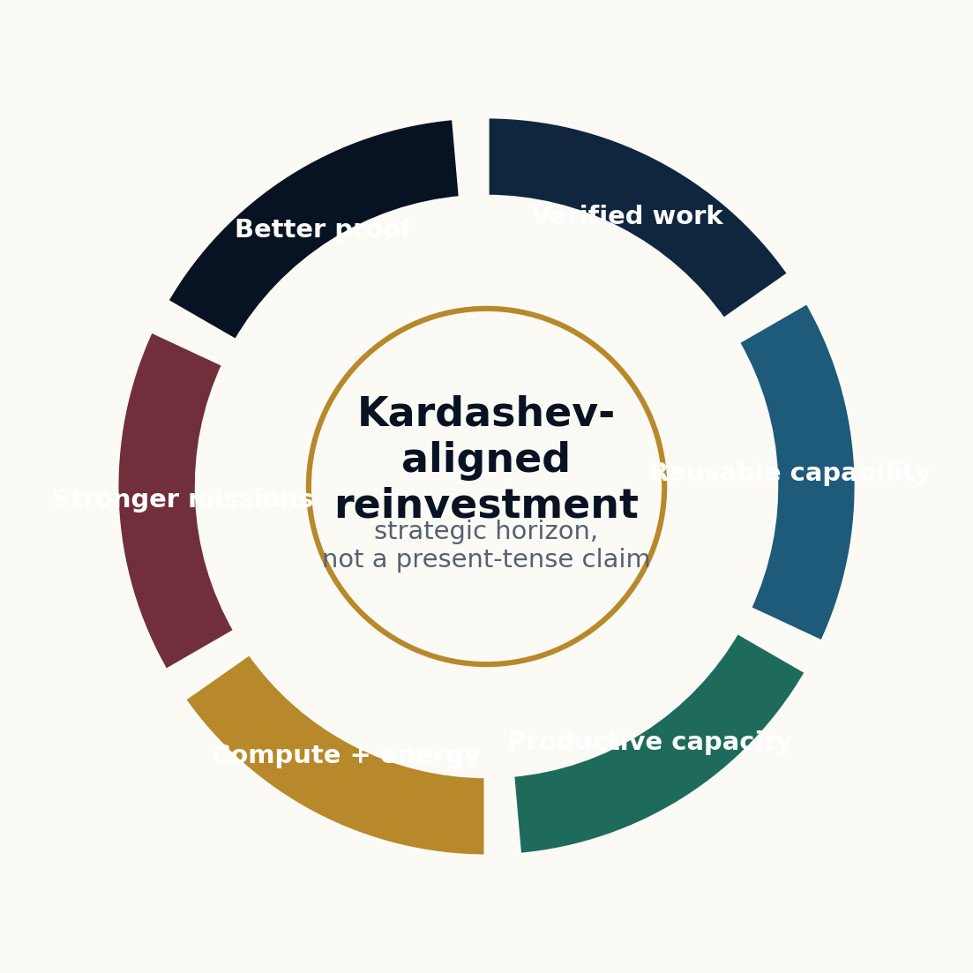

13. Readiness Ladder
Architecture, evidence tooling, and repository hygiene can be strong before deployment authorization exists. Mainnet authorization remains evidence-gated: compile, tests, rehearsal, docket, external review, legal/tax/security review, governance ceremony, public claims review, and founder approval.
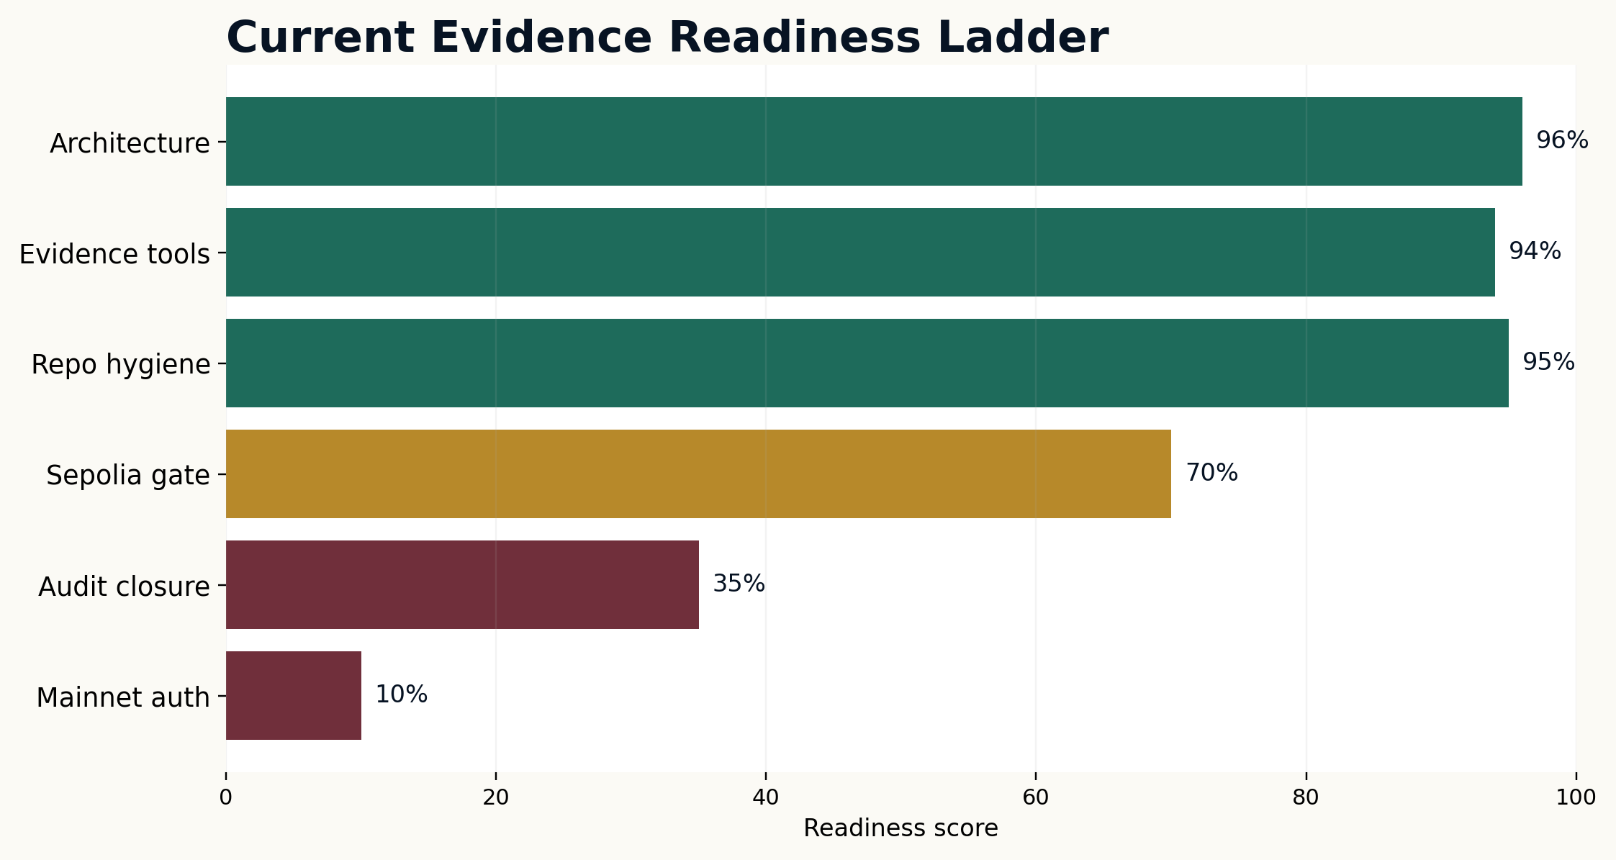

14. Season 001 Proof Mission Program
Season 001 should begin with a narrow proof program, not a broad-market launch. The first missions must create proof cards, reviewer history, and evidence discipline. Five missions are sufficient to establish the loop: support workflow, claims-safe launch, workshop qualification, sponsor mission design, and reviewer quality.
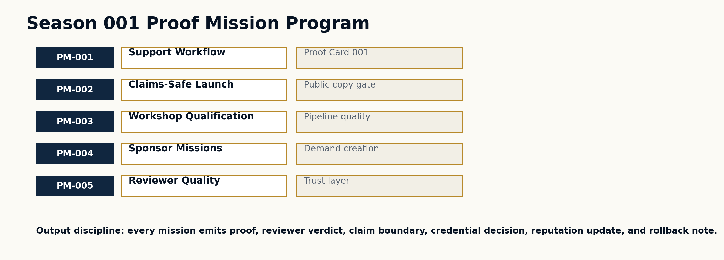

15. Proof Gradient Selection Law
The selection law is simple: an upgrade may influence future work only if it demonstrates positive verified value under bounded risk and rollback readiness. Formally:
Promote(u) = 1 iff Proof(u) ∧ EvalPass(u) ∧ RiskOK(u) ∧ ScopeOK(u) ∧ CanaryOK(u) ∧ MonitorOK(u) ∧ RollbackReady(u).
Rejected candidates remain valuable. They become negative controls, failure examples, red-team material, and future benchmark cases. A proof system that hides failure cannot claim to govern improvement.

16. Falsification Tests
Failure condition | Meaning | Required response
Proof is not predictive | Accepted artifacts fail on hidden future tasks. | Tighten proof standards and reduce propagation scope.
Baselines win | Static or ordinary agent workflows beat accepted upgrades. | Reject upgrade class; publish negative result.
Gate is gameable | Candidates exploit proxy metrics or evaluator weaknesses. | Change metrics, add adversarial reviews.
Rollback fails | Promoted artifacts cannot be safely reverted. | Suspend propagation and repair rollback registry.
Evidence is unreplayable | Dockets cannot be independently inspected. | No settlement; no stronger claim.
Overhead dominates | Governance cost exceeds verified value. | Reduce coordination burden and focus on higher-value missions.

17. Claim Boundary
This paper defines a sovereign RSI architecture and a deployment program. It does not claim achieved AGI, ASI, superintelligence, autonomous sovereignty, guaranteed ROI, investment return, safety certification, legal approval, tax approval, security approval, energy abundance, or Kardashev Type II achievement. The claim becomes empirical only through real tasks, strong baselines, replayable ProofBundles, evaluator attestations, safety and cost ledgers, delayed-outcome checks, and independent review.

18. One-Page Constitution
Aim. Act. Prove. Evolve. GoalOS gives the institution direction. PlanOS gives it strategy. Capability OS gives it reusable ability. AGIALPHA coordinates proof-settled work. AEP-001 defines valid evidence. The Proof Gradient decides what may evolve. The Evolution Ledger records what happened. The Evidence Docket makes claims auditable. The Selection Gate promotes only what proved itself.
A model can answer. An agent can act. A sovereign intelligence institution must prove.

19. Formal Object Model
The architecture is implementable because every important institutional event has a typed object. The point is not more paperwork; the point is that every future upgrade can be traced back to a mission, a run, a proof packet, a validation decision, a settlement event, a rollout receipt, and a rollback target.
Object | Owner | Decision it enables
GoalOSCommit | Aim Council | What should be attempted, under whose authority, and with which constraints.
RunCommitment | Strategy Desk | Which agents, tools, context, policies, credentials, and budgets are allowed.
ProofBundle | Proof Engineers | Whether the work can be inspected, replayed, challenged, and settled.
EvalAttestation | Reviewer Council | Whether the candidate passed tests, baselines, risk gates, and policy checks.
SelectionCertificate | Selection Gate | Whether the artifact may influence future work.
RolloutReceipt | Release Office | Where the artifact may operate, at what scope, and under what monitor.
RollbackReceipt | Rollback Desk | How the system reverts or contains a failed improvement.
ChronicleEntry | Evidence Office | How the organization remembers what happened and why.

20. AGIALPHA Utility Boundary
AGIALPHA is used as a coordination asset for proof-settled work. It coordinates posting, bonding, review, settlement, credentials, reputation, and protocol operations. The token does not define truth; evidence does. The token does not replace product revenue, legal review, tax review, or security review. It coordinates utility only where public proof, accountability, and settlement are needed.
Use | Permitted role | Boundary
Mission posting | Sponsor stakes a reward and posts a bounded proof mission. | No investment framing.
Builder claim | Builder posts a bond and accepts the evidence requirements. | No entitlement to reward without accepted proof.
Proof submission | Builder submits proof references and proof-card hash. | Private evidence remains off-chain.
Reviewer validation | Reviewer stakes reputation and/or bond to validate evidence. | Review can be challenged.
Settlement | Reward and bonds settle only after validation clears. | No replay, no settlement.
Reputation | Accepted work updates non-transferable reputation. | Reputation follows proof, not token balance alone.

21. Sovereign Domain Playbook
The architecture is designed for sovereign domains where the cost of unverified action is high and the value of cumulative proof is enormous. Each domain begins with one repeatable workflow, not an unrestricted mandate. The proof room expands only when evidence and rollback readiness exist.
Domain | First proof mission | Sovereign value
AI governance | Claims-safe launch and policy review workflow. | Reduces public-claims risk and improves institutional trust.
Cybersecurity | Defensive evidence docket for safe remediation readiness. | Turns findings into governed improvements without leaking sensitive data.
Energy / compute | Useful compute per dollar and watt improvement workflow. | Links verified efficiency to reinvested compute and energy capacity.
Public services | Eligibility, routing, and citizen-response workflow. | Improves service quality while preserving auditability and rollback.
Enterprise operations | Support, procurement, and trust-center response workflow. | Creates repeatable evidence for departments and buyers.
Scientific operations | Experiment planning and validation workflow. | Improves research execution while keeping claims bounded and replayable.

22. Benchmark and Proof Program
The system should be judged by whether proof predicts future improvement, whether accepted artifacts beat baselines, whether reviewer decisions are reliable, whether rollback works, and whether coordination overhead remains below verified value. The benchmark program is adversarial by design.
Benchmark | Question | Promotion requirement
GoalOS-Bench | Can aims be specified, bounded, and audited before agents act? | Commitments are complete, authorized, and rollback-aware.
ProofGradient-Bench | Do proof packets predict hidden-task improvement? | Accepted upgrades beat strong baselines under equal budget.
SelectionGate-Bench | Can the gate reject proxy gaming and unsafe novelty? | Negative controls are rejected and failure cases are published.
EvidenceDocket-Bench | Can independent reviewers inspect and replay the evidence? | Dockets reduce audit time and false approvals.
SovereignPilot-Bench | Can one real workflow become reusable capability? | Proof Card, credential, reputation, and delayed-outcome monitor are complete.
Capacity-Bench | Does verified work improve productive capacity? | Useful work per cost/watt/time improves without hidden risk.

23. Implementation Gate Register
The implementation path is intentionally gated. Strong architecture is not deployment authorization. Each gate creates a stronger artifact, and no gate should be skipped for appearance of speed.
Gate | Evidence required | Decision
Repository readiness | Static QA, safety scan, no private data, no paid product leakage. | Engineering handoff.
Compile and tests | Install, compile, test suite, static analysis, readiness verifier. | Sepolia rehearsal permission.
Ethereum Sepolia rehearsal | Deployment manifest, mission flow, proof card, credential, reputation, settlement. | External audit closure request.
Evidence Docket | Filled docket with transaction links, proof bundle, review record, cost/risk ledger. | Claims review.
External review | Security findings, closure matrix, remediation evidence. | Governance ceremony preparation.
Governance ceremony | Admin roles, treasury, pauser, reviewer manager, founder approval. | Mainnet discussion only.
Mainnet authorization | Legal, tax, security, claims, treasury, evidence, and founder signoff. | Deployment may be considered.

24. Strategic Interpretation
The strongest form of this architecture is not a claim that the system has already achieved superintelligence. It is the claim that sovereign intelligence organizations need a way to make improvement legible, replayable, challengeable, settleable, and reversible. The civilization-scale horizon becomes credible only through a ladder of verified work: one proof room, one proof card, one benchmark, one successful rollback, one capacity gain, one validated reinvestment decision at a time.

References
Boucher, V. GoalOS: The Proof-of-Evolution Constitution AEP-001 Institutional Standard. QUEBEC.AI & MONTREAL.AI, June 2026.
Boucher, V. AGI ALPHA: A Scalable Substrate for Intelligence Organizations. QUEBEC.AI & MONTREAL.AI, June 2026.
Ethereum smart-contract documentation; Solidity documentation; OpenZeppelin contracts; Ethereum attestation and content-addressing references.
NIST AI Risk Management Framework; W3C Verifiable Credentials; OWASP agentic AI guidance.

