QUEBEC.AI | MONTREAL.AI
GoalOS-native alpha-AGI
Ascension using AGIALPHA
Sovereign RSI Architecture for Evidence-Governed Intelligence Organizations
A model can answer. An agent can act. A sovereign intelligence institution must prove.
Vincent Boucher
President, QUEBEC.AI & MONTREAL.AI | Sovereign AI, AI-First Institutions, AI Governance & Governed Agents
Corporate Sovereign RSI Edition v6.1
Institutional boundary
This paper defines a sovereign RSI architecture, proof standard and implementation direction. It does not authorize deployment or claim achieved AGI, superintelligence, guaranteed economic return, legal approval, tax approval, security approval or Kardashev Type II achievement.

Reader Map
This edition is designed for board members, sovereign AI leaders, protocol engineers, commercialization teams and reviewers. It uses a ledger-inspired ivory, navy and gold visual language with no floating text boxes. Every figure is bounded; every table is page-safe; every claim is evidence-gated.
Executive thesis
GoalOS-native alpha-AGI Ascension turns the original agent-market vision into a proof-governed sovereign intelligence operating system. GoalOS defines what should improve. AGIALPHA coordinates proof-settled work. Evidence Dockets make claims auditable. The Proof Gradient decides what may influence future work.

Abstract
AI-first institutions should not merely automate work; they should generate evidence sufficient to govern what may improve next. This paper presents GoalOS-native alpha-AGI Ascension using AGIALPHA: a sovereign RSI architecture in which institutional aims become commitments, agent work becomes ProofBundles, reviewers produce attestations, the Proof Gradient selects only evidence-backed upgrades, and Evidence Dockets make claims auditable. AGIALPHA is treated as a utility coordination asset for proof-settled work: mission posting, bonds, reviewer accountability, settlement, proof-card actions, credentials, reputation and access. The paper does not claim achieved AGI, superintelligence, guaranteed financial return or deployment authorization. It defines the institutional machinery required to test whether useful AI workflow work can become governed, reusable, compounding capability.

Canonical Contributions
Contribution | Why it matters
Sovereign RSI constitution | RSI is defined as proof-backed upgrade rights, not uncontrolled self-modification.
GoalOS-native reimplementation | The original Ascension primitives become GoalOS, AEP-001, Evidence Dockets, Proof Cards, credentials and reputation.
AGIALPHA proof-settlement model | AGIALPHA coordinates proof work without exposing private intelligence or creating investment claims.
Large multi-agent operating theater | Specialist roles cooperate through bounded authority and artifact discipline.
Evidence Docket standard | Consequential claims are backed by commitments, runs, proofs, evals, risk, settlement, rollout and rollback evidence.
Sovereign commercial deployment path | Self-serve products, proof rooms, sponsor missions and enterprise pilots become one compounding system.
Falsifiable proof program | The architecture becomes credible only through real tasks, baselines, replay, attestations, delayed outcomes and independent review.

1. Sovereign RSI Architecture
The architecture is not a swarm and not a design metaphor. It is an operating theater in which every role has bounded authority and every transition emits evidence. RSI means that accepted artifacts earn limited rights to shape future missions.
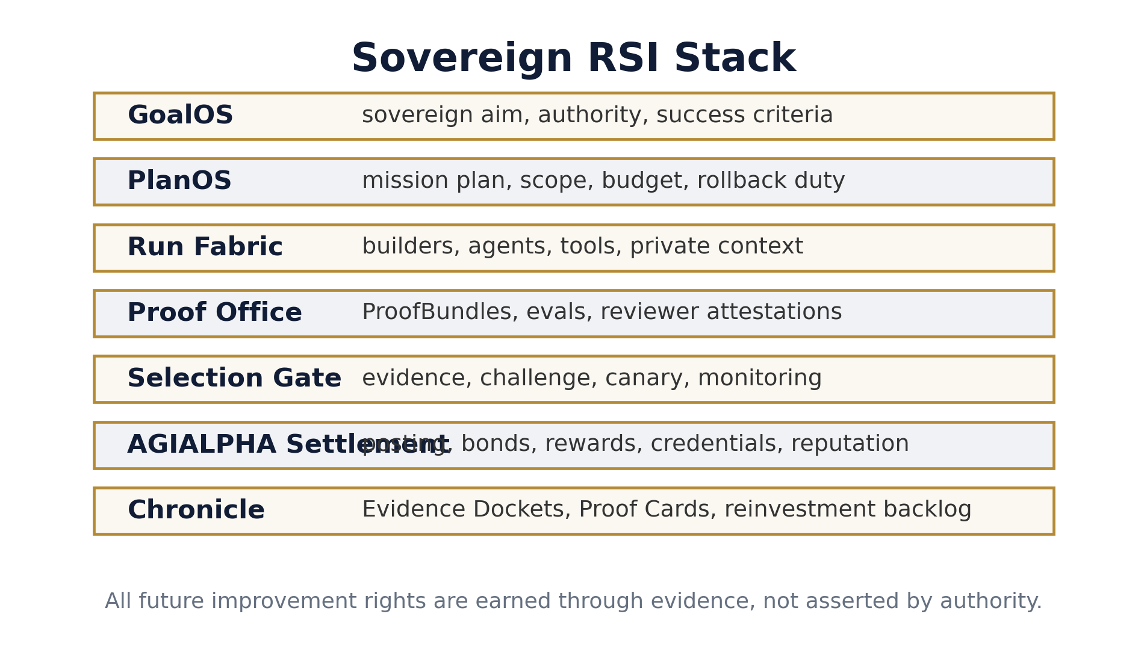
Figure 1. GoalOS-native sovereign RSI stack.

2. Reimplementation Mapping
The reimplementation preserves the durable primitives of the original Ascension concept while replacing speculative or ambiguous mechanics with auditable institutional objects.
Original primitive | GoalOS-native primitive | Upgrade
Ascension thesis | GoalOS-native proof-of-evolution thesis | From visionary agent constellation to evidence-governed intelligence organization.
Insight | GoalOS Opportunity Intelligence | Workflow opportunities replace unsupported foresight.
Nova-Seeds | Proof Seeds / Opportunity Dockets | Mission-ready artifacts with evidence requirements and claim boundaries.
FusionPlans | PlanOS Mission Plans | Executable routes with budget, scope, risk and rollback duties.
MARK | AGIALPHA Proof Mission Board | A market for proof work rather than speculative foresight.
Sovereign | Proof Room / Enterprise RSI Pilot | Institutional transformation through auditable workflow improvement.
Marketplace | AGIALPHA Proof Work Network | Sponsor-builder-reviewer coordination with credentials and reputation.
Agents | Builders / Agent Operators | Accountable operators who generate evidence.
Jobs | GoalOS Proof Missions | Goal, metric, bounty, proof requirements, reviewer rubric and public-safe output.
Validator Council | Reviewer Network + Selection Gate | Bonded review, challenge windows, scope control and rollback readiness.
Architect | Proof Gradient / AEP-001 | A governed evolution law for what may improve future work.

3. AGIALPHA Proof-Settlement Chain
AGIALPHA is used as a utility coordination asset for proof-settled work: mission posting, builder bonds, proof bonds, reviewer bonds, settlement, proof-card actions, credentials and reputation. Normal product sales do not need token friction.
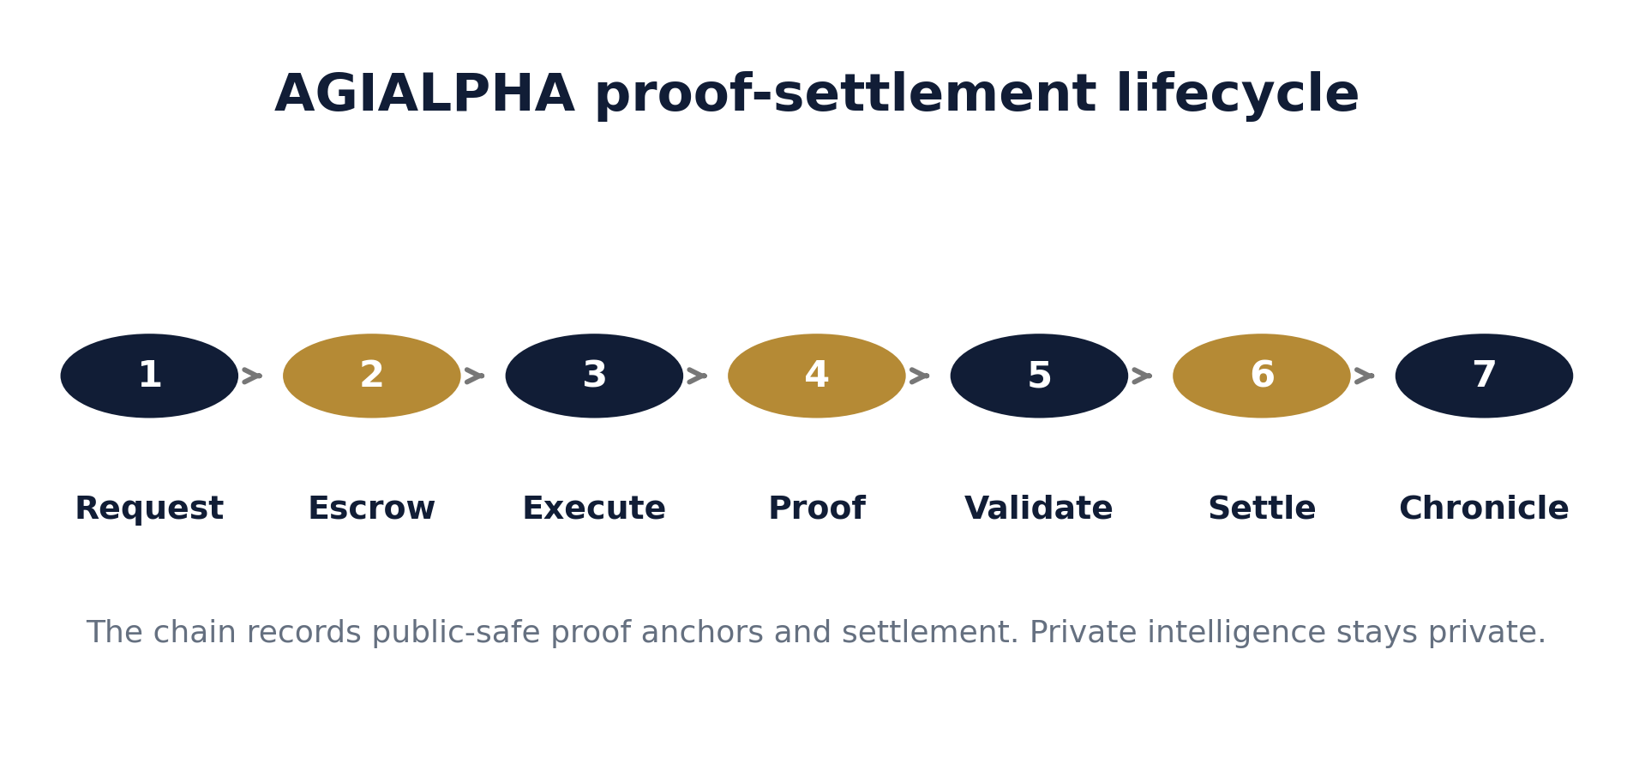
Figure 2. Request -> Escrow -> Execute -> Proof -> Validate -> Settle -> Chronicle.

4. Multi-Agent Coordination Fabric
The system demonstrates large-scale coordination through specialization. Each role emits a concrete artifact; each artifact can be reviewed, challenged, accepted, rejected or rolled back.
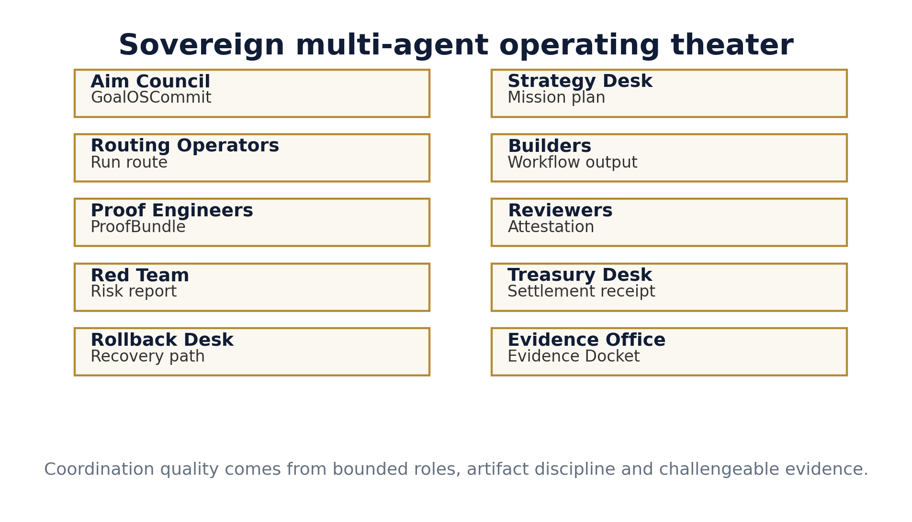
Figure 3. Bounded specialist-agent operating theater.

5. RSI as Operational Law
The system does not rely on open-ended self-modification as a promise. RSI is implemented as a law of propagation: no artifact can influence future work until it survives evidence, evaluation, reviewer validation, challenge, canary scope, monitoring and rollback readiness.
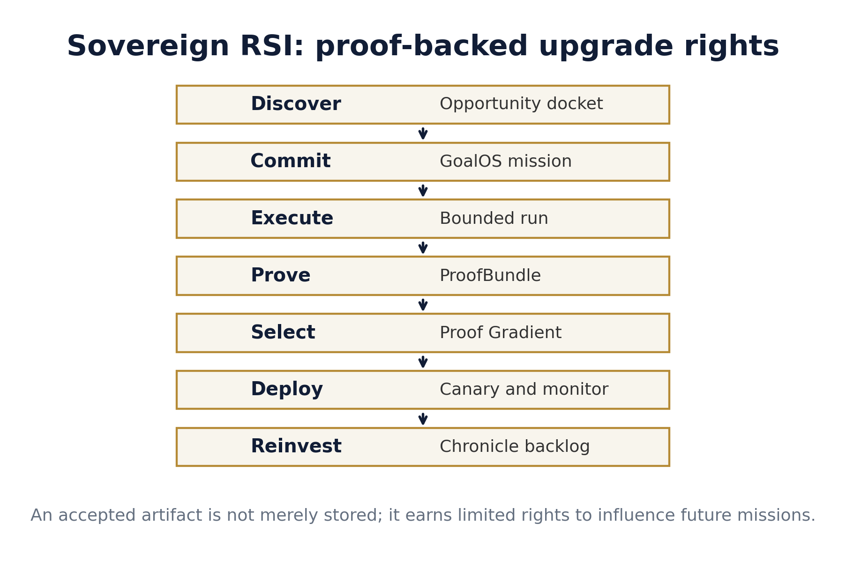
Figure 4. Proof-backed upgrade rights.
Sovereign RSI law
An artifact may shape future work only after evidence, evaluation, reviewer validation, scope control, challenge window, canary rollout, monitoring and rollback readiness.

6. Goals Used
Goal | Explanation
Sovereign Aim Integrity | Every mission preserves declared aim, risk class and authority boundary.
Proof-Settled Work | Work becomes reusable only after evidence, evaluation and review.
RSI With Rollback | Accepted improvements include monitoring and recovery paths.
Private Intelligence, Public Proof | Sensitive work stays off-chain; public-safe anchors become verifiable.
Reputation Through Evidence | Reputation follows approved work and review quality.
Commercial Compounding | Proof Cards and Evidence Dockets create trust that can sell the next GoalOS tier.
Capacity Reinvestment | Verified capacity gains fund better agents, evals, safety and useful infrastructure.

7. Plans Used
Plan | How it is used
Opportunity Docket Plan | Convert workflow pain into a sponsor-ready mission with a measurable success condition.
Mission Settlement Plan | Use AGIALPHA for posting, claim bonds, proof bonds, reviewer bonds and reward settlement.
Evidence Docket Plan | Package commitments, ProofBundles, eval attestations, risk records and settlement receipts.
Selection Gate Plan | Promote only artifacts that pass evidence, evals, risk, scope, challenge and rollback gates.
Sovereign RSI Plan | Turn accepted improvements into versioned artifacts that can shape future missions.
Season 001 Plan | Launch five focused proof missions before scaling the mission board.
Deployment Gate Plan | Progress from repository evidence to rehearsal, external review and formal authorization.

8. Skills Used
Skill | Operational role
GoalOS Commit Compiler | Turns sovereign intent into a signed, versioned mission object.
Opportunity Docket Writer | Frames a workflow opportunity with pain, metric, evidence and sponsor value.
Mission Router | Routes proof missions to qualified builders and reviewers.
Builder Operator | Executes workflow improvement and emits traceable artifacts.
ProofBundle Assembler | Packages outputs, hashes, scorecards, cost, latency and replay material.
Reviewer Attestation | Validates whether evidence supports the claimed improvement.
Red Team Examiner | Searches for unsafe claims, private data leakage and brittle improvements.
Proof Gradient Judge | Applies selection criteria to decide what may influence future work.
Rollout Planner | Defines scope, canary, monitoring and rollback path.
Evidence Docket Publisher | Creates the proof room used by executives, auditors and partners.
Settlement Steward | Coordinates AGIALPHA reward, bonds, credentials and reputation updates.
Chronicle Curator | Stores approved proof memory for future mission design.

9. Evidence Docket as Proof Room
The Evidence Docket is the institutional proof room. It is designed to let executives, auditors, reviewers and sponsors inspect what was claimed, what was done, what evidence exists, who reviewed it, how it was settled and whether rollback remains possible.
Evidence Docket contents
Commit evidence, run evidence, ProofBundle, eval attestation, risk ledger, settlement receipt, rollout scope, rollback path and public claim boundary.

10. AGIALPHA Settlement, Credentials and Reputation
Mechanism | Institutional effect
Mission posting | Sponsors commit resources to defined proof work.
Builder bond | Builders accept accountability for completion.
Proof bond | Proof submitters stake on the seriousness of the evidence.
Reviewer bond | Reviewers have skin in the quality of their validation.
Proof Card | Public-safe proof artifact creates trust without leaking private intelligence.
Credential | Accepted work becomes legible capability.
Reputation | Future access is guided by evidence, not assertion.

11. Selection Law
A candidate upgrade is selected only if verified improvement exceeds its cost, risk and novelty penalties, and only if all hard gates pass.
Selection condition
Promote(a) is TRUE only when Proof(a) is sufficient, Eval(a) passes, Risk(a) is acceptable, Scope(a) is authorized, Challenge(a) clears, Canary(a) passes, Monitor(a) is active, and Rollback(a) is ready. Otherwise: revise, reject, quarantine or retire.

12. Capacity Reinvestment Horizon
The civilization-scale horizon is treated as a disciplined research program. The measurable near-term pathway is: work creates proof; proof creates trusted artifacts; trusted artifacts improve future work; improvements compound capacity; capacity can be reinvested into compute, energy efficiency, safety, public-good infrastructure and scientific or institutional capability.
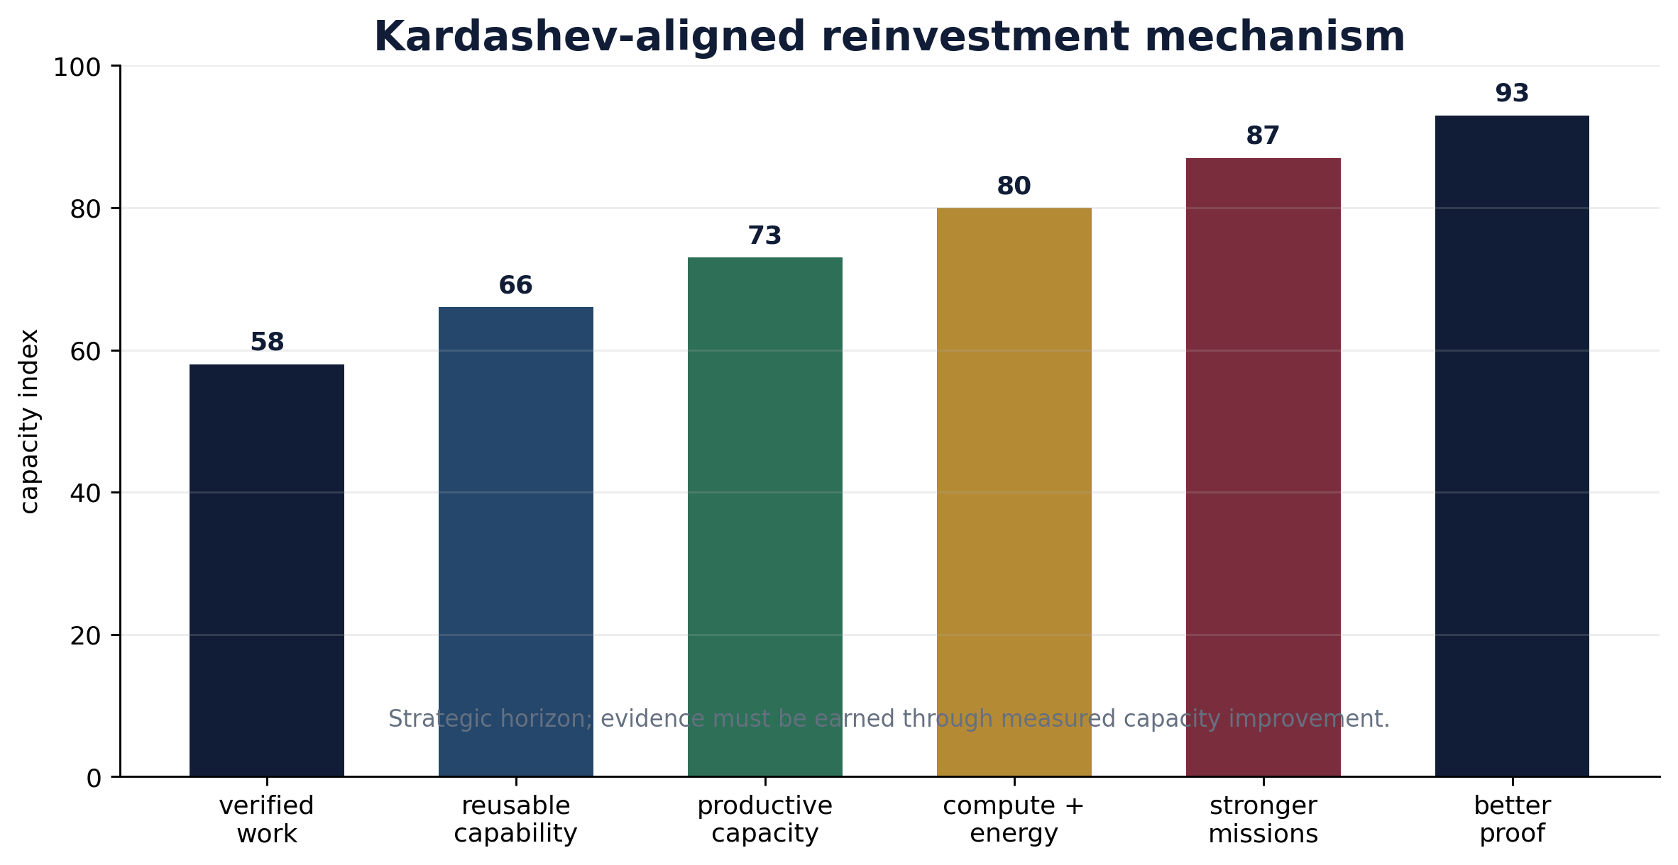
Figure 5. Clean reinvestment mechanism; no present-tense endpoint claim.

13. Readiness Ladder
The repository and implementation package can be strong before deployment authority exists. Authority must be earned through compile/tests, rehearsal, Evidence Docket, external review, legal/tax/security review, governance ceremony, public claims review and formal approval.
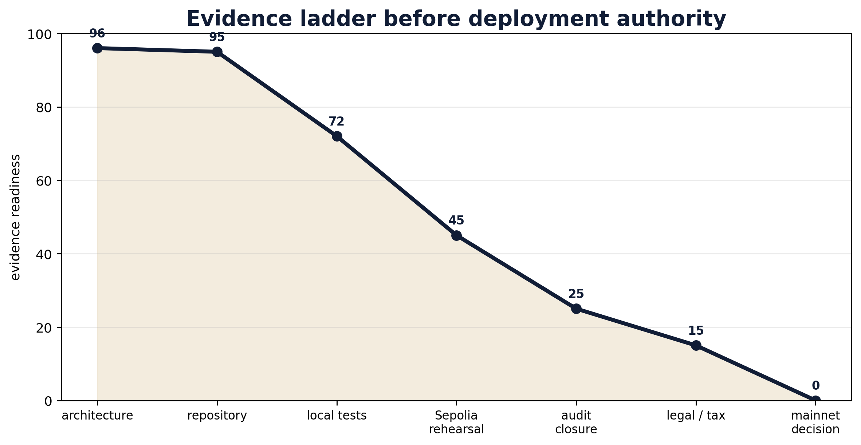
Figure 6. Evidence gates before deployment authority.

14. Season 001 Proof Mission Program
Mission | Workflow | Proof artifact | Business value
PM-001 | Customer Support Reply Workflow | Proof Card 001 | Support quality and safe escalation
PM-002 | Claims-Safe Launch Content | Proof Card 002 | Public messaging and claim boundary
PM-003 | Workshop Application Qualification | Proof Card 003 | Pipeline quality and conversion
PM-004 | Sponsor Proof Job Creation | Proof Card 004 | Sponsor demand formation
PM-005 | Builder / Reviewer Quality | Proof Card 005 | Proof economy reliability

15. Sovereign Domain Applicability
The architecture is most useful where private intelligence must stay protected while evidence, review, reputation and rollout decisions must become institutionally verifiable.
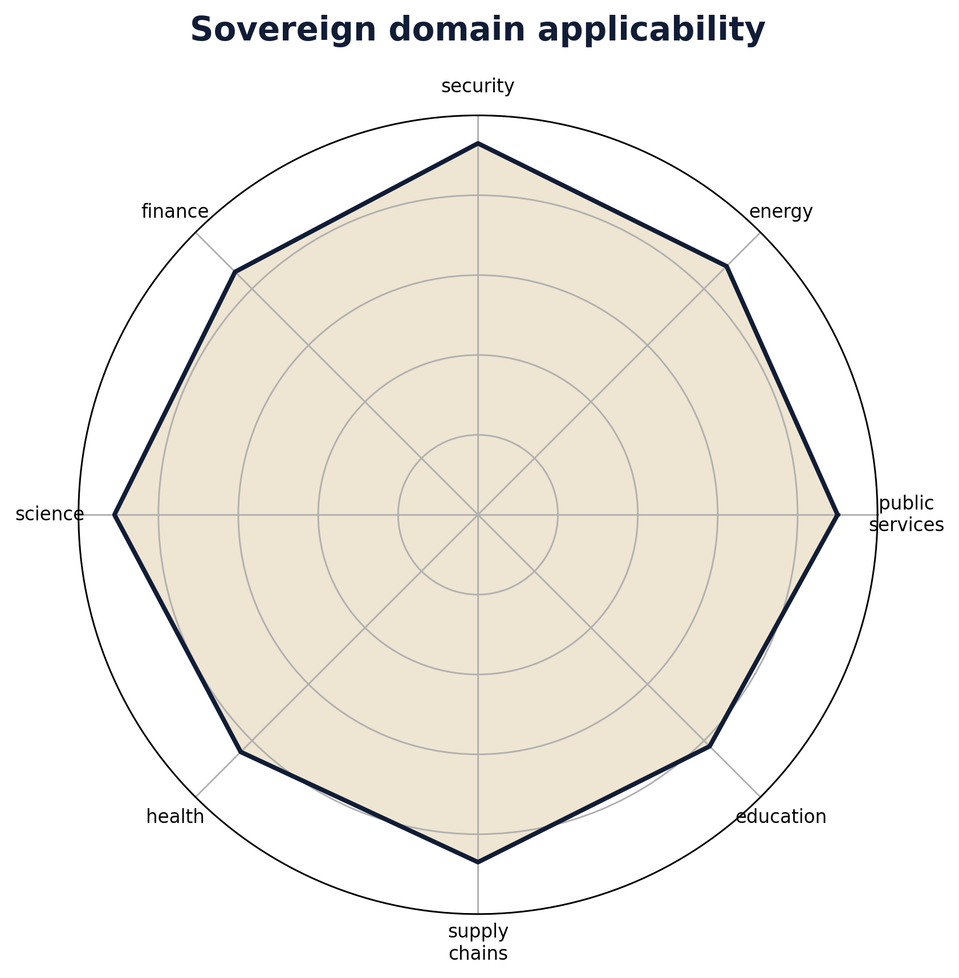
Figure 7. Sovereign domains where proof-governed RSI is most useful.

16. Contract and Registry Architecture
Module | Purpose
Mission Board | Posts missions, handles claims, proof submission, reviewer validation, settlement and states.
Proof Card Registry | Registers public-safe proof-card hashes and URIs.
Proof Credential | Issues non-transferable credentials for accepted proof work.
Reputation Ledger | Tracks evidence-backed non-transferable reputation.
Launch Gate Registry | Records authorization evidence and blocks premature deployment claims.
Legacy Evidence Registry | Preserves AGIJobManager as genesis context without making it the current architecture.
Evidence Docket Schema | Defines what a proof room must contain before claims mature.
Current status: evidence-ready audit candidate. Not external audit closure. Not legal approval. Not tax approval. Not security approval. Not deployment authorization.

17. Falsification Tests
Failure mode | What would falsify the claim
Proof fails to predict improvement | Accepted artifacts do not outperform baselines.
Reviewers are gameable | Low-quality or collusive reviews pass selection.
Cost exceeds value | Coordination overhead exceeds verified value created.
Rollback fails | Accepted improvements cannot be reversed safely.
Privacy boundary fails | Private evidence leaks through public proof anchors.
AGIALPHA use is narrative-only | Token activity does not coordinate real posting, bonding, review or settlement.
Evidence Dockets are incomplete | Claims cannot be replayed or inspected independently.

18. Claim Boundary
This paper defines a research architecture, implementation direction and evidence program. It does not authorize deployment. It does not guarantee economic outcomes. It does not claim achieved AGI, ASI, superintelligence, autonomous sovereignty, investment return, audit closure, legal approval, tax approval, security approval or Kardashev Type II achievement.

19. Canonical Constitution
GoalOS-native alpha-AGI Ascension
GoalOS sets the aim. AGIALPHA coordinates proof-settled work. AEP-001 defines valid evidence. The Proof Gradient decides what may evolve. The Artifact Vault stores reusable intelligence. The Run Fabric executes bounded agents. The Proof Ledger records what happened. The Selection Gate promotes only what survived evidence. The Chronicle preserves institutional memory. The intelligence stays private. The proof becomes verifiable. The network improves only through verified work.

References
Boucher, Vincent. GoalOS: The Proof-of-Evolution Constitution. AEP-001 Institutional Standard. QUEBEC.AI and MONTREAL.AI, June 2026.
Boucher, Vincent. AGI ALPHA: A Scalable Substrate for Intelligence Organizations. April 2026.
AGIALPHA token tracker, Ethereum mainnet: 0xA61a3B3a130a9c20768EEBF97E21515A6046a1fA.
MontrealAI/goalos-agialpha-ascension repository foundation and evidence-ready implementation packages.

