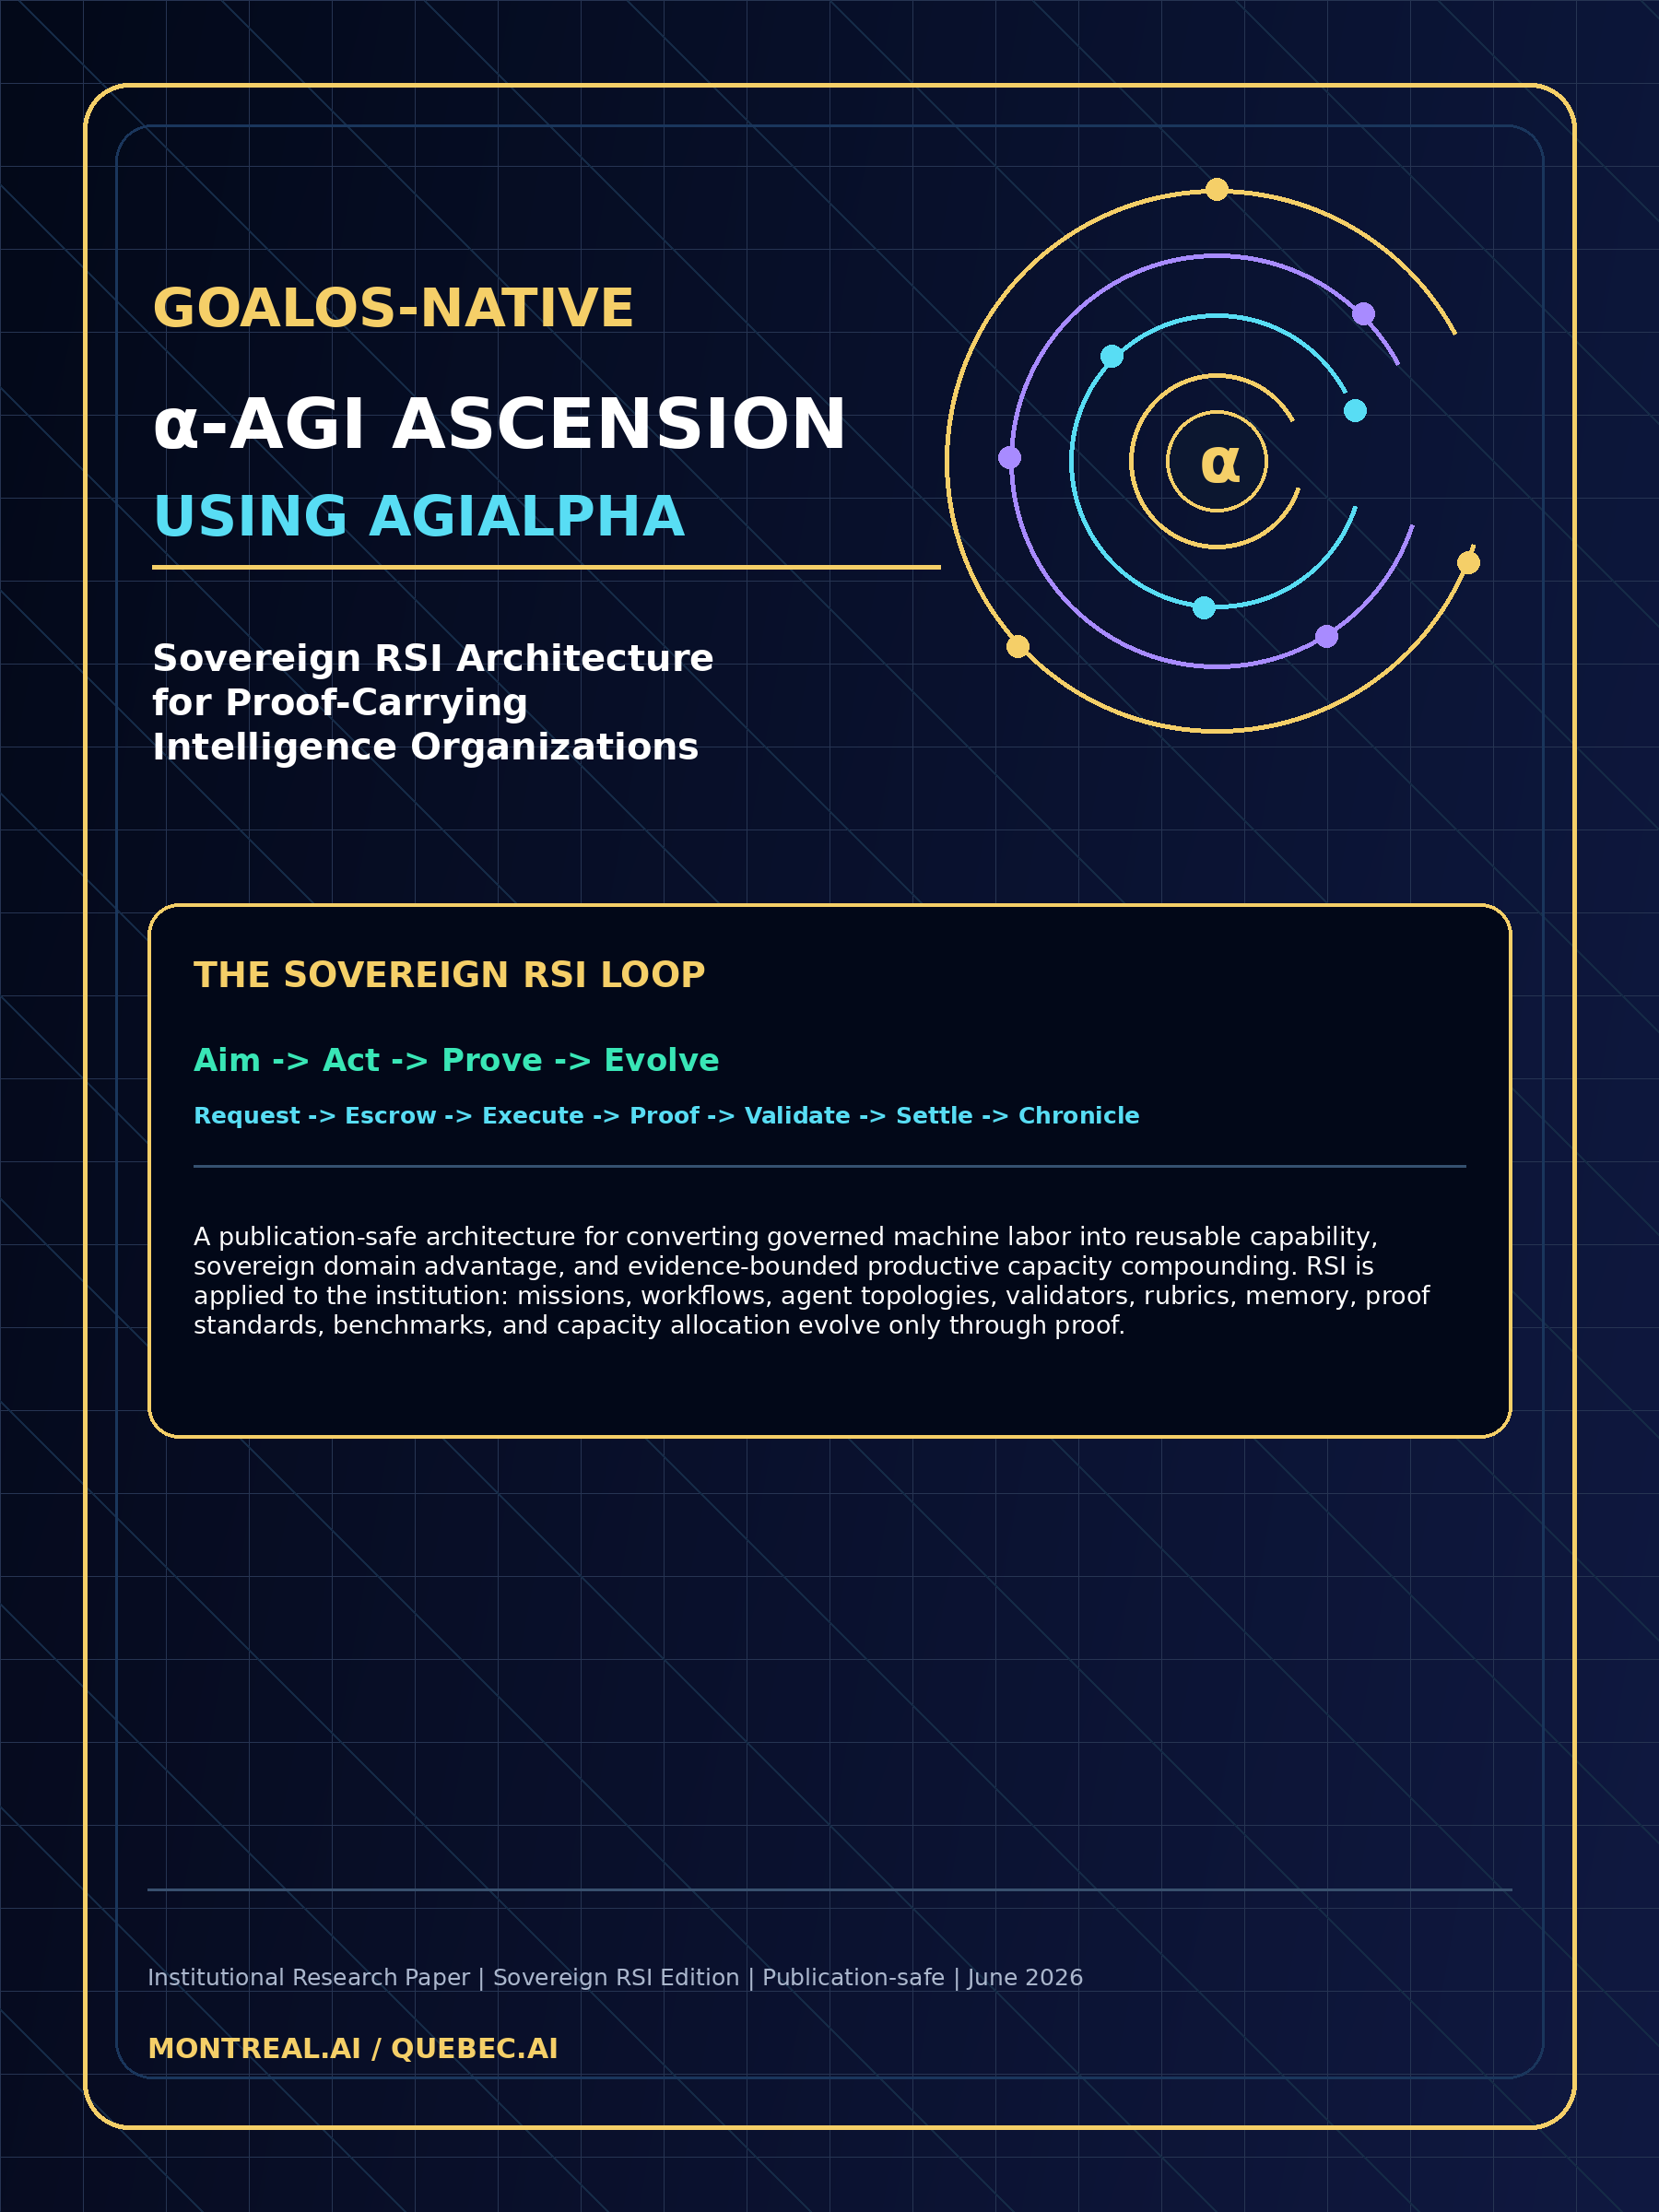

GoalOS-native α-AGI Ascension using AGIALPHA
Sovereign RSI Architecture for Proof-Carrying Intelligence Organizations
Institutional Research Paper | Sovereign RSI Edition | Publication-safe | June 2026

1. EXECUTIVE ABSTRACT
GoalOS-native α-AGI Ascension using AGIALPHA is a sovereign RSI architecture for proof-carrying intelligence organizations. It converts model capability into governed machine labor, governed labor into verified capability, verified capability into protected domain advantage, and protected domain advantage into productive capacity that can fund stronger future work.
The thesis is not that a model has already become superintelligent. The thesis is that economically useful and institutionally governable superintelligence requires an organizational substrate above models: agents, jobs, validators, memory, ProofBundles, capability archives, markets, settlement, governance, and capacity allocation.
The system applies recursive self-improvement at the institutional layer. The base model does not silently rewrite itself. Instead, the institution improves its own proof-carrying artifacts: missions, workflows, decomposition patterns, routing policies, validation rubrics, evidence standards, replay tools, benchmark suites, memory objects, and capacity-allocation policies.
AGIALPHA is treated as a utility coordination asset for proof-settled work: staking, accountability, escrowed settlement, epoch accounting, validator coordination, and protocol parameters. It is not framed as equity, dividends, ownership, profit rights, yield, or an investment claim.
The North Star is a governed value-to-capacity flywheel: verified work -> reusable capability -> productive capacity -> infrastructure -> compute, science, and useful energy -> stronger future work. The Kardashev Type II horizon is a civilizational direction of travel, not a present achievement claim.
Publication-safe claim boundary: this paper proposes architecture, mechanisms, benchmarks, and implementation doctrine. It does not claim achieved AGI, ASI, superintelligence, empirical SOTA, guaranteed economic return, or achieved Type-II capability.

2. SOURCE DOCTRINE: WHAT IS BEING UNIFIED
The AGI ALPHA doctrine defines intelligence as an organizational substrate, not merely as model performance. It centers agents, jobs, validators, tools, memory, markets, settlement, governance, capacity allocation, and strategic capability development. Its proof-settlement chain is Request -> Escrow -> Execute -> Proof -> Validate -> Settle -> Chronicle.
The GoalOS Proof-of-Evolution Constitution defines the institutional law: Aim -> Act -> Prove -> Evolve. It separates private intelligence execution from public proof commitments and requires proof, evaluation, scope control, rollback, and challengeability before propagation.
GoalOS-native α-AGI Ascension is the synthesis: GoalOS supplies institutional aim and evolution law; AGIALPHA supplies proof-settled coordination; AGI Alpha Nodes supply bounded runtime; Evidence Dockets supply auditable claims; Sovereign RSI supplies the compounding engine.
Doctrine element | Operational meaning | Ascension implementation
GoalOS Aim layer | Signed mission, budget, authority, risk, evaluators, rollback obligations | Every Sovereign Domain begins as a GoalOSCommit
AEP proof boundary | Private execution off-chain; public proof commitments on-chain | Trace roots, output hashes, attestations, receipts, Proof Cards
AGI ALPHA loop | No ProofBundle, no settlement; no replay, no settlement | AGIALPHA-denominated work must produce replayable proof
Proof Gradient | Score is advisory; gates are mandatory | Capabilities propagate only after evidence, eval, risk, canary, and rollback gates
Sovereign RSI | The institution improves its work substrate | Missions, workflows, routers, validators, archives, rubrics recursively improve

3. THE SOVEREIGN RSI THESIS
Conventional automation asks: can an AI complete this task? Sovereign RSI asks: can an intelligence organization improve the machinery by which future tasks are discovered, decomposed, executed, validated, settled, remembered, and converted into protected capacity?
The native search space is not only prompts or neural architectures. It is the institutional space of agents, jobs, validators, tools, proof templates, task curricula, evidence standards, quality-diversity archives, routing policies, settlement mechanisms, and governance rules.
The system is recursive because each accepted improvement changes the next round of institutional search. Better decomposition produces better jobs; better jobs produce better proof; better proof improves validation; better validation improves capability archives; better archives produce stronger future mandates.
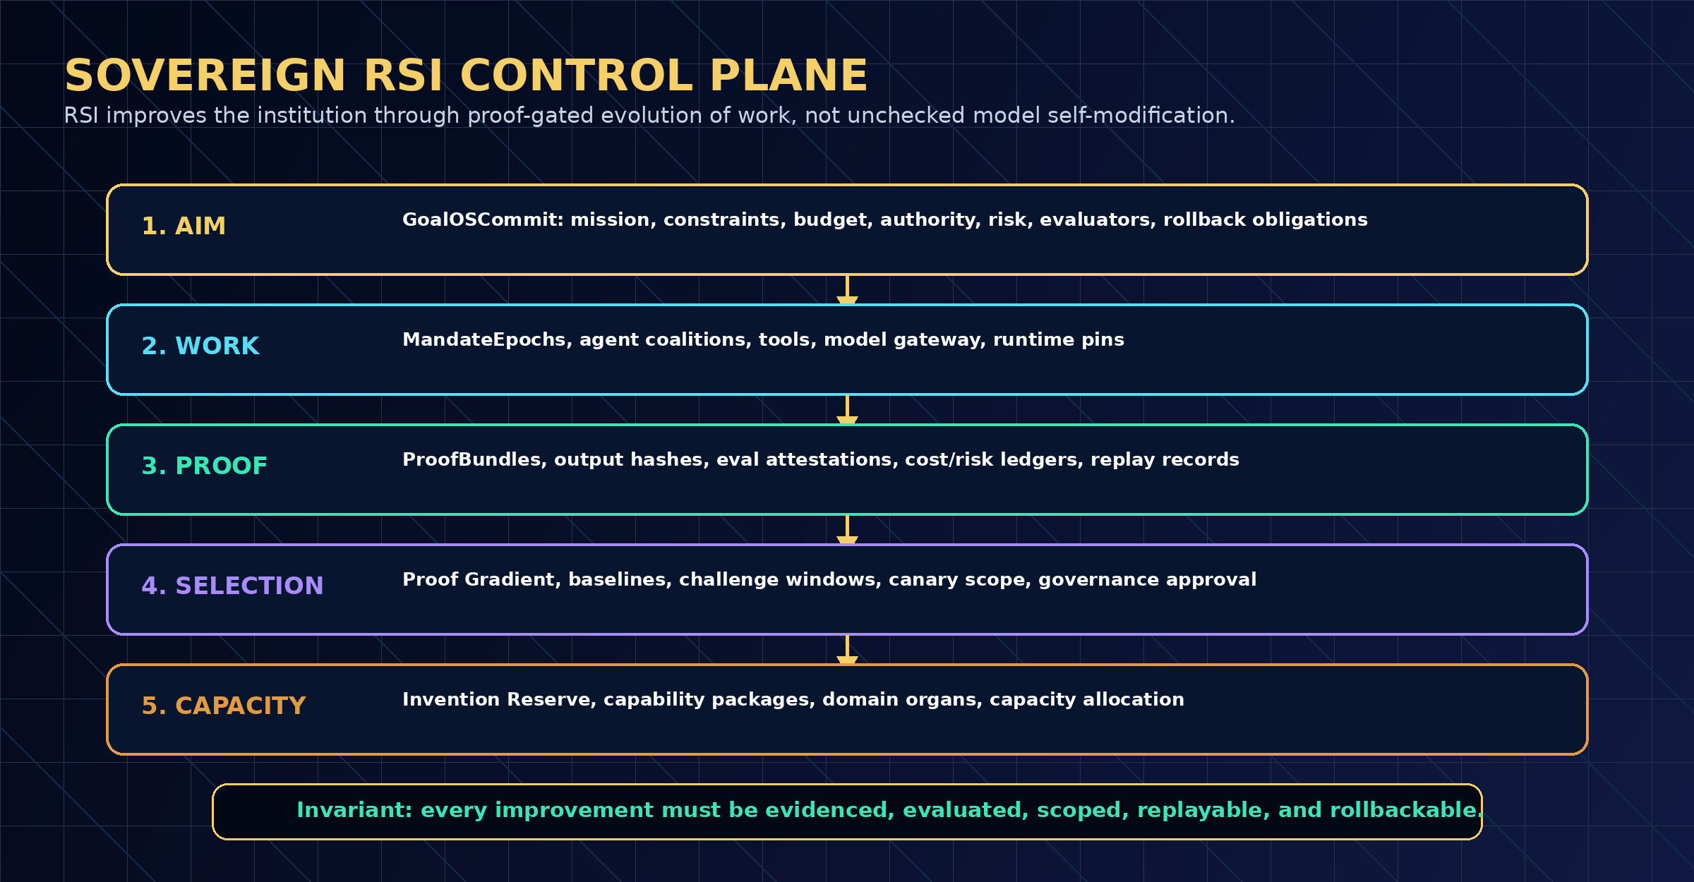
Figure 1 - Sovereign RSI Control Plane
4. SOVEREIGN RSI IS NOT UNCONTROLLED SELF-MODIFICATION
The base model is not the sovereign. The institution is the sovereign. The model may propose, search, summarize, evaluate, or execute bounded work, but authority is attached to commitments, policies, validators, evidence, and rollback obligations.
The organization evolves proof-carrying artifacts: workflows, planning patterns, prompt templates, evaluator rubrics, memory items, tool policies, risk rules, routing strategies, benchmark suites, and capability packages.
Every proposed artifact version must carry evidence, compare against baselines, preserve claim boundaries, define rollback, and survive the Selection Gate. Production deployment is a governance event, not a model impulse.
What changes | Who may propose | What must prove it | Promotion gate
Workflow | Agent, architect, reviewer | Benchmark uplift, proof integrity, cost/risk delta | SelectionCertificate
Prompt template | Agent or human | Reduced failure rate; no claim-boundary regression | EvalPass + ChallengeCleared
Validator rubric | Reviewer council | Lower false acceptance / false rejection | Validator quorum
Memory item | Workflow architect | Evidence source, expiration, owner, affected workflows | Memory approval
Agent topology | Router or architect | Better verified work per cost/risk and no unsafe action | Canary + rollback
Domain policy | Admin or governance | Scope, risk class, legal/safety boundary | Authority approval

5. MECHANISTIC PROOF OF LARGE MULTI-AGENT COORDINATION
The coordination claim is mechanistic: a large multi-agent system can produce more verified, reusable, risk-bounded work than a single agent or an ungated swarm when tasks are decomposable, agents have differentiated capability or context, and validation is independent, replayable, and economically meaningful.
Let J be a portfolio of jobs, A a set of specialized agents, V a validator council, M a memory/archive substrate, R a routing family, and G a governance policy. The goal is not raw output volume. The goal is maximum verified effect: accepted work, reusable capability, reduced risk, lower coordination overhead, and stronger future work.
Sovereign RSI uses decomposition, routing, validation, replay, settlement, and archive promotion to turn many agent actions into one institutional learning step.
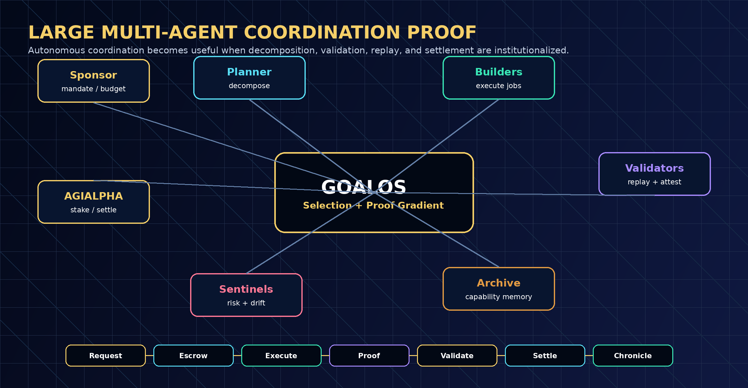
Figure 2 - Large Multi-Agent Coordination Engine
System | Coordination mode | Failure mode | Sovereign RSI advantage
Single agent | One model/operator loop | Context bottleneck; weak self-critique | Multi-agent decomposition and independent validation
Unstructured swarm | Many agents with weak governance | Noise, duplication, reward hacking | ProofBundles, validators, settlement gates, QD archive
Static workflow | Repeatable but slow to improve | Drift, stale rubrics, missed transfer | Evidence-driven improvement proposals and benchmark comparisons
Sovereign RSI | Bounded execution + proof-gated evolution | Coordination overhead if poorly routed | Routing, Proof Gradient, α-WU metrology, rollback, capacity allocation

6. OBJECTIVE FUNCTION: MAXIMUM VERIFIED EFFECT
GoalOS-native α-AGI Ascension does not maximize automation. It maximizes risk-adjusted verified capacity. A capability that cannot be verified, replayed, safely scoped, or converted into future useful capacity is not promoted merely because it appears novel.
The practical objective is to increase expected verified work, reusable capability, productive capacity, infrastructure, scientific progress, and useful capacity while reducing cost, safety/legal/security risk, uncertainty, coordination overhead, and harmful concentration.
Term | Meaning | Metric
Verified work | Externally accepted, replayable work output | validated α-WU / cost / risk
Reusable capability | Artifact that improves future tasks | transfer lift, reuse rate, dependency integrity
Productive capacity | Capability retained or deployed for durable advantage | capacity value, recurring utility, cost reduction
Infrastructure | Compute, tools, labs, robotics, data, validators, security | capacity growth per epoch
Risk burden | Safety, privacy, legal, security, or governance exposure | critical incidents, policy violations, rollback debt
Coordination overhead | Cost of routing, communication, validation, arbitration | overhead ratio, latency, validator burden

7. AGIALPHA UTILITY COORDINATION LAYER
AGIALPHA is the coordination asset for proof-settled machine labor. Its role is operational: stake, escrow, settlement, epoch accounting, validator quorum, slashing parameters, fee routing, and market permeability. It is not equity, not dividends, not ownership, and not a claim on any entity.
In GoalOS-native α-AGI Ascension, AGIALPHA makes work economically legible. A MandateEpoch can define budget, proof requirements, acceptance tests, validators, dispute windows, and settlement conditions before autonomous bounded execution begins.
This creates a utility loop: agents are accountable; validators are bonded; sponsors fund bounded mandates; ProofBundles control settlement; Chronicle entries produce reputation; reputation improves routing; routing improves future verified work.
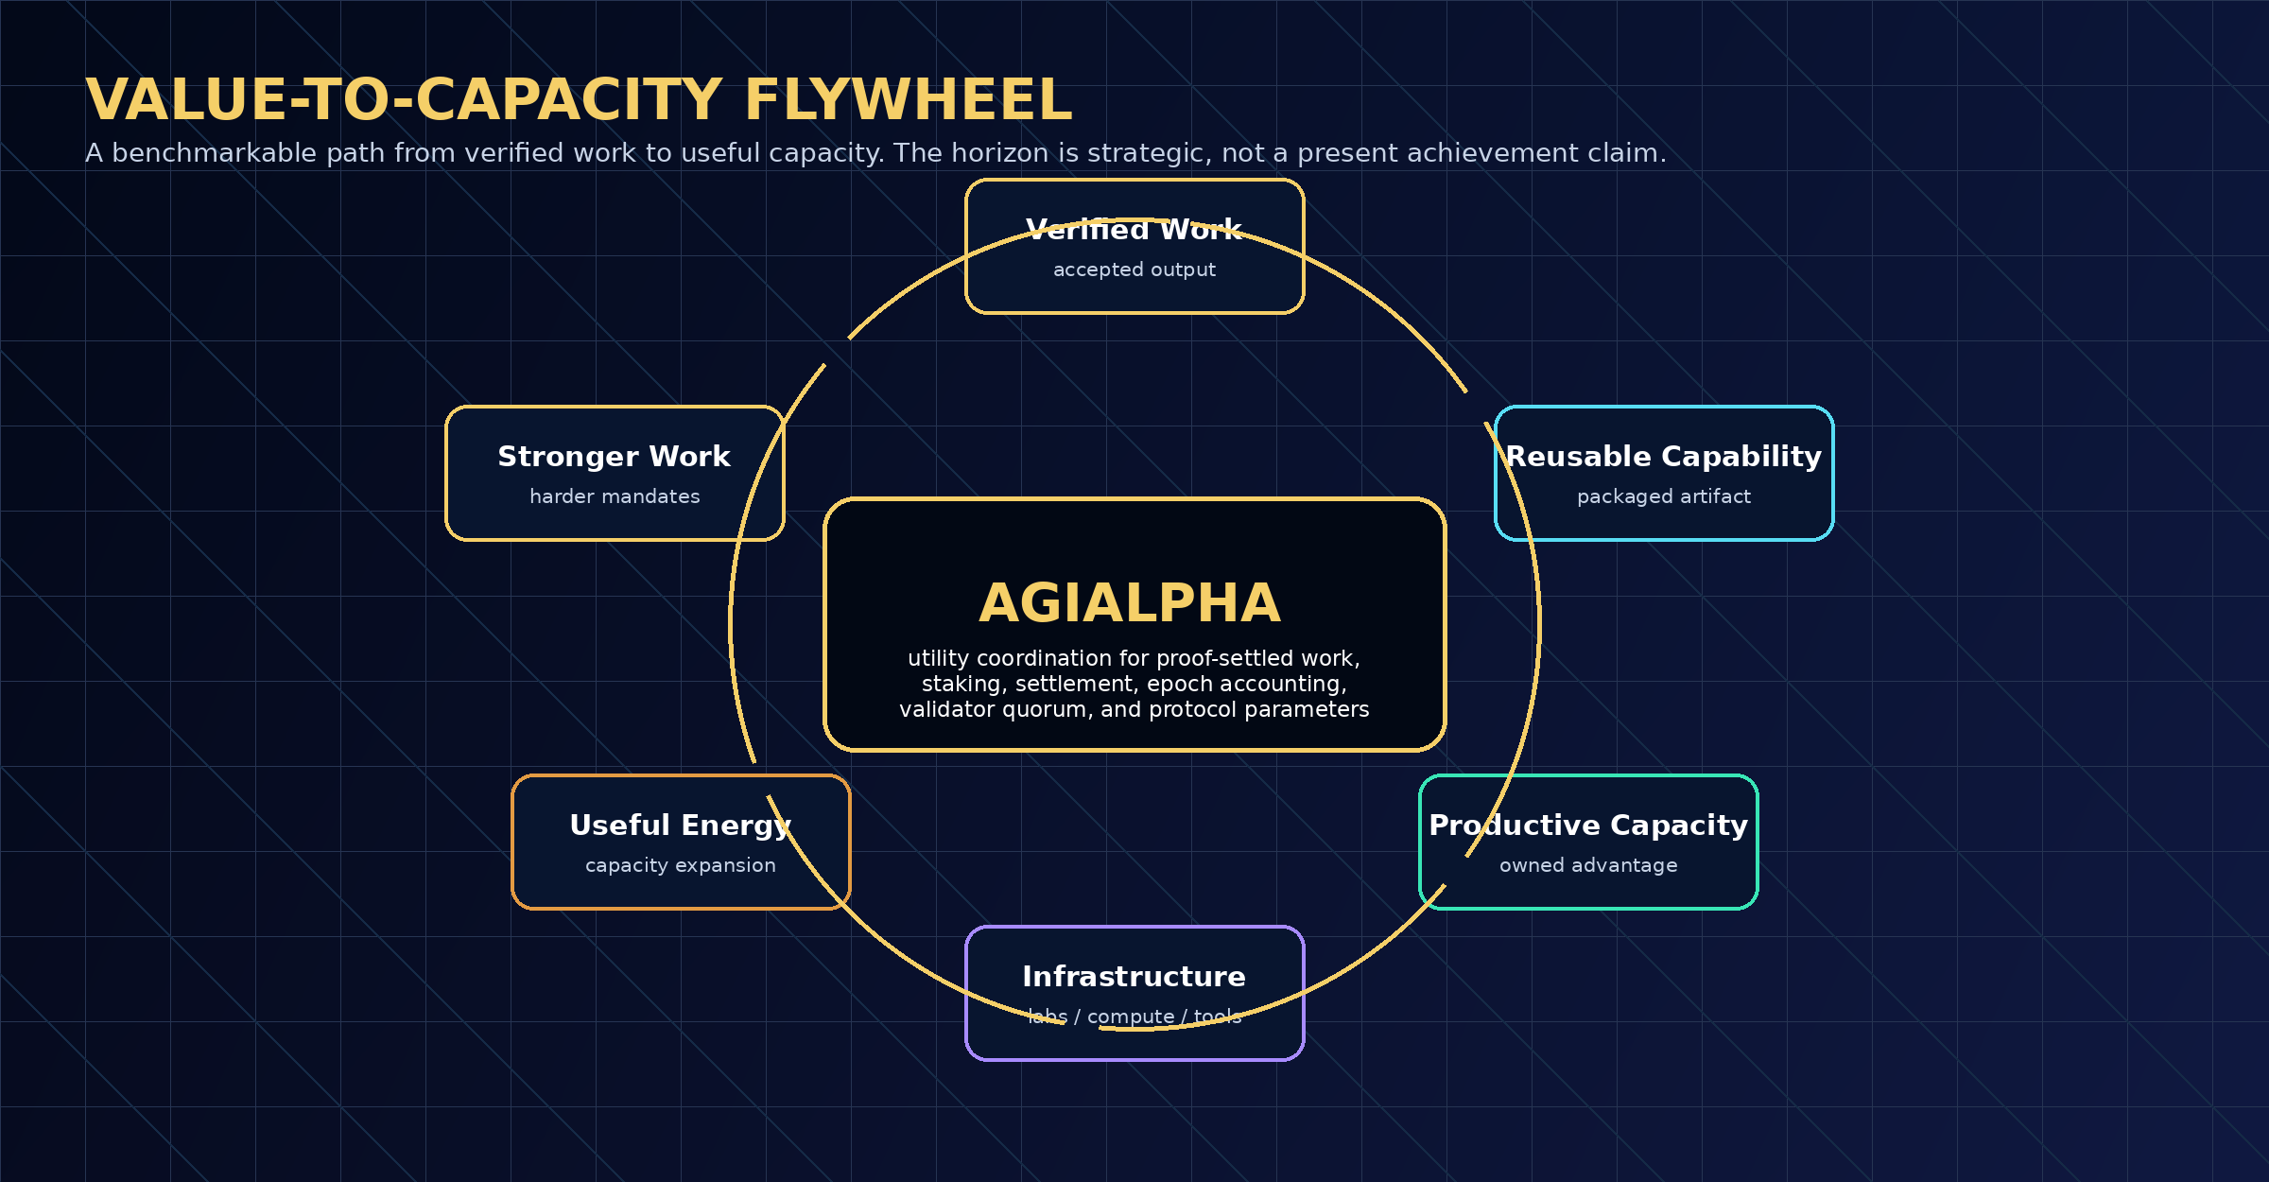
Figure 3 - AGIALPHA Utility Coordination and Value-to-Capacity Flywheel
8. SOVEREIGN DOMAINS: WHERE COMPOUNDING STARTS
The highest-value deployment is not horizontal task completion. It is the creation of specialized Sovereign Domain organs: bounded intelligence institutions that build, validate, and retain domain-specific capability.
A Sovereign Domain is selected when the work has high value, repeatability, proof surfaces, protected data/knowledge leverage, and compounding artifacts. Each domain has its own archive, validators, benchmarks, safety invariants, claim boundaries, and capacity allocation policy.
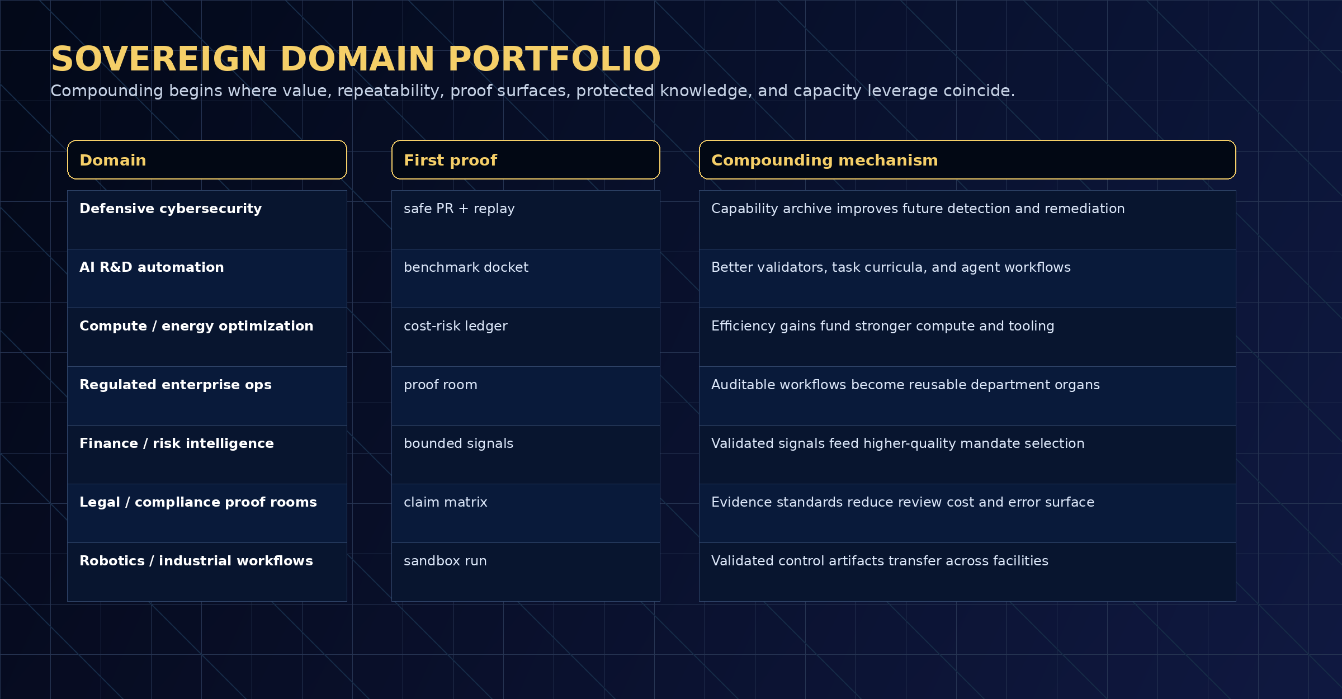
Figure 4 - Sovereign Domain Portfolio
Domain | Why it compounds | First proof | Gate
Defensive cybersecurity | Findings and remediation patterns become a reusable immune system | safe PR + replay | no offensive capability
AI R&D automation | Validators, rubrics, and benchmark suites improve future research work | benchmark docket | no SOTA claim without benchmark
Compute / energy optimization | Cost reductions fund stronger compute and tooling | cost-risk ledger | measured savings only
Regulated enterprise ops | Auditable workflows become department organs | proof room | approval + privacy boundary
Finance / risk intelligence | Validated signals improve future mandate selection | bounded signal docket | no investment-performance claim
Compliance proof rooms | Evidence standards reduce review cost and errors | claim matrix | legal boundary

9. SOVEREIGN RSI SKILL STACK
The system is not a single agent. It is an elite institutional skill stack. Each skill is a reusable capability that can itself be evaluated, versioned, governed, and improved.
The strategic advantage comes from composing skills into plans and plans into domains. The same proof discipline that governs work also governs skill evolution: no untested validator, no unproven routing policy, no invisible memory update, no unreviewed high-risk tool permission.
Skill | Use | Proof metric
Mission decomposition | Turn strategic aim into bounded jobs | coverage, dependency clarity, budget fit
Coalition routing | Assign work to specialized agents/nodes | validated output per cost/risk
Evaluator design | Create rubrics and tests | false promotion / false rejection rate
Proof packaging | Emit ProofBundles and dockets | replay completeness, signature integrity
Capability archiving | Preserve stepping stones and lineages | transfer lift, reuse rate
Red-team and sentinels | Detect unsafe promotion and drift | critical incidents = 0
Capacity allocation | Fund stronger future work | capacity growth per verified epoch

10. SELECTION GATE AND PROOF GRADIENT
The Proof Gradient is not a vibe, a popularity score, or a marketing metric. It is a selection discipline. It admits only upgrades whose verified quality, transfer, value, and evidence integrity dominate cost, risk, coordination overhead, uncertainty, and rollback debt.
The hard gates are constitutional: ProofValid, EvalPass, Risk <= rho, RollbackReady, CanaryReady, ScopeAuthorized, and ChallengeWindowCleared. A high score cannot bypass these gates.
This makes RSI safe enough to be useful: the system can generate many candidates, but only a narrow class of evidenced, scoped, reversible improvements can propagate.
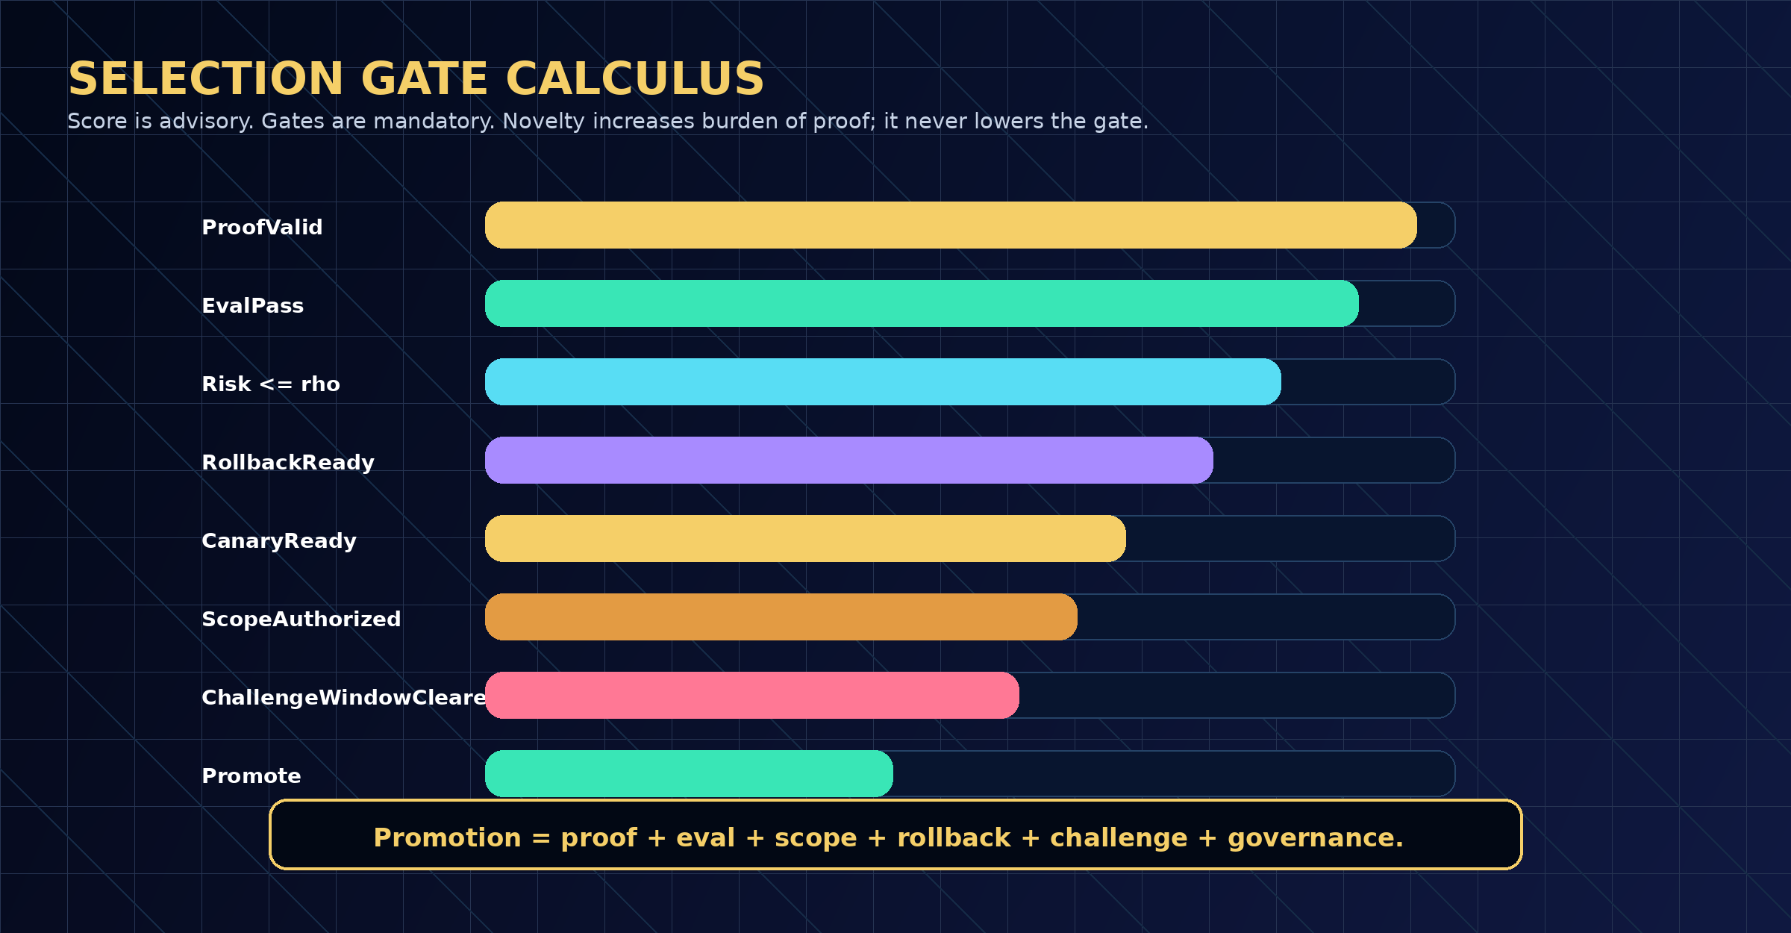
Figure 5 - Selection Gate and Proof Gradient
11. EVIDENCE DOCKETS AND PROOF CARDS
Every claim must have a proof room. An Evidence Docket ties a claim to baselines, manifests, proof packets, evaluation attestations, costs, risks, public/private boundaries, replay paths, and rollback obligations.
Public-safe Proof Cards are compressed trust surfaces. They do not expose sensitive data. They show what was attempted, what evidence exists, what was validated, what was rejected, what remains uncertain, and what would falsify the claim.
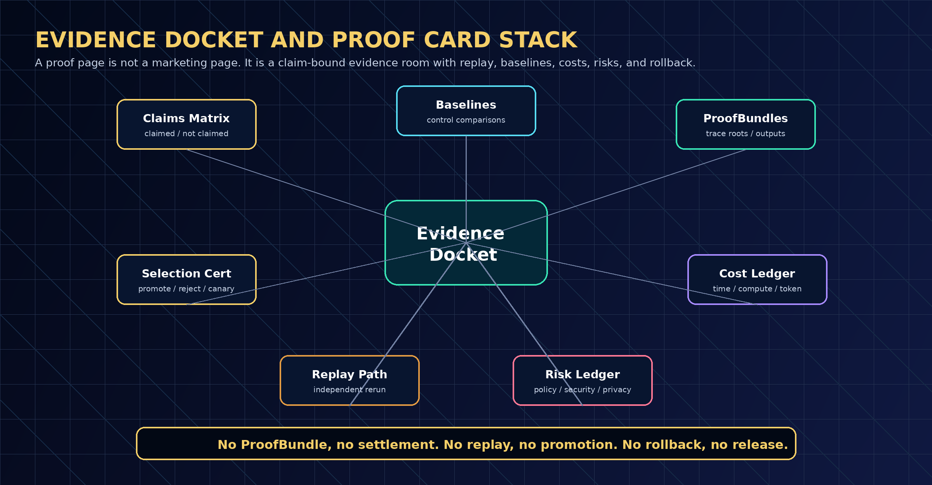
Figure 6 - Evidence Docket and Proof Card Stack
12. MANDATEEPOCH AND ALPHA-FACTORY
A MandateEpoch is the unit of governed autonomous work. It begins with a sponsor mandate and budget. It defines policy, evaluator coverage, descriptor schema, risk class, promotion thresholds, and capacity allocation policy. It ends with settlement, Evidence Docket publication, archive update, and a decision about whether the improved artifact may influence future work.
The internal microjob alphabet includes PROPOSE, CAUSALIZE, SCORE_FAST, SCORE_DEEP, NOVELTY, REDTEAM, ARCHIVE_INSERT, VALIDATE_REPLAY, PROMOTE_CANDIDATE, PACKAGE_CAPABILITY, and UPDATE_INSIGHT_SIGNAL.
This is where the system meaningfully uses RSI: each epoch improves the institution that will run the next epoch. Better rubrics improve validators; better validators improve selection; better selection improves archives; better archives improve future mandates.
13. QUALITY-DIVERSITY ARCHIVE AND INVENTION RESERVE
A conventional workflow system stores past outputs. Sovereign RSI stores stepping stones: diverse, high-quality artifacts that may not be immediately dominant but can become crucial when recombined in future domains.
The Quality-Diversity archive preserves validated tasks, environments, workflows, validators, causal mechanisms, proof templates, operator playbooks, and capacity allocation strategies. The Invention Reserve decides which artifacts are retained internally, licensed selectively, open-sourced strategically, or deployed into protected domains.
The archive prevents premature convergence. The reserve prevents premature commoditization. Together they create compounding institutional memory.
Archive object | Why it matters | Promotion gate
Task environment | Creates curriculum for future agents | replayable, safe, useful
Agent workflow | Reusable execution pattern | beats baseline under equal budget
Validator rubric | Improves proof quality | reduces false accept/reject rate
Causal motif | Compresses operational insight | mechanism test + negative controls
Capability package | Reusable productive capacity | transfer lift + rollback readiness
Domain organ | Specialized institutional capability | governance, safety, evidence, adoption

14. CIVILIZATIONAL VALUE-TO-CAPACITY HORIZON
The quote that a superintelligent machine could create immense wealth and help reach Kardashev Type II civilization level is treated here as a strategic horizon. This paper does not claim present achievement. It defines a disciplined pathway that could make such a horizon institutionally testable.
The pathway is not magic. It is a compounding chain: verified work creates reusable capabilities; capabilities create productive capacity; productive capacity funds infrastructure; infrastructure expands compute, labs, robotics, science, and useful energy; expanded capacity supports stronger future verified work.
The difference between rhetoric and strategy is measurement. Each link in the flywheel requires evidence: cost reduction, capability transfer, capacity allocation, infrastructure conversion, energy/compute leverage, safety/risk accounting, delayed outcomes, and independent replay.
Civilizational ambition becomes credible only when each intermediate link is measured, challengeable, and reversible. Grand strategic horizons are benchmark programs, not press claims.

15. GOVERNANCE ARCHITECTURE
Governance is not a committee appended to the system. It is part of the runtime. Authority is attached to commitments, role roots, validator membership, allowed tools, risk classes, budgets, approval rules, challenge windows, rollout scope, and rollback targets.
High-risk domains require stronger validator quorum, longer challenge windows, stricter tool policies, deeper replay, and more conservative rollout. Sovereign RSI therefore scales capability and governance together.
The key governance principle is separation of powers: sponsors fund mandates; builders execute; validators attest; sentinels watch drift and risk; governors set policy; auditors inspect claims; settlement follows proof.
Role | Authority | Failure prevented
Sponsor | Creates bounded mandates and budgets | unfunded or vague objectives
Builder / Agent | Executes permitted workflows | unbounded autonomy
Validator | Reviews proof and replay | false acceptance
Sentinel | Monitors drift, safety, leakage, anomalies | silent degradation
Governor | Sets policy, quorum, scope, rollback rules | governance capture
Auditor | Inspects dockets and claim boundaries | marketing overclaim
Settlement layer | Releases value after validation | payment without proof

16. SAFETY ENVELOPE AND CLAIM DISCIPLINE
The system is designed for proof-first, publication-safe ambition. The civilizational horizon is used as a strategic direction of travel, not as a present achievement claim. Every stronger claim must be earned through Evidence Dockets, baselines, replay, external validators, delayed outcomes, and risk accounting.
The system rejects unbounded autonomy, unverifiable outputs, and uncontrolled propagation. It replaces them with bounded mandates, replayable ProofBundles, independent validation, Evidence Dockets, Selection Gates, canary rollout, and rollback.
Publication-safe boundary: this paper does not claim achieved AGI, achieved ASI, autonomous sovereignty, empirical SOTA, guaranteed economic return, energy abundance, or Type-II capability.
Claim class | Allowed statement | Forbidden implication
Architecture | A proof-carrying RSI institution design | achieved AGI/ASI
Token utility | Coordination asset for staking, settlement, validation | equity, dividends, ownership, yield
Sovereign domains | High-value deployment surfaces | guaranteed profits
Evidence | Dockets and ProofCards make claims auditable | marketing page as proof
RSI | Institutional artifact evolution under gates | uncontrolled self-modification

17. BENCHMARK AND FALSIFICATION PROGRAM
The system must be evaluated against baselines: single agent, static workflow, memory-only agent, unstructured swarm, human-only baseline, incumbent automation, and previous best Sovereign RSI version.
A strong benchmark suite measures validated α-WU per dollar, hour, watt, and risk unit; transfer lift; replay completeness; false promotion; negative-control rejection; cost reduction; reviewer burden; policy violations; and delayed-outcome integrity.
Falsification is straightforward: if the system cannot beat equal-budget baselines on reproducible real tasks, if validators accept unsafe artifacts, if replay fails, or if improvements increase risk faster than benefit, the thesis has not earned promotion.
Benchmark | Question answered | Promotion metric
RSI real-task benchmark | Does the new version improve real work? | validated α-WU per cost/risk
Coordinator benchmark | Does routing beat simpler baselines? | accepted output / overhead
Evidence replay benchmark | Can outsiders reproduce proof? | replay pass rate
Safety stress test | Does it reject unsafe candidates? | critical incident count = 0
Capacity transfer benchmark | Do artifacts help adjacent tasks? | transfer lift and reuse rate
Delayed-outcome gauntlet | Do improvements remain good later? | post-deployment quality trend

18. IMPLEMENTATION BLUEPRINT
The first production-grade implementation should begin with one Sovereign Domain organ, not an unfocused general system. The highest-quality initial wedge is a domain with strong proof surfaces, meaningful value, low tolerance for unverified claims, and repeatable workflows.
Recommended first domains include defensive cybersecurity, enterprise proof rooms, AI workflow quality control, compliance evidence operations, compute/cost optimization, and AI R&D benchmark automation. Each produces artifacts that can become reusable capability and can be tested without claiming achieved AGI or ASI.
The implementation stack should include a GoalOSCommit registry, MandateEpoch runner, agent/node roster, model gateway, tool permission registry, ProofBundle builder, Evidence Docket generator, validator workbench, Selection Gate, capability archive, Chronicle, and analytics dashboard.
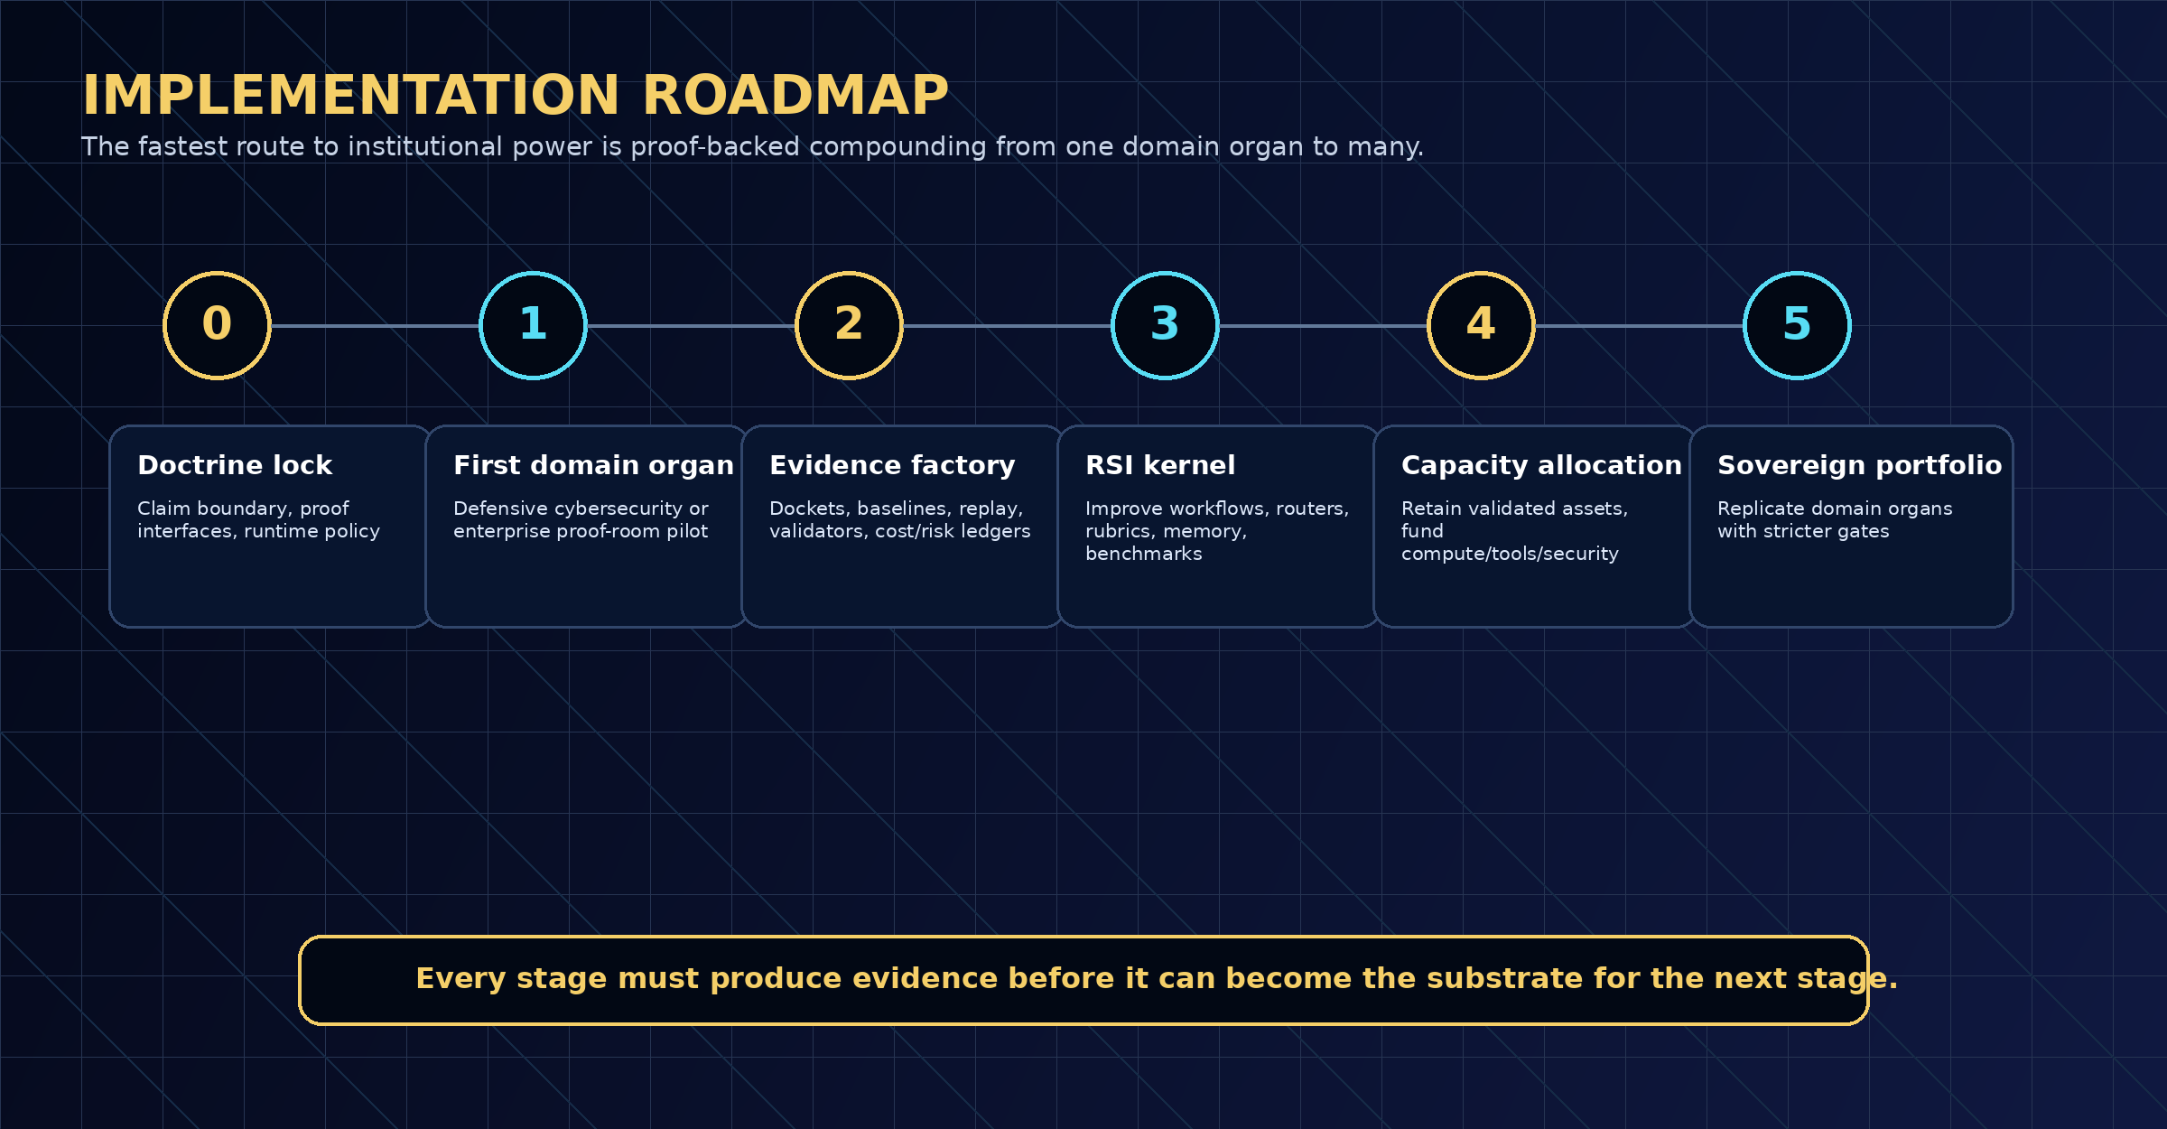
Figure 7 - Sovereign RSI Implementation Roadmap
19. CONCLUSION: THE SOVEREIGN RSI INSTITUTION
GoalOS-native α-AGI Ascension using AGIALPHA is a design for proof-carrying intelligence organizations. It turns RSI from a speculative model-level slogan into a governed institutional process: generate candidates, execute bounded work, validate proof, preserve useful diversity, select cautiously, allocate capacity, and improve the substrate for the next epoch.
Its strongest claim is not that it already possesses superintelligence. Its strongest claim is that a civilization-positive path to such capability requires exactly this kind of institution: one that can coordinate large numbers of agents autonomously, but only under proof, replay, evaluation, settlement, governance, and rollback.
The strategic advantage is compounding. Each verified job can become a reusable capability. Each reusable capability can become a domain organ. Each domain organ can become productive capacity. Each unit of productive capacity can fund stronger future work. That is the sovereign RSI flywheel.
Final doctrine: private intelligence executes; public proof coordinates. Agents act; institutions prove. RSI propagates only through evidence.

SOURCE NOTE AND BOUNDARY
This publication-safe research paper is grounded in the AGI ALPHA organizational-substrate thesis and the GoalOS Proof-of-Evolution Constitution. It proposes architecture, mechanisms, benchmark doctrine, and implementation strategy. It does not claim achieved AGI, ASI, empirical SOTA, guaranteed economic return, or achieved civilization-scale capability.

