AEP-004
Selection Gate Standard
Promote only what proved itself
Version 1.1 Institutional Edition · Proof Gradient / Agent Evolution Protocol
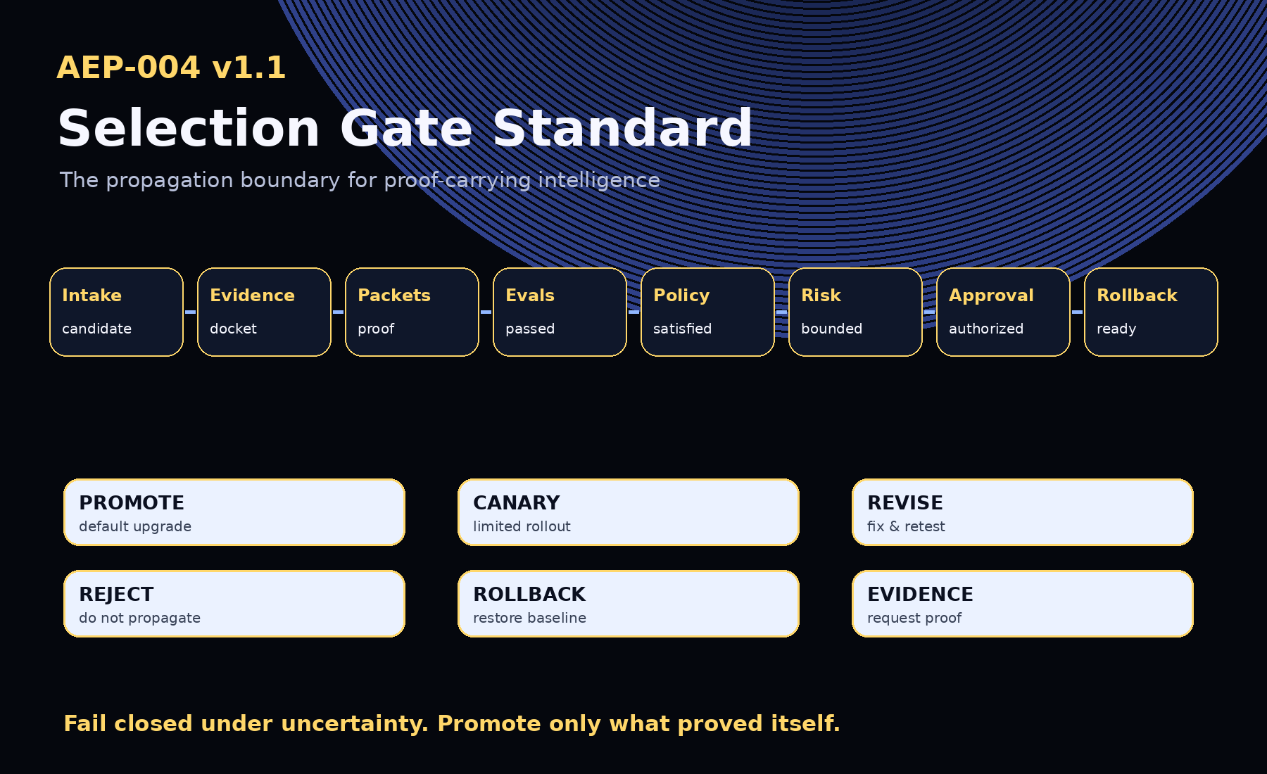
AEP-001 defines the protocol. AEP-002 defines the docket. AEP-003 defines the packet. AEP-004 defines the gate.

1. Abstract
AEP-004 defines the Selection Gate: the propagation boundary that decides whether a candidate artifact, workflow, policy, tool, evaluation, context recipe, model route, agent behavior, or capability may be promoted, canaried, revised, rejected, archived, rolled back, or held for more evidence.
A Selection Gate is the institutional mechanism that converts proof into governed evolution.

2. Canonical Law
No proof, no evolution.
No eval, no propagation.
No rollback, no release.

3. v1.1 Implementation Upgrade
- Gate modes: advisory, manual, automated_bounded, emergency
- Challenge records and certificate expiration
- Revocation and supersession model
- Fail-closed invariants
- Reference decision engine and conformance tools

4. Gate Decisions
Decision | Meaning
promote | Candidate may become the active default within approved scope.
approve_canary | Candidate may be deployed to limited scope under monitoring.
revise | Candidate has partial merit but must be modified and re-evaluated.
reject | Candidate must not propagate.
archive | Candidate is retained as evidence/history but not used.
rollback | Existing promoted capability must be reverted to prior safe state.
needs_more_evidence | Candidate cannot be judged until additional proof exists.

5. Gate Modes
- advisory - recommends but does not enforce
- manual - institutional approver issues final certificate
- automated_bounded - automatic only in low-risk bounded scope
- emergency - pre-authorized rollback under incident conditions

6. Selection Certificate
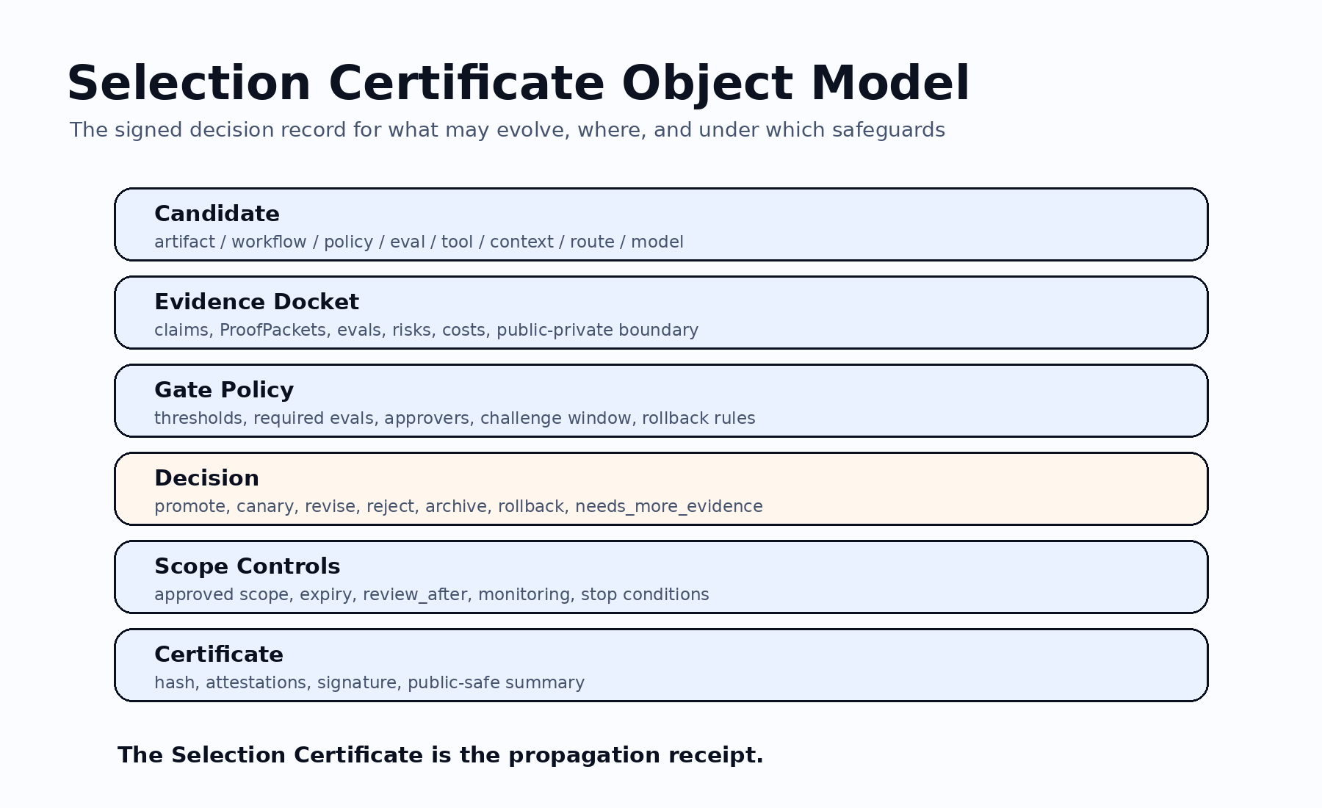
The Selection Certificate is the signed or recorded decision proving what may evolve, where, for how long, under what monitoring, and with which rollback target.

7. Decision Criteria
- Evidence sufficiency
- Evaluation sufficiency
- Policy sufficiency
- Risk sufficiency
- Cost and latency sufficiency
- Approval sufficiency
- Challenge sufficiency
- Rollout sufficiency
- Rollback sufficiency
- Claim-boundary sufficiency

8. Conservative Default Logic
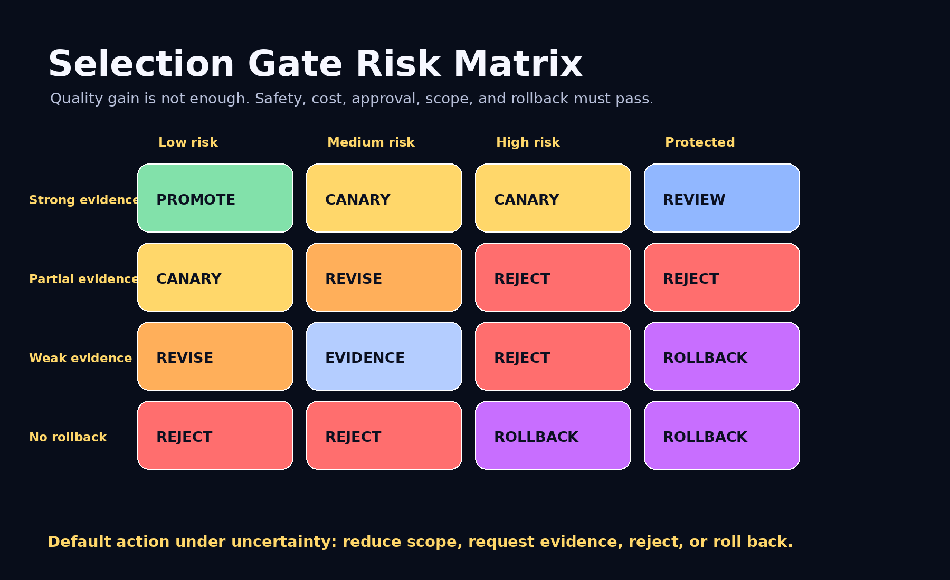

9. Selection Gate Lifecycle
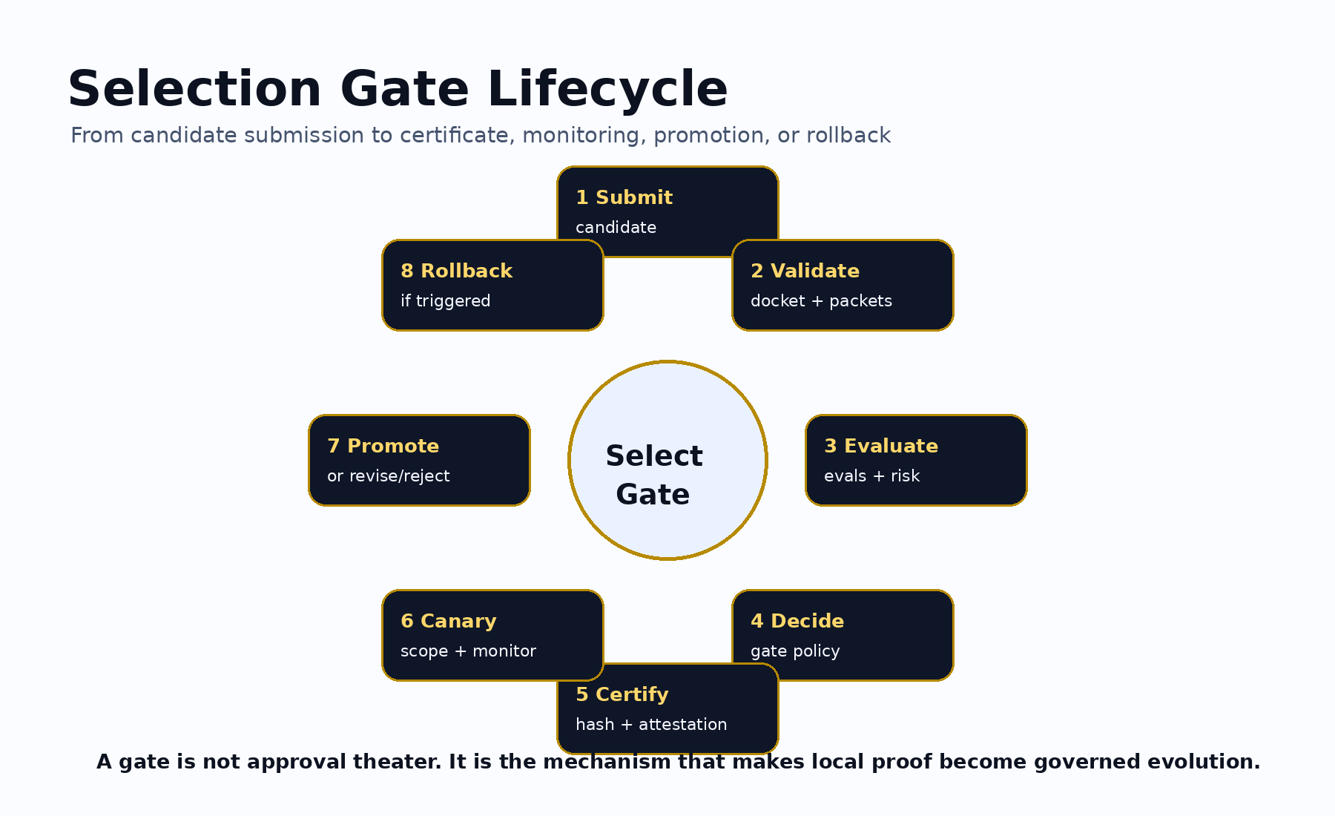

10. Invariants
- Promote requires evidence, eval success, risk acceptance, scope, monitoring, and rollback readiness.
- Canary requires evidence, eval success, limited scope, monitoring, stop conditions, and rollback readiness.
- Reject must record why the candidate cannot propagate.
- Rollback must identify the rollback target and trigger.
- Needs_more_evidence must specify missing evidence.
- Archive must not silently promote or route traffic.
- A protected-risk candidate must not promote through automated_bounded mode unless explicitly authorized.
- A public Selection Certificate must not leak private or protected evidence.
- A Selection Certificate must include a claim boundary.
- Under uncertainty, the gate must fail closed.

11. Conformance Levels
Level | Requirement
Level 0 | Informal selection with evidence and reason.
Level 1 | Basic Selection Gate with candidate and decision record.
Level 2 | Evaluated gate with eval, risk, and rollback status.
Level 3 | Operational gate with policy, canary, monitoring, approval, challenge record, and claim boundary.
Level 4 | Institutional gate with signed certificate, audit export, rollback readiness, expiry, review date, and public/private boundary.
Level 5 | Sovereign / regulated gate with jurisdiction, protected-boundary classification, authorized approvers, evaluator attestations, timestamp authority, challenge window, revocation model, and public-safe controls.

12. Claim Boundary
AEP-004 does not claim achieved AGI, achieved ASI, perfect safety, legal compliance certification, financial or legal advice, guaranteed ROI, production readiness, government endorsement, or national-security readiness. AEP-004 defines a selection and propagation standard.
GoalOS promotes only what proved itself.

