AEP-005
Tool Permission Standard
Scoped, approved, leased, revocable, and provable tool use
Version 1.1 Institutional Edition · Proof Gradient / Agent Evolution Protocol
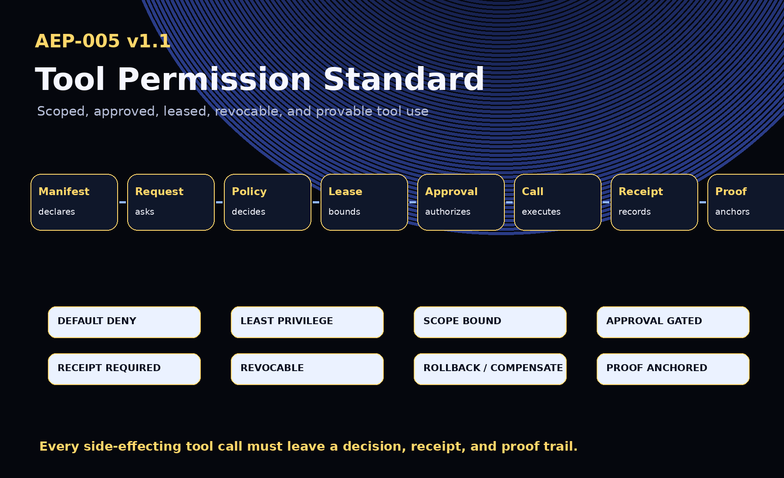
AEP-001 defines the protocol. AEP-002 defines the docket. AEP-003 defines the packet. AEP-004 defines the gate. AEP-005 defines the permission.

1. Abstract
AEP-005 defines the Tool Permission Standard: the governance layer that determines whether an AI agent, workflow, model route, human operator, or automated system may use a tool, under what scope, for how long, with which approvals, what evidence must be recorded, and what rollback or compensation path is required.
A model may know a tool exists. An agent may request a tool. Only the Tool Gateway may authorize its use.

2. Canonical Law
No tool without permission.
No action without scope.
No high-risk tool without approval.
No side effect without receipt.
No irreversible action without rollback or compensation.
No permanent authority without expiration.
No proof, no evolution.

3. v1.1 Upgrades
- Permission leases
- Revocation receipts
- Compensation receipts
- Break-glass requests
- Data-boundary rules
- Rate-limit policies
- Separation of duties
- Tool Gateway audit tooling

4. Tool Authority Model
- Ability - the tool exists and can technically be called.
- Authority - the agent or workflow is allowed to request it.
- Scope - the permitted boundaries of use.
- Lease - the permission is time-bounded and revocable.
- Approval - human, policy, or institutional authorization.
- Execution - the actual tool call.
- Receipt - the execution result and side effects are recorded.
- Proof - the decision and receipt anchor into ProofPackets and Evidence Dockets.
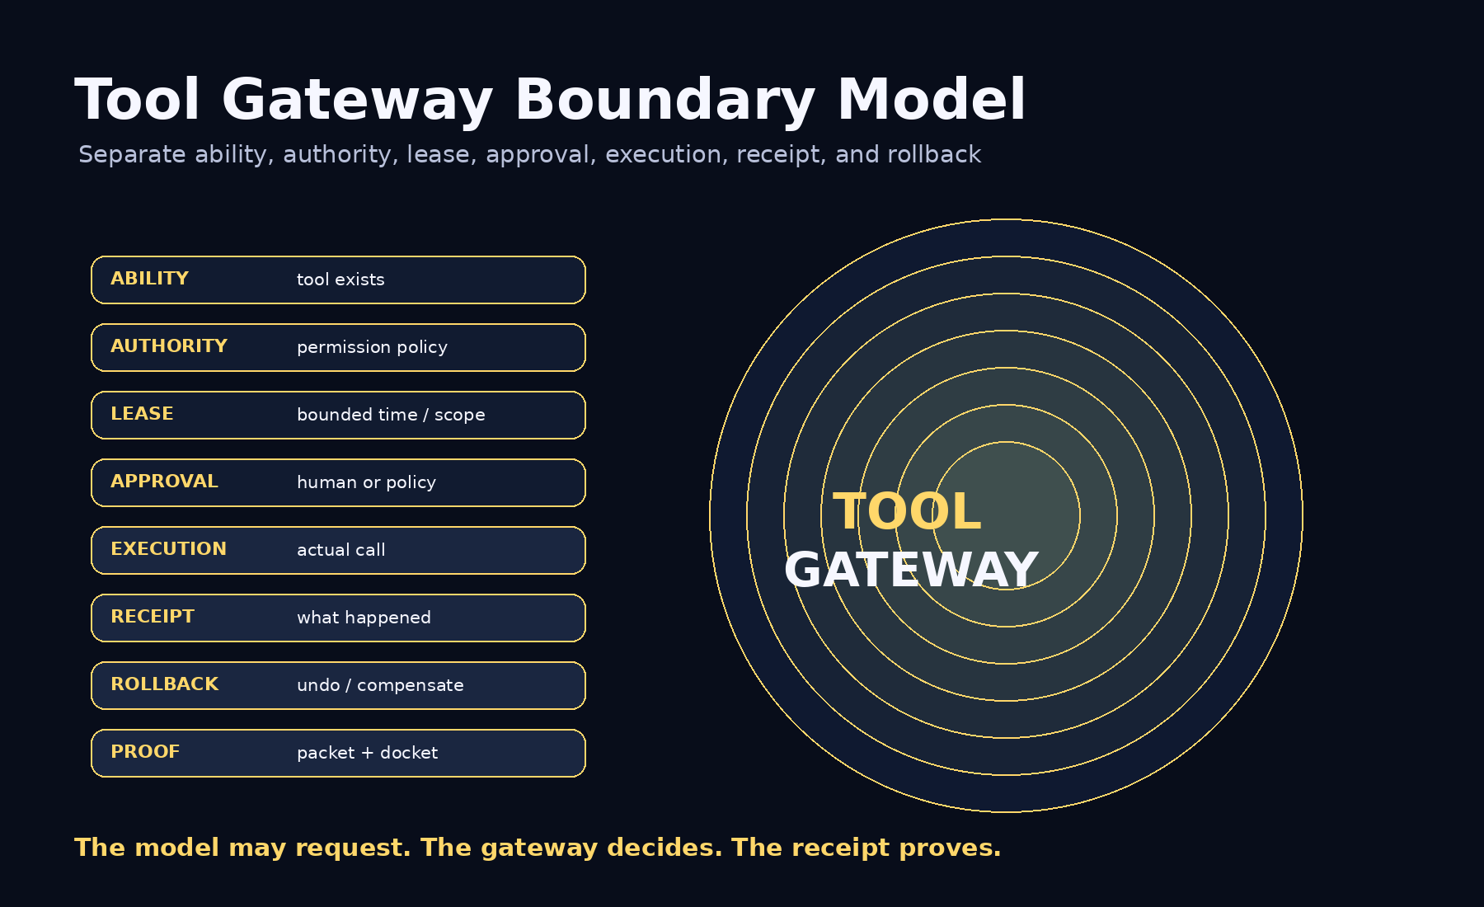

5. Permission Classes
Permission Class | Meaning
none | Tool unavailable.
read | Observe, retrieve, inspect, list, or query without changing state.
draft | Prepare output without applying it.
transform | Transform data without external side effects.
write | Change internal state or modify a system.
execute | Run code, jobs, scripts, automations, or computational tasks.
external_contact | Contact external people, systems, vendors, customers, agencies, or public endpoints.
send | Send a message, publication, email, form, API request, or external output.
delete | Delete, destroy, revoke, remove, or irreversibly alter a resource.
deploy | Release, publish, ship, merge, promote, or activate a capability.
payment | Spend money, transfer value, initiate purchase, or access payment rails.
secret_access | Read or use secrets, credentials, tokens, keys, private data, or protected evidence.
admin_change | Change permissions, roles, policies, accounts, infrastructure, routing, or governance.
protected_operation | High-impact or regulated operation requiring special authorization.
break_glass | Emergency use outside normal policy with mandatory review.

6. Core Objects
Object | Purpose
Tool Manifest | Declares tool identity, permissions, risk, data access, side effects, approval and evidence requirements.
Tool Permission Policy | Defines who may use which tools, in what scopes, with which approvals, limits, rollback and compensation.
Tool Request | Records the request before tool use.
Tool Permission Decision | Records allow, deny, approval_required, or restricted allow decisions.
Permission Lease | Records time-bounded and revocable authority.
Approval Receipt | Records human or institutional approval.
Tool Call Receipt | Records what happened after execution.
Revocation Receipt | Records termination of tool authority.
Compensation Receipt | Records remediation when rollback is impossible or insufficient.
Break-Glass Request | Records emergency use outside normal policy.

7. Permission Lattice and Lease Model
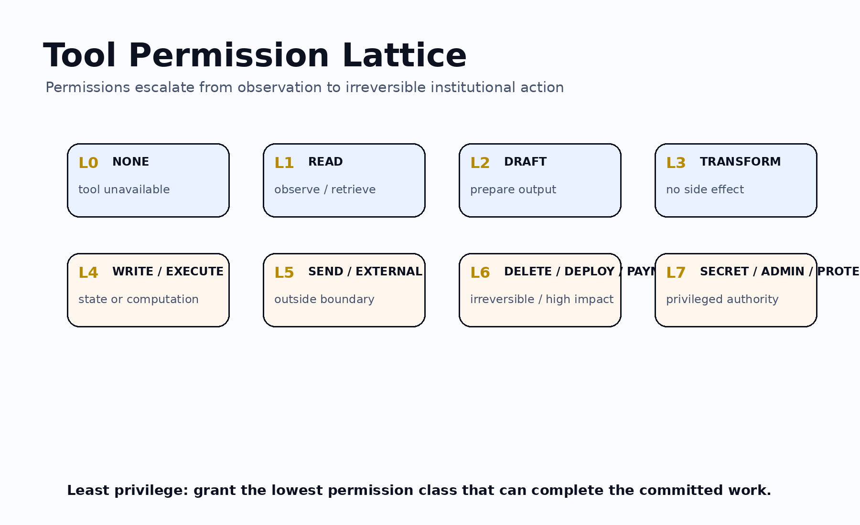
A permission is not a permanent power. It is a bounded lease. High-impact tools require expiry, revocation, receipt, rollback or compensation.
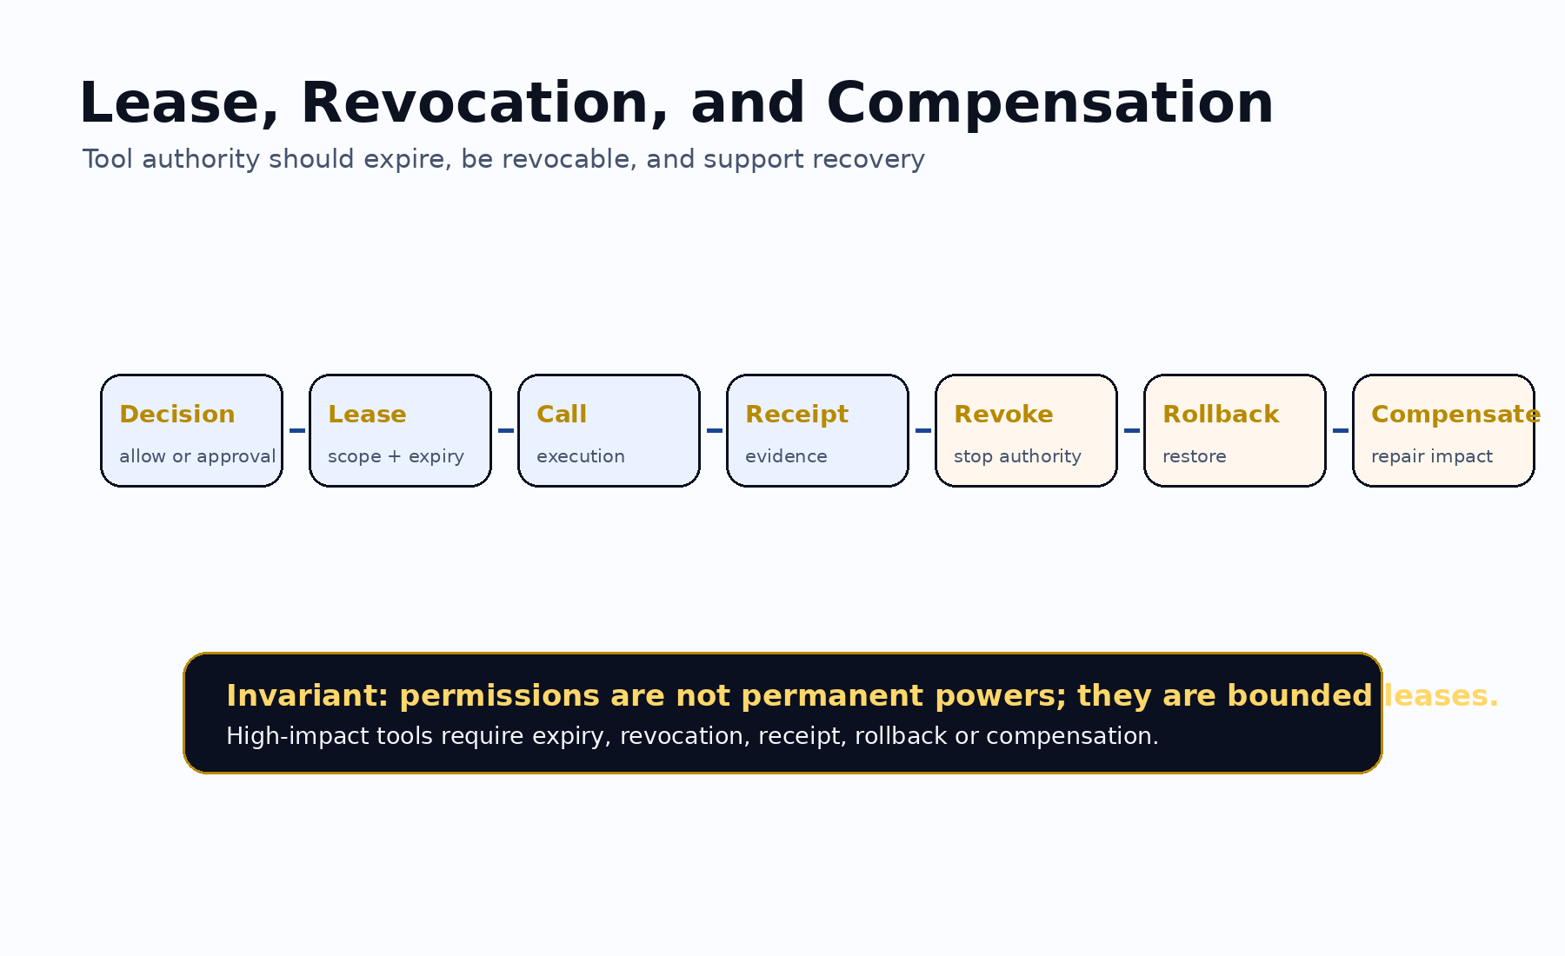

8. Default-Deny Rule
- No tool manifest exists.
- No policy applies.
- Requested class is not supported.
- Requested class is denied.
- Approval is required but absent.
- Scope is missing.
- Lease is missing or expired.
- Rollback or compensation is required but missing.
- Protected data lacks authorization.
- Budget or rate limit is exceeded.
- Separation of duties is violated.
- The gateway cannot evaluate the policy.

9. High-Risk Permission Rules
- write requires evidence, policy, scope, lease, and receipt.
- send / external_contact requires approval unless explicitly pre-authorized.
- delete requires approval, rollback or compensation plan, and receipt.
- deploy requires Selection Gate or release authority, monitoring, and rollback.
- payment requires financial authorization, budget scope, and receipt.
- secret_access requires protected access authority and evidence controls.
- admin_change requires elevated approval and separation of duties.
- break_glass requires emergency justification, temporary scope, monitoring, and post-incident review.

10. Conformance Levels
Level | Requirement
Level 0 | Informal tool note.
Level 1 | Tool manifest.
Level 2 | Gateway decision.
Level 3 | Scoped leased permission.
Level 4 | Institutional permission with approval, leases, receipts, ProofPackets, rollback/compensation, revocation, and audit export.
Level 5 | Sovereign / regulated permission with jurisdiction, retention, data boundary, authorized approvers, separation of duties, public/private/protected evidence boundary, institutional review, revocation, and post-incident controls.

11. Claim Boundary
AEP-005 does not claim achieved AGI, achieved ASI, perfect safety, legal compliance certification, financial or legal advice, guaranteed ROI, production readiness, government endorsement, or national-security readiness. AEP-005 defines a tool permission and proof standard.
GoalOS allows only what is scoped, approved, leased, revocable, and provable.

