AEP-006
Rollback Receipt Standard
Recovery must be proven, not merely promised
Version 1.1 Institutional Edition · Proof Gradient / Agent Evolution Protocol
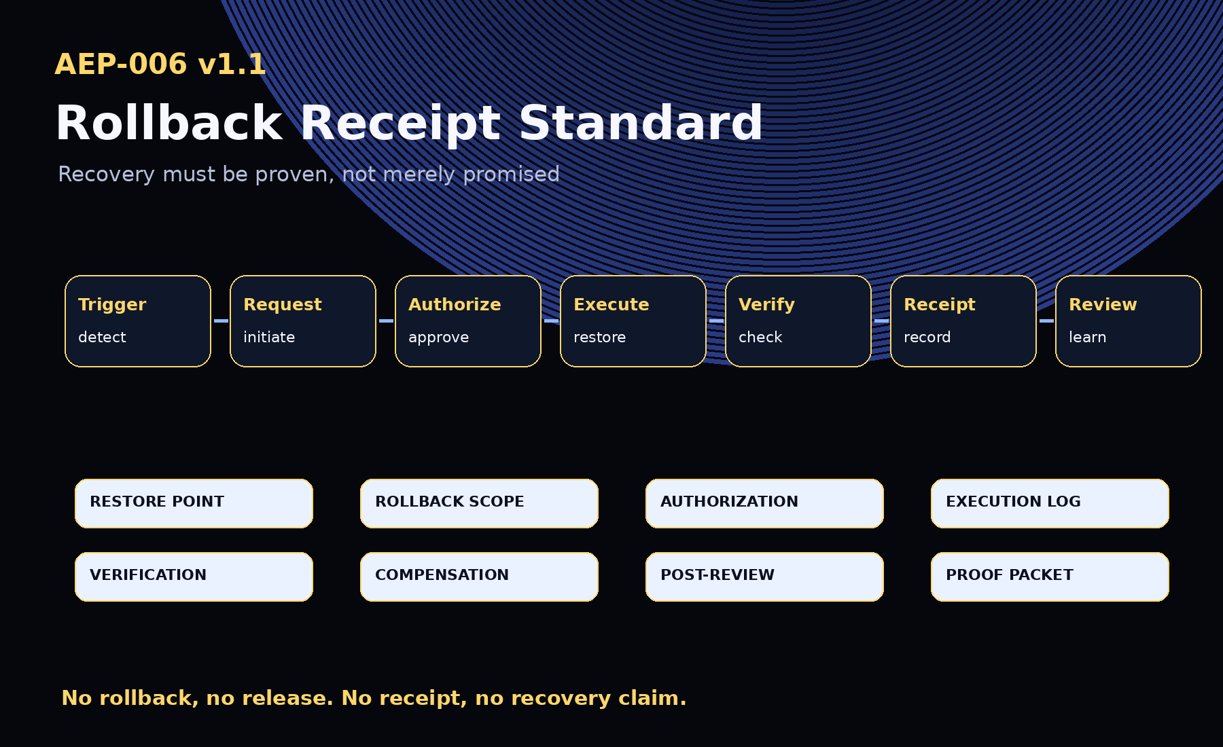
AEP-001 defines the protocol. AEP-002 defines the docket. AEP-003 defines the packet. AEP-004 defines the gate. AEP-005 defines the permission. AEP-006 defines the recovery proof.

1. Abstract
AEP-006 defines the Rollback Receipt Standard: the proof standard for recovery, restoration, reversal, compensation, freeze, quarantine, post-rollback verification, and post-incident review after machine work fails, violates policy, exceeds scope, causes side effects, degrades quality, or requires controlled reversion.
A rollback is not complete because someone says it is complete. A rollback is complete only when recovery is executed, verified, and recorded.

2. Canonical Law
No rollback, no release.
No receipt, no recovery claim.
No restore point, no promotion.
No compensation path, no irreversible action.
No post-rollback verification, no closure.
No proof, no evolution.

3. Required Objects
Object | Purpose
Rollback Trigger | Records the signal that initiated recovery.
Rollback Plan | Defines the target, owner, steps, verification, and compensation path.
Rollback Request | Initiates rollback.
Rollback Authorization | Records approval.
Rollback Receipt | Records execution.
Rollback Verification | Proves recovery succeeded or failed.
Compensation Receipt | Records remediation when rollback is impossible or insufficient.
Post-Rollback Review | Turns failure into reusable knowledge.
Recovery Bundle | Aggregates recovery proof objects.
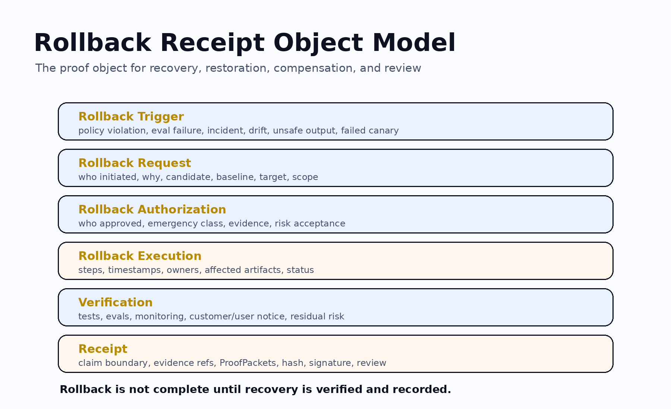

4. Status Values and Action Types
- Status: not_required, ready, requested, authorized, in_progress, completed, verified, partial, failed, compensation_required, compensated, quarantined, archived.
- Actions: restore_baseline, revert_artifact, revert_workflow, revoke_permission, stop_canary, freeze_rollout, quarantine, disable_agent, disable_tool, revert_deployment, undo_transaction, send_correction, compensate, escalate_incident, manual_review.

5. Decision Matrix
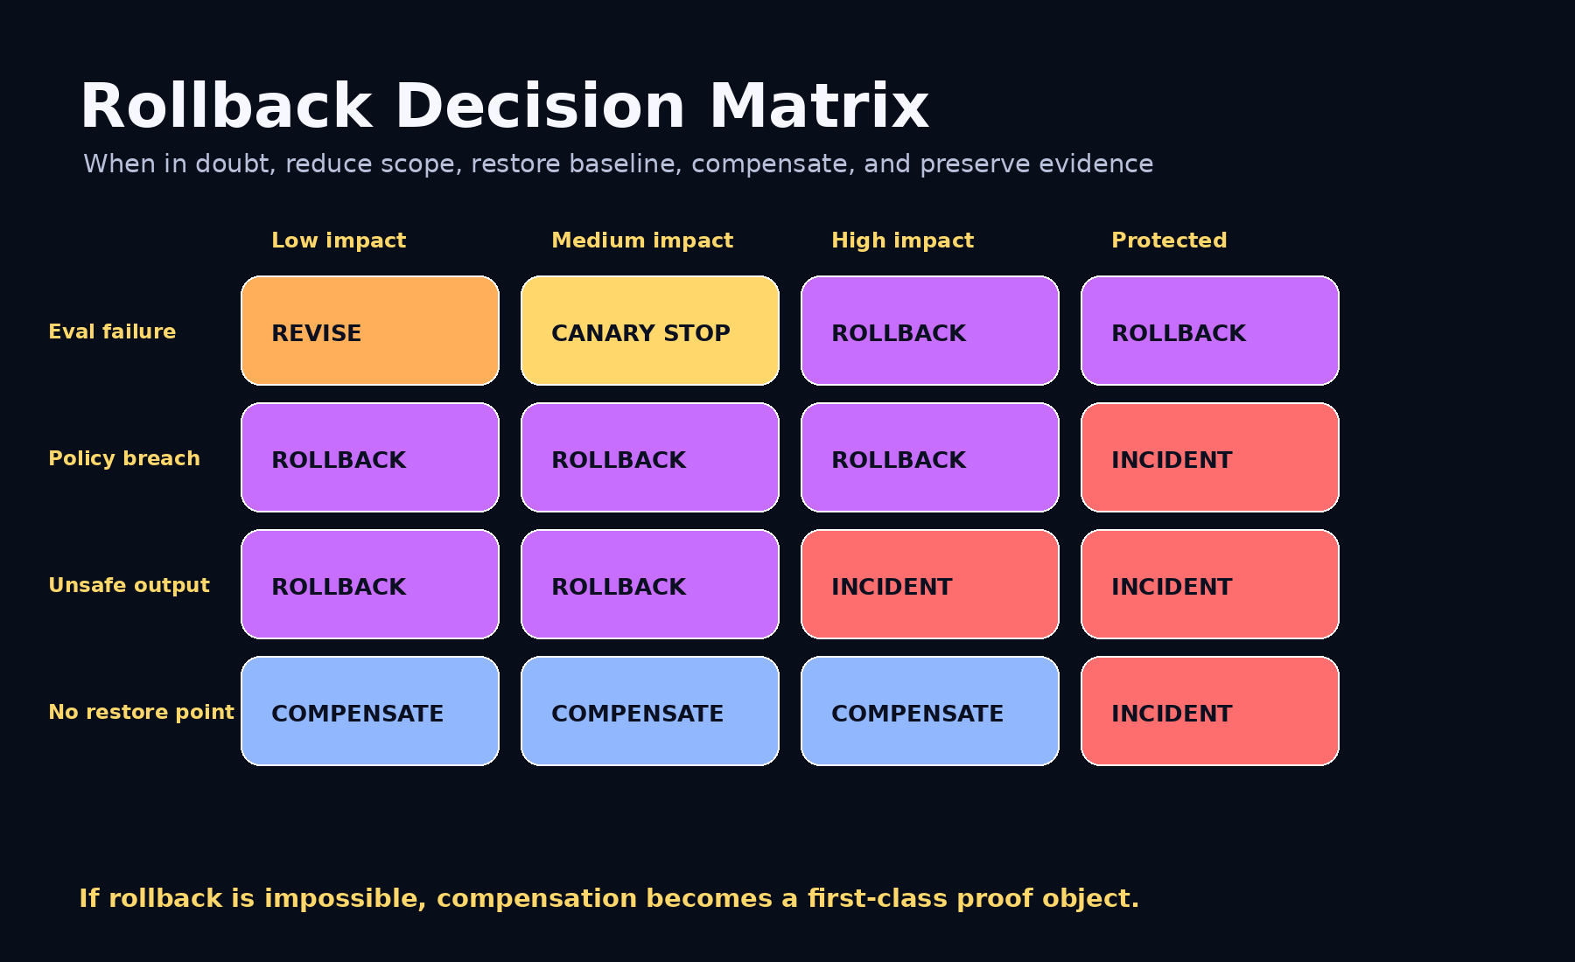

6. Recovery Timeline
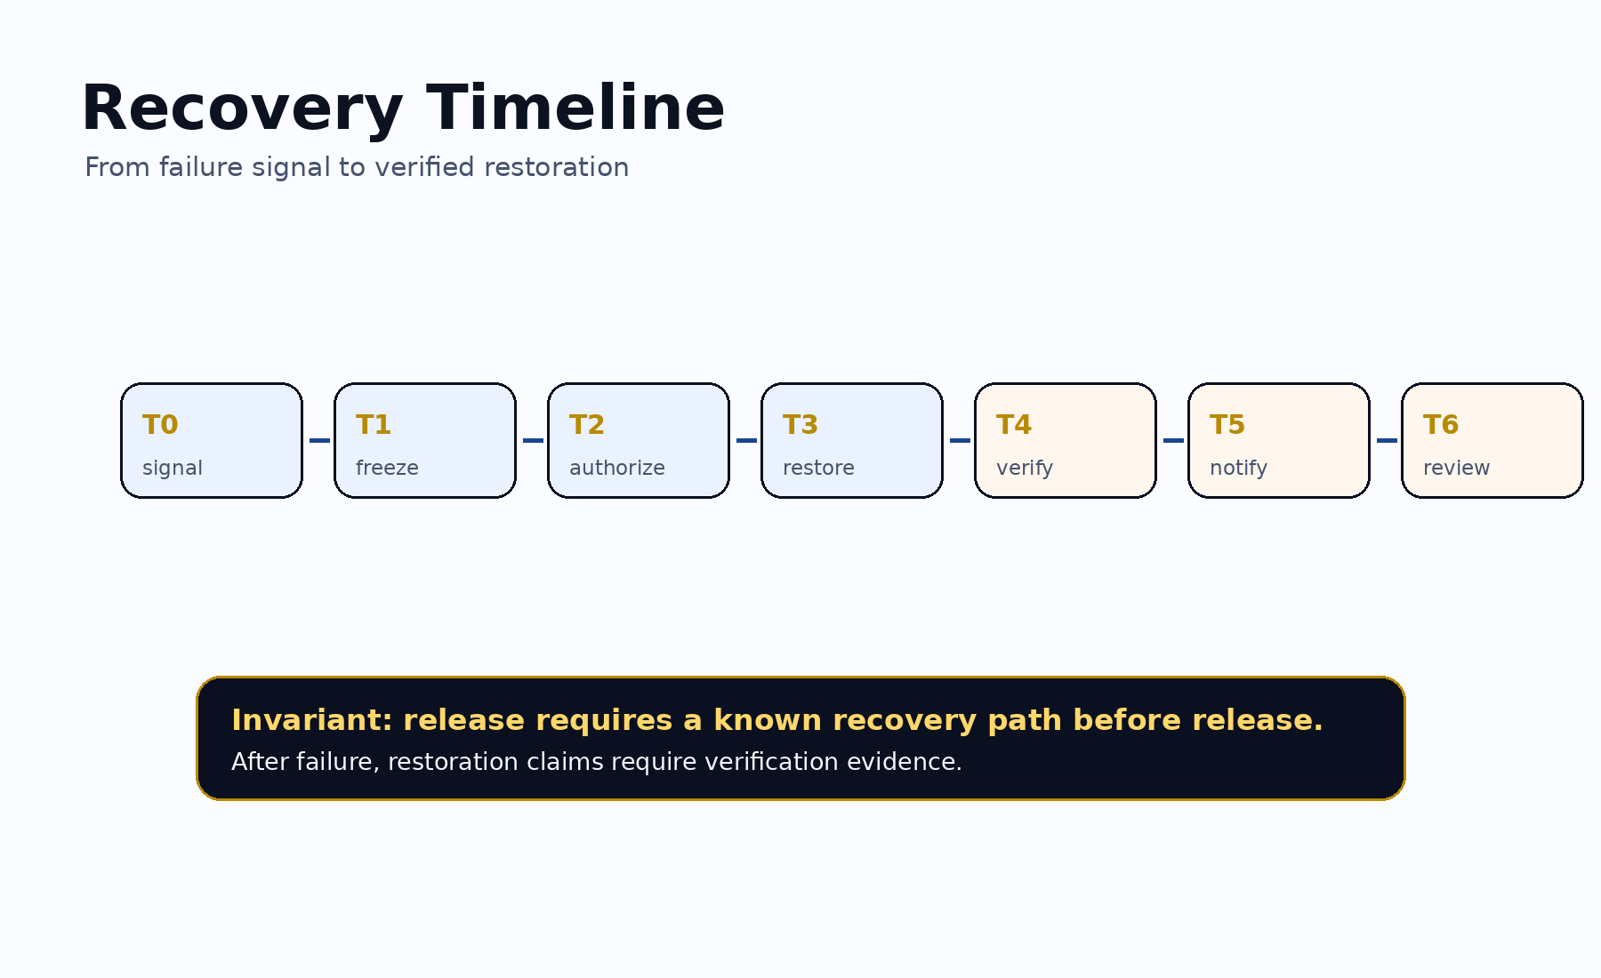

7. Required Release Invariant
- Rollback target
- Rollback plan
- Rollback owner
- Rollback trigger
- Verification plan
- Compensation path if rollback is impossible
- Evidence Docket or release proof
- Selection Certificate or equivalent release authority

8. Conformance Levels
Level | Requirement
Level 0 | Informal rollback note.
Level 1 | Rollback plan exists.
Level 2 | Rollback execution receipt exists.
Level 3 | Rollback verification exists.
Level 4 | Institutional rollback with authorization, evidence, ProofPackets, Selection Certificate refs, tool receipts, compensation path, public/private boundary, and post-rollback review.
Level 5 | Sovereign / regulated rollback with jurisdiction, retention, protected-boundary classification, authorized approvers, public-safe controls, affected-public notice rules, post-incident review, and audit export.

9. Claim Boundary
AEP-006 does not claim achieved AGI, achieved ASI, perfect safety, legal compliance certification, financial or legal advice, guaranteed ROI, production readiness, government endorsement, or national-security readiness. AEP-006 defines a recovery proof standard.
GoalOS releases only what can recover, and proves when recovery happens.

