AEP-007
Public-Safe Proof Report Standard
Public proof without private leakage
Version 1.2 Institutional Edition · Proof Gradient / Agent Evolution Protocol
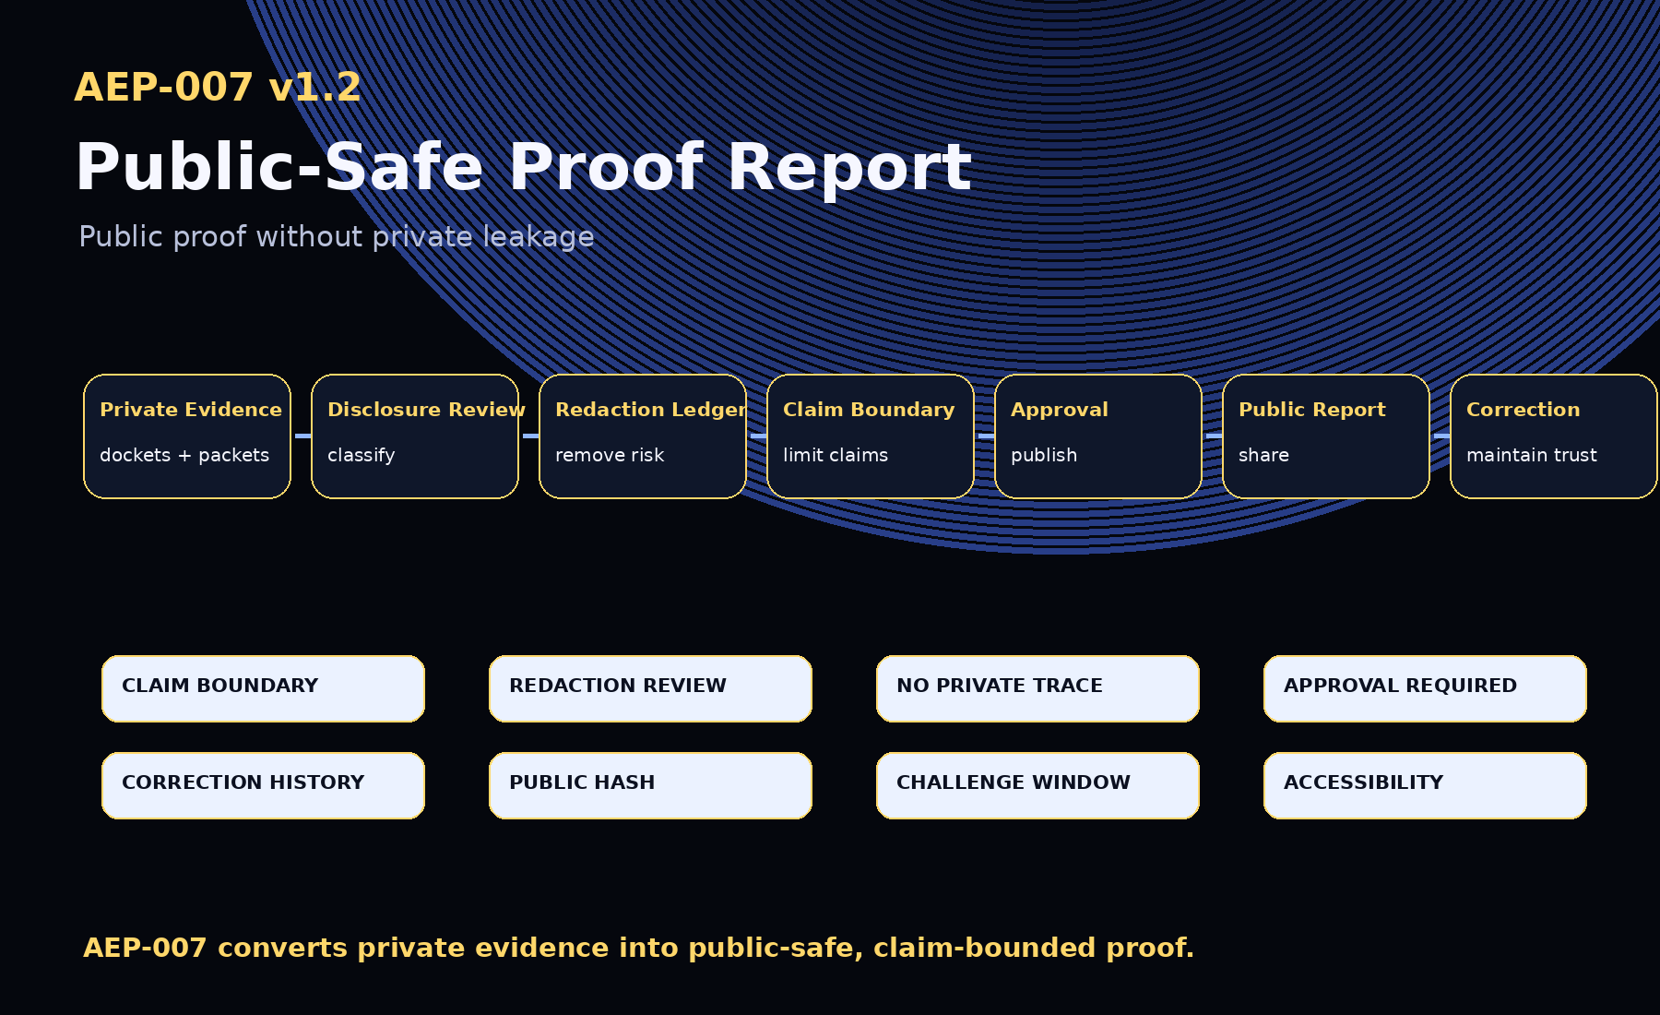
AEP-007 defines the public proof. GoalOS proves publicly without leaking privately.

1. Abstract
AEP-007 defines the Public-Safe Proof Report Standard: the reporting layer that converts private or protected machine-work evidence into a public-safe proof report that can be shared without leaking private or protected material.

2. Canonical Law
No public claim without claim boundary.
No public proof without redaction review.
No private trace in public report.
No protected data in public proof.
No publication without approval.
No correction without history.
No proof, no evolution.

3. v1.2 Upgrades
- Disclosure review objects
- Challenge records
- Retraction notices
- Report bundles
- Embargo / responsible disclosure controls
- Public claim levels
- Accessibility profile
- Proof Card profile
- Leakage audit tooling

4. Disclosure Classes
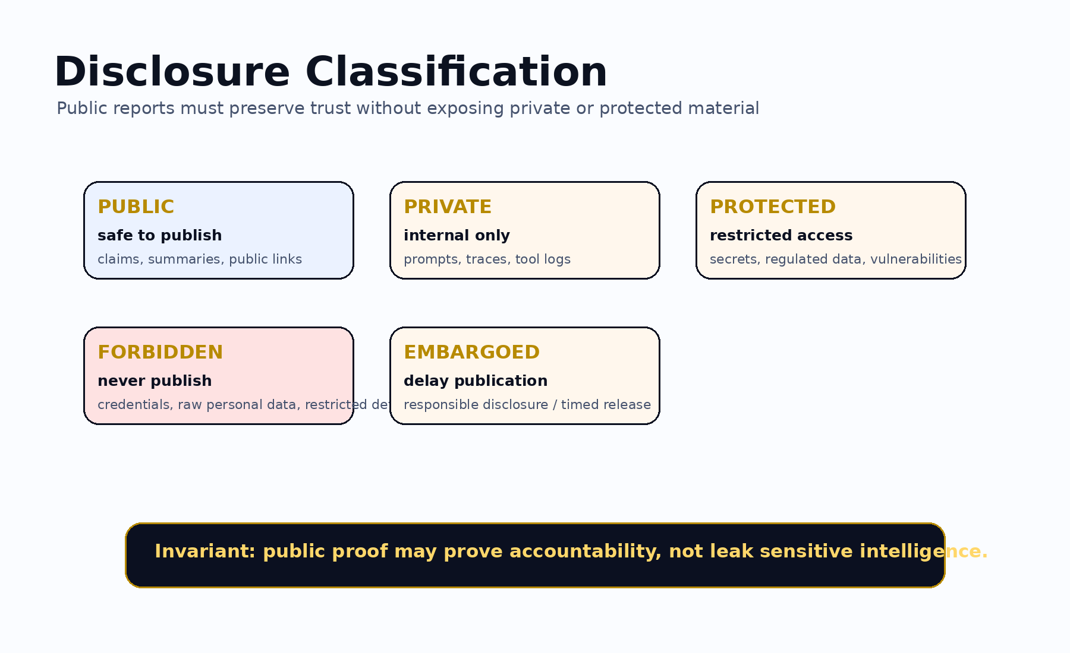
Class | Meaning
public | Safe to publish.
private | Internal only.
protected | Restricted to authorized roles.
forbidden | Never publish.
embargoed | Not yet publishable.

5. Public Claim Levels
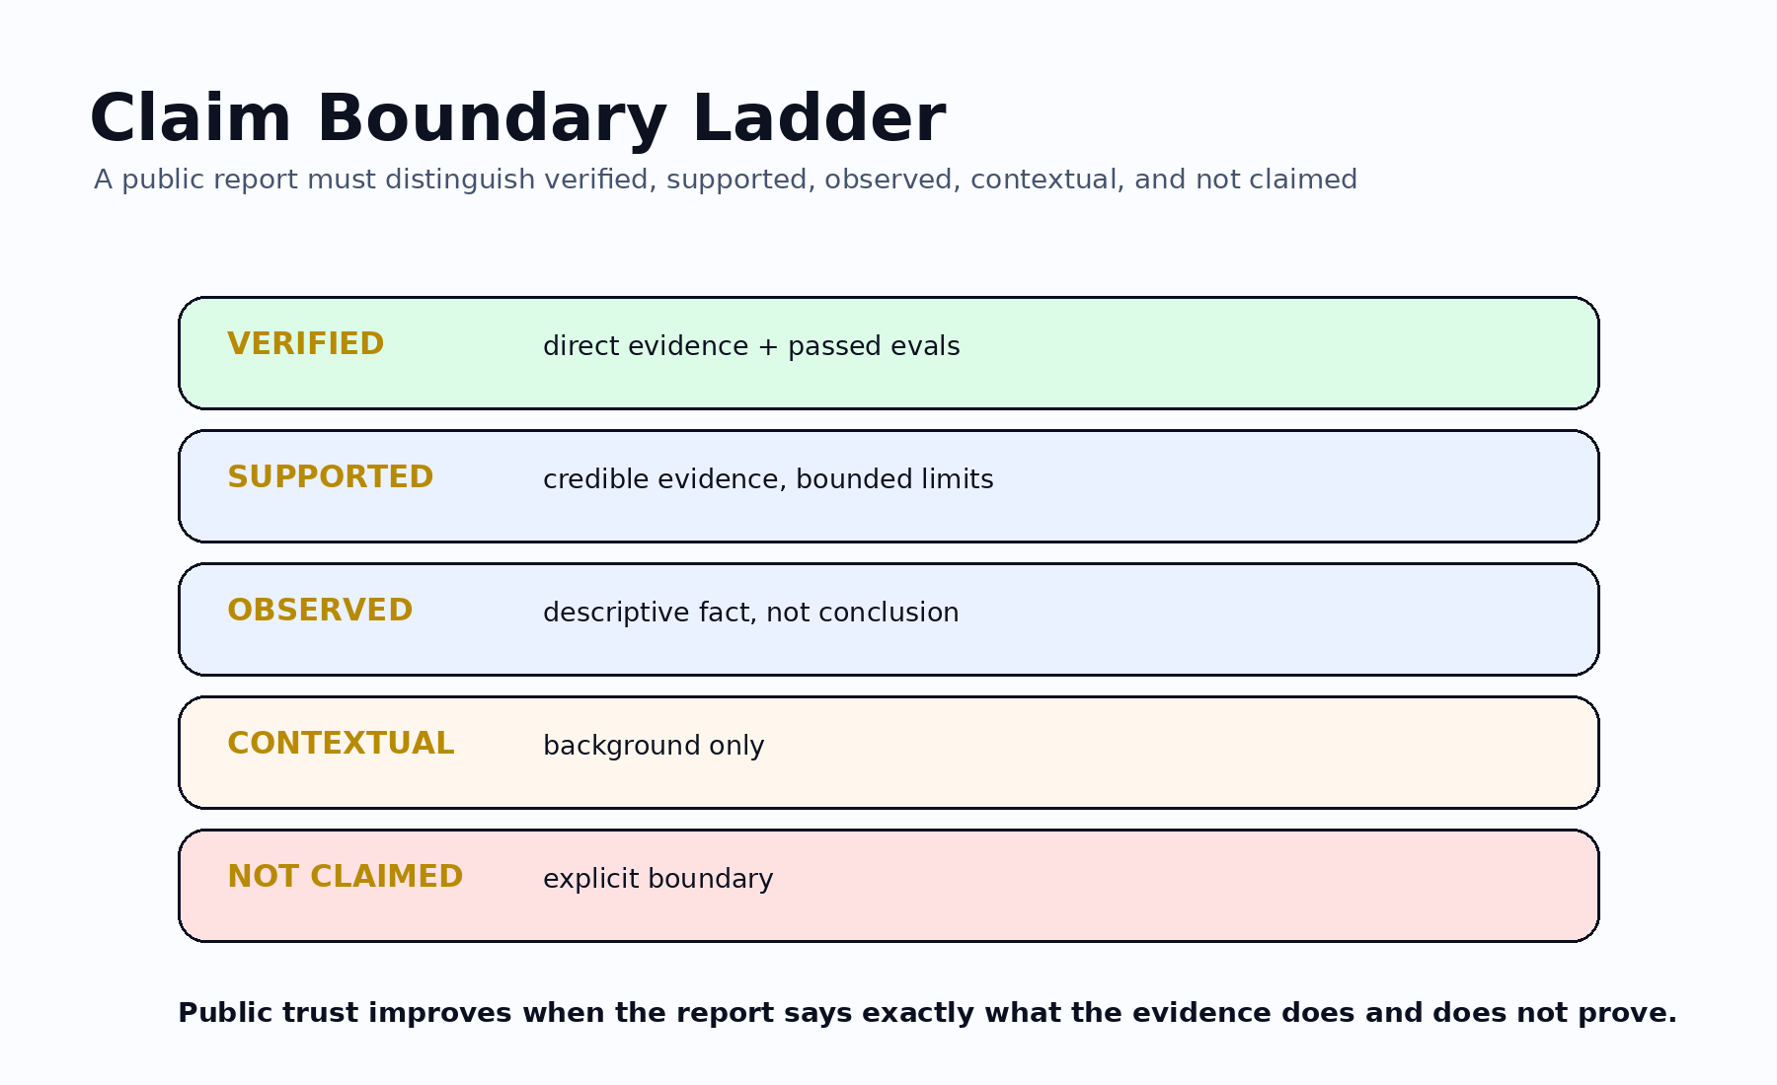

6. Required Report Sections
- Report Manifest
- Source Evidence References
- Public Claim Matrix
- Evidence Summary
- Evaluation Summary
- Risk and Limitation Summary
- Rollback / Recovery Summary
- Redaction Ledger
- Publication Approval
- Correction and Retraction Policy
- Public Artifact Links
- Final Claim Boundary

7. Lifecycle
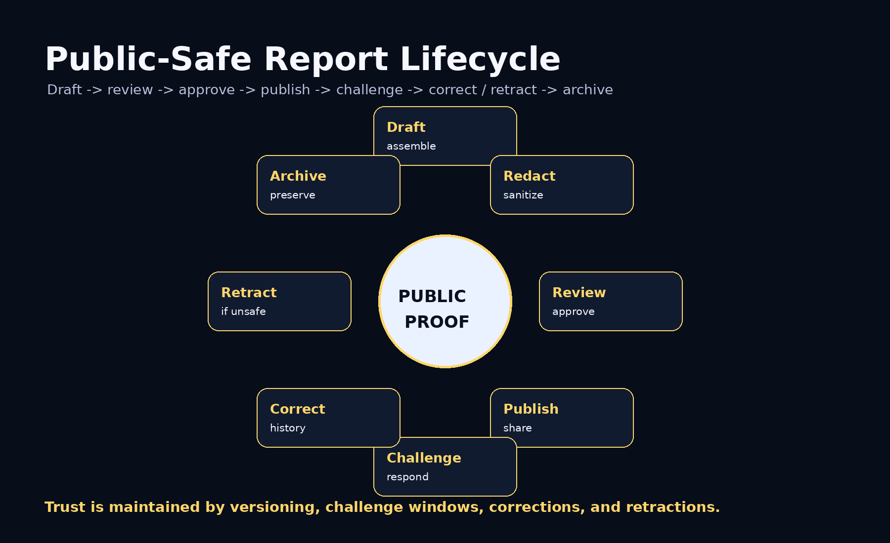

8. Zero-Leak Invariants
- No raw private prompts in public report.
- No raw private traces in public report.
- No secrets, keys, credentials, or tokens in public report.
- No regulated personal data by default.
- No exploit details without responsible disclosure review.
- No unsupported claim in public report.
- No publication without approval.
- Under uncertainty, redact or withhold.

9. Conformance Levels
Level | Requirement
Level 0 | Informal public proof with claim boundary.
Level 1 | Basic report with manifest, claim matrix, evidence summary, limitations, and claim boundary.
Level 2 | Reviewed report with redaction ledger and publication approval.
Level 3 | Operational report with source docket refs, ProofPacket refs, eval summary, rollback summary, correction policy, and public artifact links.
Level 4 | Institutional report with disclosure review, redaction audit, challenge window, correction/retraction history, report hash, and audit export.
Level 5 | Sovereign / regulated report with jurisdiction, retention, protected-boundary review, responsible disclosure controls, authorized approvers, challenge/retraction governance, accessibility profile, and machine-readable bundle.

10. Claim Boundary
AEP-007 does not claim achieved AGI, achieved ASI, perfect safety, legal compliance certification, financial or legal advice, guaranteed ROI, production readiness, government endorsement, or national-security readiness. AEP-007 defines a public-safe proof reporting standard.
GoalOS proves publicly without leaking privately.

