AEP-008
Proof Room Standard
Governed workspaces for institutional machine-work proof
Version 1.1 Institutional Edition · Proof Gradient / Agent Evolution Protocol
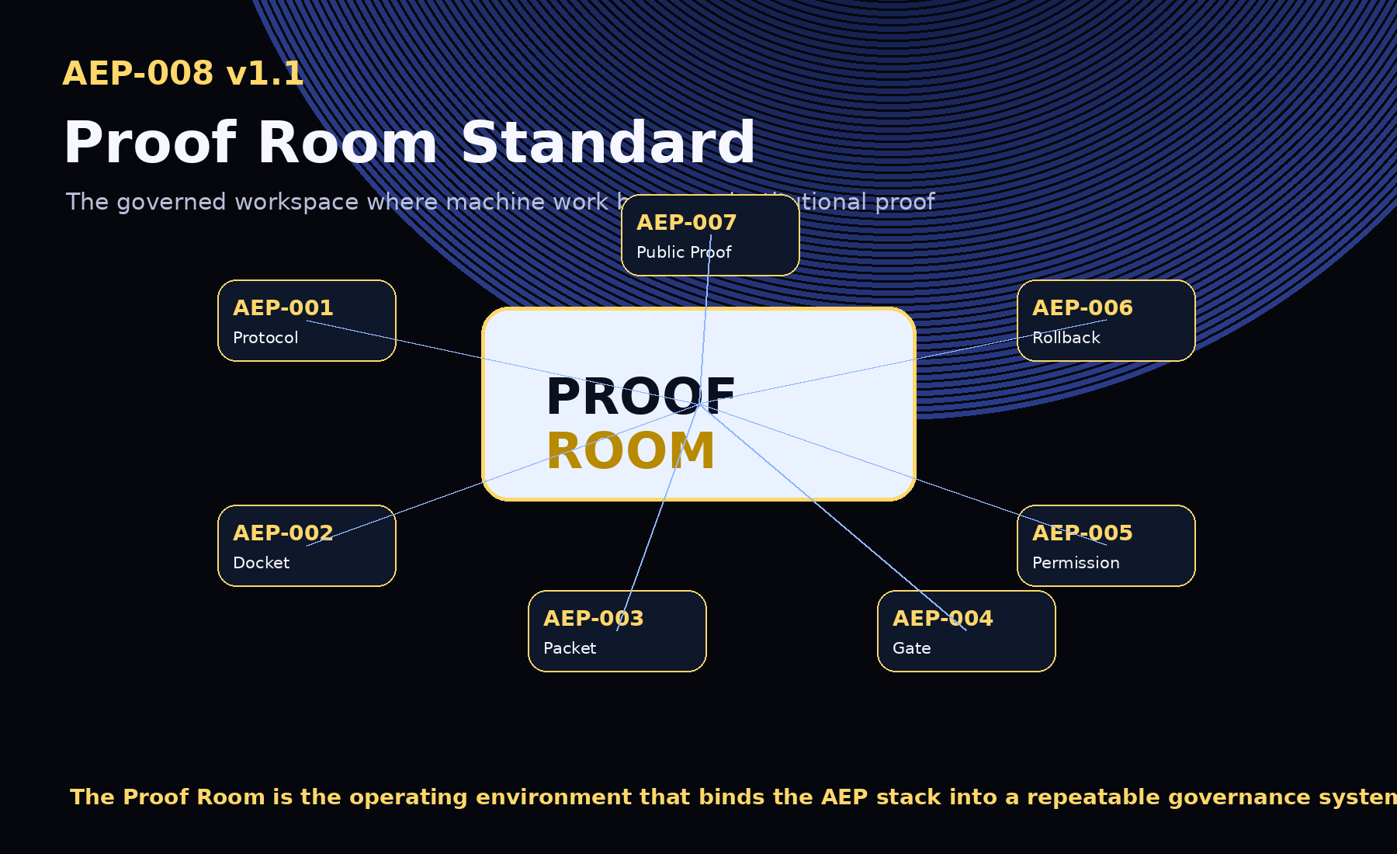
AEP-001 defines the protocol. AEP-002 defines the docket. AEP-003 defines the packet. AEP-004 defines the gate. AEP-005 defines the permission. AEP-006 defines recovery proof. AEP-007 defines public proof. AEP-008 defines the room.

1. Abstract
AEP-008 defines the Proof Room: the governed workspace where machine work becomes institutional proof. A Proof Room binds commitments, runs, ProofPackets, Evidence Dockets, Selection Gate decisions, Tool Permission records, Rollback Receipts, and Public-Safe Proof Reports into one controlled room with roles, scope, boundaries, review, approvals, publication rules, audit export, and closure.

2. Canonical Law
No room without charter.
No run without scope.
No evidence without boundary.
No promotion without gate.
No tool without permission.
No release without rollback.
No public proof without redaction.
No closure without archive.
No proof, no evolution.

3. Relationship to the AEP Stack
Standard | Role
AEP-001 | Protocol
AEP-002 | Evidence Docket
AEP-003 | ProofPacket
AEP-004 | Selection Gate
AEP-005 | Tool Permission
AEP-006 | Rollback Receipt
AEP-007 | Public-Safe Proof Report
AEP-008 | Proof Room

4. Proof Room Modes
Mode | Purpose
sandbox | Low-risk learning, demonstration, experimentation.
team | Shared team workflow improvement.
institutional | Enterprise, regulated, audit-ready governance.
public_safe | External proof report preparation and approval.
incident | Recovery, rollback, quarantine, compensation.
sovereign | Public-sector, national, jurisdictional, or protected use.

5. Lifecycle
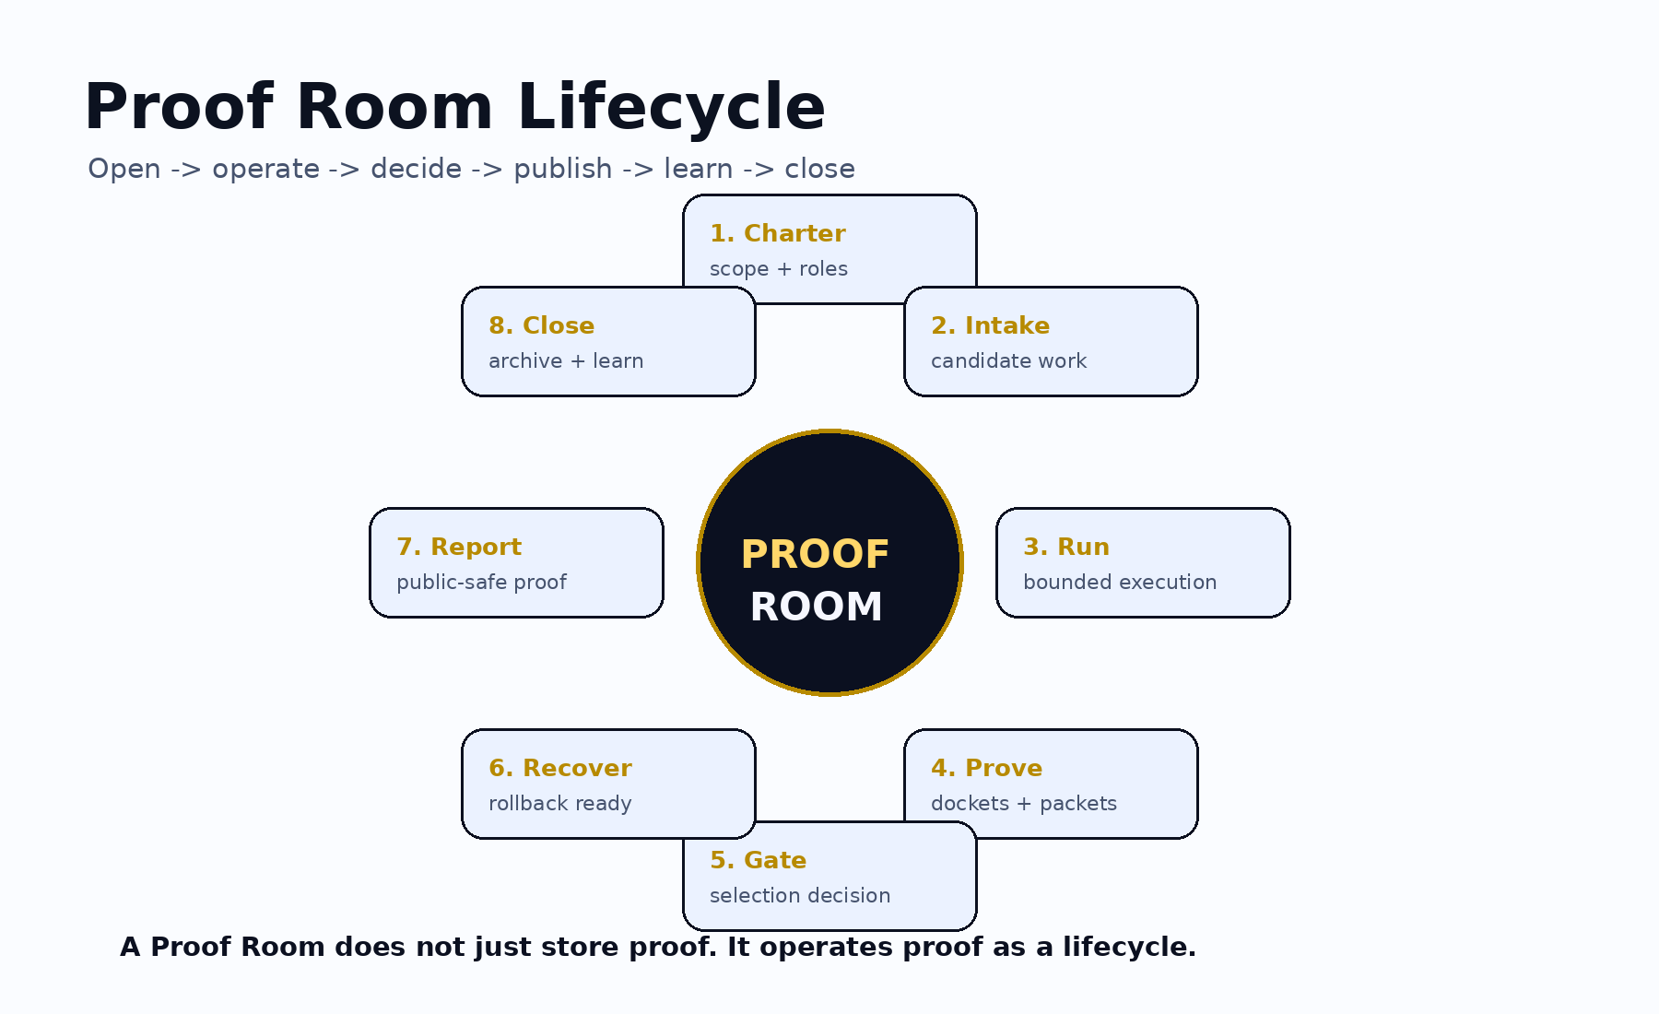
A Proof Room operates proof as a lifecycle: charter, scope, roles, bounded work, evidence, selection, recovery, public-safe reporting, audit export, closure, and archive.

6. Roles and Separation of Duties
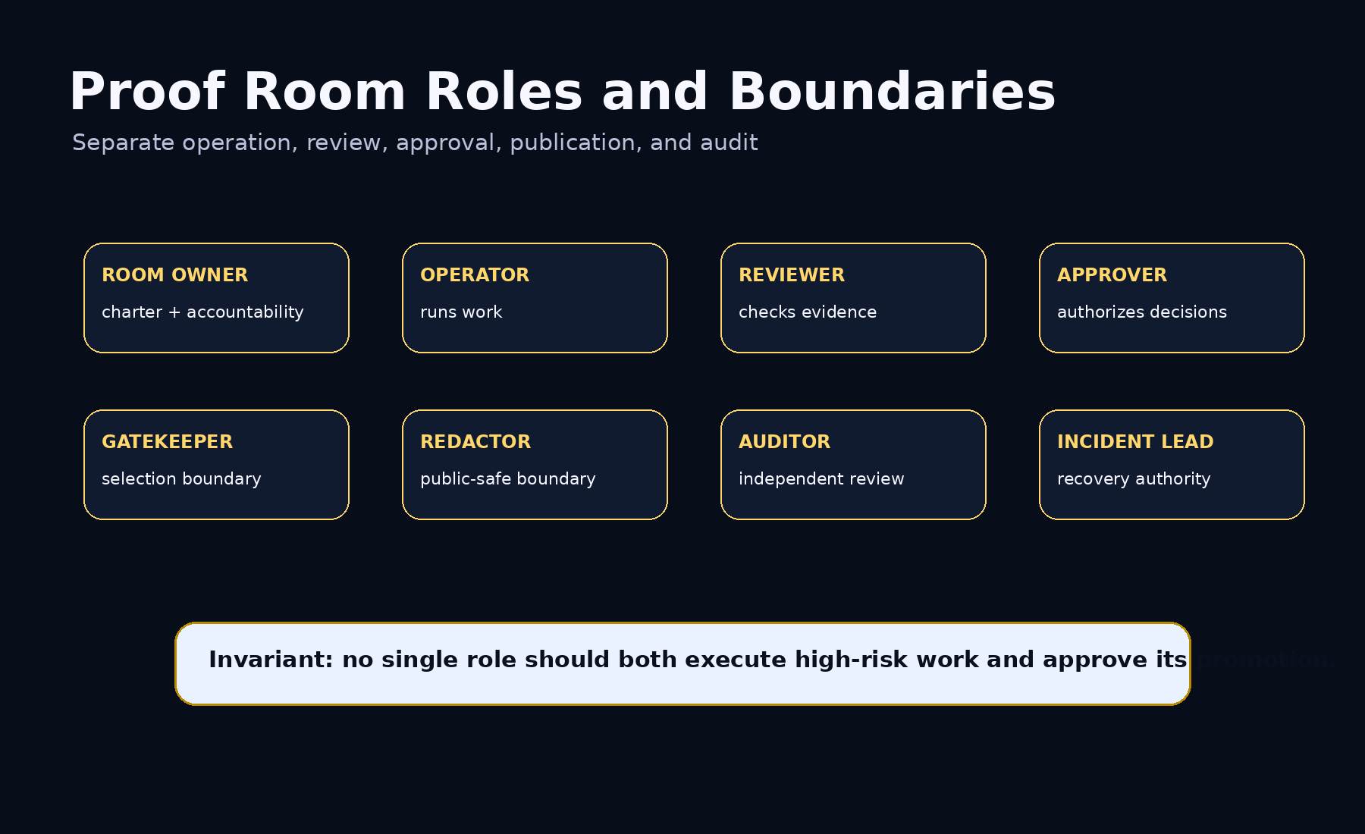
A high-risk room must not allow the same actor to execute a candidate, approve its promotion, publish the public report, and audit their own decision.

7. Core Objects
Object | Purpose
Manifest | Identifies room, mode, owner, jurisdiction, purpose, status, boundary, and charter.
Charter | Defines mission, criteria, scope, agents, tools, data, evals, gate, rollback, publication, closure.
Scope Boundary | Defines tenant, user, agent, tool, data, environment, jurisdiction, time, budget, publication scope.
Role Registry | Assigns roles and records separation-of-duties requirements.
Evidence Boundary | Defines public/private/protected evidence, retention, access, and publication rules.
Work Item Registry | Tracks governed work items and references runs, dockets, gates, rollbacks, reports.
Registers | Track artifacts, permissions, dockets, packets, gates, rollback, and reports.
Decision Log | Records decisions, approvers, evidence, claim boundaries, supersession, and status.
Audit Export | Exports room evidence for review.
Closure Report | Records what was proved, published, private, unresolved, and archived.

8. Operating Modes and Boundaries
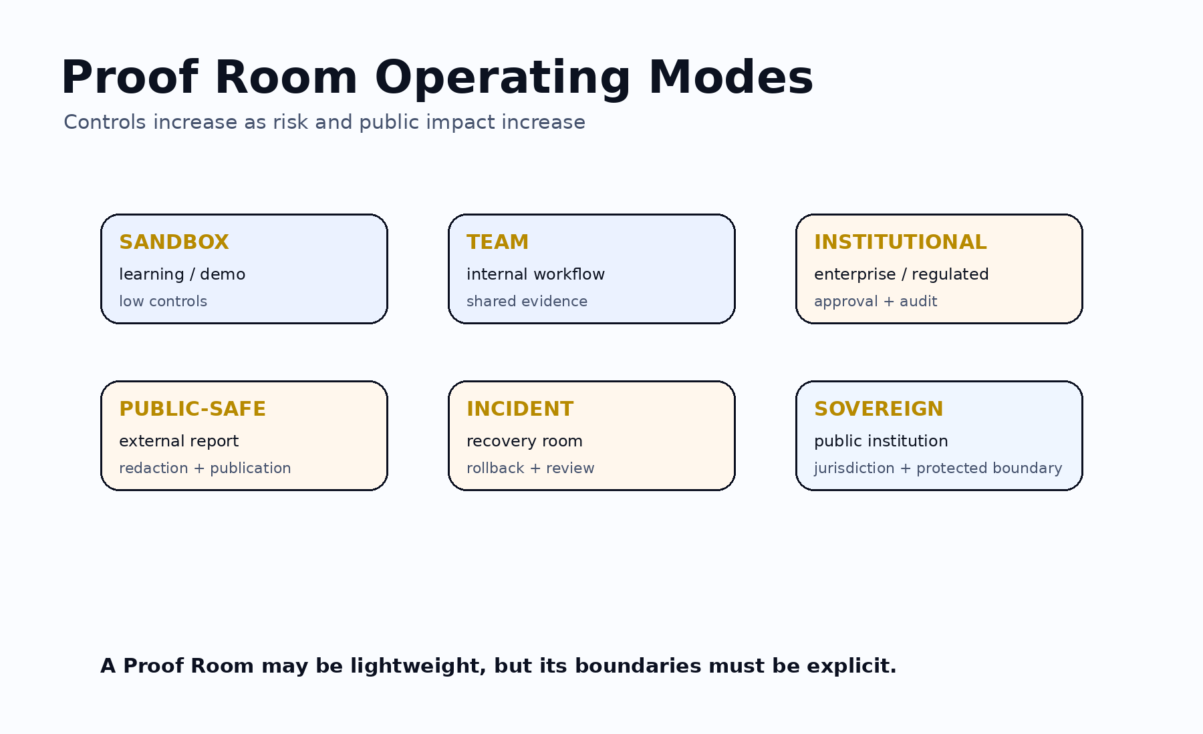

9. Invariants
- No Proof Room without a charter.
- No room without scope boundary.
- No high-risk room without separation of duties.
- No evidence without classification.
- No run without commitment reference.
- No promotion without Selection Gate reference.
- No release without rollback reference.
- No public report without redaction review.
- No closure without audit export or archive reference.
- Under uncertainty, reduce scope or escalate review.

10. Conformance Levels
Level | Requirement
Level 0 | Informal Proof Room.
Level 1 | Basic room with manifest, charter, scope, roles, boundary, work item registry.
Level 2 | Operational room with docket, packet, permission, and decision registers.
Level 3 | Institutional room with gates, rollback, public reports, separation of duties, audit, closure.
Level 4 | Regulated room with protected boundary, retention, jurisdiction, approvers, independent review.
Level 5 | Sovereign room with sovereign jurisdiction, protected controls, public-institution roles, policy traceability, archive requirements.

11. Claim Boundary
AEP-008 does not claim achieved AGI, achieved ASI, perfect safety, legal compliance certification, financial or legal advice, guaranteed ROI, production readiness, government endorsement, or national-security readiness. AEP-008 defines an operating standard for Proof Rooms.
GoalOS turns machine work into governed, reviewable, recoverable, and public-safe institutional proof.

