AEP-003
ProofPacket Schema
Atomic proof units for machine work
Version 1.1 Institutional Edition · Proof Gradient / Agent Evolution Protocol
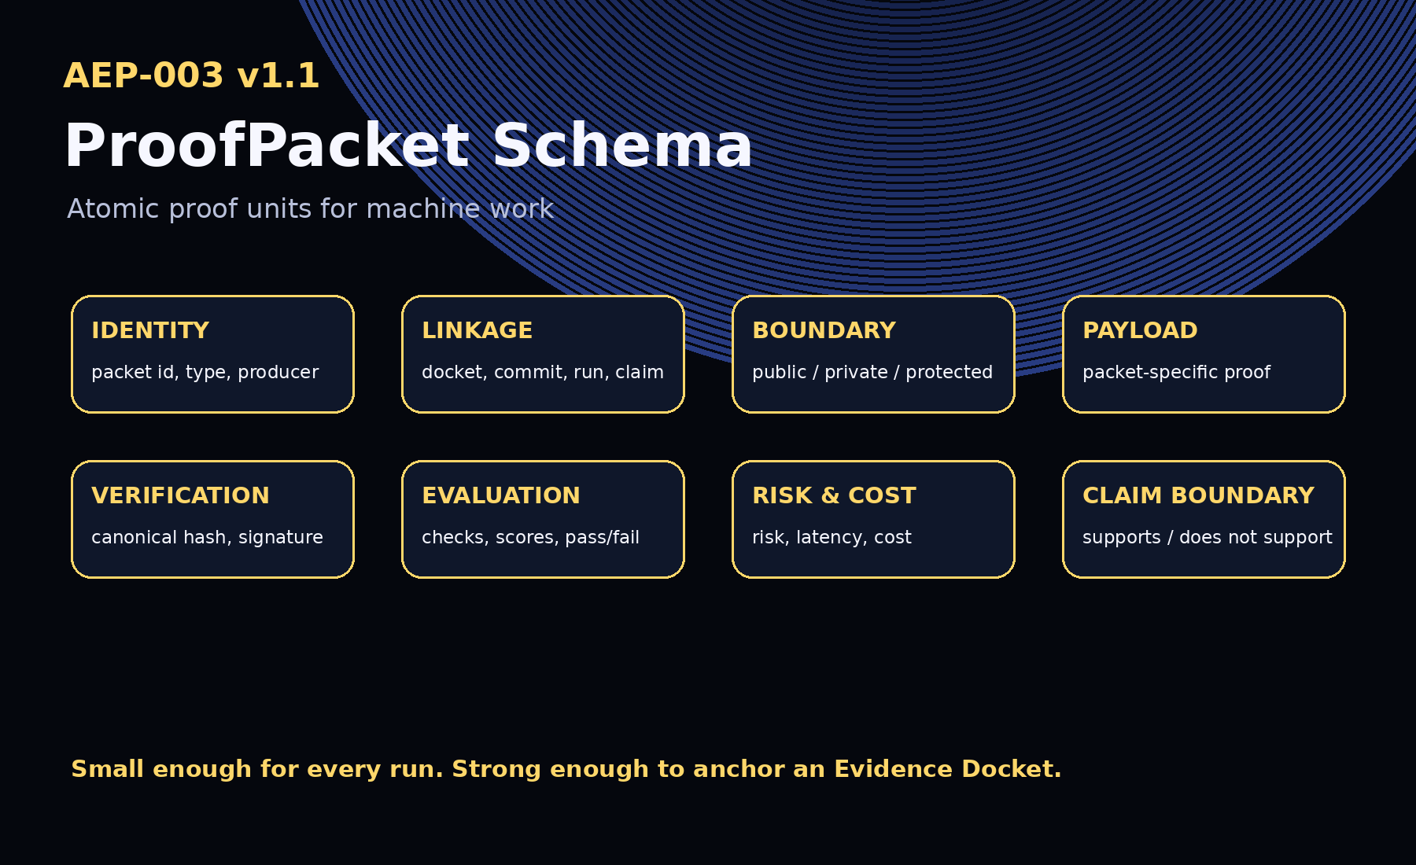
AEP-001 defines the protocol. AEP-002 defines the docket. AEP-003 defines the packet.

1. Abstract
AEP-003 defines the ProofPacket: the atomic evidence unit emitted by an AI-agent run, machine-work step, tool call, evaluation, policy decision, selection decision, rollout event, rollback event, or public-safe report event.
AEP-001 defines the constitutional protocol. AEP-002 defines the Evidence Docket. AEP-003 defines the packet-level schema that makes machine work traceable, portable, tamper-evident, and composable.

2. Canonical Law
No proof, no evolution.
No eval, no propagation.
No rollback, no release.

3. v1.1 Implementation Upgrade
- Canonicalization profile
- Attestation and bundle schemas
- Full examples for all packet types
- Hash, validation, conformance, and chain-verification tools
- Website, conformance CI, and release workflows

4. Design Principles
- Atomic
- Hashable
- Composable
- Boundary-aware
- Claim-bounded
- Evolvable
- Rollback-aware

5. Required Fields
Field | Purpose
packet_id | Unique packet identifier.
schema | Must be AEP-003.
schema_version | Schema version.
packet_type | commit, trace_event, tool_call, eval_result, rollback_event, etc.
created_at | Creation timestamp.
producer | Agent, system, human, organization, workflow, or validator.
docket_id | Related AEP-002 Evidence Docket.
commitment_id | Related commitment.
run_id | Related machine-work run.
claim_refs | Claims supported or bounded by the packet.
evidence_refs | Evidence references.
boundary | Public/private/protected visibility boundary.
payload | Packet-type-specific content.
hash | Canonical packet hash.
claim_boundary | Supported and unsupported claims.

6. Packet Types
Packet Type | Purpose
commit | Mission, authorization, constraints, success criteria, failure criteria.
trace_event | Relevant execution event without full trace exposure.
tool_call | Tool use, permission class, approval state, result summary.
policy_decision | Policy decision, denial, escalation, or approval requirement.
approval | Human or institutional authorization.
eval_result | Evaluation, test, score, check, or evaluator attestation.
evidence_ref | Reference to evidence stored elsewhere.
risk_event | Risk, incident, mitigation, residual concern.
cost_event | Cost, latency, token count, compute time, human-review burden.
selection_decision | Selection Gate decision.
rollout_event | Canary scope, monitoring plan, propagation limit.
rollback_event | Rollback trigger, target, action, owner, recovery.
public_report | Public-safe report publication event.

7. Canonical JSON and Hashing
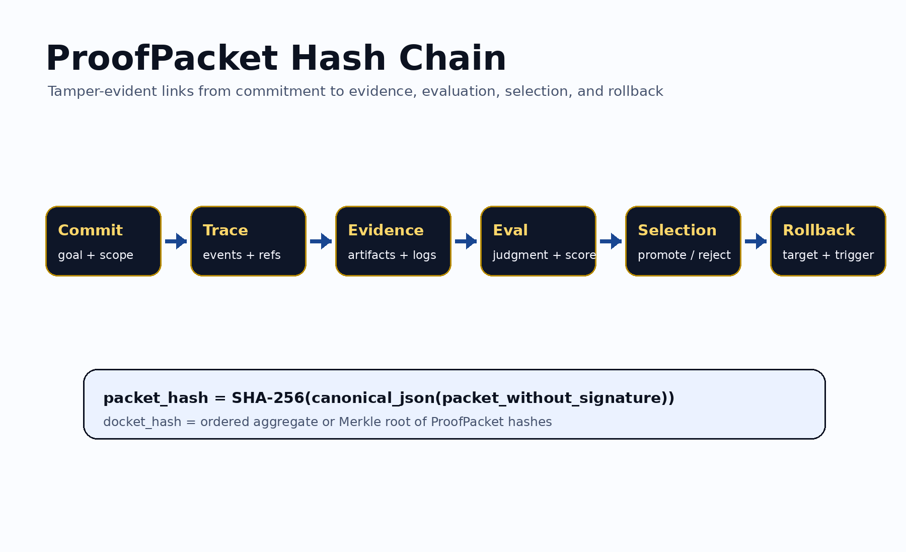
A ProofPacket should be hashed using deterministic canonical JSON: remove mutable signature fields, set hash to a zero-placeholder, sort object keys, encode as UTF-8, and hash using SHA-256 unless another approved algorithm is specified.
packet_hash = SHA256(canonical_json(packet_without_signature))

8. Boundary Block
- access_class: public, private, protected, or restricted
- public_safe: true or false
- contains_sensitive_data: true or false
- publication_allowed: true or false
- jurisdiction and retention policy

9. Lifecycle
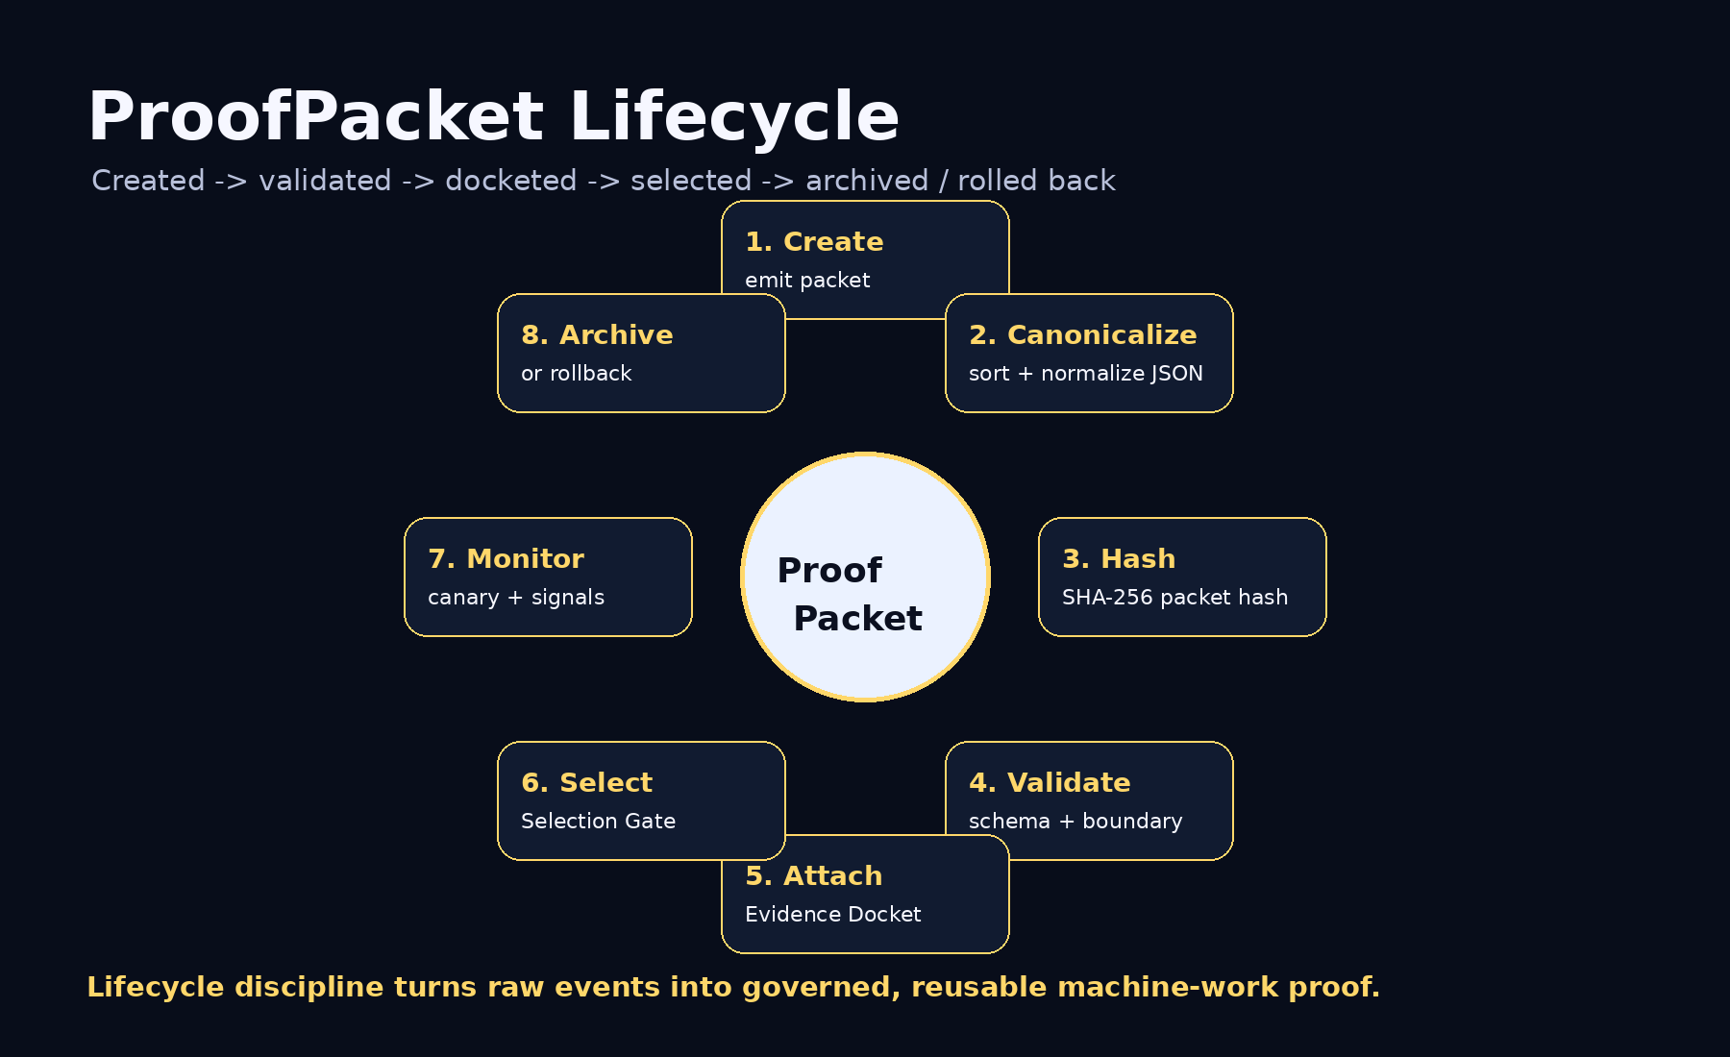

10. Conformance Levels
Level | Requirement
Level 0 | Informal human-readable proof fragment.
Level 1 | Valid JSON packet.
Level 2 | Hashable packet with valid canonical hash.
Level 3 | Docket-linked packet.
Level 4 | Institutional packet with policy, eval, risk, cost, boundary, attestation, and Selection Gate references.
Level 5 | Sovereign / regulated packet with jurisdiction, retention, protected-boundary classification, signer, timestamp authority, and restricted appendix controls.

11. Security and Privacy Requirements
Do not place secrets, personal data, regulated data, private prompts, full sensitive traces, credentials, confidential tool outputs, or protected operational details in a public ProofPacket. Use references, hashes, and access-class markers instead.

12. Claim Boundary
AEP-003 does not claim achieved AGI, achieved ASI, perfect safety, legal compliance certification, financial or legal advice, guaranteed ROI, production readiness, government endorsement, or national-security readiness. AEP-003 defines an atomic proof schema.
GoalOS makes machine work provable one packet at a time.

