**Project Design – Q&A API**

This document provides an overview of the high-level requirements, their priorities, and estimates of their size.

1. **Use Case Diagram**

Provide a use case diagram where the use cases are uniquely numbered. Remove figure below before submitting.

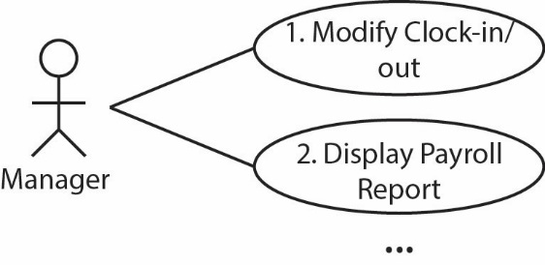

1. **User Stories**

Provide a user story for each use case in the format shown below. Remove sub-sections (Functional…, Non-…, Notes) if not needed. The numbers (*e.g.* US 1) should correspond to the use cases above.

US 1 – *Title*

*Description…*

**Functional/System Requirements**

*Description…*

**Non-Functional Requirements**

*Description…*

**Notes**

*Description…*

US 2 – *Title*

…

1. **User Story Prioritization & Size Estimates**
2. Make a table like the one below that shows the user stories arranged by priority. In other words, make a decision about which user story should be developed first, second, *etc.*

|  |  |  |  |
| --- | --- | --- | --- |
| US ID | Title | Priority | Size (Story Points) |
| 4 | Clock-in/Clock-out | 1 |  |
| 6 | Login | 2 |  |
| 1 | Modify Clock-in/out | 3 |  |
| … | … | … | … |

1. Write a paragraph explaining the rationale behind your prioritization. You don’t have to explain every single US, but should give some general idea why some are prioritized higher.
2. Estimate the size of each user story with story points and place the value in the table above. Write a paragraph explaining the technique you used to determine your story point estimates. Also explain the difference in points between at least two user stories of your choice
3. **Design**

**4a. Class Diagram – Classes Only**

You will provide a class diagrams showing only the classes and their associations required to model the system.

**4b. Class Diagram – Full**

You will provide a class diagrams showing the classes, their associations, attributes, and methods required to model the system.

**4c. Class Detail**

You will provide a numbered, alphabetical listing of classes in your model with an explanation of the role each class fulfills.

**Submission**

1. This document should be stored in a *docs* folder in your repository.