**Project Design – Q&A API**

This document provides an overview of the high-level requirements, their priorities, and estimates of their size.

1. **Use Case Diagram**

Provide a use case diagram where the use cases are uniquely numbered. Remove figure below before submitting.

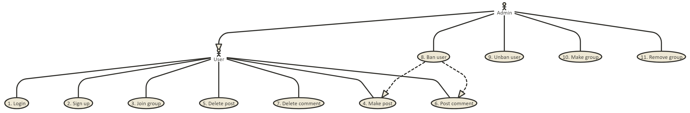

1. **User Stories**

Provide a user story for each use case in the format shown below. Remove sub-sections (Functional…, Non-…, Notes) if not needed. The numbers (*e.g.* US 1) should correspond to the use cases above.

US ID

1. Login
   1. A. have a required field to enter an email
   2. B. Have a required field to enter a password
   3. C. If the password or email is not valid inform the user
2. Sign up
   1. A. have a email field where users can add valid email
   2. B. Have a password field where users can add password
   3. C. Have a 3rd field where users must add email 2 time to make sure its correct
   4. Non-Functional Requirements
      1. It should only take 1-2 minutes to sign up
3. Join group
   1. A. User can go to a sub tab that has all groups.
   2. B. User has ability to add groups to his favorites
   3. C. Have a list of favorite groups
   4. D. If already in group tell user
4. Make a thread
   1. A. User can make a thread with a title and body
   2. B. If the user is not sign in then they can't make a post
5. del a post
   1. A. Admin can del * posts
   2. B. User can only del post that was made my them
6. Make comment
   1. A. If user is not signed up can't make a comment
   2. B. If user is sign in then they can comment on thread
7. Delete comment
   1. A. Admin can del* Comment
   2. B. Poster can del*Comment
   3. C. user can del it comments on post
8. Ban user
   1. A. If user is breaking rules of the group admin can remove them from the site with a ban function where the admin put the user ID into the function
   2. Non-Functional Requirements
      1. It should tell the user they have been banded
9. Ban user
   1. A. If user is breaking rules of the group admin can remove them from the site with a ban function where the admin put the user ID into the function
   2. Non-Functional Requirements
      1. It should tell the user they have been banded
10. Make a group
    1. A. Admin can make groups
    2. B. Users can add a group make request to the admin
11. Leave a group
    1. A. Admin can remove any member from a group
    2. B. User can leave a group in any time
12. See post
    1. A. A user can see all threads posted by groups he follows
    2. B. Then can select the thread and view more details on the thread
13. **User Story Prioritization & Size Estimates**
14. Make a table like the one below that shows the user stories arranged by priority. In other words, make a decision about which user story should be developed first, second, *etc.*

|  |  |  |  |
| --- | --- | --- | --- |
| US ID | Title | Priority | Size(Story point) |
| 1 | Sign Up | 1 | 2 |
| 2 | Login | 2 | 1 |
| 10 | Make a Group | 3 | 3 |
| 4 | Make a thread | 4 | 3 |
| 3 | Join Group | 5 | 3 |
| 12 | See post | 6 | 5 |
| 6 | Make Comment | 7 | 3 |
| 5 | Del post | 8 | 3 |
| 7 | Del comment | 9 | 3 |
| 11 | Leave a Group | 10 | 3 |
| 9 | Ban user | 11 | 3 |
| 8 | Unban user | 12 | 3 |

1. Write a paragraph explaining the rationale behind your prioritization. You don’t have to explain every single US, but should give some general idea why some are prioritized higher.
   1. The prioritization is based on the flow of the project. A user will have to first sign up and then sign in to our API, and then the user will be granted the right to make a group and make a thread in the group, etc. Sign up has the most priority because even though it might be the easiest method to implement, but without signing up an account, the user would not do much with our API.
2. Estimate the size of each user story with story points and place the value in the table above. Write a paragraph explaining the technique you used to determine your story point estimates. Also explain the difference in points between at least two user stories of your choice
   1. The technique that we used is Fibonacci Sequence with the story points of 1 2 3 5 8 12 20...The reason why we used this method was because with the Fibonacci sequence increases, the number gaps increase too. It clearly differential the difficulty levels. For example, we gave sign up a story point of 2 and view feed a story point of 5. It clearly differential the complexities of these two methods
3. **Design**

**4a. Class Diagram – Classes Only**

You will provide a class diagrams showing only the classes and their associations required to model the system.

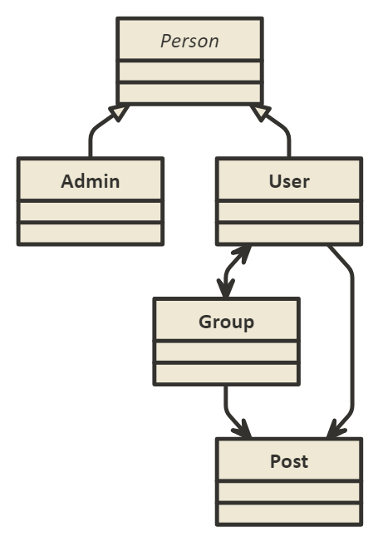

**4b. Class Diagram – Full**

You will provide a class diagrams showing the classes, their associations, attributes, and methods required to model the system.

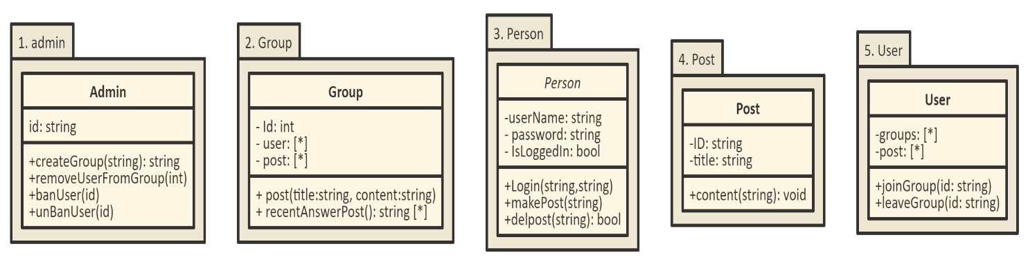

**4c. Class Detail**

You will provide a numbered, alphabetical listing of classes in your model with an explanation of the role each class fulfills.

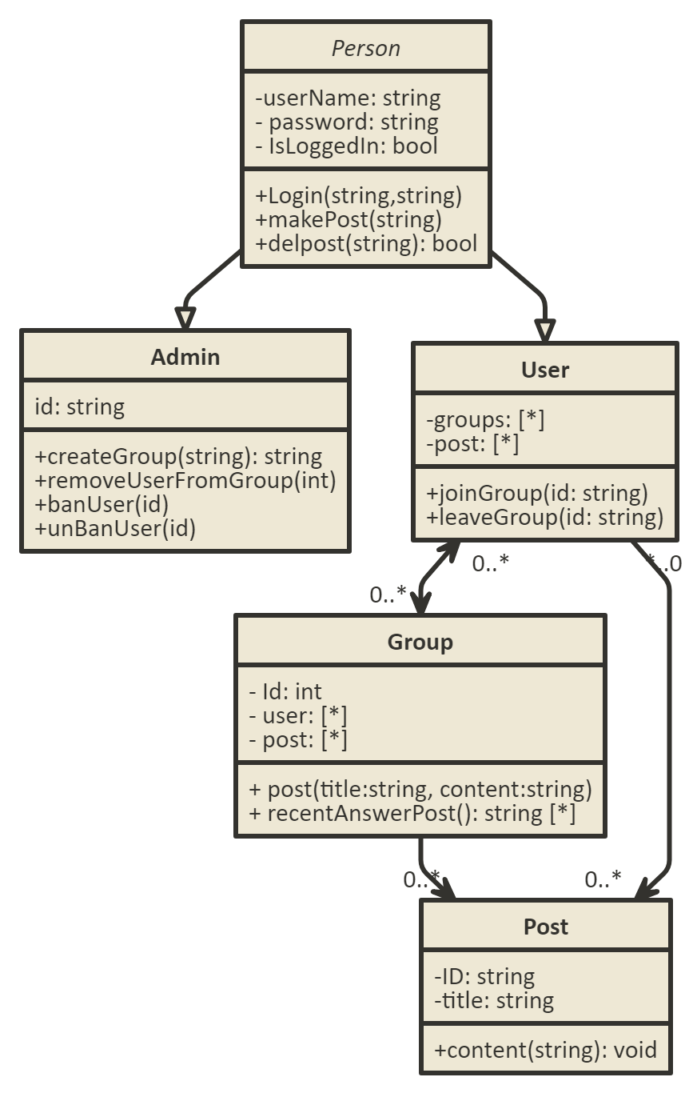

**Submission**

1. This document should be stored in a *docs* folder in your repository.