IIO60320 Mobile Programming with Android

Project

Group IIO12S2

James Pearce F6137

Antti Minkkinen G7786

Fall Semester 2014

# Introduction

The idea of the project is to create a prototype of an application to share the prices of certain products in certain shops and help find the cheapest product from nearby shops.

# Objectives

The main objective of this project is to create an application that can connect to a database that contains products, shops and product prices. The application is supposed to be able to add products and shops and add prices for products in different shops.

The application can be used for searching products and their prices in different shops and a map of shops can also be displayed when searching.

The user can easily find the lowest prices for products in nearby shops.

The prototype is not planned for a large user group so that the work required on the backend is smaller. For a version designed to larger amounts of user’s abuse prevention and database protections should be implemented.

# Layouts

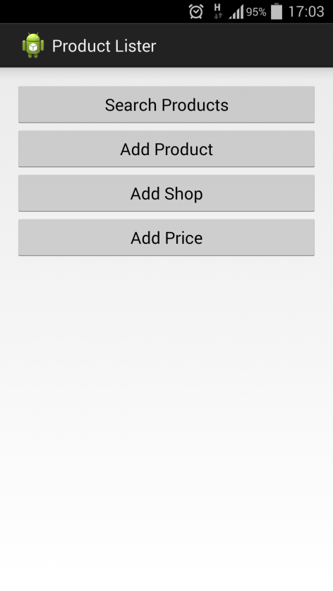

The main activity is used for navigation.

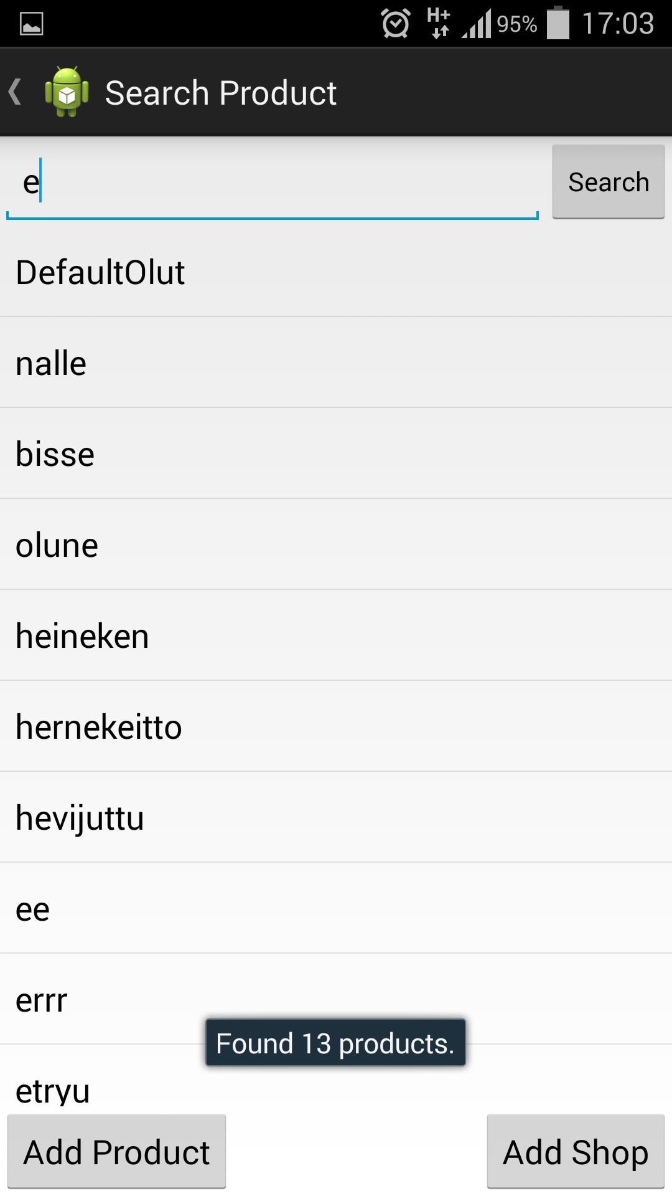

This activity is used for searching products from the database. The search filters products based on product name and category. After selecting a product from the list the product price activity is displayed. The user can also press ‘Add Product’ which shows the Add product activity or the user can press ‘Add Shop’ which shows the Add Shop activity.

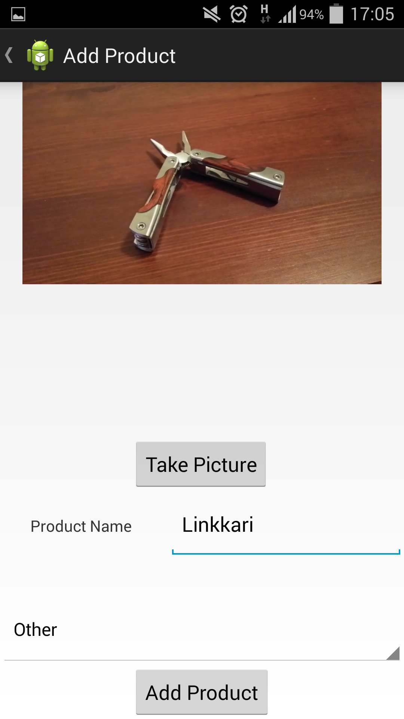

This activity is used to add products to the database. The user can take a picture of the product. Product name and category (and sub categories) can be selected.

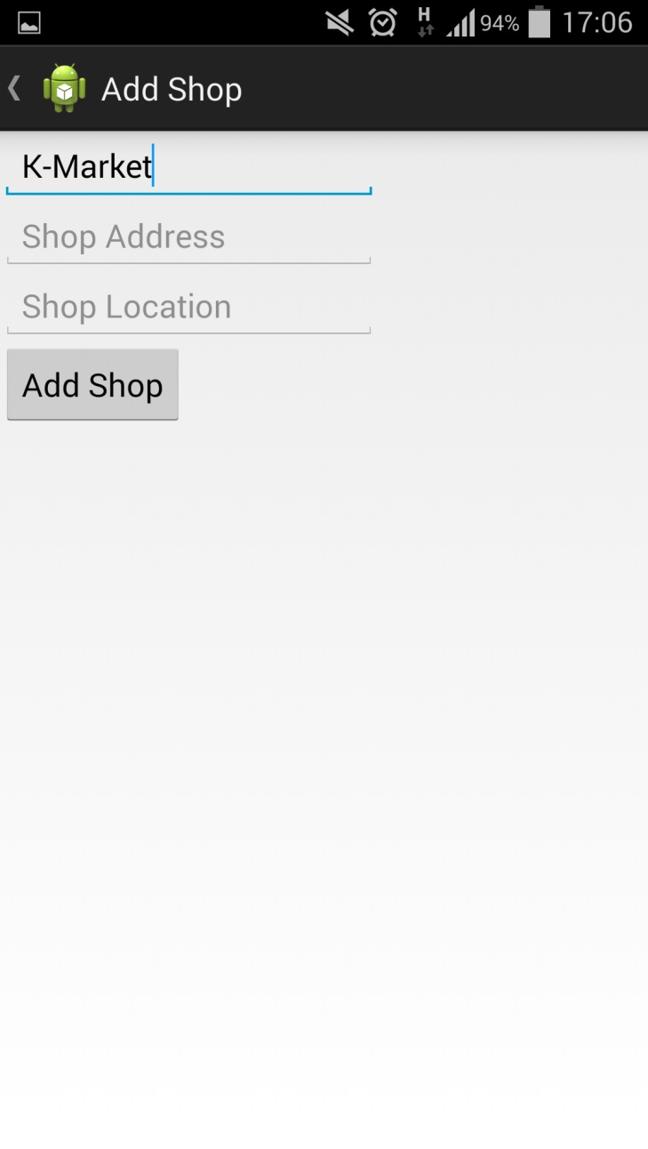

This activity is used to add a shop to the database. The user can type the name of the shop and address.

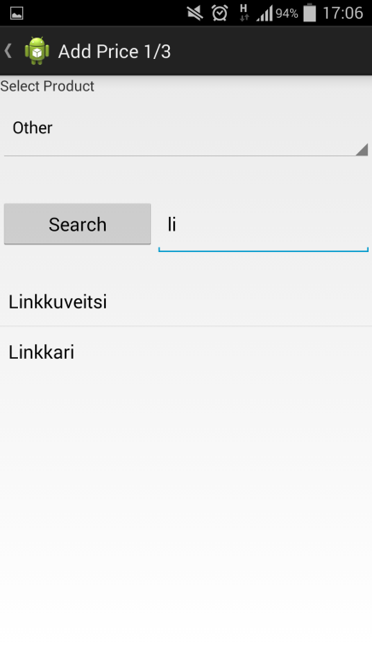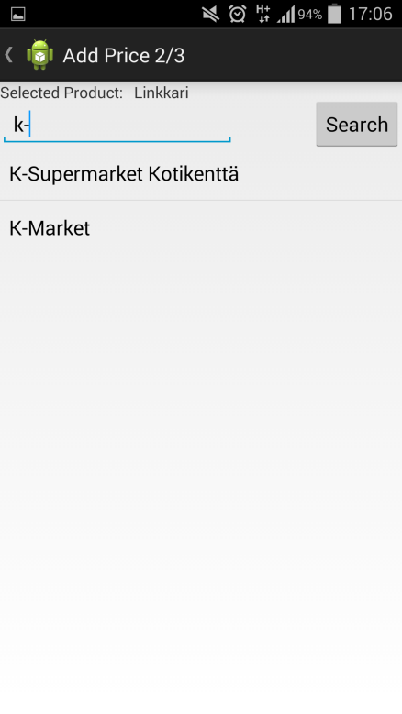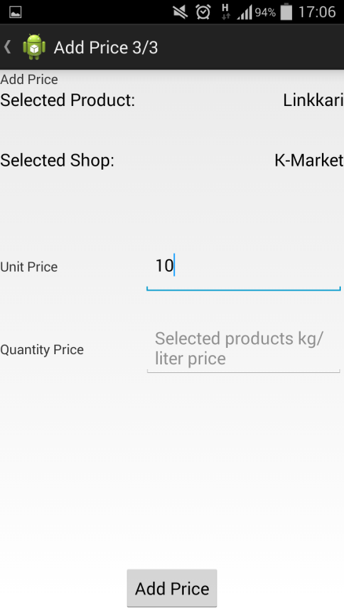These activities are used to add a price to a product in a certain shop. The product can be manually selected or it can be automatically selected if the user navigated here from other product. In the second screen the user selects the shop by searching from the list. The third screen is used for adding the price(s) of the product.

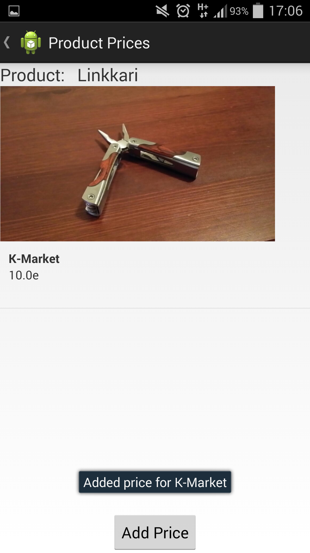

This activity displays the price of the selected product in the shop to the user. The user can navigate to add price activity with the button.

# \\JAMES-PC\Users\James\gitti\AndroidProgramming\doc\classdiagram.pngClass diagram

The model for the MySQL database contains entries for Products and Categories for products and Shops that can be linked to products with a unit price or a quantity price (or both).

# Deployment

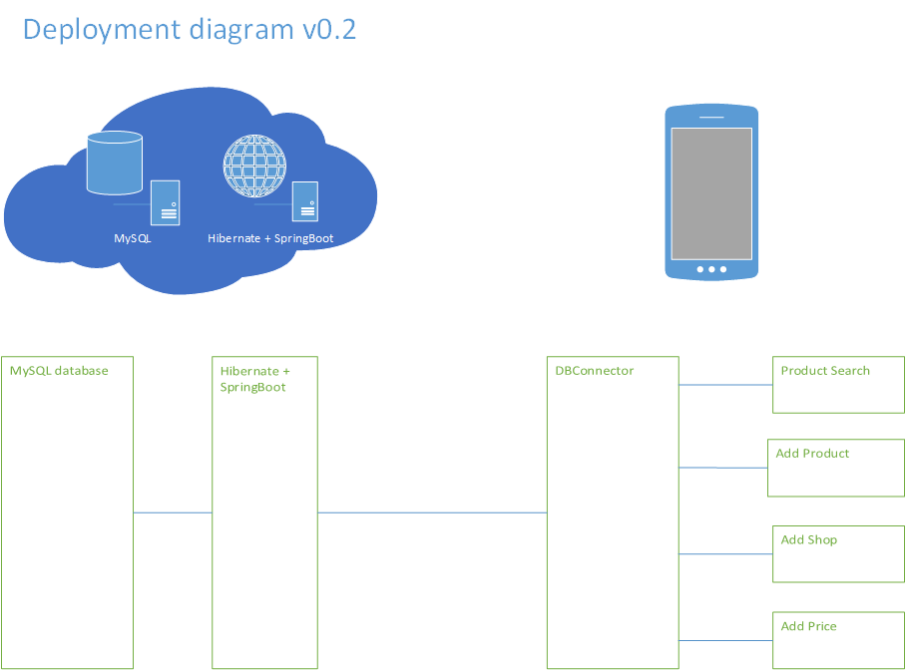

The prototypes “deployment” diagram. It shows how the applications java classes communicate with the DB Connector that connects to a REST backend system using JSON.

# Work load and planning

Week 44

Planning and feasibility study.

Week 45

Setup database from Digital Ocean and start to implement business logic and activities.

Week 46

Database working and some data can be inserted from app. Most of the apps layouts and activities can be viewed but do not have full functionality.

Week 47

Working on the activities.

Week 48

Implementing the camera into the app.

Week 49

Testing the prototype.

Week 50

The final touches to the prototype and the seminar.

# Problems

The major problem on the programming side was time, with so many other projects running simultaneously and both of the group members being sick near the end of the project although not sick simultaneously it reduced productivity. Problems with the product that we could foresee were mainly around the user and how can the product be made foolproof to prevent abuse and how much can we trust the user.

# Solutions

Possible solutions could be: Have people use their own database and have a built in database switcher that could be used to change databases easily, with this solution we could have an open database that could be maintained by some people who would go through the uploaded prices and images to make sure they make sense; make the application so that you cannot upload wrong prices by some means; lastly the application could have a game like element to it and have the users audit the uploaded prices and share some kind of reputation that would define how much the price could be trusted. Removing the camera function would make most of these solutions even more viable.

# Grade breakdown

Most of the planned features were implemented and the application works as it should. Given the extent of the project and the usage of different technologies and a backend system we think our final grade should be a 5, depending on how the presentation goes.

Hours spent on project:

### Antti Minkkinen [g7786@student.jamk.fi](mailto:g7786@student.jamk.fi)

| **Date** | **Hours** | **Info** |
| --- | --- | --- |
| 29.10. | 6 | Writing documentation, making mockups and database planning |
| 3.11. | 4 | Setting up database server and database tables |
| 7.11. | 6 | Writing data classes and figuring out dbconnector |
| 8.11. | 4 | Product search from database |
| 9.11. | 6 | Tweaking Product Add and categories from database |
| 19.11.-27.11. | 10 | Implementing the new JavaEE based backend system on Android side |
| 6.12. | 8 | Shop adding done. Starting on price adding. |
| 7.12. | 8 | Price adding done. Product image uploading works too. |
| 8.12. | 6 | Fine tuning stuff to make the app usage better. |

### James Pearce [f6137@student.jamk.fi](mailto:f6137@student.jamk.fi)

| **Date** | **Hours** | **Info** |
| --- | --- | --- |
| 29.10. | 6 | Writing documentation, working on creating activities |
| 1.11. | 4 | Writing documentation |
| 8.11. | 4 | Working on activities and layouts |
| 10.11. | 4 | Working on documentation and trying to get my device to work again |
| 11.11. | 1 | Small tweaks |
| 12.11. | 3 | Working on the layouts |
| 19.11. | 3 | Working on the shop add layout |
| 26.11. | 3 | Working on activities |
| 1.12. | 3 | Working on layouts and struggling with git |
| 6.12. | 8 | Camera functionality and working on layouts |
| 7.12. | 3 | Working on layouts, ProductPrices |