Capstone Project

Project Title: Mobile devices trends analysis

Developer: Eric Solis

Tools: YouTube API, Apache Kafka, Apache Spark, Hbase, AWS, Tableau

Start Date: Friday, August 7, 2020

Duration: 4 days

Bussiness Case:

In this project, the stakeholder wants to identify the interests of the audience in mobile phones. For this, we are going to analyze YouTube videos from tech channels to identify phone reviews and use the statistics of the videos to identify which mobile companies catch the attention of the audience. This data is very useful to identify potential customers and direct ads more precisely.

Data Flow Diagram:

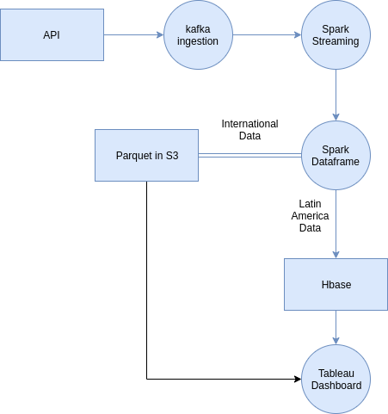 Data flow diagram of the pipeline created with https://www.diagrameditor.com/

Apache Kafka:

Apache Kafka is an open source stream-processing software platform developed by the Apache Software Foundation, written in Scala and Java. The project aims to provide a unified, high-throughput, low-latency platform for handling real-time data feeds. Kafka can connect to external systems (for data import/export) via Kafka Connect and provides Kafka Streams, a Java stream processing library.

Apache Spark:

Apache Spark is a data processing framework that can quickly perform processing tasks on very large data sets, and can also distribute data processing tasks across multiple computers, either on its own or in tandem with other distributed computing tools. These two qualities are key to the worlds of big data and machine learning, which require the marshalling of massive computing power to crunch through large data stores. Spark also takes some of the programming burdens of these tasks off the shoulders of developers with an easy-to-use API that abstracts away much of the grunt work of distributed computing and big data processing.

Hbase:

Hbase is an open-source non-relaional distributed database modeled after Google’s Bigtable and written in Java. It is developed as part of Apache Software Foundation's Apache Hadoop project and runs on top of HDFS or Alluxio, providing Bigtable-like capabilities for Hadoop. That is, it provides a fault-tolerant way of storing large quantities of sparse data (small amounts of information caught within a large collection of empty or unimportant data, such as finding the 50 largest items in a group of 2 billion records, or finding the non-zero items representing less than 0.1% of a huge collection).

AWS S3:

Amazon S3 or Amazon Simple Storage Service is a service offered by Amazon Web Services AWS) that provides object storage through a web-service interface. Amazon S3 uses the same scalable storage infrastructure that Amazon.com uses to run its global e-commerce network. Amazon S3 can be employed to store any type of object which allows for uses like storage for Internet applications, backup and recovery, disaster recovery, data archives, data-lakes for analytics, and hybrid cloud storage.

Tableau:

Tableau is a powerful and fastest growing data visualization tool used in the Business Intelligence Industry. It helps in simplifying raw data into the very easily understandable format. Data analysis is very fast with Tableau and the visualizations created are in the form of dashboards and worksheets. The data that is created using Tableau can be understood by professional at any level in an organization. It even allows a non-technical user to create a customized dashboard.

