The following is a list of noticed abnormalities with the program behavior:

- There will be some command that does not execute properly with the pipe, while others do. For example, one such command would be ls | wc, which fails to output result to the screen. It only does so after the user quits the shell. The following is the image of trying to execute the command:

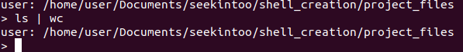
However, for other commands it may work fine as shown below in the image. But the printing is improper as the results print with the next user prompt area. It takes up the space for the user to type their commands in. Image:

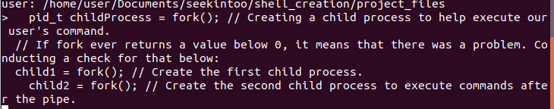

- The redirection to a file has not yet been implemented, however another issue has been noticed with it. If a user executes a command to redirect out to a file, then the user prompt starts misbehaving. It will sometimes take multiple key strokes to get one letter in, other times, even if a legitimate command is typed in, it does not recognize command. Image for such a case:

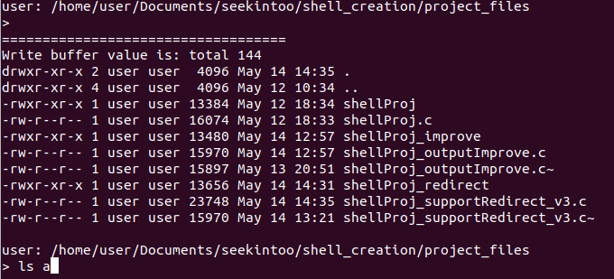
In the above screenshot, I was trying to type “ls -al”. The shell upon misbehaving only managed to pick up “ls a”.

Following this, I could not execute legitimate commands either, such as “exit” to quit the shell. I sent a keyboard interrupt and noticed that in the terminal, I could no longer see my keystrokes for anything. This could mean a potential memory leak occuring somewhere during either the redirection, or command piping process.

