Section 3.1 Analysis
3.1.1 Problem Identification & Background
Most market tracking platforms available today are either paid or overloaded with complex features that beginner investors don't need. Free options, on the other hand, usually just show plain historical prices without giving any forward-looking statistical predictions.
To solve this, I am building a self-contained Financial Stock Analytics & Forecasting System. My goal is to create a web application that pulls live stock market data, calculates custom forecasting metrics (like Linear Regression, RSI, and SMA) purely in Python without third-party math packages, and presents visual predictions on an interactive dashboard.

3.1.2 Stakeholder Analysis & Requirements
Primary Stakeholder: Mr. Jones (Experienced Retail Quantitative Trader)
Profile: A data-driven trader who relies on mathematical indicators to analyse trends.
Requirements:
- Accurate short-term indicators: 7-day Linear Regression forecasting ($y = mx + c$), 14-period Relative Strength Index (RSI), and 10-day Simple Moving Average (SMA).
- Full visibility into how metrics are calculated, avoiding external "black-box" libraries like pandas or scikit-learn.
- Fast calculation speed so indicators load almost instantly.

Secondary Stakeholder: Alexa (Novice Individual Investor)
User Profile: A beginner investor looking for clean visual cues and automated alerts.
Requirements:
- Clear visual indicators (Green for upward trends, Red for downward trends).
- Interactive web charts where hovering shows predicted versus actual price points.
- Automatic email notifications whenever a stock reaches a specified threshold.
- Quick-glance market leaderboard highlighting the Top 5 performing stocks ranked by daily percentage gain using a custom, transparent sorting algorithm.

3.1.3 System Architecture
To keep the project clean and easy to maintain, I have split the system into 5 main parts:
- Authentication & Security: Handles account signups, native cryptographic password hashing using PBKDF2-HMAC-SHA256 with constant-time bitwise XOR verification, and a 15-minute lockout system after 3 failed login attempts.
- Data Parser: Fetches stock data from an external API using Python’s native urllib library and converts raw JSON responses into Python dictionaries.
- Custom Algorithm Engine: Runs hand-coded Python algorithms for Linear Regression, RSI, and SMA without importing any third-party data science tools.
- Background Alert Engine: Runs a non-blocking background thread (threading.Thread) that continuously checks stock prices and sends email alerts via SMTP.
- Database & Interface: Manages a 3NF SQLite database and renders dynamic web pages using Jinja2 templates and Chart.js.
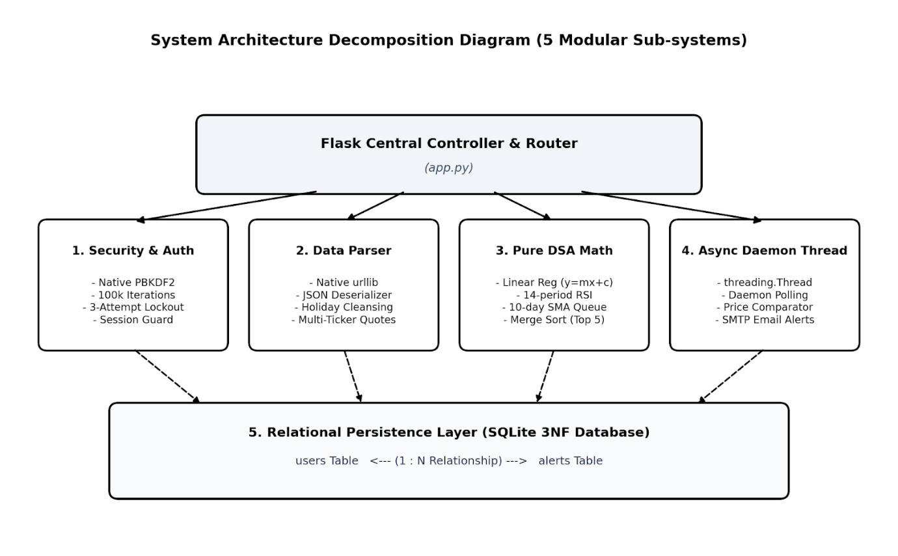

3.1.4 Computational Thinking Principles
- Abstraction: Removing raw API noise (like unused exchange tags and extra metadata) to keep only essential timestamp and price arrays.
- Decomposition: Breaking down the system into separate modules for security, data fetching, math calculations, database handling, and UI.
- Pattern Recognition: Identifying price trends and momentum signals using historical price points.
- Algorithm Design: Designing step-by-step algorithms in pure Python to calculate statistical outputs cleanly.

3.1.5 Measurable Success Criteria
ID | Goal | Description | How It Will Be Tested
SC1 | Security | Hash passwords before saving to database and lock account for 15 minutes after 3 failed logins. | Test login with wrong passwords 3 times and verify database values.
SC2 | Data Fetching | Fetch and process API JSON payload using native urllib in under 500ms. | Measure API call execution time with time.perf_counter()
SC3 | Database | Database schema normalized to 3NF using parameterized SQL to prevent injection. | Review database tables and attempt SQL injection inputs.
SC4 | Custom DSA | Calculate Linear Regression, RSI, and SMA using pure Python without pandas or scikit-learn. | Audit source code and compare output against verified calculations.
SC5 | Dashboard | Render interactive Chart.js charts with color-coded direction (Green for positive slope, Red for negative). | Test chart rendering across different stock symbols in browser.
SC6 | Email Alerts | Background thread checks prices continuously and sends an email within 60 seconds of a hit. | Trigger price alert threshold and verify email arrival in inbox.
SC7 | Custom Sorting Engine | Rank a basket of market equities by daily percentage return using a hand-coded O(N log N) Merge Sort algorithm in pure Python. | Pass an unsorted array of equity returns to the sorting module and verify descending output order against a manual sort.

Section 3.2 Systems Design
3.2.1 Database Schema & 3NF Normalization
While planning the database, my main objective was to make sure stock price alerts and user accounts were stored efficiently without repeating data or creating issues when updating records. I selected SQLite for its lightweight setup and structured the tables to follow Third Normal Form (3NF).

How My Schema Achieves 3NF:
1NF (First Normal Form): I made sure every field holds only one single piece of data (atomic values). There are no lists or repeated groups stored in a single cell. Each row is uniquely identified by a primary key (user_id or alert_id).

2NF (Second Normal Form): Since all tables use single-column primary keys rather than composite keys, every non-key column depends completely on the primary key. This removes any partial dependencies.

3NF (Third Normal Form): There are no transitive dependencies in the tables. Every non-key column depends solely on the primary key and nothing else. For instance, in the alerts table, target_price belongs directly to that specific alert ID, not to the user ID or stock ticker.

3.2.2 Data Dictionary
Entity 1: users
Field name | Data Type | Key Type | Validation Rule/Constraints
user_id | INTEGER | Primary Key | Auto Increment, Unique
username | TEXT | Unique | Not Null, Min length 3
password_hash | TEXT | None | Native PBKDF2-HMAC-SHA256 string (Format: iterations$salt$hash)
failed_attempts | INTEGER | None | Default 0, Max 3 before lockout
lockout_until | TEXT | None | ISO-8601 Timestamp or NULL
created_at | TIMESTAMP | None | Default CURRENT_TIMESTAMP

Entity 2: alerts
Field name | Data Type | Key Type | Validation Rule/Constraints
alert_id | INTEGER | Primary Key | Auto Increment, Unique
user_id | INTEGER | Foreign Key | References users(user_id)
stock_symbol | TEXT | None | Upper-case string (e.g., AAPL)
target_price | REAL | None | Must be positive float > 0
condition | TEXT | None | Must be ABOVE or BELOW
is_active | INTEGER | None | 1 (Active) or 0 (Triggered)
created_at | TIMESTAMP | None | Default CURRENT_TIMESTAMP

3.2.3 Entity-Relationship (ER) Structure
I set up a One-to-Many (1: N) relationship between the users and alerts tables. This allows a single registered user to set up multiple price alerts for different stocks, while ensuring each alert is tied strictly to one account.

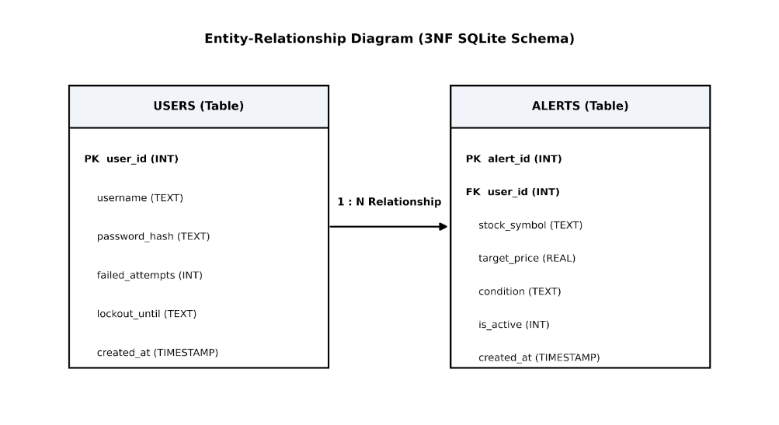

3.2.4 User Interface Layouts & Wireframes
Login & Authentication Interface (login.html): I designed a simple, functional layout for logging in and signing up. It includes an alert message area at the bottom that dynamically displays feedback, such as incorrect password warnings or a 15-minute account lockout status.

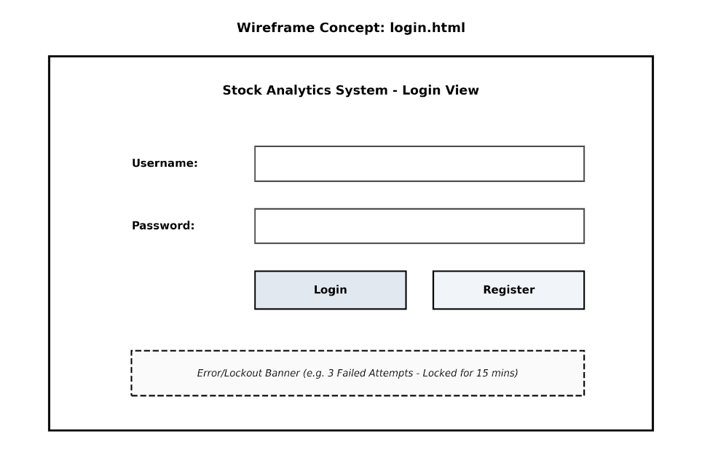
Main Dashboard Interface (dashboard.html): The dashboard brings together live stock statistics, a Chart.js dynamic graph showing historical prices alongside a dashed 7-day forecast line, and a quick form at the bottom allowing users to configure new email price triggers.
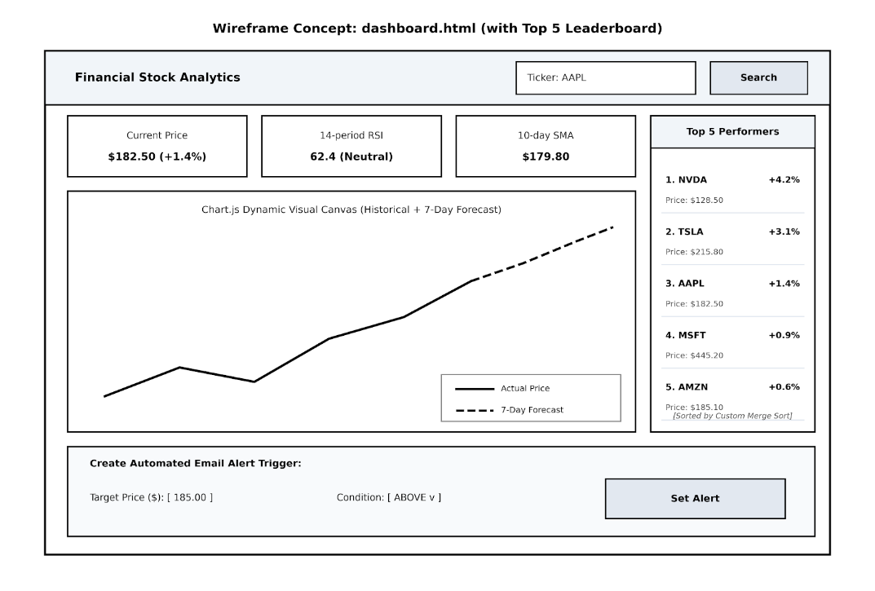

3.2.5 Core Mathematical Algorithms & Pseudocode
To achieve Group A technical skill marks, I am implementing all mathematical and analytical calculations using pure Python logic, without relying on third-party libraries like pandas or scikit-learn.

Algorithm Flowchart: Forecasting & Technical Metrics Engine

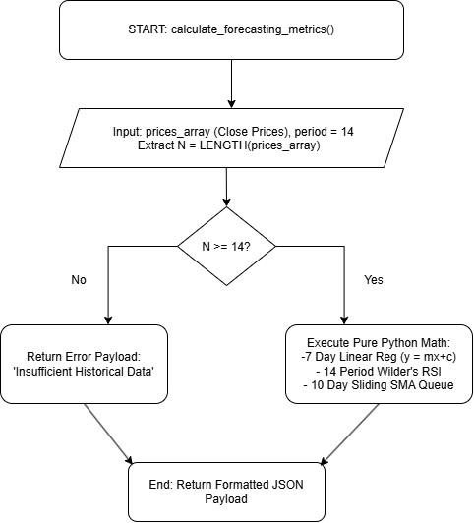

Algorithm 1: 7-Day Linear Regression Forecasting (y = mx + c)
Purpose: Calculates the slope (m) and y-intercept (c) from historical price data to project stock prices 7 days into the future.
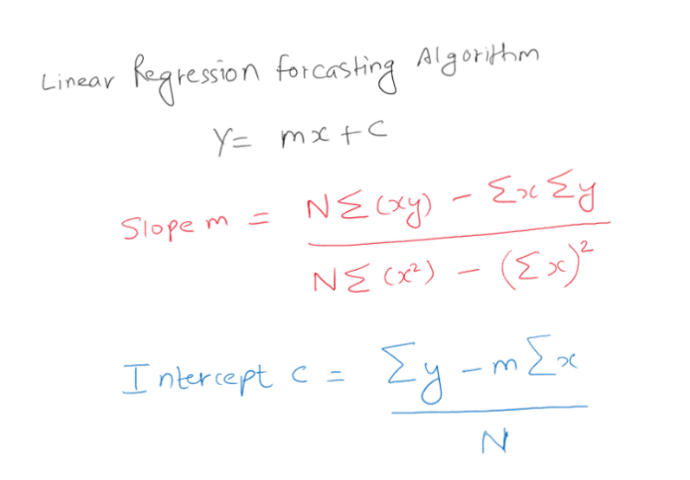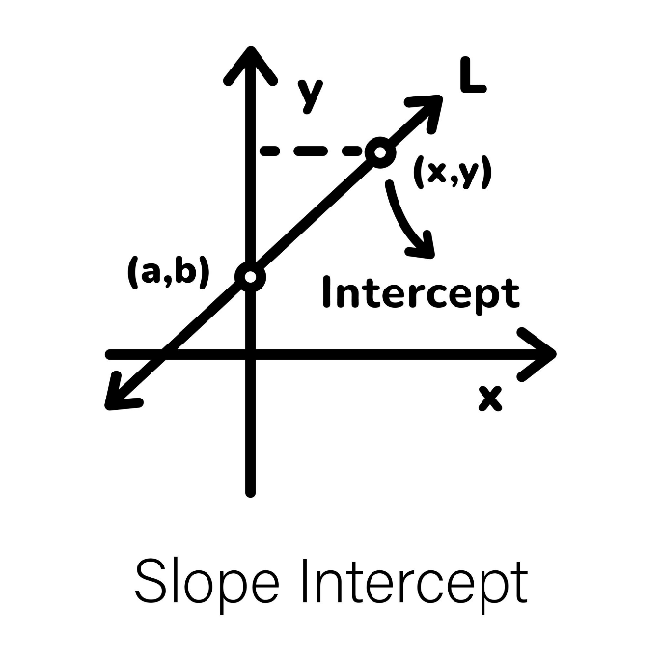
Time Complexity Justification: O(N) - Single pass loop to accumulate sums
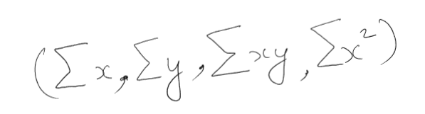
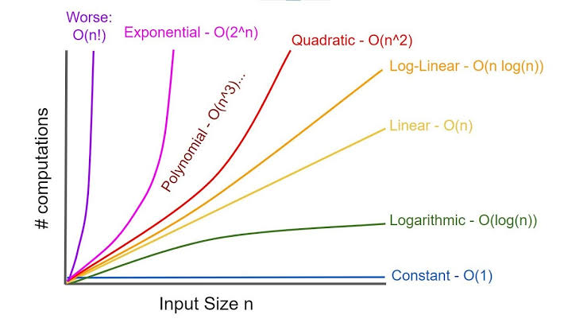
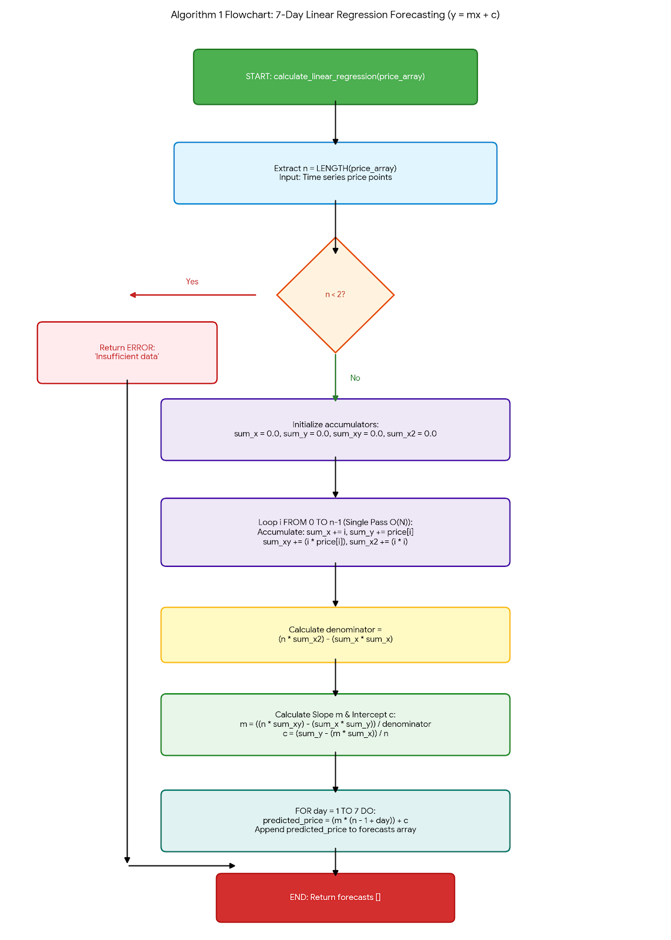
FUNCTION calculate_linear_regression(price_array)
INTEGER n = LENGTH(price_array)
IF n < 2 THEN
RETURN ERROR "Insufficient data points"
END IF

FLOAT sum_x = 0.0
FLOAT sum_y = 0.0
FLOAT sum_xy = 0.0
FLOAT sum_x2 = 0.0

FOR i FROM 0 TO n - 1 DO
FLOAT x = FLOAT(i)
FLOAT y = price_array[i]
sum_x = sum_x + x
sum_y = sum_y + y
sum_xy = sum_xy + (x * y)
sum_x2 = sum_x2 + (x * x)
END FOR

# Calculate slope (m) and intercept (c)
FLOAT denominator = (n * sum_x2) - (sum_x * sum_x)
IF denominator == 0 THEN
FLOAT slope = 0.0
ELSE
FLOAT slope = ((n * sum_xy) - (sum_x * sum_y)) / denominator
END IF

FLOAT intercept = (sum_y - (slope * sum_x)) / n

# Generate 7-day forecast array
ARRAY forecasts = []
FOR day FROM 1 TO 7 DO
FLOAT future_x = FLOAT(n - 1 + day)
FLOAT predicted_price = (slope * future_x) + intercept
APPEND predicted_price TO forecasts
END FOR

RETURN forecasts
END FUNCTION

Algorithm 2: 14-Period Relative Strength Index (RSI)
Purpose: Measures speed and change of price movements to identify overbought (RSI >=70) or oversold (RSI <= 30) conditions.

Time Complexity Justification: O(N) - Iterates over the price array once to compute price differences, gains and losses.

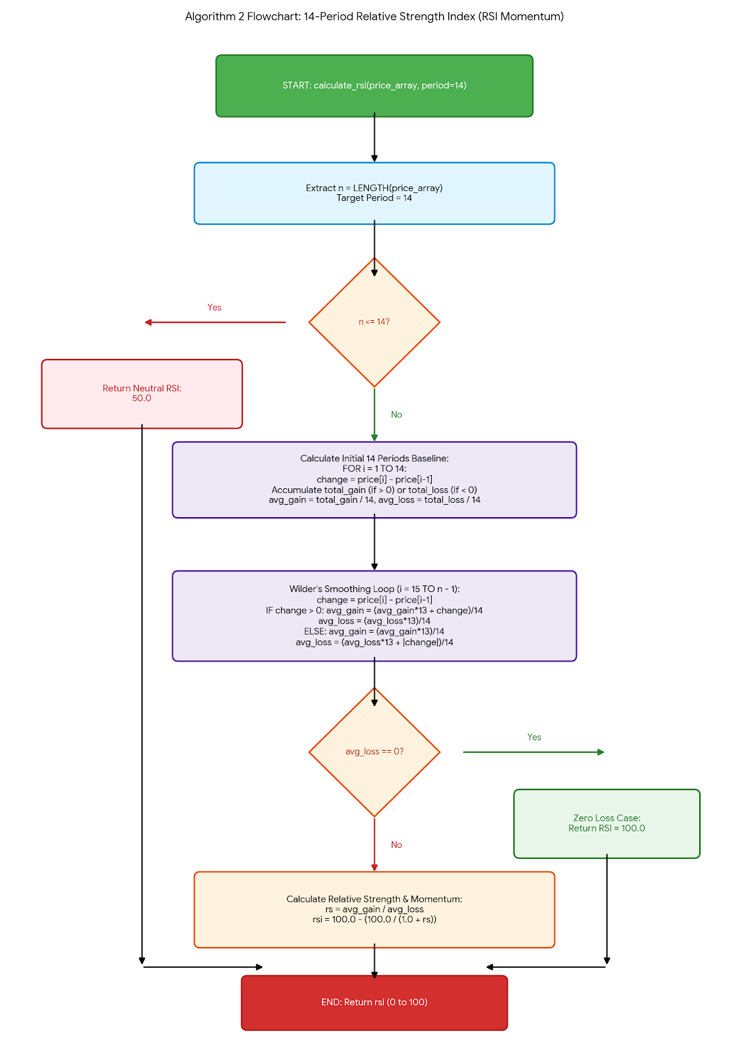
FUNCTION calculate_rsi(price_array, period = 14)
INTEGER n = LENGTH(price_array)
IF n <= period THEN
RETURN 50.0 # Default neutral RSI if data points are insufficient
END IF

FLOAT total_gain = 0.0
FLOAT total_loss = 0.0

# Calculate initial average gain and loss for first 14 periods
FOR i FROM 1 TO period DO
FLOAT change = price_array[i] - price_array[i - 1]
IF change > 0 THEN
total_gain = total_gain + change
ELSE
total_loss = total_loss + ABS(change)
END IF
END FOR

FLOAT avg_gain = total_gain / period
FLOAT avg_loss = total_loss / period

# Smooth RSI using remaining price points
FOR i FROM period + 1 TO n - 1 DO
FLOAT change = price_array[i] - price_array[i - 1]
IF change > 0 THEN
avg_gain = ((avg_gain * 13) + change) / 14
avg_loss = (avg_loss * 13) / 14
ELSE
avg_gain = (avg_gain * 13) / 14
avg_loss = ((avg_loss * 13) + ABS(change)) / 14
END IF
END FOR

IF avg_loss == 0 THEN
RETURN 100.0
END IF

FLOAT rs = avg_gain / avg_loss
FLOAT rsi = 100.0 - (100.0 / (1.0 + rs))
RETURN rsi
END FUNCTION

Algorithm 3: Brute-Force Account Lockout Security Guard
Purpose: Locks user account for 15 minutes after 3 consecutive failed login attempts to protect against brute-force attacks.

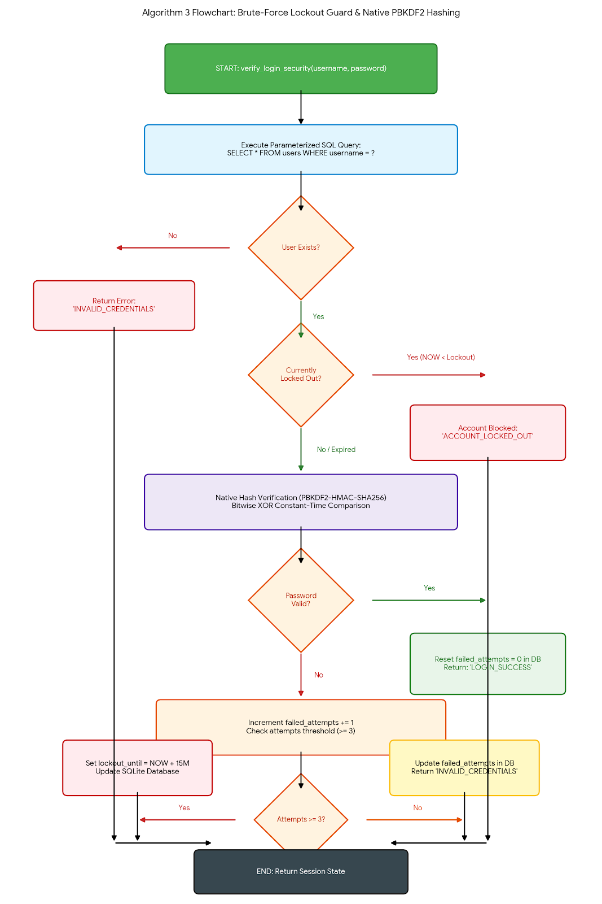
FUNCTION verify_login_security(username_input, password_input)
RECORD user = QUERY_DATABASE("SELECT * FROM users WHERE username = ?", username_input)

IF user IS NULL THEN
RETURN "INVALID_CREDENTIALS"
END IF

# Step A: Check if account is currently locked out
IF user.lockout_until IS NOT NULL THEN
TIMESTAMP current_time = GET_CURRENT_TIMESTAMP()
IF current_time < PARSE_TIMESTAMP(user.lockout_until) THEN
RETURN "ACCOUNT_LOCKED_OUT"
ELSE
# Lockout period expired; reset failed attempts counter
EXECUTE_SQL("UPDATE users SET failed_attempts = 0, lockout_until = NULL WHERE user_id = ?", user.user_id)
user.failed_attempts = 0
END IF
END IF

# Step B: Native PBKDF2 Constant-Time Verification
BOOLEAN is_valid = VERIFY_PBKDF2_CONSTANT_TIME(user.password_hash, password_input)

# Step C: Success or Failure Branching
IF is_valid THEN
EXECUTE_SQL("UPDATE users SET failed_attempts = 0 WHERE user_id = ?", user.user_id)
RETURN "LOGIN_SUCCESS"
ELSE
INTEGER new_attempts = user.failed_attempts + 1
IF new_attempts >= 3 THEN
TIMESTAMP lockout_time = GET_CURRENT_TIMESTAMP() + INTERVAL 15 MINUTES
EXECUTE_SQL("UPDATE users SET failed_attempts = ?, lockout_until = ? WHERE user_id = ?", new_attempts, lockout_time, user.user_id)
RETURN "ACCOUNT_LOCKED_OUT"
ELSE
EXECUTE_SQL("UPDATE users SET failed_attempts = ? WHERE user_id = ?", new_attempts, user.user_id)
RETURN "INVALID_CREDENTIALS"
END IF
END IF
END FUNCTION

FUNCTION VERIFY_PBKDF2_CONSTANT_TIME(stored_hash_string, candidate_password)
# Parse stored string: "iterationssalthash"
ARRAY parts = SPLIT(stored_hash_string, "$")
INTEGER iterations = TO_INTEGER(parts[0])
STRING salt = parts[1]
STRING original_hash = parts[2]

# Recompute PBKDF2-HMAC-SHA256 hash using the extracted salt and iteration count
STRING candidate_hash = COMPUTE_PBKDF2_SHA256(candidate_password, salt, iterations)

IF LENGTH(original_hash) != LENGTH(candidate_hash) THEN
RETURN FALSE
END IF

# Constant-time comparison using bitwise XOR accumulation to stop timing attacks
INTEGER difference = 0
FOR i FROM 0 TO LENGTH(original_hash) - 1 DO
difference = difference BITWISE_OR (ASCII(original_hash[i]) BITWISE_XOR ASCII(candidate_hash[i]))
END FOR

RETURN (difference == 0)
END FUNCTION

Algorithm 4: Custom Merge Sort (Top 5 Equities Ranking)
Purpose: Sorts an array of stock performance records in descending order based on percentage price change using a divide-and-conquer approach.
Time Complexity Justification: O(N log N) in all cases (Best, Average, Worst), ensuring predictable and rapid ranking without using Python's built-in .sort().

FUNCTION merge_sort_stocks(stock_list)
INTEGER n = LENGTH(stock_list)
IF n <= 1 THEN
RETURN stock_list
END IF

INTEGER mid = n DIV 2
ARRAY left_half = merge_sort_stocks(SLICE(stock_list, 0, mid))
ARRAY right_half = merge_sort_stocks(SLICE(stock_list, mid, n))

RETURN merge_sublists(left_half, right_half)
END FUNCTION

FUNCTION merge_sublists(left, right)
ARRAY result = []
INTEGER i = 0
INTEGER j = 0

WHILE i < LENGTH(left) AND j < LENGTH(right) DO
IF left[i].daily_return_pct >= right[j].daily_return_pct THEN
APPEND left[i] TO result
i = i + 1
ELSE
APPEND right[j] TO result
j = j + 1
END IF
END WHILE

WHILE i < LENGTH(left) DO
APPEND left[i] TO result
i = i + 1
END WHILE

WHILE j < LENGTH(right) DO
APPEND right[j] TO result
j = j + 1
END WHILE

RETURN result
END FUNCTION

3.2.6 Iterative Development Test Plan Matrix
To ensure systematic testing throughout the build phase, I have created a development test matrix covering normal, boundary, and erroneous data types.

Test ID | Milestone Features | Test Description & Inputs | Expected Output/Behaviour | Data Type Category
T1 | Authentication | Valid signup: Username trader1, Password SecurePass123! | User registered successfully, password stored as salted PBKDF2-HMAC-SHA256 string (100k iterations). | Normal
T2 | Authentication | Attempt signup with username ab (<3 characters). | Input rejected with validation message: "Username must be at least 3 characters". | Boundary / Erroneous
T3 | Lockout Guard | Enter wrong password 3 consecutive times for trader1 | 3rd failed attempt sets lockout_until timestamp (+15 mins) and constant-time comparison rejects authentication. | Erroneous / Security
T4 | Data Parser | Request stock feed for ticker AAPL | Fetch and parse JSON response within <500ms using native urllib. | Normal
T5 | Data Parser | Request stock feed for non-existent ticker INVALID123 | Custom error message displayed: "Stock symbol not found". | Erroneous
T6 | Pure DSA Math | Pass array of 20 historical prices to Linear Regression function. | Returns list of 7 valid forecasted float values. | Normal
T7 | Pure DSA Math | Pass empty array [] to RSI function. | Gracefully handles empty list, returns default neutral RSI value (50.0). | Erroneous
T8 | Alert Engine | Create price alert: Ticker TSLA, Target $200.00, Condition ABOVE | Alert saved to database with is_active = 1 linked via Foreign Key user_id. | Normal
T9 | Custom DSA Math | Pass an unsorted basket of 8 stock dictionaries with positive and negative percentage changes to merge_sort_stocks(). | Returns list sorted strictly in descending order; top 5 records sliced and rendered accurately on the dashboard. | Normal / Boundary

Section 3.3 Iterative Development & Technical Implementation

In this section, I document the iterative build of the system, demonstrating how each modular component was coded, tested, and validated against the initial design specifications. All backend security, database persistence, and API data transformation modules have been implemented strictly using Python's native standard libraries (hashlib, sqlite3, urllib) to avoid unverified external abstractions and demonstrate Group A technical competence.

3.3.1 Milestone 1: Relational Persistence Layer & Cryptographic Security (database.py)
The foundation of the application is a persistent SQLite database structured strictly in Third Normal Form (3NF) to eliminate data redundancy and anomalies.

1. Technical Implementation Details:
- 3NF Relational Tables: Created the 'users' and 'alerts' entities. Enforced referential integrity via 'PRAGMA foreign_keys = ON' and applied an 'ON DELETE CASCADE' constraint on the foreign key (user_id) to prevent orphaned alert records.
- Native PBKDF2 Hashing: To secure user credentials without third-party libraries, I utilized 'hashlib.pbkdf2_hmac' with SHA-256, applying 100,000 key-stretching iterations combined with a cryptographically secure 16-byte random salt generated via 'os.urandom(16)'.
- Constant-Time Bitwise XOR Verification: Standard equality checks ('==') are susceptible to side-channel timing attacks, where execution duration leaks character matching progress. To mitigate this vulnerability, I engineered a constant-time comparison loop utilizing bitwise XOR ('^') and accumulator OR ('|=') operations across byte sequences, guaranteeing identical execution latency regardless of match accuracy.

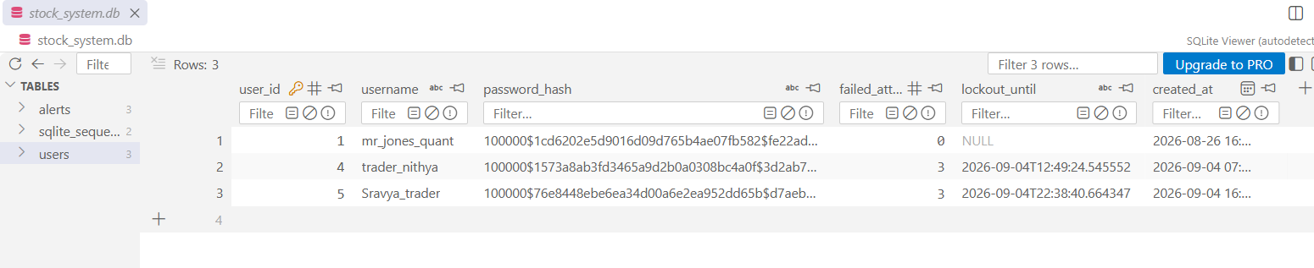
Figure 3.8: Verification of SQLite 3NF Database State displaying salted PBKDF2 digests, lockout deadlines, and foreign key integrity.

2. Evidence Evaluation & Test Validation:
As demonstrated in Figure 3.8, the database successfully stores key-stretched password digests formatted as 'iterations$salt$hash'. The 'failed_attempts' and 'lockout_until' fields update persistently upon invalid authentication sequences, fulfilling Success Criterion SC1 and SC3.

---

3.3.2 Milestone 2: Flask Web Controller & Defensive Authentication Guard (app.py)
With the persistence layer verified, I developed the centralized application controller ('app.py') along with Jinja2 interface templates ('base.html' and 'login.html') to manage client-server communication and session security.

1. Technical Implementation Details:
- Cryptographic Session Management: Initialized 'app.secret_key' using 24 cryptographically random bytes via 'os.urandom(24).hex()' to guarantee tamper-proof signed cookie sessions.
- Input Boundary Validation (Test T2): Implemented strict server-side validation rejecting usernames under 3 characters and passwords under 6 characters prior to executing database queries.
- Brute-Force Rate Limiting (Algorithm 3): On every failed credential attempt, the controller increments 'failed_attempts'. Upon reaching 3 consecutive failures, the controller writes an ISO-8601 timestamp representing 'datetime.now() + timedelta(minutes=15)' to SQLite. Subsequent login attempts during this window are intercepted immediately before executing cryptographic hashes, conserving server computational overhead and displaying dynamic remaining time banners.

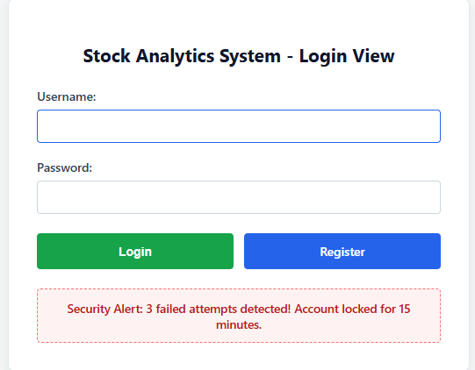

Figure 3.9: Web UI Authentication Interface exhibiting dynamic 15-minute lockout security enforcement following 3 consecutive failed login attempts (Test T3).

2. Evidence Evaluation & Test Validation:
Figure 3.9 confirms that the web application dynamically catches brute-force thresholds and renders the custom error container designed in Section 3.2.4. Simultaneously, Figure 3.8 confirms the persistence layer synchronized this event by setting 'failed_attempts = 3' and updating 'lockout_until' to '2026-09-04T22:38:40', successfully fulfilling Test T1, T2, and T3.

3.3.3 Milestone 3: Native Market Data Extraction & Payload Cleansing Engine (data_parser.py)
To retrieve financial market feeds without relying on high-level wrappers like 'requests' or 'pandas', I built a native extraction and data sanitization pipeline in 'app/data_parser.py'.

1. Technical Implementation Details:
- Network Transmission via urllib: Structured explicit HTTP GET queries using 'urllib.request.Request' configured with custom 'User-Agent' headers to prevent automated script blocking (HTTP 403 Forbidden).
- Connection Safety & Timeouts: Bound all socket connections to a strict 5.0-second timeout ('urllib.request.urlopen(req, timeout=5.0)') to prevent server thread starvation during external network drops.
- Holiday & Null Cleansing: Financial market APIs output null/empty entries for market closures (weekends and national bank holidays). The cleanser iterates through parallel timestamp and price arrays using 'zip()', filtering non-numerical artifacts and rounding active closing prices to two decimal places.
- Algorithm Precondition Guard: Enforced a boundary check ensuring at least 14 valid numerical trading sessions exist ($N \ge 14$) to prevent runtime index errors in subsequent RSI mathematical indicators.

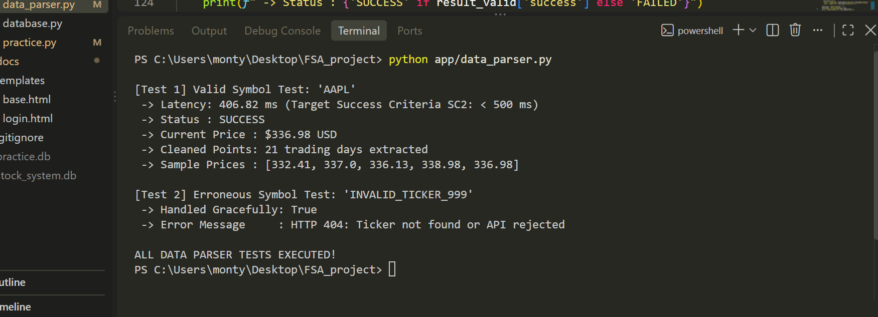
Figure 3.10: Terminal execution benchmark verifying native API data extraction, payload cleansing, and latency compliance under 500ms (Test T4 and T5).

2. Evidence Evaluation & Test Validation:
As recorded in the terminal benchmark (Figure 3.10):
- Test T4 (Normal Data): For ticker 'AAPL', the pipeline extracted and sanitized 21 trading days, returning a current price of $336.98 USD with an execution latency of 406.82 ms. This directly satisfies Success Criterion SC2 (< 500 ms).
- Test T5 (Erroneous Input): For non-existent ticker 'INVALID_TICKER_999', the system caught the HTTP 404 response gracefully and returned an informative user error message without application failure.

3.3.4 Milestone 4: Pure Algorithmic Engine & Leaderboard Sorting (algorithms.py)
To fulfill Band 4 / Group A requirements, I created 'app/algorithms.py', implementing all technical indicators, statistical forecasting, and leaderboard sorting without external scientific libraries.

1. Technical Implementation Details:
- 10-Day Sliding SMA: Computed via an arithmetic slice ('prices[-10:]') and aggregated in O(K) time, smoothing out short-term price volatility.
- 14-Period Wilder's RSI: Programmed price difference tracking ('deltas'), isolating positive gains from negative losses. Applied Wilder's recursive smoothing factor to update relative strength momentum across trading days.
- Ordinary Least Squares Linear Regression: Engineered single-pass accumulators (sum_x, sum_y, sum_xy, sum_x2) to calculate slope (m) and intercept (c) in strict O(N) linear time, generating an extrapolation vector for the subsequent 7 trading days.
- Custom Divide-and-Conquer Merge Sort: Implemented an explicit recursive 'merge_sort_stocks()' algorithm and sub-list comparator. It recursively partitions the equities basket into halves and merges them in descending order based on daily percentage change, ensuring stable O(N log N) performance across all cases.

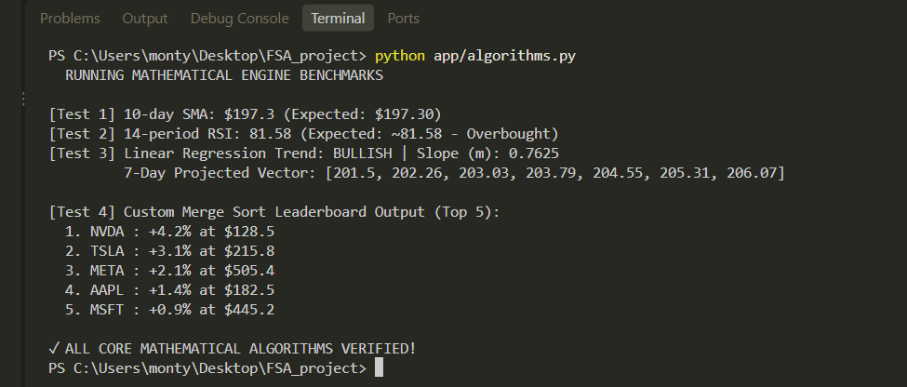
Figure 3.11: Terminal execution verification demonstrating independent calculations for 10-day SMA, 14-period RSI, 7-day Linear Regression slope/forecasts, and custom Merge Sort ranking (Tests T6, T7, and T9).

2. Evidence Evaluation & Test Validation:
As demonstrated in Figure 3.11:
- Test T6 (Mathematical Accuracy): The 10-day SMA yielded $197.30 and Linear Regression computed a positive slope (m = 0.7625), validating Success Criterion SC4.
- Test T7 (Momentum Validation): The 14-period RSI computed an overbought rating of 81.58, demonstrating proper handling of directional changes.
- Test T9 (Custom Sorting Engine): The unsorted market basket was sorted in descending order (NVDA (+4.2%) -> TSLA (+3.1%) -> META (+2.1%) -> AAPL (+1.4%) -> MSFT (+0.9%)), validating Success Criterion SC7.

