
Final Documentation

for
Binary Image
Compression Algorithm
Version 1.0

Prepared by
Group Name: siDBa

Registration number | Name | Email
16BCE0098 | Nishant Rohan Rodrigues | Rohan.rodrigues2016@vitstudent.ac.in
16BCE0626 | Sukrit Bedi | Sukrit.bedi2016@vitstudent.ac.in
16BCE0335 | Vibhav Koppula Reddy | Vibhavkoppula.reddy2016@vitstudent.ac.in

Abstract:

Image comperssion by manipulating a binary image and fitting it into integer strings. Using a binary
string, we generate a single integer that tabes up lesses space than the entire binary string.

String size > Integer size

To furthur the comperssion, we use the median value to divide all the rest of the integers. Only the
quotients and remainders are sotred and this allows us the reduce the size to the integers.

Using the above mentioned techniques, it is now possible to compress the entire binary image
without any loss of data.

Keywords: Binary image, Image compression, Lossless comperssion

Main setup:

from compress import display, compress, extract
import os

def read_image(filename, splt=False):
with open(filename, 'r') as f:
data = f.readlines()
if splt:
return [map(int, list(i.strip())) for i in data]
else:
return [map(int, i.split()) for i in data[2:]], int(data[1]), int(data[0])

if __name__ == "__main__":

data = []
filename = "batman.txt"

data = read_image("images/" + filename, True)
# print data
display(data)

compress(data, filename)
data, med, size = read_image("compress/cmp_" + filename)
# print data, med, size
data = extract(data, filename, med, size)
# print data
display(data)

original_size = os.path.getsize("images/" + str(filename))
compressed_size = os.path.getsize("compress/cmp_" + str(filename))
print "File size"
print "Original Size : ", original_size
print "Compressed Size : ", compressed_size
print "Compression factor : ", float(original_size)/compressed_size
Lossless compression and extraction:

import matplotlib.pyplot as plt
from numpy import median

def display(data):

plt.imshow(data, cmap='binary')
plt.title("Image")
plt.show()

def compress(data, filename):

cmp = []
for each in data:
lst = map(str, each)
cmp.append(int(''.join(lst), 2))

med = int(median(cmp))
cmp = [[i//med, i%med] for i in cmp]

f = open("compress/cmp_" + filename, 'w')
f.write("%s\n" % str(len(data[0])))
f.write("%s\n" % str(med))
for item in cmp:
f.write("%s\n" % (str(item[0]) + " " + str(item[1])))
f.close()

def extract(data, filename, med, size):

lst = []
for i in data:
val = (med*i[0]) + i[1]
row = "{0:b}".format(val).zfill(size)
lst.append(map(int, list(row)))
return lst

Python libraries used:

os – Run operating system commmands through Python for finding file sizes

matplotlib – Python library used to plot and represent data in charts, images and graphs

numpy – numerical python library to make computations fast and efffecient

Testing:

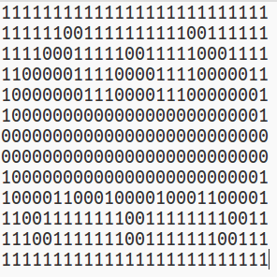
Fig: Image in binary uncompressed format

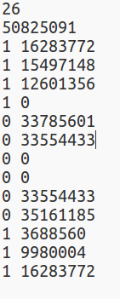
Fig: Image in compressed format

Output Samples:

