**DESIGN AND FABRICATION OF PAPER BAG MAKING MACHINE**

**A Course Project report Submitted in partial fulfillment of the Academic requirements for the award of the degree of**

**Bachelor of Technology**

Submitted by

**19H51A04M6 – B. PAVAN KUMAR**

**19H51A04P7 – T. SRI CHARAN**

**19H51A05N7 – K. LOHITHA**

**19H51A05N8 – M. MOUNIKA**

**19H51A05P7 – P. UDAYSREE**

**UNDER THE COURSE**

**ENGINEERING EXPLORATION & PRACTICE**



**CENTRE FOR ENGINEERING EDUCATION RESEARCH**

**CMR COLLEGE OF ENGINEERING & TECHNOLOGY**

**(Autonomous)**

**(NAAC Accredited with ‘A’ Grade & NBA Accredited)**

**(Approved by AICTE, Permanently Affiliated to JNTU Hyderabad)**

**KANDLAKOYA, MEDCHAL ROAD, HYDERABAD-501401**

**2019-20**

**CENTRE FOR ENGINEERING EDUCATION RESEARCH**

**CMR COLLEGE OF ENGINEERING & TECHNOLOGY**

**(Autonomous)**

**(NAAC Accredited with ‘A’ Grade & NBA Accredited)**

**(Approved by AICTE, Permanently Affiliated to JNTU Hyderabad)**

**KANDLAKOYA, MEDCHAL ROAD, HYDERABAD-501401**



**CERTIFICATE**

This is to certify that the course project report entitled **“DESIGN AND FABRICATION OF PAPER BAG MAKING MACHINE”** is a bonafide work done by **B.PAVAN KUMAR (19H51A04M6), T. SRI CHARAN (19H51A04P7), K.LOHITHA(19H51A05N7), M.MOUNIKA(19H51A05N8), P.UDAYSREE (19H51A05P7)** of I B.Tech II Sem, in partial fulfillment of the requirements for the award of the degree of Bachelor of Technology, submitted to Centre for Engineering Education Research, CMR College of Engineering & Technology, Hyderabad during the Academic Year 2019-2020.

**(Names of the project coordinators)**

**1. MR.RAJESH ---------Asst.prof**

**2. MS.ARCHANA ------------Asst.prof**

**3. MR.SATHISH --- -------Asst.prof Mrs.Sowjanya**

Head CEER

**DECLARATION**

We, the students of I B.Tech II Sem of Centre for Engineering Education Research , CMR COLLEGE OF ENGINEERING & TECHNOLOGY, Kandlakoya, Hyderabad, hereby declare, that under the supervision of our guide course coordinators, we have independently carried out the project titled “**DESIGN AND FABRICATION OF PAPER BAG MAKING MACHINE**” and submitted the report in partial fulfillment of the requirement for the award of Bachelor of Technology in by the Jawaharlal Nehru Technological University, Hyderabad (JNTUH) during the academic year 2019-2020.

Name, Roll Number and Signature of the students

**19H51A04M6 – B. PAVAN KUMAR**

**19H51A04P7 – T. SRI CHARAN**

**19H51A05N7 – K. LOHITHA 19H51A05N8 – M. MOUNIKA**

**19H51A05P7 – P. UDAYSREE**

**ACKNOWLEDGEMENT**

We are obliged and grateful to thank Mrs.D.Sowjanya, Head(CEER), CMRCET, for her cooperation in all respects during the course.

We would like to thank the Principal of CMRCET, Dr.V.A.Narayana, for his support in the course of this project work.

Finally we thank all our faculty members and Lab Assistants for their valid support.

We own all our success to our beloved parents, whose vision, love and inspiration has made us reach out for these glories.

**ABSTRACT**

In this 21st century, with increasing population, markets and industries, and large production, usage of plastic bags has rapidly increased. On the counter side, plastic is non-biodegradable and is toxic. Further, people dump plastic bags at many places which results in environmental degradation. These bags are sometimes consumed by domestic animals, leading to their death. An alternate solution to this problem is the deployment of paper bags, in place of plastic bags. However, existing paper bag machines are expensive (INR 3, 00,000) and even are the paper used for making the bag. Further the existing machine technology occupies large space, as big as a hall and it is even very difficult to shift it from place to place. So, in this paper, we have come up with a solution: A portable low-cost paper-bag machine that uses news-paper to build paper-bag. The news-paper with a single fold will be fed into the machine via human assistance. The articulated 5 D.O.F robotic arm serving as folding mechanism, in conjunction with 2-wheeled robot serving as gluing mechanism, being controlled by micro-controller and DC motors, creates a paper bag. This paper is structured as follows: Section II describes the block diagram, Section III describes working, and Section IV describes Tools review, Section V describes Results and Conclusion, Section VI future improvements and Section VII lists out references.

Upon fixing the paper, the human should press reset button provided with robot. The micro-controller ports will be initialized. The glue bottle will be turned down and now the glue starts flowing. The 2 forward IR sensors‟ reading would be analyzed and the robot would be moved forward and the turning will be done accordingly, by controlling wheel motors. Once the robot reaches end of path, the robot stops, the glue bottle will be turned up, and the glue stops flowing. Then the 4 IR transmitters attached at robot front would signal towards the photo diode connected at path end. 4 IR sensors have been connected in order to rectify the line-of-sight problem caused when using 1 IR sensor. This signal received by the photodiode, is a signal for the robotic arm to start folding mechanism. Then, the robot starts back traversal by collecting 2 backward IR sensors‟ signals and controlling the motors accordingly to move the robot to the path beginning. The robot stops. The glue would be applied at desired places.

TABLE OF CONTENTS

|  |  |  |  |
| --- | --- | --- | --- |
| **CHAPTERS** | | **DESCRIPTION** | **PAGE No** |
|  |  | Abstract | 5 |
| 1 |  | Introduction | 6 |
| 2 |  | Literature Review  (Journals) | 6-8 |
| 3 |  | Problem Definition | 8 |
|  | 3.1 | Problem Statement | 9 |
|  | 3.2 | Objective | 9 |
|  | 3.3 | Requirement Analysis | 10 |
|  | 3.4 | Methodology | 11-12 |
| 4 | 4.1 | Conceptual Design | 13 |
|  | 4.2 | Block Diagram | 14 |
|  | 4.3 | Design Description | 14-16 |
| 5 |  | Implementation | 17-19 |
|  | 5.1 | Results And Discussions | 19 |
|  | 5.2 | Conclusions | 20 |
| 6 |  | Appendix | 20 |
|  | 6.1 | References | 21 |
|  | 6.2 | Source Code | 22-26 |

**1.INTRODUCTION:**

The Plastic considered as one of the greatest inventions by virtue of its use in carrying things has become a major element in polluting the environment. It is almost impossible to destroy plastic bags. Plastic bags remain in the soil for centuries, degrading the soil, preventing it from replenishing its nutrients, and rendering to barren. This ultimately results infertile land becoming barren and turning into desert. It is estimated that the life expectancy of plastic bags is around 250 to 500 years. In current situation, the use of plastic bags for every single work has become a usual thing. Right from buying grocery from market to shopping in malls everywhere plastic bag is been used. The use of plastic bags across the country has increased, and it is continuously increasing day by day. Paper bags on the other hand, come from wood, which comes from trees, which grow in the earth's soil. The trees needed to make paper bags are considered renewable resources. Once paper is made, it can be recycled and used to create more paper goods. Bags made from paper are bio-degradable and hence highly environment friendly than plastic bags. Throughout India people make paper carry bags by hand in their homes as per the local demand. Generally, women in the family take up the paper bag business as a second source of income. The use of paper bags is promoted nowadays. This project is based on reuse of papers for manufacturing paper bags instead of using recycled papers. It also aims on switching traditional manual method of paper bag manufacturing to low cost semi-automated system in order to achieve the goal of mass production of paper bags through automation. Due to mass production, the cost of the final bags is expected to be low as compared to the paper bags available in the market made by traditional manual method.

**2.LITERATURE REVIEW:**

N. R. Patil, Jonathan Lobo, AqueelMadki, Rohit Bhande, Shripad Bodhankar. [1] **“Automated Paper Bag Making Machine**” In this research paper, they have design and develop an automated Paper bag making machine for different objectives and which integrate all the objectives together using Arduino. Compensating for the shortcomings of other already available systems, there project is feasible, high efficiency and high robustness. They have automated paper envelope machine in order to reduce the man power and to increase the efficiency and quality of the product and ultimately to increase the preparedness to face emergency situations. There system contains the parts which are easily available. Almost all the single paper folding machines currently available in the market are very much expensive. Therefore, proposed system has simple and easy mechanism which allow operator to use it easily.

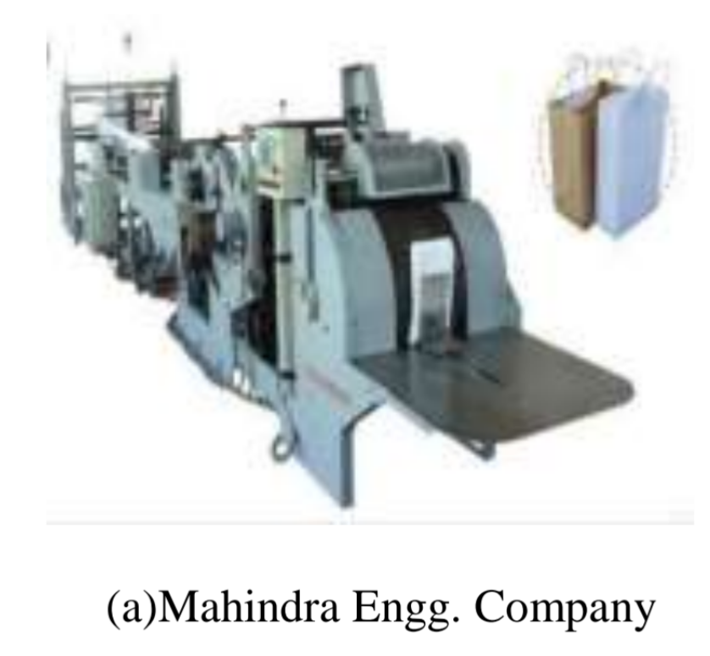

Mangesh M. Daundkar, Mrs.Bhairavi N. Savan. [2] “**An Optimized Embedded System for Automated Paper Bag Production”** In this paper, they have used micro-controller based design approach which has kept the cost of the system significantly low as compared to PLC based designs. They have used recycled approximately A4 size which is feed into machine with the help of two rollers they have used two IR sensors one is used for applying adhesive and the second sensor is triggered which signifies that middle portion of the page is at the center of the other roller and a blade is applied to fold a paper into two halves and passed through a roller so that the glue placed on one half portion of the page gets stick to other half of the page which gives a nice half A4 size paper bag. The proposed system has required lees manpower than traditional method of manufacturing paper bags. Any kind of paper quality can be used for production whether it is virgin or recycled. Any size of paper bag can be produced by adjusting the roller length.

ThivankaKasunGunawardena, P R Dadigamuwa and B G D AMadhusanka. [3] “**Low Cost Automated Machine for Paper Gathering and Folding**” they have used most of the parts in this machine are gathered from junk yards. There are thousands of machines like Photocopy machines, Printers, Roneo machines thrown out to junk yards which dealing with papers. The parts like rollers, feeders, gear wheels etc, of this machine were used from the thrown out yards. Most of the sensors used in this machine are inexpensive and simple. But they are well enough to do main tasks properly. Motors also used in this design can easily find in the junk yards or machine separating places. They can buy at low prices. Therefore, there machine is low cost as compared other machines in market. This automated system is portable and capable of working independently without much human intervention. Subramanian SenthilkannanMuthu, Yi Li, PhD, J.Y. Hu, PhD, P.Y. Mok, PhD.

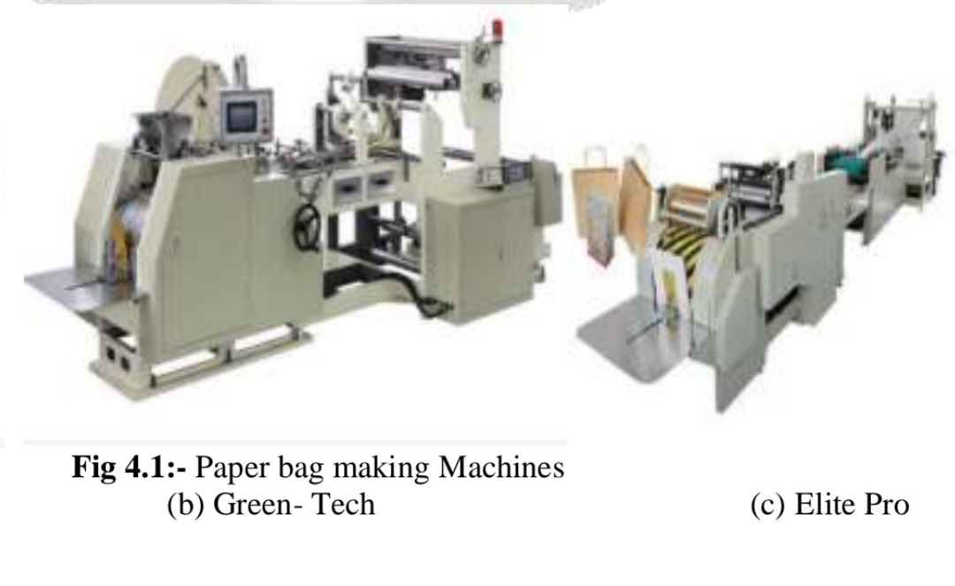

[4] “We have proposed a cheap, “**Portable paper-bag making machine fabricated”** to produce paper-bags and reduce the usage of plastic bag for a green and safe society. The system is semi-automatic which is capable of producing a paper bag from drawing sheets. The system can be implemented in a small scale industry for producing paper bags and it will automatically minimize the trend of plastic bags.

**3.Problem Definition:**

The study of above Research papers and actual visit to the paper bag manufacturing industries. We find that Bag making machines produce bags that are used to pack various types of goods in food and beverage, pharmaceutical and consumer product industries. In general, these machines are fully automatic and require operator intervention only to replenish the raw material and remove the finished products. But these machines are costly and they require papers as the raw material. These papers are strengthened by adding chemicals in order to make them bear load in the form of paper bags. However, this strengthening of recycled paper by adding chemicals creates a lot of pollution which in turn harms the environment. The major drawbacks of the existing machines are too large, occupy huge area, imported, too costly, require many people to operate, need of separate machines for creasing, folding and gluing. So the current method of manufacturing of paper bag from this recycled paper has above mentioned disadvantage which is the problem statement. Our project aims at fabrication and development of compact, low cost paper bag making machine for the mass production of carry bags from drawing sheets or used paper. The machine will be able to produce paper bags made of recycled or reused papers. The paper bag produced will be an alternative to a particular category of polythene bags usually used. The machine will be designed considering all the criteria of its realistic paper bag production.

**3.NEED STATEMENT:**

Plastic consumption should be reduced to avoid Environmental effects and government is taking many steps to avoid plastic carry bags, so there is a need to design a machine that can make alternative bags for sustainable development.

**3.1 Problem Statement:**

* Plastic bags are one of the worst and most unnecessary plastic polluters of the earth so we avoid to the use of plastic bags we made paper bags.
* ❖ Other paper bags to increase the strengthened by adding chemical creates a lot of pollution which in turns harms the environment.
* ❖ A small percentage of these end of being recycled, and some people try to reuse old plastic bags for other purposes, but the vast majority of plastic bags are used a single time

**3.1 AIM:-**

To design a low cost semi-automatic paper bag making machine for micro enterprises.

3.2 OBJECTIVE:-

1. To minimize the human effort.

2. To develop simple mechanism to perform the operation.

3. To increase the efficiency and quality of the products.

4. To analyze the demand of paper bag.

5. To develop a machine which can be used mostly where there is shortage of electricity.

6. To increase the production rate with the less cost

***3.3 Requirement Analysis:***

***COMPONENTS:-***

The project model is designed to low cost semi-automatic paper bag making machine. The major components of the machine are as follows:-

1.AC motor

2.Pedestal bearing

3.Pulley

4.Gear

5.Folding SS arm’s

6.Glue solenoids or roller

7.Pneumatic cylinder

8.Body frame

9.Conveyor belt

10.Controller circuit

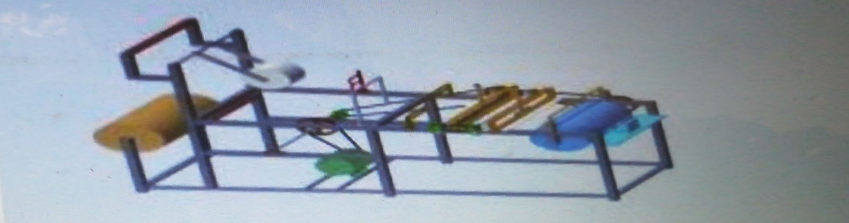

**3.4 Methodology**:

The Paper pulling mechanism is use to pull the paper from the paper roll and by pulling it through the rollers it passes to the folding mechanism where the paper is fold from one side and further passes to gluing mechanism where the one sided open fold is pasted with the help of glue. After gluing the cutting operation is carried out and punching on the top side of the bag.

The output of the system is a paper bag when the paper roll is input into the machine. Motor is use in the system to transmit the power and operate conveyor speed reduction mechanism, feeding and folding mechanism. The paper from paper roll is pulled with the help of pulling mechanism then this paper which will passed to the folding mechanism by using roller, belt and conveyor. Gluing mechanism is used in the system to apply glue on the paper. After this operations the cutting operation is carried out and then punching on the top side of the bag. In these way final product is taken out that is paper bag**.**

The machinery has got a touch screen and PC control system indicating that the machine shows the real time progress of the work.

Programmed counting system- the machine has got an automatic counting provision. So once the user inputs the number, the device ejects out the right quantity of paper bags set from the system.

In this the Aurduino software used to controller the operator and the code is given by using C & C++ in it.

Colour mark tracking system – this function ensures that the paper bag cutting is precise in a form pattern after printing.

Dense designed mechanical transmission -this kind of design ensures that the material is stably passed, improves the mechanical properties and producing clean paper bags with superior appearance.

Features and performances:

•It has got a very high tensile strength

•They are easy to maintain

•Excellent finishes.

•It Produces bags of precise dimensions.

•The central control and the touch screen operates with PLC programmable logic controller.

*They have got Production capacity in the range of 25000 pieces per hour and even more for some.

•Maximum bag length produced a range between 7 inches to 27 inches.

•They consume power in the range of 3 to 4 HP motor.

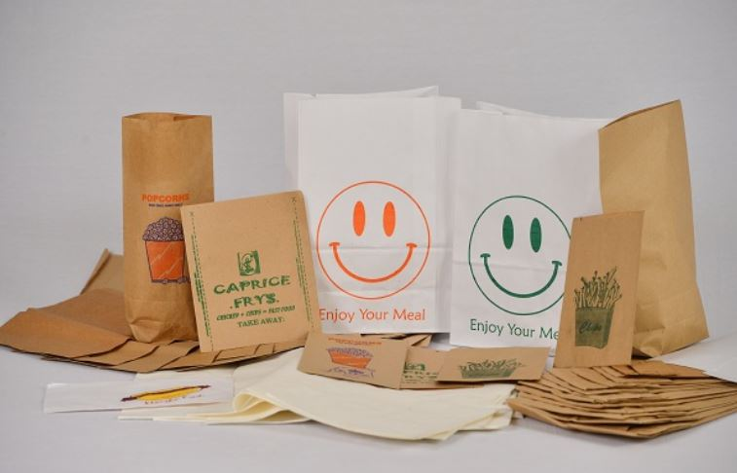

Final product:-

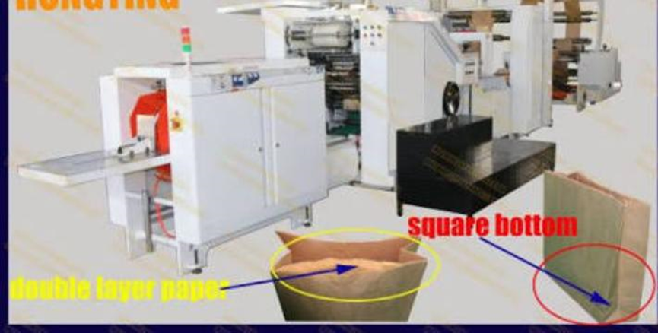

**4.1 Conceptual Design:**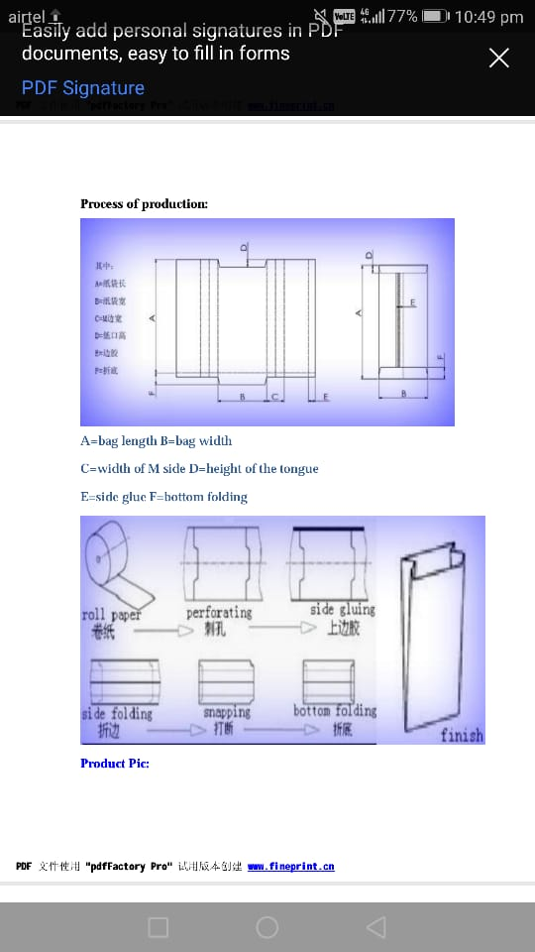

**4.2 Block Diagram:**

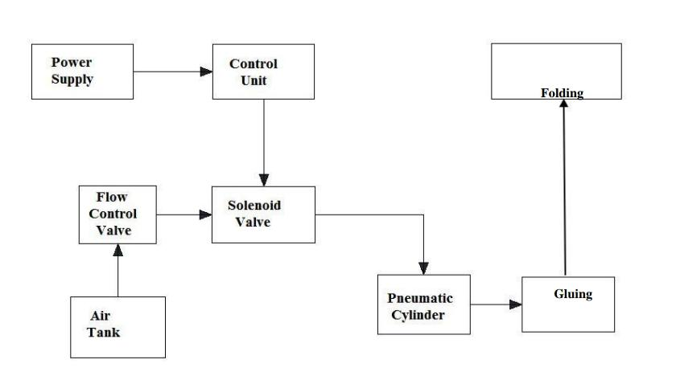

**4.3 Design Description:**

The Paper pulling mechanism is use to pull the paper from the paper roll and by pulling it through the rollers it passes to the folding mechanism where the paper is fold from one side and further passes to gluing mechanism where the one sided open fold is pasted with the help of glue. After gluing the cutting operation is carried out and punching on the top side of the bag.



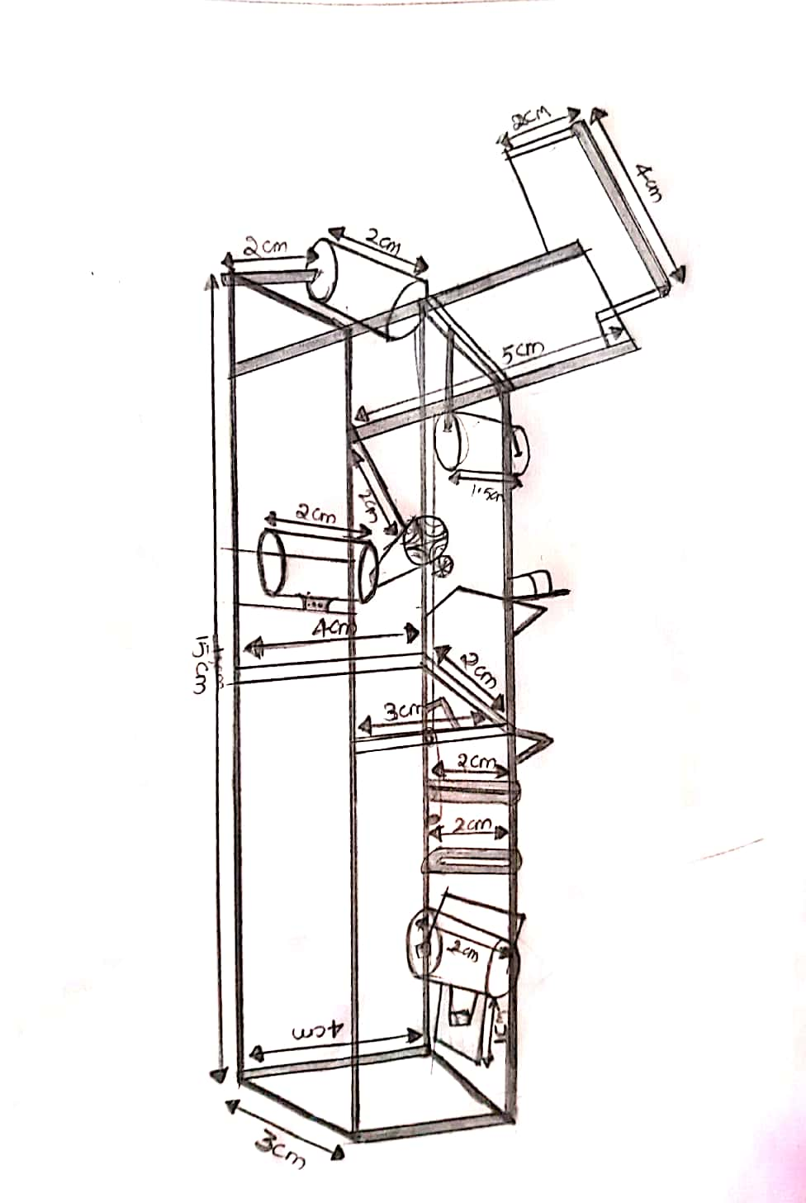

***CIRCUIT DIAGRAM AND STIMULATION:***

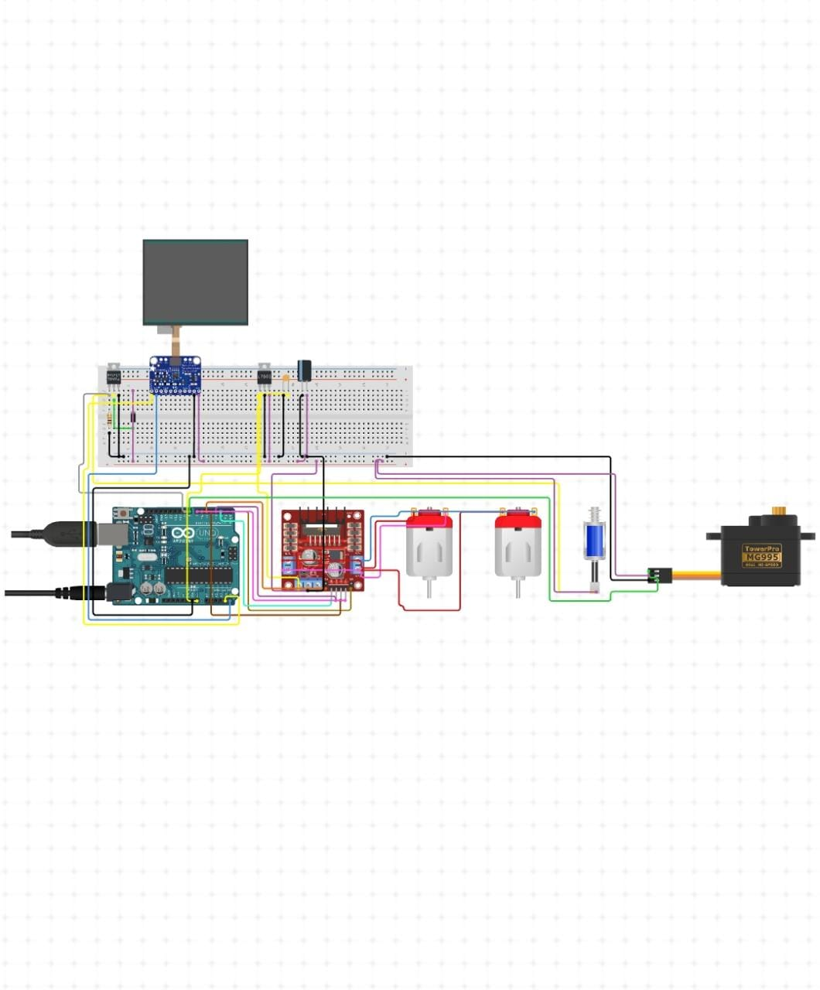

***https://www.circuito.io/app?components=9442,10334,11015,11021,276649,7654322***

***htpps://www.tinkercad.com/things/9jxihJYIf2H-ee-lab/editel?sharecode=o70dY4kcl54FgaDSGNI-vqSNsg8Belpk17SCcnSQsf8***

***(Stimulation link)***

***EXISTING SOLUTIONS*:**

Hedding Potable Paper Bags:

Square bottom with handle punching paper Making machine

• In 1852, Francis Wolle, a schoolteacher, invented the first machine to mass-produce paper bags.

[1] Wolle and his brother patented the machine and founded the Union Paper Bag Company.

• In 1871, inventor Margaret E. Knight designed a machine that could create flat-bottomed paper bags, which could carry more than the previous envelope-style design.

• In 1883, Charles Stilwell patented a machine that made

square bottom paper bags with pleated sides, making

them easier to fold and store.

[2] This style of bag came to be known as the S.O.S.

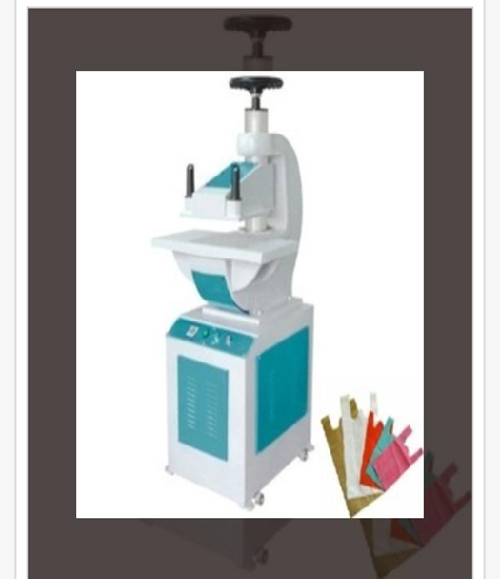

Paper shopping bags, brown paper bags, grocery bags, paper bread bags and other light duty bags have a single layer of paper. A variety of constructions and designs are available. Many are printed with the names of stores and brands. Paper bags are not waterproof. Types of paper bag are: laminated, twisted, flat tap. The laminated bag, whilst not totally waterproof, has a laminate that protects the outside to some degree.

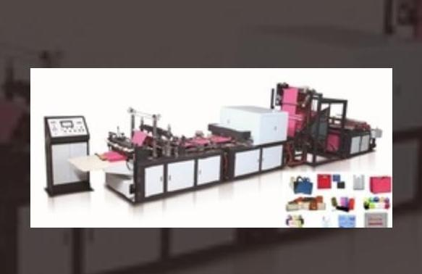 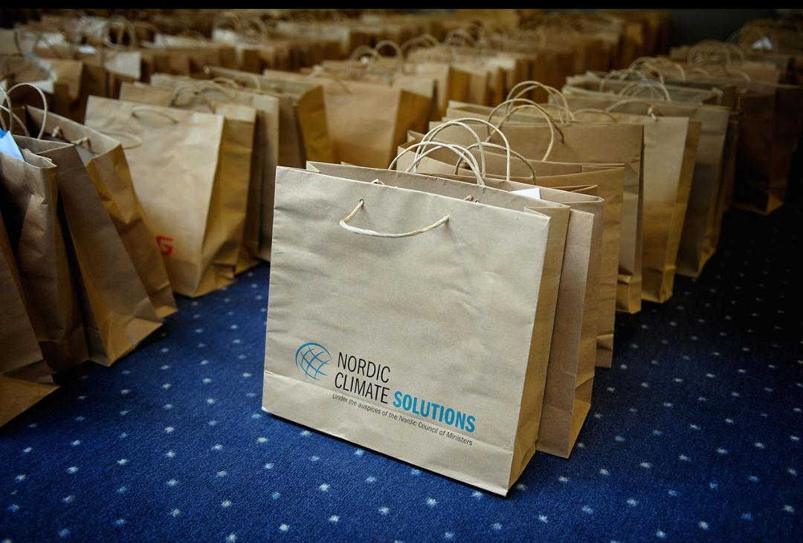

Multiwall (or multi-wall) paper sacks or shipping sacks are often used as shipping containers for bulk materials such as fertilizer, animal feed, sand, dry chemicals, flour and cement. Many have several layers of sack papers, printed external layer and inner plies.[9] Some paper sacks have a plastic film, foil, or polyethylene coated paper layer in between as a water-repellant, insect resistant, or rodent barrier. There are two basic designs of bags: open mouth bags and valve bags. An open mouth bag is a tube of paper plies with the bottom end sealed. The bag is filled though the open mouth and then closed by stitching, adhesive, or tape. Valve sacks have both ends closed and are filled through a valve. A typical example of a valve bag is the cement sack.

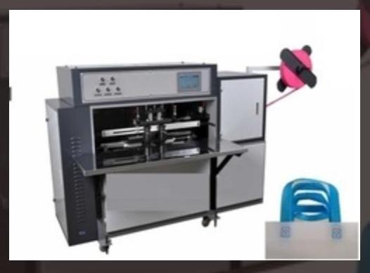

**Square Bottom Paper Bag Making Machine with double layer paper rolls machine making**

Square bottom paper bag making machine is a versatile machine that uses rolling paper as a raw material. It produces 100 percent biodegradable paper bags for shopping and food handling. If you may be wondering, this is the machine responsible for making those paper bags with the square bottoms

All other machines paramters such as the control system are quite similar.

* The double layer tape printing square bottom bag consists of feeding equipment, printing equipment, modeling device, receiving device.
* This paper introduces the touch screen man-machine interface, easy to modify and fine tuning. Alarm and Working status can be displayed on the screen



**IMPLEMENTATION:**

**5.1 Results And Discussions**:

* It is used to make paper bags, which doesn’t effect harm the environment. Paper bag is made of papers with the help of machine.
* We are able to reduce the plastic used.
* We have been able to design and develop a low cost semi- automatic paper bag making machine. The machine converts paper into a paper bag with the help of paper bag making machine. We are able to reduce the plastic used.
* Thus, we have come up with a low-cost semi-automatic paperbag making machine. Since we have used Indian clone of OWI Robotic Arm, the total system cost is INR 3000. Currently the system can produce 1 paper-bag per minute. This is because of the 5V DC geared motor used in entire system. Also glue needs to be replaced frequently. Further one human assistance is required. However, the machine can be deployed in small scale industries, homes, etc. and the paper-bag can be used for carrying vegetables and fruits, for small stationaries, can be used in medical shops for carrying medicines, etc.

**5.2 CONCLUSION:**

Plastic bags which harm our environment, aquatic life and human health and moreover are not degradable have paper bag as an alternative. We designed a paper bag machine which produce paper bags which will not only be eco-friendly and degradable, but also will have high load carrying capacity, and nice aesthetics. Drawing sheets which are a waste from educational institutions will be used as a raw material for manufacturing paper bag of our design. A manufacturing setup for producing our designed paper bag was fabricated. This fabricated setup used drawing sheets as raw material due to which its raw material cost got reduced. This machine is cheaper, compact and portable than currently available paper bag manufacturing machines.

**6. APPENDIX:**

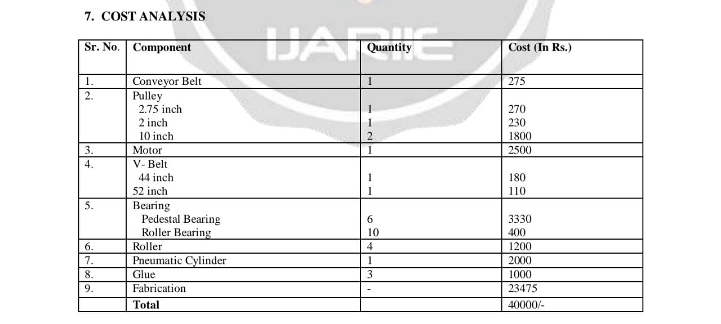

**6.1 REFERENCE**:

1) N. R. Patil, Jonathan Lobo, AqueelMadki, RohitBhande, ShripadBodhankar. [1] “Automated Paper Bag Making Machine”, in May 2017 IJIRT, Volume 3 Issue 12, ISSN: 2349-600.

2) Mangesh M. Daundkar, Mrs. Bhairavi N. Savan. [2] “An Optimized Embedded System for Automated Paper Bag Production”, International Journal of Advanced Research in Electronics and Communication Engineering (IJARECE),Volume 5, Issue 1, January 2016.

3) S.Shashank, Rajath, Nayan Kumar .V, Harish A.G, S.M. Narasimhan. [3] “Portable Paper-Bag Making Machine”, inInternational Journal of Engineering Science and Computing, Volume 7 Issue No.4, April 2017.

4) ThivankaKasunGunawardena, P R Dadigamuwa and B G D A.Madhusanka, “Low Cost Automated Machine for Paper Gathering and Folding” in European Journal of Advances in Engineering and Technology, 2015, 2(2): 4043 Research Article ISSN: 2394 – 658X.

5) Subramanian SenthilkannanMuthu, Yi Li, J.Y. Hu, PhD1, P.Y. Mok,Xuemei Ding, “Eco-Impact of Plastic and PaperShopping Bags’’ , The Hong Kong Polytechnic University, Institute of Textiles & Clothing, Kowloon NA HONG KONG,College of Fashion, Donghua University, Shanghai, China.

**6.2 SOURCE CODE:**

#include "Arduino.h”

#include "DCMDriverL298.h“

#include "Servo.h“

// Pin Definitions

#define DCMOTORDRIVERL298_PIN_INT 2

#defineDCMOTORDRIVERL298_PIN_ENB 6

#define DCMOTORDRIVERL298_PIN_INT2 3

#define DCMOTORDRIVERL298_PIN_ENA 5

#define DCMOTORDRIVERL298_PIN_INT3 4

#define DCMOTORDRIVERL298_PIN_INT4 7

#define SERVOMD_PIN_SIG 8

#define PULLPUSHSOLENOID_PIN_SIG 9

// Global variables and defines

const int servoMDRestPosition = 20; // Starting position//

const int servoMDTargetPosition = 150; // Position when event is detected//

object initialization

DCMDriverL298dcMotorDriverL298(DCMOTORDRIVERL298_PIN_ENA,DCMOTORDRIVERL298_PIN_INT1,DCMOTORDRIVERL298_PIN_INT2,DCMOTORDRIVERL298_PIN_ENB,DCMOTORDRIVERL298_PIN_INT3,DCMOTORDRIVERL298_PIN_INT4);

Servo servoMD;

// define vars for testing menu

const int timeout = 10000; //define timeout of 10 sec

char menuOption = 0;

long time0;

// Setup the essentials for your circuit to work. It runs first every time your circuit is powered with electricity.

void setup()

{

// Setup Serial which is useful for debugging

// Use the Serial Monitor to view printed messages

Serial.begin(9600);

while (!Serial) ; // wait for serial port to connect. Needed for native USB Serial.println("start");

servoMD.attach(SERVOMD_PIN_SIG);

servoMD.write(servoMDRestPosition);

delay(100);

servoMD.detach();

pinMode(PULLPUSHSOLENOID_PIN_SIG, OUTPUT);

menuOption = menu();

}

void loop()

{

if(menuOption == '1')

{

// L298N Motor Driver with Dual Micro DC Motors (Geared) - Test Code

//Start both motors. note that rotation direction is determined by the motors connection to the driver.

//You can change the speed by setting a value between 0-255, and set the direction by changing between 1 and 0.

dcMotorDriverL298.setMotorA(200,1);

dcMotorDriverL298.setMotorB(200,0);

delay(2000); //Stop both motors

dcMotorDriverL298.stopMotors();

delay(2000);

}

else if(menuOption == '2')

{

// Standard Size - High Torque - Metal Gear Servo - MG995 - Test Code

// The servo will rotate to target position and back to resting position with an interval of 500 milliseconds (0.5 seconds)

servoMD.attach(SERVOMD_PIN_SIG); // 1. attach the servo to correct pin to control it. servoMD.write(servoMDTargetPosition); // 2. turns servo to target position. Modify target position by modifying the 'ServoTargetPosition' definition above

delay(500); // 3. waits 500 milliseconds (0.5 sec). change the value in the brackets (500) for a longer or shorter delay in milliseconds.

servoMD.write(servoMDRestPosition); // 4. turns servo back to rest position. Modify initial position by modifying the 'ServoRestPosition' definition above.

delay(500); // 5. waits 500 milliseconds (0.5 sec). change the value in the brackets (500) for a longer or shorter delay in milliseconds.

servoMD.detach(); // 6. release the servo to conserve power. When detached the servo will NOT hold it's position under stress.

}

else if(menuOption == '3')

{

// Solenoid Push-Pull - 5v (Small) - Test Code

digitalWrite(PULLPUSHSOLENOID_PIN_SIG, HIGH); //Turn Solenoid on.

delay(1000);

//waits 1000 milliseconds (1 sec).

change the value in the brackets (1000) for a longer or shorter delay in milliseconds. digitalWrite(PULLPUSHSOLENOID_PIN_SIG, LOW); //Turn Solenoid off.

delay(1000);

//waits 1000 milliseconds (1 sec). change the value in the brackets (1000) for a longer or shorter delay in milliseconds.

}

if (millis() - time0 > timeout)

{ menuOption = menu(); } }

// Menu function for selecting the components to be tested// Follow serial monitor for instrcutionsV

char menu()

{ Serial.println(F("\nWhich component would you like to test?"));

Serial.println(F("(1) L298N Motor Driver with Dual Micro DC Motors (Geared)")); Serial.println(F("(2) Standard Size - High Torque - Metal Gear Servo - MG995")); Serial.println(F("(3) Solenoid Push-Pull - 5v (Small)"));

Serial.println(F("(menu) send anything else or press on board reset button\n"));

while (!Serial.available()); // Read data from serial monitor if received

while (Serial.available())

{

char c = Serial.read();

if (isAlphaNumeric(c))

{

if(c == '1')

Serial.println(F("Now Testing L298N Motor Driver with Dual Micro DC Motors (Geared)")); else if(c == '2')

Serial.println(F("Now Testing Standard Size - High Torque - Metal Gear Servo - MG995")); else if(c == '3')

Serial.println(F("Now Testing Solenoid Push-Pull - 5v (Small)"));

else

{

Serial.println(F("illegal input!"));

return 0;

}

time0 = millis();

return c; }

}

}

 