Background:  
We have two wells that are producing gas, and each well has sensors in every steps of the flowing pipeline.

Gas is flowing through Reservoir -> Tubing pipeline -> Casing Pressure -> Choke -> Line pipeline -> Compressor, and it can flow based on the pressure difference of each step.

Reservoir Pressure, Tubing Pressure, Casing Pressure -> Choke position (0% ~ 100%), Line Pressure

If we open the choke 100%, the Casing Pressure will be equal to Line Pressure.  
  
We have sensors in Tubing Pressure, Casing Pressure -> Line Pressure, Choke Position and are getting the real-time meter values every 10 minutes.  
And we are calculating the Reservoir Pressure based on engineering principles.  
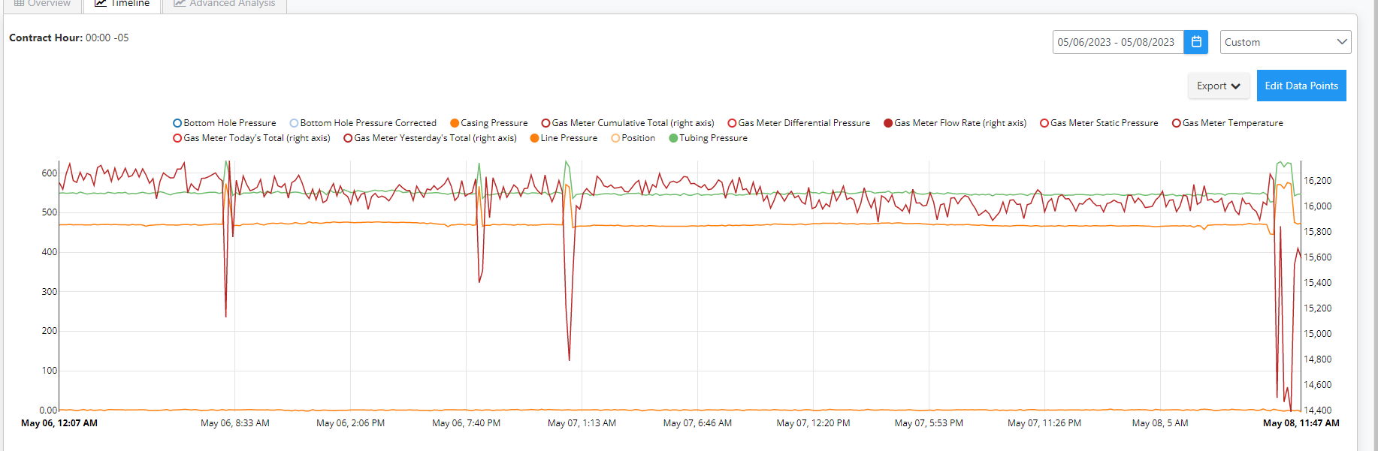  
  
Context:  
Companies are combing several wells in the flowing pipeline. In other words, gas which is flowing out from well-1, well-2 is combined at some point.  
Reservoir 1 -> Tubing pipeline 1 -> Casing pipeline1 -> Choke 1 -> Line pipeline 1 -> Combine point  
Reservoir 2 -> Tubing pipeline 2 -> Casing pipeline2 -> Choke 2 -> Line pipeline 2 -> Combine point

At this combination point, there is pressure value which is called junction pressure.

When the well is working alone, individually, the gas flow rate will increase as we open more choke (when the choke value is increasing).   
As two wells pipelines are combined at some point, the gas flow rates of both wells are affecting each other.  
In other words, the independent gas flow rate of well 1(when it is individual well) is different from combined gas flow rate of well 1 (when two wells are combined) at same choke position. This is happening because those two wells are combined, for example, the junction pressure might be higher than the line pressure1, then the gas will flow back to the well or whatever the reason.

Target:  
Using the historical data, we should figure out what would the combined flow rate (sum of flow rates of both wells) be based on choke positions.  
For example, we should be able to get Gas Flow Rates of both wells on choke positions.  
(Sample output file is attached)  
  
Input:  
Attached two csv files which include historical meter values of both wells. But use data when both wells’ line pressures are in 530 - 630 (both wells) psi.

Criteria:

Engineering Principles for wells sharing lines:

* Trends on gas rates, tubing pressure, choke, and line pressures:
* When the choke position of the well in increased : the tubing pressure of the well decreases and the gas rate of the well will increase as per the TPR/IPR. This increase in gas rate causes the line pressure of the well to increase. It should be noted that when tubing pressure decreases and line pressure increases on varying chokes, it is possible that at a given position the tubing pressure and line pressure are very close to each other. This can be termed as the maximum potential of the well that can be achieved by opening chokes. Any further increase in choke position will cause negligible decrease in tubing pressure / increase in gas rates. If the tubing pressures are still found to be high, it is recommended to use compressors on such wells to reduce the line pressures to get higher gas rates.
* It is also possible that tubing pressure of the well decreases without any intervention or changes on the surface conditions, this is because of the natural decline in the well potential and in such case the gas rates, tubing pressures and line pressures on the well are expected to decrease.
* When the choke position is decreased: The vice versa of the above condition is expected to happen here. Tubing pressure increase----> gas rates decrease ----> line pressures decrease.
* Factors that impact line pressure of the well which can be caused by
* Changes in gas rate on the same well: If the gas rate on the well increases the line pressure will increase and vice versa.
* Changes in gas rate on the sharing well: if the gas rate on sharing well increases the line pressure will increase and vice versa.
* Issues in compressor: If more compressors are operating, the line pressures will be lower. Any issue causing downtime in compressors can increase the line pressures on the wells.
* changes in combination of wells sharing lines.
* Changes in gas rates even when chokes are not changed on the well:
* Increase in line pressures: The tubing pressure of the well will also increase causing the gas rate to decrease. In this case, if the choke allows, it can be opened to decrease the tubing pressures and the gas rates on the well can be increased.
* Decrease in line pressure: The tubing pressure will decrease automatically causing the gas rates to increase. In this case, if it is desired to restrict the gas rate of the well, the choke position can be reduced to bring the gas rate down to original conditions.
* It should be noted that it is possible that more than one events are taking place at the same time or in close time interval on the well, in such case the cumulative impact of each change should be taken into consideration to study the well behavior.