**Q1) Create an XML file to store records of four persons with their name, age and addresses**

**Default.aspx.cs:**

Using System;

Using System.Collections.Generic;

Using System.Linq;

Using System.Web;

Using System.Web.UI;

Using System.Web.UI.WebControls;

Using System.Xml.Linq;

Public partial class _Default : System.Web.UI.Page

{

Protected void Page_Load(object sender, EventArgs e)

{

XDocument xmlDoc = XDocument.Load(HttpContext.Current.Server.MapPath(“XMLFile.xml”));

Var persons = from p in xmlDoc.Root.Elements(“Person”)

Where (Convert.ToInt16(p.Element(“Age”).Value) < 60)

Select new

{ Name = p.Element(“Name”).Value,

Address = p.Element(“Address”).Value,

Age = p.Element(“Age”).Value

};

GridView1.DataSource = persons;

GridView1.DataBind();

}

}

**Default foraspx:**

<%@ Page Language=”C#” AutoEventWireup=”true” CodeFile=”Default.aspx.cs” Inherits=”_Default” %>

<!DOCTYPE html>

<html xmlns=<http://www.w3.org/1999/xhtml>>

<head runat=”server”>

<title></title>

</head>

<body>

<form id=”form1” runat=”server”>

<div>

<asp:GridView ID=”GridView1” runat=”server” OnSelectedIndexChanged=”Page_Load”>

</asp:GridView>

<asp:Label ID=”Label2” runat=”server” Text=”Kavita Ankita”></asp:Label>

</div>

</form>

</body>

</html>

**XMLFile.xml:**

<?xml version=”1.0” encoding=”utf-8” ?>

<Persons>

<Person>

<Name>VAISHNAVI</Name>

<Address>Khar</Address>

<Age>19</Age>

</Person>

<Person>

<Name>KAVITA</Name>

<Address>Virar</Address>

<Age>27</Age>

</Person>

<Person>

<Name>ANKITA</Name>

<Address>Andheri</Address>

<Age>32</Age>

</Person>

<Person>

<Name>TANAYA</Name>

<Address>Bandra</Address>

<Age>45</Age>

</Person>

</Persons>

**Output**:

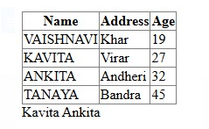

**Q2) Create asynchronous timer using AJAX**

**WebForm1.aspx:**

<%@ Page Language="C#" AutoEventWireup="true" CodeBehind="WebForm1.aspx.cs" Inherits="WebApplication15.WebForm1" %>

<form id="form1" runat="server">

<asp:Label ID="Label1" runat="server" Text="Current Time: "></asp:Label>

<asp:Label ID="Label4" runat="server" Text=" "></asp:Label>

&nbsp;<asp:ScriptManager ID="ScriptManager1" runat="server">

</asp:ScriptManager>

<asp:Timer ID="Timer1" runat="server" OnTick="Timer1_Tick">

</asp:Timer><br />

<asp:Button ID="Button1" runat="server" Text="Stop" OnClick="Button1_Click" /><br />

<asp:Label ID="Label3" runat="server" Text="Welcome to AJAX"></asp:Label>

<asp:UpdatePanel ID="UpdatePanel1" runat="server">

</asp:UpdatePanel>

<asp:UpdateProgress ID="UpdateProgress1" runat="server">

</asp:UpdateProgress>

</form>

**WebForm1.aspx.cs:**

using System;

using System.Collections.Generic;

using System.Linq;

using System.Web;

using System.Web.UI;

using System.Web.UI.WebControls;

namespace WebApplication15

{ public partial class WebForm1 : System.Web.UI.Page

{

protected void Page_Load(object sender, EventArgs e)

{ }

protected void Timer1_Tick(object sender, EventArgs e)

{ Label4.Text = DateTime.Now.ToString();

}

protected void Button1_Click(object sender, EventArgs e)

{ System.Threading.Thread.Sleep(1500);

}

}

}

**Output:**

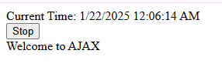

**Q1. Create an application to demonstrate following operations**

1. **Generate Fibonacci series.**
2. **Test for prime numbers. iii. Test for vowels.**
3. **Use of foreach loop with arrays**
4. **Reverse a number and find sum of digits of a number.**

**Default.aspx**

|  |  |  |
| --- | --- | --- |
| <% | @ Page Title="Home Page" Language="C#" MasterPageFile="~/Site.Master" AutoEventWireup="true" | |
| CodeFile="Default.aspx.cs" Inherits="_Default" | | %> |

<asp:Content ID="BodyContent" ContentPlaceHolderID="MainContent" runat="server">

<div>

&nbsp;<br />

<asp:Label ID="Label1" runat="server" Text="Select the Operation : "></asp:Label> &nbsp;

<asp:DropDownList ID="DropDownList1" runat="server">

<asp:ListItem>fibonacci</asp:ListItem>

<asp:ListItem>prime</asp:ListItem>

<asp:ListItem>vowels</asp:ListItem>

<asp:ListItem>rev &amp; sum</asp:ListItem>

<asp:ListItem Value="foreach"></asp:ListItem>

</asp:DropDownList>&nbsp;

<br />

<asp:Label ID="Label2" runat="server" Text="Enter the No, String or Character : "></asp:Label>&nbsp;&nbsp;

<asp:TextBox ID="TextBox1" runat="server"></asp:TextBox>

<br />&nbsp

<asp:Button ID="Button1" runat="server" OnClick="Button1_Click" Text="Submit" />

<br />

<asp:Label ID="Label3" runat="server"></asp:Label>&nbsp;:

<asp:Label ID="Label4" runat="server"></asp:Label>

<br />

<asp:Label ID="Label5" runat="server"></asp:Label>

<br />

</div>

</asp:Content>

**Class: SYIT(NEP ) Sem: IV Roll No.: SYIT35 Date : 23/11/2024 Course Name: Advance Web Programming Page no:**

**Practical Number: 02**

# Default.aspx.cs

using System;

using System.Collections.Generic; using System.Linq; using System.Web; using System.Web.UI; using System.Web.UI.WebControls;

public partial class _Default : Page

{

protected void Page_Load(object sender, EventArgs e)

{

}

protected void Button1_Click(object sender, EventArgs e)

{

if (DropDownList1.SelectedItem.Text.Equals("fibonacci"))

{

int n = Convert.ToInt32(TextBox1.Text.ToString()); int fno = 0; int sno = 1; int sum = 0; int i = 2;

Label3.Text = "The fibonacci series is : "; Label4.Text = fno.ToString() + ", " + sno.ToString();

while (i < n)

{

sum = fno + sno;

fno = sno; sno =

sum; i++;

Label4.Text = Label4.Text + ", " + sum.ToString();

}

}

else if (DropDownList1.SelectedItem.Text.Equals("prime"))

{

int i;

int num = Convert.ToInt32(TextBox1.Text.ToString());

Label3.Text = "Result = ";

for (i = 2; i < num - i; i++)

{

**Class: SYIT(NEP ) Sem: IV Roll No.: SYIT35 Date : 23/11/2024 Course Name: Advance Web Programming Page no:**

**Practical Number: 02**

break;

if (num % i == 0)

}

if (num == 1)

{

Label4.Text = "1 is neither prime nor composite";

}

else if (i <= (num / 2))

{

else

}

Label4.Text = num + " is not a prime number";

}

{

Label4.Text = num + " is a prime number";

}

else if(DropDownList1.SelectedItem.Text.Equals("vowels"))

{

|  |  |  |  |  |  |  |  |
| --- | --- | --- | --- | --- | --- | --- | --- |
| Label3.Text = "Result = | | | | "; | char s = | |  |
| Convert.ToChar(TextBox1.Text); | | | |  | switch(s) | | { |
| case | 'a': | case | 'A': | case | | 'e': | |
| case | 'E': | case | 'i': | case | | 'I': | |
| case | 'o': | case | 'O': | case | | 'u': | |

case 'U': Label4.Text = s + " is vowel"; break; default: Label4.Text = s + " is consonant"; break;

}

}

else if (DropDownList1.SelectedItem.Text.Equals("rev & sum"))

{

Label3.Text = "Result ";

int n, rev = 0, d,sum=0; int num =

int.Parse(TextBox1.Text); n = num; while (n > 0)

{

d = n % 10;

n = n / 10; sum =

sum + d; rev = rev

* 10 + d; }

Label4.Text = "Reverse of "+num + " is : " + rev.ToString();

**Class: SYIT(NEP ) Sem: IV Roll No.: SYIT35 Date : 23/11/2024 Course Name: Advance Web Programming Page no:**

**Practical Number: 02**

Label5.Text = "Sum of " + num + " is : " + sum.ToString();

}

else if (DropDownList1.SelectedItem.Text.Equals("foreach"))

{

Label3.Text = "Result ";

int[] a = new int[] { 99, 98, 92, 97, 95 }; foreach(int i in a)

{

Label4.Text = Label4.Text + ", " + i;

}

}

}

}

# Output:

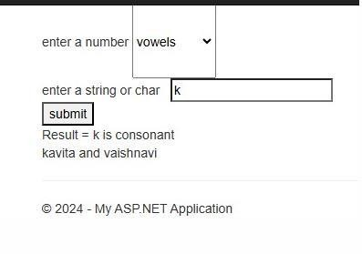

**ANKITA PANDEY**

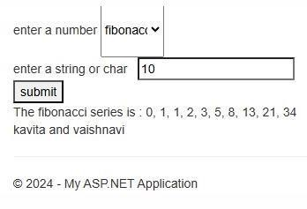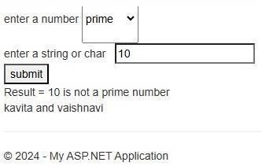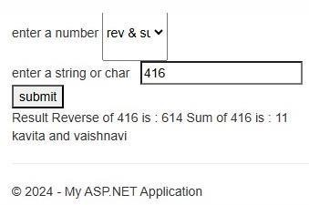

**ANKITA PANDEY**

**-**

**ANKITA PANDEY**

**ANKITA PANDEY**

**Class: SYIT(NEP ) Sem: IV Roll No.: SYIT35 Date : 23/11/2024 Course Name: Advance Web Programming Page no:**

**Practical Number: 02**

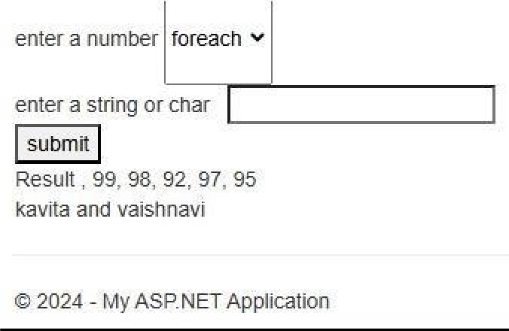

**ANKITA PANDEY**

**Q2. Create simple application to perform following operations**

1. **Money Conversion**

**Default.aspx**

|  |  |  |
| --- | --- | --- |
| <% | @ Page Title="Home Page" Language="C#" MasterPageFile="~/Site.Master" | |
| AutoEventWireup="true" CodeFile="Default.aspx.cs" Inherits="_Default" | | %> |

<asp:Content ID="BodyContent" ContentPlaceHolderID="MainContent" runat="server">

<div class="jumbotron"; &nbsp;

<asp:Label ID="Label1" runat="server" Text="Amount : "></asp:Label>

<asp:TextBox ID="TextBox1" runat="server"></asp:TextBox>

<br /> &nbsp;

<asp:Button ID="Button1" runat="server" OnClick="Button1_Click" Text="Convert" /> <br />

<asp:Label ID="Label2" runat="server"></asp:Label>&nbsp; <br />

<asp:Label ID="Label3" runat="server"></asp:Label><br />

<asp:Label ID="Label4" runat="server"></asp:Label><br />

<asp:Label ID="Label5" runat="server"></asp:Label>

</div>

</asp:Content>

# Default.aspx.cs

using System;

using System.Collections.Generic;

**Class: SYIT(NEP ) Sem: IV Roll No.: SYIT35 Date : 23/11/2024 Course Name: Advance Web Programming Page no:**

**Practical Number: 02**

using System.Linq; using System.Web; using System.Web.UI;

using System.Web.UI.WebControls;

public partial class _Default : Page

{

protected void Page_Load(object sender, EventArgs e)

{

}

protected void Button1_Click(object sender, EventArgs e)

{

double a = Double.Parse(TextBox1.Text); Conv obj = new Conv(a);

obj.rtd();

Label2.Text = "Rupees to Dollar : "+Convert.ToString(obj.d); obj.dtr();

Label3.Text ="Dollar to Rupees : " +Convert.ToString(obj.r); obj.rte();

Label4.Text ="Rupees to Euro : " +Convert.ToString(obj.e); obj.etr();

Label5.Text ="Euro to Rupees : " +Convert.ToString(obj.r);

}

}

# Conv.cs

using System;

using System.Collections.Generic; using System.Linq; using System.Web; public class Conv

{

public double r, e, a,d; public Conv(double amount)

{

a = amount;

}

public void rtd()

{

**Class: SYIT(NEP ) Sem: IV Roll No.: SYIT35 Date : 23/11/2024 Course Name: Advance Web Programming Page no:**

**Practical Number: 02**

d = a / 68.96;

}

public void dtr()

{

r = a * 68.96;

}

public void rte()

{

e = a / 77.35;

}

public void etr()

{

r = a * 77.35;

}

}

Output:-

8

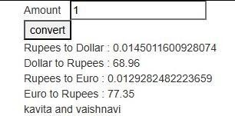

**ANKITA PANDEY**

# Quadratic equation Default.aspx

|  |  |  |
| --- | --- | --- |
| <% | @ Page Title="Home Page" Language="C#" MasterPageFile="~/Site.Master" | |
| AutoEventWireup="true" CodeFile="Default.aspx.cs" Inherits="_Default" | | %> |

<asp:Content ID="BodyContent" ContentPlaceHolderID="MainContent" runat="server">

<div class="jumbotron"> &nbsp;

<asp:Label ID="Label1" runat="server" Text="Enter the value of a : "></asp:Label>

**Class: SYIT(NEP ) Sem: IV Roll No.: SYIT35 Date : 23/11/2024 Course Name: Advance Web Programming Page no:**

**Practical Number: 02**

<asp:TextBox ID="TextBox1" runat="server"></asp:TextBox>

<br />&nbsp;

<asp:Label ID="Label2" runat="server" Text="Enter the value of b : "></asp:Label>

<asp:TextBox ID="TextBox2" runat="server"></asp:TextBox>

<br />&nbsp;

<asp:Label ID="Label3" runat="server" Text="Enter the value of c : "></asp:Label>

<asp:TextBox ID="TextBox3" runat="server"></asp:TextBox><br /> &nbsp;

<asp:Button ID="Button1" runat="server" OnClick="Button1_Click" Text="calculate "

/><br /> &nbsp;&nbsp;

<asp:Label ID="Label4" runat="server"></asp:Label>br />

</div>

</asp:Content>

# Default.aspx.cs

using System;

using System.Collections.Generic; using System.Linq; using System.Web; using System.Web.UI; using System.Web.UI.WebControls;

public partial class _Default : Page

{

protected void Page_Load(object sender, EventArgs e)

{

}

protected void Button1_Click(object sender, EventArgs e)

{

int a, b, c;

a = Int32.Parse(TextBox1.Text);

b = Int32.Parse(TextBox2.Text); c = Int32.Parse(TextBox3.Text); quadeqtn qe = new quadeqtn(a, b, c);

Label4.Text = qe.msg;

**Class: SYIT(NEP ) Sem: IV Roll No.: SYIT35 Date : 23/11/2024 Course Name: Advance Web Programming Page no:**

**Practical Number: 02**

}

}

# Quadeqtn.cs

using System; using System.Collections.Generic; using System.Linq; using System.Web;

public class quadeqtn

{

public double x1, x2; public string msg;

public quadeqtn(int a, int b, int c)

{

Double d;

d = b * b - (4 * a * c); if (d == 0)

{

x1 = b / (2.0 * a); x2 = x1; msg = "Both the roots are equal<br>1st Root : " + x1 + "<br>2nd Root :

" + x2 + "<br>";

}

else if (d > 0)

{

x1 = (-b + Math.Sqrt(d)) / (2 * a);

x2 = (-b - Math.Sqrt(d)) / (2 * a);

msg = "Both the roots are different<br>1st Root : " + x1 + "<br>2nd Root : " + x2 + "<br>";

}

else {

msg = "Roots are imaginary , No solution";

}

}

}

Output:-

**Class: SYIT(NEP ) Sem: IV Roll No.: SYIT35 Date : 23/11/2024 Course Name: Advance Web Programming Page no:**

**Practical Number: 02**

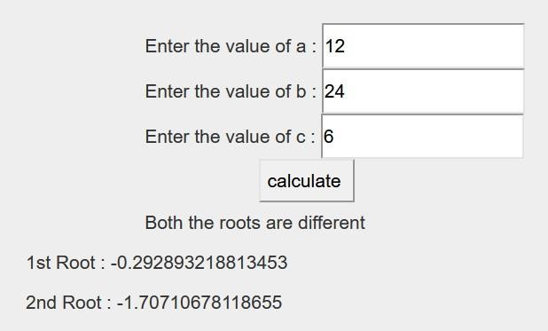

# Temperature Conversion Default.aspx

|  |  |  |
| --- | --- | --- |
| <% | @ Page Title="Home Page" Language="C#" MasterPageFile="~/Site.Master" | |
| AutoEventWireup="true" CodeFile="Default.aspx.cs" Inherits="_Default" | | %> |

<asp:Content ID="BodyContent" ContentPlaceHolderID="MainContent" runat="server">

<div class="jumbotron">&nbsp

<asp:Label ID="Label1" runat="server" Text="Celcius : "></asp:Label>

<asp:TextBox ID="TextBox1" runat="server"></asp:TextBox>

<br />&nbsp;

<asp:Button ID="Button1" runat="server" OnClick="Button1_Click1" Text="Celcius to Farenheit" Width="297px" />

<br />&nbsp;

<asp:Label ID="Label2" runat="server"></asp:Label>

<br />&nbsp;

<asp:Label ID="Label3" runat="server" Text="Farenheit : "></asp:Label> &nbsp;<asp:TextBox ID="TextBox2" runat="server"></asp:TextBox>

<br />&nbsp;

<asp:Button ID="Button2" runat="server" OnClick="Button2_Click1" Text="Farenheit to Celcius : " />

<br />&nbsp;

<asp:Label ID="Label4" runat="server"></asp:Label>

</div>

</asp:Content>

**Class: SYIT(NEP ) Sem: IV Roll No.: SYIT35 Date : 23/11/2024 Course Name: Advance Web Programming Page no:**

**Practical Number: 02**

# Default.aspx.cs

using System;

using System.Collections.Generic; using System.Linq; using System.Web; using System.Web.UI; using System.Web.UI.WebControls;

public partial class _Default : Page

{

protected void Page_Load(object sender, EventArgs e)

{}

protected void Button1_Click1(object sender, EventArgs e)

{

double c = Double.Parse(TextBox1.Text); Conv obj = new Conv(c);

obj.ctf();

Label2.Text = "Celsius to Farenheit : " + obj.f.ToString();

}

protected void Button2_Click1(object sender, EventArgs e)

{

double c = Double.Parse(TextBox2.Text); Conv obj = new Conv(c);

obj.ftc();

Label4.Text = "Farenheit to Celcius : " + obj.c.ToString();

}

}

**Conv.cs**

using System;

using System.Collections.Generic; using System.Linq; using System.Web; public class Conv

{

public double temp, f, c; public Conv(double t)

{

temp = t;

**Class: SYIT(NEP ) Sem: IV Roll No.: SYIT35 Date : 23/11/2024 Course Name: Advance Web Programming Page no:**

**Practical Number: 02**

}

public void ctf()

{

f = ((temp *9/5)) + 32;

}

public void ftc()

{

c = ((temp - 32)*5) / 9;

}

}

**Output:-**

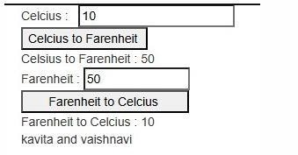

**ANKITA PANDEY**

# Function Overloading Default.aspx

|  |  |  |
| --- | --- | --- |
| <% | @ Page Title="Home Page" Language="C#" MasterPageFile="~/Site.Master" | |
| AutoEventWireup="true" CodeFile="Default.aspx.cs" Inherits="_Default" | | %> |

<asp:Content ID="BodyContent" ContentPlaceHolderID="MainContent" runat="server">

<div class="jumbotron">

<asp:Label ID="Label1" runat="server" Text="Function 1 : "></asp:Label>nbsp;

<asp:Label ID="Label5" runat="server"></asp:Label><br />

<asp:Label ID="Label2" runat="server" Text="Function 2 :"></asp:Label> &nbsp;

<asp:Label ID="Label6" runat="server"></asp:Label><br />

<asp:Label ID="Label3" runat="server" Text="Function 3 :"></asp:Label> &nbsp;

<asp:Label ID="Label7" runat="server"></asp:Label><br />

**Class: SYIT(NEP ) Sem: IV Roll No.: SYIT35 Date : 23/11/2024 Course Name: Advance Web Programming Page no:**

**Practical Number: 02**

<asp:Label ID="Label4" runat="server" Text="Function 4 :"></asp:Label> &nbsp;

<asp:Label ID="Label8" runat="server"></asp:Label><br />

<asp:Button ID="Button1" runat="server" OnClick="Button1_Click" Text="Overload" />

</div>

</asp:Content>

# Default.aspx.cs

using System;

using System.Collections.Generic; using System.Linq;

using System.Web; using System.Web.UI;

using System.Web.UI.WebControls;

public partial class _Default : Page

{

protected void Page_Load(object sender, EventArgs e)

{

}

protected void Button1_Click(object sender, EventArgs e)

{

funcol fo = new funcol(); fo.sum(10, 20); fo.sum(10, 20, 30);

fo.sum(14.2f, 1.8f); fo.sum(12.0f, 23.1f, 23.43f); Label5.Text = Convert.ToString(fo.x);

Label6.Text = Convert.ToString(fo.y); Label7.Text = Convert.ToString(fo.u); Label8.Text = Convert.ToString(fo.v);

}

}

# Funcol.cs

using System;

**Class: SYIT(NEP ) Sem: IV Roll No.: SYIT35 Date : 23/11/2024 Course Name: Advance Web Programming Page no:**

**Practical Number: 02**

using System.Collections.Generic; using System.Linq; using System.Web;

public class funcol

{

public int x, y; public float u, v; public funcol()

{ x = y =

0; u = v =

0.0f;

}

public void sum(int a,int b)

{ x =

a + b; }

public void sum(int a, int b, int c)

{

y = a + b +c;

}

public void sum(float a, float b)

{ u =

a + b; }

public void sum(float a, float b, float c)

{

v = a + b +c;

}

}

Output:-

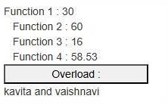

**ANKITA PANDEY**

1. **Demonstrate the use of GridView control in asp.net.**

**Default.aspx**

<%@ Page Title="Home Page" Language="C#" MasterPageFile="~/Site.Master" AutoEventWireup="true" CodeBehind="Default.aspx.cs" Inherits="WebApplication41._Default" %>

<asp:Content ID="BodyContent" ContentPlaceHolderID="MainContent" runat="server">

<asp:GridView ID="GridView1" runat="server" AutoGenerateColumns="False" DataKeyNames="ProductID" DataSourceID="SqlDataSource2" AllowPaging="True">

<Columns>

<asp:BoundField DataField="ProductID" HeaderText="ProductID" InsertVisible="False" ReadOnly="True" SortExpression="ProductID" />

<asp:BoundField DataField="ProductName" HeaderText="ProductName" SortExpression="ProductName" />

<asp:BoundField DataField="SupplierID" HeaderText="SupplierID" SortExpression="SupplierID" />

<asp:BoundField DataField="CategoryID" HeaderText="CategoryID" SortExpression="CategoryID" />

<asp:BoundField DataField="QuantityPerUnit" HeaderText="QuantityPerUnit" SortExpression="QuantityPerUnit" />

<asp:BoundField DataField="UnitPrice" HeaderText="UnitPrice" SortExpression="UnitPrice" />

<asp:BoundField DataField="UnitsInStock" HeaderText="UnitsInStock" SortExpression="UnitsInStock" />

<asp:BoundField DataField="UnitsOnOrder" HeaderText="UnitsOnOrder" SortExpression="UnitsOnOrder" />

<asp:BoundField DataField="ReorderLevel" HeaderText="ReorderLevel" SortExpression="ReorderLevel" />

<asp:CheckBoxField DataField="Discontinued" HeaderText="Discontinued" SortExpression="Discontinued" />

</Columns>

</asp:GridView>

<asp:SqlDataSource ID="SqlDataSource2" runat="server" ConnectionString="<%$ ConnectionStrings:NorthwindConnectionString3 %>" ProviderName="<%$ ConnectionStrings:NorthwindConnectionString3.ProviderName %>" SelectCommand="SELECT [ProductID], [ProductName], [SupplierID], [CategoryID], [QuantityPerUnit], [UnitPrice], [UnitsInStock], [UnitsOnOrder], [ReorderLevel], [Discontinued] FROM [Products]"></asp:SqlDataSource>

<asp:SqlDataSource ID="SqlDataSource1" runat="server" ConnectionString="<%$ ConnectionStrings:NorthwindConnectionString2 %>" ProviderName="<%$ ConnectionStrings:NorthwindConnectionString2.ProviderName %>" SelectCommand="SELECT [ProductID], [ProductName], [SupplierID], [CategoryID] FROM [Products]"></asp:SqlDataSource>

</asp:Content>

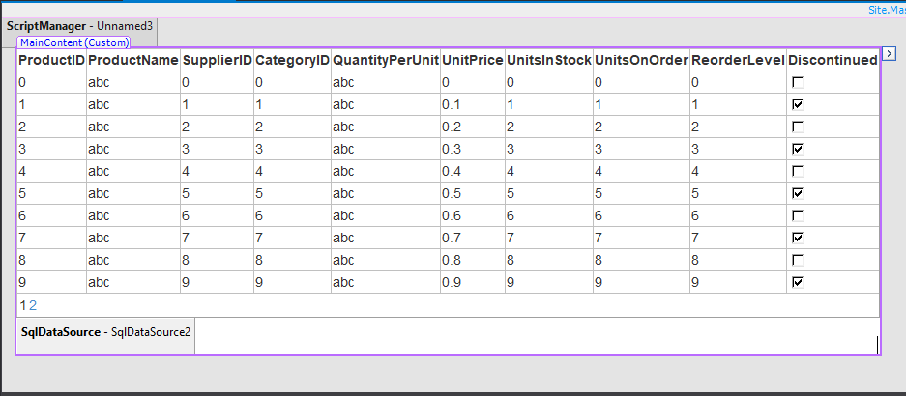

**OUTPUT :**

**Q1) Demonstrate the use of User Control (Textbox, Label and Button).**

**CODE:  
Default.aspx:**

<%@ Page Title="Home Page" Language="C#" MasterPageFile="~/Site.Master" AutoEventWireup="true" CodeBehind="Default.aspx.cs" Inherits="WebApplication13._Default" %>

<%@ Register src="WebUserControl1.ascx" tagname="WebUserControl1" tagprefix="uc1" %>

<asp:Content ID="BodyContent" ContentPlaceHolderID="MainContent" runat="server">

<uc1:WebUserControl1 ID="WebUserControl11" runat="server" />

</asp:Content>

**Webusercontrol1.ascx:**

<%@ Control Language="C#" AutoEventWireup="true" CodeBehind="WebUserControl1.ascx.cs" Inherits="WebApplication13.WebUserControl1" %>

<asp:Label ID="Label1" runat="server" Text="Name :"></asp:Label>

<asp:TextBox ID="TextBox1" runat="server"></asp:TextBox><br /><br />

<asp:Label ID="Label2" runat="server" Text="City :"></asp:Label>

<asp:TextBox ID="TextBox2" runat="server"></asp:TextBox><br /><br />

<asp:Button ID="Button1" runat="server" Text="Submit" OnClick="Button1_Click" /><br />

<asp:Label ID="Label3" runat="server" Text=""></asp:Label><br />

**Webusercontrol1.ascx.cs:**

using System;

using System.Collections.Generic;

using System.Linq;

using System.Web;

using System.Web.UI;

using System.Web.UI.WebControls;

namespace WebApplication13

{

public partial class WebUserControl1 : System.Web.UI.UserControl

{

protected void Page_Load(object sender, EventArgs e)

{

}

protected void Button1_Click(object sender, EventArgs e)

{

Label3.Text = "Your name is : " + TextBox1.Text + " You are from : " + TextBox2.Text;

}

}

}

**OUTPUT:**

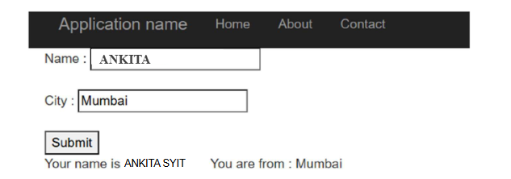

**Q.2) Create an application where input taken (copyright) from user display in footer.**

**CODE:  
Default.aspx:**

<%@ Page Title="Home Page" Language="C#" MasterPageFile="~/Site.Master" AutoEventWireup="true" CodeBehind="Default.aspx.cs" Inherits="WebApplication14._Default" %>

<%@ Register src="WebUserControl1.ascx" tagname="WebUserControl1" tagprefix="uc1" %>

<asp:Content ID="BodyContent" ContentPlaceHolderID="MainContent" runat="server">

<uc1:WebUserControl1 ID="WebUserControl11" runat="server" />

</asp:Content>

**Webusercontrol1.ascx:**

<%@ Control Language="C#" AutoEventWireup="true" CodeBehind="WebUserControl1.ascx.cs" Inherits="WebApplication14.WebUserControl1" %>

<asp:TextBox ID="TextBox1" runat="server"></asp:TextBox><br /><br />

<asp:Button ID="Button1" runat="server" Text="Submit" OnClick="Button1_Click" /><br /><br />

<asp:Label ID="Label1" runat="server" Text="Label"></asp:Label>

**Webusercontrol1.ascx.cs:**

using System;

using System.Collections.Generic;

using System.Linq;

using System.Web;

using System.Web.UI;

using System.Web.UI.WebControls;

namespace WebApplication14

{

public partial class WebUserControl1 : System.Web.UI.UserControl

{

protected void Page_Load(object sender, EventArgs e)

{

}

protected void Button1_Click(object sender, EventArgs e)

}

}

**OUTPUT:**

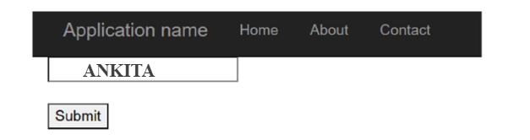

**Working with Web Forms and Controls**

**a. Create a simple web page with various sever controls to demonstrate setting and use of their properties. (Example :AutoPostBack)**

**Default.aspx**

<%@ Page Title="Home Page" Language="C#" MasterPageFile="~/Site.Master" AutoEventWireup="true" CodeFile="Default.aspx.cs" Inherits="_Default" %>

<asp:Content ID="BodyContent" ContentPlaceHolderID="MainContent" runat="server">

<div class="jumbotron"> Name :

<asp:TextBox ID="TextBox1" runat="server"></asp:TextBox>

<br />

Rno :&nbsp;&nbsp;

<asp:TextBox ID="TextBox2" runat="server"></asp:TextBox>

<br />

Class : <asp:RadioButton ID="RadioButton1" runat="server" Text="FY" />

<asp:RadioButton ID="RadioButton2" runat="server" Text="SY" />

<asp:RadioButton ID="RadioButton3" runat="server" Text="TY" />

<br /> Course :

<asp:DropDownList ID="DropDownList1" runat="server" OnSelectedIndexChanged="DropDownList1_SelectedIndexChanged">

<asp:ListItem>BSC(IT)</asp:ListItem>

<asp:ListItem>BSC(CS)</asp:ListItem>

<asp:ListItem>BMS</asp:ListItem>

</asp:DropDownList>

<br />

<asp:Button ID="Button1" runat="server" OnClick="Button1_Click" Text="Submit" />

<br />

<asp:Label ID="Label1" runat="server"></asp:Label>

</div>

</asp:Content>

**Default.aspx.cs**

using System;

using System.Collections.Generic; using System.Linq;

using System.Web; using System.Web.UI;

**Class: SYIT(NEP)**

**Sem: IV Roll No.: SYIT61 Date : 27/11/2024**

**Course Name: Advance Web Programming Page no:**

**Practical Number: 05**

using System.Web.UI.WebControls;

public partial class _Default : Page

{

protected void Page_Load(object sender, EventArgs e)

{}

protected void DropDownList1_SelectedIndexChanged(object sender, EventArgs e)

{

Label1.Text = "You have ben enrolled " + DropDownList1.SelectedItem;

}

protected void Button1_Click(object sender, EventArgs e)

{

string s; if(RadioButton1.Checked==true)

{

s = RadioButton1.Text;

}

else if (RadioButton2.Checked == true)

{

s = RadioButton2.Text;

}

else

{

s = RadioButton3.Text;

}

Label1.Text = "You have been enrolled in " + s + "" + DropDownList1.SelectedItem;

}

}

Output:-

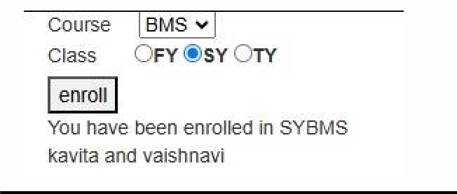

Q1) Demonstrate the use of Master page with Webform.

Steps:

1. Open a Visual Studio 2015 in that create a new project with Empty Web form
2. Go to solution Explorer in that right click on your project(prc10) -> Add->New items->Web forms Master Page (site1.master).
3. Go to Design view of Site master in that insert a table with 3 rows and 2 column in the above tab

“Tabel”.

1. Write a content in column of table and add some images in the columns. Adding images in site: 1. Right click on project -> add->existing items.
   1. In existing items -> select folder where images are save->select a images.
   2. Click on Add.
   3. Drag and Drop images in the master page (Drag-drop).
2. To change the background color of your particular row & column go to property -> style -> …-> go to background option in that select a background color which you want to display in your row and columns
3. To add Multiple Web forms of Particular site. Go to your project right click on -> add-> New item->in that click on Web forms with Master Page. Similarly, add multiple web forms pages (it returns .aspx).
4. For add sqlDataSource go to Toolbox in that select Grid view in site master or particular website. Choose data source in that -> <New data source> ->sqlDatasource->Next->choose connection in that

->New Connection-> “Microsoft Access Database file”->Next->Select Data File Name :-> Browse-> Select file from folder -> Test Connection -> Next -> Select * from data which means return all the data -> next-> Test Query->Finish.

1. Insert Menu to add in site master page to connect multiple webform. Go go toolbook-> menu->edit item menu->add->NevigateUrl->select a web form -> text= “Priya” and click on ok.

Site Master:

<%@ Master Language="C#" AutoEventWireup="true" CodeBehind="Site1.master.cs" Inherits="Practical_AWP_10.Site1" %>

<!DOCTYPE html>

<html xmlns="<http://www.w3.org/1999/xhtml>">

<head runat="server">

<title></title>

<asp:ContentPlaceHolder ID="head" runat="server">

</asp:ContentPlaceHolder>

<style type="text/css">

.auto-style1 { width: 100%;

}

.auto-style2 { width: 194px; height: 184px;

}

</style>

</head>

<body>

**Class: SYIT**

**Sem: IV Roll No.: SYIT35 Date: 7/1/25**

**Course Name: Advance Web programming Page no:**

**Practical Number: 10**

<form id="form1" runat="server">

<div>

<asp:ContentPlaceHolder ID="ContentPlaceHolder1" runat="server">

<table class="auto-style1">

<tr>

<td style="background-color: #0000FF">&nbsp;</td>

<td style="background-color: #FF00FF">Bhavan&#39;s College (Andheri) SYIT06</td>

</tr>

<tr>

<td style="background-color: #0000FF">&nbsp;</td>

<td style="background-color: #FF0066">

<img alt="" class="auto-style2" longdesc="Image from the internet which descibe symbol of Lord krishna" src="download.jpg" /></td>

</tr>

<tr>

<td style="background-color: #0000FF">&nbsp;</td>

<td style="background-color: #FF00FF">@copyright by Priyachoudhary<asp:GridView ID="GridView1" runat="server" AutoGenerateColumns="False" DataKeyNames="CategoryID" DataSourceID="SqlDataSource1">

<Columns>

<asp:BoundField DataField="CategoryID" HeaderText="CategoryID" InsertVisible="False" ReadOnly="True" SortExpression="CategoryID" />

<asp:BoundField DataField="CategoryName" HeaderText="CategoryName" SortExpression="CategoryName" />

<asp:BoundField DataField="Description" HeaderText="Description" SortExpression="Description" />

</Columns>

</asp:GridView>

<asp:SqlDataSource ID="SqlDataSource1" runat="server" ConnectionString="<%$ ConnectionStrings:NorthwindConnectionString %>" ProviderName="<%$ ConnectionStrings:NorthwindConnectionString.ProviderName %>" SelectCommand="SELECT * FROM [Categories]"></asp:SqlDataSource>

<asp:Menu ID="Menu1" runat="server">

<Items>

<asp:MenuItem NavigateUrl="~/WebForm2.aspx" Text="2nd page" Value="2nd page"></asp:MenuItem>

<asp:MenuItem NavigateUrl="~/WebForm3.aspx" Text="3rd page" Value="3rd page"></asp:MenuItem>

</Items>

</asp:Menu>

</td>

</tr>

</table>

</asp:ContentPlaceHolder>

</div>

</form>

**Class: SYIT**

**Sem: IV Roll No.: SYIT35 Date: 7/1/25**

**Course Name: Advance Web programming Page no:**

**Practical Number: 10**

</body>

</html>

Webfrom1.as

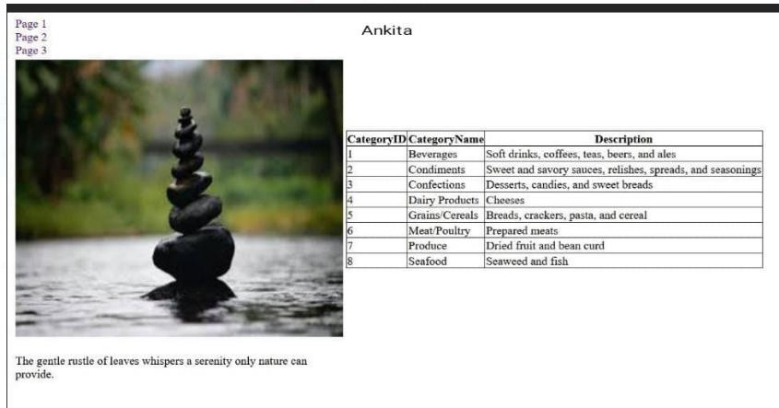

Webform2.aspx

**Class: SYIT**

**Sem: IV Roll No.: SYIT35 Date: 7/1/25**

**Course Name: Advance Web programming Page no:**

**Practical Number: 10**

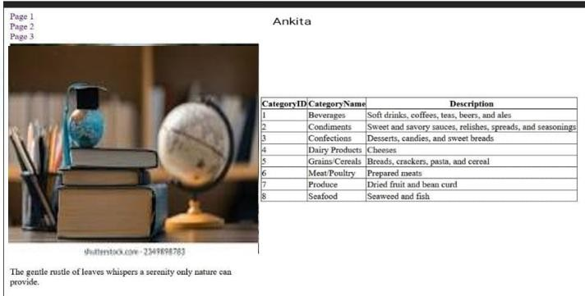

Webform3.aspx



**1.Factorial of a Number**

# Default.aspx

<%@ Page Title="Home Page" Language="C#" MasterPageFile="~/Site.Master" AutoEventWireup="true" CodeBehind="Default.aspx.cs" Inherits="WebApplication4._Default" %>

<asp:Content ID="BodyContent" ContentPlaceHolderID="MainContent" runat="server">

<asp:Label ID="lblNumber" runat="server" Text="Enter a Number"></asp:Label>

<asp:TextBox ID="txtNum" runat="server"></asp:TextBox>

<asp:Button ID="btnNum" runat="server" OnClick="btnNum_Click" Text="Generate Factorial" />

</asp:Content>

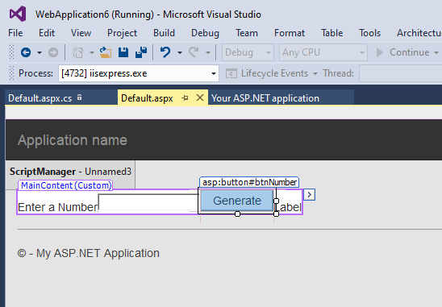

# Default.aspx.cs

using System;

using System.Collections.Generic; using System.Linq;

using System.Web; using System.Web.UI;

using System.Web.UI.WebControls;

namespace WebApplication6

{

public partial class _Default : Page

{

protected void Page_Load(object sender, EventArgs e)

**Class: SYIT(NEP) Sem: IV Roll No.: SYIT35 Date : 21/11/2024**

**Course Name: Advance Web Programming Page no:**

**Practical Number: 01**

{

}

protected void btnNumber_Click(object sender, EventArgs e)

{

Int64 n, fact = 1, i;

n = Int64.Parse(txtNumber.Text); for (i = 1; i <= n; i++)

fact = fact * i;

lblResult.Text = "the factorial of" + n + "is" + fact.ToString();

}

}

}

**OUTPUT:**

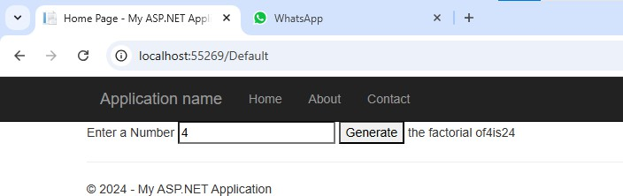

1. **Reverse of a Number**

# Default.aspx

<%@ Page Title="Home Page" Language="C#" MasterPageFile="~/Site.Master" AutoEventWireup="true" CodeBehind="Default.aspx.cs" Inherits="WebApplication8._Default" %>

<asp:Content ID="BodyContent" ContentPlaceHolderID="MainContent" runat="server">

<div class="jumbotron">

<asp:Label ID="lblNumber" runat="server" Text="Enter a Number"></asp:Label>

**Class: SYIT(NEP) Sem: IV Roll No.: SYIT35 Date : 21/11/2024**

**Course Name: Advance Web Programming Page no:**

**Practical Number: 01**

<asp:TextBox ID="txtNumber" runat="server"></asp:TextBox>

<asp:Button ID="btnNumber" runat="server" OnClick="btnNumber_Click" Text="Reverse" />

<asp:Label ID="lblResult" runat="server" Text="Label"></asp:Label>

</div>

</asp:Content>

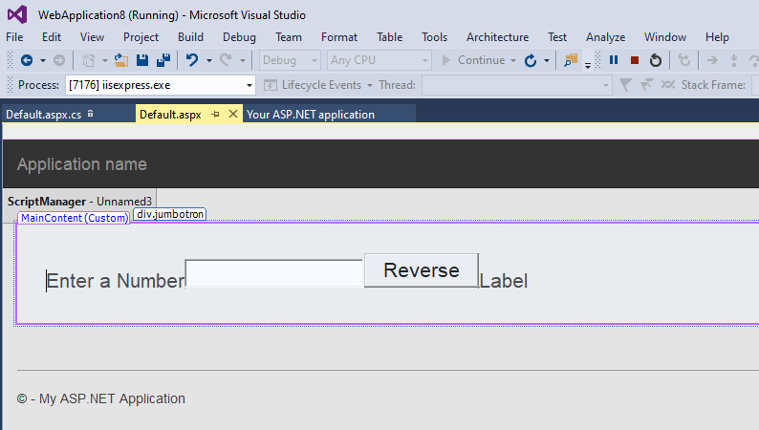

# Default.aspx.cs

using System;

using System.Collections.Generic; using System.Linq;

using System.Web; using System.Web.UI;

using System.Web.UI.WebControls;

namespace WebApplication8

{

public partial class _Default : Page

{

protected void Page_Load(object sender, EventArgs e)

{

**Class: SYIT(NEP) Sem: IV Roll No.: SYIT35 Date : 21/11/2024**

**Course Name: Advance Web Programming Page no:**

**Practical Number: 01**

}

protected void btnNumber_Click(object sender, EventArgs e)

{

Int32 n, rev = 0, rem, num;

num = Int32.Parse(txtNumber.Text); n = num;

while (n > 0)

{

rem = n % 10;

rev = (rev * 10) + rem; n = n / 10;

}

lblResult.Text = Convert.ToString(rev);

}

}

}

**OUTPUT:**

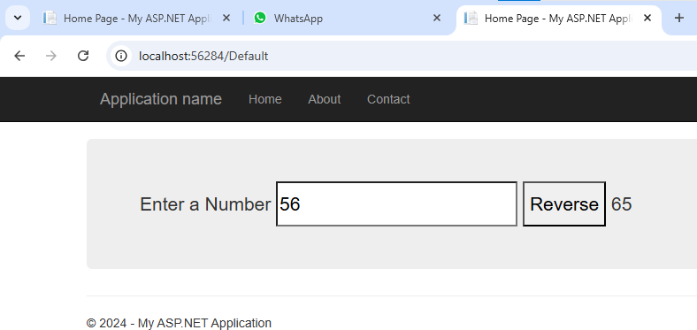

1. **Fibbonacci Series**

# Default.aspx

<%@ Page Title="Home Page" Language="C#" MasterPageFile="~/Site.Master" AutoEventWireup="true"

**Class: SYIT(NEP) Sem: IV Roll No.: SYIT35 Date : 21/11/2024**

**Course Name: Advance Web Programming Page no:**

**Practical Number: 01**

CodeBehind="Default.aspx.cs" Inherits="WebApplication9._Default" %>

<asp:Content ID="BodyContent" ContentPlaceHolderID="MainContent" runat="server">

<div></div>

<asp:Label ID="lblNumber" runat="server" Text="Enter a Number"></asp:Label>

<asp:TextBox ID="TextBox1" runat="server"></asp:TextBox>

<asp:Button ID="label3" runat="server" OnClick="txtfibbo_Click" Text="Fibbonacci" />

<asp:Label ID="label4" runat="server" Text="result"></asp:Label>

</div>

</asp:Content>

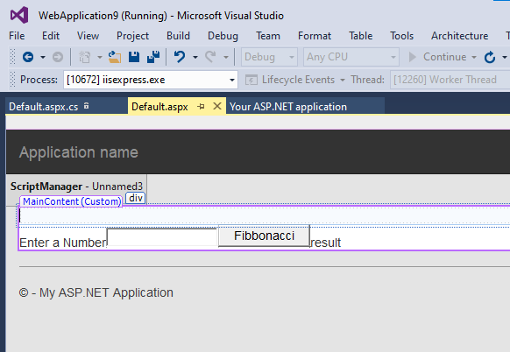

# Default.aspx.cs

using System;

using System.Collections.Generic; using System.Linq;

using System.Web; using System.Web.UI;

using System.Web.UI.WebControls;

namespace WebApplication9

{

public partial class _Default : Page

**Class: SYIT(NEP) Sem: IV Roll No.: SYIT35 Date : 21/11/2024**

**Course Name: Advance Web Programming Page no:**

**Practical Number: 01**

{

protected void Page_Load(object sender, EventArgs e)

{

}

protected void txtfibbo_Click(object sender, EventArgs e)

{

int n = Convert.ToInt32(TextBox1.Text.ToString()); int fno = 0;

int sno = 1; int sum = 0; int i = 2;

label4.Text = fno.ToString() + "," + sno.ToString(); while (i < n)

{

sum = fno + sno; fno = sno;

sno = sum; i++;

label4.Text = label4.Text + "," + sum.ToString();

}

}

}

}

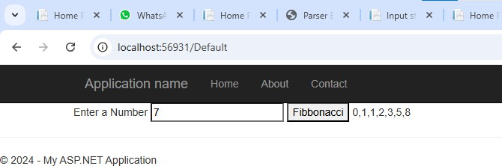

1. **Test for Prime Number**

# Default.aspx

<%@ Page Title="Home Page" Language="C#" MasterPageFile="~/Site.Master" AutoEventWireup="true" CodeBehind="Default.aspx.cs" Inherits="WebApplication10._Default" %>

**Class: SYIT(NEP) Sem: IV Roll No.: SYIT35 Date : 21/11/2024**

**Course Name: Advance Web Programming Page no:**

**Practical Number: 01**

<asp:Content ID="BodyContent" ContentPlaceHolderID="MainContent" runat="server">

<asp:Label ID="lblNumber" runat="server" Text="Enter a Number"></asp:Label>

<asp:TextBox ID="TextBox1" runat="server"></asp:TextBox>

<asp:Button ID="btn" runat="server" OnClick="btn_Click" Text="Check" />

<asp:Label ID="Label2" runat="server" Text="label"></asp:Label>

</asp:Content>

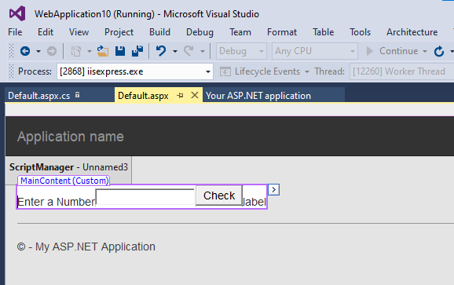

# Default.aspx.cs

using System;

using System.Collections.Generic; using System.Linq;

using System.Web; using System.Web.UI;

using System.Web.UI.WebControls;

namespace WebApplication10

{

public partial class _Default : Page

{

protected void Page_Load(object sender, EventArgs e)

{

**Class: SYIT(NEP) Sem: IV Roll No.: SYIT35 Date : 21/11/2024**

**Course Name: Advance Web Programming Page no:**

**Practical Number: 01**

}

protected void btn_Click(object sender, EventArgs e)

{

int num = Convert.ToInt32(TextBox1.Text.ToString()); int i;

for(i=2;i< num-1;i++)

{

if (num % i == 0) break;

}

if(num==1)

{

Label2.Text = "1 is neither prime nor composite";

}

else if (i<=(num/2))

{

Label2.Text = num + "is a prime number";

}

else

{

Label2.Text = num + "is not a prime number";

}

}

}

}

**OUTPUT:**

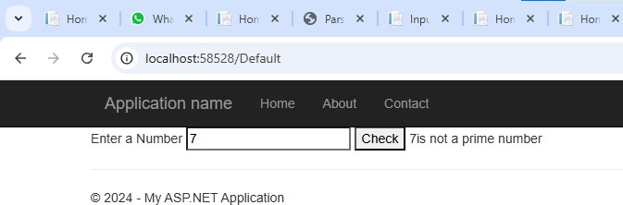

**Q1. Create Application for the following**

1. **Constructor overloading Default.aspx**

<%@ Page Title="Home Page" Language="C#" MasterPageFile="~/Site.Master" AutoEventWireup="true" CodeFile="Default.aspx.cs" Inherits="_Default"

%>

<asp:Content ID="BodyContent" ContentPlaceHolderID="MainContent" runat="server">

<div class="jumbotron">

<asp:Label ID="Label1" runat="server"></asp:Label><br />

<asp:Label ID="Label2" runat="server"></asp:Label><br />

<asp:Label ID="Label3" runat="server"></asp:Label><br />

<asp:Label ID="Label4" runat="server"></asp:Label><br />

<asp:Button ID="Button1" runat="server" OnClick="Button1_Click1" Text="Overload Constructor" />

</div>

</asp:Content>

**Default.aspx.cs** using System;

using System.Collections.Generic; using System.Linq; using System.Web; using System.Web.UI; using System.Web.UI.WebControls; public partial class _Default : Page

{ protected void Page_Load(object sender, EventArgs e)

{}

protected void Button1_Click1(object sender, EventArgs e)

{ Marksheet a = new Marksheet(); Marksheet b = new Marksheet(100); Marksheet c = new Marksheet(40,120); Marksheet d = new Marksheet(30,80,50); Label1.Text = "Marksheet1 = " + a.tot(); Label2.Text = "Marksheet2 = " + b.tot(); Label3.Text = "Marksheet3 = " + c.tot(); Label4.Text = "Marksheet4 = " + d.tot(); }

}

Constructor.cs using System; using System.Collections.Generic; using System.Linq; using System.Web; public class Marksheet { private float m1, m2, m3; public Marksheet()

{ m1 = 20; m2 = 30; m3 = 40; }

public Marksheet(float ms)

{ m1 = ms; }

public Marksheet(float ms1,float ms2)

**Class: SYIT(NEP ) Sem: IV Roll No.: SYIT61 Date : 26/11/2024 Course Name: Advance Web Programming Page no:**

**Practical Number: 04**

{ m1 = ms1; m2 = ms2; }

public Marksheet(float ms1, float ms2,float ms3)

{ m1 = ms1; m2 = ms2; m3 = ms3; } public float tot()

{ float t = m1 + m2 + m3; return t; }

}

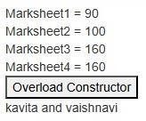**Output:-**

1. **Interface Default.aspx**

<%@ Page Title="Home Page" Language="C#" MasterPageFile="~/Site.Master" AutoEventWireup="true" CodeFile="Default.aspx.cs" Inherits="_Default"

%>

<asp:Content ID="BodyContent" ContentPlaceHolderID="MainContent" runat="server">

<div class="jumbotron"> Enter Radius :

<asp:TextBox ID="TextBox1" runat="server"></asp:TextBox>

<br /> &nbsp;&nbsp;&nbsp;&nbsp;&nbsp;

<asp:Button ID="Button1" runat="server" OnClick="Button1_Click" Text="Calculate Radius" />

<br />

<asp:Label ID="Label1" runat="server"></asp:Label>

</div>

</asp:Content>

**Default.aspx.cs** using System; using System.Collections.Generic; using System.Linq; using System.Web; using System.Web.UI;

using System.Web.UI.WebControls;

public partial class _Default : Page

{ protected void Page_Load(object sender, EventArgs e)

{ }

protected void Button1_Click(object sender, EventArgs e)

{ Circle c = new Circle();

**Class: SYIT(NEP ) Sem: IV Roll No.: SYIT61 Date : 26/11/2024 Course Name: Advance Web Programming Page no:**

**Practical Number: 04**

c.input(float.Parse(TextBox1.Text)); Label1.Text = "Area of circle is : " + c.ans(); }

}

**Intrfc.cs**

using System; using System.Collections.Generic; using System.Linq; using System.Web;

public interface calculation

{ float ans(); float input(float r); } public class Circle:calculation { public float rad, a;

public Circle()

{ rad = 0.0f;

}

public float input(float r)

{ rad = r;

return rad; } public float ans()

{ a = rad * rad * 3.14f ; return a; }

}

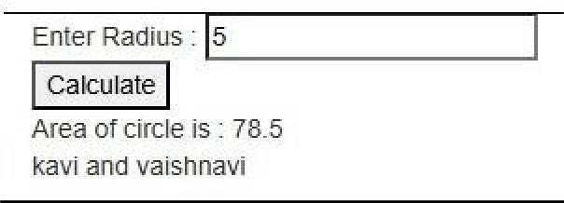**Output:-**

1. **Demonstrate the use of Calendar control to perform following operations. a. Display message in calendar control**

**Default.aspx**

<%@ Page Title="Home Page" Language="C#" MasterPageFile="~/Site.Master" AutoEventWireup="true" CodeFile="Default.aspx.cs" Inherits="_Default" %>

<asp:Content ID="BodyContent" ContentPlaceHolderID="MainContent" runat="server">

<div class="jumbotron">

<asp:Calendar ID="Calendar1" runat="server" FirstDayOfWeek="Sunday" NextPrevFormat="FullMonth" OnDayRender="Calendar1_DayRender" OnSelectionChanged="Calendar1_SelectionChanged" TitleFormat="Month"></asp:Calendar>

</div>

</asp:Content>

**Class: SYIT(NEP ) Sem: IV Roll No.: SYIT61 Date : 26/11/2024 Course Name: Advance Web Programming Page no:**

**Practical Number: 04**

**Default.aspx.cs**

using System;

using System.Collections.Generic; using System.Linq; using System.Web; using System.Web.UI; using System.Web.UI.WebControls; public partial class _Default : Page

{ protected void Page_Load(object sender, EventArgs e)

{ }

protected void Calendar1_SelectionChanged(object sender, EventArgs e)

{ }

protected void Calendar1_DayRender(object sender, DayRenderEventArgs e)

{ if(e.Day.Date==new DateTime(2019,8,12))

{ e.Cell.Controls.Add(new LiteralControl("<br/>Holiday")); } if (e.Day.Date == new DateTime(2019, 8, 16))

{ e.Cell.Controls.Add(new LiteralControl("<br/>Project")); }

}

}

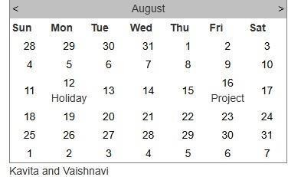**Output:-**

* 1. **Display Vacation in Calendar control Default.aspx**

<%@ Page Title="Home Page" Language="C#" MasterPageFile="~/Site.Master" AutoEventWireup="true" CodeFile="Default.aspx.cs" Inherits="_Default"

%>

<asp:Content ID="BodyContent" ContentPlaceHolderID="MainContent" runat="server">

<div class="jumbotron">

<asp:Calendar ID="Calendar1" runat="server" BackColor="Yellow" FirstDayOfWeek="Sunday" NextPrevFormat="FullMonth" OnDayRender="Calendar1_DayRender" OnSelectionChanged="Calendar1_SelectionChanged" TitleFormat="Month"></asp:Calendar>

</div>

</asp:Content>

**Default.aspx.cs**

using System;

using System.Collections.Generic; using System.Linq; using System.Web; using System.Web.UI;

**Class: SYIT(NEP ) Sem: IV Roll No.: SYIT61 Date : 26/11/2024 Course Name: Advance Web Programming Page no:**

**Practical Number: 04**

using System.Web.UI.WebControls; public partial class _Default : Page

{

protected void Page_Load(object sender, EventArgs e)

{

}

protected void Calendar1_SelectionChanged(object sender, EventArgs e)

{

}

protected void Calendar1_DayRender(object sender, DayRenderEventArgs e)

{

if(e.Day.Date>=new DateTime(2019,8,12)&& (e.Day.Date <= new DateTime(2019, 8, 22)))

{

e.Cell.BackColor = System.Drawing.Color.Red;

}

}

}

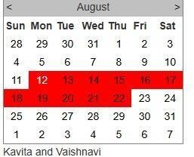**Outupt:-**

* 1. **Select end day in calendar control using style Default.aspx**

<%@ Page Title="Home Page" Language="C#" MasterPageFile="~/Site.Master" AutoEventWireup="true" CodeFile="Default.aspx.cs" Inherits="_Default" %>

<asp:Content ID="BodyContent" ContentPlaceHolderID="MainContent" runat="server">

<div class="jumbotron">

<asp:Calendar ID="Calendar1" runat="server" BackColor="Yellow" FirstDayOfWeek="Sunday" BorderColor="Red" ShowGridLines="True" NextPrevFormat="FullMonth" OnDayRender="Calendar1_DayRender"

OnSelectionChanged="Calendar1_SelectionChanged" TitleFormat="Month" SelectedDayStyleBackColor="Maroon" DayHeaderStyle-BorderColor="Wheat" BorderStyle="Dotted">

**Class: SYIT(NEP ) Sem: IV Roll No.: SYIT61 Date : 26/11/2024 Course Name: Advance Web Programming Page no:**

**Practical Number: 04**

</asp:Calendar>

</div>

</asp:Content>

**Default.aspx.cs** using System;

using System.Collections.Generic; using System.Linq; using System.Web; using System.Web.UI;

using System.Web.UI.WebControls;

public partial class _Default : Page

{

protected void Page_Load(object sender, EventArgs e)

{

}

protected void Calendar1_SelectionChanged(object sender, EventArgs e)

{

}

protected void Calendar1_DayRender(object sender, DayRenderEventArgs e)

{

}

}

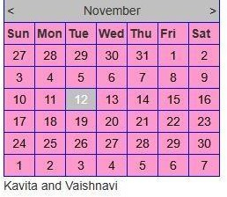**Outupt:-**

* 1. **Difference between two calendar dates Default.aspx**

<%@ Page Title="Home Page" Language="C#" MasterPageFile="~/Site.Master" AutoEventWireup="true" CodeFile="Default.aspx.cs" Inherits="_Default"

%>

**Class: SYIT(NEP ) Sem: IV Roll No.: SYIT61 Date : 26/11/2024 Course Name: Advance Web Programming Page no:**

**Practical Number: 04**

<asp:Content ID="BodyContent" ContentPlaceHolderID="MainContent" runat="server">

<div class="jumbotron">

<asp:Calendar ID="Calendar1" runat="server" BackColor="Yellow" Caption="Calendar1" FirstDayOfWeek="Sunday" ForeColor="Blue" NextPrevFormat="ShortMonth" TitleFormat="Month"> </asp:Calendar>

<asp:Calendar ID="Calendar2" runat="server" BackColor="Blue" Caption="Calendar2" FirstDayOfWeek="Sunday" ForeColor="Yellow" NextPrevFormat="ShortMonth" TitleFormat="Month"> </asp:Calendar>

<asp:Button ID="Button1" runat="server" OnClick="Button1_Click" Text="Calculate difference" />

<br />

Difference between two dates is :

<asp:Label ID="Label1" runat="server"></asp:Label>

</div>

</asp:Content>

**Default.aspx.cs** using System;

using System.Collections.Generic; using System.Linq; using System.Web; using System.Web.UI;

using System.Web.UI.WebControls;

public partial class _Default : Page

{

protected void Page_Load(object sender, EventArgs e)

{

}

protected void Calendar1_SelectionChanged(object sender, EventArgs e)

{

}

protected void Calendar1_DayRender(object sender, DayRenderEventArgs e)

{

}

protected void Button1_Click(object sender, EventArgs e)

{

TimeSpan t = Calendar2.SelectedDate - Calendar1.SelectedDate; Label1.Text = t.Days.ToString();

}

}

**Class: SYIT(NEP ) Sem: IV Roll No.: SYIT61 Date : 26/11/2024 Course Name: Advance Web Programming Page no:**

**Practical Number: 04**

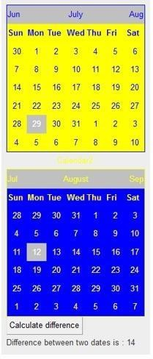**Output:-**

**Q1. Design an asp web form to show validation control. Default.aspx:**

<asp:Label ID="Label1" runat="server" Text="Enter Class:"></asp:Label> &nbsp;&nbsp;&nbsp;&nbsp;&nbsp;&nbsp;&nbsp;&nbsp;&nbsp;&nbsp;&nbsp;&nbsp;&nbsp;&nbsp;

<asp:TextBox ID="txtclass" runat="server"></asp:TextBox>

<asp:RangeValidator ID="RangeValidator1" runat="server" ControlToValidate="txtclass" ErrorMessage="Enter a value between 6 to 12" MaximumValue="12" MinimumValue="6" Type="Integer"></asp:RangeValidator>

<br />

<asp:Label ID="Label2" runat="server" Text="Select House:"></asp:Label> &nbsp;&nbsp;&nbsp;&nbsp;&nbsp;&nbsp;&nbsp;&nbsp;&nbsp;&nbsp;&nbsp;&nbsp;

<asp:DropDownList ID="DropDownList1" runat="server">

<asp:ListItem>Red</asp:ListItem>

<asp:ListItem>Yellow</asp:ListItem>

<asp:ListItem>Blue</asp:ListItem>

<asp:ListItem></asp:ListItem>

</asp:DropDownList>

<asp:RequiredFieldValidator ID="RequiredFieldValidator1" runat="server" ControlToValidate="DropDownList1" ErrorMessage="Select a color for house"></asp:RequiredFieldValidator>

<br />

<asp:Label ID="Label3" runat="server" Text="Enter Email Address"></asp:Label> &nbsp;

<asp:TextBox ID="TextBox2" runat="server"></asp:TextBox>

<asp:RegularExpressionValidator ID="RegularExpressionValidator1" runat="server" ControlToValidate="TextBox2" ErrorMessage="Enter valid email address" ValidationExpression="\w+([-+.']\w+)@\w+([-.]\w+)\.\w+([-

.]\w+)*"></asp:RegularExpressionValidator>

<br />

<asp:Button ID="Button1" runat="server" Text="Button" />

<asp:ValidationSummary ID="ValidationSummary1" runat="server" />

<asp:Label ID="Label4" runat="server" Text="Vaishnavi"></asp:Label>

</asp:Content>

**Output:**

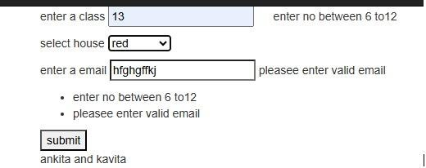

**Class: SYIT Sem: IV Roll No.: SYIT61 Date: 14-12-2024**

**Course Name: Advanced Web Programming Page no:**

**Practical Number:- 09**

**Q2. Design asp web form to accept academic bank of credits, email, marks in 3 subjects and find out the percentage obtained by the student.**

**Default.aspx:**

<%@ Page Title="Home Page" Language="C#" MasterPageFile="~/Site.Master" AutoEventWireup="true" CodeBehind="Default.aspx.cs" Inherits="WebApplication15._Default" %>

<asp:Content ID="BodyContent" ContentPlaceHolderID="MainContent" runat="server">

<asp:Label ID="Label1" runat="server" Text="Enter ABC id:"></asp:Label>

<asp:TextBox ID="TextBox1" runat="server"></asp:TextBox>

<asp:RegularExpressionValidator ID="RegularExpressionValidator1" runat="server" ControlToValidate="TextBox1" ErrorMessage="Enter correct ABC id" ValidationExpression="^\d{4}-\d{4}-\d{4}$"></asp:RegularExpressionValidator>

<br />

<asp:Label ID="Label2" runat="server" Text="Enter Email Address:"></asp:Label>

<asp:TextBox ID="TextBox2" runat="server"></asp:TextBox>

<asp:RequiredFieldValidator ID="RequiredFieldValidator1" runat="server" ControlToValidate="TextBox2" ErrorMessage="Email Address is compulsory"></asp:RequiredFieldValidator>

<br />

<asp:Label ID="Label3" runat="server" Text="Enter marks of Major subject:"></asp:Label>

<asp:TextBox ID="TextBox3" runat="server" OnDataBinding="Button1_Click" OnTextChanged="Button1_Click"></asp:TextBox>

<asp:RangeValidator ID="RangeValidator2" runat="server" ControlToValidate="TextBox3" ErrorMessage="Enter marks between 1 to 100" MaximumValue="100" MinimumValue="0" OnDataBinding="Button1_Click" Type="Integer"></asp:RangeValidator>

<br />

<asp:Label ID="Label4" runat="server" Text="Enter marks of Minor subject:"></asp:Label>

<asp:TextBox ID="TextBox4" runat="server" OnDataBinding="Button1_Click" OnTextChanged="Button1_Click"></asp:TextBox>

<asp:RangeValidator ID="RangeValidator3" runat="server" ControlToValidate="TextBox4" ErrorMessage="Enter marks between 1 to 100" MaximumValue="100" MinimumValue="0" OnDataBinding="Button1_Click" Type="Integer"></asp:RangeValidator>

<br />

<asp:Label ID="Label5" runat="server" Text="Enter marks of OE subject:"></asp:Label>

<asp:TextBox ID="TextBox5" runat="server" OnDataBinding="Button1_Click" OnTextChanged="Button1_Click"></asp:TextBox>

<asp:RangeValidator ID="RangeValidator4" runat="server" ControlToValidate="TextBox5" ErrorMessage="Enter marks between 1 to 100" MaximumValue="100" MinimumValue="0" OnDataBinding="Button1_Click" Type="Integer"></asp:RangeValidator>

<br />

<asp:Button ID="Button1" runat="server" OnClick="Button1_Click" OnDataBinding="Button1_Click" Text="Percentage" />

**Class: SYIT Sem: IV Roll No.: SYIT61 Date: 14-12-2024**

**Course Name: Advanced Web Programming Page no:**

**Practical Number:- 09**

<br />

<asp:Label ID="Label6" runat="server" OnDataBinding="Button1_Click"></asp:Label>

<br />

<asp:Label ID="Label7" runat="server" Text="Vaishnavi"></asp:Label>

<br />

</asp:Content>

**Default.aspx.cs:**

using System;

using System.Collections.Generic; using System.Linq;

using System.Web; using System.Web.UI;

using System.Web.UI.WebControls;

namespace WebApplication15

{

public partial class _Default : Page

{

protected void Page_Load(object sender, EventArgs e)

{

}

protected void Button1_Click(object sender, EventArgs e)

{

int a, b, c;

a = Int32.Parse(TextBox3.Text);

b = Int32.Parse(TextBox4.Text);

c = Int32.Parse(TextBox5.Text); percentage p = new percentage(a, b, c); Label6.Text = p.y;

}

}

}

**percentage.cs**

using System;

using System.Collections.Generic; using System.Linq;

using System.Web; namespace WebApplication15

**Class: SYIT Sem: IV Roll No.: SYIT61 Date: 14-12-2024**

**Course Name: Advanced Web Programming Page no:**

**Practical Number:- 09**

{

public class percentage

{

public double x; public string y;

public percentage(int a, int b, int c)

{

int z;

z = a + b + c;

x = (z / 300.0) * 100;

y = "Percentage: " + x.ToString("F2") + "%";

}

}

}

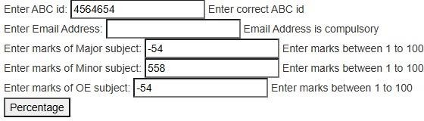**Output:**

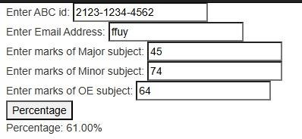

# Q1. Write an application to create the following

1. **Single Inheritance Default.aspx**

<%@ Page Title="Home Page" Language="C#" MasterPageFile="~/Site.Master" AutoEventWireup="true" CodeFile="Default.aspx.cs" Inherits="_Default" %>

<asp:Content ID="BodyContent" ContentPlaceHolderID="MainContent" runat="server">

<div class="jumbotron">

<asp:Label ID="Label1" runat="server" Text="Function 1 "></asp:Label>

<br />

<asp:Label ID="Label2" runat="server" Text="Function 2 "></asp:Label>

<br />

<asp:Label ID="Label3" runat="server" Text="Function 3 "></asp:Label>

<br />

<asp:Button ID="Button1" runat="server" OnClick="Button1_Click" Text="Sigle Inheritance" />

</div>

</asp:Content>

# Default.aspx.cs

using System;

using System.Collections.Generic; using System.Linq; using System.Web; using System.Web.UI;

using System.Web.UI.WebControls;

public partial class _Default : Page

{

protected void Page_Load(object sender, EventArgs e)

{

}

protected void Button1_Click(object sender, EventArgs e)

{

basec b = new basec();

Label1.Text = "Calling base class method from base class object." + b.parentmethod(); derived d = new derived();

Label2.Text = "Calling base class method from derived class object." + d.parentmethod(); Label3.Text = "Calling derived class method from derived class object." + d.childmethod();

}

}

**Class: SYIT(NEP ) Sem: IV Roll No.: SYIT61 Date : 25/11/2024 Course Name: Advance Web Programming Page no:**

**Practical Number: 03**

**Conv.cs** using System;

using System.Collections.Generic; using System.Linq; using System.Web;

public class basec

{ public string parentmethod()

{

string p = "This is base class"; return p;

} }

public class derived:basec

{

public string childmethod()

{

string c = "This is derived class method"; return c;

}

}

Output:-

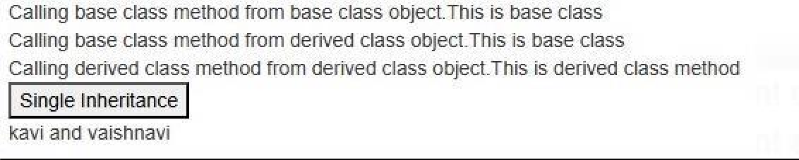

**ANKITA PANDEY**

# Multilevel Inheritance Default.aspx

<%@ Page Title="Home Page" Language="C#" MasterPageFile="~/Site.Master" AutoEventWireup="true" CodeFile="Default.aspx.cs" Inherits="_Default" %>

<asp:Content ID="BodyContent" ContentPlaceHolderID="MainContent" runat="server">

<div class="jumbotron">

<asp:Label ID="Label1" runat="server"></asp:Label><br />

<asp:Label ID="Label2" runat="server"></asp:Label><br />

<asp:Label ID="Label3" runat="server"></asp:Label><br />

<asp:Button ID="Button1" runat="server" OnClick="Button1_Click" Text="Mutilevel Inheritance" />

</div>

</asp:Content>

**Class: SYIT(NEP ) Sem: IV Roll No.: SYIT61**

**Date:25/11/2024 Course Name: Advance Web Programming**

**Page no:**

**Practical Number: 03**

# Default.aspx.cs

using System;

using System.Collections.Generic; using System.Linq; using System.Web; using System.Web.UI;

using System.Web.UI.WebControls;

public partial class _Default : Page

{

protected void Page_Load(object sender, EventArgs e)

{

}protected void Button1_Click(object sender, EventArgs e)

{

C obj = new C(); Label1.Text = obj.show(); Label2.Text = obj.display(); Label3.Text = obj.output();

}

}

**C.cs** using System;

using System.Collections.Generic; using System.Linq; using System.Web;

public class A { public String show()

{

return ("First base class");

} }

public class B:A

{

public string display()

{

return ("Second base class & first derived class");

} }

public class C : B

{

public string output()

{ return ("Second derived class");

}

}

**Class: SYIT(NEP ) Sem: IV Roll No.: SYIT61 Date : 25/11/2024 Course Name: Advance Web Programming Page no:**

**Practical Number: 03**

# Output:-

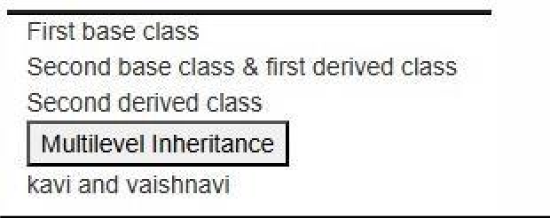

**ANKITA PANDEY**

1. **Multiple Inheritance Default.aspx**

<%@ Page Title="Home Page" Language="C#" MasterPageFile="~/Site.Master" AutoEventWireup="true" CodeFile="Default.aspx.cs" Inherits="_Default" %>

<asp:Content ID="BodyContent" ContentPlaceHolderID="MainContent" runat="server"> <div class="jumbotron">

Enter Length : -&nbsp;&nbsp;

<asp:TextBox ID="TextBox1" runat="server"></asp:TextBox>

<br />

Enter Breadth : -

<asp:TextBox ID="TextBox2" runat="server"></asp:TextBox>

<br /> &nbsp;&nbsp;&nbsp;&nbsp;&nbsp;&nbsp;&nbsp;&nbsp;&nbsp;&nbsp;&nbsp;

<asp:Button ID="Button1" runat="server" OnClick="Button1_Click" Text="Calculate " />

<br />

Area of Rectangle : -

<asp:Label ID="Label1" runat="server"></asp:Label>

</div>

</asp:Content>

**Default.aspx.cs** using System;

using System.Collections.Generic; using System.Linq; using System.Web; using System.Web.UI;

using System.Web.UI.WebControls;

public partial class _Default : Page

{ protected void Page_Load(object sender, EventArgs e)

{

}

protected void Button1_Click(object sender, EventArgs e)

{ rect r = new rect();

**Class: SYIT(NEP ) Sem: IV Roll No.: SYIT61**

**Date:25/11/2024 Course Name: Advance Web Programming**

**Page no:**

**Practical Number: 03**

r.sides(Convert.ToInt16(TextBox1.Text), Convert.ToInt16(TextBox2.Text)); int aor = r.area();

Label1.Text = Convert.ToString(aor);

}

}

**Lengthofrect.cs** using System;

using System.Collections.Generic; using System.Linq; using System.Web;

public class lengthofrect { public int length, breadth; public void sides(int l,int b)

{ length = l; breadth = b;

} }

public interface calc

{ int area(); }

public class rect:lengthofrect,calc

{

public int area()

{

return length * breadth;

}

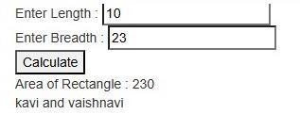}

Output:-

**ANKITA PANDEY**

# Heirarchical Inheritance Default.aspx

<%@ Page Title="Home Page" Language="C#" MasterPageFile="~/Site.Master" AutoEventWireup="true" CodeFile="Default.aspx.cs" Inherits="_Default" %>

<asp:Content ID="BodyContent" ContentPlaceHolderID="MainContent" runat="server">

<div class="jumbotron">

**Class: SYIT(NEP ) Sem: IV Roll No.: SYIT61 Date : 25/11/2024 Course Name: Advance Web Programming Page no:**

**Practical Number: 03**

<asp:Label ID="Label1" runat="server" Text="Label"></asp:Label>

<br />

<asp:Label ID="Label2" runat="server" Text="Label"></asp:Label>

<br />

<asp:Button ID="Button1" runat="server" OnClick="Button1_Click" Text="Heirarchical Inheritance" />

</div>

</asp:Content>

# Default.aspx.cs

using System;

using System.Collections.Generic; using System.Linq; using System.Web; using System.Web.UI;

using System.Web.UI.WebControls;

public partial class _Default : Page

{

protected void Page_Load(object sender, EventArgs e)

{}

protected void Button1_Click(object sender, EventArgs e)

{

Q q = new Q();

Label1.Text="Calling "+q.showP() + " from " + q.showQ(); R r = new R();

Label2.Text= "Calling "+r.showP() + " from " + r.showR();

}

}

# Hci.cs

using System; using System.Collections.Generic; using System.Linq; using System.Web;

public class P {

public string showP()

{

String a = "Parent class"; return a;

} } public class Q:P {

public string showQ()

{

String b = "Child1 class";

**Class: SYIT(NEP ) Sem: IV Roll No.: SYIT61**

**Date:25/11/2024 Course Name: Advance Web Programming**

**Page no:**

**Practical Number: 03**

return b;

} } public class R : P

{

public string showR()

{

String c = "Child2 class"; return c;

}

}

Output:-

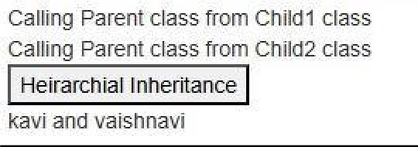

**ANKITA PANDEY**

1.Create a Adrotator. Code:

Default.aspx

<%@ Page Title="Home Page" Language="C#" MasterPageFile="~/Site.Master" AutoEventWireup="true" CodeBehind="Default.aspx.cs" Inherits="WebApplication21._Default" %>

<asp:Content ID="BodyContent" ContentPlaceHolderID="MainContent" runat="server">

<p>

<strong>Advertisement YASH SYIT43</strong>

</p>

<p>

<asp:XmlDataSource ID="XmlDataSource1" runat="server" DataFile="~/XMLFile1.xml"></asp:XmlDataSource>

</p>

<p>

<asp:AdRotator ID="AdRotator1" runat="server" DataSourceID="XmlDataSource1" Height="200px" Width="300px" />

</p>

<p>

<asp:XmlDataSource ID="XmlDataSource2" runat="server" DataFile="~/XMLFile1.xml"></asp:XmlDataSource>

</p>

<p>

<asp:AdRotator ID="AdRotator2" runat="server" DataSourceID="XmlDataSource1" Height="200px" Width="300px" />

</p>

<p>

<asp:XmlDataSource ID="XmlDataSource3" runat="server" DataFile="~/XMLFile1.xml"></asp:XmlDataSource>

</p>

<p>

<asp:AdRotator ID="AdRotator3" runat="server" DataSourceID="XmlDataSource1" Height="200px" Width="300px" />

</p>

</asp:Content> XMLFile.xml

<?xml version="1.0" encoding="utf-8" ?>

<Advertisements>

<Ad>

</Ad>

<Ad>

<ImageUrl>YASH2.jpg</ImageUrl>

<Impressions>10 </Impressions>

<NavigateUrl>https://[www.netflix.com](http://www.netflix.com/)</NavigateUrl>

<Keywords>yash1</Keywords>

<Alternate >Google pe lelo</Alternate>

<ImageUrl>YASH1.jpg</ImageUrl>

<Impressions>10 </Impressions>

<NavigateUrl>https://[www.instagram.com](http://www.instagram.com/)</NavigateUrl>

<Keywords>yash2</Keywords>

<Alternate>amazon</Alternate>

</Ad>

<Ad>

</Ad>

<ImageUrl>YASH4.jpg</ImageUrl>

<Impressions>10 </Impressions>

<NavigateUrl>https://[www.flipkart.com](http://www.flipkart.com/)</NavigateUrl>

<Keywords>yash3</Keywords>

<Alternate>facebook</Alternate>

</Advertisements> Output:

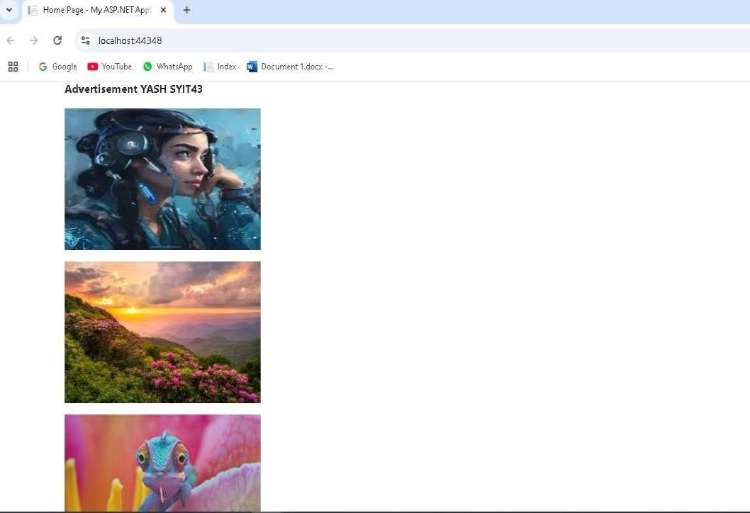

1)

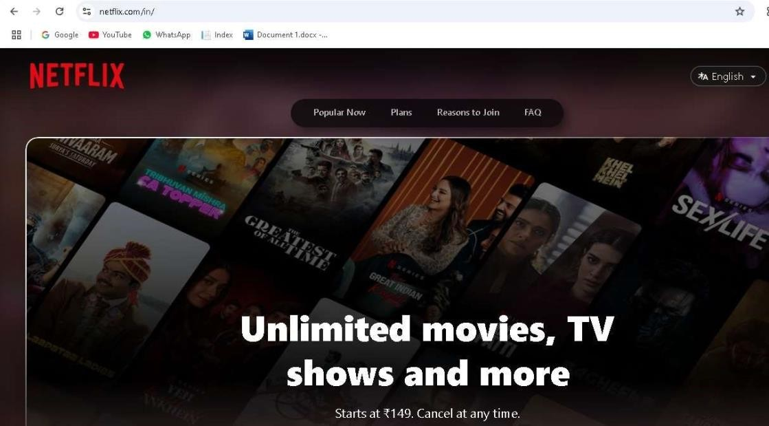

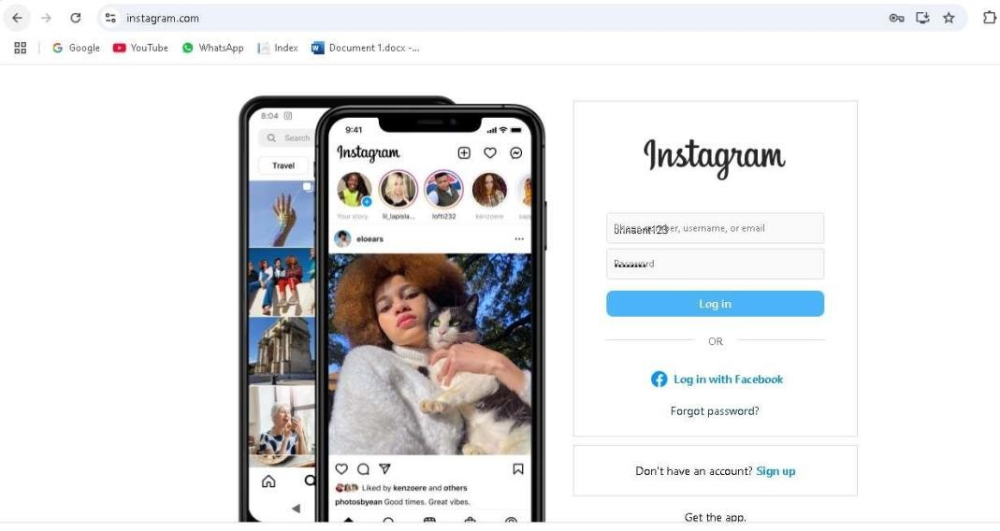2)

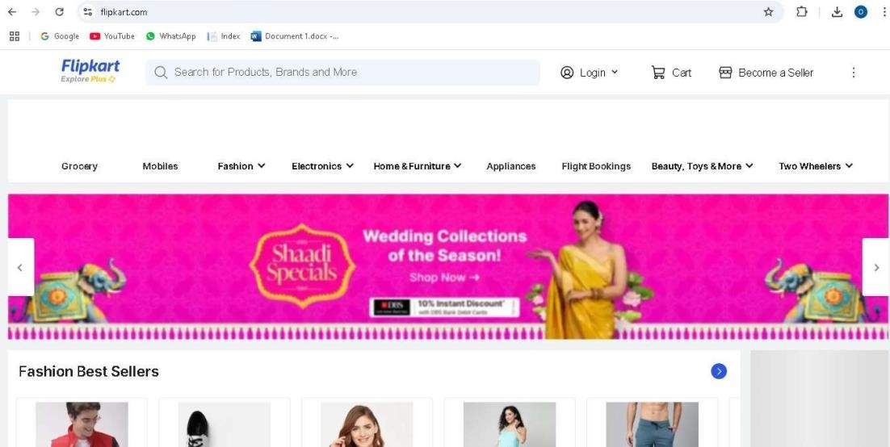3)

**Practical Number: 01**

**Default.aspx.cs:**

Using System;

Using System.Collections.Generic; Using System.Linq;

Using System.Web; Using System.Web.UI;

Using System.Web.UI.WebControls; Using System.Xml.Linq;

Public partial class _Default : System.Web.UI.Page

{

Protected void Page_Load(object sender, EventArgs e)

{

XDocument xmlDoc = XDocument.Load(HttpContext.Current.Server.MapPath(“XMLFile.xml”)); Var persons = from p in xmlDoc.Root.Elements(“Person”)

Where (Convert.ToInt16(p.Element(“Age”).Value) < 60)

Select new

{

Name = p.Element(“Name”).Value, Address = p.Element(“Address”).Value, Age = p.Element(“Age”).Value

};

GridView1.DataSource = persons; GridView1.DataBind();

}

}

**Default foraspx:**

<%@ Page Language=”C#” AutoEventWireup=”true” CodeFile=”Default.aspx.cs” Inherits=”_Default” %>

<!DOCTYPE html>

<html xmlns=<http://www.w3.org/1999/xhtml>>

<head runat=”server”>

<title></title>

</head>

<body>

<form id=”form1” runat=”server”>

<div>

<asp:GridView ID=”GridView1” runat=”server” OnSelectedIndexChanged=”Page_Load”>

</asp:GridView>

<asp:Label ID=”Label2” runat=”server” Text=”Kavita Ankita”></asp:Label>

</div>

</form>

</body>

</html>

**XMLFile.xml:**

**Class: SYIT(NEP) Sem: IV Roll No.: SYIT35 Date : 21/11/2024**

**Course Name: Advance Web Programming Page no:**

**Practical Number: 01**

<?xml version=”1.0” encoding=”utf-8” ?>

<Persons>

<Person>

<Name>VAISHNAVI</Name>

<Address>Khar</Address>

<Age>19</Age>

</Person>

<Person>

<Name>KAVITA</Name>

<Address>Virar</Address>

<Age>27</Age>

</Person>

<Person>

<Name>ANKITA</Name>

<Address>Andheri</Address>

<Age>32</Age>

</Person>

<Person>

<Name>TANAYA</Name>

<Address>Bandra</Address>

<Age>45</Age>

</Person>

</Persons>

**Output**:

