Lab work on dynamic analysis of microgrids

Duration : 6 hours

In this lab work, we aim to analysis and control a remote microgrids including AC loads, PV, DEG (Diesel Generator) and energy storage devices such as Battery Energy System (BES), Flywheel Energy System (FES) or Supercapacitor Energy System (SES). The figure 1 illustrates the common connection on AC grids of these components, using sometimes power electronics converters for synchronization of AC sources (for DEG), inverter DC to AC voltages (for PV and storage devices) and control active and reactive power flows into the grid (Power Management System and Energy Management System).

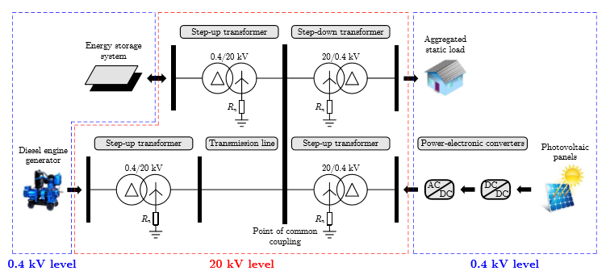

We are interested in controlling the frequency, focusing especially on primary frequency control. Neglecting all the grid losses, the microgrid can be modelled as a simple system where all the sources and loads are connected to a PCC (Point of Common Connection).

1. **Modelling of the Diesel Engine**

The DEG associated to its prime gouvernor, the shaft and all the actuators used to control the speed and the torque of the turbine/motor, can be modelled as a simple first-order system with a time constant equal to Td.

The DEG est used for primary and secondary frequency controls with a droop ($S_{d}$) and a integrator gain ($K_{ig}$). Prove that the dynamic variation of the DEG power can be modelled in Laplace domain as :

$$∆P_{diesel}\left(p\right)=-\frac{1}{1+T_{d}.p}\left(\frac{1}{S_{d}}+\frac{K_{ig}}{p}\right).∆f_{grid}(p)$$

When we focus on primary frequency control, the dynamic equation is then deduced as :

$$\frac{d∆P_{diesel}}{dt}=\frac{-1}{T_{d}}∆P_{diesel}-\frac{1}{T_{d}.S_{d}}∆f_{grid}$$

1. **Modelling of the grid**

Disturbances and load variations are compensated by kinetic energy of rotating generators and motors connected to the grid and self-regulating of loads. The frequency variation can then be modelled as a function of the algebraic sum of active powers, and depends on the equivalent inertia (denoted H) of all the generators and motors connected to the grid, but also the damping factor of global loads (denoted $D_{load})$:

$$\frac{df_{grid}}{dt}=\frac{1}{2H}\frac{{f_{gride}}^{2}}{f_{grid}}\left(P_{ESS}+P_{diesel}+P_{PV}-P_{load}\right)-\frac{D_{load}}{2H}{f_{gride}}^{2}$$

Find the corresponding dynamic equation for small signal variations of $f_{grid}$ ($∆f_{grid}$).

1. **Dynamic behaviour of MG without any ESS (Energy Storage System).**

Calculate the transfer function $\frac{∆f_{grid}}{∆P_{diff}}$ where $P_{diff}=P_{PV}-P_{load}$. You assume first that no ESS is required to improve the frequency response of the MG.

Plot the Bode diagram of this transfer function:

* With a perfect time response of the Diesel engine ($T_{d}=0$).
* With different coefficients of inertia (H)
* With different damping factors ($D_{load}$)

Analyse the influence of DEG and H on this frequency response. Determine the frequency of any disturbance which has the highest impact on grid frequency.

Finally, propose a technology of storage device for primary frequency control.

Analyse the advantage of such a modelling of ancillary service compared to classical time responses.

1. **State-space system modelling of the microgrid and stability analysis**

In this lab work, supercapacitors are studied in order to provide peak powers to the MG in order to reduce the transient on DEG.

The global electrical scheme is described on figure 2.

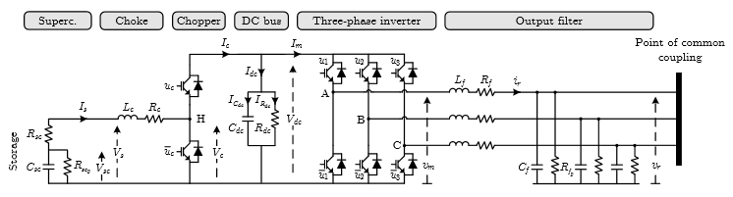

Figure 2 – Electrical model of ESS

The state-space system of the ESS is detailed below ; this system of equations is deduced from voltage and current loops in the electrical system. The inverter is modelled with Park framework attached to the PCC voltage.

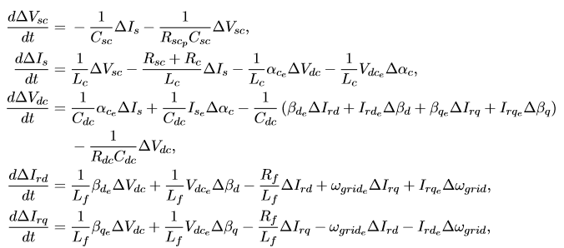

The steady-state point is calculated for null derivatives. The set point is detailed in the following table.

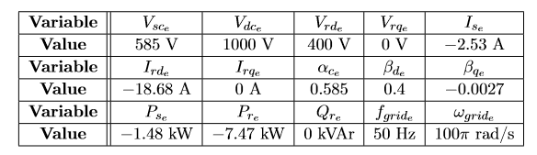

Write the state-space system of the MG for small-signal variations, defining $∆f_{grid}$ and $∆V_{dc}$ are the output of the control loops.

Assuming that currents are controlled with classical and fast PI controllers, how this state-space system can be simplified ?

Analyse the stability of this state-space system, using the matrix of sensitivity and eigenvalues calculations.

What can you conclude on the MG stability ?

1. **Dynamic response of the studied MG**

Open the file MG.mdl and analyse the different blocks of the Simulink file.

Analyse the architecture of control implemented in this example. Considering the question 4., how could you improve this strategy on control ?

Analyse the time response of frequency and DC bus voltage according to different scenario. In particular, analyse the nominal response of the system for different disturbance (with small and high signal variations) and the robustness on dynamic performances against some uncertainties.

What can you conclude on design and control of such a microgrid ?

**Annex 1 : MG parameters**

|  |  |  |
| --- | --- | --- |
| Equivalent inertia constant | H | 2 MW.s |
| Rated active power of DEG | $$P_{Diesel, e}$$ | 1 MW |
| Droop value of DEG | $$S_{d}$$ | 6% or 1.5 MW/Hz |
| Proportional gain for secondary control of DEG | $$K_{iG}$$ | 0.08 MW |
| Time constant of Diesel engine | $$T_{d}$$ | 0.22 s |
|  | | |
| Photovoltaic power | $$P_{PVe}$$ | 0.2 MW |
| Load active power | $$P_{loade}$$ | 1.2 MW |
| Damping load constant | $$D_{load}$$ | 0 MW/Hz |
|  | | |
| DC/DC converter inductance | $$L_{c}$$ | 2.2 mH |
| DC/DC converter resistance | $$R_{c}$$ | 2.5 mΩ |
| PWM switching frequency | $$f_{PWM}$$ | 4 kHz |
| Output filter inductance | $$L_{f}$$ | 0.46 mH |
| Output filter series resistance | $$R_{f}$$ | 4.8 mΩ |
| Output filter capacitance | $$C_{f}$$ | 153 µF |
| Output filter parallel resistance | $$R_{fp}$$ | 16 Ω |
|  | | |
| Supercapacitor capacitance | $$C_{sc}$$ | 61.9 F |
| Series resistance | $$R_{sc}$$ | 16.8 mΩ |
| Parallel resistance | $$R_{scp}$$ | 231 Ω |
| Range of voltage | $$V_{sc min}- V_{sc max}$$ | 390 V – 780 V |
|  |  |  |
| DC bus capacitance | $$C_{dc}$$ | 195 mF |
| DC bus resistance | $$R_{dc}$$ | 167 Ω |
| DC bus voltage (set point) | $$V_{dc}$$ | 1000 V |