

TP Report: Micro-Grid

Hybridization of Light Rail System

**Monychot SARY**

**Hasanat KHAN**

**2024 - 2025**

# Introduction

The hybridization of light rail system involved connected with an auxiliary energy source, as like ONESS (On-Board Energy Storage System), to optimize energy usage. This study and testing will make the improvement of the energy efficiency by enabling energy recovery during braking and balancing the power demand in idea to be more sustainability and operational flexibility.

# Statement of Problem

For the light rail system using hybridization, there are many of issues to study as such energy management of the system (EMS), load profile analysis, EMS design, storage technology selection also the ONESS design and sizing.

# Methodology

## Energy Management System and EMS Design

Energy Management System as we known EMS is responsible for managing and analyzing energy input and energy output within system. For this study case, two methods have been proposed to analyze and manage the energy consumption: using a Directional Rectifier or a Bi-directional Rectifier. To determine the most suitable option, an evaluation of the end consumption for each rectifier is required. The convention signs: Pload is positive for traction mode (corresponding to a phase of discharge of storage); Pload is negative for braking mode (corresponding to a phase of charging storage);

## ONESS Design, Sizing and Storage Technology Selection

To find the potential of power hybridization (PPH) we will use formula *Equation 1*in the *Appendix A*. The value of the PPH must be between 0 to 1. PPH close to 1 mean that the system interested to become the hybridization system. Energy Potential Hybridization (EPH), *Equation 2* is the main constraint for the sizing of the ONESS. The constraint must be written by *Equation 3,Appendix B*. For calculate the power that provided by grid, we use the low pass filter method with depend on the power of load with the cutoff frequency. After that ONESS size will be implement *Equation 6* *Appendix C.*

In this case study, we assumed the conversion efficiency is 90%. The actual power from ONESS will be multiply by the conversion efficiency to the power output from the converter. The calculation of the energy charge based on the whether ONESS is charging or discharging will be calculated by using *Equation 7, Appendix D*.

## Type of Storage

In this lab, two type of the storage will be get to implement. Battery Storage and Supercapacitor storage are the two of the storage technologies in the transportation nowadays [1]. In the battery storage, it has three another type of battery such as Li-ion Battery, NiMH Battery and Lead Fluid [2]. Assume that voltage cell of battery is 3.7V with 2500mAh and 120Wh/kg. Depth of Discharge (DOD) is depended on each type of battery as like Li-ion between 20% to 80% with price 130$/kWh [3], NiMH battery between 80% to 100% with price between 200$ to 500$/kWh and Lead Fluid battery between 20% to 50% with price $100 to 200$/kWh [1], [2]. On the other hand, supercapacitor has cutoff frequency around closely to 1Hz and we assume that energy density of supercapacitor is 10Wh/kg with 5Wh per cell and the price is very high cost around 10000$/kWh [4].

## Flywheel and Associated Motor

Calculate the energy capacity required for the flywheel based on the PPH determined in the load profile analysis. The flywheel must be store during the braking phases by using Equation *8, Appendix E.* is an optimal angular velocity that calculated by using Equation *13*, *Appendix E*. Based on the calculated inertia and desired mass or material properties. The moment of inertia for a solid cylindrical flywheel can be estimated by using Equation *9*. The accelerate and decelerate the flywheel, the associated motor must be selected. The motor’s power should be meet the peak power demands of the flywheel during energy capture and release. This can be estimated by using Equation *10*. The torque needed to accelerate a flywheel can be found from Equation *11*, *Appendix E.* Angular acceleration is the rate of change of angular velocity over. The time should take to reach the speed at the period and calculated by using Equation *12, Appendix E.*

# Result and Discussion

## Analysis of the Energy Consumption of One Vehicle

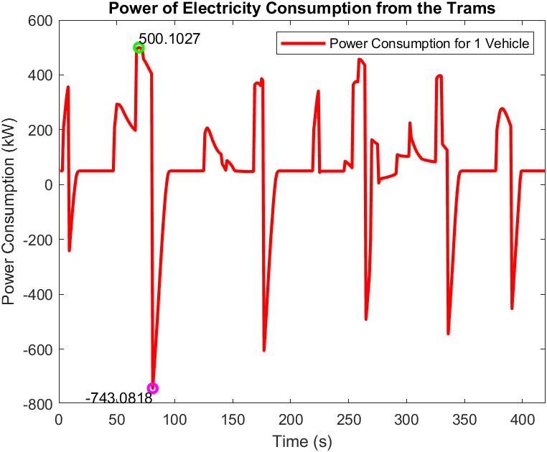

Figure 1: Power Consumption in period t

This ***Figure 1*** is going to talk about the power consumption from the trams in the period time (s). The positive sign of the line graph represents traction mode, corresponding to a phase of consumption from the substation or main grid, with the maximum consumption being about 500 kW. The negative sign of the line graph shows for the baking mode that corresponds to the phase of the charging to the main grid. As a result of the tramway system nowadays, they used the traditional rectifier with diode or bridge rectifier. The bridge rectifier is using the diode as the main component, as that diode just allows only one direction of current.

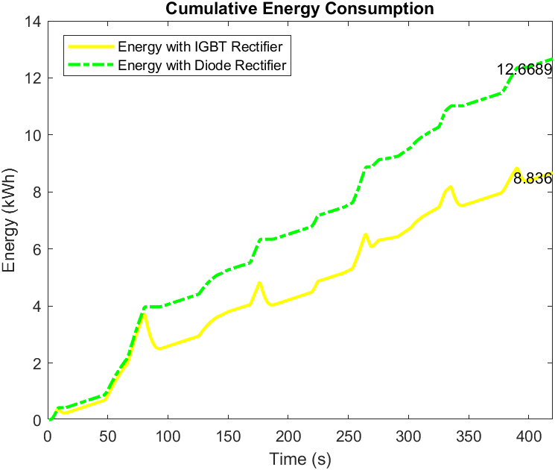

Figure 2: Cumulative Energy Consumption

## Total Energy Consumption

The result shown in ***Figure 2*** of the directional substation (diode) and bi-directional substation (IGBT), we can see the energy consumption is much different from each other since the directional substation will consume 12.67 kWh, while the bi-directional substation just consumes less than the directional substation around **3.8329 kWh.** As the result of this analysis, we suggest using an IGBT rectifier to have bidirectional current that can inject some power from the baking point into the grid.

## PPH and EPH

As the result PPH and EPH by using Equation *1* and Equation *2*, we saw that PPH is almost **0.8511** will EPH is just **0.059**. By analyzing the result from the implement, this study will be more interested to being a hybridization as the result of PPH close 1.

* 1. Spectrum Frequency of PESS Power

The frequency spectrum shown in ***Figure 3*** of PESS power shows that the most significant power variations occur at low frequencies, with the magnitude peaking around 89 in the frequency at . As the frequency increasing, the power magnitude steadily declines, indicating the higher-frequency have the smaller impact to the grid consumption. At the high-frequency correspond to rapid fluctuations or noise which less critical to the main grid system. Additionally, to filter the noise or small impact from energy consumption, low frequency will be implemented in the energy management system in result of improvement the energy efficiency and grid stability and make the vehicle more reliable.

Figure 3: PESS Power Frequency Spectrum

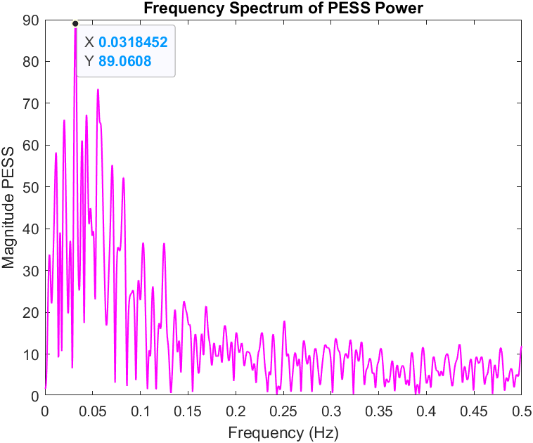

## EMS Power Sharing

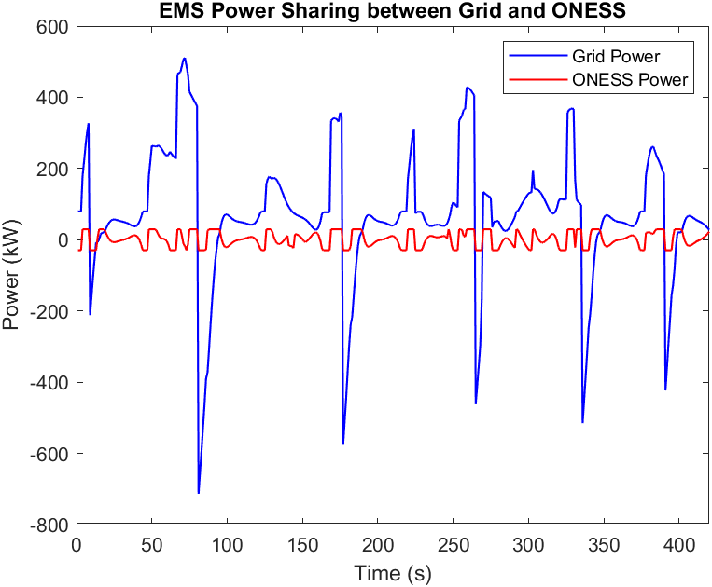

Figure 4: Sharing Power between Grid and ONESS depend on the Spectrum Frequency

In ***Figure 4***, the EMS power-sharing strategy between the main grid and the ESS highlights that vehicle power consumption draws significantly more from the grid than from the ESS. To understand ONESS's behavior within this system, a low-pass filter with a cutoff frequency was applied to filter out noise. With data sampled every second, the sampling frequency is set at . The resulting ONESS power, shown by the red curve, ranges between a maximum of **29.521 kW** and a minimum of **-29.521 kW**, indicating the charge and discharge power under the energy potential hybridization **(EPH)** constraint. This demonstrates ONESS’s role as a buffer, helping to offload demand from the grid and smooth out short-term fluctuations.



Figure 5: ONESS System Analysis

## Sizing ONESS

We assume that the overall conversion efficiency in the system is 90% (converters and losses of the storage facility. The energy stored any point in times depended on the power balance managed by the EMS. ONESS charges when excess power is during the low grid power in the periods time and discharges energy to support the load demands. The energy charges and discharges in this time periods up to . To control ONESS, EMS is the main adaptations thing that we need to control the value of ONESS also to reduce peak loads and manage energy flow more efficiently. To have the ONESS, we also applied the filter (Low-Pass Filter) in the EMS to smooth the ONESS usage and balance usage between the ONESS and the grid. Depend on the analysis on *Figure 5* of the ONESS capacity need is **39 kWh** usage with three types of the battery that proposed in the methodology with investment and capacity.

* Li-ion : **6258.5 USD** with **48.1 kWh** to supply 39kWh with
* NiMH : **14189.3 USD** with **40.5 kWh** to supply 39kWh with **.**
* Lead Fluid : **11554.1 USD** with **77 kWh** to supply 39kWh with .

From the [1], [2], [3], [4] with our calculation, **Li-ion is the best** type of battery that used in the system. Moreover, to make sure that battery is the best type of storage system, supercapacitor also calculated.Furthermore, Mass and Cells in the battery have less than supercapacitor to make the weight much less than also the cost of supercapacitor much higher than the investment cost of the battery. As the result, the system of this study case will design to use with **Li-ion battery.**

For storage system as flywheels, the size of the wheel of this scenario assume that radius is 0.5m with the rotation speed around 10000RPM, the angular velocity is calculated as . The associated motor is sized based on the torque (T) generated by the angular acceleration and the result in peak motor power output of **455 kW.**

## Optimization Result

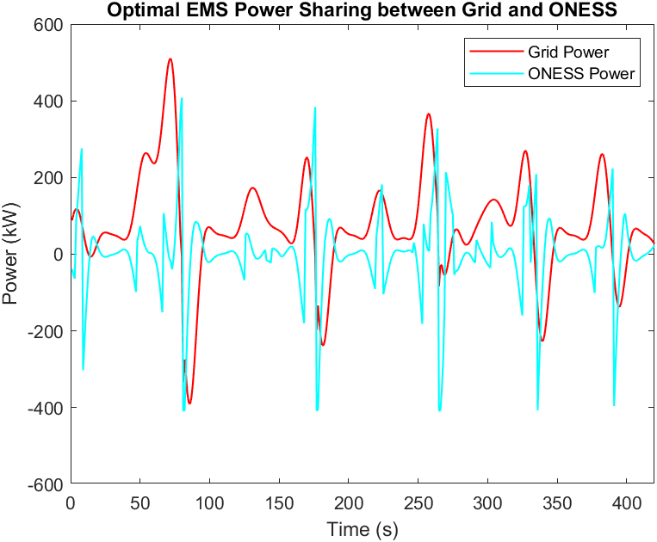

Figure 6: Optimal Power Sharing between Grid and ONESS

In this section, Quadratic Linear programming will use as optimization tools to find the optimal cut off, DOD and Energy Potential Hybridization (EPH). Particle Swarm Optimization algorithm (PSO) will use to implement the objective function. The objective function of this study case is going to find the optimal price of the battery system and the value of EPH interest shown in Equation *14* . After simulation, the result of the implement shown in *Figure 6* and *Figure 7.*

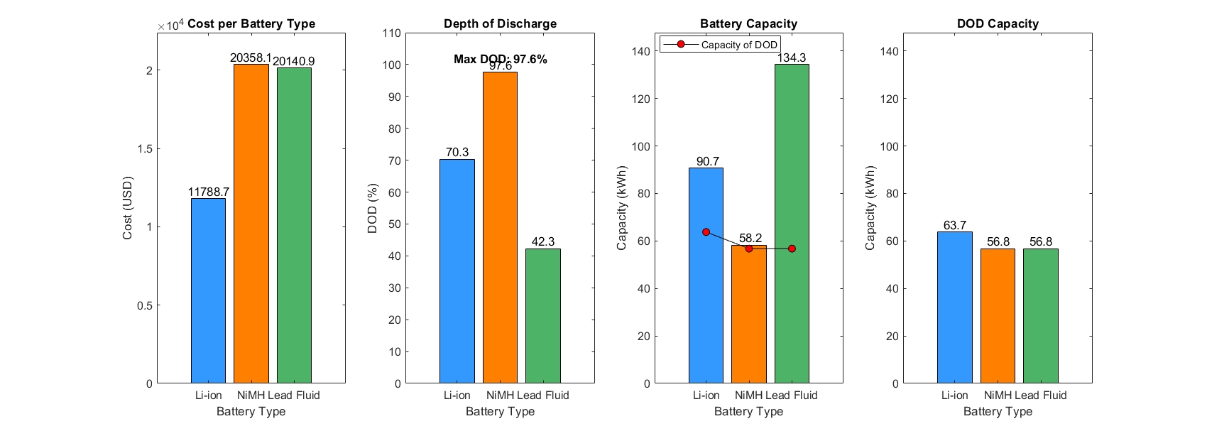

Figure 7: Result of the Optimization with Objective Function

* Battery Type : Li-ion
* The cutoff Frequency :
* Depth of Discharges :
* Energy Potential Hybridization : 0.8161
* Minimum Cost : 11788.71 USD

|  |  |
| --- | --- |
|  |  |

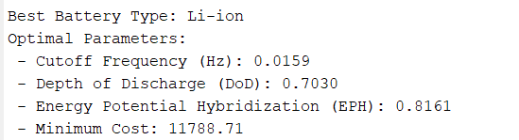

# Reference

[1] H. Chen, T. N. Cong, W. Yang, C. Tan, Y. Li, and Y. Ding, “Progress in electrical energy storage system: A critical review,” 2009, *Science Press*. doi: 10.1016/j.pnsc.2008.07.014.

[2] A. Eftekhari and D.-W. Kim, “Sodium-ion batteries: New opportunities beyond energy storage by lithium,” *J Power Sources*, vol. 395, pp. 336–348, Aug. 2018, doi: 10.1016/j.jpowsour.2018.05.089.

[3] D. O. Akinyele and R. K. Rayudu, “Review of energy storage technologies for sustainable power networks,” *Sustainable Energy Technologies and Assessments*, vol. 8, pp. 74–91, 2014, doi: https://doi.org/10.1016/j.seta.2014.07.004.

[4] A. Burke, “Ultracapacitors: Why, How, and Where Is the Technology,” *J Power Sources*, vol. 91, pp. 37–50, Nov. 2000, doi: 10.1016/S0378-7753(00)00485-7.

# Appendices

## Appendix A:Power of Potential Hybridization (PPH)

|  |  |  |
| --- | --- | --- |
|  |  | Equation 1 |

## Appendix B:Energy of Potential Hybridization (EPH)

|  |  |  |
| --- | --- | --- |
|  |  | Equation 2 |
|  |  | Equation 3 |
| Useful Energy (Eu) |  | Equation 4 |
| Energy Stored (Es) |  | Equation 5 |

## Appendix C:Power of the Energy Storage System

|  |  |  |
| --- | --- | --- |
|  |  | Equation 6 |
|  | : Power from Grid with average power of the load. (kW) |  |
|  | : Power of the Energy Storage System |  |

## Appendix D: **C**alculate energy change of ONESS

|  |  |  |
| --- | --- | --- |
|  |  | Equation 7 |
|  | : Energy of On-Board Energy Storage System (kWh) |  |
|  | : On-Board Energy Storage System (kW) |  |
|  | : Efficiency of the conversion system |  |

## Appendix E:Flywheel and Associated Motor

|  |  |  |
| --- | --- | --- |
|  |  | Equation 8 |
|  |  | Equation 9 |
|  |  | Equation 10 |
|  |  | Equation 11 |
|  |  | Equation 12 |
|  |  | Equation 13 |

## Appendix F: Optimization Function

|  |  |  |
| --- | --- | --- |
|  |  | Equation 14 |

## Appendix G: TP Coding

TP Code : <https://github.com/Monychot-SARY/Hybridization-of-Light-Rail-System.git>

Or : [Submit](https://itcedukh-my.sharepoint.com/:f:/g/personal/monychot_sary_gsc_itc_edu_kh/EsjU8-NQdOhPj5Tdsa256eEBlV7pDMgz4DY-4WdbdeDhpA?e=PzvNzR)