As of this writing, our unit test code coverage can be seen in the breakdown below:

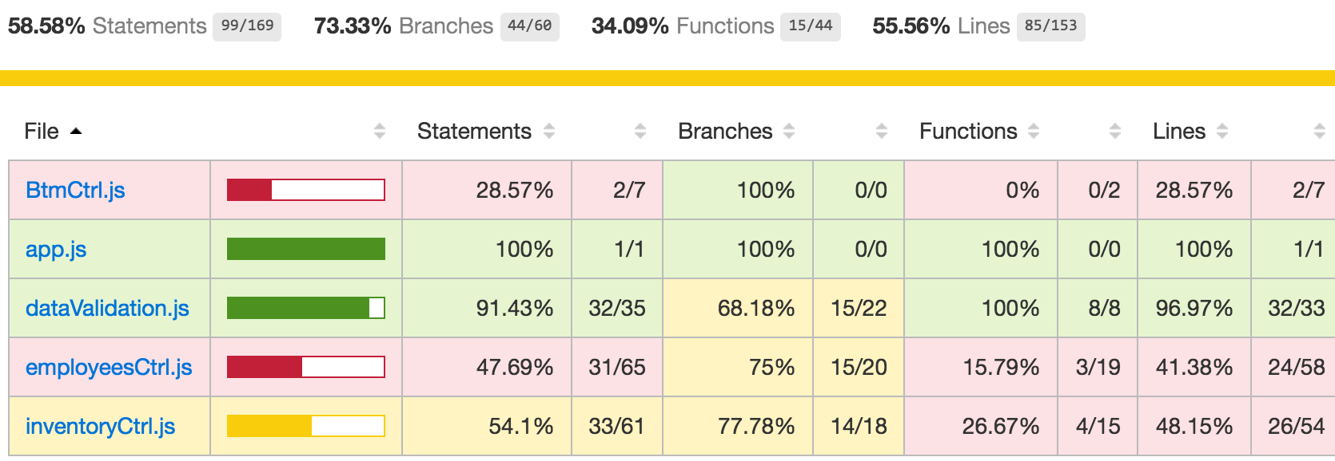

The full report can be found here: <https://github.com/larrylzhao/therollingcars/tree/master/report-html>

App.js is simply a declaration of the application. This is why we see 100% coverage on this file.

dataValidation.js is a giant piece of our application’s business logic. Essentially all of the input and output of our application will pass through this code. This is why the code coverage for this file is very high at 91.43%. In fact, the only piece of code not validated is if a custom alert message is not set, a default one is displayed in its place. This is a very easy piece of code to test and can be added in the future.

employeesCtrl.js and inventoryCtrl.js have very similar issues. Almost all of the untested statements are related to REST API calls to the backend. We can try to find a way to mock the http responses from the backend to unit test the API calls.