###Importing the project into SonarQube, checking the app folder (will work on LCOV later)

C:\cvn\1\therollingcars>C:\sonar-scanner-2.8\bin\sonar-runner.bat

WARN: sonar-runner.bat script is deprecated. Please use sonar-scanner.bat instead.

C:\sonar-scanner-2.8\bin\..

INFO: Scanner configuration file: C:\sonar-scanner-2.8\bin\..\conf\sonar-scanner.properties

INFO: Project root configuration file: C:\cvn\1\therollingcars\sonar-project.properties

INFO: SonarQube Scanner 2.8

INFO: Java 1.8.0_111 Oracle Corporation (64-bit)

INFO: Windows 10 10.0 amd64

INFO: User cache: C:\Users\fabio\.sonar\cache

INFO: Load global repositories

INFO: Load global repositories (done) | time=117ms

INFO: User cache: C:\Users\fabio\.sonar\cache

INFO: Load plugins index

INFO: Load plugins index (done) | time=20ms

INFO: SonarQube server 6.1

INFO: Default locale: "en_GB", source code encoding: "UTF-8"

INFO: Process project properties

INFO: Load project repositories

INFO: Load project repositories (done) | time=76ms

INFO: Load quality profiles

INFO: Load quality profiles (done) | time=139ms

INFO: Load active rules

INFO: Load active rules (done) | time=669ms

INFO: Publish mode

INFO: ------------- Scan Sample-Project

INFO: Language is forced to js

INFO: Load server rules

INFO: Load server rules (done) | time=176ms

INFO: Base dir: C:\cvn\1\therollingcars

INFO: Working dir: C:\cvn\1\therollingcars\.sonar

INFO: Source paths: app

INFO: Test paths: test

INFO: Source encoding: UTF-8, default locale: en_GB

INFO: Index files

INFO: 25 files indexed

INFO: Quality profile for js: Sonar way

INFO: Sensor Lines Sensor

INFO: Sensor Lines Sensor (done) | time=24ms

INFO: Sensor SCM Sensor

INFO: SCM provider for this project is: git

INFO: 25 files to be analyzed

INFO: 25/25 files analyzed

INFO: Sensor SCM Sensor (done) | time=1423ms

INFO: Sensor XmlFileSensor

INFO: Sensor XmlFileSensor (done) | time=2ms

INFO: Sensor JavaScript Squid Sensor

INFO: 21 source files to be analyzed

INFO: Unit Test Coverage Sensor is started

INFO: 21/21 source files have been analyzed

WARN: No coverage information will be saved because LCOV file cannot be found.

WARN: Provided LCOV file path: report/lcov.dat. Seek file with path: C:\cvn\1\therollingcars\report\lcov.dat

WARN: No coverage information will be saved because all LCOV files cannot be found.

INFO: Integration Test Coverage Sensor is started

INFO: Overall Coverage Sensor is started

WARN: No coverage information will be saved because LCOV file cannot be found.

WARN: Provided LCOV file path: report/lcov.dat. Seek file with path: C:\cvn\1\therollingcars\report\lcov.dat

WARN: No coverage information will be saved because all LCOV files cannot be found.

INFO: Sensor JavaScript Squid Sensor (done) | time=1026ms

INFO: Sensor Zero Coverage Sensor

INFO: Sensor Zero Coverage Sensor (done) | time=49ms

INFO: Sensor Code Colorizer Sensor

INFO: Sensor Code Colorizer Sensor (done) | time=15ms

INFO: Sensor CPD Block Indexer

INFO: DefaultCpdBlockIndexer is used for js

INFO: Sensor CPD Block Indexer (done) | time=10ms

INFO: Calculating CPD for 14 files

INFO: CPD calculation finished

INFO: Analysis report generated in 331ms, dir size=83 KB

INFO: Analysis reports compressed in 141ms, zip size=61 KB

INFO: Analysis report uploaded in 232ms

INFO: ANALYSIS SUCCESSFUL, you can browse http://localhost:9000/dashboard/index/sample:js

INFO: Note that you will be able to access the updated dashboard once the server has processed the submitted analysis report

INFO: More about the report processing at http://localhost:9000/api/ce/task?id=AVjKRBzdjPSy38ymihAi

INFO: Task total time: 5.883 s

INFO: ------------------------------------------------------------------------

INFO: EXECUTION SUCCESS

INFO: ------------------------------------------------------------------------

INFO: Total time: 7.199s

INFO: Final Memory: 46M/315M

INFO: ------------------------------------------------------------------------

###Adding the other folders

C:\cvn\1\therollingcars>C:\sonar-scanner-2.8\bin\sonar-runner.bat

WARN: sonar-runner.bat script is deprecated. Please use sonar-scanner.bat instead.

C:\sonar-scanner-2.8\bin\..

INFO: Scanner configuration file: C:\sonar-scanner-2.8\bin\..\conf\sonar-scanner.properties

INFO: Project root configuration file: C:\cvn\1\therollingcars\sonar-project.properties

INFO: SonarQube Scanner 2.8

INFO: Java 1.8.0_111 Oracle Corporation (64-bit)

INFO: Windows 10 10.0 amd64

INFO: User cache: C:\Users\fabio\.sonar\cache

INFO: Load global repositories

INFO: Load global repositories (done) | time=108ms

INFO: User cache: C:\Users\fabio\.sonar\cache

INFO: Load plugins index

INFO: Load plugins index (done) | time=15ms

INFO: SonarQube server 6.1

INFO: Default locale: "en_GB", source code encoding: "UTF-8"

INFO: Process project properties

INFO: Load project repositories

INFO: Load project repositories (done) | time=152ms

INFO: Load quality profiles

INFO: Load quality profiles (done) | time=57ms

INFO: Load active rules

INFO: Load active rules (done) | time=300ms

INFO: Publish mode

INFO: ------------- Scan Sample-Project

INFO: Language is forced to js

INFO: Load server rules

INFO: Load server rules (done) | time=131ms

INFO: Base dir: C:\cvn\1\therollingcars

INFO: Working dir: C:\cvn\1\therollingcars\.sonar

INFO: Source paths: app, auth, public

INFO: Test paths: test

INFO: Source encoding: UTF-8, default locale: en_GB

INFO: Index files

INFO: 41 files indexed

INFO: Quality profile for js: Sonar way

INFO: Sensor Lines Sensor

INFO: Sensor Lines Sensor (done) | time=28ms

INFO: Sensor SCM Sensor

INFO: SCM provider for this project is: git

INFO: 16 files to be analyzed

INFO: 16/16 files analyzed

INFO: Sensor SCM Sensor (done) | time=1175ms

INFO: Sensor XmlFileSensor

INFO: Sensor XmlFileSensor (done) | time=2ms

INFO: Sensor JavaScript Squid Sensor

INFO: 37 source files to be analyzed

INFO: Unit Test Coverage Sensor is started

INFO: 37/37 source files have been analyzed

WARN: No coverage information will be saved because LCOV file cannot be found.

WARN: Provided LCOV file path: report/lcov.dat. Seek file with path: C:\cvn\1\therollingcars\report\lcov.dat

WARN: No coverage information will be saved because all LCOV files cannot be found.

INFO: Integration Test Coverage Sensor is started

INFO: Overall Coverage Sensor is started

WARN: No coverage information will be saved because LCOV file cannot be found.

WARN: Provided LCOV file path: report/lcov.dat. Seek file with path: C:\cvn\1\therollingcars\report\lcov.dat

WARN: No coverage information will be saved because all LCOV files cannot be found.

INFO: Sensor JavaScript Squid Sensor (done) | time=1525ms

INFO: Sensor Zero Coverage Sensor

INFO: Sensor Zero Coverage Sensor (done) | time=156ms

INFO: Sensor Code Colorizer Sensor

INFO: Sensor Code Colorizer Sensor (done) | time=6ms

INFO: Sensor CPD Block Indexer

INFO: DefaultCpdBlockIndexer is used for js

INFO: Sensor CPD Block Indexer (done) | time=7ms

INFO: Calculating CPD for 27 files

INFO: CPD calculation finished

INFO: Analysis report generated in 277ms, dir size=155 KB

INFO: Analysis reports compressed in 161ms, zip size=107 KB

INFO: Analysis report uploaded in 37ms

INFO: ANALYSIS SUCCESSFUL, you can browse http://localhost:9000/dashboard/index/sample:js

INFO: Note that you will be able to access the updated dashboard once the server has processed the submitted analysis report

INFO: More about the report processing at http://localhost:9000/api/ce/task?id=AVjKScHajPSy38ymihAj

INFO: Task total time: 5.659 s

INFO: ------------------------------------------------------------------------

INFO: EXECUTION SUCCESS

INFO: ------------------------------------------------------------------------

INFO: Total time: 6.893s

INFO: Final Memory: 48M/381M

INFO: ------------------------------------------------------------------------

###Found 4 Bugs, 49 Vulnerabilities, 6h of Technical Debt, 93 Code Smells, 6 Duplicated Blocks (10.5%)

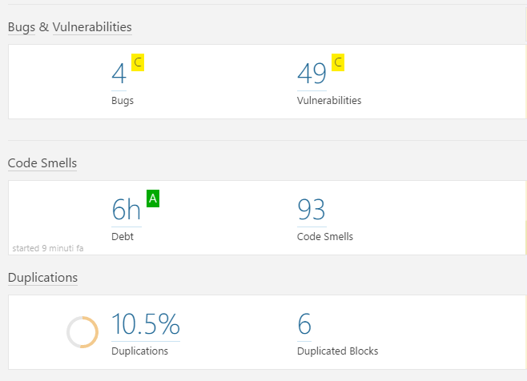

###Let’s check the bugs first

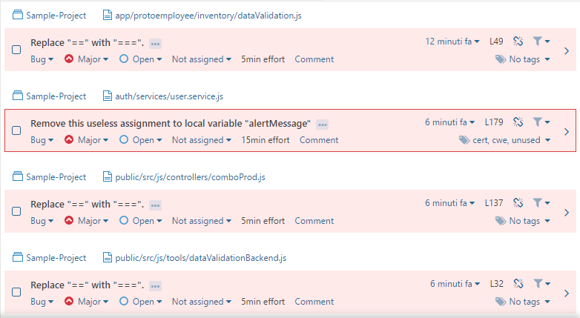

Looks trivial stuff, let’s fix them

(it is interesting that SonarQube doesn’t like this assignment: var alertMessage = '';)

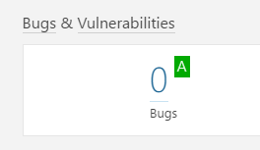

Yeah, 0 bugs now

Let’s look at the 49 vulnerabilities. We can divide them by kind:

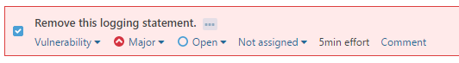

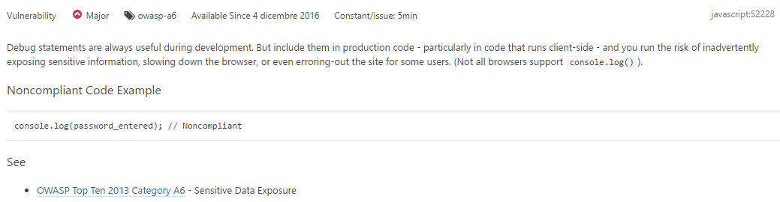

We have 44 of them



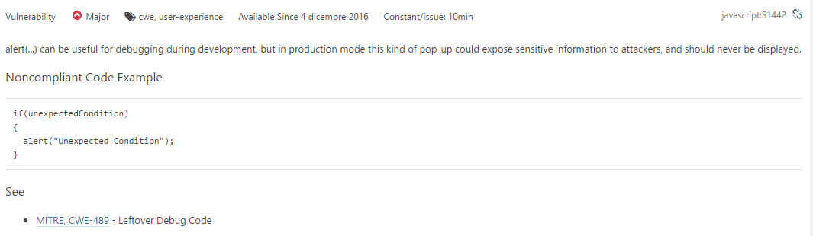

We have 5 of them

Since this is a class project, we decided to keep them.

Let’s look at the 93 code smells, let’s start with the 34 Major, I will only list the kinds

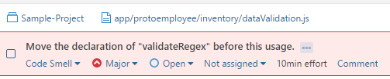

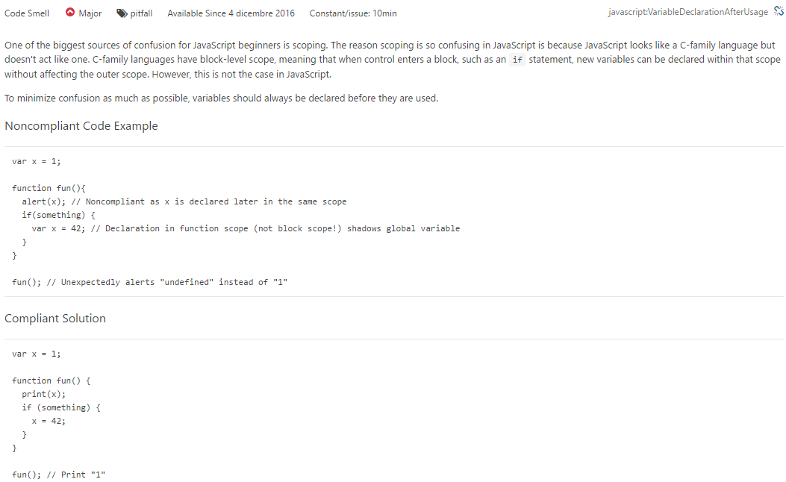

This is very interesting



This is obvious

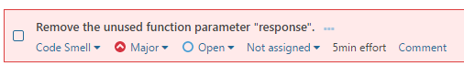

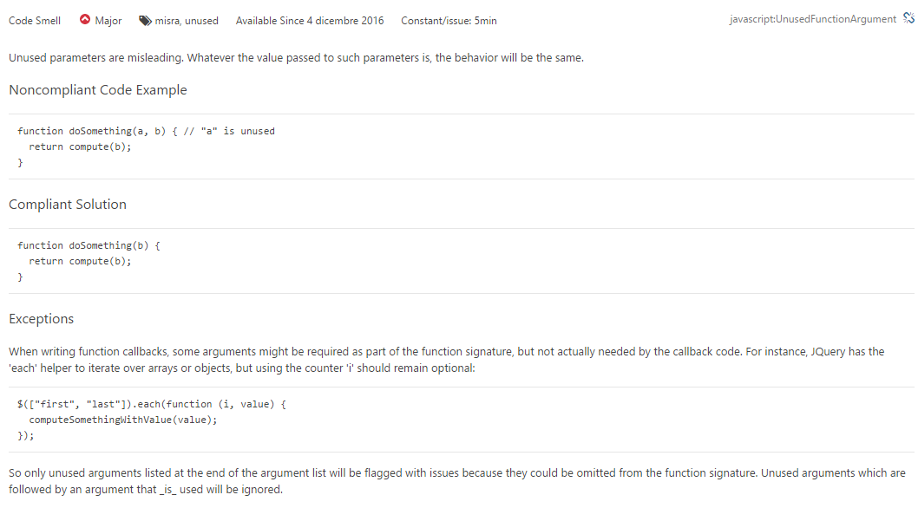

This is worth an investigation

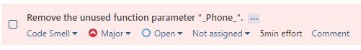

This should be fixed, we have many of them using different parameters

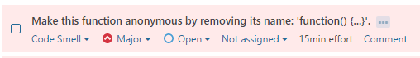

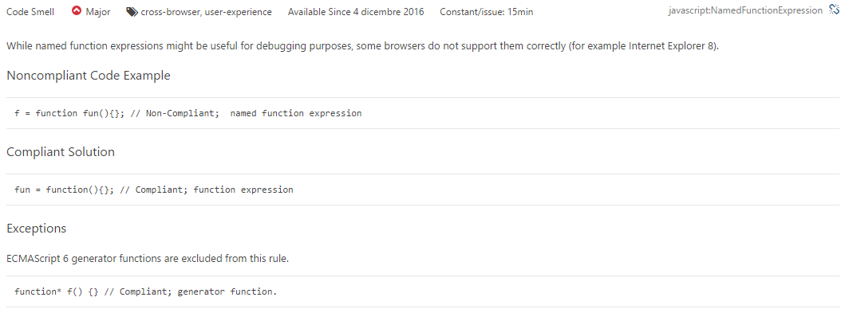

Interesting

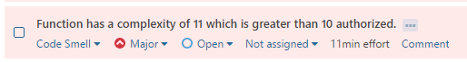

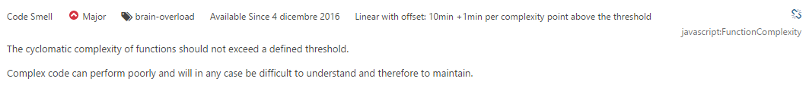

Very interesting! (sorry for being happy when I find something that should be fixed, I like that those things are reported by the tool)

Let’s look at the 41 minors:

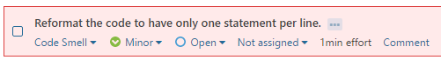

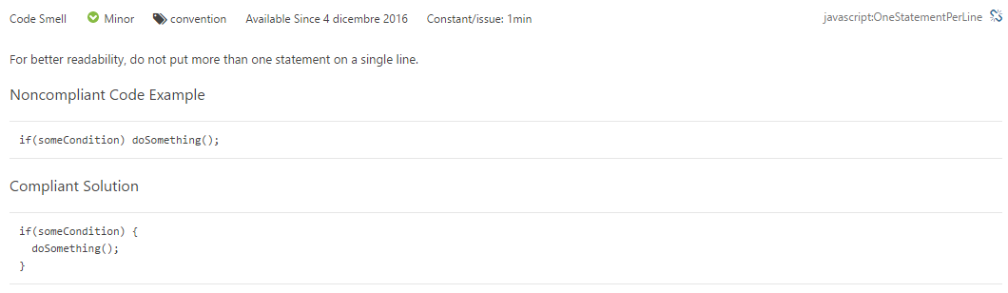

41 times this same thing, I believe it should be fixed.

Let’s look at the 18 info:

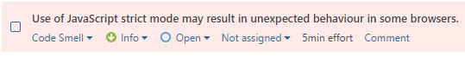

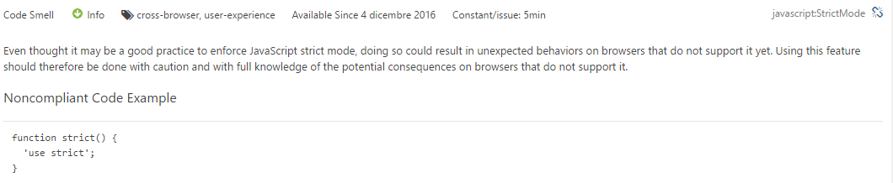18 times this same thing, we should research more about this functionality.

Finally, let’s look at the 6 blocks of duplicated code:

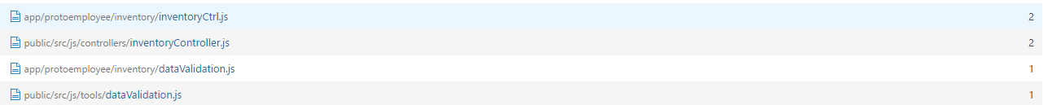

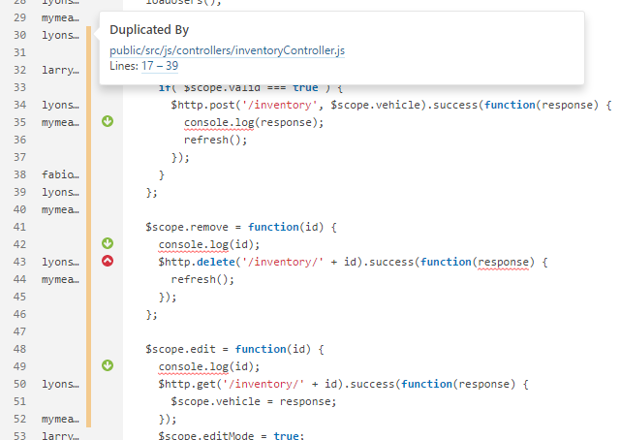

Here we have one issues that we are aware of. It is related to the move of some code from iteration one to iteration two, we included it to a different part of the program. The old files should be deleted, I’m going to open a task for that.