TheRollingCars – System Tests

Prajesh Praveen Anchalia - pp2546

Fabio Mastromatteo - fm2498

Larry Zhao - lz2479

Anthony Mazza - am4564

Alexander Lyons - aml2297

Contents

1. Prerequisite 3

2. New User Registration 3

2.1 (optional) New user registration – bad user 3

2.2 New user registration – test validation 3

3. User Login 4

3.1 (optional) User login – invalid user 4

3.2 (optional) User login – not existing user 4

3.3 User login 4

4. Users and Customers management 5

4.1 Employee login 5

4.2 Check the users list 5

4.3 (optional) Add a new user – invalid data 6

4.4 Add a new user 6

4.5 Modify a user 6

4.6 Logging in using the “New Customer” credentials 7

4.7 (optional) check directly on the DB 7

4.8 Change my account 8

4.9 Cancel a user 8

5. Inventory Management 9

5.1 Insert a new vehicle 9

5.2 Modify a vehicle 9

5.3 List the vehicle as a customer 10

5.4 Delete a car 10

# Prerequisite

* Employee System Test account: systestemployee@mail.com password SystestEmployee123

# New User Registration

## (optional) New user registration – bad user

* Go to <http://localhost:3000/> - Click Register
* Enter the bad sample user:

|  |  |
| --- | --- |
| First Name | Bad |
| Last Name | User |
| Phone Number | 1234567890 |
| Email Address | baduser@mail.com |
| Password | BadUser123 |

* Click on Register
* Verify that we get the error message:

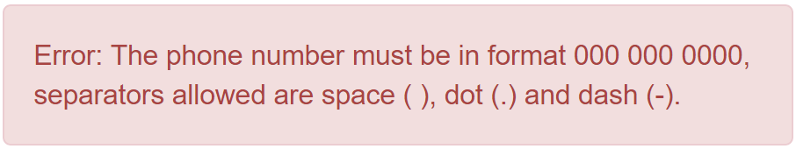

## New user registration – test validation

* Go to <http://localhost:3000/> - Click Register
* Enter the sample user:

|  |  |
| --- | --- |
| First Name | Systest |
| Last Name | Customer |
| Phone Number | 800 555 5555 |
| Email Address | systestcustomer@mail.com |
| Password | SystestCustomer123 |

* Click on Register
* Verify that we get the success message:

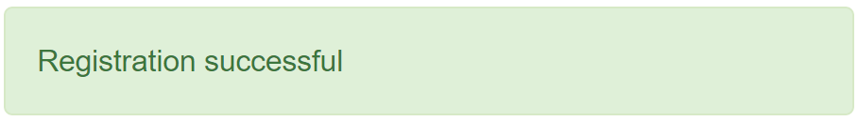

# User Login

## (optional) User login – invalid user

* Go to <http://localhost:3000/login>
* Enter the invalid user credentials:

|  |  |
| --- | --- |
| Email Address | NotAnEmail |
| Password | 1234 |

* Click on Login
* Verify that we get the error message:

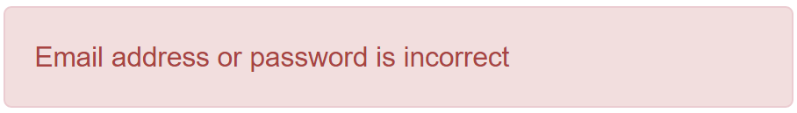

## (optional) User login – not existing user

* Go to <http://localhost:3000/login>
* Enter the not existing user credentials:

|  |  |
| --- | --- |
| Email Address | idontexist@mail.com |
| Password | IDontExist123 |

* Click on Login
* Verify that we get the error message:



## User login

* Go to <http://localhost:3000/login>
* Enter the credentials of system test user that we previously created:

|  |  |
| --- | --- |
| Email Address | systestcustomer@mail.com |
| Password | SystestCustomer123 |

* Click on Login
* Verify that we successfully enter the website and that we don’t have an employee tab

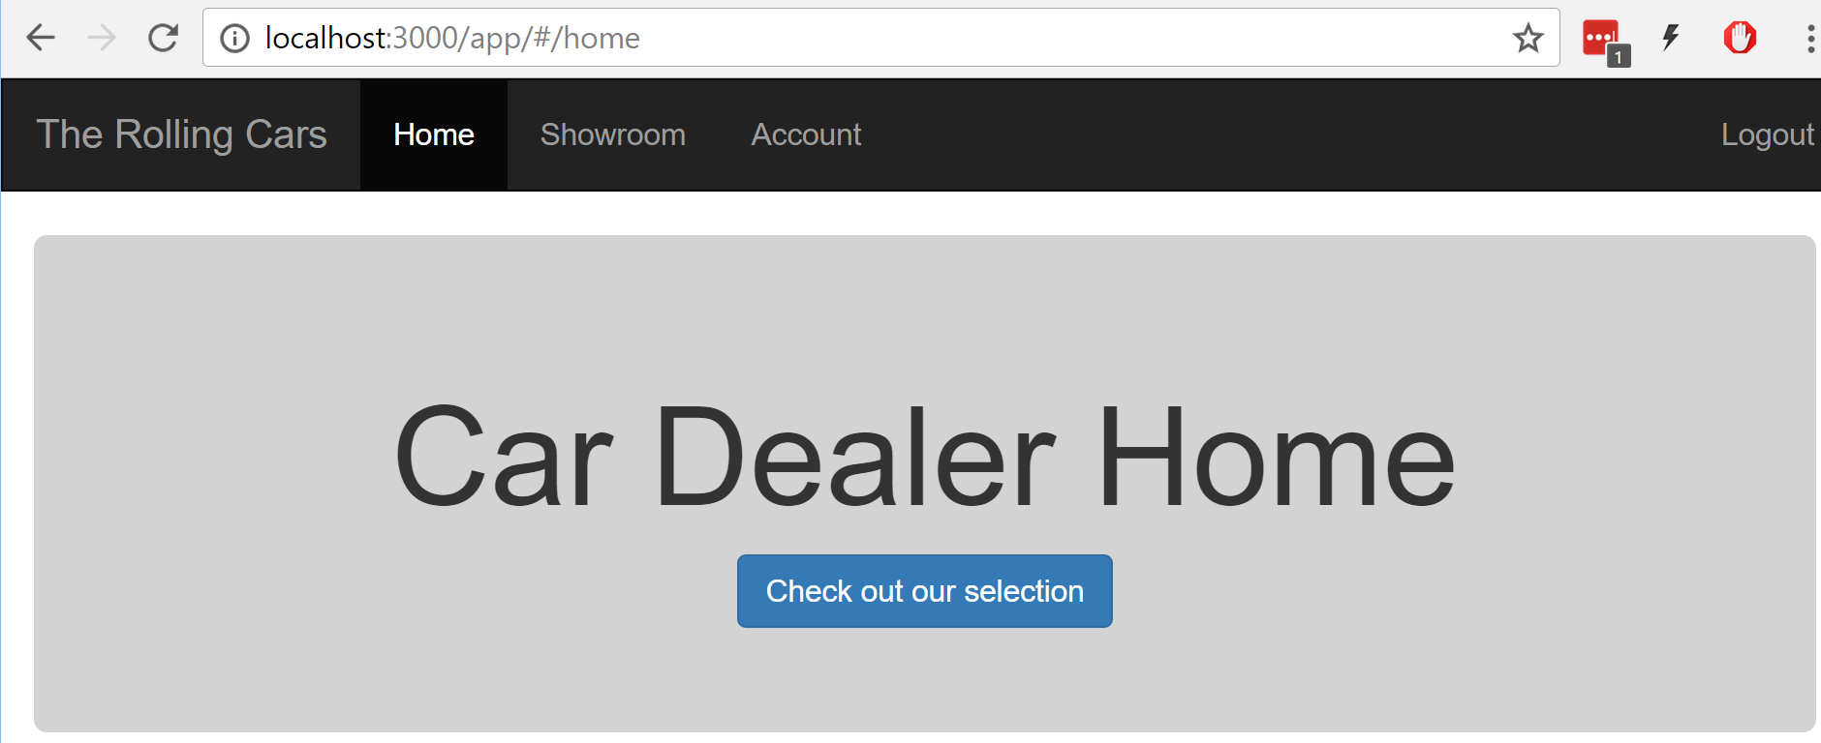

* Logout

# Users and Customers management

## Employee login

* Go to <http://localhost:3000/login>
* Enter the Employee System Test credentials:

|  |  |
| --- | --- |
| Email Address | systestemployee@mail.com |
| Password | SystestEmployee123 |

* Verify that we successfully enter the website and that the employee tab is visible

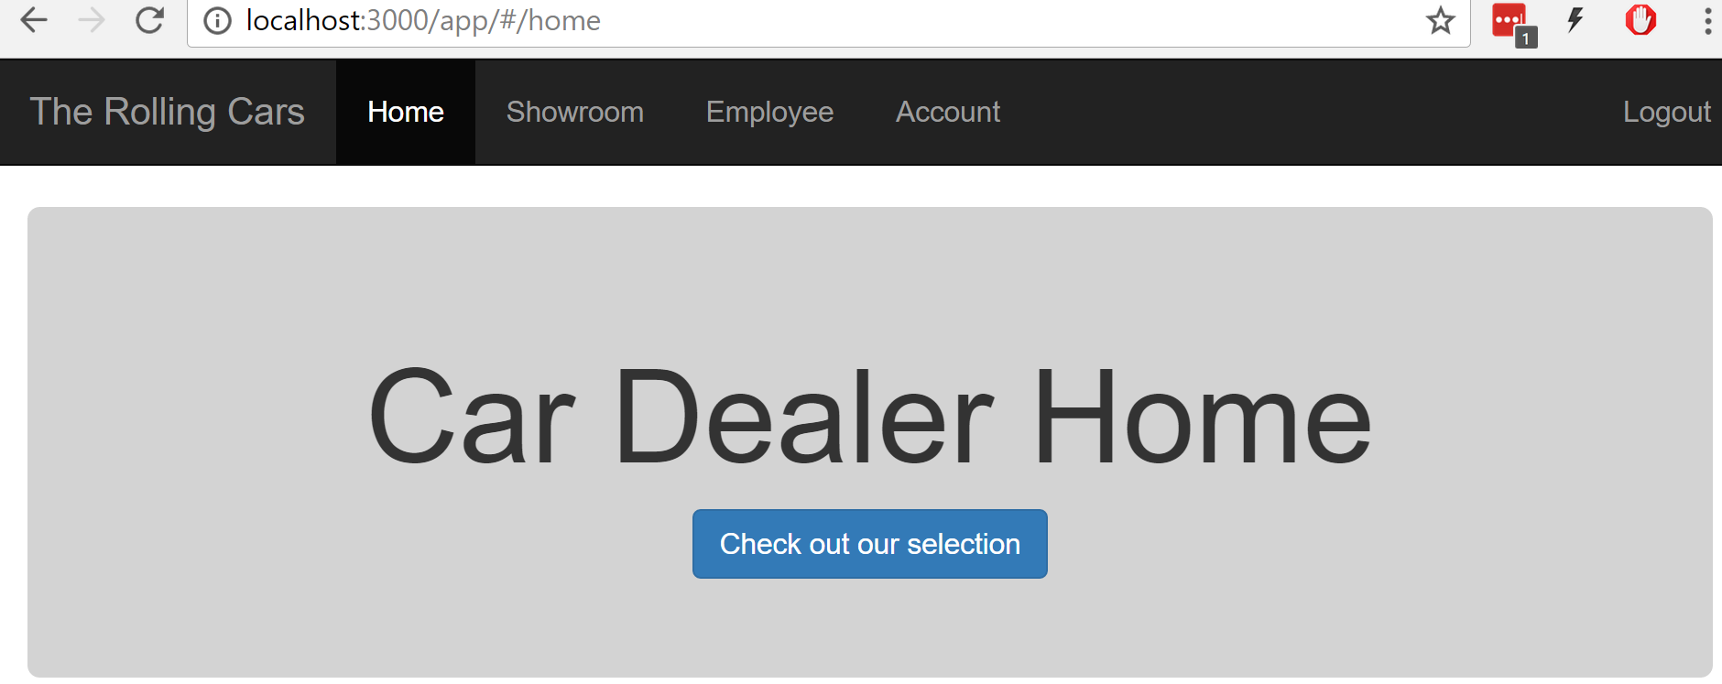

## Check the users list

* Click on Employee – Users
* Check that we can see the “Systest User” and “Systest Employee”

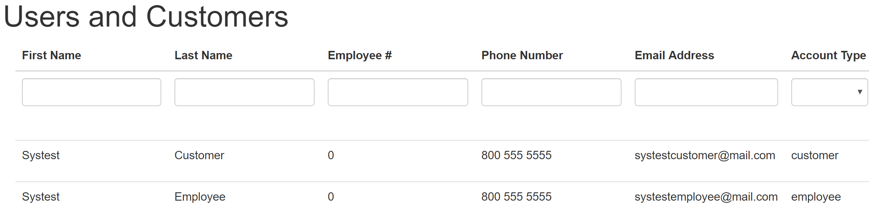

## (optional) Add a new user – invalid data

* Click on Employee – Users
* Add the invalid user

|  |  |
| --- | --- |
| First Name | Invalid |
| Last Name |  |
| Employee # | 123456 |
| Phone Number | 800 555 5555 |
| Email Address | baduser@mail.com |
| Account Type | customer |
| Password | Invalid123 |

* Add User
* Verify that you get the following error message

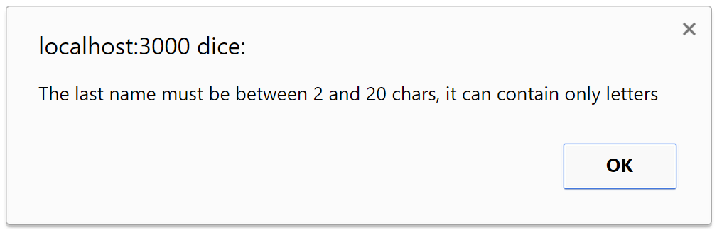

## Add a new user

* Click on Employee – Users
* Add the new user

|  |  |
| --- | --- |
| First Name | New |
| Last Name | Customer |
| Employee # | 123456 |
| Phone Number | 800 555 5555 |
| Email Address | newcustomer@mail.com |
| Account Type | customer |
| Password | NewCustomer123 |

* Add User
* Verify that the new user is listed



## Modify a user

* Click on Employee – Users
* Click on the Edit button next to the newly created “New Customer”
* Change the employee number in 654321
* Click on Update
* Verify that the user is updated



## Logging in using the “New Customer” credentials

* Logout
* Go to <http://localhost:3000/login>
* Enter the credentials of system test user that we previously created:

|  |  |
| --- | --- |
| Email Address | newcustomer@mail.com |
| Password | NewCustomer123 |

* Click on Login
* Verify that you can successfully enter



## (optional) check directly on the DB

* Check on the DB that only the three users have been created (no data reached the DB in case of failed attempts) - (I am using RoboMongo)
* Command: db.getCollection('users').find({})

{

"_id" : ObjectId("584c5eecf2432e3da8a8d06c"),

"firstName" : "Systest",

"lastName" : "Customer",

"phoneNumber" : "800 555 5555",

"emailAddress" : "systestcustomer@mail.com",

"hash" : "$2a$10$OmifvR6J0KGwwQGDtacHy.E8YhcojeS0rwJL5TsdIaHBRValR9CO2",

"usertype" : "customer",

"employeeNumber" : "0"

},

{

"_id" : ObjectId("584c648ef2432e3da8a8d06d"),

"firstName" : "Systest",

"lastName" : "Employee",

"phoneNumber" : "800 555 5555",

"emailAddress" : "SystestEmployee@mail.com",

"hash" : "$2a$10$LO93a23ffaiZiI77LP74POpC.11W8ygQgjOvu5Dfw.Lb02mbuOeki",

"usertype" : "employee",

"employeeNumber" : "0"

},

{

"_id" : ObjectId("584c6996f2432e3da8a8d06e"),

"firstName" : "New",

"lastName" : "Customer",

"employeeNumber" : "123456",

"phoneNumber" : "800 555 5555",

"emailAddress" : "newcustomer@mail.com",

"usertype" : "customer",

"hash" : "$2a$10$DLoaTPUzCNPe81WabjSye.aizkDyC48JylTeYg1NJs1mQNBx4jERu"

}

## Change my account

* Click on account
* Change the phone number from 800 555 5555 to 800 555 8888
* Save
* Click showroom, then account again
* Check that you see the new phone number 800 555 8888
* Logout

## Cancel a user

* Go to <http://localhost:3000/login>
* Enter the Employee System Test credentials:

|  |  |
| --- | --- |
| Email Address | systestemployee@mail.com |
| Password | SystestEmployee123 |

* Click on Employee – Users
* Click the Remove button next to the “New Customer”
* Verify that the “New Customer” is not on the list any longer

# Inventory Management

## Insert a new vehicle

* Go to <http://localhost:3000/login>
* Enter the Employee System Test credentials:

|  |  |
| --- | --- |
| Email Address | systestemployee@mail.com |
| Password | SystestEmployee123 |

* Click on Employee – Inventory
* Add a new vehicle

|  |  |
| --- | --- |
| Make | Ford |
| Model | Mustang |
| Model Year | 2016 |
| Exterior Color | Blue |
| Price | 15000 |
| Invoice Cost | 13500 |
| Miles | 100 |
| Description | Cool and fast |
| Image URL | https://i.ytimg.com/vi/ABWMNsB0_SQ/maxresdefault.jpg |

* Click on the + button
* Check that you can see the newly inserted car

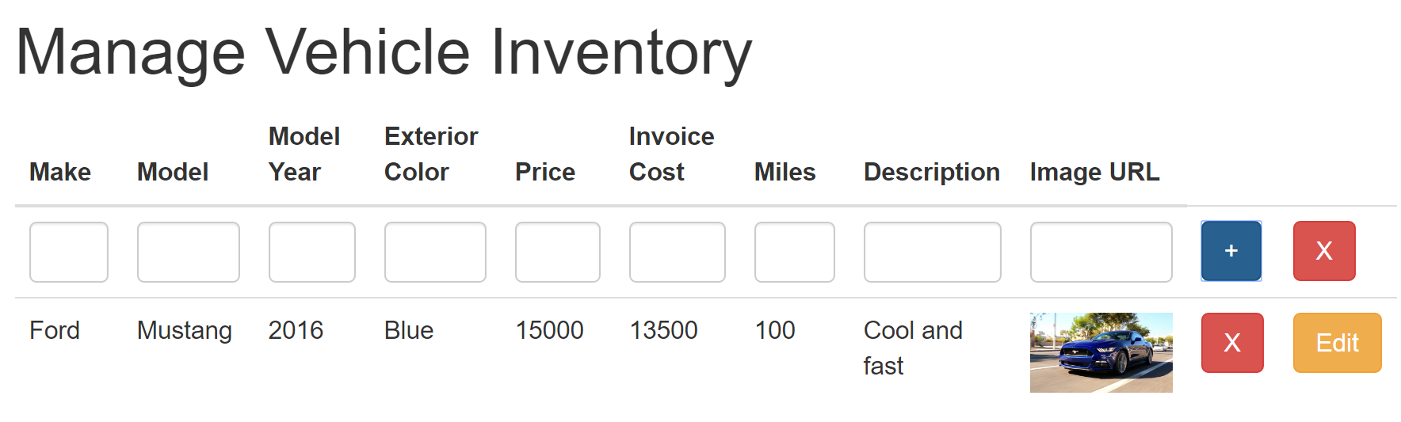

## Modify a vehicle

* Click on Employee – Inventory
* Press the button Edit next to the Ford Mustang
* Change the Price from 15000 to 16000
* Click on Update
* Check that the new price is displayed



## List the vehicle as a customer

* Logout
* Go to <http://localhost:3000/login>
* Enter the Employee System Test credentials:

|  |  |
| --- | --- |
| Email Address | systestcustomer@mail.com |
| Password | SystestCustomer123 |

* Click on Showroom
* Check the you see the Mustang and that it shows the new price of 16000 USD

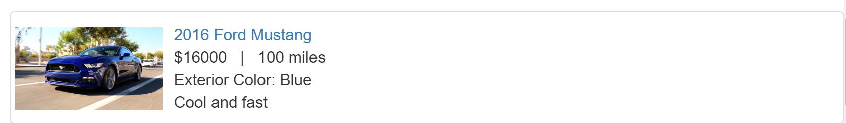

* Click on the “2016 Ford Mustang” link
* Check that you can visualize the full profile

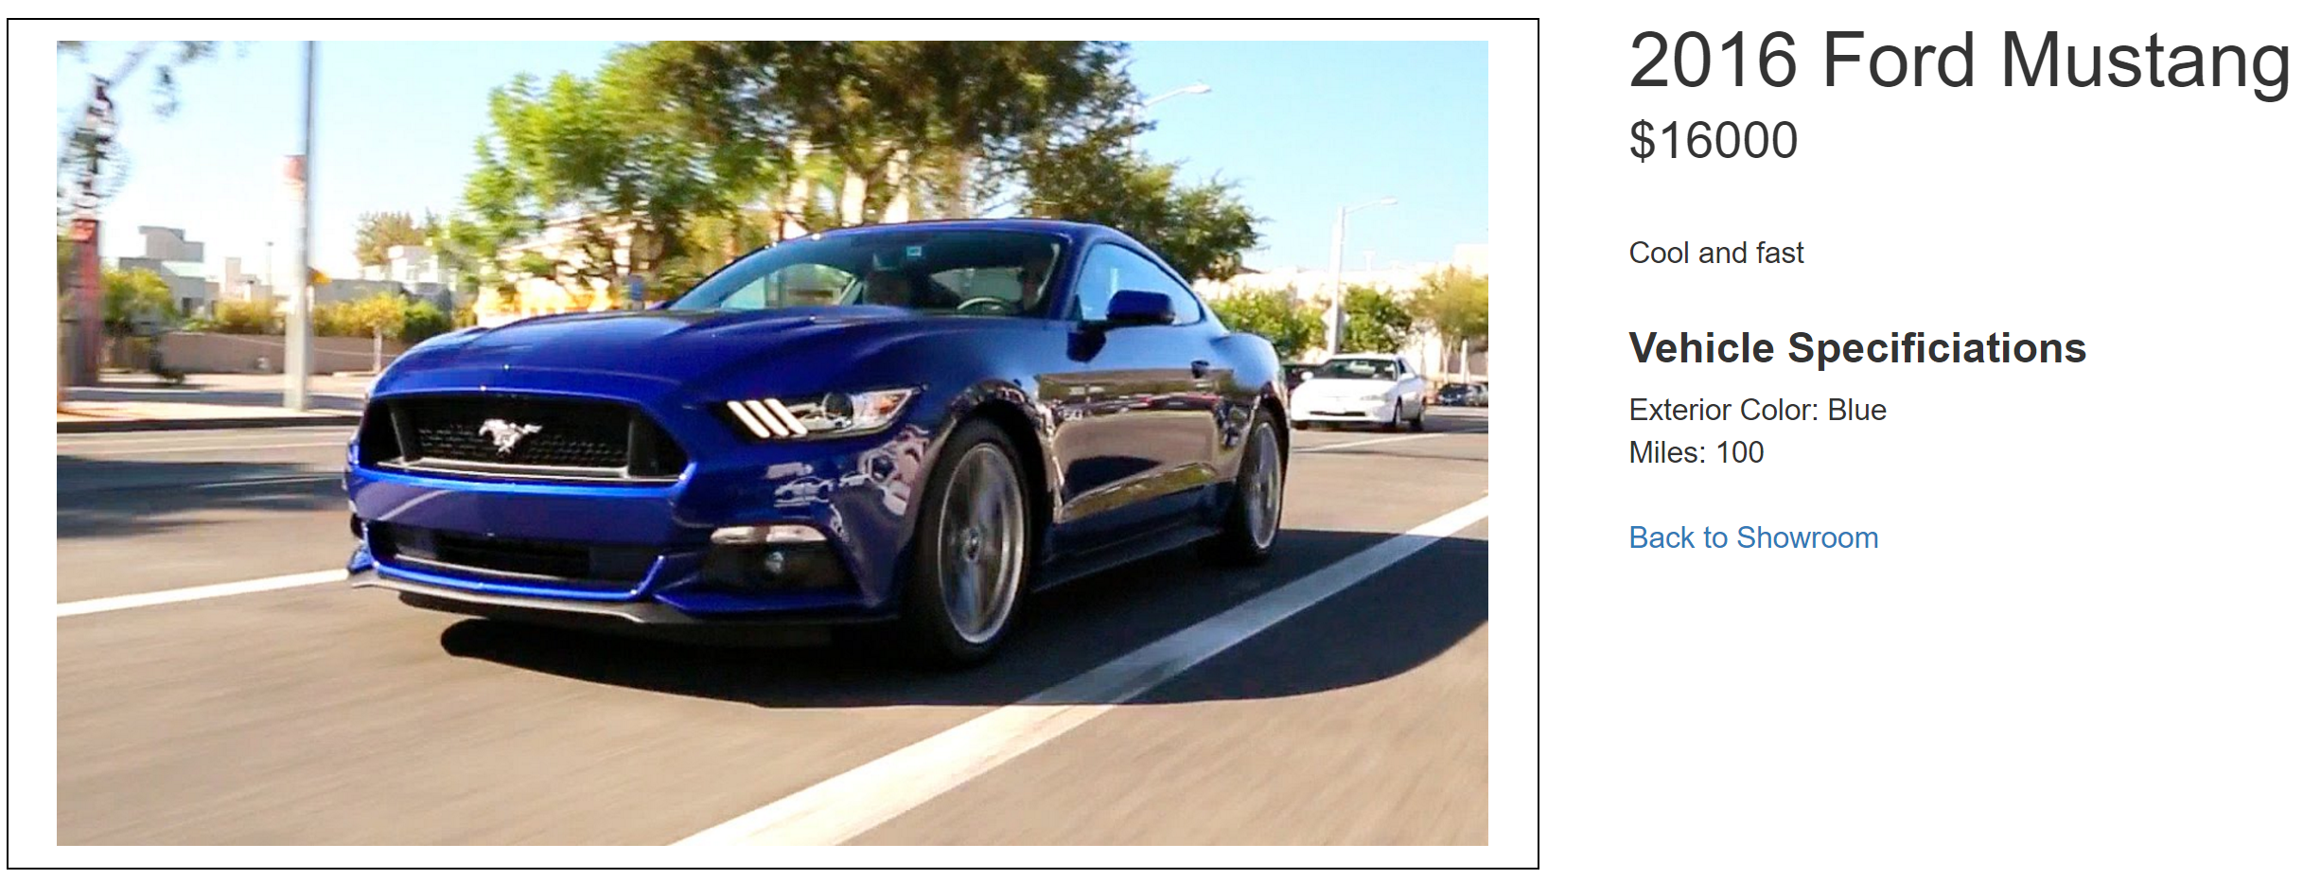

* Click Back to Showroom
* Logout

## Delete a car

* Go to <http://localhost:3000/login>
* Enter the Employee System Test credentials:

|  |  |
| --- | --- |
| Email Address | systestemployee@mail.com |
| Password | SystestEmployee123 |

* Click on Employee – Inventory
* Click on the red X next to the Mustang
* Check that the Inventory is empty
* Logout