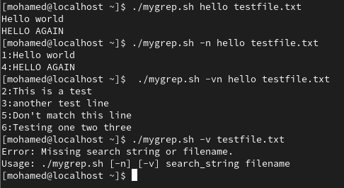

1. A breakdown of **how your script handles arguments and options.**

**First**, it checks if the first argument is --help. If yes, it prints a usage guide and exits.

**Then**, it goes into a while loop to process options:

* If -n is found, it sets show_line_number=true.
* If -v is found, it sets invert_match=true.
* If -vn or -nv are found (combined flags), it sets **both** flags to true.

After processing all options, the next two arguments ($1 and $2) are treated as:

* $1 = search string
* $2 = filename

2. A short paragraph: **If you were to support regex or -i/-c/-l options, how would your structure change?**

1. I would **switch to using getopts** for cleaner option parsing instead of manual checking. getopts makes handling multiple options easier and more scalable.
2. For **regex**: Not much change is needed because grep already supports regex. I would pass the search pattern directly.
3. For **-i** (ignore case): I would add a flag and decide whether to run grep with or without the -i option.
4. For **-c** (count matches): I would add a counter and print the number of matching lines instead of the lines themselves.
5. For **-l** (only list filenames with matches): I would stop reading after finding the first match and just print the filename once.

3. What part of the script was hardest to implement and why?

The hardest part was **handling multiple combined options** like -vn or -nv **without overcomplicating** the script.  
In a simple script like this, it's easy to miss that users might combine options together (like -nv instead of -n -v).  
Also, making sure that the script **still reads the correct search string and filename after parsing options** took a little careful shifting.

Q2

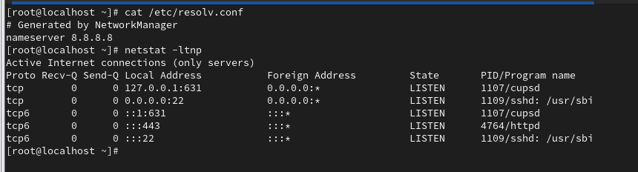

3- Trace the Issue – List All Possible Causes

|  |
| --- |
| DNS |

|  |  |
| --- | --- |
| - Wrong record for internal.example.com  - Internal DNS server down  - /etc/resolv.conf points to bad DNS server | |
| Network |

|  |
| --- |
| - Firewall blocks port 80/443  - Service not listening  - Routing issue between client and server |

|  |
| --- |
| Local |

|  |  |
| --- | --- |
| - /etc/hosts misconfigured | |
| Security |

|  |
| --- |
| - SELinux blocking httpd (rare, but possible) |

Permission

4. Propose and Apply Fixes

For DNS

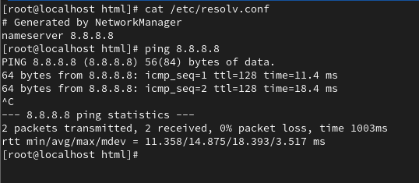

For Local

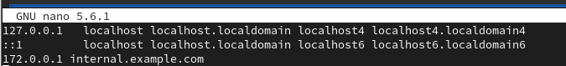

For SELinux

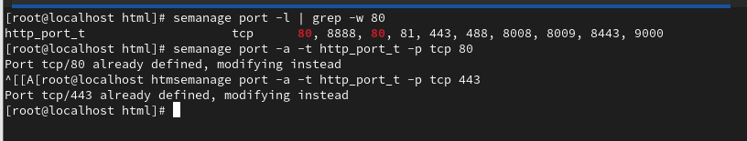

For Network

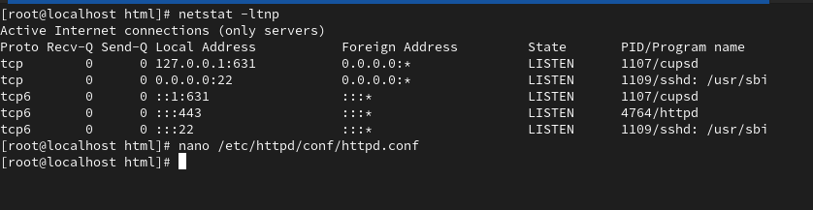



For Permission

