Evaluation Report

1. Experiment Overview
The experiment evaluates three prompt variants — Zero-Shot, Few-Shot, and Role Prompting — across three real-world business tasks:
- Log Triage Summarization
- Arabic PII Redaction Checking
- Customer Complaint Reply Drafting
Each task was tested using three different inputs, with each input assigned to a different prompt variant. Every experiment was run using GPT-5.5 and Gemini 3.5 Flash, resulting in 18 total model runs.

2. Evaluation Methodology
Each output was evaluated based on its accuracy against predefined evaluation criteria and expected answers for each input.
The models were then compared across three dimensions:
- Accuracy: How correctly the output satisfies the task requirements and evaluation criteria.
- Cost: Calculated from input and output token usage using each model's API pricing.
- Latency: Measured as the time required to generate each response.
The final comparison uses the aggregated results across all 18 experiments to assess the trade-off between quality, cost, and response speed.

Accuracy:
GPT-5.5 achieved a slightly higher overall accuracy than Gemini 3.5 Flash (98.9% vs. 96.7%), a difference of 2.2 percentage points. Both models achieved 100% on log triage and Arabic PII detection, with the performance gap occurring in customer complaint drafting. Gemini's main issues were failure to explicitly follow certain output constraints and making unsupported action claims in some customer-support responses.
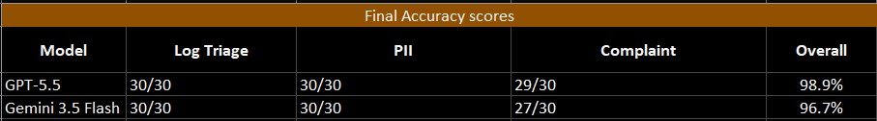

Costs:
GPT-5.5 incurred a total cost of $0.085, compared with $0.019 for Gemini 3.5 Flash. This makes GPT-5.5 approximately 4.47× more expensive, while Gemini is approximately 77.6% cheaper. Given that the accuracy difference was only 2.2 percentage points, Gemini provided a substantially more cost-efficient result in this experiment.
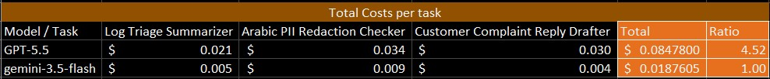

Latency:
Gemini 3.5 Flash achieved a total latency of 13.64 seconds, compared with 41.18 seconds for GPT-5.5. GPT-5.5 was therefore approximately 3.02× slower, while Gemini reduced total latency by approximately 66.9%.
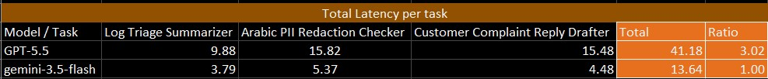

Final observation:
Across the three evaluation dimensions, GPT-5.5 achieved the highest accuracy, but the advantage was relatively small. Gemini 3.5 Flash achieved 96.7% accuracy while costing 77.6% less and completing the experiments approximately 66.9% faster.
Overall, the results indicate that Gemini 3.5 Flash provided the better efficiency trade-off in this test: it delivered nearly the same accuracy at substantially lower cost and latency. GPT-5.5 would be preferable when the additional 2.2 percentage points of accuracy justify its significantly higher cost and latency.

