

**PERSONAL INFORMATION**

|  |  |  |  |  |  |
| --- | --- | --- | --- | --- | --- |
| Patient ID | **BN22052024018** | Group | **Collect fees** | | |
| Patient name | **SARAYUTPHAVADEE** | Age | **47** | Sex | **Male** |
| Address | **Koica vientianeVientiane** | | | | |
| Initial diagnosis or chief complain |  | | | | |

**RESULTS**

|  |
| --- |
| **1. Diagnosis from Newlife LCRP system:** |

Future lung cancer prediction per year:

|  |  |  |  |  |  |  |
| --- | --- | --- | --- | --- | --- | --- |
|  | **1-Year risk** | **2-Year risk** | **3-Year risk** | **4-Year risk** | **5-Year risk** | **6-Year risk** |
| **Index** | 0.23 | 0.23 | 0.23 | 0.2 | 0.2 | 0.2 |

General conclusion:

|  |
| --- |
| **2. Images matter** |

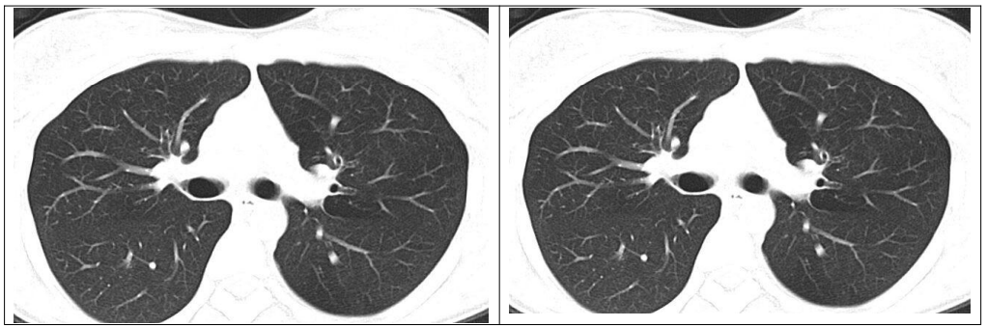

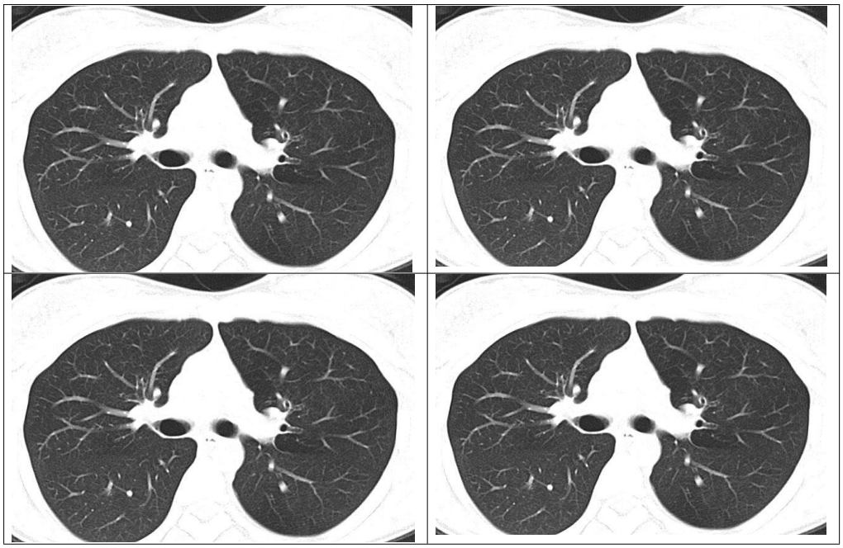

Vientiane, date … month … year …

|  |  |
| --- | --- |
| Physician | Chief of Laboratory |
|  |  |
|  | NewLife Labs |

*\* The information provided on this report was generate by Sybil’s AI tool. Always seek the advice of your physician or other qualified health providers with any questions.*

*\* We would like to thank Sybil for providing a useful tool for early diagnosis of lung cancer risk.*