Test 1: Write a story
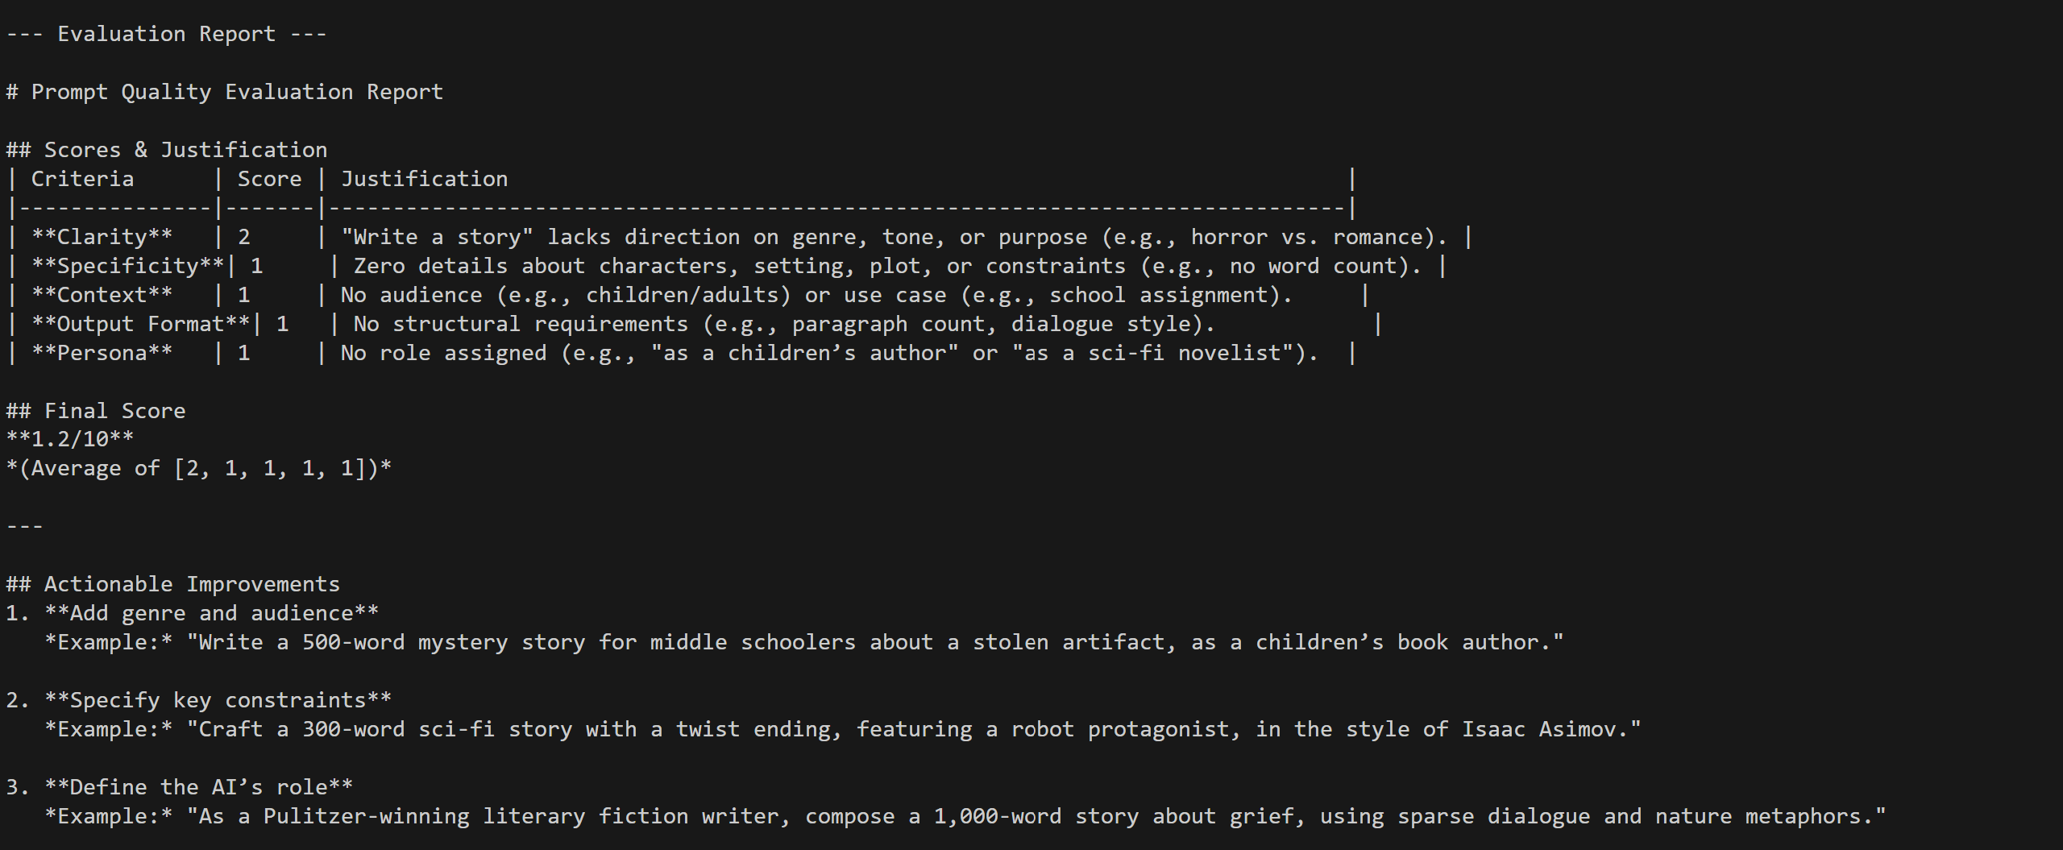

vemv2) PS C:\Users\Vishn\Documents\Agentic AI Training\demolanggraph\day3\Assignments> python ScoringAgent_v2.py
---Prompt Quality Scoring Agent!(Ready)---
Type your prompt to evaluate, or 'exit' to quit.

Please enter your prompt for evaluation: Write a story.

> Entering new AgentExecutor chain...

Invoking: `calculate_final_score` with `{'format_score': 1, 'persona': 1, 'clarity': 2, 'specificity': 1, 'context': 1}`
responded: <report>
# Prompt Quality Evaluation

## Scores
| Criteria | Score | Justification |
|---------------|-------|-------------------------------------------------------------------------------|
| Clarity | 2 | Vague goal with no direction on genre, tone, or purpose. "Write a story" is too broad. |
| Specificity | 1 | Zero details about characters, setting, plot, or constraints. |
| Context | 1 | No audience, use case, or background provided (e.g., "for children" or "for a school project"). |
| Output Format | 1 | No word count, structure, or stylistic requirements specified. |
| Persona | 1 | No expert role assigned (e.g., "as a children's author" or "as a mystery novelist"). |

## Final Score
**1.2** (Average of [2, 1, 1, 1, 1])

Final Score: 1.2/10# Prompt Quality Evaluation Report

## Scores & Justification
| Criteria | Score | Justification |
|---------------|-------|-------------------------------------------------------------------------------|
| **Clarity** | 2 | "Write a story" lacks direction on genre, tone, or purpose (e.g., horror vs. romance). |
| **Specificity**| 1 | Zero details about characters, setting, plot, or constraints (e.g., no word count). |
| **Context** | 1 | No audience (e.g., children/adults) or use case (e.g., school assignment). |
| **Output Format**| 1 | No structural requirements (e.g., paragraph count, dialogue style). |
| **Persona** | 1 | No role assigned (e.g., "as a children’s author" or "as a sci-fi novelist"). |

## Final Score
**1.2/10**
*(Average of [2, 1, 1, 1, 1])*

---

## Actionable Improvements
1. **Add genre and audience**
*Example:* "Write a 500-word mystery story for middle schoolers about a stolen artifact, as a children’s book author."

2. **Specify key constraints**
*Example:* "Craft a 300-word sci-fi story with a twist ending, featuring a robot protagonist, in the style of Isaac Asimov."

3. **Define the AI’s role**
*Example:* "As a Pulitzer-winning literary fiction writer, compose a 1,000-word story about grief, using sparse dialogue and nature metaphors."

> Finished chain.

--- Evaluation Report ---

# Prompt Quality Evaluation Report

## Scores & Justification
| Criteria | Score | Justification |
|---------------|-------|-------------------------------------------------------------------------------|
| **Clarity** | 2 | "Write a story" lacks direction on genre, tone, or purpose (e.g., horror vs. romance). |
| **Specificity**| 1 | Zero details about characters, setting, plot, or constraints (e.g., no word count). |
| **Context** | 1 | No audience (e.g., children/adults) or use case (e.g., school assignment). |
| **Output Format**| 1 | No structural requirements (e.g., paragraph count, dialogue style). |
| **Persona** | 1 | No role assigned (e.g., "as a children’s author" or "as a sci-fi novelist"). |

## Final Score
**1.2/10**
*(Average of [2, 1, 1, 1, 1])*

---

## Actionable Improvements
1. **Add genre and audience**
*Example:* "Write a 500-word mystery story for middle schoolers about a stolen artifact, as a children’s book author."

2. **Specify key constraints**
*Example:* "Craft a 300-word sci-fi story with a twist ending, featuring a robot protagonist, in the style of Isaac Asimov."

3. **Define the AI’s role**
*Example:* "As a Pulitzer-winning literary fiction writer, compose a 1,000-word story about grief, using sparse dialogue and nature metaphors."

Please enter your prompt for evaluation:

Test 2 : Explain quantum physics
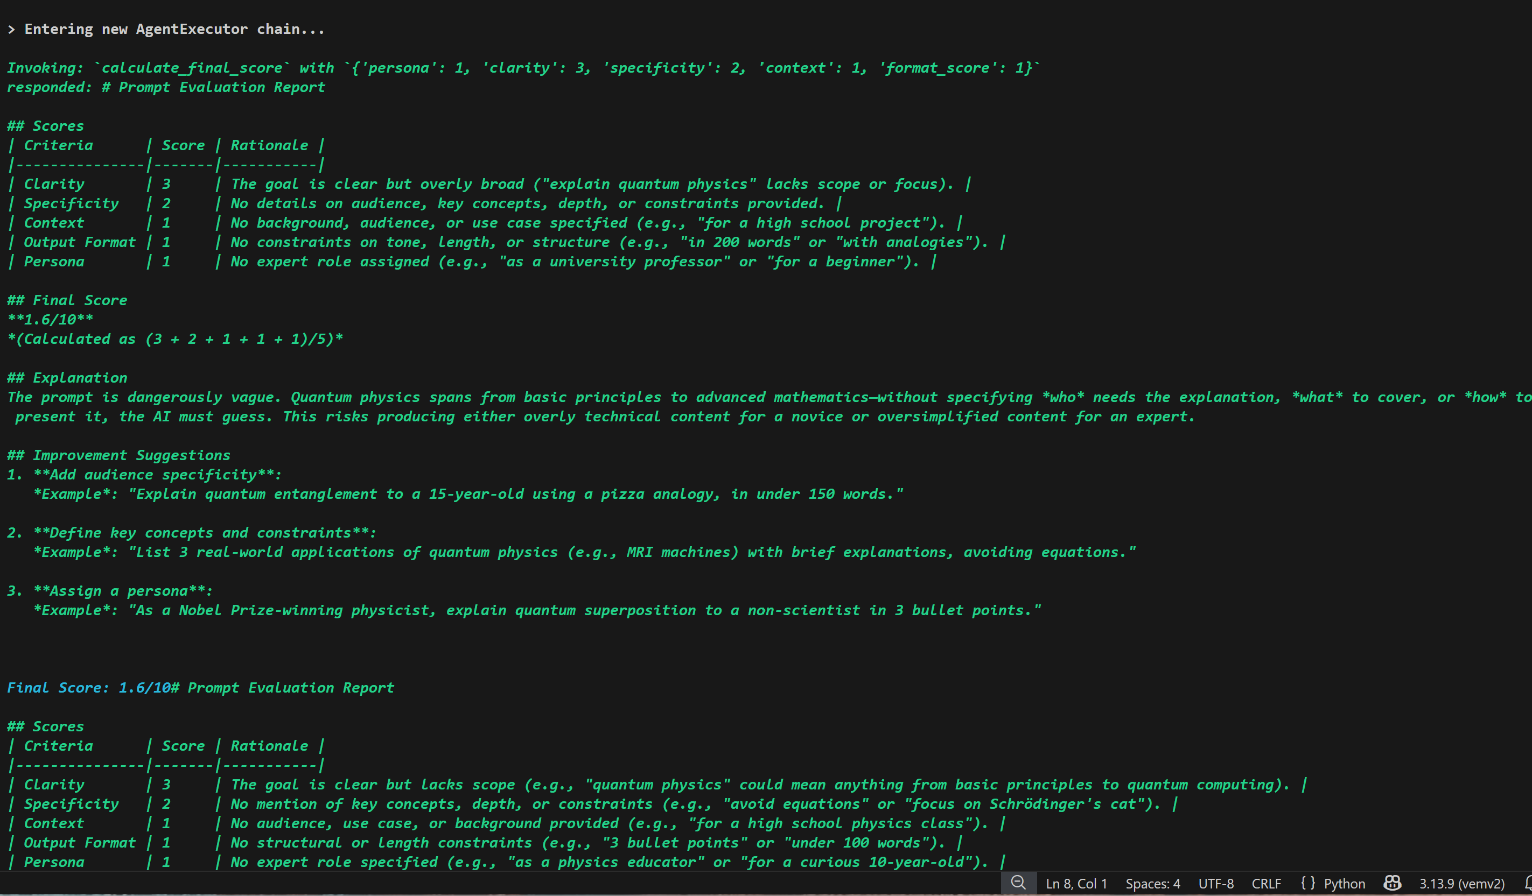
vemv2) PS C:\Users\Vishn\Documents\Agentic AI Training\demolanggraph\day3\Assignments> python ScoringAgent_v2.py
---Prompt Quality Scoring Agent!(Ready)---
Type your prompt to evaluate, or 'exit' to quit.

Please enter your prompt for evaluation: Explain quantum physics.

> Entering new AgentExecutor chain...

Invoking: `calculate_final_score` with `{'persona': 1, 'clarity': 3, 'specificity': 2, 'context': 1, 'format_score': 1}`
responded: # Prompt Evaluation Report

## Scores
| Criteria | Score | Rationale |
|---------------|-------|-----------|
| Clarity | 3 | The goal is clear but overly broad ("explain quantum physics" lacks scope or focus). |
| Specificity | 2 | No details on audience, key concepts, depth, or constraints provided. |
| Context | 1 | No background, audience, or use case specified (e.g., "for a high school project"). |
| Output Format | 1 | No constraints on tone, length, or structure (e.g., "in 200 words" or "with analogies"). |
| Persona | 1 | No expert role assigned (e.g., "as a university professor" or "for a beginner"). |

## Final Score
**1.6/10**
*(Calculated as (3 + 2 + 1 + 1 + 1)/5)*

## Explanation
The prompt is dangerously vague. Quantum physics spans from basic principles to advanced mathematics—without specifying *who* needs the explanation, *what* to cover, or *how* to present it, the AI must guess. This risks producing either overly technical content for a novice or oversimplified content for an expert.

## Improvement Suggestions
1. **Add audience specificity**:
*Example*: "Explain quantum entanglement to a 15-year-old using a pizza analogy, in under 150 words."

2. **Define key concepts and constraints**:
*Example*: "List 3 real-world applications of quantum physics (e.g., MRI machines) with brief explanations, avoiding equations."

3. **Assign a persona**:
*Example*: "As a Nobel Prize-winning physicist, explain quantum superposition to a non-scientist in 3 bullet points."

Final Score: 1.6/10# Prompt Evaluation Report

## Scores
| Criteria | Score | Rationale |
|---------------|-------|-----------|
| Clarity | 3 | The goal is clear but lacks scope (e.g., "quantum physics" could mean anything from basic principles to quantum computing). |
| Specificity | 2 | No mention of key concepts, depth, or constraints (e.g., "avoid equations" or "focus on Schrödinger's cat"). |
| Context | 1 | No audience, use case, or background provided (e.g., "for a high school physics class"). |
| Output Format | 1 | No structural or length constraints (e.g., "3 bullet points" or "under 100 words"). |
| Persona | 1 | No expert role specified (e.g., "as a physics educator" or "for a curious 10-year-old"). |

## Final Score
**1.6/10**
*(Calculated as (3 + 2 + 1 + 1 + 1)/5)*

## Explanation
This prompt is dangerously vague. Quantum physics spans decades of research and requires tailored explanations for different audiences. Without specifying *who* needs the explanation, *what* to cover, or *how* to present it, the AI must guess—resulting in either overly technical content for beginners or oversimplified content for experts.

## Improvement Suggestions
1. **Define audience and scope**:
*Example*: "Explain quantum superposition to a 12-year-old using a coin-flipping analogy, in 3 sentences."

2. **Specify constraints**:
*Example*: "List 2 quantum computing applications (e.g., cryptography) with one-sentence explanations, avoiding math."

3. **Assign a persona**:
*Example*: "As a TED Talk speaker, explain quantum entanglement in 60 seconds using a 'magic trick' analogy."

> Finished chain.

--- Evaluation Report ---

# Prompt Evaluation Report

## Scores
| Criteria | Score | Rationale |
|---------------|-------|-----------|
| Clarity | 3 | The goal is clear but lacks scope (e.g., "quantum physics" could mean anything from basic principles to quantum computing). |
| Specificity | 2 | No mention of key concepts, depth, or constraints (e.g., "avoid equations" or "focus on Schrödinger's cat"). |
| Context | 1 | No audience, use case, or background provided (e.g., "for a high school physics class"). |
| Output Format | 1 | No structural or length constraints (e.g., "3 bullet points" or "under 100 words"). |
| Persona | 1 | No expert role specified (e.g., "as a physics educator" or "for a curious 10-year-old"). |

## Final Score
**1.6/10**
*(Calculated as (3 + 2 + 1 + 1 + 1)/5)*

## Explanation
This prompt is dangerously vague. Quantum physics spans decades of research and requires tailored explanations for different audiences. Without specifying *who* needs the explanation, *what* to cover, or *how* to present it, the AI must guess—resulting in either overly technical content for beginners or oversimplified content for experts.

## Improvement Suggestions
1. **Define audience and scope**:
*Example*: "Explain quantum superposition to a 12-year-old using a coin-flipping analogy, in 3 sentences."

2. **Specify constraints**:
*Example*: "List 2 quantum computing applications (e.g., cryptography) with one-sentence explanations, avoiding math."

3. **Assign a persona**:
*Example*: "As a TED Talk speaker, explain quantum entanglement in 60 seconds using a 'magic trick' analogy."

Please enter your prompt for evaluation:
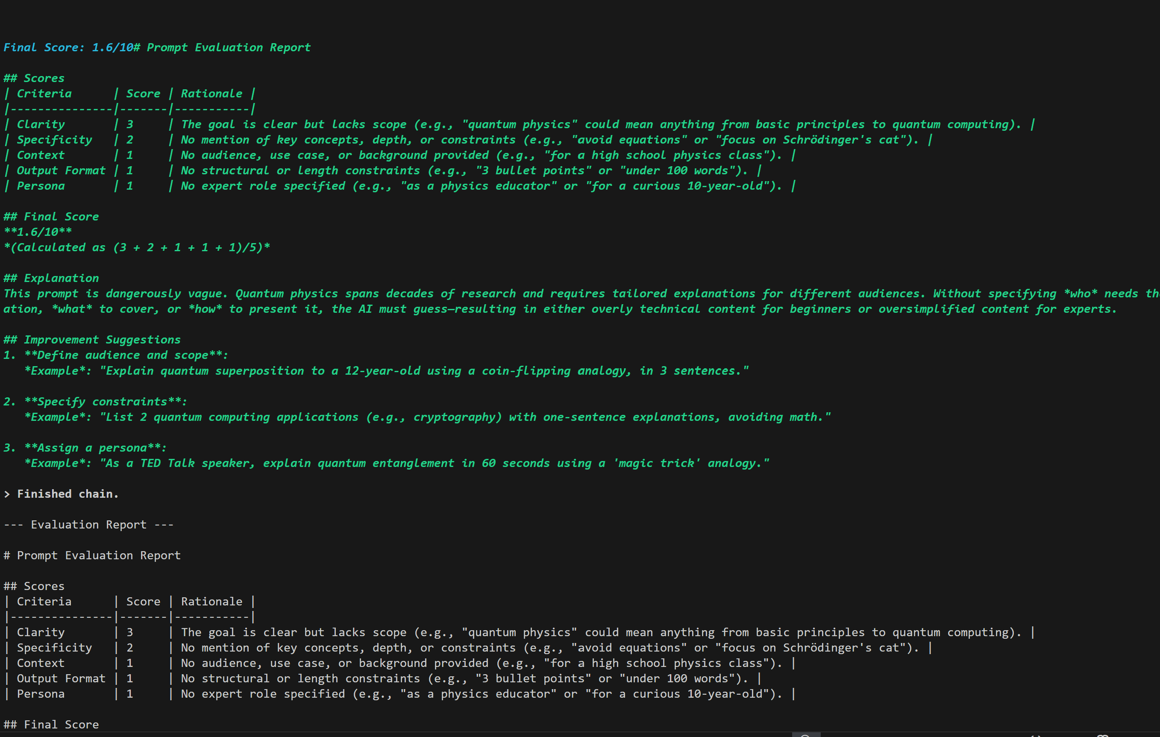

Test 3: Explain how a car engine works for a beginner.
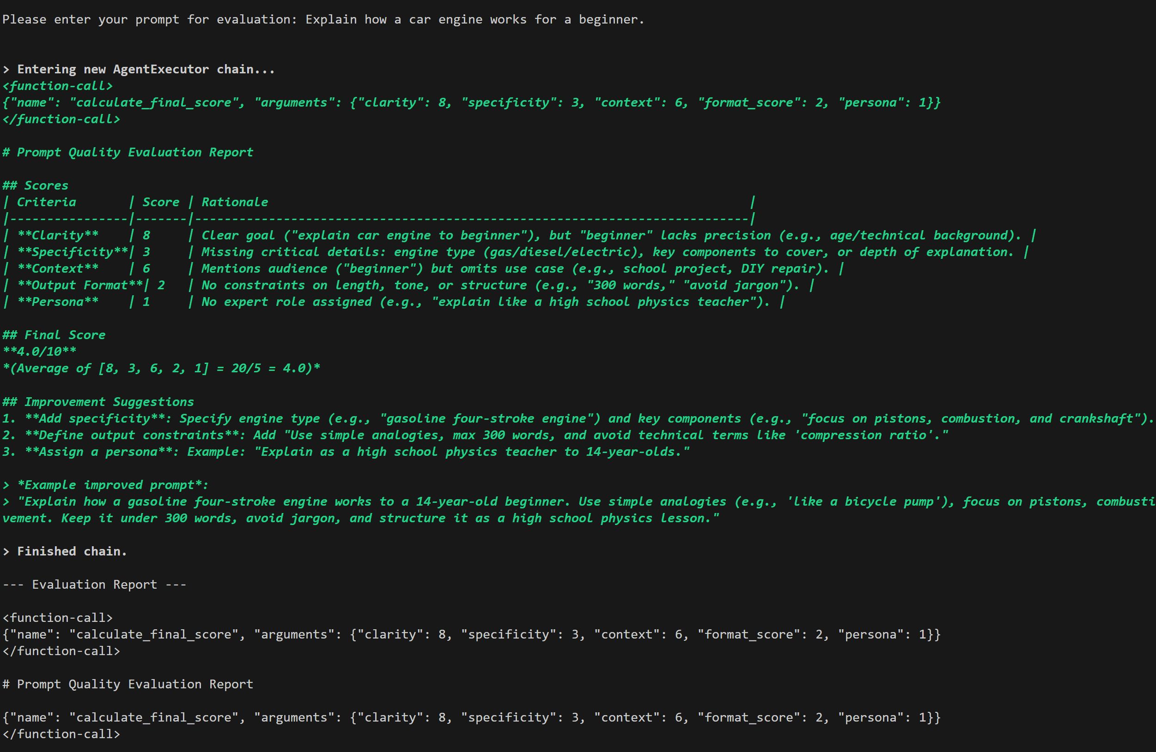

Test 4: You are an expert Python developer. Review the following code for security vulnerabilities and output your findings as a JSON list

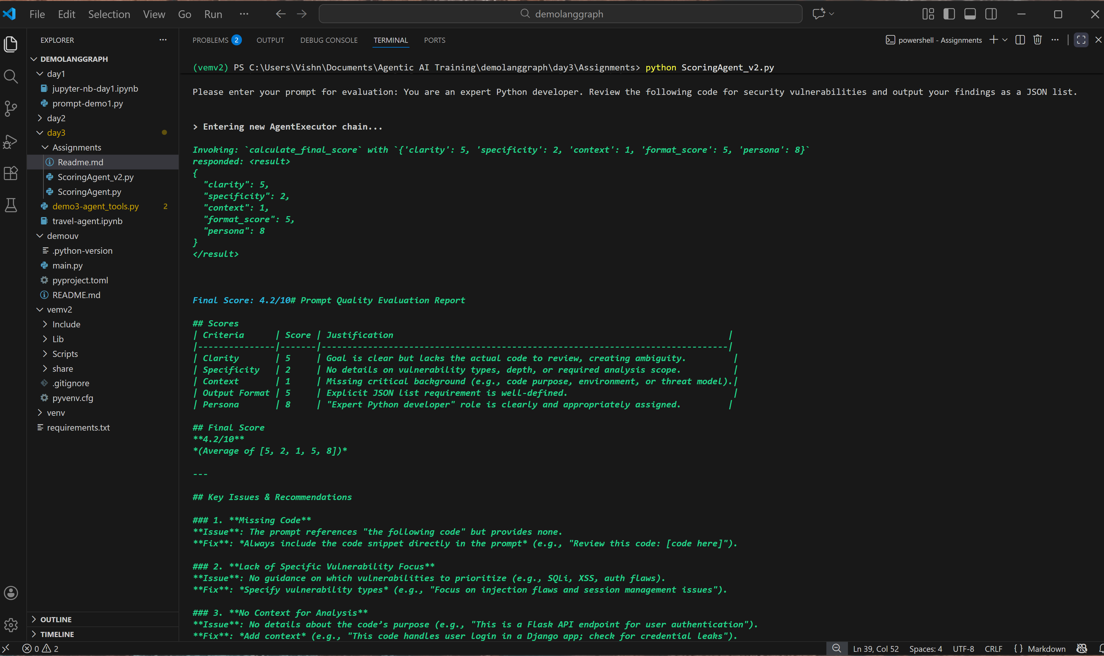

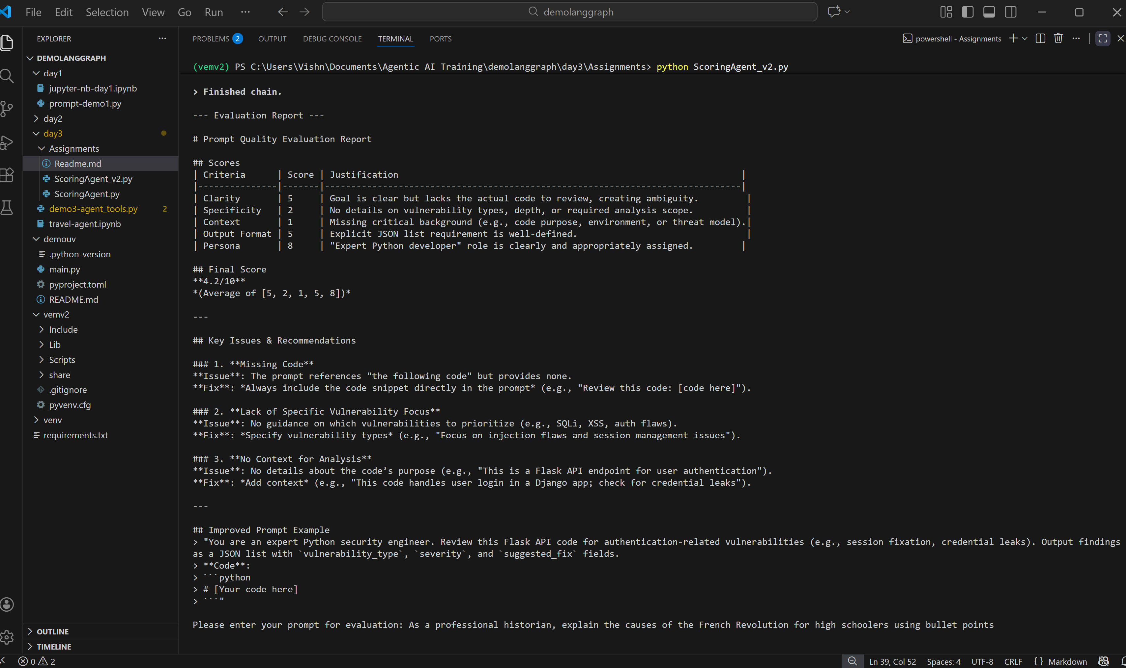
Test 5 : As a professional historian, explain the causes of the French Revolution for high schoolers using bullet points

