Input:
Q4 2025 Global Operations Performance Report
1. Executive Overview The fourth quarter of 2025 was characterized by strong revenue growth but significant pressure on operational margins. Total revenue reached $15.4 million, a 14% increase over Q3, driven largely by the high-performance "Nexus" hardware line. However, the cost of goods sold (COGS) rose by 9% due to an unexpected increase in lithium-ion battery costs and a 15% spike in trans-Pacific shipping rates during November.
2. Key Performance Indicators (KPIs)
- Net Revenue: $15.4M (Target: $14.5M)
- Gross Margin: 38.5% (Target: 41.0%)
- Customer Retention: 94% (Target: 92%)
- Operating Expenses: $4.2M (Target: $4.0M)
- Net Promoter Score (NPS): 78 (Previous: 72)
3. Regional Performance
- North America: Outperformed expectations with 22% growth in the enterprise sector.
- EMEA: Remained stagnant due to new energy compliance regulations impacting manufacturing timelines.
- APAC: Faced logistics bottlenecks, though consumer demand remained at record highs.
4. Risks and Forward-Looking Opportunities
- Risk - Regulatory Compliance: New EU environmental mandates (Policy 2026-A) may require a full redesign of the Nexus cooling system by Q3 2026, potentially costing $1.2M in R&D.
- Risk - Supply Chain: Over-reliance on a single vendor for semiconductors in Taiwan remains a critical vulnerability.
- Opportunity - Subscription Model: Trial runs for the "Nexus-as-a-Service" model showed a 40% conversion rate among small businesses, suggesting a path to recurring revenue.
- Opportunity - Automation: Implementing AI-driven warehouse sorting is projected to reduce labor costs by 12% starting in Q2.

Output :
Assistant Analysis:

## Q4 2025 Global Operations Performance Report Summary

Q4 2025 saw strong revenue growth fueled primarily by the "Nexus" hardware line, reaching $15.4 million – a 14% increase over Q3 despite facing significant pressure on operational margins. Gross margin hit 38.5%, slightly below the target of 41.0%. North America outperformed expectations with strong enterprise sector growth. However, challenges arose from increased lithium-ion battery costs and trans-Pacific shipping rate spikes, contributing to a COGS increase by 9% and impacting operational profitability. Despite these headwinds, the company achieved a Customer Retention rate of 94%, exceeding the target of 92%. A positive sign emerged with a 40% conversion rate for the "Nexus-as-a-Service" model among small businesses, indicating potential for recurring revenue.

**Key Metrics Table:**

| Metric | Q4 2025 (Actual) | Target | % Change (Q3 to Q4) | Source |
|------------------------|-----------------|------------|-------------------|--------------|
| Net Revenue | $15.4M | $14.5M | +14% | [Source] |
| Gross Margin | 38.5% | 41.0% | -2.5% | [Source] |
| Customer Retention | 94% | 92% | +2% | [Source] |

**Risks and Opportunities:**

* **Risk - Regulatory Compliance:** New EU environmental mandates (Policy 2026-A) require a full redesign of the Nexus cooling system, potentially costing $1.2M in R&D by Q3 2026.
* **Opportunity - Subscription Model:** Trial runs for "Nexus-as-a-Service" showed a 40% conversion rate among small businesses, suggesting a path to recurring revenue. This could contribute significantly to stable revenue streams and potentially lower churn rates.
* **Opportunity - Automation:** Implementing AI-driven warehouse sorting is projected to reduce labor costs by 12%, starting in Q2. This can help drive operational efficiency and cost savings, while contributing to higher productivity levels.
Screenshots:
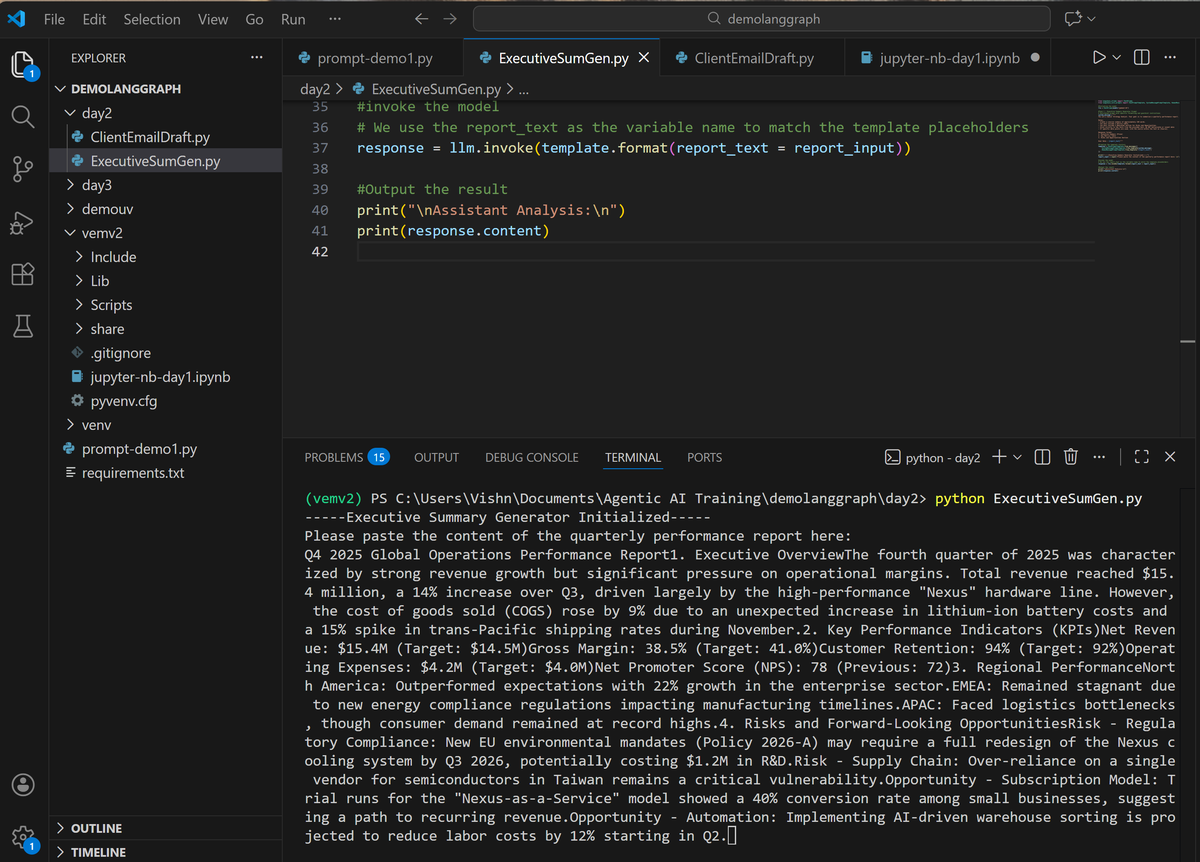
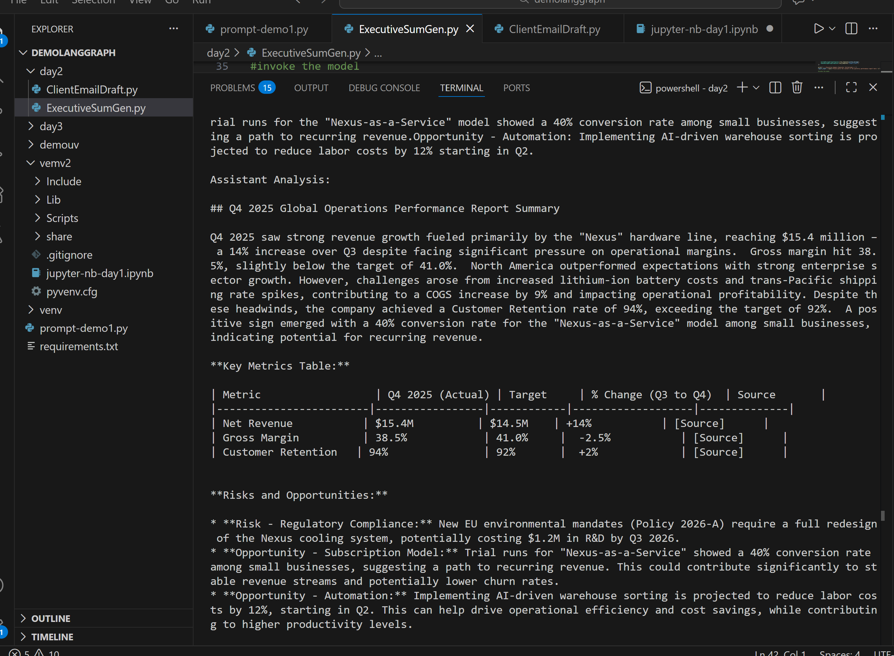
Git Link:

